DS2 Decision & Iteration Log

Name: Jehvarnai Green smith

Contents
01 GROOMING OPTIONS TO DISCUSS 4
02 INFORMATION TO SHARE 4
03 HOW AN ENQUIRY WORKS 4
1. Why I chose this scenario and tool 5
2. What information and reading I used 5
3. How I created the artefact 5
4. What changes I made and why 6
5. Feedback and checking used 6
6. Final explanation and remaining limitations 6

HAPPY PAWS  DOG GROOMING / NEW CUSTOMER GUIDE  A calm start to your dog’s grooming visit  Use this short guide to discuss your dog’s needs, ask about suitable services and understand the next steps before an appointment is confirmed. | 

01 GROOMING OPTIONS TO DISCUSS
Bath & gentle dry  Ask whether this suits your dog’s coat and comfort. |  | Brush-out / de-shedding  Discuss loose coat, tangles and matting.
Coat trim / full groom  Talk about coat type and the finish you want. |  | Nail care  Mention sensitivity around paws or handling.

02 INFORMATION TO SHARE
- Dog’s breed, age and approximate size  - Coat type and current condition  - Preferred grooming outcome | - Skin sensitivities or health concerns  - Stress triggers or handling preferences  - Previous grooming experience

03 HOW AN ENQUIRY WORKS
 | 1  Tell us  Share your dog’s needs.   | › | 2  Discuss  Ask about options and total price.  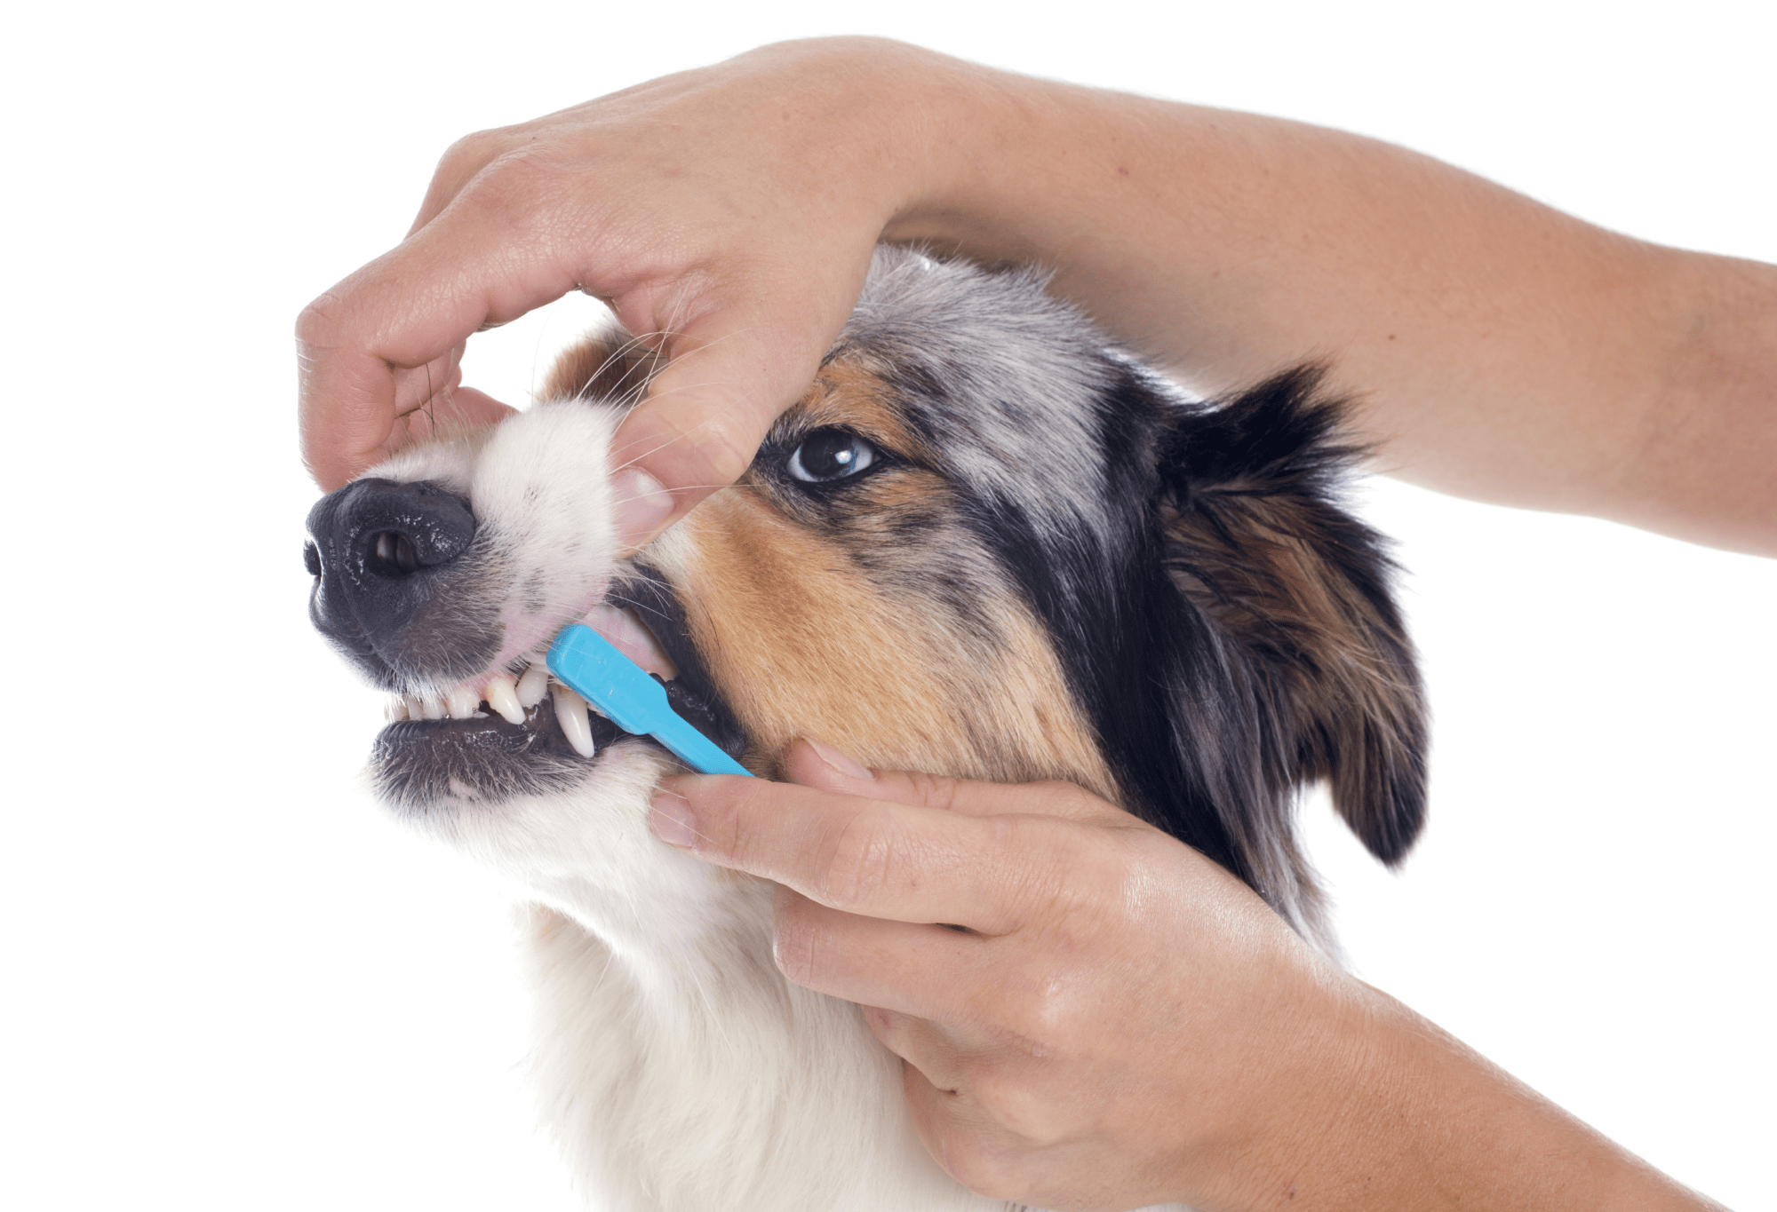 | › | 3  Confirm  Agree the service and appointment.  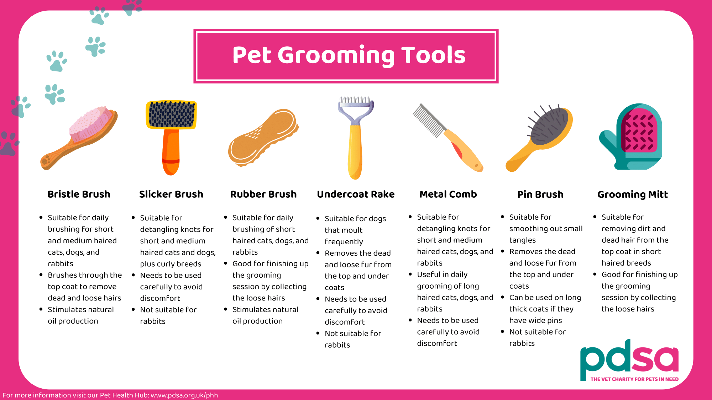
PRICES AND YOUR DOG’S COMFORT
Please ask for the complete price before agreeing to a booking, including any additional charges. Tell the groomer about health, coat or anxiety concerns before the visit.

DECISION & ITERATION LOG
Selected scenario: Happy Paws Dog Grooming-------Artefact: Word customer enquiry guide

1. Why I chose this scenario and tool
The DS2 task is not a complex technology project it is one business scenario and one useful digital artefact. When a first customer needs information to make an appointment to visit, I chose to put them in contact with Happy Paws Dog Grooming. My solution is a one page enquiry guide which can be printed or emailed to participants. As this does not involve numerical calculations, I selected a file format that is suitable for written information – Microsoft Word. For stock or sales, it would be better to use Excel and for PowerPoint, it would be better to save it as a one-page document. In addition, the owner can change the text in the page later without redoing the entire page. The audience point is a dog owner who is seeking an easy next step.

2. What information and reading I used
The business name and assessment design were borrowed from the module content. The recordings provided only the basic scenario for Happy Paws, and so I did not come up with a real address, phone number, hours or prices. I stated the service list as choices only and not a "must have". The RSPCA (n.d.) suggests asking a dog groomer about the physical and behavioural requirements of a dog, and PDSA (n.d.) provides more details about grooming requirements for dogs. Questions that I used from these sources to include were on coat, sensitive skin, and anxiety. The information that I used for pricing was based on guidance from the Competition and Markets Authority (2026) who stated that price information provided to customers should be clear and accurate.

3. How I created the artefact
I started with thinking about the questions the customer might ask, what can I ask, what should I say to the groomer, and, now what? I subdivided the page into three sections, each numbered, and emphasized with an introduction. I then went on to include an options grid, a short information checklist and a three-step enquiry sequence. It is a "how to" document rather than an essay and is achieved through the use of short sentences and white space. I’ve created the content in Word, and then used AI features to edit and format it as an editable Word document .docx that I can check and modify all the words and formatting of in Word. GOV.UK Design community recommends that words be short and straightforward to avoid unnecessary effort from the users.

DECISION & ITERATION LOG / CONTINUED

4. What changes I made and why
I made a basic draft of the Happy Paws Dog Grooming business document in Microsoft Word software. The first version contained information about the business, its services and booking process in general terms. The overall structure was rather spare and there were few colours used, limited headings and some irrelevant information. Upon reading the initial draft, I made several changes to enhance the visual appeal, clarity and usability for customers. The first step was to take the information and break it down into logical sections for it to be easily understood by customers about the services available and how to book them. I also shortened some sentences and eliminated the "blank" fields in the service options, and made some wording changes to ensure the options did not imply that unconfirmed services or prices were guaranteed. Secondly, I made the design much more consistent, using a uniform colour scheme, adding more clear headings, and making the font size and spacing between sections more consistent. Dark text on light backgrounds were used to improve readability. Regarding text-background contrast, Hall and Hanna (2004) found that it is a key attribute for readability in text messages and regarding visual appearance in users' perception of digital interfaces Lavie and Tractinsky (2004) emphasise this point. Lastly, I made the reminder to pay for services more prominent so that customers will understand the significance of verifying service pricing prior to reserving.

5. Feedback and checking used
Following this updated version, I made comparisons between the two versions to find ways in which the content, layout and readability of the two versions has improved. I looked to see if there were a consistent flow of headings, info was presented logically and if the colours worked to make it easy for me to read the document. I have also checked the artefact against the assignment check list to make sure that it was using an approved tool and covered a practical business need and presented information clearly. A tutor or business owner/customer did not provide any formal feedback. I employed the self-review technique to be able to identify and fix problems with the first draft. I also took into account W3C "Guidance for Accessibility" (2024) recommendations such as readable text and good colour contrast. All these changes resulted in a clearer, organised and professional business document that would be appropriate to its targeted customers.

6. Final explanation and remaining limitations
When the artefact is complete, Happy Paws has a clear point of departure in which to communicate with new customers. It is useful in practice; the reader will be able to see where he can have discussion points, may prepare the necessary details and understand the order of enquiry. The format is short to not overwhelm people, but not an alternative to a full service policy. Even a real business would still have to ensure the service area, booking procedure, overall costs and privacy details before using it. The Information Commissioner’s Office gives guidance about what a small organisation should be doing when collecting personal information. There is a main restriction that a full scenario sheet is not provided, so it will be vital that the artefact is cross-checked prior to submission to the teacher or public. No customer testing nor real business approval is claimed.
Outcome: one amended, digital product, and a documented and evidence-based design process. No research or feedback was fabricated.

REFERENCE LIST
Competition and Markets Authority (2026) ‘Providing clear and accurate information about prices: summary’. GOV.UK, updated 7 January. Available at: https://www.gov.uk/government/publications/price-transparency-cma209/providing-clear-and-accurate-information-about-prices-summary (Accessed: 25 October 2026).
GOV.UK Design community. ‘Writing for user interfaces’. GOV.UK Service Manual. Available at: https://www.gov.uk/service-manual/design/writing-for-user-interfaces (Accessed: 25 October 2026).
Hall, R.H. and Hanna, P., 2004. The impact of web page text-background colour combinations on readability, retention, aesthetics and behavioural intention. Behaviour & information technology, 23(3), pp.183-195.
Information Commissioner’s Office. ‘How to write a privacy notice and what goes in it’. Available at: https://ico.org.uk/for-organisations/advice-for-small-organisations/privacy-notices-and-cookies/how-to-write-a-privacy-notice-and-what-goes-in-it/ (Accessed: 25 October 2026).
Lavie, T. and Tractinsky, N., 2004. Assessing dimensions of perceived visual aesthetics of web sites. International journal of human-computer studies, 60(3), pp.269-298.
PDSA. ‘How often should you groom your pet?’ Available at: https://www.pdsa.org.uk/pet-help-and-advice/looking-after-your-pet/all-pets/grooming-pets (Accessed: 25 October 2026).
RSPCA. ‘Choosing the right dog groomer’. Available at: https://www.rspca.org.uk/adviceandwelfare/pets/dogs/health/grooming (Accessed: 25 October 2026).
World Wide Web Consortium (W3C) (2024) ‘Web Content Accessibility Guidelines (WCAG) 2.2’, W3C Recommendation, 12 December. Available at: https://www.w3.org/TR/WCAG22/ (Accessed: 25 October 2026).

