UNIVERSITY OF WALES TRINITY SAINT DAVID

ACADEMIC AND EMPLOYABILITY SKILLS

Name:Madalina Stefana Baciu
ID:1814625
Lecture Name:Sylvia Hoffmann
Submission Date:07.05.2019

Table of contents
Introduction 2
Academic and employability skills 2
Effective skills that employers want 3
Interpersonal skills and communication 3
Set of performance objectives and own responsibilities 4
Motivational techniques can be used to develop a quality of performance 5
Hygiene Factors 6
Motivating Factors 7
Identifying skill Gap 7
Step 1: Plan 7
Step 2: Identify crucial skills 7
Step 3: measure current skills 7
Employment skills 8
Positive attitude 8
Communication 8
Teamwork 8
Self-management 8
Recommendation 9
Conclusion 9
References 10

Introduction
Employability skill is defined as transferable skills required by individuals to make them more employable. I am a cosmetician and work at home. I want to open a salon in future which need some skill and also need to improve my current skill in the flied of cosmetician. Along with this perspective, good technical understanding and subject knowledge, employers outline a set of skills that they want while recruiting an employee. All the job seekers need foundational academic knowledge for developing their skills. Employability skills have been cited by the employers as the most important skills that are more critical to the organisational success in a 21st-century economy. The current report discusses different academic skills and employability skills that are important for an organisation.

Academic and employability skills
Experience and Education may make someone eligible to apply for the recruitment, to be successful in most roles; employers expect that the workers that are involved in the organisation have appropriate skills for better productivity. As opined by the works of Cottrell (2010), employability skills have become a decisive factor through which employers select candidates and hire candidates for the organisation. In the words of Cottrell (2010), employability skills are critical to achieve and keep employment along with career progression. In my case I have observed that gradually I have acquired these employability skills that helped me to gain this position where I am currently in.
Businesses required potential leaders with a track of records to develop open management positions. Employers can also be advantageous in many ways from close partnership working with training providers and educations on work in improving employability skills (Mackevic, 2014). The managers are the main leaders that come up with creative ideas and put them into impact in developing the economic growth and development. It also develops proper economic ideas of the region though developing taxes and jobs which enhances the standard of beneficiaries. Team work has all the potentiality and also encourages the employees to work efficiently and do the task in more innovative and efficient ways.

Effective skills that employers want

Interpersonal skills and communication
Here i have describing the skills which is very essential for a cosmetician as I have plan to open my own Salon in near future. And I am focusing on the major skills to explain what are really necessary for opening a salon.
- Creativity
The ability to learning new things and creative mind to explore newer style of fashion to impress and attract the customers. Exploring new ideas, identifying fashion s and analysis and applied to the clients and customers.
- Team working
Team Working is the most important key to complete the task in an efficient manner and achieve the goals of the organisation. In a depressed and stressful condition, an entrepreneur can overcome the situation with a high rate of confidence. The entrepreneur should have an improver personality for enhancing better decision and maintaining ethics in the workplace.
In the words of Mackevic (2014), while working in a team, the team leader motivates the employees and decides the tasks among between them so that they can share the tasks and their knowledge with each other. As per my analysis, the tasks given by the organisation become easier and exciting if it is done within the team. The team members can learn a more innovative way to complete the tasks in a given short period of time.

- Ability to learn and adapt
While working for an organisation it is very important for the employee to be more enthusiastic about the work as well as to determine the ways to understand from their own mistakes. If the employees recognise their own mistakes then they can rectify themselves in a more easy and efficient way (Maund et al. 2017).
Maintaining a tactful, friendly manner
When the employers are recruiting the employees, employers need to make sure that the employees are methodical and organised. As opined by the works of Cottrell (2008), the employees are able to plan the work accordingly to meet the exact deadlines as well as the targets. Guiding the progress of work is to ensure that whether the employees are in track in order to meet the deadline.

- Working under pressure and to deadlines
as per my viewpoint, it is important to handle the stress that develops with deadlines and make sure that the team needs to achieve the goals. In the words of Greetham (2013), when the employees work under pressure then they are more potential to do the tasks in the given deadline. The employees need to have those skills so that can work under pressure and do the task more efficiently.

Set of performance objectives and own responsibilities
In the perspective of recruiting the employees, there are efficient responsibilities and roles that are needed to be accomplished in an effective manner. In the words of Cottrell (2010), an organisation needs to understand about strategy analysis for the development of the business. Organisation development states the study of successful business changes and their performance (Cottrell, 2010).
While recruiting the employees, it is very important for the managers to ensure that they are selecting the potential candidate for the organisation. Solving workplace problems is a concrete goal for the individuals and the employees to solve. In the words of Cottrell (2010), setting a proper standard for the employees has proper concrete goals to meet. When establishing and identifying the standards of the employees, goals setting set a proper stage of developing an aspects of worksites in turn to develop the performance of the organisation.
Effectiveness against defined objectives
Measurement of the effectiveness of accomplishing the task on the given time is very important for the organisation. For maintain the standard in the quality services, the employers needs to conduct a proper training session so that the employees can get all the required knowledge about the company. In the words of Mackevic, (2014), in relation to this, the employers need to send their team members to their customers so that they can identify their requirements. Then it is also very important to ensure that the demand of the consumers is fulfilled on time. As per the Belbin theory, it is very important to determine the behavioural weaknesses and strengths in the organisation. Therefore, Belbin’s theory provides language to ensure the individuals and teams work and communicate together with effective understanding.
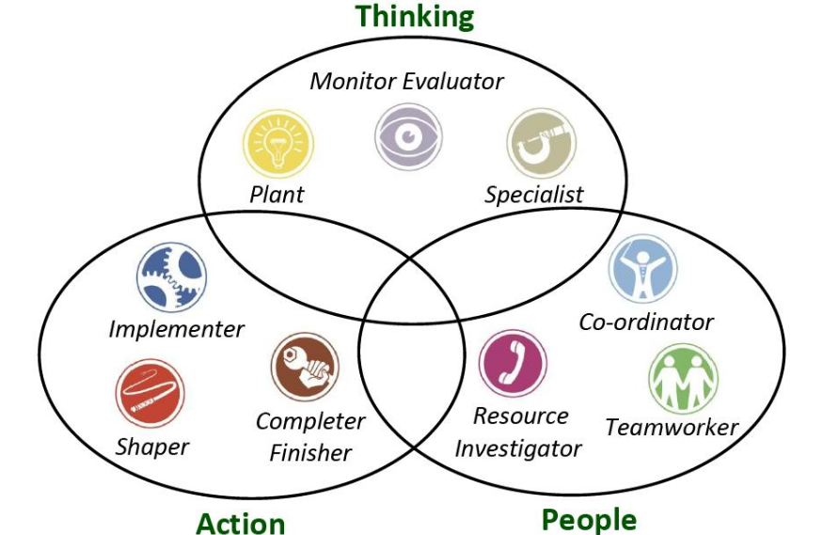
Figure 1: Belbin’s theory
(Source: Influenced from Mackevic, 2014)

Motivational techniques can be used to develop a quality of performance

Identifying skill Gap
Skill gap analysis can be performed on two levels such as:

Step 1: Plan
Team:
Team can even determine if the employees acquire the potentiality to perform in an upcoming project or if the individual need to recruit externally.
Individual:
The employers can identify the skills a job needs and compare them on an actual skill level of employees.

Step 2: Identify crucial skills
Some important skills have difficulties filling jobs due to skill gaps. The employers need to identify their skills that the employees need to have in order to complete the tasks.

Step 3: measure current skills
To measure skill levels, individuals could use:
- Interviews with the employees
- Assessment and surveys
- Feedback for the employees
- Skill management software

Employment skills
There are mainly seven important employability skills such as:

Positive attitude
Having a positive attitude in an organisation is very important to get a better productivity. The employees need to maintain a positive attitude in the organisation. In the words of Cottrell (2010), if the employees do not have a positive attitude then they cannot accomplish the demands of the customers.

Communication
While working in an organisation, it is very important to have effective communication skills with each other’s. Effective communication skills can even help the employees to understand each other’s tasks and complete on the given timeline.

Teamwork
Working as a team can be effective for the organisation to gain the productivity in the small span of time. Working in a team work can help the employee to gain knowledge while sharing their thoughts with each other’s.

Self-management
Self-management skills are the most important aspects in the workplace because they help to contribute to an effective work environment for the co-workers. Effective management skills have an effective power to change each aspects of the organisation. Self-management skills refer to major abilities to handle the feeling, activities and emotions.

Evaluation of own skills
In order to start the new beauty salon and as a cosmetician and a first time entrepreneur, there are some key skills that I need to implement in my working methods such as:
Creativity Team building
Creativity is the key point for beauty salon business to attract the customers. In order to gain actual productivity, team building is the most efficient tool that helps employees in developing a team that performs well. Some effective ideas that can be used to run a beauty salon include establishing effective channels of communication and conducting events outside the salon which can be helpful for advertising the salon (Cottrell, 2010).
Mentoring and training
As being a salon owner, I am also partly a mentor to the employees. By finding ways to help them to expand their horizons initially, both in technical skills and as individuals, I can ensure that they become proper assets to the salon and can also inspire goodwill and, loyalty.
Conflict management
While identifying the source of conflict, I have to make sure where the conflict is stemming from by listening to both the emerging sides. In the words of Mackevic (2014), most of the conflicts have their individual roots in long standing tiffs. This also helps in steering the conversation in a more emerging direction rather than starting to point fingers at each other.

Recommendations
- Entrepreneur mind-set determines the state of the brain which aid to implement the tasks through entrepreneurial activities. The opportunities innovation and various value creations are used to draw the entrepreneurial mind-set of an individual.
- Creativity plays a major role for cosmetician by creating new techniques and new fashion for gaining competitive advantage as the whole process is based on the exploration of new methods. By admitting the failure and starting the task again is categorised as an important aspect of determination.
- In a depressed and stressful condition, an entrepreneur can overcome the situation with a high rate of confidence. The entrepreneur should have an improver personality for enhancing better decision and maintaining ethics in the workplace.
- The business personality is categorised as a necessary pillar to generate the tendency of helping the individuals. It is the moral duty of improver is to establish outcome to demand quality feedback from the customers.

Conclusion
As a cosmetician and a mind with entrepreneurial mind-set I have to improve the skill that i have lack. As creativity and good communication is a great way to motivate worker and customers so these skill must be improved. Analysis of skill Gap can helps to determine the skill needed for further improvement. It can be analysed from the aforesaid discussion, that strategy analysis is based on facilitating, researching, mapping, analysing business abilities so that it can achieve the business goals. The company should look at their present state, the future state, risk and financial aspects of its organisation. Guiding the progress of work is to ensure that whether the employees are in track in order to meet the deadline. Communication being written and verbal is one of the most crucial employability skills for individuals to possess. Employers seek skills that support them to develop a peaceful and effective working environment.

References
Cottrell, S. (2010) Skills for Success: The Personal Development Planning Handbook (2nd edition). Hampshire: Palgrave MacMillan
Cottrell, S. (2011) Critical thinking skills: Developing effective analysis and argument (Palgrave study skills). 2nd edn. Basingstoke: Palgrave Macmillan.
Gibbs, G. (1988) Learning by doing: A guide to teaching and learning methods. London: FEU.
Greetham, B. (2013) How to write better essays. Basingstoke: Palgrave Macmillan.
Mackevic, V. (2014) From confusion to conclusion. How to write a FirstClass essay..2nd edition. Edited by Tom Wild. United States: Createspace
Maund, A. Schriek, M. and Tinkler, P. (2017). Certificate in Higher Education: Skills for the Workplace Student Yearbook. Sage Publications
McMillan, K. and Weyers, J. (2006) The smarter student: Skills and strategies for success at university, London: Prentice Hall.
Morgan, P. (2016). The Business Student’s Guide to Study and Employability. Sage Publications
OpenLearn. (2016) Skills for study [online] available at http://www.open.edu/openlearn/skills-for-study
Pears, R. and Shields, G. (2010) Cite them right: The essential referencing guide. 8th edn. Basingstoke: Palgrave Macmillan

