
Skills for the Workplace
Module Assignment Submission
Student Name: | Azad Khan
Student Number: | 1711422
Module No: | BMSK4003_LON
Module Title: | DIGITAL SKILLS AND RESERCH METHODS
Teacher: | Balanderan Kandasamy

Statement of Confirmation of Authenticity
By the act of making this submission, the student declares that this is the work of the student named above. The work has not, in whole or in part, been knowingly presented elsewhere for assessment, or where assessment has been built on a previous assessment, this has been identified. Where materials have been used from other sources it has been properly acknowledged. If this statement is untrue, the student acknowledges that an assessment offence has been committed.
Attention is drawn to the plagiarism and unfair practice policies of both the University and of ILM.

Contents
Introduction 3
Evaluate the appropriate use of Technology to improve workplace efficiency and employability 3
Cloud file storage 3
Smartphone’s 3
What are the benefits of using these applications/devices? 4
Demonstrate appropriate use of technology and its applications in the workplace 4
How linKedin network will help me most in my search for work or a better job. 4
How I would use each one in the workplace 5
The disadvantages I think there are using these networks in the workplace 5
What are the differences and similarities between each social network 5
What are the implications with regard to personal and professional security 6
Organise knowledge and learning through use of a range of information resources and present work at the appropriate level 7
Conclusion 9
Reference 10

Introduction
This report will be focused on the use of modern technologies within the workplace. During the report I will discuss about how use of technology appropriately helps efficiently improve workplace and employability, Demonstrate appropriate use of technology and its applications in the workplace and Organising knowledge and learning through use of a range of information resources and present work at the appropriate level.

Evaluate the appropriate use of Technology to improve workplace efficiency and employability

Cloud file storage

The benefits of using a cloud storage is you can access this from anywhere in the world, also say a manager wouldn’t need to send email to everyone to update employees of upcoming events, employees can access cloud themselves. Employers can also access cloud from when they go on holidays or on the go on your mobile device. Worldwide access to shared pools of adaptable system resources and higher-level services that can be rapidly provisioned with minimal management effort, often over the Internet. Cloud computing relies on sharing of resources to achieve the quality of being logical and consistent and similar to a public utility. By using cloud storage cloud computing allows enterprises to get their applications up and running faster, with improved manageability and less maintenance this helps you improve workplace efficiency.
I prefer using Apples iCloud to using Samsungs Google cloud because and I would definitely recommend apple iCloud to new users as I find it more easy to use and I believe it is more users friendly anyone can use it as it is a simple straightforward app.

Smartphone’s

Apple Smartphone’s are easy to use for me, everything is organised in a smart way from the app store to iTunes store. It uses an iOS which need to be updated from time to time. Compared to Samsung iphone I think is more easy to use, from the touch screen functions which are displayed moderately to purchasing from app store. It has a virtual keyboard; you can set what you want to access on a locked screen. You have choice of different iphones sizes you want to buy, I think iphone SE is the best value for money as it came before iphone 7 and has all the same functionality as an iphone 7 apart from being smaller than iphone 6 and 7. The iphone model looks appealing as well as doing other functions like video, photos, play music and all the other normal functions like text, email and calls. Although they take the mick when releasing new iphones by adding little by little functions they do improve on durability and apps. Using an iphone is like having so many things at once but in a compact size, the hard outer casing when dropped so many times which I did and surprised the glass didn’t break or the iphone itself doesn’t crash. I think apple is the best phone to come out (well from iphone 4 and onwards) since Sony Ericsson which I had in the school days which kind of looked like a compact brick. Iphone has improved with iphone 8 and iphone X with their facial recognition, compared to the Samsung phones with sumsang play store and google the iphone Smartphone I find is much more easy to use, to me it is pleasing to the eye.
Samsung Smartphone’s the screens look small, the virtual keyboard looks more complicated, using play store and Google store are not that easy for me I don’t know about other users but having my wife use it for a year or two I got her an iphone which is more user friendly. Samsungs outer casing don’t look that nice it looks more plastic like iphones 5c model

What are the benefits of using these applications/devices?

The benefits of using a iphone when you are using adobe clips it is shorter which is better when enjoying demanding augmented-reality apps, a smoother experience The speed difference make’s playing the most intensive games enjoyable. With apple you have apple TV which you can access from your iphone which you can screen mirror. You can also access a whole range of self taught activities i.e. learn theory test for driving, download free language apps you can also pay with your phone using apple pay so if ever you’ve forgotten your wallet you can pay your bus/train fares pay also in most stores. Apple iphone has family sharing so if ever your children wanted to purchase something you would be notified via email and can confirm or prevent shock bills.
Apple has the best support team which I found useful when I had to cancel a double Netflix account they refunded two months of transactions and gave me a month free viewing. You can search vast database of useful help articles on Apple's website, whenever you have problems with phone or viewing apple TV you can get help via live chat or schedule an appointment at an Apple Store Genius Bar and also they do apple workshops for new iphone users which is family orientated so you can take your children’s along and learn how to use a Macbook or your iphone. The apples iOS lets you download when you want it to download you can never miss it in the settings as you may also receive a notification or prompt you to download.
Apple’s siri is also very good like the Amazon’s Alexa, who lets you call anyone when telling siri to call or what weather like now is. The apples device is like your own personal laptop/music player/email as well as your phone and messenger. You can access social media and a whole range of information you couldn’t access 20 years ago (via your mobile device).

Demonstrate appropriate use of technology and its applications in the workplace

How linKedin network will help me most in my search for work or a better job.

I believe LinkedIn will help me most in my search for work or a better job as this is a professional site for businesses and employment oriented service that you can access via websites or mobile apps. It would act as our own personal CV. It is mainly used as a professional networking where employers posts jobs and potential job seekers posting their CVs. It acts as our professional bio data which is accessed by millions of professional people around the world. It allows members both employers and workers to create a profile and connections to each other in an online social network. It mediates as a middle man to members where you and I can connect to other contacts via introduction through a contact of ours or an existing relationship. It creates a bond between members and gives us a stepping stones to greater success although not everyone is a high flyer straight away.

How I would use each one in the workplace

I would use LinkedIn as a professional network to look for jobs this is my professional bio data which will help me in gaining a job whether I am successful or not it will help me build a professional relationship between contacts. LinkedIn will help me access a lot of potential employers.

I would use Facebook as a personal/family profile as people as young as 13 years can join, although it’s created by Mark Zuckerberg and friends who were havard students. It’s used by institutions and universities and high schools around the world. Facebook is nowadays used by young people as a cheaper way to communicate via instant message, share photos/videos follow people keep followers up to date of your daily life. It’s a fun app for old and young to use although you can get trolled and all your personal information is on display it can play as a villain or friend to users.

I would use twitter as an app to stay up to date on important information from live train information to up to date on media/news, I wouldn’t use it as a personal or family app maybe some people do, for me twitter like the name implies you would use to tweet people information from football to upcoming celebrity events or watch live events.

What advantages there are in using these networks in the workplace

You can engage and build relationships, you can stretch out further than your own immediate surroundings, and building employee loyalties can help to strengthen a company as a whole. Communicating effectively further than email or telephone helps you in a certain topics to be
Satisfactorily addressed in this type of interaction. I can never miss any subjects or goings on around the world. Provide businesses with analysis and trends, can provide us with endless information
Help’s in better employer/employee relationships. Improve self development, learning and discovery. Employees can check compare with other peers learning more about opportunities as they come with better improvements.

The disadvantages I think there are using these networks in the workplace

Company networks are prone to Hackers as they can use social media platforms to gain entry to personal information. Workers may engage in harassing behaviours toward co-workers on a social network, which will result in HR taking action can result in loss of employments and imprisonment. Negative posts from former or current employees, or even clients casting the employer in a negative light, may damage the employer's reputation.
Employers become more likely to charges of discrimination, privacy violations and interfering with employees' rights, among other violations, when social media is used in the workplace.
Some employees may spend an inappropriate amount of time on social media for personal reasons while at work. Wages and hour issues can sometimes be a headache. Less able employees or the disadvantaged are restricted to certain working hours may incur additional loss of hours, including overtime, more easily through social media use.

What are the differences and similarities between each social network

Social networks tend to put forward specific peer-to-peer associations. A community tends to allow members to find and start their own links.
A social network contains a huge range of people who may have nothing in common; communities bring together a characterised group.
Social networks usually control the member/user experience; communities usually provide more workability and options.
Social networks are generally managed which actions and policies are initiated at the highest level, broadcast mechanisms, communities generally allow more member ideas and discussion. Social networks tend to be mutually exclusive, you can't mix Google+ content into a Facebook post, communities tend to provide non supporting holdings for all types of content to be shared, from social networks, as well as original content.

What are the implications with regard to personal and professional security

Information security threats come in many forms not the same as another or each other. Some of the greatest occurring threats today are cyber and hacker attacks, theft of developed property, identity theft, theft of equipment or information, sabotage, and information extortion. Most people like me (Trojan horses) have experienced software attacks of some sort. Viruses, worms, phishing attacks, and Trojan horses are a few common examples of software attacks. The theft of developed/intelligent property has also been an extensive issue for many businesses in the IT field. Identity theft is the attempt to act as someone else usually to obtain that person's personal bio data or to take advantage of their access to vital information ie; bank details. Theft of equipment or information is becoming more prevalent today due to the fact that most devices today are mobile, are prone to theft and have also become far more desirable as the amount of data capacity increases. Crippling usually consists of the action of causing damage of an organization′s website in an attempt to cause loss of confidence on the part of its customers. Information extortion consists of theft of a company′s property or information as an attempt to receive a payment in exchange for returning the information or property back to its owner, as with ransomware. Governments, military, corporations, financial institutions, hospitals and private businesses amass a great deal of confidential information about their employees, customers, products, research and financial status. Should confidential information about a business' customers or finances or new product line fall into the hands of a competitor or a black hat hacker, a business and its customers could suffer widespread, irreparable financial loss, as well as damage to the company's reputation.

Organise knowledge and learning through use of a range of information resources and present work at the appropriate level

https://twitter.com/azadkha09516287

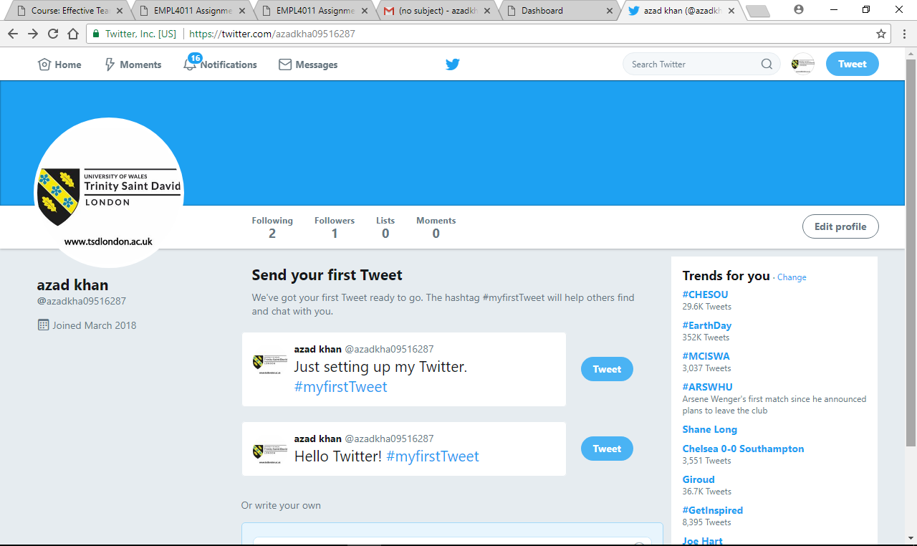

https://www.facebook.com/profile.php?id=100024878529449

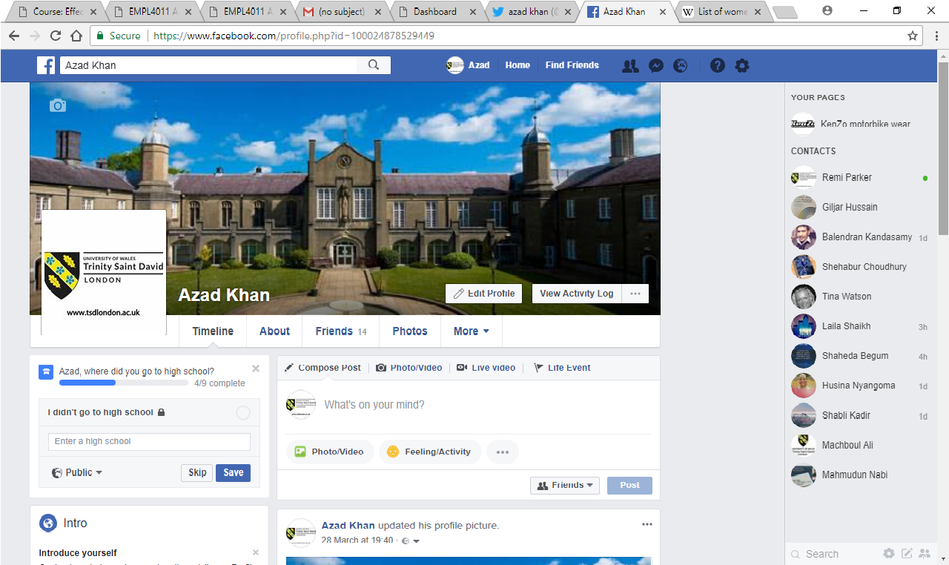
www.linkedin.com/in/azad-khan-06623615b

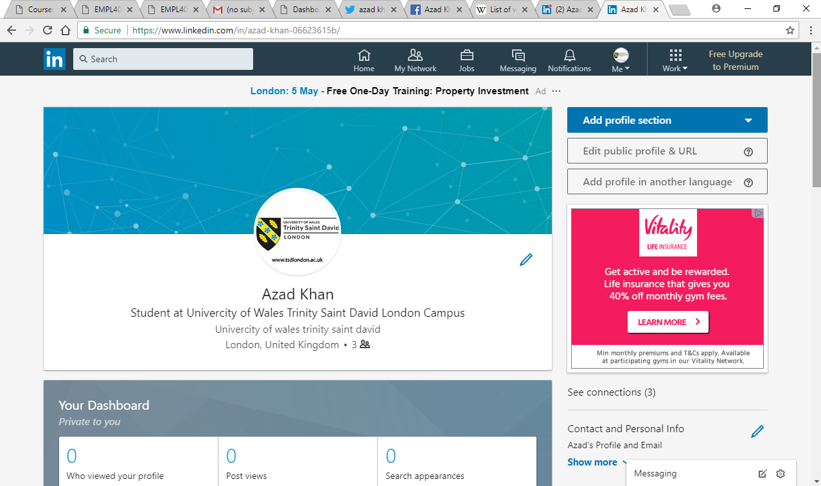

Conclusion

Cloud computing has the potential to be a wild force by affecting the deployment and use of technology, it is an essential part of today’s technology in how we do and perform in business workplace. The cloud could be the next evolution in the history of computing, following in the footsteps of mainframes, minicomputers, PCs, servers, smart phones, and so on, and radically changing the way business and companies manage IT. Although I would question regarding security (from hackers) within the cloud and how customers and cloud service communication service providers will manage issues and expectations, that Prevention is the only thing that a non-IT firm can incorporate within their cyber security strategy, Reaction is something companies can implement in way of contingency planning in order to ensure at least some level of continuity of business given computer systems are compromised, for example, planning the use of a paper work system - slower but still provides some degree of business continuity, specifically in life-critical business' such as healthcare but less good or important than it really is to say simply that cloud computing has generated interest in the marketplace.

Reference
Smartphone difference in apple and Samsung
Date accessed 22/04/2018
https://www.youtube.com/watch?v=WwhK_5jgJBo

The benefits of cloud computing in business
Date accessed 22/04/2018
https://www.youtube.com/watch?v=j7qRUDTEtl4

