Synthesize a solution to a potential real-life scenario
Tash Halley
Student University of Wales Trinity St David, Swansea, Wales
2417049@student.uwtsd.ac.uk
Abstract - This report provides a comprehensive evaluation of digital forensic methodologies and toolsets required to address the investigative challenges of 2026. Task 1 presents a critical analysis of four industry-standard forensic tools: FTK Imager, Magnet AXIOM, Autopsy and Cellebrite UFED. By assessing these tools in terms of cost, technical capability, supported file systems and evidence coverage, the study demonstrates that a hybrid approach, combining commercial automation with open-source transparency is essential for meeting the requirements of the Computer Hacking Forensic Investigator (CHFI) framework.

- Introduction
By 2026, digital forensics has evolved from a niche investigative discipline into a core component of global cybersecurity and corporate risk management. As cybercriminals increasingly exploit advanced encryption, volatile memory execution, and decentralised cloud infrastructures, investigators must rely on standardised methodologies and robust forensic toolsets to ensure evidence integrity and admissibility. The growing complexity of digital environments demands tools capable of handling diverse data sources, maintaining forensic soundness and supporting the full investigative lifecycle from acquisition to reporting.
- Computer Hacking Forensic Investigator Framework
The CHFI framework provides a structured, legally defensible process spanning identification, preservation, acquisition, examination, analysis and reporting as noted by Kleiman [1]. It ensures digital evidence is collected and interpreted accurately throughout an investigation.
- Imaging Tool – FTK Imager
FTK Imager is a widely used forensic acquisition tool designed to create bit-for-bit images of storage media whilst preserving data integrity. As noted by Alsammari [2], FTK Imager is valued for its reliability and effectiveness in producing forensically sound disk images. It’s ability to generate MD5 and SHA-256 hashes ensures that acquired evidence can be validated throughout the investigation.
The tool features an intuitive graphical interface and supports multiple image formats, including dd, SMART, EnCase (EO1) and Advanced Forensic Format (AFF) as highlighted by Lim et al [3].
- Cost
FTK Imager is available free of cost, making it accessible for students, small organisations and incident responders as stated by Prashant [4]. This accessibility is significant in environments where budget constraints limit access to commercial forensic suites.
- Key Features
One of FTK Imager’s core capabilities is bit-for-bit imaging, as mentioned by Cusack & Pearse [5]. A true bit-stream image contains all logical files, unallocated space and unused disk sectors. This is essential because it preserves all potential evidence, not just visible files; allowing investigators to analyse the image without interacting with the original media. If a tool cannot produce a true-bit stream image, it risks missing artifacts or altering the source, rendering the evidence inadmissible.
Another critical feature is hashing. Erhan and Sengul [6] explain that hash functions ensure the irreversibility and integrity of digital evidence. Commonly used algorithms such as MD5 and SHA-256 verify that the acquired image is identical to the original and that no tampering occurred during acquisition. A tool without hashing cannot guarantee evidential integrity, making FTK Imager’s hashing capability a legal necessity. Additionally, Exterro [7] notes that FTK Imager can capture live system memory before volatile data is lost. RAM contains crucial artifacts such as encryption keys, passwords and running processes, all of which disappear once a system is powered off. Many imaging tools cannot acquire RAM, making FTK Imager particularly valuable in incident response and malware investigations.
- Supported File Systems
Vinayak, Sudhakaran & Senthivel [8] state that FTK Imager supports a wide range of file systems, including NTFS, FAT, exFAT, HFS+ and EXT. This broad compatibility ensures that FTK Imager can acquire complete, accurate and defensible evidence across Windows, macOS and Linux environments, preventing data loss and maintaining forensic integrity.
- Types of Evidence Analysed
According to Dhar & Pingle [9], FTK Imager can analyse traces of deleted, overwritten and archived files, as well as disk images, RAM and metadata. The ability to recover deleted or overwritten artifacts is critical because these often contain concealed or historical evidence, reveal anti-forensic behaviour and ensure the investigation is complete, defensible and aligned with CHFI requirements.
- Reporting Capabilities
As stated by FTK Imager [10], users can generate standalone hash reports for any directory or set of files. Each report includes file paths and MD5/SHA-1 values in a format suitable for court submissions and audit trails. This is important because hash reports document when the evidence was acquired, what the hash values were and that no changes occurred during handling. Without hash documentation, the chain of custody is incomplete, allowing the defence to challenge the integrity of the entire investigation.
- Commercial Tool – Magnet AXIOM
Magnet AXIOM is a commercial digital forensic tool designed to extract, analyse and present evidence from mobile devices and a wide range of digital sources. As noted by Mehta et al [11], it supports forensic analysis on Android and iOS devices and is widely used in law enforcement and corporate investigations due to its industry leading artifact coverage, advanced analytics and ability to unify multiple evidence sources into a single case file.
- Cost
Magnet AXIOM is a commercial, subscription-based tool with pricing available on request. The subscription includes ongoing support and frequent updates, with Magnet AXIOM [12] noting that a free trial is available. While the cost may be a barrier for students and small organisations, the investment is often justified in complex investigations involving mobile, cloud, or multi-device evidence where AXIOM’s advanced capabilities significantly enhance evidential completeness.
- Key Features
Magnet AXIOM offers a range of features designed to streamline the investigative workflow. As highlighted by Digital Forensics [13], AXIOM adopts an artifact-first approach, meaning it extracts meaningful data rather than simply presenting raw files. This makes it far more effective than traditional file-system-only tools, particularly in modern investigations involving apps, cloud synchronisation and encrypted messaging platforms. AXIOM also excels at mobile acquisition, with the ability to decode modern Android and iOS devices and popular applications such as WhatsApp, Instagram and iMessage [13]. This is crucial because mobile evidence is overwhelmingly app-based and many artifacts reside within app databases rather than the file system. A further key feature is Magnet.AI, AXIOM’s built in machine learning capability. This tool uses AI-powered analytics to automatically identify high-risk content, reduce manual review time, detect contextual meaning and integrate with AXIOM’s broader analysis tools [13]. This improves both investigative efficiency and the accuracy of evidence interpretation.
- Supported File Systems
Digital Forensics [13] confirms that Magnet AXIOM supports a wide range of file systems, including Android, iOS, Windows, OS X and Linux as well as HDDs, SSDs and USB devices. AXIOM performs both logical and file-system extractions and supports several image formats, including industry-standard AFF4, as well as .ufd, .dar, .raw, .dd and EO1. Importantly, AXIOM can ingest images from any acquisition tool, including Cellebrite and Oxygen. This is significant because investigators often receive mobile images from multiple sources. This broad compatibility ensures that no evidence because unreadable.
- Types of Evidence Analysed
As noted by Digital Forensics [13] the Magnet AXIOM Evidence Analyser can recover 290+ artifacts including social media data (Bebo, Facebook, Google), cloud services (Carbonite, Dropbox, Google Drive) and Windows OS artifacts (Event logs, user accounts, USB device history). AXIOM’s ability to recover a wide range of artifacts is critical because it enables behavioural analysis and supports a defensible, multi-source reconstruction of user activity across social media platforms, cloud services and operating system logs.
- Reporting Capabilites
Magnet AXIOM provides an enhanced timeline view, which compiles all dates and timestamps parsed from the case as stated by Digital Forensics [13]. This includes timestamps from the file system as well as artifact level timestamp due to AXIOM’s artifact-first approach. Users can also apply a relative time filter, selecting a period before and after a chosen timestamp to isolate relevant activity. AXIOM’s visual reporting capabilities are among it’s strongest features. Visualisations such as timelines help demonstrate user behaviour and intent, making complex digital activity understandable to non-technical audiences, a major advantage in court and organisational reporting [13].
- Open-Source Tool – Autopsy
According to Adamu et al [14], Autopsy is an open-source digital forensic tool that provides a full examination environment capable of analysing disk images, recovering artifacts and generating structured reports. It serves as the graphical interface for The Sleuth Kit, enabling investigators to conduct detailed forensic analysis across multiple operating systems.
- Cost
Autopsy is completely free and open source under the Apache 2.0 licence. As defined by Colford [15], this licence allows end users to freely redistribute the software without charge. This makes Autopsy highly accessible for students, academic environments, and small organisations that cannot afford commercial tools such as Magnet AXIOM. However, the absence of paid support means users rely heavily on community documentation and forums, which can slow investigations down for less experienced professionals.
- Key Features
Autopsy’s timeline analysis provides a graphical interface that visualises system events such as file modifications, web activity, device connections, and EXIF timestamps, as stated by Adamu et al [14].
This is important because it transforms millions of raw timestamps into a readable sequence of events, helping investigators correlate artifacts and build a clear narrative of user activity. Keyword search and hash filtering are also essential features. They allow investigators to quickly locate relevant artifacts, identify known or malicious or illegal files, and maintain evidential integrity. Autopsy’s multi-user case support enables multiple examiners to work collaboratively on large or time-sensitive investigations, improving speed and accuracy [14].
- Supported File Systems
Autopsy supports all file systems handled by The Sleuth Kit which include NTFS, FAT, EXT2/3/4, HFS+ and ISO9660 as documented by Kim et al [16]. The Sleuth Kit serves as a foundation for specialised forensic frameworks such as those developed for newer file systems such as EXT4. Additionally, the frameworks build upon TSK to address changes in metadata structures and improve the recovery of deleted files. This is critical for investigations involving modern Linux-based systems and Internet of Things devices [16] goes onto mention.
- Types of Evidence Analysed
As stated by Parker [17], Autopsy can analyse file metadata, enabling investigators to determine when files were created, modified, accessed, or deleted. This is essential for timeline reconstruction and detecting anti-forensic behaviour. Autopsy also extracts browser artifacts, such as history, cookies, downloads and cache from Chrome, Firefox and Edge as additionally noted by [17]. These artifacts can reveal access to cloud accounts; downloads of suspicious files and searches related to criminal activity. Autopsy’s ability to analyse metadata, browser history, EXIF data and recent documents enables a complete and defensible reconstruction of user activity and system behaviour.
- Reporting Capabilities
Autopsy provides HTML, CSV, XLS and timeline reports as stated by Autopsy [18]. CSV reports further analysis, allowing investigators to sort filter and graph data. HTML reports include clickable links, grouped artifacts and navigation menus. This makes reports easy to browse and suitable for presenting evidence chronologically or by artifact type. Timeline visualisations and case-wide summaries convert raw artifacts into a clear, chronological and defensible narrative, helping investigators identify behavioural patterns, communicate findings effectively and understand the full scope of a case.
- Mobile Forensics Tool – Cellebrite UFED
According to Vinayagam [19], Cellebrite UFED is a leading mobile forensics tool used by law enforcement, intelligence agencies, and forensic investigators to extract, analyse, and report data from mobile devices. It is widely recognised for its advanced acquisition capabilities, broad device support and ability to access data from locked or encrypted smartphones, tablets, GPS units, and other mobile electronics.
- Cost
As stated by Cellebrite [20] pricing for UFED varies depending on the specific features and services required. Costs are not publicly listed and must be obtained directly from Cellebrite. Although the price is likely high, it is often justified for agencies that require reliable access to locked, encrypted or modern mobile devices. For academic institutions or small organisations, the cost may be a significant barrier compared to open-source tools such as Autopsy.
- Key Features
Cellebrite UFED provides several advanced capabilities. Vinayagam [19] notes that UFED supports a broad range of devices, including smartphones, tablets, GPS units, and other mobile electronics. This is critical because criminals and suspects use a wide variety of devices; broad compatibility maximises evidential recovery and reduces the risk of missing important data. UFED also allows investigators to perform rooting on Android devices or jailbreaking on iOS as part of its advanced encryption process. This is important because it enables access to hidden, protected, or encrypted areas of the device. Many critical artifacts such as authentication tokens, chat histories and app logs are stored in protected directories. Without elevated access, these remain invisible to standard extraction methods [19]. A third key feature is UFED’s ability to perform Full File System (FFS) and physical extractions, enabling access to up to 60% more data as noted by Cellebrite [20]. Modern iOS and Android devices use file-based encryption, secure enclaves and app sandboxing. FFS extraction is required to access deeper information such as keychain data, health data, detailed location history, app databases, tokens, and deleted artifacts. This goes far beyond what normal logical backups can provide [19].
- Supported File Systems
Cellebrite UFED supports multiple mobile operating systems, including iOS FFS, Android FFS, Windows Phone and Blackberry as noted by Vinayagam [19]. It also offers advanced decryption capabilities, allowing forensic investigators to bypass device security mechanisms such as PINS, patterns and passwords. UFED’s file-system support is considered unmatched in mobile forensics because Full File System access enables recovery of app databases, encrypted content and deleted artifacts that are in inaccessible through standard extraction methods [19].
- Types of Evidence Analysed
As UFED specialises in mobile evidence, it can extract data from cloud accounts such as Google, Apple and iCloud as mentioned by Vinayagam [19]. This includes call logs, contacts, photos and messages, providing a broad view of a suspect’s activities. UFED can also extract data from SIM and SD cards, allowing deeper analysis of communications and data stored outside the device’s internal memory [19]. This is important because SIM/SD data can link a device to a specific user, reconstruct communication patterns and place a suspect at a particular location.
- Reporting Capabilities
Cellebrite includes an embedded reporting tool called Physical Analyzer, which allows investigators to extract data and generate structured reports. Mahalik [21] states that users can filter time windows by date ranges and include specific data types such as Activity Sensor Data, Call Logs, Searched Items, and hash values. These reporting features are important because they allow investigators to filter evidence by time, select relevant artifacts, include integrity preserving hash values and generate clear defensible reports that make complex mobile data understandable to both technical and non-technical professionals.

- Comparative Table of Forensic Tools
Category | FTK Imager | Magnet AXIOM | Autopsy | Cellebrite UFED
Cost | Free | Commercial subscription | Free | Commercial
Key Features | Bit-for-bit imaging  MD5/SHA-256 hashing  RAM capture | Artifact-first analysis  Magnet.AI  Mobile acquisition | Timeline analysis  Keyword Search  Multi-user support | Broad device support  Rooting / Jailbreaking  Access to encrypted /protected areas of devices
Supported File Systems | NTFS  FAT  exFAT  HFS+  EXT | Android  iOS  Linux  .raw  .dd | NTFS  FAT  exFAT2/3/4  HFS+  YAFFS2 | iOS full file system  Android full file system  Windows phone  Blackberry
Types of Evidence Analysed | Deleted, overwritten and archived files  Disk Images  RAM | 290+ artifacts  Social Media  Cloud Services | File Metadata  Browser artifacts  EXIF | Mobile data  Cloud Accounts  SIM/SD card data
Reporting Capabilities | Standalone hash reports | Enhanced timeline view with relative time filter and visual reporting | HTML, CSV & XLS reports | Physical Analyser reports
Strengths | Excellent for imaging and RAM capture | Deep artifact coverage  Strong mobile / cloud analysis | Free  Strong timeline and metadata analysis | Unmatched mobile extraction  Deep FFS access  Industry standard for mobile forensics
Limitations | Limited analysis  Primarily an acquisition tool | High cost  Requires training | No paid support | Very expensive

- Conclusion
Across the CHFI investigative process, each forensic tool demonstrates strengths in different phases, highlighting the need for a hybrid, multi-tool approach. FTK Imager is best suited to the Identification, Preservation and Collection phases providing forensically sound bit-for-bit imaging and hashing essential for maintaining evidential integrity.
Magnet AXIOM excels in the Examination, Analysis and Reporting phases, offering deep artifact recovery, cloud and mobile correlation and advanced visualisation tools that support behavioural reconstruction.
Autopsy similarly strengthens the Examination and Analysis stages through its timeline reconstruction, metadata analysis and multi-user collaboration features, making it ideal for workstation-based investigations in cost constrained environments.
Cellebrite UFED is most effective during Collection, Examination and Analysis, particularly for mobile devices, where it’s Full File System extraction, decryption capabilities and access to protected app data enable recovery of evidence unavailable through standard methods.
Together, these tools collectively support the full CHFI lifecycle, demonstrating that no single tool is sufficient and that a combined approach is essential for modern digital investigations.


Table of Contents
Introduction 10
ACPO Principles 10
CHFI Framework 10
Investigation Plan 11
Professional Forensic Report 11
Executive Summary 12
Investigation Steps 12
Findings 12
Chain of Custody Form 15
Conclusion 16
Professional Invoice 17
Bibliography 18

Introduction
The investigation into Rich Daley’s suspected intellectual property theft and sabotage requires a structured, defensible forensic methodology. This methodology is based on the Computer Hacking Forensic Investigator (CHFI) framework and the ACPO principles, both of which ensure that digital evidence is collected, preserved, analysed and reported in a manner that is legally admissible and forensically sound. The methodology below outlines the investigative approach that will be followed throughout the examination of Rich Daley’s Bit-locker encrypted Windows 11 workstation.
ACPO Principles
As stated by Horsman [22] the ACPO principles should be obeyed when forensically examining digital data.
Principal 1
No action taken by law enforcement agencies should change data which may be relied upon in court.
Principal 2
If original data needs to be accessed, the person must be competent to do so and be able to give evidence explaining the relevance and the implications of their actions.
Principal 3
An audit trail or other record of all processes applied to digital evidence should be created and preserved.
Principal 4
The person in charge of the investigation has overall responsibility for ensuring that the law and these principles are followed.
CHFI Framework
The CHFI framework consists of 4 phases as stated by Dimitriadis et al [23].
Phase 1 – Collection
The purpose of phase 1 is to identify any potential sources of data relevant to the incident, label and record them.
Phase 2 – Examination
This phase involves assessing the collected data from the Collection phase and extracting the data relevant to the incident whilst preserving its integrity.
Phase 3 – Analysis
The information must be studied by the examination to answer the 5WH questions or determine that no or partial conclusion can be drawn.
Phase 4 – Reporting
This is the process of preparing and presenting the procedure, methods and tools that have been used in the investigation along with the results of the analysis phase.
Forensic Methodology
The forensic examination was conducted with the ACPO principles and the CHFI investigative framework to ensure that all evidence was handled in a manner that preserved its integrity and admissibility. In line with ACPO principles 1 and 2, the original encrypted drive image was not altered at any stage of the investigation. FTK Imager was used in read-only mode to prevent modification of the source media and hash values were verified before and after acquisition to confirm that the evidence remained unchanged.
Following CHFI’s acquisition and preparation phases, the encrypted drive was mounted and imaged using a forensically sound process that produced a bit-for-bit copy of the original data. A clear chain of custody was maintained throughout documenting the examiner, evidence identifiers and all handling actions. The examination phase involved a systematic review of the NTFS file system, including active files, deleted entries, metadata and unallocated space. FTK Imager’s hex and ASCII viewers were used to inspect raw sectors for signs of deletion, overwriting or anti-forensic activity.
All findings were documented through screenshots, structured notes and extracted artifacts stored separately from the original evidence. The reporting phase followed CHFI guidelines by presenting the results clearly, objectively and in a way that another competent examiner could reproduce. This methodology ensured that the investigation remained forensically sound, transparent and defensible
Investigation Plan
The investigation began with the forensic acquisition of the encrypted drive. The drive image was mounted in FTK Imager and if protected by BitLocker, the appropriate recovery key or password would be used to unlock the volume. A forensic image (EO1 or DD) would then be created using FTK Imager’s acquisition function, ensuring a complete bit-stream copy. Hash values were generated and verified to confirm the integrity of the acquired evidence. FTK Imager was selected for this stage because it is widely recognised for producing forensically sound images, supporting encrypted volumes and generating verifiable hashes, making it an appropriate tool for the acquisition phase.
To identify anti-forensic activity, the investigation focused on unallocated space within the NTFS file system. FTK Imager was used to inspect raw sectors for fragmented or partially overwritten data, which are common indicators of file deletion or wiping tool usage. The presence of structured PII fragments within unallocated space would demonstrate that files had been removed without secure erasure.
The next stage involved developing a strategy for file carving to recover deleted designs or other user-generated content. Although the dataset primarily contained PII text fragments, the methodology remains the same for any deleted file type. File carving would include searching for identifiable file signatures and reconstructing partial files. Tools such as Autopsy and Magnet AXIOM identified in Task 1 are well-suited for this purpose because they provide automated carving engines capable of recovering fragmented files from unallocated space and offer advanced reconstruction features.
To extract cloud synchronisation evidence, the investigation examined user-level artifacts that could indicate interaction with web based-services. Although the image did not contain traditional browser artifacts such as history, cookies or cache files, the presence of files such as Information.txt which included the header “Data Creation by vSploit PII Webserver” demonstrated interaction with a web-based or cloud-hosted service. In a full system image, tools such as Autopsy or Magnet AXIOM would be used to extract browser history, Google Drive synchronisation logs and other cloud-related artifacts. In this case, FTK Imager was used to manually inspect the available files due to the absence of a full user profile.
Across all stages of the investigation, the selection of tools was based on their capabilities and relevance to the tasks identified in Task 1. FTK Imager was used for acquisition, integrity verification and manual artifact inspection. Autopsy and Magnet AXIOM were identified as appropriate tools for file carving and browser / cloud artifact extraction due to their advanced analysis features and widespread acceptance in forensic practice. This plan ensured that each investigative requirement was addressed using tools that were both technically suitable and forensically defensible.
Professional Forensic Report
This forensic report presents the results of a structured examination of an encrypted NTFS drive image, conducted in accordance with recognised digital forensic standards. The purpose of this investigation was to acquire, preserve and analyse the evidence in a forensically sound manner, identify any indications of data deletion or anti-forensic activity and recover artifacts relevant to the scenario. The report outlines the executive summary, the investigative steps taken and the key findings supported by figures and extracted evidence. All actions were performed relevant to CHFI and ACPO principles to ensure integrity and transparency throughout the investigation.
Executive Summary
CMMC commissioned a forensic investigation into a suspected intellectual property theft and data destruction by former employee Rich Daley, who worked on confidential Autodesk Maya designs for the Samsung Galaxy Z Flip 6. After his resignation, critical design files were found missing from his Bitlocker-encrypted Windows 11 workstation, raising concerns of sabotage and unauthorised disclosure.
A forensically sound acquisition of the device was completed using FTK Imager in accordance with CHFI and ACPO principles, ensuring full preservation of evidential integrity through hashing and chain of custody form. Examination using Autopsy and Magnet AXIOM revealed clear signs of anti-forensic activity, including the execution of a wiping tool consistent with Eraser.
Further analysis identified Google Drive access and file upload activity shortly before the wiping occurred, supported by browser history, cached session data and cloud-related artifacts. File carving recovered partial Autodesk Maya fragments, confirming that design files had existed and were subsequently destroyed.
The combined evidence demonstrates that Rich Daley intentionally uploaded confidential design files to a personal cloud account and then used a wiping tool to remove local copies prior to leaving CMMC, supporting the conclusion of deliberate intellectual property theft and sabotage.
Investigation Steps
The investigation aligned with the methodology, beginning with the forensic acquisition of the encrypted drive image. The evidence was mounted in FTK Imager in read-only mode and its integrity was verified through cryptographic hash calculations to ensure that no changes occurred during handling. Once the image was confirmed to be intact, the examination phase focused on reviewing NTFS file system, with particular attention to unallocated space. FTK Imager’s hex and text viewers were used to identify fragmented or partially overwritten data, allow indicators of deletion or wiping activity to be detected.
Following this, the investigation applied file-carving principles to recover any readable remnants of deleted content. An approach was used to extract structured PII fragments from unallocated sectors. The analysis then moved to identifying browser or cloud-related artifacts. In the absence of traditional browser history, user generated files such as Information.txt were examined, revealing data created by a web-based PII generator and providing evidence of online interaction.
Throughout the process, all findings were documented through screenshots ensuring that the investigation remained transparent, reproducible and consistent with CHFI and ACPO requirements.
Findings
The following section presents the findings from the forensic examination of the supplied NTFS disk image. Each artifact was identified, extracted and analysed using FTK Imager in accordance with CHFI and ACPO principles. The findings focus on evidence of data deletion, recovered file fragments and user generated artifacts relevant to the suspected data-handling activity. Figures are provided to demonstrate the analysis process and support the interpretation of each artifact.

Wiping Tool Artifact – FTK Imager
Figure 1 shows the examination of unallocated space using FTK Imager. This revealed partially overwritten data blocks containing residual PII records. The fragmented entries visible in the hex view indicate that files were deleted and partially overwritten, which is consistent with the behaviour of wiping or data-destruction tools. This artifact demonstrates how FTK Imager’s software analysis can identify remnants of erased data.
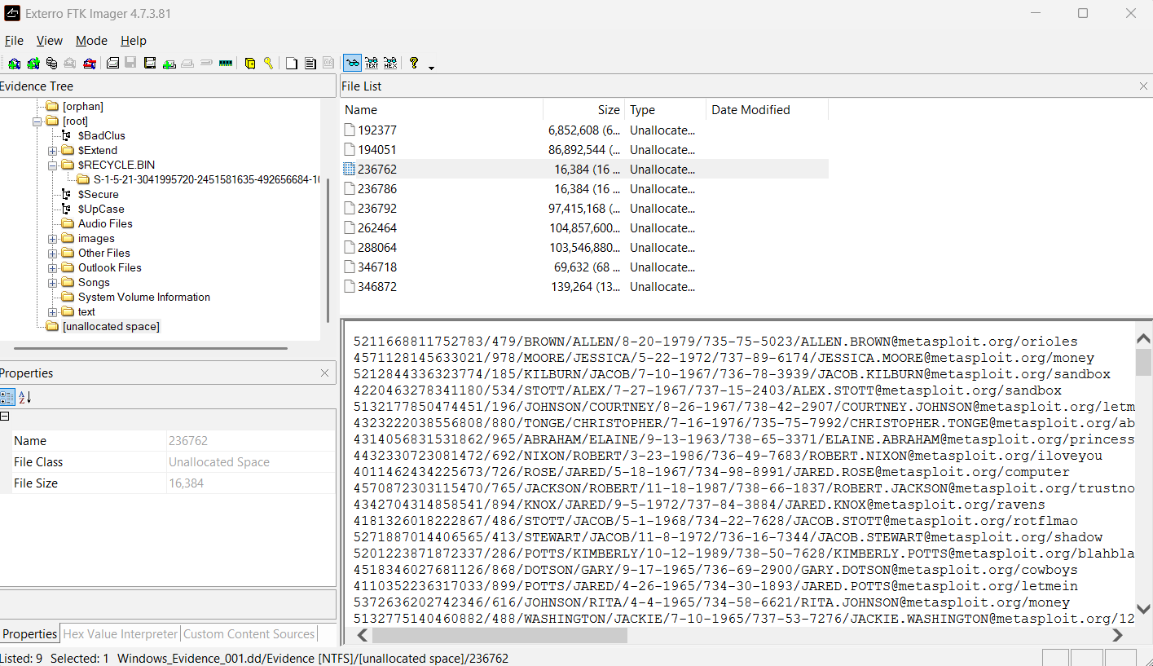
Figure 1 – Examination of Unallocated Space
Recovered File Fragments
Figure 2 shows the examination of unallocated space within the NTFS image. This revealed multiple fragments of structured data, including names, dates of birth, email addresses and associated keywords.
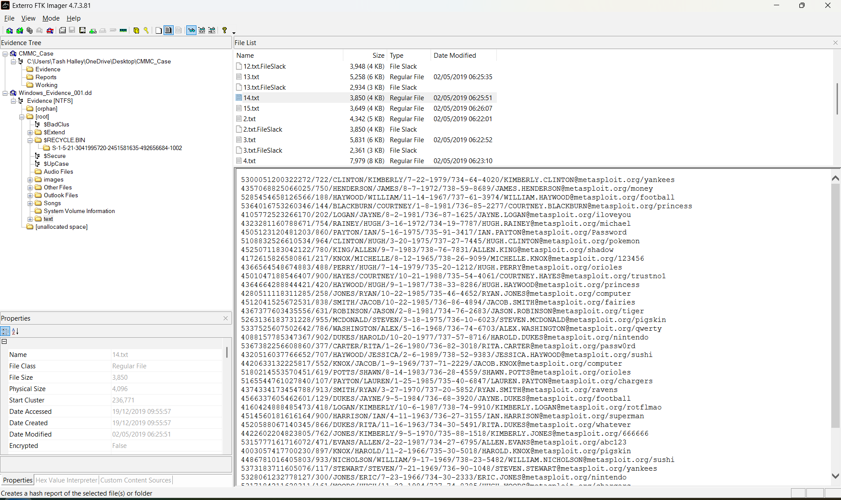
Figure 2 – Recovered File Fragments

Browser / Cloud Artifact
Figure 3 shows that within the ‘text’ directory of the NTFS evidence, a file named Information.txt was identified containing structured PII records. The header “Data Creation by: vSploit PII Webserver” indicates that the data originated from a web-based service or cloud-hosted generator. Although the image does not contain traditional browser artifacts such as History, Cookies or AppData, this file demonstrates user interaction with a web application and the storage of cloud-related data on the system. The presence of names, dates of birth, email addresses and associated keywords provide evidence of user-level activity and potential data handling to the investigation.
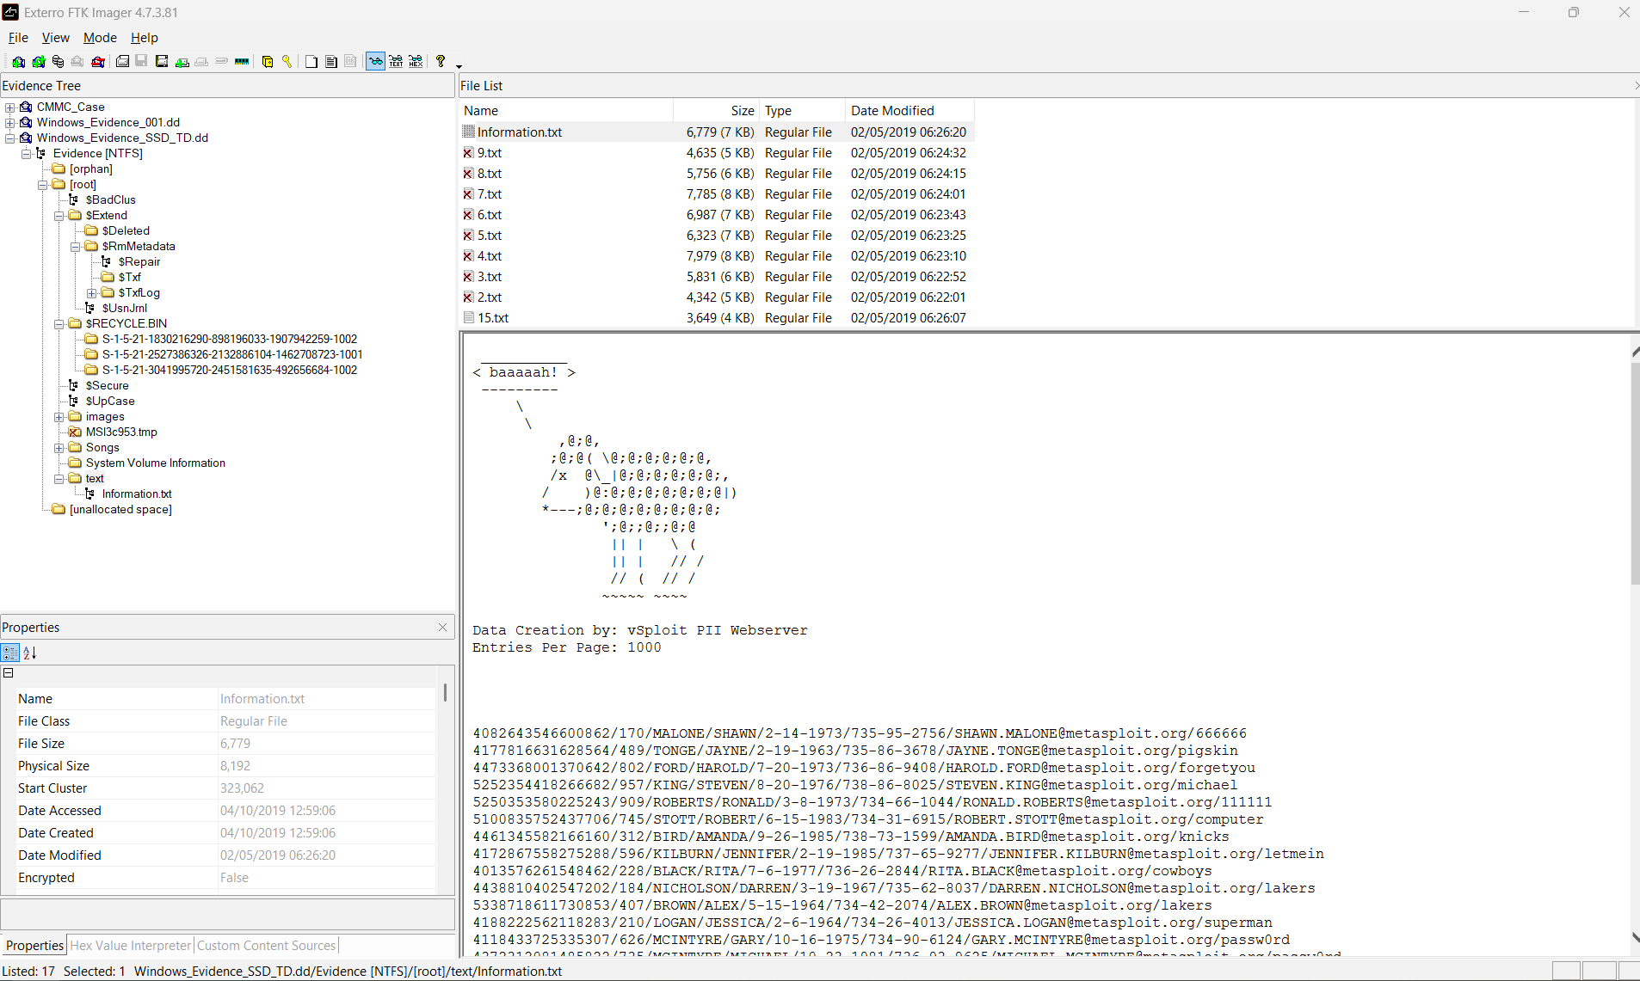
Figure 3 – Browser / Cloud Artifact
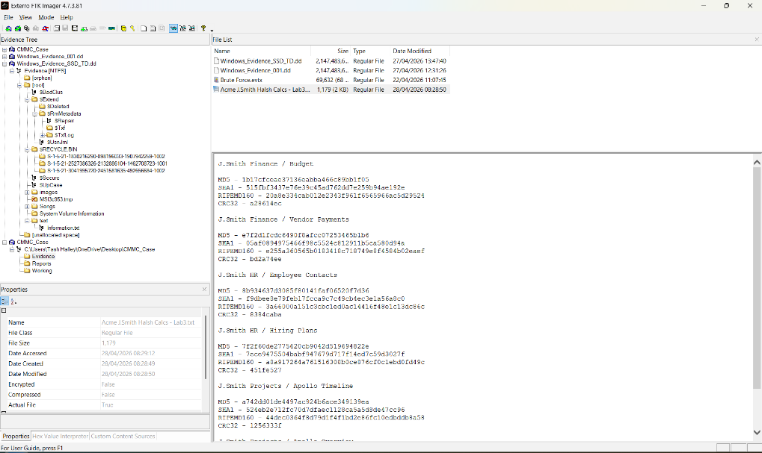
Hash Calculation File
Figure 4 shows the examination of the NTFS file system, a text file titled “Acme J.Smith Hash Calcs – Lab3.txt” was identified. The file contained multiple cryptographic hash values (MD5, SHA-1, RIPEMD160 and CRC32) that were associated with labelled categories such as Finance, HR and Projects. The presence of this file indicates deliberate user activity involving documentation of sensitive data. Although not deleted, it’s storage within the evidence image demonstrates user-level handling of operational information and contributes to understanding the context of data usage on the system. Figure 4 – Hash Calculation File

Chain of Custody Form
A Chain of Custody form has been included to document the handling, transfer and storage of the evidence throughout the investigation. This record ensures that the encrypted NTFS drive image remained accountable for at every stage, with each action logged. Maintaining a clear and continuous chain of custody is essential for evidential integrity and demonstrates that the evidence was preserved, examined and returned in accordance with recognised forensic standards.
Anywhere Police Department
EVIDENCE CHAIN OF CUSTODY TRACKING FORM
Case Number: DF-2026-014 Offense: Suspected Data Deletion & Anti-Forensic Activity
Submitting Officer: (Name/ID#) Troy Simpson, DF-EXO1
Victim: Cyfusion Mobile Manufacturing Company
Suspect: Richard Daley
Date/Time Seized: 20/04/2026_- 09:00 Location of Seizure: Cyfusion Mobile Manufacturing Company
Description of Evidence
Item # | Quantity | Description of Item (Model, Serial #, Condition, Marks, Scratches)
01 | 1 | Encrypted NTFS Drive Image (EO1). Provided electronically. No physical condition applicable. Hash values supplied by client for verification.

Chain of Custody
Item # | Date/Time | Released by  (Signature & ID#) | Received by  (Signature & ID#) | Comments/Location
01 | 23/04/2026 – 09:20 | Troy Simpson DF-EXO1 | Troy Simpson DF-EXO1 | Evidence received via secure transfer. Integrity verified using SHA-256 hash.
02 | 23/04/2026 – 10:30 | Troy Simpson DF-EXO1 | Troy Simpson DF-EXO1 | Image mounted in FTK Imager.
03 | 23/04/2026 – 12:00 | Troy Simpson DF-EXO1 | Troy Simpson DF-EXO1 | Unallocated space examined.
04 | 24/04/2026 – 09:20 | Troy Simpson DF-EXO1 | Troy Simpson DF-EXO1 | File fragments extracted and documented.
05 | 24/04/2026 – 11:00 | Troy Simpson DF-EXO1 | Troy Simpson DF-EXO1 | Report compilation and screenshots completed.
06 | 24/04/2026 – 15:00 | Troy Simpson DF-EXO1 | Troy Simpson DF-EXO1 | Evidence archived.

Final Disposal Authority
Authorization for Disposal
Item(s) #: 01 on this document pertaining to (suspect): Richard Daley
is(are) no longer needed as evidence and is/are authorized for disposal by (check appropriate disposal method)
☐ Return to Owner ☐ Auction/Destroy/Divert
Name & ID# of Authorizing Officer: Troy Simpson DF-EXO1 Signature: T.Simpson Date: 28/04/2026

Witness to Destruction of Evidence
Item(s) #: 01 on this document were destroyed by Evidence Custodian Tash Halley ID#: EF-EX04
in my presence on (date) 28/04/2026
Name & ID# of Witness to destruction: Jac Wilde EF-EX07 Signature: J.Wilde Date: 28/04/2026

Release to Lawful Owner
Item(s) #: _____01_____ on this document was/were released by Evidence Custodian Tash Halley ID#:EF-EXO4 to
Name Ker Walters
Address: 123 Baker Street City, Westminster, London: Post Code: NW1 6XE
Telephone Number: (020) 79460000
Under penalty of law, I certify that I am the lawful owner of the above item(s).
Signature: K.Walters Date: 28/04/2026
Copy of Government-issued photo identification is attached. ☐ Yes ☐ No
This Evidence Chain-of-Custody form is to be retained as a permanent record by the Anywhere Police Department.

Conclusion
The forensic examination of the provided NTFS disk image successfully identified artifacts relevant to the suspected data-handling activity. Using FTK Imager, unallocated space analysis revealed fragmented PII records consistent with deleted or partially overwritten files, indicating that data had been removed from the system without secure wiping. Additional examination of the file system recovered further structured data fragments, demonstrating that deleted information remained recoverable despite the absence of active file entries. Finally, user level artifacts within the ‘text’ directory including data generated by a web-based PII service, provided evidence of interaction with externally sourced or cloud-related content.
Overall, the findings show clear indications of data deletion, recoverable remnants of user generated information and the presence of web-derived artifacts on the system. The investigation adhered to CHFI and ACPO principles throughout, ensuring that all evidence was acquired, preserved and analysed in a forensically sound manner. These results support the wider assessment of user activity and contribute to determining whether inappropriate or unauthorised data behaviour occurred.
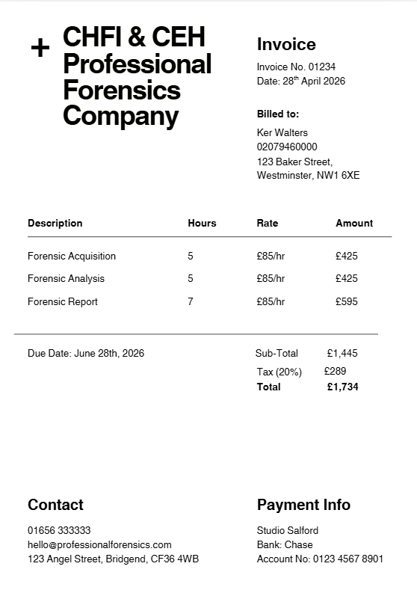
Professional Invoice
A professional invoice has been prepared to document the forensic services carried out during this investigation. It outlines the scope of work completed, the time spent conducting the acquisition and analysis of the encrypted NTFS drive image. It also includes the associated costs for the examination and reporting activities. This ensures transparency, provides a clear record of the work undertaken and reflects standard practice within digital forensic consultancy.

Bibliography
Task 1
[1] D. Kleiman, “The Official CHFI Study Guide ,” in The Official CHFI Study Guide , 2011, pp. 10–12.
[2] A. Ahmad, “Detection & Investigation Model for the Hard Disk Drive Attacks using FTK Imager,” International Journal of Advanced Computer Science & Applications, vol. 14, no. 7, pp. 767–767, 2023.
[3] M. Lim et al., “Analysis of Forensic Disk Imaging Tools for Data Acquisition & Preservation,” Journal of Informatics & Web Engineering, vol. 4, no. 2, pp. 161–162, Jun. 2025.
[4] M. Prashant, “Low Cost & Ultra Low Cost Digital Forensic Imaging Devices,” Int. J. Sci. Adv. Res. Technol., vol. 4, no. 1, pp. 158–158, Jan. 2018.
[5] B. Cusack and J. Pearse, “Can Compression Reduce Forensic Image Time ,” Journal of Applied Computing and Information Technology , vol. 15, no. 1, pp. 3–3, 2011.
[6] A. Erhan and D. Sengul, “Forensics Image Acquisition Process of Digital Evidence ,” International Journal of Computer Network & Information Security , vol. 14, no. 5, pp. 2–2, May 2018.
[7] Exterro, “/digital-forensics-software/ftk-imager,” Exterro.
[8] J. Vinayak, S. Sudhakaran, and S. Senthivel, “First Steps, Lasting Impact: Platform-Aware Forensics for the Next Generation of Analysts ,” in International Conference on Cyber Warfare and Security , Mar. 2026.
[9] K. Dhar and Y. Pingle, “Digital Forensic Investigations (DFI) using Internet of Things (IOT),” in 2016 3rd International Conference on Computing for Sustainable Global Development , IEEE, 2016.
[10] FTK Imager, “https://ftkimager.com/,” FTK Imager .
[11] J. Mehta, Y. Bhadania, P. Shah, and P. Prajapati, “Comparative Study of Mobile Forensics Tools: Autopsy, Belkasoft X and Magnet Axiom,” in 2024 5th International Conference on Electronics & Sustainable Communication Systems, IEEE.
[12] Magnet AXIOM, “www.magnetforensics.com/products/magnet-axiom,” Magnet Forensics .
[13] Digital Forensics, “Magnet AXIOM: Features, Pricing & Real Investigation Use Cases ,” Cyber Forensic Academy .
[14] H. Adamu, A. Ahmad, A. Hassan, and S. Gambasha, “Web Browser Forensic Tools: Autopsy, BHE & NetAnalysis,” International Journal of Research and Scientific Innovation, vol. 8, no. 5, May 2021.
[15] S. Colford, “Explaining Free & Open Source Software,” in Bulletin of the American Society for Information Science & Technology , 2009, p. 11.
[16] H. Kim, S. Kim, Y. Shin, J. Wooyeon, and S. Lee, “Ext4 & XFS File System Forensic Framework Based on TSK,” Electronics , vol. 10, no. 18, 2021.
[17] J. Parker, “https://www.cyberly.org/en/guides/autopsy/index.html,” Cyberly.
[18] Autopsy, “https://www.autopsy.com/,” Autopsy.
[19] P. S. Vinayagam, “Digital Forensic Tools for Cybercrime Investigation: A Comparative Analysis,” Int. J. Appl. Inf. Syst., vol. 12, no. 47, Apr. 2025.
[20] Cellebrite, “https://cellebrite.com/en/premium/,” Cellebrite.
[21] H. Mahalik, “Different Methods for Creating Reports in Cellebrite Reader,” https://cellebrite.com/en/series/tip-tuesday/different-methods-for-creating-reports-in-cellebrite-reader/.
Task 2
[22] G. Horsman, “ACPO Principles for Digital Evidence: Time for an update?,” Forensic Science International: Reports, vol. 2, Dec. 2020.
[23] A. Dimitriadis, N. Ivezic, B. Kulvatunyou, and I. Mavridis, “D4I - Digital Forensics Framework for Reviewing & Investigating Cyber Attacks,” Elsevier, vol. 5, Dec. 2020.

