Group Report
Student Name:
Radu Acris;
Deni Apostolov;
Mariana Acris.
Students Numbers: 2239621; 2244458; 2239619.
Module Leader: Dr Akash Puranik.
Lecturer: Dr. Fahad Khan.
Module code: LCBB4003.
Introducing the Modern Workplace
Assignment Title:
How Group effectiveness and wellbeing of employees can be improved in a chosen organization.

Table of Contents
1. Executive Summary: 3
2.Introduction: 4
3. Theories associated with managing groups and concepts: 5
4. How Tesco create an inclusive working environment?!: 7
5. Assess the approaches used to managing employee welfare in Tesco organization: 11
6. Clear short- and long-term priorities: 12
7. Health, safety and wellbeing: 13
9.Conlcusion: 17
10.Bibliography: 18
11. Appendix A: Group Report. 20

1. Executive Summary:

This group report examines the group effectiveness and wellbeing of Tesco employees, focusing on key factors that contribute to organizational success and employee satisfaction. Tesco, one of the largest retailers globally, faces the challenge of maintaining high levels of productivity and employee morale amidst a rapidly changing business landscape.
Group effectiveness is crucial for Tesco's operations as it directly impacts productivity, innovation, and customer satisfaction. Effective teams within Tesco demonstrate clear communication, shared goals, and mutual accountability. By fostering a culture of collaboration and inclusivity, Tesco can leverage the diverse skills and perspectives of its workforce to drive performance and achieve strategic objectives.

‘’How Group effectiveness and wellbeing of Tesco employees can be improved?!’’.

2.Introduction:

In today's fast-paced and driven business circumstances, the success of businesses relies heavily on the effectiveness and wellbeing of their employees.
As one of the largest multinational retailers, Tesco understands the critical importance of fostering a work environment that promotes both group effectiveness and employee wellbeing.
This introduction will explore the significance of these factors within Tesco and outline the key themes that will be discussed in this analysis. Tesco operates in a dynamic industry where customer demands are constantly evolving, competition is intense, and market trends are rapidly changing. In such an environment, the collective performance of teams and the overall wellbeing of employees play pivotal roles in driving organizational success.
In this analysis, we will delve into the strategies employed by Tesco to promote group effectiveness and enhance employee wellbeing across its diverse workforce. We will explore initiatives such as team-building activities, training programs, flexible work arrangements, and employee assistance programs. Additionally, we will examine the impact of these initiatives on various aspects of Tesco's operations, including customer satisfaction, employee turnover, and financial performance.

3. Theories associated with managing groups and concepts:


Fig.1 . (Tesco, 2024).
Groups are assemblies of people who come together based on common characteristics, interests and goals or associations (Young, 1989). These shared characteristics could include demographic factors, like age and gender, ethnicity or socio-economic class, as well as shared beliefs, values, hobbies, or objectives. Groups can go from small unofficial gatherings, like a group of friends, to enormous formal organizations like clubs, societies, or political parties. The members of a group often interact with each other, collaborate towards common objectives, and may develop a sense of identity or belonging within the group (Young, 1989).
There are several theories and concepts that Tesco applies or can implement associated with managing groups, teams, and organizations:
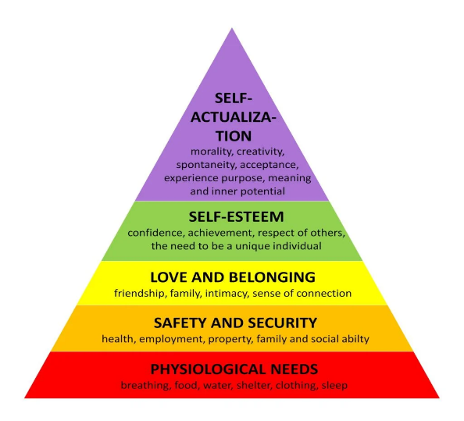
- Maslow's Hierarchy of Needs: Abraham Maslow's theory advises that persons have a hierarchy of requirements, varying from physiological needs (like food and shelter) to self-actualization (achieving one's full potential). Tesco managers can use this model to identify what motivates their employees and fit their management advance appropriately (Mcleod, 2024).
Fig.2. (Mcleod, 2024).
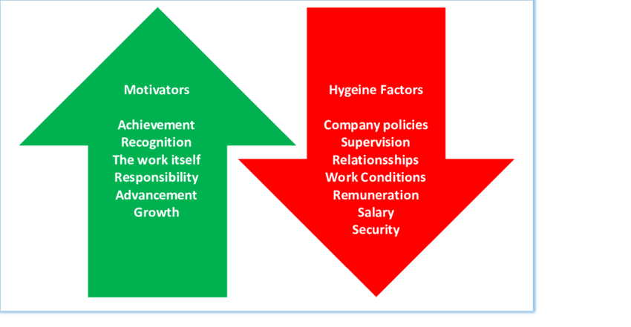
- Herzberg's Two-Factor Theory: Frederick Herzberg meant that there are two sets of aspects that inspire employee motivation and satisfaction: hygiene factors (like salary, functioning conditions, and corporation policies) and
motivators (like appreciation, responsibility, and chances for growth). Tesco managers use this theory to understand what motivates their team members and create a more satisfying work environment (Mark A. Tietjen, 1998).
Fig.3. (MacPherson, 2019).

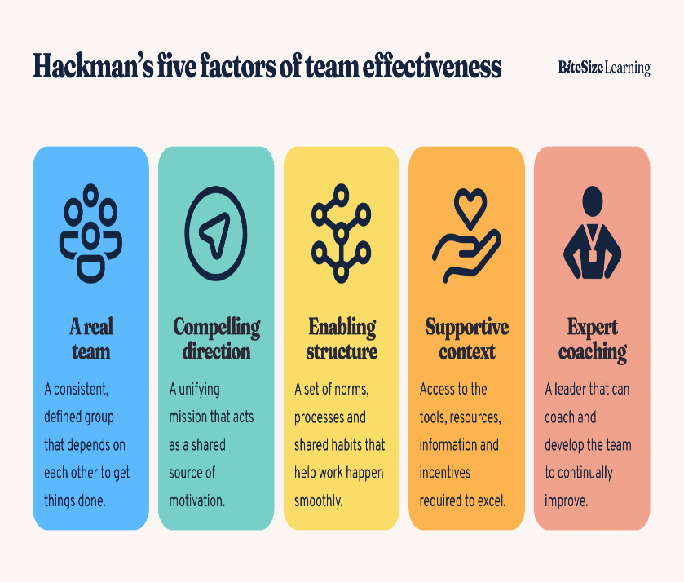
- Hackman's Model of Team Effectiveness: Explained by J. Richard Hackman, this model relates five factors that contribute to team effectiveness: clear goals, a compelling purpose, strong team formation, supportive structural context, and skilled team members. Tesco managers can use this model to create environments where teams can thrive (Hackman, 2024).
Fig.4. (Hackman, 2024).

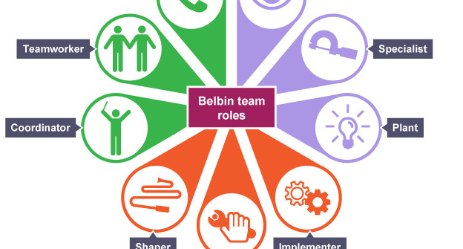
- Belbin's Team Roles: Meredith Belbin identified nine team roles that individuals tend to adopt when working in groups. These parts include the Plant, Coordinator, Shaper, Monitor Evaluator, Team Worker, Implementer, Completer Finisher, Specialist, and Resource Investigator. At Tesco managers use this theory to build well-rounded teams and allocate roles effectively (S. G. Fisher, 1998).
Fig.5. (Erhan, 2018).
These theories and concepts provide frameworks and tools that Tesco managers use or can use to understand group dynamics, motivate employees, and effectively lead teams and the business.

4. How Tesco create an inclusive working environment?!:

Fig.6. (Tarry, 2021).

It's evident that Tesco places a strong importance on variety and inclusion within its workplace culture. The company's commitment to treating everyone fairly and respectfully, valuing individuality, and fostering a sense of belonging is commendable. By actively celebrating the diversity of its colleagues and creating an inclusive environment, Tesco not only enhances its workplace culture but also reflects the diversity of the communities it serves.
The commitment from the Tesco PLC Board to build a more diverse business and provide equal opportunities for all colleagues is crucial. This includes initiatives such as recruitment practices, learning and development opportunities, as well as supporting colleague networks focused on inclusion.
- Recruitment:
Tesco is committed to adopting variety and inclusion within its staff. Promoting a workplace where people from all environments feel appreciated and respected not only aligns with ethical philosophy but also contributes to a more innovative and productive environment (S. G. Fisher, 1998).
Implementing a zero-tolerance policy towards bullying, discrimination, and harassment sends a clear message that such behaviours are unacceptable and will not be tolerated within the organization. It's essential to have robust mechanisms in place to address any instances of misconduct promptly and effectively, ensuring that all employees feel safe and supported. By actively striving to attract and welcome a diverse range of applicants, Tesco is not only reflecting the communities it serves but also tapping into a wealth of talent and perspectives. This approach can lead to better decision-making, increased creativity, and enhanced customer satisfaction. Continuing to uphold these values and practices will not only benefit Tesco as a company but also contribute positively to society as a whole (S. G. Fisher, 1998).
- Anti-harassment:
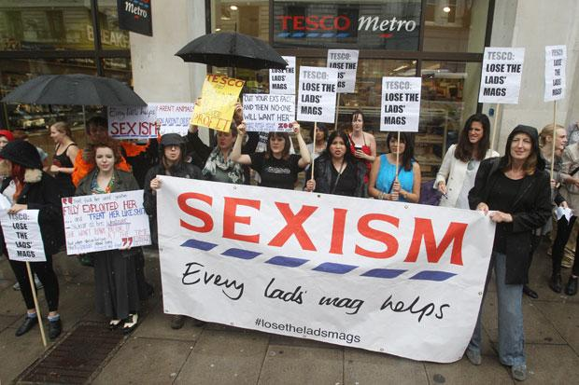
Fig.7. (Herald, 2013).
It's commendable that Tesco is committed to fostering an inclusive workplace culture that values diversity and actively works to prevent harassment of any kind. Having clear policies in place, such as the 'Bullying and Harassment' policy, is crucial for setting expectations and providing guidance on appropriate behaviour for all employees, suppliers, and partners (Charlotte Rayner, 2020). Encouraging colleagues to report incidents of harassment they witness and holding managers accountable for addressing inappropriate behaviour sends a strong message that such conduct will not be tolerated within the organization. It's also essential to ensure that there are robust mechanisms in place for handling complaints effectively and confidentially, so employees feel safe coming forward with their concerns.
Continuously educating employees about the importance of respect, diversity, and inclusion, and providing training on recognizing and preventing harassment, can further reinforce the organization's commitment to creating a positive and respectful work environment for everyone (Charlotte Rayner, 2020).
- UK Colleague Networks:
The Tesco colleague networks serve as a platform for fostering equality within the organization and advancing diversity and inclusion (D&I) goals. By facilitating discussions, these networks encourage colleagues to address common challenges, share experiences related to career growth, and connect with peers who share similar values and interests across various departments (Andrew Currah, 2004). Additionally, they provide opportunities for mentorship, enabling individuals to receive guidance and support in their professional development journey. Through these networks, the Tesco aims to empower colleagues to actively contribute to creating an inclusive environment where everyone feels valued and supported. By leveraging the diverse perspectives and experiences of its workforce, the business can make informed decisions that benefit colleagues and customers (Andrew Currah, 2004).
- Disability at Tesco:

Fig.8.(Tesco, 2024).
By leveraging the skills and experiences of people with disabilities, as well as fostering partnerships with organizations like Remploy, Shaw Trust, Whizz-Kidz, and the Business Disability Forum, Tesco is actively working towards creating a more inclusive workplace and society. Celebrating significant dates like the International Day of Persons with Disabilities helps raise awareness and drive positive change, while participating in initiatives like the Disability Confident scheme and the Valuable 500 demonstrates Tesco dedication to leading by example in disability inclusion.
Tesco focus on attracting, developing, and retaining disabled talent through various programs and partnerships, not only benefits the organization but also contributes to a more diverse and equitable workforce (Andrew Currah, 2004).
- Gender Equality at Tesco:
It's truly commendable to see Tesco's ongoing commitment to gender equality and diversity in the workplace. Being recognized in The Times Top 50 Employers for Gender Equality for the third consecutive year is a testament to Tesco's dedication to fostering an inclusive environment. Participating in initiatives like the 30% Club and Tech She Can not only demonstrates Tesco's support for gender diversity but also actively contributes to the broader efforts to increase representation of women in traditionally underrepresented fields such as technology (Carys Roberts, 2019). Moreover, exceeding the targets set by the HM Treasury Women in Finance Charter showcases Tesco Bank's strong commitment to gender balance at the highest levels of leadership. Achieving 41% female representation at the Board and 40% at the Executive Committee level is a significant accomplishment and sets a positive example for others in the finance industry. Furthermore, signing up to the FTSE Women Leaders voluntary target of achieving 40% female representation at the highest levels of leadership across the Tesco Group by 2025 demonstrates a continued dedication to fostering gender diversity and inclusion throughout the organization.
Overall, Tesco's efforts in promoting gender equality not only benefit its employees but also set a standard for other organizations to follow (Carys Roberts, 2019).

5. Assess the approaches used to managing employee welfare in Tesco organization:

Workers are incontestably the highest valuable asset for all organizations, and it is the responsibility of each organization to safeguard their interests and wellbeing (Kar, 2021). Providing a conducive work environment is imperative, including ensuring safety, cleanliness, proper facilities, and adequate rest areas. Safety measures should be prioritized to protect employees from hazards and alleviate any undue pressure they may face. Financing in proper education not only enhances workers' skills but also impacts to their overall health and career development.
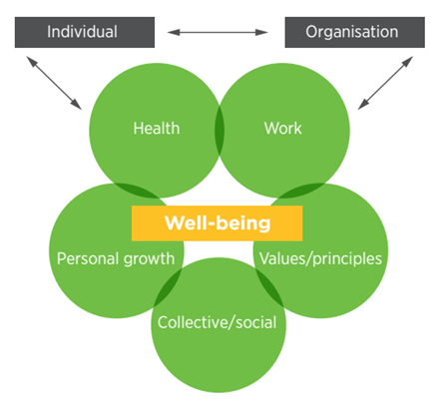
Additionally, fair compensation and rewards are essential to recognize and motivate employees, fostering higher morale and performance. Beyond these foundational elements, organizations should uphold ethical values, foster positive employee relationships, embrace diversity and inclusion, and exhibit proper leadership. By adhering to these principles, organizations can create a culture where employees feel valued, respected, and supported, ultimately leading to greater satisfaction, productivity, and success for both employees and the organization as a whole (Kar, 2021).
Fig.9.sourse of https://www.locusassignments.com/solution/unit-3-managing-human-resources-assignment-tesco.

6. Clear short- and long-term priorities:
Tesco's strategic priorities play a pivotal role in navigating the challenges posed by the cost-of-living crisis while simultaneously pursuing its longer-term ambitions (Enders & Jelassi, 2009). The retailer's commitment to these priorities underscores its dedication to delivering value to customers and stakeholders while maintaining financial discipline. Let's explore these strategic priorities:
- Customer Focus
- Operational Efficiency
- Innovation and Adaptability
- Financial Discipline
By staying true to these strategic priorities, Tesco demonstrates its resilience and adaptability in navigating economic headwinds while remaining focused on delivering value to customers and shareholders alike. This disciplined approach underscores Tesco's commitment to serving as a trusted and responsible retailer, even amidst challenging market conditions (Enders & Jelassi, 2009).
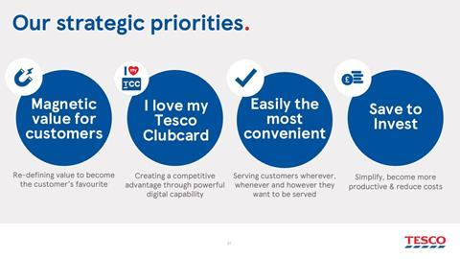
Fig.10. Source of https://www.retail-week.com/grocery/strategy-spotlight-five-ways-tesco-is-storming-ahead-of-its-big-four-peers/7044314.article

Tesco's fourth priority, "Save to invest," exemplifies the company's commitment to leveraging its resources not only to enhance convenience and competitiveness but also to drive significant contributions towards longer-term health and sustainability initiatives. Through strategic endeavors such as the Better Baskets initiative, Tesco has demonstrated tangible progress in promoting healthier product options and addressing pressing societal issues like plastic pollution and obesity.
By setting ambitious targets for the sale of healthy products and plastic reduction, Tesco is actively working towards creating a positive impact on public health and the environment. Furthermore, its commitment to achieving net-zero carbon emissions by 2035 showcases its dedication to combatting climate change and promoting sustainable business practices.
Tesco's decision to link a substantial portion of executive bonuses to environmental, social, and governance (ESG) targets underscores its commitment to accountability and responsible leadership. This forward-thinking approach not only aligns incentives with sustainability goals but also sets a precedent for other retailers to prioritize ESG considerations in their business strategies.
In summary, Tesco's "Save to invest" priority serves as a testament to its commitment to driving positive change and making meaningful contributions towards a healthier, more sustainable future. Through concerted efforts and strategic investments, Tesco is leading the way in demonstrating that profitability and sustainability are not mutually exclusive, but rather complementary aspects of a successful business model (Enders & Jelassi, 2009).

7. Health, safety and wellbeing:
We do our best to help colleagues live a healthier and more sustainable lifestyle so they can be their best at work and home –
Matthew Barnes (Tesco CEO,UK).

- Colleague Wellbeing:
Ensuring that employees feel supported and valued not only enhances their individual experiences but also contributes to a positive work environment overall (John Milliman, 2003). Offering a variety of support options adapted to the diverse needs of the team members is crucial, as everyone may require different types of assistance to maintain their mental, physical, and overall wellbeing. By providing such support, they're fostering a culture of care and empathy within the organization, which can lead to increased productivity, satisfaction, and loyalty among employees. A such a great work is making Tesco a place where every colleague can thrive (John Milliman, 2003).

- Work-life Balance:
Tesco prioritizes what matters to its employees, recognizing that their well-being and personal priorities are important:
- Part-time working;
- Fixed/staggered shift pattern;
- Working on a set number of days a week;
- Job sharing with a colleague;
- Working from home/remotely as appropriate;
- Lifestyle breaks (after two years’ service).
Fig.11. Source of https://www.tesco-programmes.com/life-at-tesco/.

- Employee Assistance Programme:
By providing access to a variety of support resources, including a Employee Assistance Programe (EAP), can greatly contribute to creating a positive and supportive work environment. Having access to experts who can offer guidance and support for both mental and physical health issues can be invaluable for employees facing challenges. This positive method not only assists individual workers in their times of need, but also provides to a healthier and more beneficial workforce overall (John Milliman, 2003).
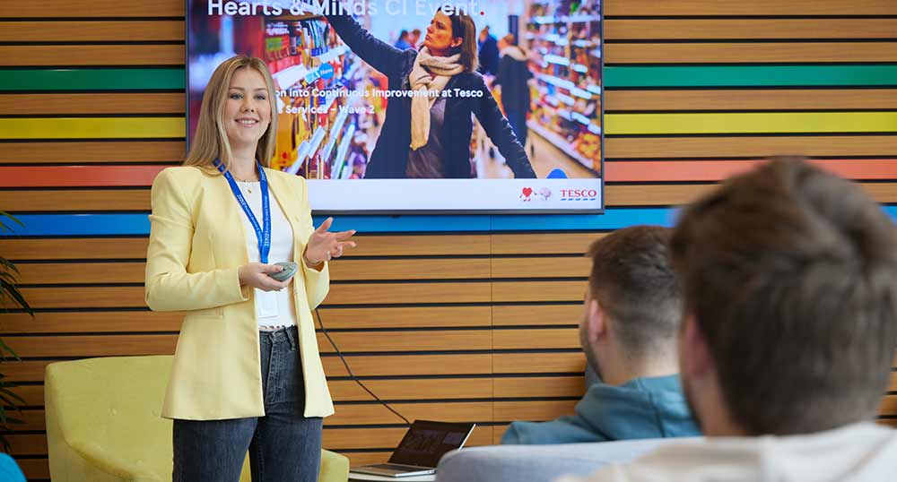
- Occupational Health:
Ensuring a safe, healthy, and inclusive workplace is paramount to Tesco. By understanding that health challenges, whether emotional, mental, or physical, can affect anyone. That's why Tesco committed to making necessary adjustments to support every colleague in carrying out their role effectively and comfortably.
Whether it's modifications to working hours, adjustments in responsibilities, or providing specialized equipment, Tesco is ready to accommodate their needs. The main goal is to empower every member of their team to thrive in their roles in the way that suits them best. Colleagues well-being is Tesco priority, and they're dedicated to creating an environment where everyone feels valued and supported (John Milliman, 2003).

8. How Group effectiveness and wellbeing of Tesco employees can be improved :
Improving group effectiveness and wellbeing among Tesco employees involves addressing various factors related to both the work environment and individual needs (S. G. Fisher, 1998). Here are some strategies that we have discussed in our group and that Tesco can consider:
- Employee Assistance Programs (EAPs): Offer counselling services, mental health support, and resources to help employees deal with personal and work-related challenges. EAPs can provide confidential assistance for issues ranging from stress and anxiety to financial or family problems.
- Training and Development: Invest in training programs to enhance employees' skills and competencies. This not only improves job performance but also boosts morale and job satisfaction. Providing opportunities for career advancement and skill development can increase motivation and engagement (Elnaga & Imran, 2013).
- Leadership Development: Provide training and support for managers to enhance their leadership skills, including communication, conflict resolution, and emotional intelligence. Effective leadership plays a crucial role in creating a positive work culture and supporting employee wellbeing (Elnaga & Imran, 2013).
- Clear Communication and Feedback: Ensure transparent communication channels within teams and between management and employees. Regular feedback sessions can help employees understand their strengths and areas for improvement, fostering a culture of continuous learning and growth.
- Team Building Activities: Organize team-building exercises and social events to strengthen bonds among team members. This can improve communication, collaboration, and trust within the group, leading to better performance and job satisfaction.
- Flexible Benefits Packages: Offer a range of benefits that cater to the diverse needs of employees, such as healthcare plans, retirement savings options, and childcare support. Allowing employees to customize their benefits package can increase satisfaction and retention.
- Regular Check-ins and Supportive Environment: Encourage open dialogue between managers and employees through regular one-on-one meetings or team discussions. Create a supportive environment where employees feel comfortable expressing concerns and seeking assistance when needed.
- Recognition and Rewards: Implement a system to recognize and reward employees for their contributions and achievements. This could include praise, bonuses, promotions, or other incentives based on performance. Recognizing employees' efforts fosters a positive work environment and increases motivation.
By implementing these strategies, Tesco can improve group effectiveness and foster a culture of wellbeing, resulting in higher employee satisfaction, productivity, and retention. Regular assessment and feedback from employees can help refine these initiatives to better meet their needs over time (Andrew Kinder, 2008).

9.Conlcusion:

From our group vision, Tesco, as one of the largest retailers globally, has demonstrated a commendable level of group effectiveness in its operations during the years. In terms of employee wellbeing, Tesco has made efforts to prioritize the welfare of its workforce. Initiatives such as employee benefits, training programs, and diversity and inclusion policies contribute to fostering a positive work environment. However, like many large corporations, Tesco faces challenges in ensuring the wellbeing of all its employees, especially concerning issues such as work-life balance, job satisfaction, and mental health support.
Overall, while Tesco demonstrates strong group effectiveness in achieving its business objectives, there is ongoing room for improvement in enhancing employee wellbeing to create a more holistic and sustainable organizational culture. Continued efforts in fostering a supportive and inclusive work environment can further contribute to Tesco's long-term success and reputation as an employer of choice.

10.Bibliography:
Andrew Currah, N. W., 2004. Networks of organizational learning and adaptation in retail TNCs. Global Networks, 4(1), pp. 1-23.
Andrew Kinder, R. H. M. P. C. L. C. D. D., 2008. Employee Well‐Being Support: A Workplace Resource. 1 ed. The Atrium, Southern Gate, Chichester,West Sussex PO19 8SQ, England: Copyright © 2008 John Wiley & Sons, Ltd.
Carys Roberts, H. P. R. S. L. R., 2019. The future is ours: women, automation and equality in the digital age, UK: Institute for Public Policy Research.
Charlotte Rayner, D. L., 2020. Bullying and Harassment in the Workplace. 3rd Edition ed. Boca Raton: CRC Press.
Elnaga, D. .. A. & Imran, A., 2013. The Effect of Training on Employee Performance. European Journal of Business and Management, 5(4).
Enders, A. & Jelassi, T., 2009. LEVERAGING MULTICHANNEL RETAILING: THE EXPERIENCE OF TESCO.COM.. EBSCO, 8(2), p. 89.
Erhan, A., 2018. linkedin. [Online]
Available at: https://www.linkedin.com/pulse/belbins-team-roles-ayla-erhan/
[Accessed 25 03 2024].
Hackman, R., 2024. [Online]
Available at: https://www.bitesizelearning.co.uk/resources/hackman-model-team-effectiveness
[Accessed 25 03 2024].
Herald, T., 2013. Protesters target Tesco stores in anti-lads' mags campaign, Scotland,Uk: The Herald.
John Milliman, A. J. C. J. F., 2003. Workplace spirituality and employee work attitudes: An exploratory empirical assessment. Journal of Organizational Change Management, 16(4), pp. 426-447.
Kar, S. K., 2021. Prioritizing the Mental Health and Well-Being of Healthcare Workers: An Urgent Global Public Health Priority. Insights in Public Mental Health: 2021, Volume 9.
MacPherson, A., 2019. Motivating Millennials: the journey to project success, The University of The West of Scotland: Allan MacPherson – B00246928.
Mark A. Tietjen, R. M. M., 1998. Motivation and job satisfaction. Management Decision, 36(4), pp. 226-231.
Mcleod, S., 2024. simplypsychology. [Online]
Available at: https://www.simplypsychology.org/maslow.html
[Accessed 25 03 2024].
S. G. Fisher, T. A. H. W. D. K. M., 1998. The structure of Belbin's team roles. Journal of Occupational and Organizational Psychology, 71(3), pp. 283-288.
Tarry, J., 2021. If Not Now, When?- 2021 report, London,Uk: Tesco.
Tesco, 2024. Tesco. [Online]
Available at: https://www.tescoplc.com/contacts/property
[Accessed 25 03 2024].
Young, I. M., 1989. Polity and Group Difference: A Critique of the Ideal of Universal Citizenship. The University of Chicago Press Journals, Issue 99, pp. 250-274.

11. Appendix A: Group Report.

This appendix's goal is to provide specifics on each student's involvement in the group project mentioned above.
The following students collaborated as teams to complete this report:
- Radu Acris (2239621);
- Deni Apostolov (2244458);
- Mariana Acris (2239619).
Student name/number | Specific topics. | Page:
Radu Acris (2239621) | - Executive Summary;  3. Theories associated with managing groups and concepts;  6. Clear short- and long-term priorities;  9.Conlcusion. | Page 3;  Page5-7;  Page 12-13;  Page 17.
Deni Apostolov (2244458) | 2.Introduction;  4. How Tesco create an inclusive working environment?!;  8. How Group effectiveness and wellbeing of Tesco employees can be improved;  9.Conlcusion. | Page 4;  Page 7-10;  Page 15-16;  Page 17.
Mariana Acris (2239619) | 2.Introduction;  5.Assess the approaches used to managing employee welfare in Tesco organization;  7. Health, safety and wellbeing;  9.Conlcusion. | Page 4;  Page 11;  Page 13-15;  Page 17.

