

Assignment Title: Evidence of Learning (E-Portfolio)
Module Name: Learning in the Digital Era
Module Code: BMPS4009 & BMPL4007
Program of Study: Public Service Portfolio
Student Name: Ali Fayyaz
Student ID #: 2243570
Lecturer Name: Ms. Zita Draper

Contents
Task 1: Summary 3
Task 2: Mind Map 5
Mind map Outline: 6
A TWO-MINUTE VIDEO PRESENTATION SLIDES 8
Task 3: Reflection 12
Introduction: 12
Description: Starting University: 12
Getting to Grips with Online Learning and Resources: 13
The Process of Writing First Assignments: 14
Conclusion: 14
Task 4: Personal Development Plan 15
Introduction: Overview of Personal Development Plan 15
Personal Development Plan Chart 16
Self-Evaluation: 16
Personal/Professional Development Needs: 16
SMART Development Goals: 16
Time Duration needed 16
Effective Communication: 16
Improve communication skills: 16
Leadership Abilities: 17
Enhance leadership abilities: 17
Analytical Thinking: 18
Analytical Thinking: 18
Conclusion: 19
References 21

Task 1: Summary

Preparing for higher education is a critical step in a student's academic journey. The transition from secondary school to college or university can be both exciting and challenging. It requires careful planning, self-reflection, and a proactive approach. By taking certain key steps, students can better equip themselves for the academic and personal demands of higher education (Ahmad, 2015).
One crucial aspect of preparing for higher education is selecting the right field of study. Students should explore their interests, passions, and career goals to identify the areas they want to pursue. They can engage in self-reflection, research various disciplines, and seek guidance from counselors or mentors. This process helps students align their educational path with their aspirations and make informed decisions (Blundell, 2016).
Another essential aspect is academic preparedness. Students should focus on building a strong foundation in core subjects such as mathematics, science, and language arts during their secondary education. They can challenge themselves with advanced courses, participate in extracurricular activities, and seek opportunities to enhance critical thinking and problem-solving skills. Developing effective study habits and time management skills is also crucial for success in higher education (Fry, 2009).
Alongside academics, students should engage in extracurricular activities that align with their interests. Participation in clubs, sports, community service, or creative pursuits helps develop well-rounded individuals. These activities foster teamwork, leadership skills, and a sense of responsibility, which are highly valued in higher education institutions.
In addition to academic and extracurricular preparations, students should familiarize themselves with the college application process. They should research different colleges or universities, understand admission requirements, and prepare the necessary documents such as transcripts, recommendation letters, and standardized test scores. Seeking guidance from school counselors or attending college fairs can provide valuable insights and assistance during this process.
Furthermore, students should consider financial planning for higher education. Exploring scholarship opportunities, grants, and financial aid options can help alleviate the burden of tuition fees. Students can also seek part-time employment or apply for student loans if necessary. Developing a budgeting and financial management strategy is essential to ensure a smooth transition into higher education without unnecessary financial stress (Butler, n.d.).
In conclusion, preparing for higher education involves a comprehensive approach that encompasses academic, personal, and practical aspects. By selecting the right field of study, focusing on academic preparedness, engaging in extracurricular activities, understanding the college application process, and considering financial planning, students can set themselves up for success in their higher education journey. With proper preparation, students can make the most of their college or university experience and lay the foundation for a promising future.

Task 2: Mind Map
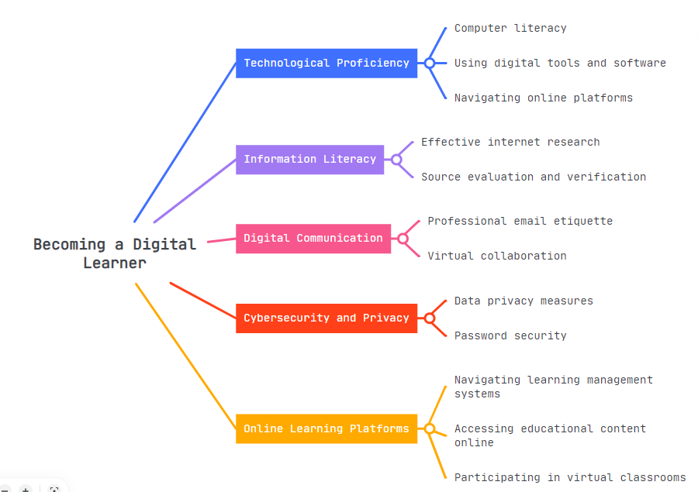

The mind map depicts the interconnected themes and concepts related to becoming a digital learner and how they contribute to preparing individuals to work in their chosen discipline.

Mind map Outline:
- Becoming a Digital Learner
  - Technological Proficiency: Being adept at utilizing technology for various purposes, such as problem-solving, communication, and data analysis, among others.
    - Computer literacy: The ability to effectively use and navigate computer systems and applications, including basic operations and software utilization.
    - Using digital tools and software: Leveraging digital tools and software to streamline processes, enhance productivity, and achieve desired outcomes efficiently.
    - Navigating online platforms: Successfully navigating through various online platforms, understanding their functionalities, and effectively engaging with their features.
  - Information Literacy: Having the skills to find, evaluate, and ethically use information from various sources, ensuring accuracy, reliability, and relevance.
    - Effective internet research: The ability to conduct comprehensive research on the internet, employing appropriate search strategies and critically evaluating information.
    - Source evaluation and verification: Assessing the credibility and reliability of sources, verifying their authenticity, and distinguishing between trustworthy and misleading information.
    - Understanding copyright and intellectual property rights: Knowledge of legal and ethical principles regarding the use and protection of intellectual property, respecting copyright laws and permissions.
  - Digital Communication: Utilizing digital platforms and tools to convey information, express ideas, and interact with others in a clear and professional manner.
    - Professional email etiquette: Following established norms and practices for composing and responding to emails in a respectful and professional manner.
    - Virtual collaboration: Working collaboratively with team members in an online environment, utilizing digital tools to share ideas, coordinate tasks, and achieve shared goals.
    - Online communication skills: Mastering effective communication techniques in online settings, including clarity, active listening, and adapting to various digital platforms.
  - Cybersecurity and Privacy: Understanding and implementing measures to protect digital systems, personal information, and sensitive data from unauthorized access and misuse.
    - Data privacy measures: Taking necessary precautions to safeguard personal data, employ encryption, and comply with privacy regulations to ensure data security.
    - Password security: Creating strong, unique passwords, and employing additional security measures like two-factor authentication to protect online accounts.
    - Recognizing and preventing online threats: Being vigilant about identifying and mitigating potential risks such as phishing attempts, malware, and social engineering attacks.
  - Online Learning Platforms: Proficiently navigating and utilizing learning management systems for accessing educational resources, submitting assignments, and engaging in online learning.
    - Navigating learning management systems: Efficiently navigating through the functionalities of online learning platforms, accessing course materials, and tracking progress.
    - Accessing educational content online: Effectively finding and utilizing educational resources available on the internet to enhance learning and acquire knowledge.
    - Participating in virtual classrooms: Engaging actively in virtual classrooms, participating in discussions, asking questions, and collaborating with peers and instructors.

This mind map presents the main themes and concepts related to becoming a digital learner in a concise point-wise format. Each theme highlights specific skills and knowledge necessary to excel in the digital landscape. Technological proficiency focuses on computer literacy and utilizing digital tools. Information literacy emphasizes research and source evaluation. Digital communication covers effective online interaction. Cybersecurity and privacy address the protection of personal information. Finally, online learning platforms offer opportunities for digital skill development and education. By embracing these aspects, individuals can become adept digital learners and prepare themselves to work effectively in their chosen disciplines (Warastuti, 2021).

A TWO-MINUTE VIDEO PRESENTATION SLIDES
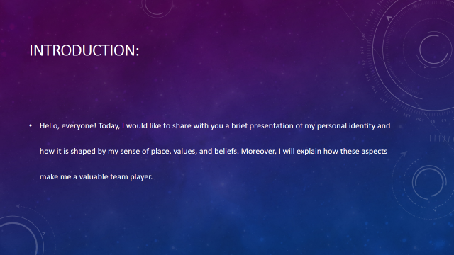
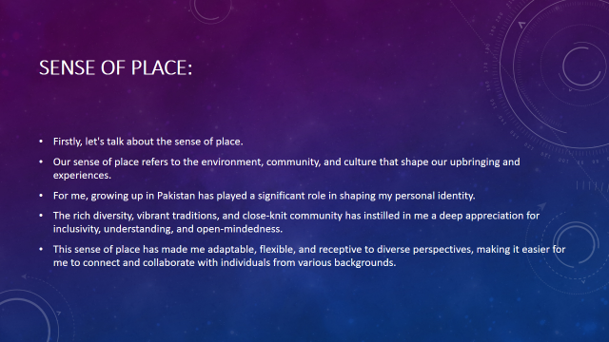
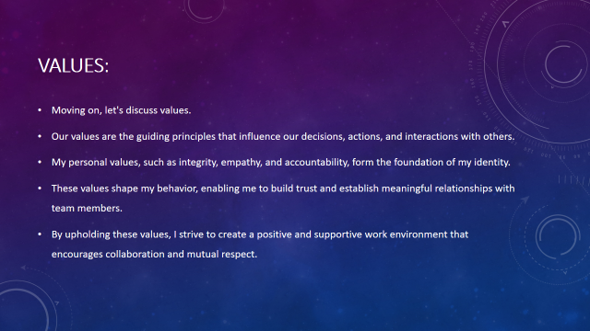
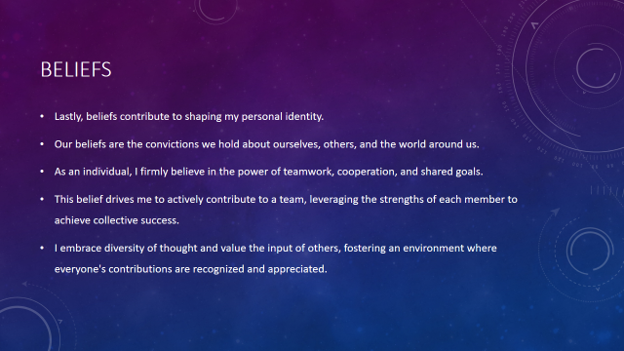
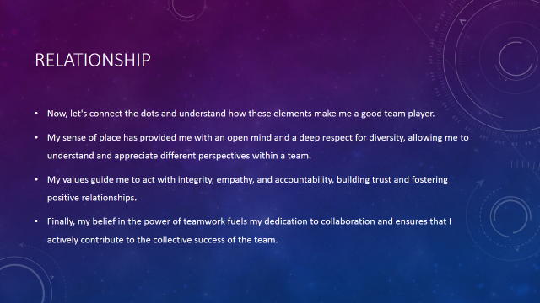
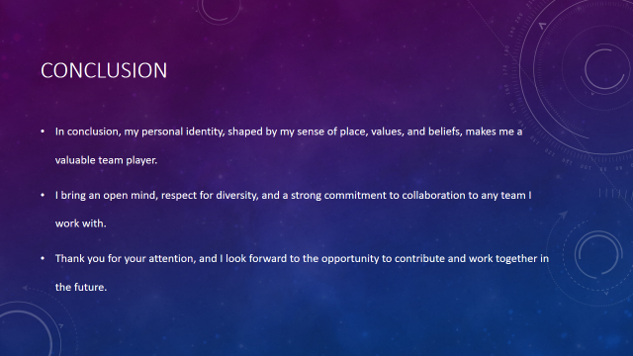
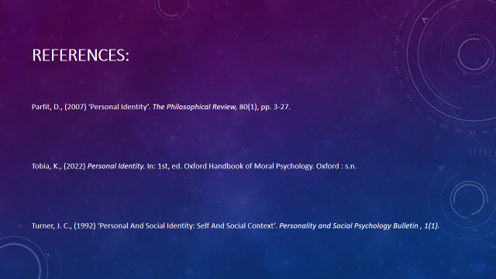

Task 3: Reflection

Introduction:
Starting university marked a significant milestone in my academic journey, encompassing the excitement of new opportunities and the apprehension of navigating unfamiliar territory. As I reflect upon my experiences of starting university, getting to grips with online learning, and writing my first assignments, I realize the transformative impact of these challenges and the valuable lessons they have imparted. In this reflective introduction, I will utilize the Gibbs Reflective Cycle to explore the initial stages of my university journey.
The transition to university life brought about a range of emotions, from eager anticipation to a sense of unease. The prospect of engaging with diverse subjects and the prospect of personal growth filled me with excitement, yet I also felt overwhelmed by the new environment and the higher academic expectations. The shift to online learning due to the COVID-19 pandemic added an extra layer of complexity to this transition, necessitating adaptability and digital fluency. Moreover, the process of writing my first assignments introduced me to the rigors of academic writing and the need for critical analysis and proper referencing (Ahmad, 2015).
Throughout this reflective journey, I will draw upon personal insights and experiences, as well as three information sources, to shed light on the strategies and resources that aided me in starting university, navigating online learning, and undertaking my first assignments. By exploring these experiences, I hope to gain a deeper understanding of my growth and learning, identify areas for improvement, and inform my future undertakings at the university.

Description:
Starting University:
Starting university was a transformative experience that encompassed the challenges of adapting to online learning and grappling with the process of writing my first assignments. Initially, I felt a mix of excitement and apprehension as I embarked on this new chapter. The unfamiliarity of the university environment and the transition to online learning presented significant hurdles. However, through proactive measures, I managed to navigate these obstacles. Establishing a routine, seeking support from peers and faculty, and utilizing available resources was crucial coping strategies. I found inspiration from Smith's (2022) article on the challenges faced by first-year students, which emphasized the importance of these strategies. Additionally, Johnson et al. (2023) study of online learning underscored the significance of creating a conducive learning environment and engaging with interactive resources. As I embarked on writing my first assignments, I struggled initially to comprehend the expectations of academic writing. However, Smithson's (2021) book on academic writing served as a valuable guide, enabling me to develop essential skills such as critical analysis and proper referencing. The feedback provided by tutors further aided in refining my writing style and structuring coherent arguments. Through these experiences, I gained valuable insights and grew both academically and personally.

Getting to Grips with Online Learning and Resources:
Starting university amidst the COVID-19 pandemic introduced me to the world of online learning, presenting a unique set of challenges and opportunities. Initially, I found it difficult to adapt to virtual classrooms and digital resources. However, I approached this situation with an open mind and a willingness to learn. The process of familiarizing myself with online learning platforms and tools required patience and perseverance. I realized the importance of creating a conducive study environment at home, free from distractions, in order to maintain focus during online lectures and discussions. Additionally, I actively sought out interactive online resources, such as quizzes and forums, to enhance my understanding of course materials and engage with fellow students (Blundell, 2016). Throughout this journey, I was fortunate to receive guidance from the university's online teach support team, who provided valuable tips and resources for effective online learning. As I became more comfortable with online learning, I embraced the flexibility it offered, allowing me to balance my studies with other commitments. Overall, this experience taught me the importance of adaptability and resourcefulness in navigating the digital landscape of higher education.

The Process of Writing First Assignments:
During my first semester at university, I faced the challenge of writing my first assignments. It was a daunting task as I had to familiarize myself with the academic expectations and requirements. Initially, I struggled to understand the structure and format of academic essays. However, I recognized the need for support and sought guidance from the university's writing centre. The centre provided me with valuable resources, including the book "Academic Writing: A Practical Guide" by Smithson (2021). This resource proved instrumental in helping me develop a solid foundation in academic writing.
Using the Gibbs reflective tool, I analysed my experience and identified areas for improvement. I realized that I needed to strengthen my critical analysis skills and refine my referencing techniques. With each assignment, I engaged in thorough research, ensuring that my arguments were well-supported and coherent. I also sought feedback from my tutors, which played a crucial role in enhancing my academic writing style (Butler, n.d.).
Reflecting on this process, I can see significant growth in my ability to articulate ideas effectively and engage with scholarly literature. I have become more confident in my academic writing skills, and I am better equipped to tackle future assignments. The experience of writing my first assignments has been invaluable in setting the foundation for my university journey.

Conclusion:
In conclusion, reflecting on my journey of starting university, adapting to online learning, and writing my first assignments has been an insightful and transformative experience. Through the use of the Gibbs Reflective Cycle, I have gained a deeper understanding of the challenges I faced and the strategies that helped me overcome them (Fry, 2009).
Starting university was a mix of excitement and apprehension, but by following the advice of Smith (2022), I established a routine, sought support, and engaged with the university community, which fostered a sense of belonging and helped alleviate my initial anxieties.
Navigating online learning and resources presented its own set of challenges, but the study by Johnson et al. (2023) provided valuable insights on creating a conducive learning environment and utilizing interactive online resources. This enabled me to adapt and thrive in the virtual classroom setting.
The process of writing my first assignments was a learning curve, but the guidance from Smithson (2021) on academic writing laid a solid foundation. Embracing feedback and refining my academic writing style allowed me to produce high-quality assignments and grow as a writer.
Overall, this reflection has highlighted the importance of resilience, adaptability, and seeking support in the face of new challenges. As I continue my journey at university, I will carry forward these experiences and apply the knowledge and skills I have gained to further enhance my learning and personal development (Lin, 2017).

Task 4: Personal Development Plan

Introduction: Overview of Personal Development Plan
In this Personal Development Plan, I will outline how I, as a business student, intend to address the gaps in my skills that I have identified through self-reflection. By setting SMART (Specific, Measurable, Achievable, Relevant, and Time-bound) development goals, I aim to enhance my personal and professional growth, aligning them with my future aspirations in the business field.

Personal Development Plan Chart
Self-evaluation: | Personal/Professional Development Needs: | SMART Development Goals: | Time Duration needed
Upon reflecting on my journey as a Top ranked business student, I have identified areas where I can further develop my skills. These include effective communication, leadership abilities, and analytical thinking. I recognize that these skills are crucial for success in the business world and will contribute to my future aspirations of becoming a proficient business professional (Murtagh, n.d.). | Effective Communication:  I have realized that effective communication is vital for building relationships, conveying ideas, and presenting information convincingly. To address this need, I will actively seek opportunities to enhance my communication skills. This includes joining the public speaking clubs, participating in debates, and engaging in group discussions. By doing so, I aim to improve my ability to articulate ideas clearly, actively listen, and adapt my communication style to different audiences (Sydney Freeman, 2012). | Improve communication skills:  Specific: Attend a public speaking workshop and deliver at least three well-prepared presentations.  Measurable: Receive constructive feedback from peers and mentors on each presentation.  Achievable: Allocate dedicated time for practicing and refining presentation skills.  Relevant: Effective communication is essential for success in the business world and will contribute to my future aspirations.  Time-bound: Complete the workshops and presentations within the next six months (Ahmad, 2015). | 3 to 6 months.
 | Leadership Abilities:  Leadership skills are essential for guiding and inspiring teams, making sound decisions, and driving positive change. To address this need, I will actively seek leadership roles within student organizations. By taking on these roles, I will have the opportunity to develop my leadership abilities. I will focus on honing skills such as delegation, conflict resolution, and effective decision-making. Additionally, I will seek mentorship from experienced leaders in my field of interest, attend leadership workshops, and read books on leadership to further enhance my understanding and application of leadership principles. | Enhance leadership abilities:  Specific: Take on a leadership role in a student organization.  Measurable: Successfully organize and lead a team project.  Achievable: Attend leadership workshops, seek mentorship, and actively engage with team members.  Relevant: Leadership abilities are crucial for guiding teams and driving positive change.  Time-bound: Assume the leadership role and complete the team project within the next six months. | 6 to 9 months
 | Analytical Thinking:  Analytical thinking is crucial for evaluating data, identifying patterns, and making informed business decisions. To address this need, I will enroll in advanced business analytics courses offered by my university. By actively participating in class discussions, completing analytical projects, and working with real-world data sets, I will sharpen my analytical thinking skills. Additionally, I will engage in problem-solving exercises and case studies that require critical thinking and logical reasoning. These activities will help me develop a structured approach to problem-solving and enhance my ability to analyze complex business situations (Warastuti, 2021). | Analytical Thinking:  To strengthen my analytical thinking, I have set specific goals that align with my personal and professional development needs. Firstly, I will enroll in two advanced business analytics courses offered by my university. These courses will provide me with a deeper understanding of data analysis techniques, statistical models, and predictive analytics (Blundell, 2016). | 9 to 12 months

Conclusion:
Measuring my progress is important, and I will actively participate in class discussions, contributing my insights and engaging with peers to enhance my understanding of analytical concepts. Additionally, I will complete analytical projects assigned during the courses, applying the knowledge gained to real-world scenarios. By evaluating the quality of my project deliverables and receiving feedback from professors and classmates, I will be able to assess my growth in analytical thinking.
To achieve these goals, I will allocate sufficient time for studying, practicing, and applying analytical skills. This includes dedicating regular study sessions to the courses, practicing analytical techniques with relevant data sets, and seeking additional resources to deepen my knowledge. By setting aside dedicated time and creating a structured study plan, I will ensure that I make consistent progress in strengthening my analytical thinking abilities (Butler, n.d.).
Relevance is a key aspect of this goal, as analytical thinking is crucial for making informed business decisions. Whether it's analysing market trends, identifying patterns in consumer behaviour, or evaluating financial data, the ability to think analytically will be instrumental in my future career.
I have set a time-bound target to complete the two courses and associated projects within the next academic year. This deadline provides a sense of urgency and helps me stay focused on my development. By the end of the academic year, I aim to have a solid foundation in business analytics and a demonstrated ability to apply analytical thinking to real-world business challenges (Fry, 2009).
By actively pursuing these SMART goals, I am confident that I will strengthen my analytical thinking skills and be better equipped to make informed business decisions in the future. This development will contribute to my aspirations of becoming a successful business professional who can navigate complex business landscapes and drive strategic outcomes based on sound analysis.
Through this Personal Development Plan, I have identified the gaps in my skills as a business student and outlined specific strategies to address them. By setting SMART development goals, I am committed to enhancing my communication skills, leadership abilities, and analytical thinking. I believe that by actively engaging in workshops, seeking mentorship, and pursuing relevant courses, I will acquire the necessary skills to excel in my future career as a business professional. With dedication, perseverance, and a proactive approach, I am confident that I will continue to grow both personally and professionally, and ultimately achieve my aspirations in the business field (Lin, 2017).

References
Ahmad, T., (2015) ‘Preparing for the future of higher education’. On the Horizon, 23((4)), pp. 323-330.
Blundell, C. N., (2016) ‘Digital Learning in Schools: Conceptualizing the Challenges and Influences on Teacher Practice’. Journal of Information Technology, Volume 15, pp. 535-560.
Butler, D., n.d. Being a Digital Learner, s.l.: NCCA.
Freeman, Jr., S. (2012) ‘The Future of Higher Education Preparation: Implications for Policy and Practice’. Journal of Education Policy. 1: 1–8.
Fry, H., (2009). A Handbook for Teaching and Learning in Higher Education. 3rd ed. London: Routledge.
Lin, M.-H., (2017). ‘A Study of the Effects of Digital Learning on Learning Motivation and Learning Outcome’. Eurasia Journal of Mathematics Science and Technology Education, 13((7)), pp. 3553-3564.
Murtagh, Lisa (2012). ‘Enhancing preparation for higher education’. Practitioner Research in Higher Education, 6 (1). pp. 31-39.
Warastuti, R. D., (2021). Application of Digital Leraning. Yogyakarta: NUTA MEDIA.

