
Module name: Changemakers: Building Your Personal Brand for Sustainable Employment
Module code: BMHP5015_LON
Lecturer name: Caroline Salami
Student name: Abosede Dehinbo
Student ID: 2313077

Contents
Introduction 3
Task 1- Unit 1: Goal Setting 4
Task 2- Unit 2: Networking in Health and Social Care in the UK: Essential Aspects, Critical Evaluation, and International Significance 6
TASK 3- UNIT 3: Analysis of "Strategies for Unlocking Employment Opportunities in Health and Social Care in the UK 7
Task 4- Unit 4: Career Role Models 8
Conclusion 10

Introduction

This assignment offers a reflective summary of my educational journey, covering four key units—' My Personal Brand,' 'It’s a Small World,' 'Opportunity Knocks,' and 'The Pursuit of Happiness'—with a focus on health and social care in the UK. It aims to examine key themes from each module and incorporate relevant academic literature to enrich my understanding. I will demonstrate how these modules have enhanced my knowledge of personal branding, global networking, opportunity recognition, and well-being, particularly in the context of health and social care.
By synthesising insights from lectures, online activities, and theoretical frameworks, this work intends to illustrate how the skills and knowledge acquired will support and develop my future professional practice. Critical reflection on these areas is vital for effective practice within the evolving UK health and social care system (Thompson, 2023).



Task 1- Unit 1: Goal Setting

Preface

This report explores the structured use of the SMART criteria in setting goals for both personal and organisational growth. According to Bovend’Eerdt, Botell, and Wade (2009), this stands for Specific, Measurable, Achievable, Relevant, and Time-bound, and serves as a foundational guideline for creating effective objectives. This approach also corresponds closely with the core elements of personal branding, including transparency and genuineness.
In the UK health and social care sector, both practitioners and service users collaboratively set goals tailored to individual needs, with the SMART framework widely adopted to ensure these objectives are clear and structured (Bjerke and Renger, 2017). The main advantages of this approach include enhanced motivation and accountability. Clearly defined objectives with explicit timeframes enable service users to understand expectations, track progress, and maintain motivation (Van de Velde et al., 2025). Furthermore, the framework supports accountability, as measurable and time-bound goals facilitate monitoring and shared responsibility between practitioners and clients. The 'Relevant' aspect of SMART ensures objectives are tailored to individual needs, increasing the likelihood of meaningful outcomes.
However, the framework is not without criticism. Its emphasis on measurability can lead to the neglect of important, yet less quantifiable, aspects of care, such as emotional well-being (Levack et al., 2015). There is also a risk that goals may be set that are not truly achievable or relevant, potentially causing dissatisfaction or disengagement, particularly among vulnerable populations. The process can also become overly administrative, detracting from person-centred approaches.
Key concepts from the Brand module that have influenced my perspective include the value of self-reflection, authentic communication, and effective goal setting. Self-awareness is crucial, allowing for a realistic evaluation of strengths and areas for growth. Applying the Johari Window model supports reflective practice by highlighting 'open' and 'blind' areas, fostering honest self-assessment and receptiveness to feedback (McCarthy et al., 2022). This process not only enhances self-awareness but also ensures that goals are developmentally appropriate. Commitment and motivation are essential, helping maintain focus and resilience despite challenges, ultimately benefiting both practitioners and those they support.
For instance, a social care provider might set a SMART goal with a client: “Participate in two community activities weekly for three months to mitigate social isolation.” This goal is explicit, measurable, achievable, relevant, and time-bound. Overall, while the SMART framework provides clear benefits in health and social care, it is important to be mindful of its limitations, ensuring a balance between structured goal-setting and person-centred care.

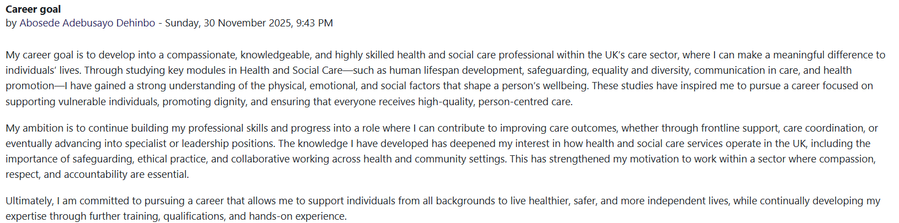
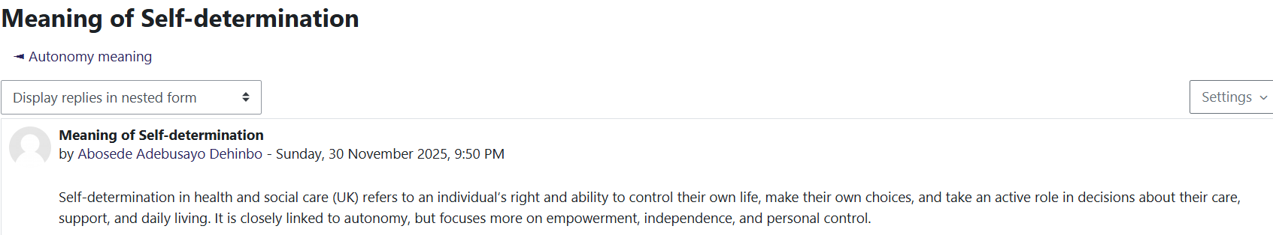

Task 2- Unit 2: Networking in Health and Social Care in the UK: Essential Aspects, Critical Evaluation, and International Significance
In the UK, networking within health and social care has become increasingly significant for delivering integrated, person-centred services. Strong professional networks enhance coordination, reduce service duplication, and improve patient outcomes, emphasising collaboration among health and social care professionals to deliver comprehensive care (Indeed Editorial Team, 2023).
Collaboration is achieved through partnerships across professions and organisations, improving service delivery and patient experiences. Multi-Disciplinary Team Meetings (MDTs) facilitate coordinated care, while Safeguarding Partnerships protect vulnerable groups, and Integrated Care Systems (ICS) aim for cohesive regional health planning. Engagement with the voluntary sector and the adoption of information-sharing tools—such as Electronic Health Records (EHRs) and professional forums—are vital for effective communication and support. Multiagency community centres offer a variety of services in one place, and peer support networks encourage the sharing of experiences. Ongoing professional development is supported by collaborative educational activities, and digital platforms like NHS Collaborate enable healthcare leaders to share resources and solutions, promoting coordinated, efficient, and patient-centred care.
The central principle of networking in health and social care is “interprofessional collaboration.” This involves multidisciplinary teams—spanning nursing, social work, physiotherapy, and mental health—working together to address complex patient needs. Such integration of expertise enables more comprehensive and effective support (Davidson et al., 2024). In practice, networking appears as regular multidisciplinary meetings, integrated information systems, and joint service contracting. The benefits of networking are significant: it streamlines referrals, ensures smooth patient transfers, and improves care coordination. Collaboration enables practitioners to address both clinical and social determinants of health, resulting in fewer hospital admissions and greater patient satisfaction. Resource and knowledge sharing further fosters a culture of continuous professional development (Xyrichis et al., 2024).
However, networking poses challenges, such as clashes in organisational culture, conflicting professional goals, and power imbalances, which can hinder effective teamwork (Crocker et al., 2020). Poor communication or unclear roles can result in care gaps or unnecessary duplication of work. Maintaining networks also requires time and resources, which can be taxing in stretched systems. Some professionals may undervalue collaborative practice (Carey et al., 2018).
Reflecting on networking theories has highlighted the deep interdependence of health and social care, with integration leading to better outcomes, as seen in Scandinavian countries (Koteyko, Hunt and Gunter, 2015). Overall, despite obstacles, networking and collaboration remain essential for improving the quality and continuity of care in the UK and globally.

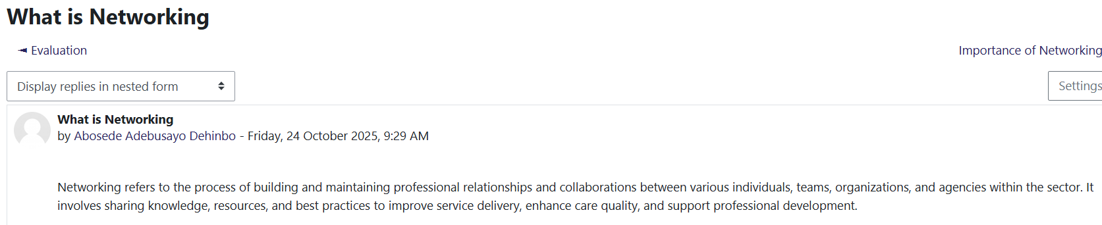

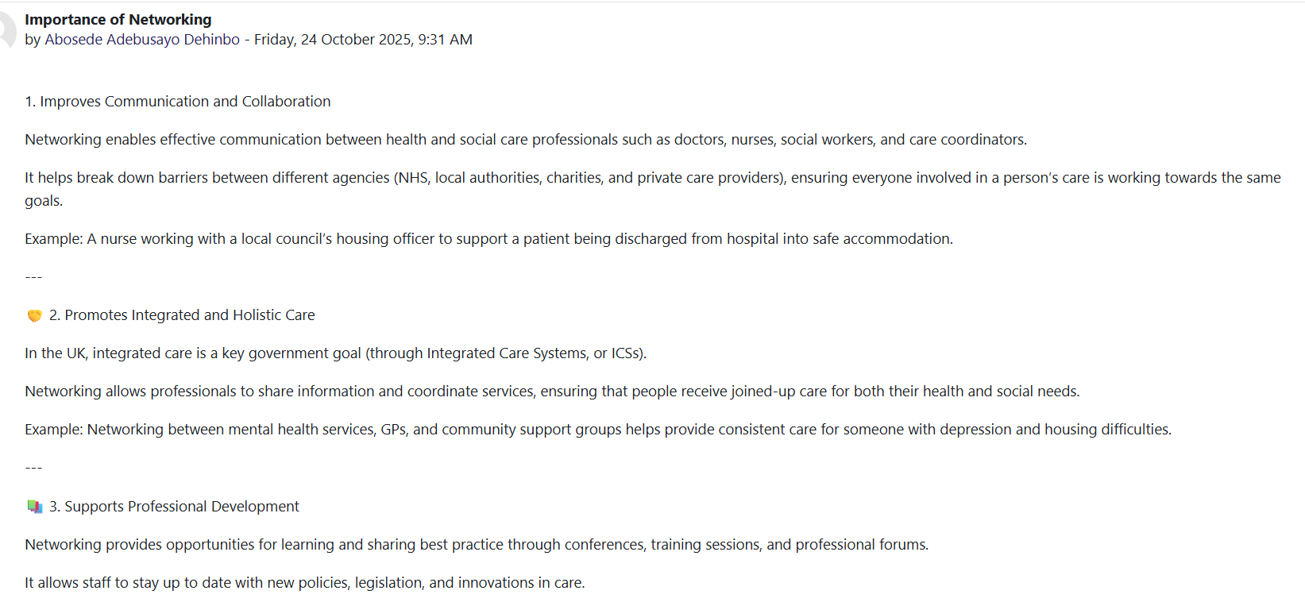
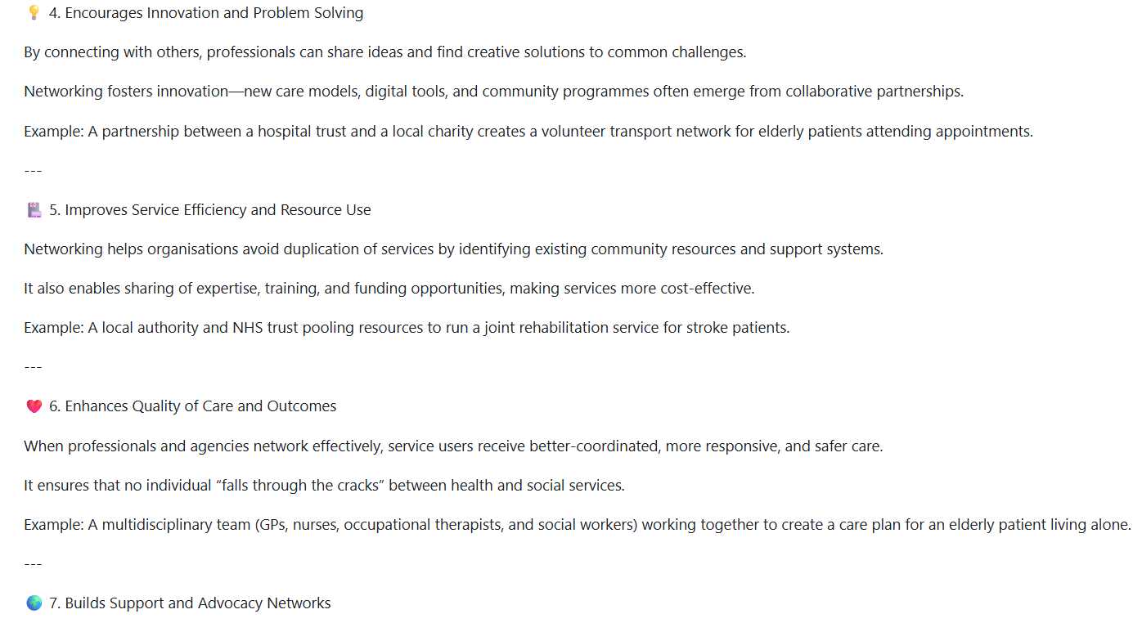

TASK 3- UNIT 3: Analysis of "Strategies for Unlocking Employment Opportunities in Health and Social Care in the UK
Definition and Theory:
Rochat and Borgen (2021) suggest that expanding work opportunities involves not only actively seeking and identifying potential career paths but also taking actions to encourage their progress. Within the UK’s health and social care sector, this process typically includes networking, gaining sector-specific qualifications, volunteering, and developing an understanding of the industry’s demands. By doing so, individuals can better access and make use of available job opportunities. Furthermore, Mitchell, Levin, and Krumboltz's Happenstance Learning Theory (1999) suggests that unexpected events often shape career development. Therefore, we encourage individuals to be proactive and flexible, enabling them to seize new or unforeseen opportunities as they present themselves.
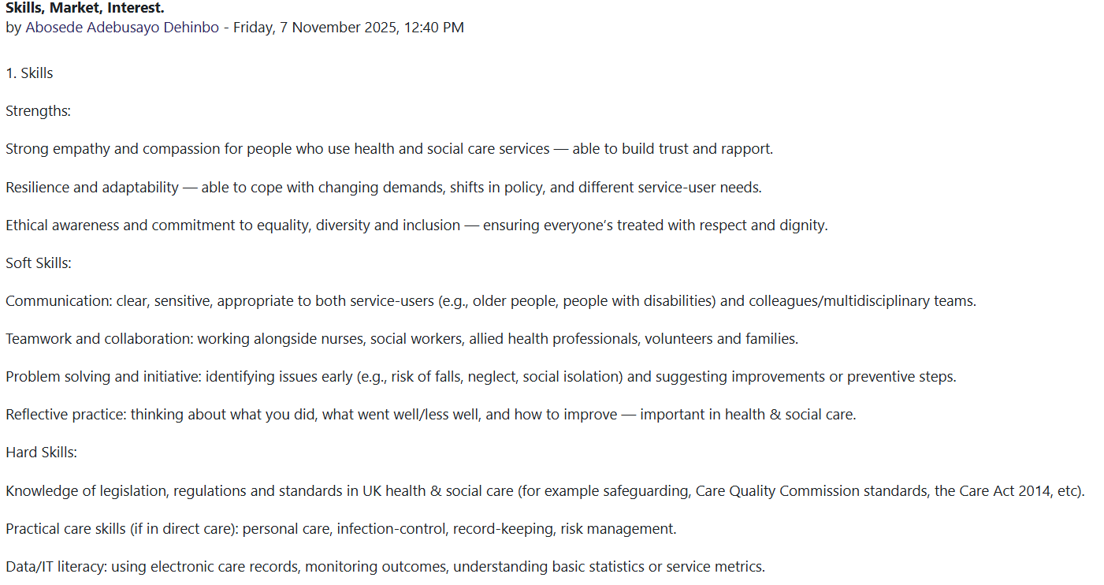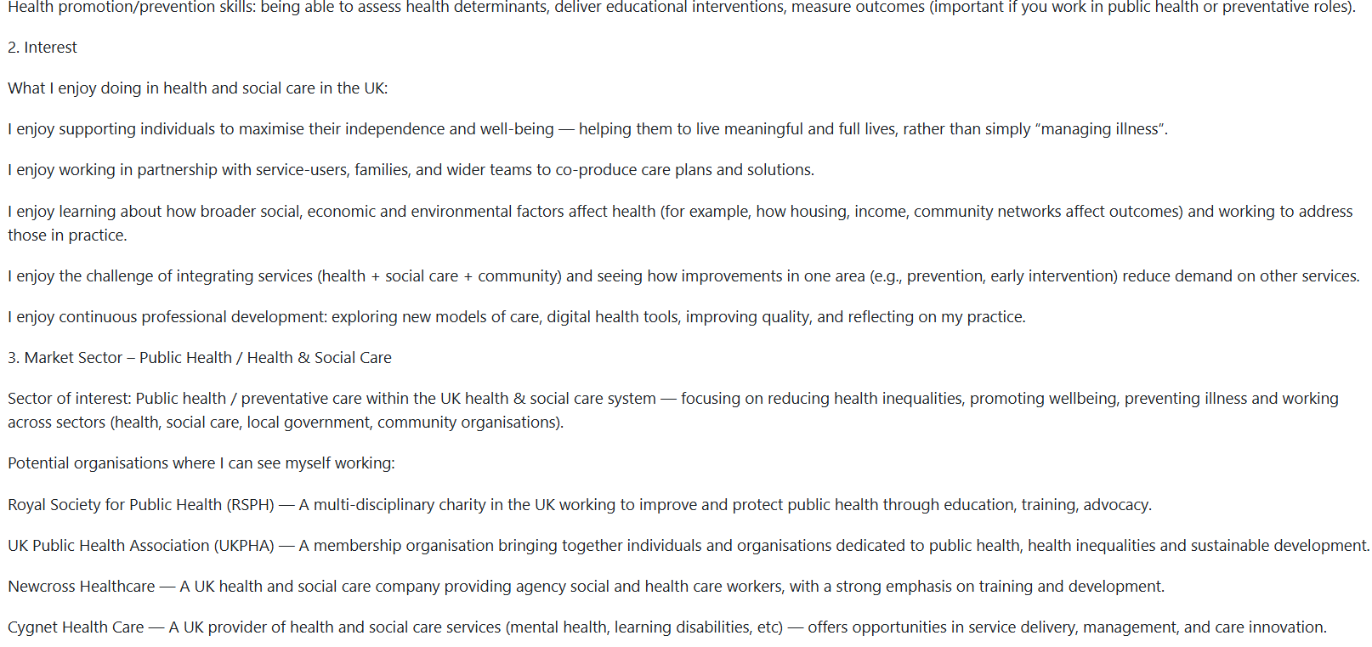

Critical Evaluation and Implementation:
In the educational material, I acknowledged the significance of both formal and informal approaches to job advancement. Structured pathways, like apprenticeships or degrees, are essential; nevertheless, informal approaches like cultivating professional networks, participating in industry events, and engaging in volunteer work are also important. This idea corresponds with (Tomlinson’s 2017) results that social capital and proactive participation significantly improve employability in the health industry.
Through introspective practice, I gained more awareness of my strengths and deficiencies. I noticed that volunteering enhances experience and broadens my professional network, increasing my visibility to prospective employers. (The NHS Leadership Academy, 2025) endorses this proactive approach, highlighting reflective practice and networking as essential components for professional advancement in health and social care.
Illustrations:
Following my participation in a local job fair and interaction with NHS recruiters, I obtained a shadowing opportunity that provided me with practical insight into healthcare careers. This experience immediately impacted my choice to obtain a certification in health and social care, illustrating how embracing such chances may affect personal and professional trajectories.
Advantages:
Enhances employability and self-assurance.
Establishes a professional network that might result in employment recommendations.
Offers pragmatic experience and industrial knowledge.
Promotes continuous education and flexibility.
Disadvantages:
This may be labour-intensive and might interfere with other obligations.
Networking may be intimidating for shy individuals.
Volunteering or unpaid positions may not be economically feasible for many individuals.
Cultivating social capital and participating in sector-specific activities significantly improve employability in health and social care. The NHS Leadership Academy (2021) emphasises the need for continuous professional development and networking for career advancement.
In summary, acquiring knowledge about "how to unlock job opportunities" has provided me with pragmatic techniques to identify and capitalise on growth prospects. By integrating theory with practice, I have more confidence in managing my professional trajectory in health and social care.
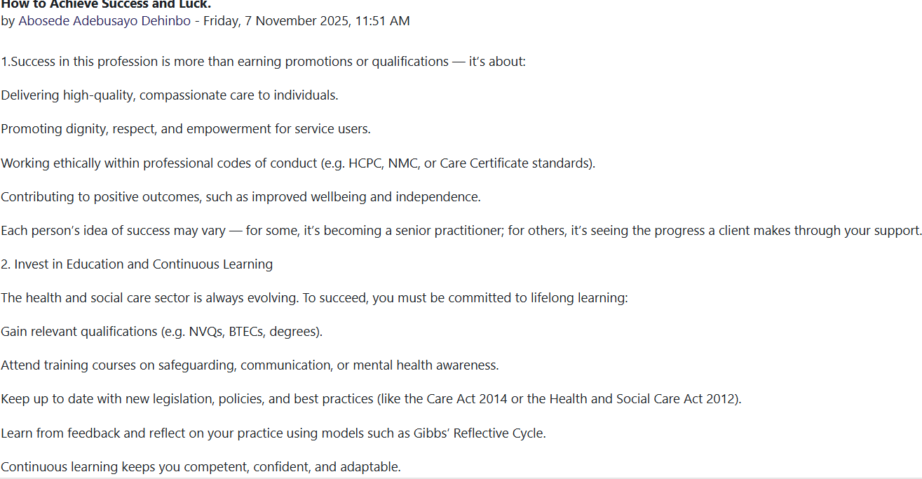

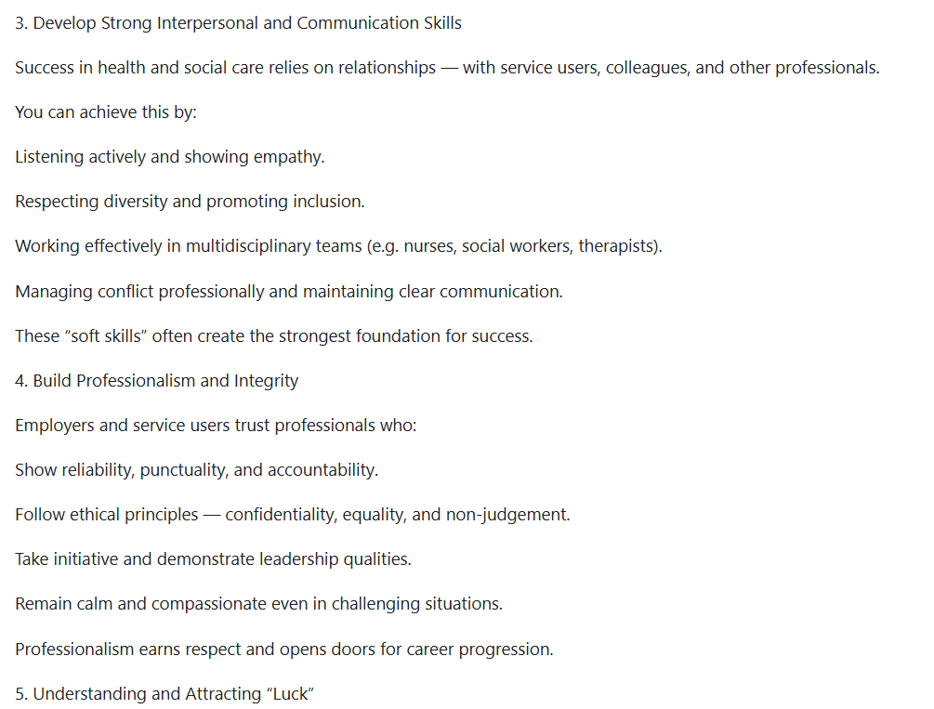

Task 4- Unit 4: Career Role Models
Career role models in health and social care are professionals whose behaviours, skills, and values exemplify best practices, motivating others to emulate their patient-centred approaches (Colombo et al., 2019). Studying UK career role models has provided valuable insights into the competencies and ethical standards vital for effective practice. Bandura’s Social Learning Theory (1977) offers a useful framework, suggesting that individuals learn behaviours and attitudes by observing others, particularly those they admire. In health and social care, observing role models not only teaches optimal practices but also inspires the adoption of positive behaviours essential for compassionate and competent care.
Role models have a vital impact on skill advancement by demonstrating the practical application of theoretical knowledge. For example, witnessing a nurse’s effective communication with patients can enhance one’s interpersonal abilities (Pakkanen et al., 2024). They also provide ethical guidance, highlighting the importance of maintaining confidentiality and advocating for patients’ rights. Furthermore, observing the achievements and career paths of respected professionals can inspire ambition and motivate individuals to set and pursue higher career goals. Engaging with role models also helps shape a strong professional identity, fostering a sense of belonging and purpose within the field.
However, there are potential drawbacks. Relying too heavily on role models may create unrealistic expectations or idealisation, often overshadowing the importance of personal growth and self-critical reflection. If a role model exhibits poor practice, there is a risk that these negative behaviours could be imitated. Moreover, a lack of diversity among role models can impede inclusion, making it more difficult for individuals from different backgrounds to see themselves within the profession.
For instance, a senior social worker who advocates for vulnerable children and shows resilience in challenging situations serves as a positive role model, encouraging newer practitioners to value advocacy and emotional intelligence. Conversely, observing professionals experiencing burnout or ethical lapses underscores the need for self-care and ongoing development.
Reflecting on the actions and experiences of role models has deepened my understanding of leadership, communication, and ethical conduct in real-world settings. These observations have clarified the skills required in health and social care and provided direction for my own professional growth. Analysing UK career role models through the lens of Social Learning Theory has emphasised the importance of observational learning and critical reflection, forming a strong basis for my continued development as a reflective, ethical, and motivated practitioner (Deniz Dirik and İnan Eryılmaz, 2024).

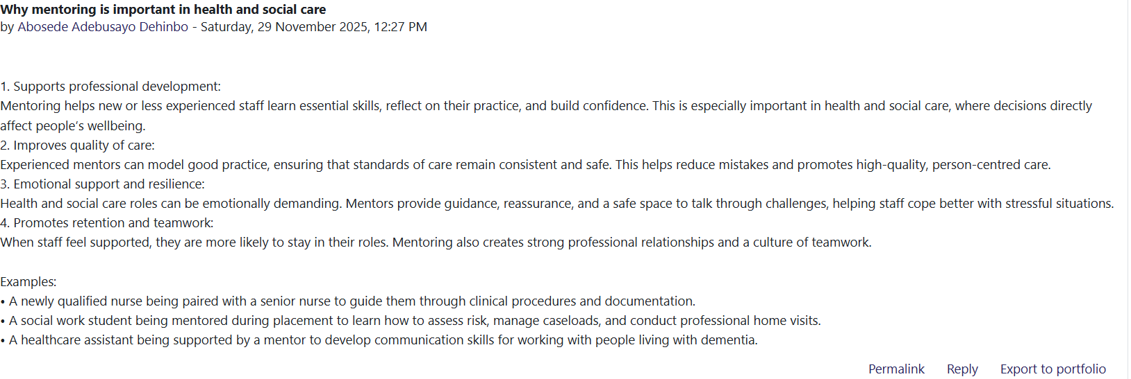

Conclusion
Strategic goal-setting and proactive networking are vital for professional advancement in health and social care in the UK. Setting clear and achievable goals helps professionals maintain their focus and motivation. Moreover, building connections with colleagues and mentors can reveal new job opportunities. Networking not only broadens one’s professional network but also grants access to valuable resources and insider information, which may lead to opportunities that are not widely advertised. Additionally, having professional role models provides guidance, inspiration, and practical advice that help individuals navigate the complexities of the field and realise their ambitions. Collectively, these strategies empower individuals to take control of their professional development and adapt to the continuously changing demands of health care. cultivating professional relationships and learning from experienced leaders are essential for personal and professional growth in this sector.
Key actions I have taken as a result of the course material and unit learning include engaging in relevant training, broadening my professional network on LinkedIn, and participating in health-sector job fairs. I used job search tactics such as customised applications and took inspiration from NHS executives, refining my approach to opportunities in health and social care.

Reference

Bandura, A. and Walters, R.H., 1977. Social learning theory (Vol. 1, pp. 141-154). Englewood Cliffs, NJ: Prentice Hall. Available at: Bandura’s Social Learning Theory (1977) - Google Scholar (Accessed: 24 November 2025).
Bjerke, M.B. and Renger, R. (2017) ‘Being smart about writing SMART objectives’, Evaluation and program planning, 61, pp. 125–127. Available at: https://doi.org/10.1016/j.evalprogplan.2016.12.009. (Accessed: 13 November 2025).

Bovend’Eerdt, T.J., Botell, R.E. and Wade, D.T. (2009) ‘Writing SMART rehabilitation goals and achieving goal attainment scaling: a practical guide’, Clinical rehabilitation, 23(4), pp. 352–361. Available at: https://doi.org/10.1177/0269215508101741. (Accessed: 13 November 2025).

Carey, G., Crammond, B. & De Leeuw, E. (2018) ‘System science and systems thinking for public health: a systematic review of the field’, BMJ Open, 8(3), pp. 1–8. Available at: Systems science and systems thinking for public health: a systematic review of the field | BMJ Open. (Accessed: 8 November 2025).

COLOMBO, I., PHD., FOLAYAN, O., PHD., FOLAYAN, N., PHD and MCKENZIE-SCHOETZ, R., (2019). The Influence of Role Models on the Sustainability of the Engineering Profession in the UK: A Case Study. ASHRAE Transactions, 125, pp. 257-263.Available at: Role Models: Helping Ethnic Minority Engineering Students Become Practicing Engineers | ashrae.org (24 November 2025).

Crocker, H., Kelly, L., Harlock, J. et al. (2020) ‘Available at: Measuring the benefits of the integration of health and social care: qualitative interviews with professional stakeholders and patient representatives | BMC Health Services Research | Full Text (Accessed: 24 November 2025).

Davidson, A.R. et al. (2024) ‘Patients’ experiences of and roles in interprofessional collaborative practice in primary care: a constructivist grounded theory study’, Primary health care research & development, 25. Available at: https://doi.org/10.1017/S1463423624000148. (13 November 2025).

Deniz Dirik & İnan Eryılmaz (2024). Exploring the career expectations of domestic and international students in an emerging country context. Higher Education Research & Development 43:5, pages 1089-1106. (Accessed: 24 November 2025).

Indeed Editorial Team (2023) ‘Professional networking: what it is and how to do it’, Indeed Career Guide. Available at: What is professional networking? | Indeed.com UK (Accessed: 25 November 2025).
Koteyko, N., Hunt, D. and Gunter, B. (2015) ‘Expectations in the field of the Internet and health: an analysis of claims about social networking sites in clinical literature’, Sociology of health & illness, 37(3), pp. 468–484. Available at: https://doi.org/10.1111/1467-9566.12203. (21 November 2025)

Levack, W.M.M., Weatherall, M., Hay‑Smith, E.J.C., Dean, S.G., McPherson, K. & Siegert, R.J. (2015). Available at: Goal setting and strategies to enhance goal pursuit for adults with acquired disability participating in rehabilitation - PubMed(Accessed: 8 November 2025).
McCarthy, J., O’Donnell, H. & Lloyd, K., 2022. Developing Self-Awareness in Health and Social Care: The Johari Window Framework. Journal of Health & Social Care, 15(2), pp. 45-58. (Accessed: 13 November 2025).
Mitchell, K.E., Al Levin, S. and Krumboltz, J.D. (1999), Planned Happenstance: Constructing Unexpected Career Opportunities. Journal of Counselling & Development, 77: 115-124. https://doi.org/10.1002/j.1556-6676.1999.tb02431.x (Accessed: 24 November 2025).
NHS Leadership Academy (2025). The importance of networking in health and care. Available at: https://wwwNetworks and Networking – East of England (Accessed: 7 November 2025).
NHS National School of Healthcare Science (2023). Example SMART (Specific, Measurable, Achievable, Realistic, Time-based) objectives. Available at: https://nshcs.hee.nhs.uk/publications/example-smart-specific-measurable-achievable-realistic-time-based-objectives-log/ (Accessed: 21 November 2025)
Pakkanen, P., Häggman-Laitila, A., Pasanen, M. & Kangasniemi, M. (2024) ‘Health and social care workers’ professional values: a cross-sectional study’, Nursing Ethics, 31(5), pp. 681–698. Health and social care workers’ professional values: A cross-sectional study - Piiku Pakkanen, Arja Häggman-Laitila, Miko Pasanen, Mari Kangasniemi, 2024(Accessed: 13 November 2025).
Rochat, S. and Borgen, W. A. (2021). British Journal of Guidance & Counselling, 51(2), pp. 298–309. Available at: Full article: Career life as a game: an overlooked metaphor for successful career transitions (Accessed: 24 November 2025).
Tomlinson, M. (2017) ‘Forms of graduate capital and their relationship to graduate employability’, Education + Training, 59(4), pp. 338–352. Available at: Forms of graduate capital and their relationship to graduate employability | Education + Training | Emerald Publishing (Accessed: 7 November 2025).
Xyrichis, A., Low, L., Reeves, S., Zwarenstein, M. & Fulop, N.J. (2024) ‘Revisiting the definition of interprofessional practice: an international Delphi study’, Journal of Interprofessional Care, 38(6), pp. 771–779. Available at: Understanding integrated care (Accessed: 13 November 2025).
Van de Velde, D., Boeykens, D., Gauwe, V. et al. (2025). Goals should be defined as CLEVER before specifying them into SMART goals: A phenomenological hermeneutical study to facilitate the implementation of goal-oriented care in primary care - Dominique Van de Velde, Dagje Boeykens, Vanessa Gauwe, Greet Steyaert, Liesbeth Ryssen, Mike Jarrey, Pauline Boeckxstaens, Peter Pype, Patricia De Vriendt, 2025. (Accessed: 13 November 2025).

