12/2/2019
Sonny Hawkins
1900372
Strategic Travel and Tourism Management
M6X02119

TABLE OF CONTENTS
Executice summary 3
INTRODUCTION 4
Background 5
Mintzber 5p’s 7
PEST ANALYSIS (APPENDIX 1) 15
Porter’s 5 forces 7
APPENDIX 2 16
technology 7
Integration of transport modes 7
stakeholders 8
volunteers and local communities 8
local businesses 9
potential partnerships 9
conclusion 10
recommendations 11
APPENDIX 3 17
APPENDIX 4 18
references 12
appendix 15

Executive Summary

The aim of this report is to make strategic recommendations to develop rail-based tourism to take advantage of the expansion set from 2022 where Transport for Wales will double the passenger capacity. However, this means strategic planning needs to take place to attract more tourists to the line. The Heart of Wales Trail Line passes through rural, upland, woodlands and beautiful landscapes en-route. Making this a potential area for growth with the expansion. The possible growth of the line in conjunction with the railway will link communities and tourism secondary spend in theory will spread up the line. This will offer opportunities for the development of tourist-based products along the route. This report looks at a number of strategic planning tools originated by academic professionals such as; Porter’s 5 forces and Mintzbergs 5 P’s to analyse the market to gain a competitive advantage and develop plans for a long-term direction.
The Heart of Wales line has a strong focus on the community and social growth. With the expansion of capacity, this line has a real potential for tourism to have an effect on the economic growth which can re-introduce money into the development of these communities along the line. However, taking advantage of the increase in passenger numbers means all stakeholders along the route must develop and promote tourist-based products to target the market. These recommendations will be gathered by benchmarking against a successful line such as The West Highland Line for comparative purposes.

Introduction
This report will make strategic recommendations as to what can be done by key stakeholders to further develop rail-based tourism in Wales.

background

The transport sector play an important role of international and national markets by supporting the movement of people and goods around the globe. Therefore, it can be said that the transport sector works in conjunction with the tourism industry and as a result, effects the growth of each sector (Duval, 2007). Therefore, the development of rail-based tourism in Wales has huge potential for economic growth in small communities. Today, technology has a huge impact on the development of the tourism and transport industry. Hall (2005) suggests that tourists demand for travel was the direct motive of the technological development of national and international transport. Consequently, technology is a crucial aspect that must be considered in strategic planning for the expansion of The Heart of Wales Line to promote rail-based tourism. According to Butler (1980), there are five factors in transport that have affected tourism due to developments in technology; reduced time, reduced financial cost, improvement in comfort, increased convenience and increased accessibility.

Furthermore, the tourism industry is continuously changing regarding technology, globalisation, consumer demand and social climate (Moutinho, Et al.2011). The failure of businesses in this industry is due to the lack of effective planning and adapting to these changes rapidly. Therefore, The Heart of Wales line must respond to these changes in the industry, especially with the rise in capacity in 2022.

.

mintzbergs 5p’s
Mintzberg (1987) research suggests that in practice, the word strategy can be used as; a plan, ploy, pattern of behaviour, a position and a perspective. Thus, Mintzberg’s 5 p’s can be an efficient and strategic planning tool for The Heart of Wales line to develop long-term direction not only to gain a competitive advantage but to be unique.

Plan - The rise in globalisation makes it crucial to evaluate the current climate of an organisation to allow growth. Therefore, the chosen framework for The Heart of Wales line is the pestle analysis. This framework provides key drivers for change that will impact on the success or failure of their strategy (Salvá,2011). See Appendix 1.

Ploy – Although the line does not have any direct competitors on the railway, new competition to the rail industry and other forms of transport puts pressure on price, cost and rate of investment to compete. The new and quicker line from Cardiff to London will enhance these factors and put huge pressure on ‘The Heart of Wales Line’. For short-term strategic planning, they provide free passes to OAP’s in the winter season.

Pattern – The Heart of Wales line can look at strategy as a pattern to see what kind of approaches have worked in the past to utilise and enhance them. For example, one of their strategies is a social and commercial development plan that is supported by network wide investment. Therefore, encouraging and increasing this strategy at further stations along the line will promote tourism for economic growth and social engagement.

Position – Using Mintzbergs 5 p’s strategy will allow The Heart of Wales line to see where they sit to define their strategy going forwards when doubling their seat capacity. For example, their pricing strategy compared to other competitors in the market and delivering great customer service. However, with the increase in capacity, the line may need to find a particular customer niche to attract the right target market such as promoting the trail to active tourists or families. Never less, Transport for Wales are the only rail service that operates on the line.

Perspective looks internally of an organisation to develop and shape its nature and culture. For The Heart of Wales line, speed of tourism development is the highest factor to develop their tourism market along the line to see an economic boost, as well as promoting the heritage and culture of these communities. Therefore, for the strategy of perspective to be successful, all stakeholders must be involved in the process to share the same perspective.

Porters Five forces
The strategy of Porters five forces is to understand how attractive an industry is, in this case, rail. This tool is a way for The Heart of Wales line to look at their competitors to shape their organisation to gain a competitive advantage by analysing the five forces (Porter, 2008). Appendix 2

technology
Technological developments introduce a wide range of new tools and benefits for organisations (Egeer and Buhalis,2008). The internet, especially the rise in social media, provides a direct platform for The Heart of Wales to advertise as well as an effective and live platform for exchange of ideas and products (Moutinho, Et al. 2011). Furthermore, these developments enable the line to develop partnerships with their stakeholders, consumers, suppliers and the public sector (Buhalis, 2003). Technology software’s in tourism are universal as strategic management relies of daily information and rely heavily on collaboration with stakeholders to deliver their products.

A trend in the rail industry is passenger loyalty schemes by encouraging loyal buying behaviour. This trend would be beneficial for The Heart of Wales line as the passenger has a choice of businesses on the route from Swansea to Shrewsbury .Evidently, the London North Eastern Railway (LNER) run a loyalty scheme which is a point-based scheme to provide customers with rewards such as, train tickets, cinema tickets, hotels, ect to promote secondary spend and economic growth (Lner.co.uk, 2019).

The development of apps makes it vital for The Heart of Wales to adapt and strategically plan to incorporate these developments into their plans. For example, the Trapeze Group is a company that helps transport companies develop partnerships with businesses to link up with car services, bicycle hire and other forms of transport. Therefore, taking advantage of these technological developments are crucial for the success of The Heart of Wales.

Integration of transport modes
Integration of transport modes and connectivity of networks play are a vital component for the development of destinations. (Duval,2007). Unfortunately, Wales does not have a successful network system or integration of transport modes. The main network route besides The Heart of Wales line is the M4 motorway. Therefore, the development of the rail line is crucial to get tourists from the train stations to their destination in a smooth and efficient operation.

linking up with other modes of transport and potentially business along the line to provide better integration of transport is a key strategy. For example, adopting the strategy set out by Twr – Y- Felin hotel is a key development for The Heart of Wales line to promote economic growth and tourism. Their strategy is to provide a shuttle service for guests to be picked up from the train station and dropped to the hotel.

Furthermore, the Scottish Government strategy to fully integrate transport to support economic development and improving access to communities is a vital component that The Heart of Wales Line should adopt. Scotland has a better integrated transport system than Wales due to better strategic planning and connectivity. Their idea for the West Highland Line is that you are able to arrive at a train station on time by a bus, then catch a ferry from the train station to Scottish island, then use another form of transport directly. Their strategy is for tourists to have a smooth-running transport system with not having to wait hours for the next mode of transport.

stakeholders
Bramwell & broom (1989) note that it is key for tourism planners to collaborate with local stakeholders. Stakeholders are individuals, groups or organisations who affect or are affected by an organisation. Furthermore, the stakeholders involved requires strategic management (Smudde and Courtright, 2011). The stakeholders involved in The Heart of Wales Line include; Transport for Wales, the community, local businesses, tourists, volunteers and consumers.

Volunteers and local communities
After a recent trip along the line I was able to gather some primary data. Interviewee’s main concerns include; the of the lack of train times, outdated trains across the line, the importance of steam trains as they attract mass tourism and they outdated website/logo. Therefore, if the local community are seeing issues then these factors will likely affect tourists in the same way.
A spokeswoman from The Heart of Wales stated that ‘without volunteers at certain stations, the line would not operate as smoothly as it does today’. Therefore, strategically managing them into the operation of the line is crucial for a smooth and successful operation. Jamal and Getz (1995) suggests that social participation is key in the community and should allow for social integration and participation in tourism development. Therefore, adopting the approach of the West Highland Line to allow communities and volunteers to utilise the unused space in the station to improve social interaction in communities could be a method for The Heart of Wales line across the entire line (Hamilton & Alexander, 2013).
Furthermore, The West Highland line is the most scenic route in the world. Their strategy is to use this scenery to promote community heritage and culture through luxury cruise tours in the development of the tourism product (Murphy, 1985). Similar to The West Highland line, the Heart of Wales line runs through some of Wales’s beautiful landscapes which is why it was rated ‘the best travel discoveries in 2018’ (The Guardian, 2018). Therefore, The Heart of Wales line should use this to their advantage like the West Highland line to strategically plan to incorporate the scenery, tours, stakeholders and heritage and culture as a way of attracting tourists.
Local Businesses
Many local businesses have concerns as they do not directly work with the line and the potential to increase tourism is enormous. They believe that promoting businesses such as hotels, restaurants, museums, spas etc. will attract a bigger market. Engaging the community and promote economic growth is part of The Heart of Wales line strategy. Therefore, developing relationships with these stakeholders could be crucial for the success of the expansion in 2022.
POTENTIAL PARTNERSHIPS
The potential partnership with the line is huge. Primarily using The Heart of Wales line to promote these businesses and offer discounts if they use the line. There are many businesses along the line and currently, there are no partnerships. For example, the Cawdor hotel is a 5-minute drive from Llandeilo. Therefore, providing a pickup service from the station to the hotel or integrate the public bus service to make additional stops for such local hotels.
Furthermore, the Eastridge woods park is based 9 miles from Shrewsbury and 11 miles from Church Stretton. The Eastridge woods park could provide trail guides that pick tourists up from these stations and provide bikes at the park, so they do not have to bring their own. Alternatively, provide a bike hire service at the station to cycle to the park for the active/explorer tourist.

conclusion
As a result of the research in this report, it is clear that there are a number of issues and trends that influence strategic planning in the transport and tourism sectors. I found that technology has a direct impact on both industries and therefore, they must both adapt to integrate these changes into their strategic planning process. Moreover, working with stakeholders and getting them involved in the decision-making process is a key factor for the success of promoting rail-based tourism along The Heart of Wales line. Furthermore, to integrate tourism and transport to promote heritage and culture into their development of tourism products is an aspect to encourage economic and social growth.

recommendations

LOYALTY POINTS
Firstly, introducing a loyalty scheme for passengers will encourage buying behaviour along the line. With 34 stops along the line, a loyalty scheme is a good initiative to work with several stakeholders such as local businesses. The idea is for customers to collect loyalty point with every journey along the line to then spend in businesses in the communities. This scheme promotes economic growth with secondary spend across the line, the increase in return loyal customers and an approach to promote rail-based tourism.

STEAM TRAIN TOURS
The demand for steam trains and the increase capacity suggests that steam train tours can be a strategy to increase rail-based tourism. The steam train tours could involve partnership with other stakeholders along the line to create a package tour. For example, the use of local foods, attractions and tour guides to add a heritage and community spirt feel to the tour as well as spreading tourist’s money alone the line.

COMMUNITY ENGAGEMENT
Part of The Heart of Wales strategy is to engage with the community and promote social wellbeing. So far, the line only has a few hub developments along the line, for example the Black Mountain Food Hub in Llandeilo station, and with the increased capacity, they have a real opportunity to expand their tourism based activities to promote both economic growth along the line and rail based tourism. Therefore, the recommendation of growing tourism-based hubs along the line such as bike rentals will be a key driver in promoting the line and getting other stakeholders involved.

DEVELOP THE BRAND
A common themed that came up from my primary research was the overall outdated brand of The Heart of Wales line. Therefore, with the increase capacity, developing and re-branding to incorporate tourism into their strategy will have a positive influence on increasing rail-based tourism in Wales. This is a real opportunity to get other stakeholders involved in the decision-making process to create a brand that is adopted by everyone. Some ideas for the branding are shown in Appendix 3. Additionally, creating a modern and comfortable train service with new facilities such as a trolley service, bike racks, faster trains to reduce time and better wifi connection to appeal to a wider market as Buter (1980) noted that these factors in transport affect tourism.

INTEGRATE MODES OF TRANSPORT AND TECHNOLOGICAL DEVELOPMENTS

Connectivity with buses and trains can be a huge development in Wales which will only promote tourism and geographically diverse economic development in Wales. Connectivity is a way for businesses and transport to work together in achieving these goals along The Heart of Wales line and Wales. For example, trains and buses are not integrated well in Wales and comparing the two modes of transport on the map, you can see huge gap in the country where we have a real opportunity to integrate different transport modes to improve our connectivity which will promote rail-based tourism, bus services, local businesses and get more people of the roads and onto trains. (Appendix 4).

Additionally, the development of shuttle services by stakeholders nearby is a crucial factor that will influence tourism along the line. This strategy could be used by hotels along the line to appeal to consumers as they will not have to worry about getting to the hotel or hiring a car and getting lost in the countryside of Wales. Furthermore, using technological advancements to their advantage such as an app to link such businesses and services to tourists’ mobile phones for easy access. For example, if you arrive by train to a community then another form of transport will be there to take you to your destination, whether that be car, bus or bicycle by a click of a button. Alternatively, using a tourist-based app to connect and promote tourism activities and businesses with tourists to provide key information about such activities to promote tourism along the line.

References

Mintzberg, h., 1987. the strategy concept i: five ps for strategy. California
management review.

The Guardian (2019). [image] Available at: https://www.theguardian.com/travel/2019/feb/05/walking-the-heart-of-wales-line-trail-railway-line

The Guardian. (2018). The best travel discoveries of 2018 chosen by Guardian writers. [online] Available at: https://www.theguardian.com/travel/2018/dec/22/best-travel-discoveries-of-2018-guardian-writers

Porter, Michael. "THE FIVE COMPETITIVE FORCES THAT SHAPE STRATEGY." Harvard Business Review 86.1 (2008): 78-93. Web.

Butler,R. (1980) The Concept of a tourist area cycle of evolution: Implications for management of resources.

Salvá, M. (2011). What Is the Medium-Term Impact of the Bric Countries? [online] Google Books. Available at: https://books.google.co.uk/books

Moutinho, and Moutinho, Luiz. Strategic Management in Tourism. 2nd ed. Wallingford: CABI, 2011. Print. CABI Tourism Texts

Smudde, Peter M, and Jeffrey L Courtright. "A Holistic Approach to Stakeholder Management: A Rhetorical Foundation." Public Relations Review 37.2 (2011): 137-44. Web.

Jamal, T & Getz, D (1995). Collaboration theory and community tourism planning

Murphy, P. (1985), Tourism: A cpmmunity approach

Dual, D. (2007). Tourism and Transport; Modes, Networks and Flows .

Hall, C.M. (2005) Tourism: Rethinking the Social Science of Mobility. Harlow: Persaon Education/Prentice Hall.

Buhalis, D. (2003) eTourism: Information Technology for Strategic Tourism Management. Pearson (Financial Times/ Prentice Hall), London.

Egger, R. and Buhalis, D. (2008) eTourism Case Studies; Management and Marketing Issues in eTourism. Butterworth Heinemann, Oxford.

Bramwell, B, & Broom, G. (1989). Tourism development action programmes: An Approach to local authority tourism initiatives.

Hamilton, K., Alexander, M. (2013) Organic Community Tourism: A Cocreated Approach. University of Strathclyde, UK.

SunDragon (2019). The Heart of Wales Line. [image] Available at: https://forums.dovetailgames.com/threads/route-proposal-heart-of-wales-line.18362/ [Accessed 1 Dec. 2019].

Preston, John, Gerard Whelan, and Mark Wardman. "An Analysis of the Potential for On-track Competition in the British Passenger Rail Industry." Journal of Transport Economics and Policy 33.1 (1999): 77-94. Web

Transport for Wales (2019). Transport for Wales. [image] Available at: https://tfwrail.wales/rovers-and-rangers/heart-wales [Accessed 1 Dec. 2019].

Ceredigion County Council (2018). Integration of train and bus service. [image] Available at: http://www.discoverceredigion.co.uk/English/footer/Transport/Pages/Transport.aspx [Accessed 1 Dec. 2019].

Lner.co.uk. (2019). Tickets & savings. [online] Available at: https://www.lner.co.uk/tickets-savings/?mq=Savingsandrewards [Accessed 2 Dec. 2019].

Appendix 1

Political
The unforeseen actions of Brexit play a huge role in the rail industry in the UK. Strategic plans must be in place to deal with any unexpected events. For example, the deal with European suppliers. Furthermore, Government support for transport regulatory policies, integration of infrastructure and environmental protection is crucial in the rail industry (Belwal,2017).
economic
The heart of wales line is doubling its capacity in 2022 which will potentially see an increase in jobs along the line and boost economic growth through the line. However, if the line is not successful and does not attract enough tourism then this might result in the loss of jobs across the line. Furthermore, the strength of the sterling pound has weakened over the years due to Brexit. With this, more people or likely to holiday at home. Additionally, the weakness of the pound could appeal to more European tourists to Britain. Consequently, marketing to both European and British tourists to boost inbound and domestic tourism is crucial to the strategic development of tourism in Wales. Furthermore, the uncertainty of Brexit puts pressure on European funding and suppliers.
social
The heart of wales line connects communities from Swansea to Shrewsbury. Part of their strategy is community engagement. Therefore, maintain good relationships with the communities and stakeholders is crucial with the expansion of the line, especially with the increase in tourist numbers.
technological
With the technological advancements, the heart of wales has an opportunity to take advantage of these tools to market their line and promote tourism, especially with the growth of social media. Social media and mobile apps are a current trend for organisations to distribute goods and services as well as communicating with these consumers and stakeholders.

Appendix 2

Threat of entry – new competition to the rail industry puts pressure on price, cost and rate of investment to compete. The new and quicker line from Cardiff to London will enhance these factors and put huge pressure on ‘The Heart of Wales Line’. Consequently, with the quicker times and reduced prices from Cardiff to London, this puts a cap on the potential customers and profit of the Heart of Wales Line, especially with the expansion of the line in 2022 (Porter, 2008).

Threat of substitute – Preston et. Al (1999) notes that the threat of substitutes is high due to different modes of transport such as, cars, coaches and buses. People’s decision-making process for which type of transport to take is usually due to factors such as price, time, convenience and comfort. For example, it takes approximately 3 hours by train to get from Swansea to Shrewsbury on the Heart of Wales Line. In comparison, it takes the same time to travel by car. However, taking the car is more convenient and comfortable for individuals and you do not run the risk of being delayed as the trains are not as frequent and are known to be delayed. Alternatively, Faster train time, more frequent and comfortable trains will aid in promoting a better train service for passengers which will take more cars off the road and promote a more sustainable attitude.

bargaining power of buyers – Consumers can put huge pressure on the line which can lead to reduced prices and demand for better quality, consequently, driving up costs for the line.

bargaining power of suppliers – Evidently, railways fundamentally need trains, railway tracks, staff and customers. The Heart of Wales Line however, has restrictions of the types of trains that can run on the tracks due to capacity constraints. Therefore, the need for new and up to date suppliers who can deal with these issues might be a possible way forward, especially with the increase of passengers in 2022.

Extent of rivalry between competitors - There are currently no other competitors that compete with Transport for Wales on the Heart of Wales Line. Therefore, the line is considered as a monopoly as they have no rivals on the line that may influence their pricing structure. However, it could be argued that other forms for transport may be direct competitors.
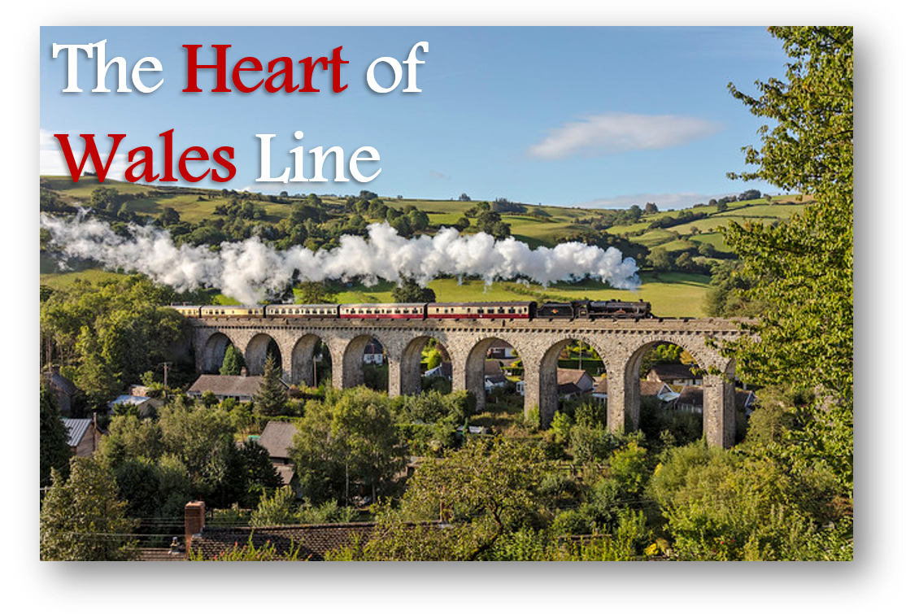
Appendix 3 – New and up-to-date designs

(SunDragon, 2019)
(The Guardian, 2019)
Appendix 4

Transport for Wales train service
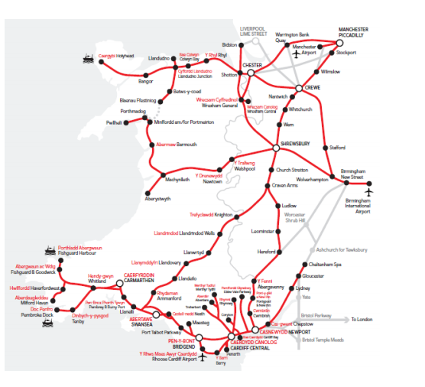
(Transport for Wales, 2019)

Integration of train and bus services

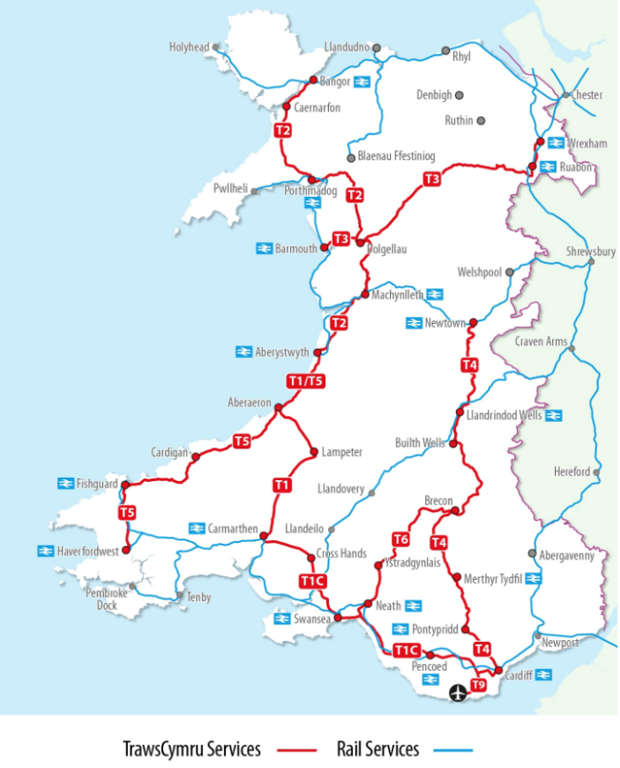
(Ceredigion County Council, 2018)

