Specific Stream Submission Tom Schultze 1802180
5th Engine Workshop Session with John Kinsella
29th October 2019
Engine Workshop

Reassembly of Inline 4 CBR 600R Engine

Health and Safety
-ALWAYS before entering workshop wear appropriate safety equipment.
Equipment worn this session:
-Eye protection: safety goggles
-Protective clothing: dust coat provided by uni and steel toe caps

- Put in generator 1x14mm
- Put on generator cover 8x8mm
- Put on top end 10x12mm
- Put in coolant pump 2x10mm
  - Different sized bolts left one is the longer bolt
- To put in cam shafts put the first piston at top dead centre (TDC) and put in cams and cam timing chain like in fig1.
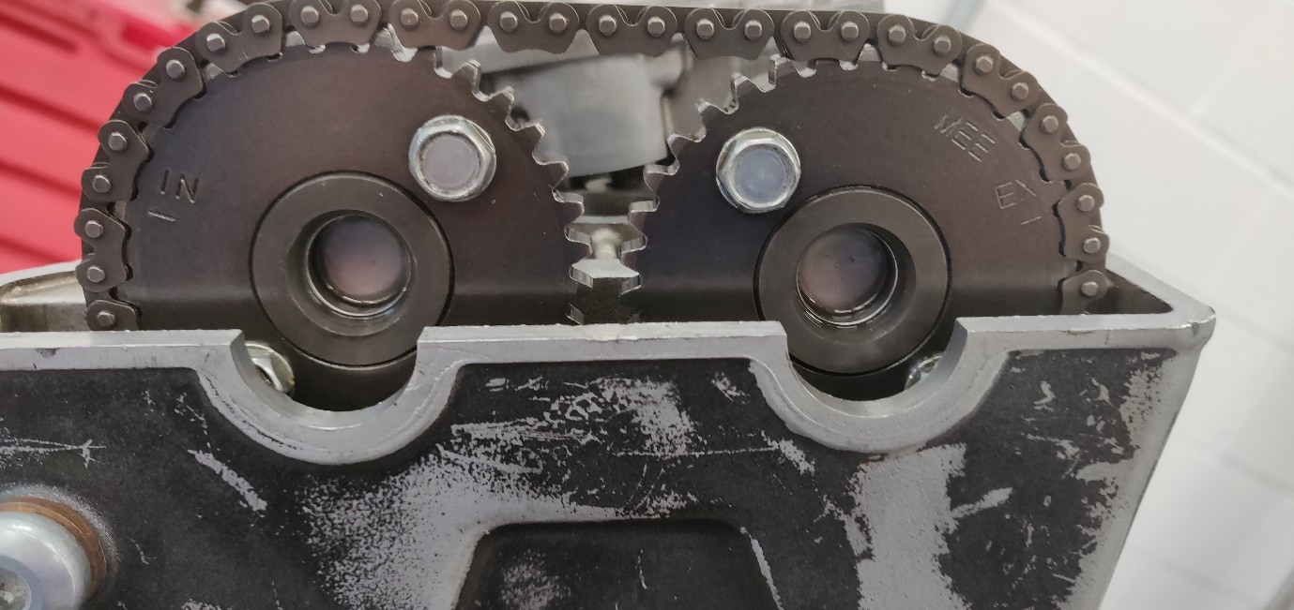
Figure 1: Picture of camshaft position with timing chain
- To put piston at TDC remove spark plug, put in screwdriver in spark plug hole and turn motor until screwdriver starts dipping again => piston is at TDC
- Put back rocker housing 16x10mm
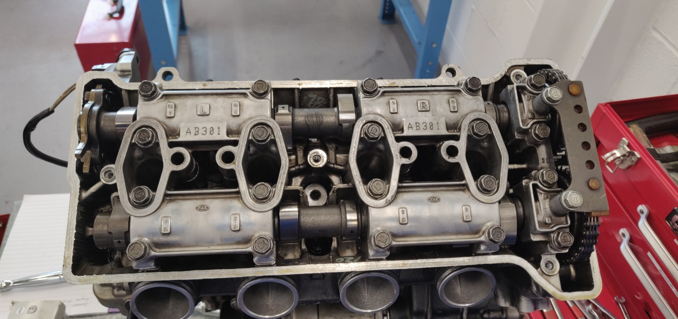
  - Watching out for inner and outer bolt lengths (Fig. 2)
Figure 2: Rocker housing

- Put on clutch cover 14x10mm
- Put on top 4x10mm

Engine is fully rebuilt again! (Fig.3)
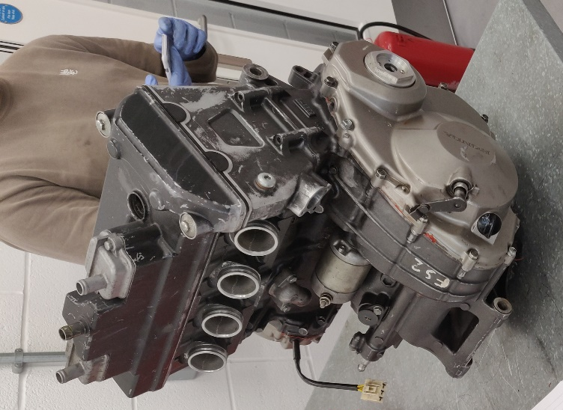
Figure 3: Fully rebuilt engine

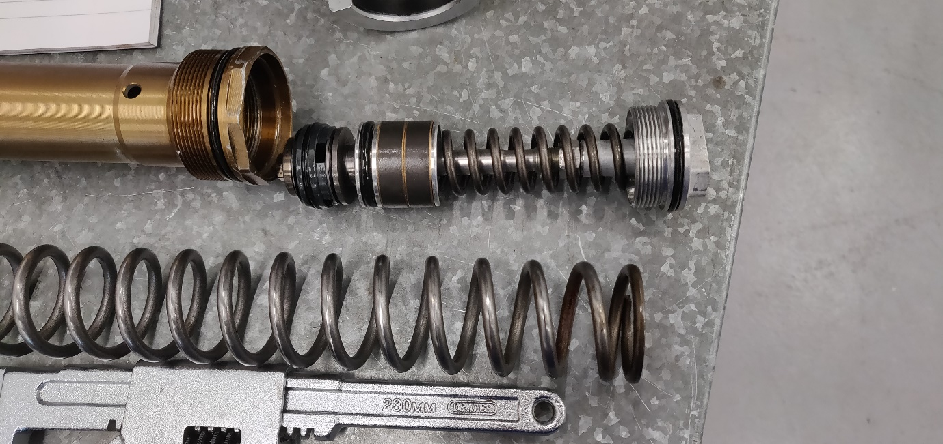
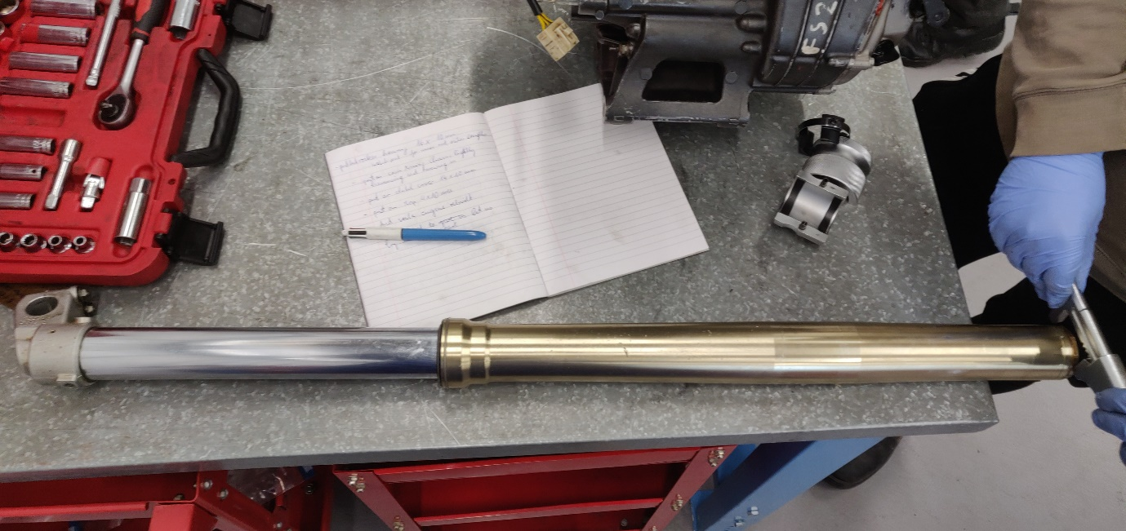
As the session was not quite finished John let us take apart the forks of the CRF 450 (Fig. 4 & 5)
Figure 5: Inner workings of the fork
Figure 4: Opening the CRF forks

End of session

