DS 1 Template

My Screenshots/Photos
- Please add 4–6 screenshots or photos of your digital life.
- You can use your phone or laptop.
- For each screenshot, write one or two sentences explaining what it shows.

Screenshot/Photo 1
- Moodle page
- 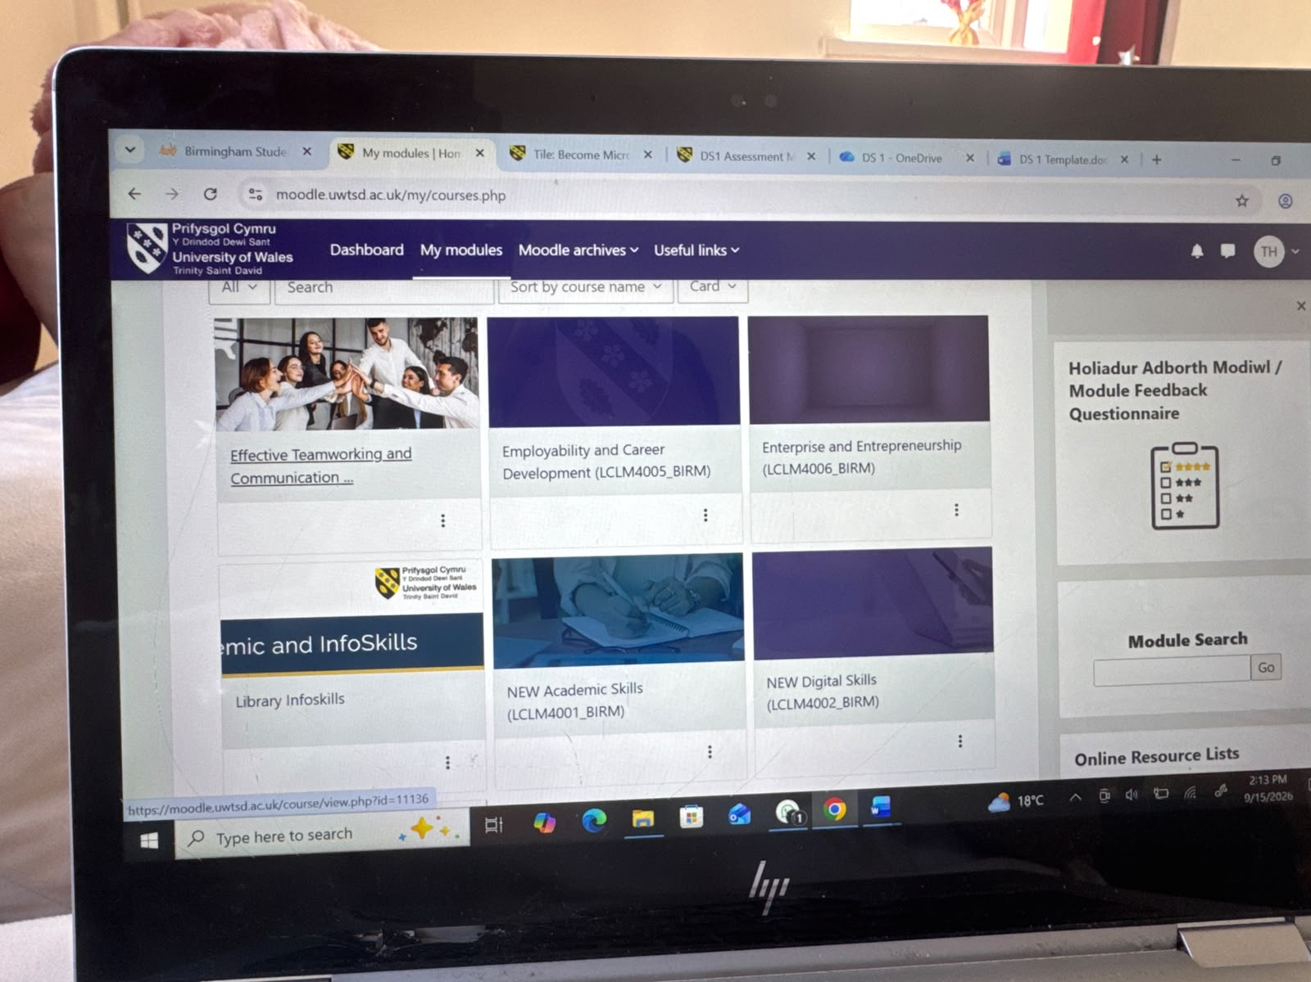
- I access my university Moodle dashboard to track module progress, review lecture slides, and manage assignment submission deadlines effectively.

Screenshot/Photo 2
- Laptop showing module work
- 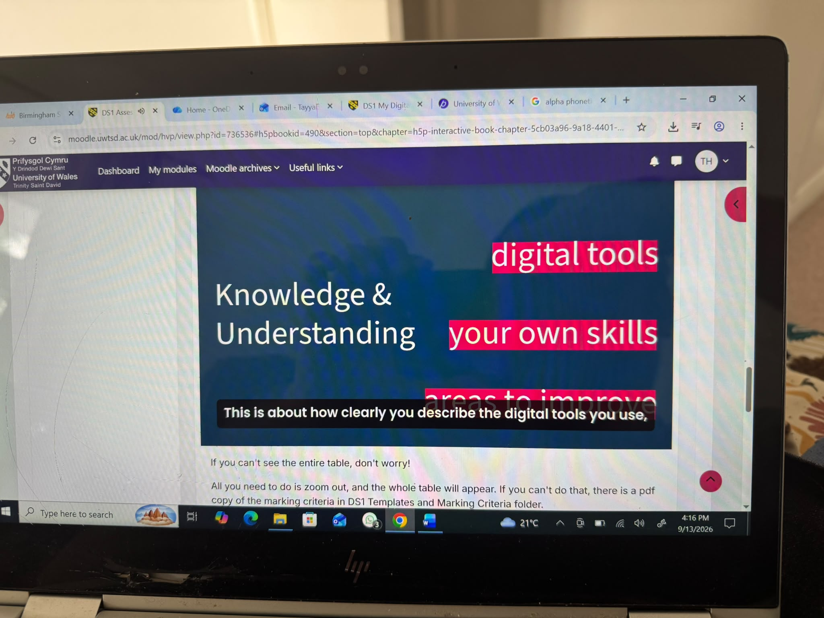
- Using my laptop allows me to work across multiple academic applications simultaneously, creating a focused digital environment for study tasks.

Screenshot/Photo 3
- OneDrive files
- 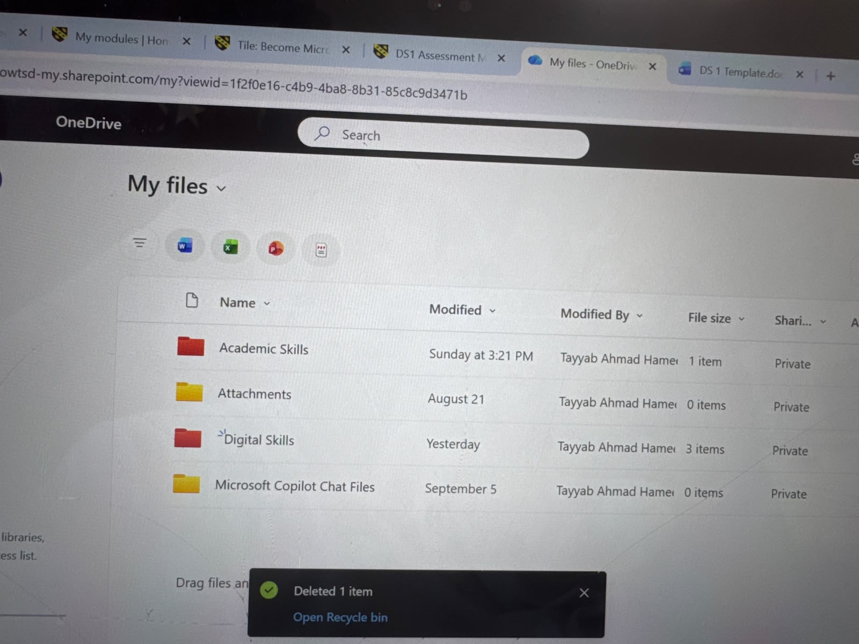
- Organising cloud files on OneDrive into dedicated module folders ensures my coursework is secure easily accessible and structured systematically.

Screenshot/Photo 4
- Outlook email
- 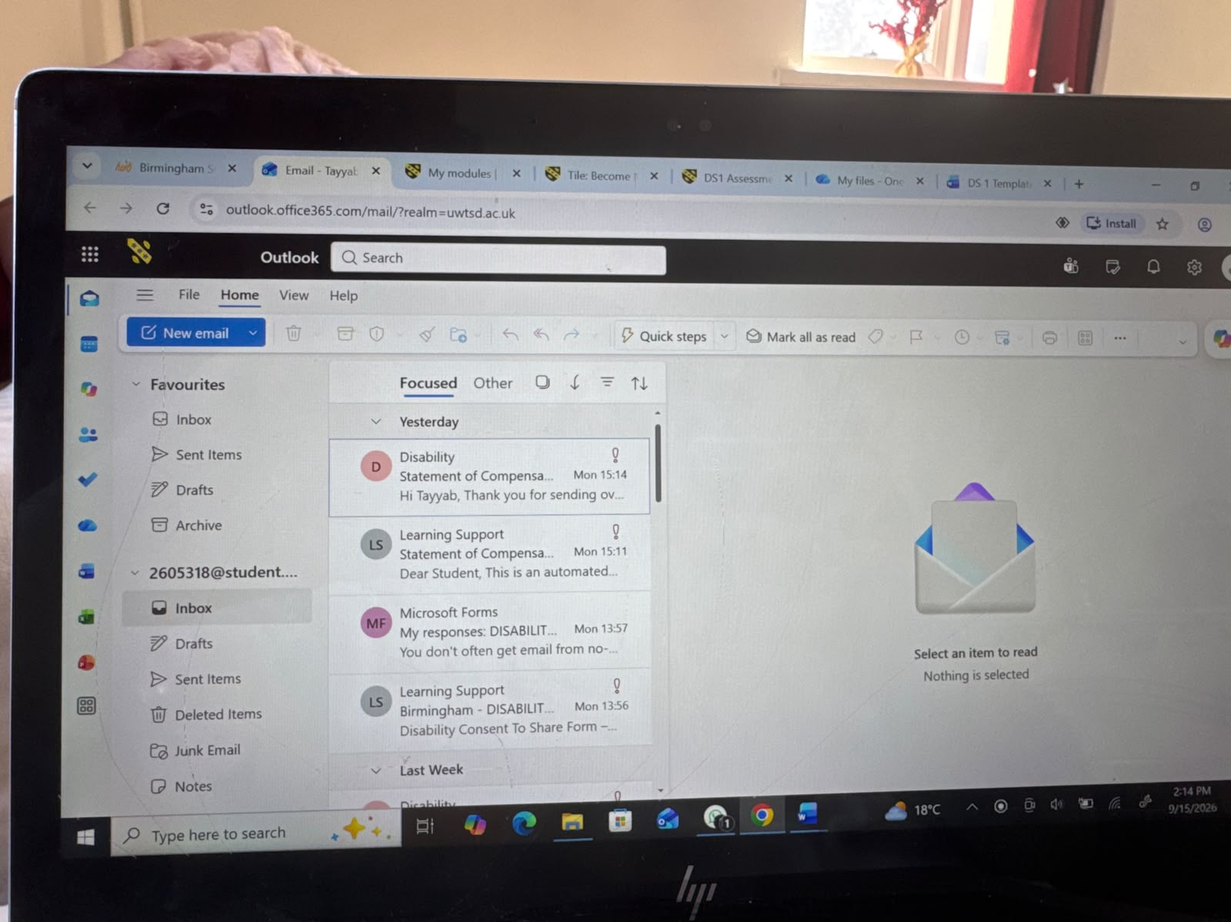
- Managing my university outlook inbox keeps me connected with tutors and administrative updates while building professional communication habits.

Screenshot/Photo 5
- Word document on laptop
- 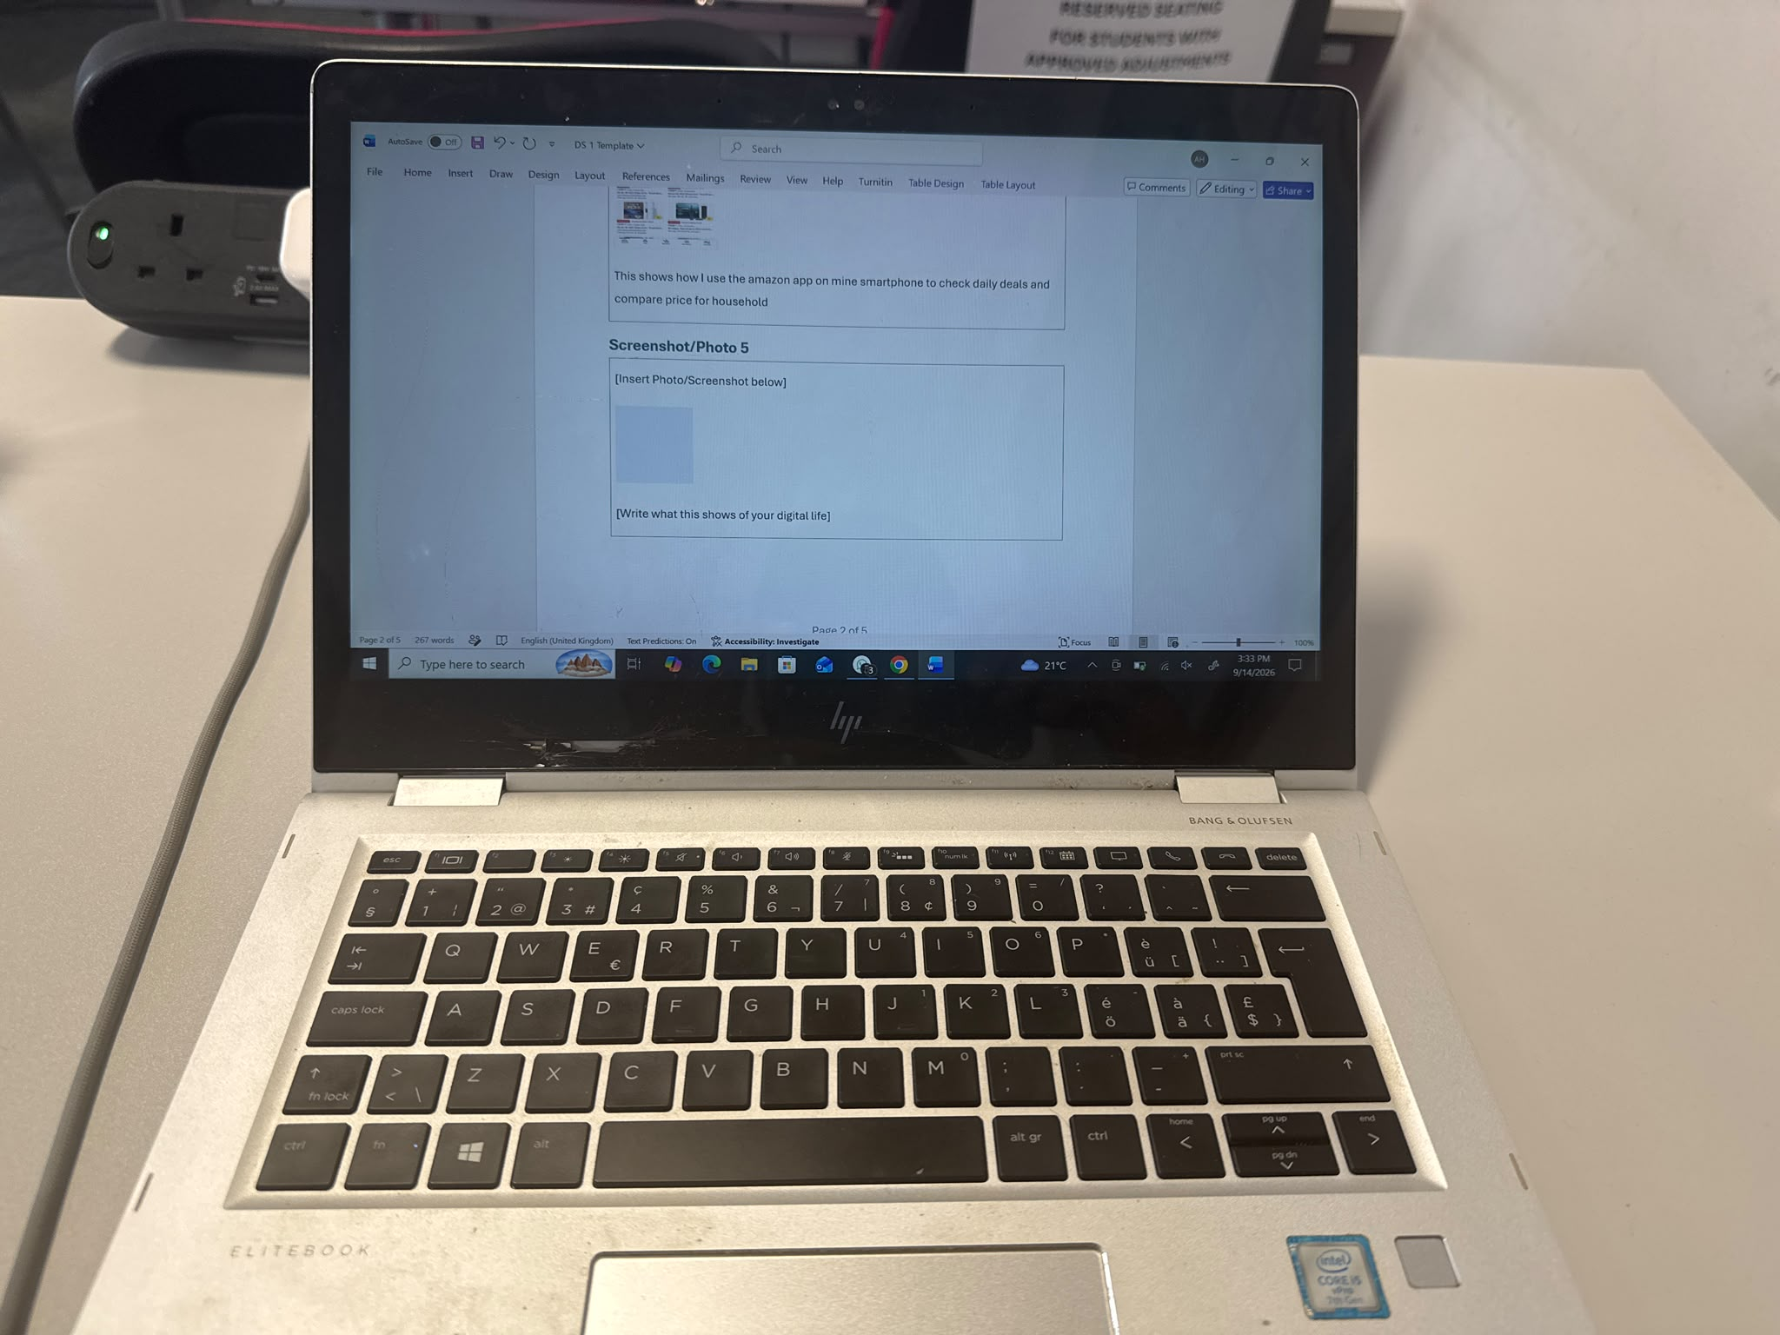
- Drafting assignments in Microsoft word utilizes cloud auto save features to protect my work and refine my academic writing structure.

Screenshot/Photo 6
- Mine LinkedIn learning
- 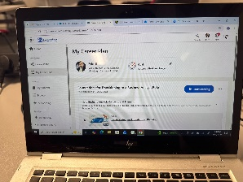
- Using LinkedIn learning to access professional development courses and build my career plan, helping me develop digital and business analysis skills for my future career.

My Short Reflection
- Write 5–8 simple sentences about your digital life.
- You can use the sentence starters below if helpful.
- I use digital tools every day to balance my university coursework and daily organization.
- I rely on tools like Moodle for tracking assignment deadlines, OneDrive for secure file storage, and Teams for communication with classmates.
- Teams is much more effective than email for quick group communication because messages are organized by topic.
- Previously, I saved files randomly without proper names, but now I organize my work into specific module folders on OneDrive using clear names.
- I sometime feel nervous while using new software like Microsoft power point, but I am practicing regularly to build my presentation skills.
- Developing digital confidence allows me to solve academic problems efficiently and prepares me to manage data in my future business career.

Sentence starters
- I use digital tools to …
- I feel confident when I …
- I want to improve …
- I often use these tools: …
- I sometimes feel nervous about …
- I hope this module will help me …
- Digital skills are important for me because …
You can write more if you want.

Submission Checklist
Before you submit, please check:
​​​ ☐ I added 4–6 screenshots
☐ I wrote short sentences for each screenshot
☐ I wrote my short reflection
☐ My work is my own
☐ My file opens correctly
​​☐ My file opens correctly

