James Gale

Data visualization

Contents
Introduction 2
Data Preparation 2
Relationships 5
Data Analysis 6
Conclusion 12

Introduction
Using PowerBI, multiple data visualization graphics and charts were created to help visualize the data to make it easier to understand. The data is regarding commercial airlines, specifically how they are performing in terms of revenue and profit. A dashboard was created using the visualizations to provide the directors with a tool to help analyse and make decisions regarding the business.

Data Preparation
The data was imported from a zipped file into PowerBI. PowerBI is one of the best tools on the market to create and display data visualizations as users have reported it being easy to use and understand.
The AircraftType query had more columns than necessary, because of this, the ones that weren't needed got deleted.
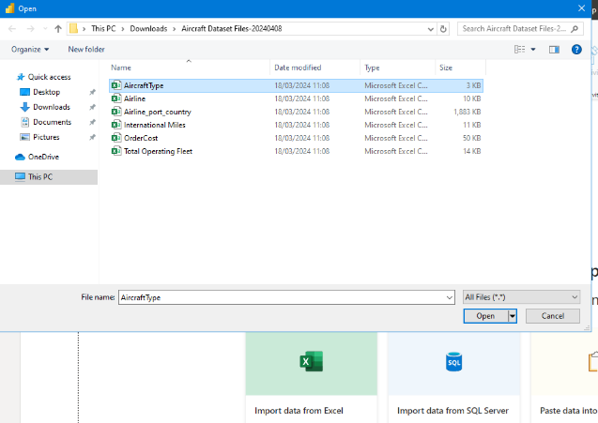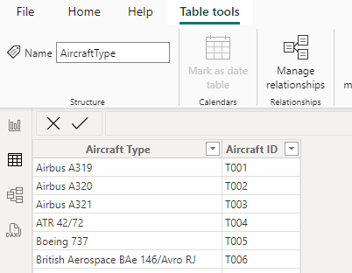
Figure 1 - importing data Figure 2 - redundancy
Some of the data was missing headers and did not look professional. By using the first row as a header, it fixed the issue and made it look more presentable.
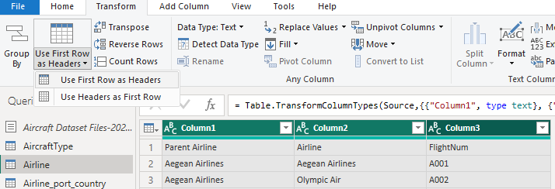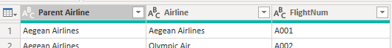Figure 3 - Adding headers

For some of the data, “null” was being displayed as a value. As the rest of the data were in a numbers format, all the “null” text was replaced by 0’s to make all the data consistent.
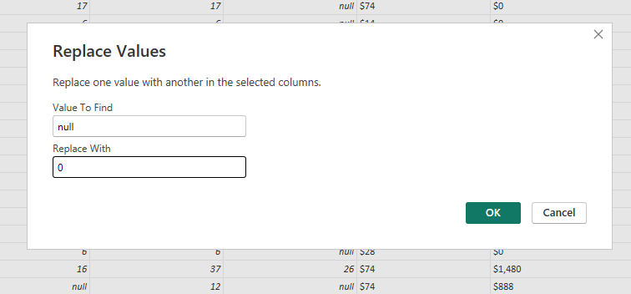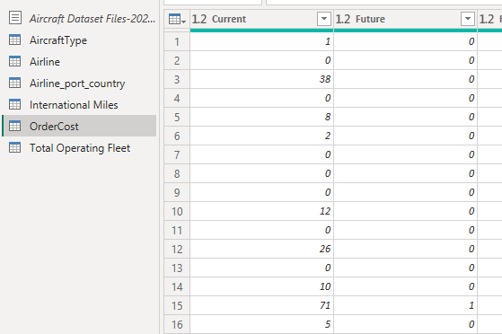
Figure 4 - replacing values
Originally, the data in the OrderCost column was a decimal number data type and did not give an accurate representation. Because of this, the data type was changed to a fixed decimal and looks much better. As the data is for money, having a fixed decimal place of 2 makes sense. There can't be more than 2 decimal places for money, you cannot have £5.111, it would be £5.11. It also makes all the data consistent. 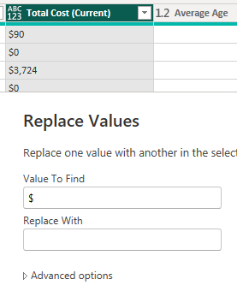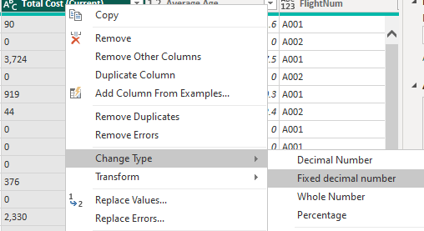
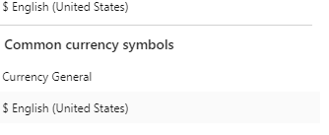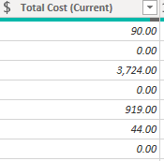Figure 5- changing data type

The Airline column needed to be split into two separate ones as this way would be easier to read and see what country the airline is in. These are methods of data preparation, which allows the data to be cleaned of any anomalies that may appear to give the most accurate data. It’s important to do as there will be less chance of error, the data will be higher quality and it makes it easier to read / understand.
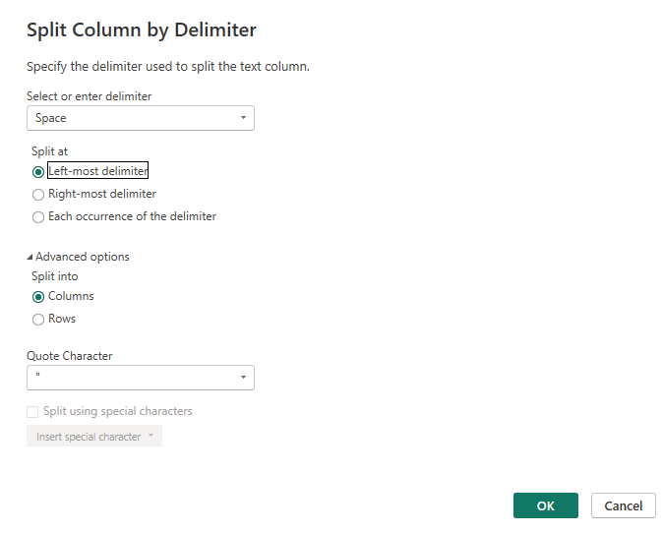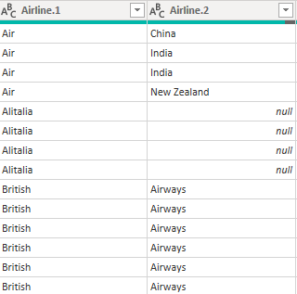
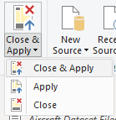 Figure 6 - data cleaning

Relationships
Relationships were used in powerbi to link the different tables together. Four primary keys were created, these are the Airline, FlightNum, Parent Airline and Aircraft ID, they were then linked to the other tables and used to display the data. A relationship can be described as one table having a foreign key which will link/reference the original primary key of the main table. In the Airlines table, the Airline flightNum column is a primary key and is used / linked to tables such as Airline_port_country, International Miles, OrderCost and Total Operating Fleet. When linked/used in the other tables, a foreign key is created for each of them and this is linked to the primary key. Allowing them to cross reference and link the data. The other relationships that reference the Airline primary key are Airline_port_country, international miles and Total Operating Fleet. Aircraft ID is used in the OrderCost. Because all relationships have one primary key that is linked to many foreign keys, this is known as a one-to-many relationship. As there are relationships that link tables together, primary keys create a unique identity for a table then foreign keys are used in other tables to link them together, this makes the database a relational one.
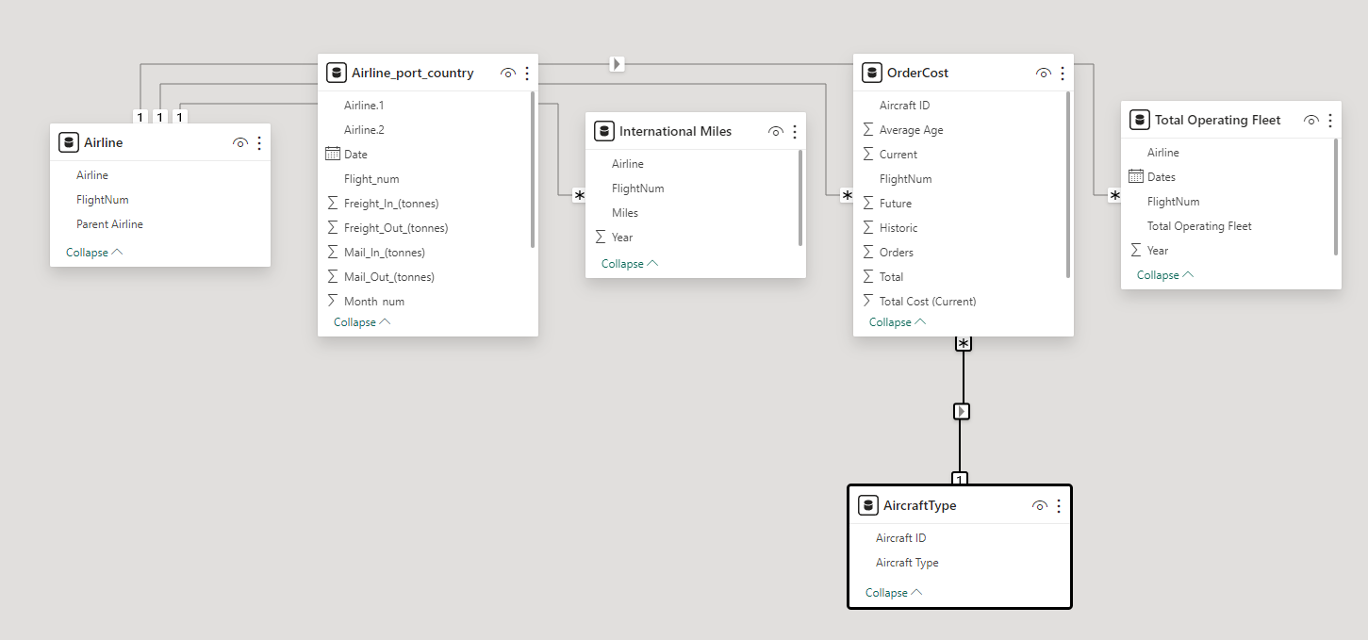
Figure 7 - Relationships

Data Analysis
A bar chart / stacked column chart was created to help analyse the orders by different aircraft types. A bar chart is a great way for displaying information, you can see the key values and understand the chart quickly. They are simple and it’s clear what is going on, compared to a line chart for example. This chart has many points/categories; it would look cluttered on a line graph. But a Bar chart is spaced out well and is displayed for users to read easily. When the chart is displayed in front of the directors, it will be clear to them what Aircraft type is performing the best and which ones may need a look into. It gives a great overall representation of how the different aircraft types are performing compared to others.
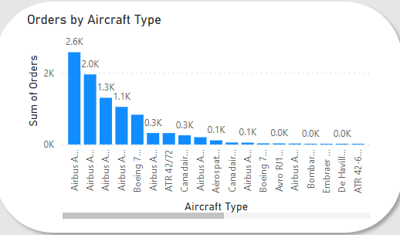Figure 8 - Orders by Aircraft type - bar chart
A stacked area chart was created to display the sum of the total cost spent by each airline. A stacked area chart is a perfect way to display how different values change over time and to understand the different trends that appear within the data. When being displayed in front of the directors, the visualization should provide an in-depth view of the different trends that are occurring for different airlines. Further allowing them to make judgements and decisions from it.
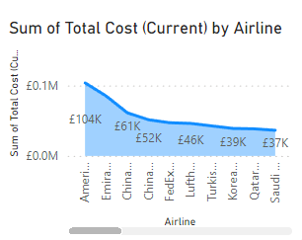Figure 9 - Total cost by Arline - stacked area chart
An area chart was created to show the freight in difference per year for all the airlines. When an airline is selected through a slicer, this chart will update automatically and display the freight trend over the years for analysis to see how well / bad that airline has been performing. Using an area chart for this is great as it’s clear to see the different trends that occur and can easily see the values change overtime. Compared to a bar chart, an area chart is much better to visualize the data. As it’s easy and clear to see the different trends that happen. Whereas a bar chart may be harder to spot smaller trends and limit the data. When the directors see this chart, immediately, they can spot any trends that are happening to do with the freight in. This graphic in particular does an amazing job of showing how the data is changing throughout the different years.
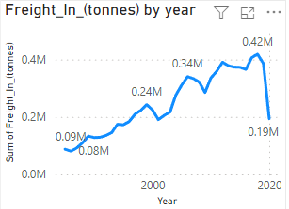Figure 10 - Freight in by year - area chart

A visual card was created to display the total number of orders for different aircrafts. It is set to be two decimal places to keep the number small and makes it easy to read. When the dashboard is shown to the directors, this number is a good indication to them of how well the business is performing. Using the slicer to select a particular aircraft type/brand gives them the option to be more specific and get a more in-depth view.
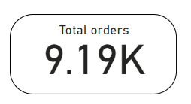Figure 11 - Total orders - Visual card

A slicer was created for the dashboard to have the option to specify which aircraft type is displayed. Once an aircraft type is chosen the dashboard charts will change accordingly and the visualizations will display data about the chosen aircraft. It’s a brilliant way to customize the dashboard and only see the specified data. A select all option was added to the slicer to provide additional options. When the dashboard is being presented, if the directors would like to view a certain aircraft type, they may use the slicer to do this. All visualizations will change to the selected aircraft type and provides them with a well-detailed dashboard to help with any further analysis or decision making.
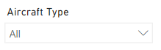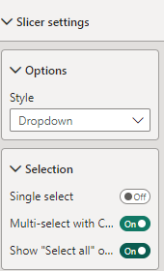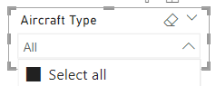
Figure 12 - Slicer

A tree map visualization was used to display the top 5 airlines by total cost. It was used over other visualizations to display the data as it can be understood well and is easy to interpret. When being presented, the directors can see the top 5 airlines that can generate the most revenue and potentially focus more on them to help increase their revenue even more.
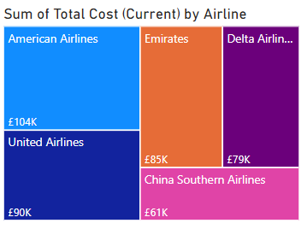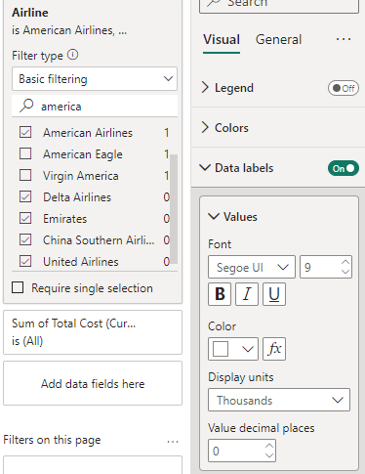
Figure 13 - Top 5 airlines - tree map

A map visualization was created to show the spread of different airlines across countries. As there are many different countries, a map visualization is a sensible option to display it as it’s interactive, and the user can move the map to see where different airlines are located. When the directors see this visualization, it clearly displays how the different airlines are spread throughout the world, it can help support them making decisions regarding where new airlines could be installed or current ones removed.
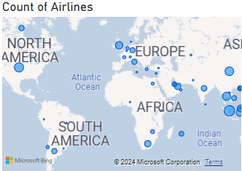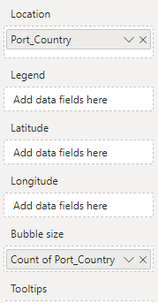Figure 14 - Count of airlines – map

A matrix visualization was created to display the busiest port. A matrix was used to show what the busiest port is by calculating the total in and out value for each one. Then the grand total for each one was displayed in a percentage for easy readability and understand how busy each one is. When the directors are shown the matrix visualization, it will provide them with a great understanding of the total passenger in and out for each port country as well as a grand total percentage to show how much each country takes up. Using the data, they may decide to add more ports in the busier countries to further increase revenue and profitability.
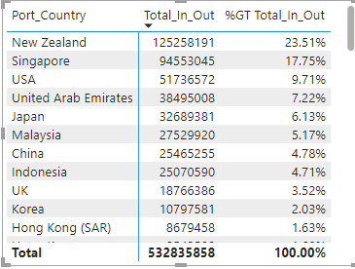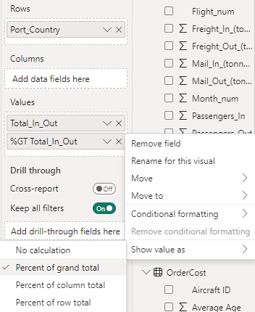Figure 15 - Busiest port - matrix

A gauge chart was used to show the variance for the freight out data. The variance means the distance all the data is from the mean value, the lower the variance, the closer to the expected result it is. It shows the spread of data, how close each bit is to the mean/average value. It’s a way to see how reliable the data is and find anomalies in the data set. When the dashboard is presented to the directors, the visualization shows them if the business is on track regarding the freight out data. If the variance is high, it suggests the business is off track and not generating enough revenue whereas if it’s low, it shows the business is performing well.
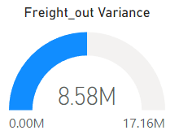Figure 16 - Freight out variance - Gauge chart

All the data visualizations are used to create a dashboard and can be presented to the directors to provide them with a tool to help analyse the businesses data. The dashboard is an amazing way to visualize data in a format that everyone can understand and use. They may use it to help analyse different trends and spot where the business may be over or under performing.
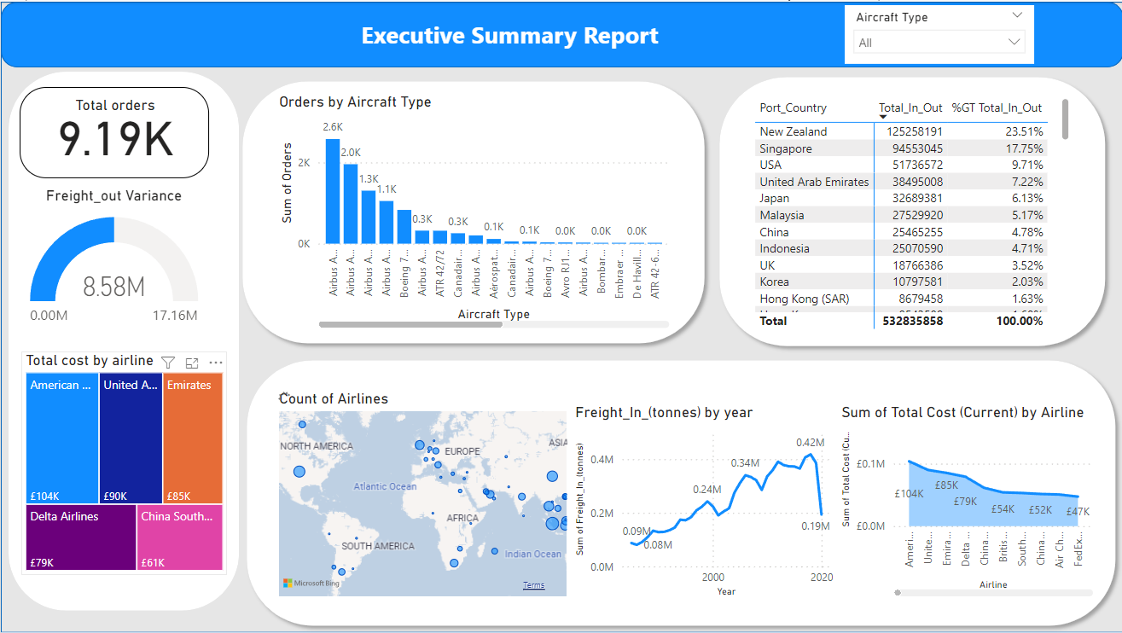
Figure 17 - Dashboard

Conclusion
Overall, the dashboard created will provide a good insight for the directors to see how different airlines are performing in terms of orders and revenue. The data visualization charts and graphs allow them to read and understand the data quickly. All important data and information are displayed for them to analyse further, as well as slicers to help them specially pick what data they want.

