Product Assessment: FamilyGuard from S.C Johnson

Stefan Zlatev 2029265
University of Wales /Trinity Saint David
London Campus
BA(Hons) Business Management
Management Economics
Assignment 1

Table of Contents
Product Assessment: FamilyGuard from S.C Johnson 3
1. Description of the Business and its main Products or Services 3
The Chosen Product 3
Why the Product was Chosen 3
2. Demand and Market Equilibrium 4
Price of substitutes: What is a substitute for the product or service? Is the substitute's price increasing or decreasing? How does this affect demand for your product or service? 4
Price of complements: What is a complement for the product or service? Is the complement's price increasing or decreasing? How does this affect demand for your product or service? 5
Consumer Income: Is consumer income increasing or decreasing? How does this affect demand for your product or service? 7
Consumer tastes & preferences: How are consumer preferences changing? How does this affect demand for your product or service? 9
Consumer expectations of price (of your product or service): Looking ahead, do consumers expect the price of your product or service to increase or decrease? How does this affect demand for your product or service? 10
Demographics: Number of Consumers (Buyers) - Is the number of buyers increasing or decreasing? How does this affect demand for your product or service? 10
3. For each of the factors that influence the Price Elasticity of Demand, describe how your main product or service (described in 2 above) is affected. 11
Does the factor indicate demand is more elastic or more inelastic? 11
Given your analysis, what pricing policy should the business employ? Why? 13
Reference List 15

Product Assessment: FamilyGuard from S.C Johnson

1. Description of the Business and its main Products or Services
S.C Johnson & Son Inc. is the company selected for analysis in this report. It is a multinational company that is privately owned. It manufactures household cleaning supplies as well as other types of consumer chemicals (Johnson, 2007). The company is based in Racine, Wisconsin. In 2017, the company had over 13,000 workers and its sales were estimated at $10 billion. The Johnson family owns the company. It produces a number of products, and it has emerged one of the leading players in the market.

The Chosen Product
One of S.C Johnson’s leading products is FamilyGuard. It is a disinfectant that is used for disinfecting multi-surfaces that people touch every day. The spray was increasing used during the COVID-19 pandemic since it kills the virus which causes the disease. Additionally, it helps in eliminating any unwanted odour, and for disinfecting germs on hard and non-porous surfaces (Levy, 2023). Users are advised to spray the pre-cleaned surfaces until they get wet before allowing the product to remain on such surfaces for around 5 minutes. This helps in killing odour and bacteria on such surfaces. It is also used for washing basins and bathtubs, basement and closets, drains and sinks, handles, door knobs, kitchen and garbage cans, and other surfaces. It remains one of the consumers’ top choices for cleaning surfaces.

Why the Product was Chosen
The product was chosen because it is one of the market leaders for consumer options for cleaning surfaces. It also contributes to the social and emotional skills and growth of children by encouraging them to play and use the spray in cleaning their hands. The spray creates a safe environment for children to play without worries of contracting COVID-19. As such, it is an important product that also adds to the freedom and cognitive growth and development of children. It gives them freedom to play.
The product has also overcome stiff competition from other products and brands to become the market leader due to its quality and reliability. It has achieved this by introducing an initiative which highlights the significance of having a clean and dedicated space at home while equipping parents with the tools required to success in the current state of family play. Therefore, the product also shows the influence of various macroeconomic aspects on its growth and market equilibrium and dynamics.

2. Demand and Market Equilibrium

Price of substitutes: What is a substitute for the product or service? Is the substitute's price increasing or decreasing? How does this affect demand for your product or service?
The product’s main competitor is Mr Clean from Proctor and Gamble while the second main competitor is the Clorox Company. While FamilyGuard retails at $5.25 on such stores as Walmart, Mr. Clean Deep Cleaning Mist Cleaner retails at $6.24 at the same Walmart stores. On the other hand, other substitute products available for customers include Pine-Sol Multi-Surface Cleaner, which retails at $8.98 at Walmart (S.C Johnson, 2023). As such, this implies that FamilyGuard retails at a lower price than the available substitutes. The comparison is shown below.

The current pricing comparison favours FamilyGuard since it is the lowest priced among the available products. Its lower price leads to an increase in the demand for the product. According to the Law of Demand as discussed by Andreyeva, Long, and Brownell (2010), the quantity demanded increases when the price decreases and demand decreases when price increases. In this case, the decrease in price will lead to an increase in demand. Consequently, this will lead to higher sales and profitability margins for FamilyGuard.
These arguments are in line with Andreyeva, Long, and Brownell’s (2010) findings on the effect of food prices on consumption. In their study, the researchers established that an increase in the prices of the products involved in the study (juice, soft drinks, and meats) would lead to a reduction in consumption. Increasing the prices by 10% would result in a 8%-10% reduction in consumption. Therefore, this implies that reducing the prices would result in the opposite effect, which increases in consumption.

Price of complements: What is a complement for the product or service? Is the complement's price increasing or decreasing? How does this affect demand for your product or service?
S.C Johnson sells various products that supplement FamilyGuard. They give consumers an option to choose a similar product for the same purpose, depending on such factors as their budget and preference. The complements are priced differently, with Pledge Beautify It Lemon Enhancing Wipes retailing at $4.99 at Walmart, Pledge® Expert Care retailing at $5.38 at the same store, and Pledge® Multisurface Wipes, Everyday Clean™ retailing at $4.67 (S.C Johnson, 2023). Similarly, the value pack, Pledge Furniture Enhancing Polish Spray, retails at $25.08, while Windex® with Vinegar Glass Cleaner sells at $4.17 at Walmart. This is illustrated below.

This shows that the complements are priced differently and hence allow customers to choose from a broader variety.
Some of the complements are cheaper than FamilyGuard. These cheaper options give customers the option of obtaining a similar product at a lower cost, and could thus shift to the complement. As a result, demand for FamilyGuard might decrease (S.C Johnson, 2023). The difference in price could result in a significant difference in the quantity of FamilyGuard demanded since the product is elastic. Similarly, some of the complements are more expensive than FamilyGuard, and this creates an opportunity for the product to take advantage of its elasticity to increase sales and demand, and consequently its profitability.
In his study, Cigliano (1980) showed the airline profitability of different companies in the two markets would be different even if the fares were increased uniformly. The difference is due to different market factors, with demand elasticity being one of the main contributing factors. As such, the demand elasticity in this market will be different from other markets due to the prevailing market conditions.

Consumer Income: Is consumer income increasing or decreasing? How does this affect demand for your product or service?
Data available shows that personal income increased $49.5 billion, which translates to 0.2% at a monthly rate. On the other hand, consumer spending was established to decrease by $41.6 billion, which translates to 0.2%, in December 2022 (Cox, 2023). The recorded increase in consumers’ personal income was attributed to increase in compensation and proprietors’ income. On the other hand, the consumers’ personal saving rate was established to be 3.4% in December 2022, compared with 2.9% in November. Such factors significantly affect demand for the product since they influence consumer spending.
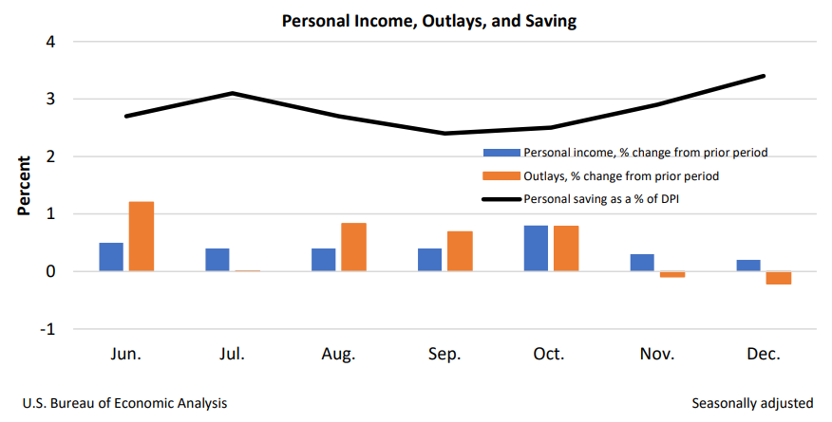
The data also shows that there was an increase in personal income among the consumers, which was a primary reflection of increase in proprietors and compensation income. In the case of compensation, the increase implied that there was an increase in private salaries and wages as per the data from the BLS (Cox, 2023). As such, the consumer trends created an opportunity for the product to experience higher sales volumes due to the ability of the consumers to purchase the product. However, the data shows that consumer spending significantly reduced in December. Such a decrease is a reflection of the increase in spending for services.
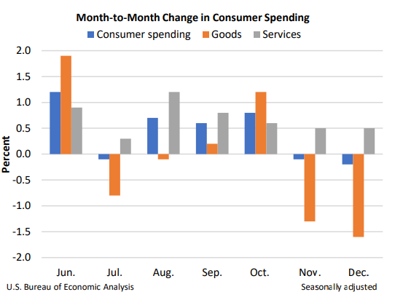
In goods, the decrease was mainly contributed by gasoline and other forms of energy goods. Such include motor vehicle lubricants, fuels, and fluids. On the other hand, some of the goods that led to the increase include utilities and housing, health, and transportation. Therefore, this implies that FamilyGuard falls within the category of products that led to an increase in consumption. As a result, the product stands higher chances of making higher sales since the market structure, as discussed by Ellickson (2015), supports this growth.
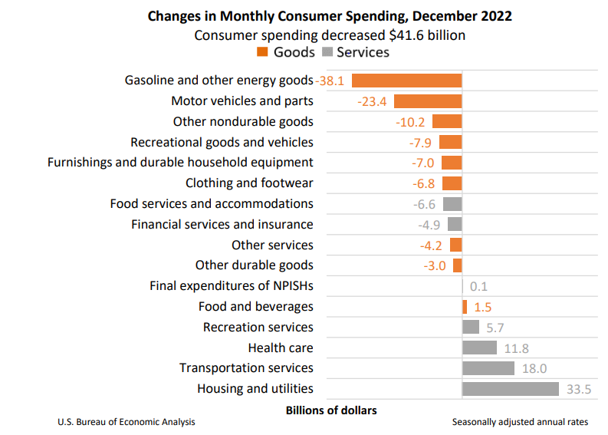

Consumer tastes & preferences: How are consumer preferences changing? How does this affect demand for your product or service?
Consumers are inclining towards products that advance sustainability as seek to become more responsible. They make decisions that seek to ensure the safety and security of their children. In relation to the same, the company has taken a new approach towards sustainability by assessing consumer behaviour and attitudes towards sustainability and responsibility. The aim of the approach was identifying the factors that drive sustainable behaviour change among consumers. As such, the company has also increased the sustainability of its products and thus meeting the needs of the customers.
Such demands and expectations and the consequent response by the company has resulted in an increase in the demand for the products. Consumers in the market understand and appreciate the company’s commitment to sustainability in its production, leading to their taking the position of increasing demand for the products. Additionally, this makes demand elastic since consumers continue understanding how the company integrates sustainability in its products and production processes.

Consumer expectations of price (of your product or service): Looking ahead, do consumers expect the price of your product or service to increase or decrease? How does this affect demand for your product or service?
Consumers expect that the product’s price will reduce. However, this might not be case due to the consumable nature of the product. The company’s base-business revenue on the currency-neutral basis will grow at a rather low-single digit rate as time moves on. As such, this means that the product will continue growing in sales and values, hence no need to lower the prices. Additionally, the prices might not lower since the product has rather limited sensitivity to any changes within the economic conditions. Most of the consumers also tend to trade up or down price tiers in categories instead of ceasing or reducing purchases entirely. This means that such inelasticity will allow the demand for the product to remain high. Additionally, the company has positioned itself such that its products are not entire replaceable and customers will continue purchasing even if the prices do not reduce.

Demographics: Number of Consumers (Buyers) - Is the number of buyers increasing or decreasing? How does this affect demand for your product or service?
Projections show that the sector market size for the product will hit a value of $11.945 billion by 2028, with the value in 2022 being $9.15 billion. This means that the market size value will have grown at a CAGR of 4.54% in that period. As such, this also means that the number of buyers for the product is increasing significantly. The increase in the number of buyers creates an opportunity for the product’s demand to increase to match the demand, as reflected in Heien and Pompelli’s (1989) study. According to the Law of Demand and Supply, supply must be increased to increase matching demand for balance in the market. It also implies that an increase in demand leads to an increase in supply. Therefore, the increasing demand arising from the increasing market value will spark an increase in the demand for the product.
The company is also positioned to attract more customers and potential buyers. It has a current Net Promoter Score (NPS) of 22 with 49% as Promoters, 24% as Passives, and 27% as Detractors as shown in the figure below. The Net Promoter Score indicates whether or not the customers would recommend the products to other potential buyers based on the rating on the scale. Therefore, the current score of 49% implies that 49% of the current customers would recommend the product to others. As such, this is likely to increase the demand for the products due to the recommendations made. Additionally, it will lead to the brand image and value of the company rising, creating another avenue for the demand of the product to increase.
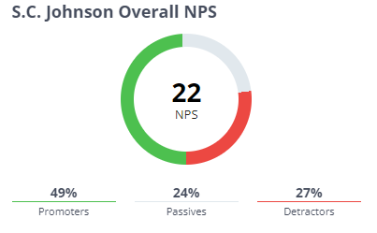

3. For each of the factors that influence the Price Elasticity of Demand, describe how your main product or service (described in 2 above) is affected.

Does the factor indicate demand is more elastic or more inelastic?
Substitution Effects. Luxury vs. Necessity - From the consumers point of view is this a luxury or a necessity? Does this factor indicate demand is more elastic or more inelastic?
Consumers consider such disinfection and cleaning products as FamilyGuard as a necessity. This perception among consumers has increased during the COVID-19 pandemic when such products became useful as a measure towards controlling the spread of the virus. There has been a dramatic increase in the need for sanitisation and personal hygiene, and this has led to consumers becoming more aware of the significance of using such products in preventing the spread of the virus. Consequently, increase implies that demand is more elastic since more and more consumers are becoming aware of the product.
The American Cleaning Institute conducted a survey in 2020 in which it was established that 86% of the consumers had increased their use of disinfectants and cleaning products. The increase was due to the growing concerns from COVID-19 and hence the need to take precautionary measures to control the spread. The increase in awareness and use of such products as FamilyGuard thus meant that demand became more elastic, and this led to higher sales and higher profitability margins. Additionally, the survey established that 71% of the individuals used disinfecting products. Therefore, this increased demand for such products, creating a platform for FamilyGuard and similar products to increase sales.
Sales data from the American market also shows that there has been an increase in the demand for disinfecting and cleaning products. According to data collected in 2020, it was established that the use of disinfecting products among the Americans increased by 34% in relation to the previous year. The study, conducted by Euromotor International, suggests that demand became more elastic as reflected in the increasing sales and demand for the products.
Another survey that was conducted by the Harris Poll in 2020 also established similar findings. It showed that 82% of the respondents involved in the study believed that using disinfecting and cleaning products like FamilyGuard was important in preventing and managing the spread of COVID-19. As such, the respondents had increased their use of the products. Similarly, 81% of the respondents believed that it was important to use disinfectants and cleaning products even without the need for controlling the spread of COVID-19. Therefore, such statistics show that consumers consider cleaning and disinfecting products as a necessity, and this leads to the demand becoming even more elastic.
As Aigner-Walder (2015) showed, various aspects of the population influence demand, with this specific study evaluating the impact of an ageing population. The study, whose findings are in line with Foot and Gomez’s (2014), showed that as the population ages, their perceptions towards luxury and necessity changes. Demand for products considered luxury decreases while demand for products considered as necessity increases. As such, the demand for this product increasing is in line with the findings of this study as parents and households consider the product a necessity as opposed to being a luxury.

Given your analysis, what pricing policy should the business employ? Why?
The business should employ value-based pricing. In this case, the perceived value to consumers should be based on how well the product is suited to the needs of the customers. According to the analysis conducted and the available data backing up the analysis, it is evident that the product has become common and consumers consider it as a necessity and not luxury. As such, this implies that they attach great value to it and are thus willing to meet the cost of obtaining it.
The value-based pricing strategy will allow the company to gain advantage over the competitors in various ways. The company will benefit from the fact that the prices will be a better fit with the perspective of the consumers and hence encourage spending. Consumers will be comfortable purchasing the products at the set prices since they appreciate the value of the product. Additionally, the prices will being the company more profits and hence allow it to acquire more resources and expand its growth and development. Therefore, the company should consider and pursue the pricing strategy and seek growth in the market.
The pricing strategy is supported by Baker’s (2013) study on competitive price discrimination. The author assessed the question of whether or not price discrimination is good or bad. He concluded that the debate should focus on the impact on competition. As such, using this pricing strategy will also focus on the impact on competition and ignore any negative criticism aimed at it. It will help in driving the company forward while ensuring the competitors are kept in check.

Reference List
Aigner-Walder, B. (2015) “Effects of the demographic changes on private consumption: An almost ideal demand system analysis for Austria,” Journal of Economic and Social Studies, 5(1), pp. 50–70. Available at: https://doi.org/10.14706/jeocss11515.
Andreyeva, T., Long, M.W. and Brownell, K.D. (2010) “The impact of food prices on consumption: A systematic review of research on the price elasticity of demand for food,” American Journal of Public Health, 100(2), pp. 216–222. Available at: https://doi.org/10.2105/ajph.2008.151415.
Bagwell, K., 2007. The economic analysis of advertising. Handbook of industrial organization, 3,
Baker, J.B. (2003) “Competitive price discrimination: The exercise of market power without anticompetitive effects (comment on Klein and Wiley),” SSRN Electronic Journal [Preprint]. Available at: https://doi.org/10.2139/ssrn.470146.
Cigliano, J.M., 1980. Price and income elasticities for airline travel: the North Atlantic market. Business Economics, pp.17-21.
Cox, J. (2023) Key fed inflation measure eased in December while consumer spending also declined, CNBC. CNBC. Available at: https://www.cnbc.com/2023/01/27/pce-inflation-december-2022-.html (Accessed: April 27, 2023).
Ellickson, P.B. (2015) “Market structure and performance,” International Encyclopedia of the Social & Behavioral Sciences, pp. 549–554. Available at: https://doi.org/10.1016/b978-0-08-097086-8.71030-0.
Foot, D.K. and Gomez, R., 2014. Population ageing and sectoral growth: The case of the UK, 2006-2026. Oxford Journal: An International Journal of Business & Economics, 2(1).
Heien, D. and Pompelli, G. (1989) “The demand for alcoholic beverages: Economic and demographic effects,” Southern Economic Journal, 55(3), p. 759. Available at: https://doi.org/10.2307/1059587.
Johnson, S., 2007. SC Johnson builds business at the base of the pyramid. Global Business and Organizational Excellence, 26(6), pp.6-17.
Levy, S. (2023) S.C. Johnson unveils FamilyGuard brand disinfectant cleaners, Drug Store News. Available at: https://drugstorenews.com/sc-johnson-unveils-familyguard-brand-disinfectant-cleaners (Accessed: April 27, 2023).
Rauch, D.E. and Schleicher, D. (2015) “Like uber, but for local governmental policy: The future of local regulation of the 'sharing economy',” SSRN Electronic Journal [Preprint]. Available at: https://doi.org/10.2139/ssrn.2549919.
S.C Johnson (2023) Disinfectant Spray Fresh Scent: FamilyGuard™ Brand, FamilyGuard. Available at: https://www.familyguardusa.com/en-us/products/familyguard-disinfectant-aerosol-spray-fresh (Accessed: April 27, 2023).

