An exploration into how occupational therapy enhances better outcomes alongside medication within older adult mental health
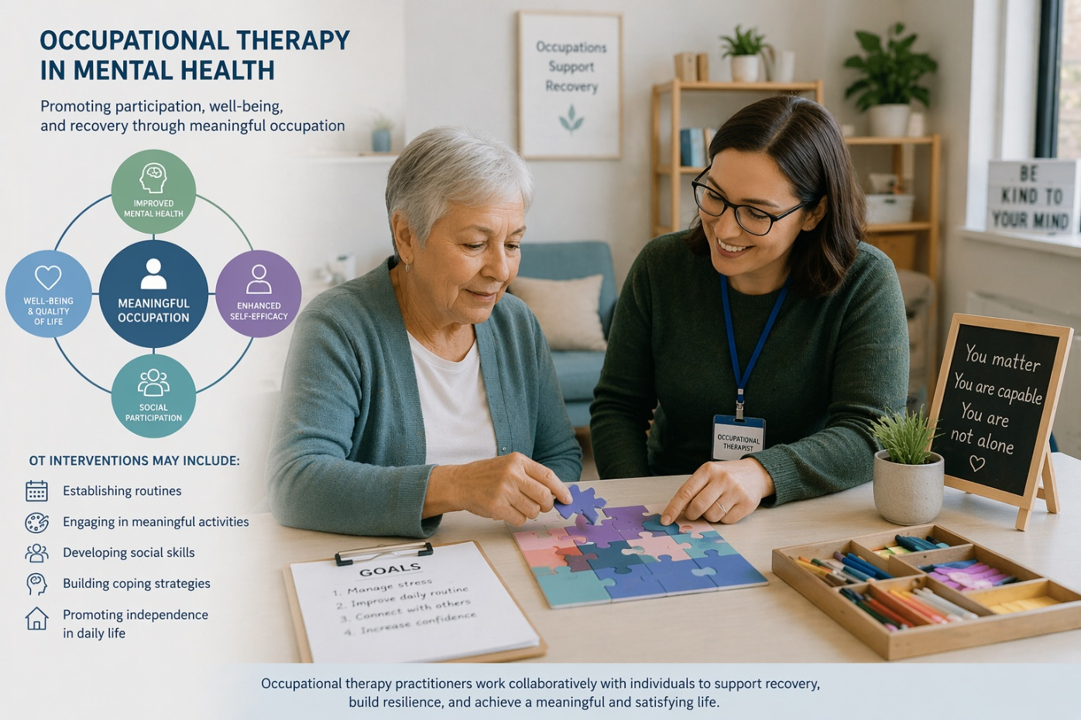

Jessica Derrett
2025 1832 31

Contents Page
- Introduction- page 3
- Case study- page 4
- Overview of condition- page 5
- Previous approaches to condition- page 6
- Current approaches to condition- page 7
- Co-production- Page 8
- Clinical governance and supervision framework- Page 9
- Conclusion- page 10
- References- page 11-13
- Appendix’s- page 14-15

Introduction
As we move through generation-to-generation anxiety and depression is still one of the more popular diagnosis of individuals under the care of the older mental health team, Department of Medical Education(2024). Occupational therapy is now a part of this team and offer a unique contribution to the care of individual’s mental health. Focusing on how individual’s symptoms effect their ability to engage in meaningful activities, but also looking at maintaining independence, while participating in every day life. Occupational therapist and Occupational therapy support workers support individuals to regain confidence, build social relationships establish routines while regaining valued roles.
The co-productive work between professionals and occupational therapy is especially important when working in the older adult community setting. Older adults are more likely to experience challenges with physical health, cognitive change, trauma and reduced social involvement. Occupational therapy then promotes positive clinical outcomes, by providing interventions that can improve engagement and motivation.
This report looks at how occupational intervention enhances outcomes within older adult community mental health team, in the case study of Vivian. It also explores how occupational therapy involvement has evolved throughout the decades. The report also examines how occupational therapy support workers deliver interventions with their skill sets. The report also draws on relevant literature to analyse how occupational therapy contributes to clinical effectiveness, service‑user experience and holistic recovery within older adult mental‑health services.

Case Study
As part of the older adult community mental health team, there is an occupational therapy team which consists of two qualified occupational therapist (OT) and one occupational therapy support worker (OTSW). Occupational therapy team receive referrals for individuals who are under the secondary mental health team. Once the individual has received an initial assessment by the qualified OT, clear goals are outlined and intervention begins with either the OT or OTSW. The OTSW is delegated duties from the qualified OT, OTSW must be able to carry out intervention safely and with a high standard of knowledge of the intervention and health condition, as set out within the Royal college of occupational therapy standards, (2026).
In this case the OTSW has been delegated to work with Vivian, a lady who experience’s anxiety and depression, Vivian has also recently been through a traumatic event which resulted in her needing a stoma bag. Vivian was being discussed within the weekly multidisciplinary team, as she had trailed many medications to try and help with her depression and anxiety but had little success, Vivian’s husband was also becoming frustrated with Vivian as she would spend long periods time in bed and very rarely leave her home. Occupational therapy offered to work with Vivian as she had not previously had any occupational therapy intervention.
An initial assessment was conducted with Vivian her husband and both the OT and OTSW. From the initial assessment it was identified that Vivian has great difficulty in the morning with motivation, Vivian had also explained that she found it very overwhelming when sequencing tasks. Also because of her stoma bag and some of the effects of this she was extremely anxious when leaving the house and explained that she has a routine of changing her stoma bag and this can become difficult when out of her home. Also, the change in her appearance due to the stoma could be contributing to Vivian’s depression, as depression is higher in stoma patients due to this, Muzi Etal, (2024). Vivian had also lost touch with friends and family due to her anxiety and isolation; Vivian’s goal was to be able to confidently access the community and build positive relationships again.
The OT and OTSW then developed an intervention that would help Vivian build confidence with accessing the community but also to help with overcoming her anxiety and depression. The OTSW started working with Vivian to build a relationship with Vivian, so that she felt more comfortable with working with new professionals. The OTSW also worked with Vivian on breaking down tasks in the morning to help overcome the over whelming feeling. This then led to working towards getting out of the house on a more regular basis. Which opened up the option of Vivian attending a discovery through activity group which is run by the qualified OT and OTSW. This was so that Vivian was ale to look at more social opportunities with individuals that have similar struggles, with hope of learning strategies to help with her anxiety and depression. Gilbert, (2014), mentions how group work is a part of compassion focused therapy and how being part of a group can help with a sense of belonging, but also help problem solve similar issues.

Overview of condition
Anxiety and depression can have a great impact on an individual’s life, symptoms can include persistent low mood, worry or fear, loss of confidence, concentration can also be affected. Alongside emotional affects physical symptoms can also be present such as fatigue, restlessness, physical tension, appetite changes, shaking, headaches or stomach ache. These are just some examples of symptoms; this can then lead onto withdrawal from friends or family, reduced ability to manage daily activities, loss of independence and quality of life, loss of meaningful roles and purpose, NHS,a(2023) and NHS,b(2023).
This can affect the relationships individuals have with family and friends, family may become more worried about individual’s resulting in the family doing more for that individual, a change a role perhaps. It could also cause some frustration in the example of the case study Vivian’s husband became frustrated with her, as he didn’t not understand her diagnosis or her struggles. Vivian’s husband viewed Vivian’s symptoms as her not wanting to help herself. This mindset and frustration could then increase the symptoms of the individual’s anxiety and depression. From his perspective he could be carrying more of the stress of running the house, finance, these could have been roles that Vivian was previously doing.
Some of the effects a person experience may also make it hard for the individual to engage with health services, this can mean that the OT support work may need to spend longer periods of time building repour with the individuals they are working with, this could then result in a delay in working with other individuals. Currently the number of adults that are receiving mental health treatment for illness such as anxiety and depression are on the rise, while women are more likely to have anxiety and depressive symptoms, MIND, (2024). Health inspectorate Wales (2024), Individual’s in Wales are waiting longer for mental health intervention, while they are waiting to be seen their mental health symptoms are worsening. This could result in more complex invention needed and at times more medication would be trailed.

Previous approaches to condition
Previously individuals who suffered with anxiety and depression would often be prescribed medication, within in the 20th century doctors would prescribe individuals wit psychotropic drugs such as benzodiazepines. Individuals would also be admitted into physiatry hospitals such as asylums for monitoring. Physiatrists would often monitor individuals for long periods of time before prescribing medication this could be medication such as psychedelic drugs such as LSD, Weston Etal, (2020).
Women were often hospitalised and diagnosed with hysteria, this would typically due to women experiencing effects of anxiety and depression. Women would more often be prescribed medication and interventions that could include blood being removed from the body either from the veins or leeches. Females were also deemed irrational and doctors would silence their concerns, often if a woman was married doctors would consult with the females’ husbands rather the females themselves, Meek, (2012). Evans & Jones, (2012) also have similar views on the historic treatment to meek, (2012) mentioning how anxiety and depression was treated with extreme solutions by removing organs such as ovaries to prevent “hysteria” which we know no as anxiety and depression. There is also mention of later on in the 20th century there was movements in which mental illnesses such as anxiety and depressions were viewed as curable and psychiatrist began to work in a multidisciplinary team approach, Evans & Jones, (2012).
Ashton, (1991) there was a high volume of medication that was being prescribed for anxiety and depression in the 20th century into the 21st century, as well as how high the volume of prescribed medication, the volume of women being prescribed medication for anxiety and depression was considerably higher than in men. Despite moving on from aggressive intervention women were still being prescribed more medication. The study goes on to say that anxiety and depression in women was often deemed a quick fix and most often symptom’s that women were experiencing often lead to further physical health issues. Ashton, (1991) also mentions how women have less social out lets compared to men, at the end of the 20th century to the beginning of the 21st century men would typically be able to go out to work and then socialise at the pub, where as women were typically still maintain the home and looking after the children, this contributed to women’s anxiety and depression and women would often using medication to help with this as again in was classed as a “simple fix”.
Other than Evans & Jones, (2012), stating about the wider multi-disciplinary team input, I found little no evidence of therapies being used with individuals with anxiety and depression. However, Meek, (2012), Evans & Jones, (2012) and Aston, (1991) talk about how the treatment of anxiety and depression evolved into the start of person-centred treatment.

Current approaches to condition
As we moved into the 21st century the way anxiety and depression was treated began to change, guidelines start to be put in place to help treatment of individuals become more consistent, but also be able to have a say in their treatment and care plan, NICE,(2026), this is a complete turnaround for how individuals were previously treated, especially for women who’s treatment were being decided by mostly male figures in their lives either doctors or their families, Meek,(2012). Medication is still prescribed but a more collaborative multi-disciplinary way of working is typically used when working with individuals with anxiety and depression. Both Archer Etal, (2012) and Abichi Etal, (2026) discuss how collaborative working such as talking therapies have been very effective when treating individuals with anxiety and depression alongside longer term medical condition. Often you find that the team working with the individual can consist of doctors, nurses, occupational therapy, psychology and social service team.
Occupational therapy is part of the collaborative and multi-disciplinary working. As seen in the case study the OTSW work is very person centred and often work with the individual to set goals that they want to achieve. The OTSW also has the skill and ability to tailor intervention for the individual they are working with the Royal college of occupational therapy standards, (2026). When carrying out interventions and assessment the OTSW will have to carry out clinical decision, they would look at factors such as risk assessment, severity of symptoms, patience preferences and goals, this is also in line with NICE, (2026), guidelines.
A part of occupational therapy is enabled individuals to do things that they want to do, this could be everyday activities such as making a meal, self-care tasks etc. Saito etal (2025) and Christie Etal (2025) both came to the conclusion that occupational therapy input has improved function and participation in individual’s as well as motivation. From a cost point of view, they mention how occupational intervention can be used early on in their diagnosis, could mean that an individual can be less reliant on services and medication. Although Satio etal, (2025), mostly has similarities with Christie Etal (2025), They do go on to say that more research is need into occupational therapy intervention and how they can be evidenced.
As medication has involved it’s clear that collaborative working in the term of medication and other therapy intervention works well with individuals with anxiety and depression, Collaborative working ensures that individuals receive consistent, holistic support. By sharing information, skills, and perspectives across the team, we can better understand each person’s needs and respond in a coordinated way. This approach is especially important for individuals who have experienced trauma, as it allows us to draw on specialist knowledge, maintain emotional safety, and provide support that is sensitive, stable, and tailored to their experiences.

Co-production
When the OTSW was working with Vivian, they used a multi-disciplinary approach so that psychological and functional needs where being met in a holistic approach. This aligns with RCOT guidance, which emphasises coordinated, person‑centred practice across professional boundaries (RCOT, 2021). Initially the OT carried out the assessment, while the OTSW carried out the intervention. Before the initial assessment the OT team would have discussed Vivian with the other professionals that were working with Vivian such as the community mental health nurses, this would be to gain background information but also to see how they would approach their initial visit. While the OTSW would be providing intervention to build on confidence and independence, the community mental health nurse would be monitoring Vivian’s mental and making any changes needed to medication, the OTSW would also feed into this feedbacking to the other professionals after each intervention. Also, psychologist would also be involved to help with psychological effects that Vivian was experiencing from her trauma, SCI, (2025).
The external support that Vivian was also receiving was from the specialist stoma nurses that were in regular contact with Vivian, also offered Vivian opportunity to attend a peer support group, with the support of the OTSW and the gain in confidence Vivian was able to attend this. The GP would also offer continuity care by regular medication review, referrals into the secondary mental health team which began the OTSW work. The OT group would also offer opportunity to support and build relationship with third sector organisation such as social groups and charities.
Despite all the benefits of co-production the OTSW does experience some barriers may occur, with the individual that the OTSW is working with due to the nature of anxiety and depression, the individual could become avoidant, become very emotional, trust also may be an issue. This could cause the individual not fully feel the benefits of the intervention, this also highlights why it is important for the OTSW to spend the time building repour. There could also be professional barriers that could affect the intervention, poor communication between the professionals being the biggest barrier, often individual’s opinions can be lost due to this, this is highlighted in Peniherio Etal, (2025). Another barrier could also be lack of understanding of each professional’s role’s, often OT staff can be labelled as “activity’s coordinators”, It is not until the OT staff work collaborative that other professionals see the positive outcomes, which normally result in individual’s staying at home or increasing their function.
Moving forward all professionals having a greater understanding of each other’s roles would further increase the benefits for the individual’s they work with, could possibly mean that individual’s access service’s such as occupational therapy sooner, again resulting individuals not relaying on mental health services, which reduce cost, Suda, Torbett and Zarzaur, (2015).

Clinical Governance
For person centred approaches that a re safe and structured clinical governance is in place to help support this. For an OTSW working with an individual such as Vivian two key components are important such as service user feedback and clinical effectiveness which help the OTSW deliver high quality intervention.
Occupational therapy always looks for service users’ feedback to help gage meaningful intervention. As previously seen when working with individuals such as Vivian they are more likely to experience fluctuation in motivation and low confidence, so its vital for that OTSW to gather feedback on how that individual is experiencing the intervention so that it can be tailored for the individual and possibly others with the same experiences. (RCOT, 2021) has big emphasis on how listening to individuals helps promote person centred care. Without feedback interventions could become tasked focus rather than therapeutic.
Supervision framework supports clinical governance by providing by providing a place for reflection and professional development, this could be done using the feedback given by individuals that the OTSW is working with, highlighting strengths and weakness of the intervention, but also to expand on plans going forward. Snowdown etal (2017), highlights that supervision for healthcare professionals has shown an improvement in consistency and quality of care, although only a small number of studies demonstrated a direct improvement in patient health, supervision for mental‑health practitioners appear to be associated with reductions in psychological symptoms among people with diagnosed mental illnesses.
Clinical effectiveness is another part of clinical governance which looks at delivering interventions that based on evidence based and outcome driven. For an OTSW this could mean using more therapeutic activities that promote structure, social connection, confidence and functional independence—factors shown to improve outcomes for older adults with anxiety and depression. Supervision supports clinical effectiveness by enabling practitioners to review progress, evaluate outcome measures and ensure interventions remain aligned with best practice and the OT care plan, Creek and Cook,(2017).
However there may be some challenges with this, individual feedback may be inconsistent due to their diagnosis or even possibly feeling judged. Clinical effectiveness may be limited by organisational pressures, time constraints or variable supervision quality. Despite these barriers, when clinical governance and supervision frameworks are applied effectively, they create a culture of safety, accountability and continuous improvement. For the OTSW, this ensures that therapeutic activity remains safe, evidence‑based and genuinely supportive of the older adult’s recovery journey.

Conclusion
Overall, there has been a drastic change in the way anxiety and depression is treated. In the past especially women were subjected to unsafe, unfair or treatments based off little understand of mental health conditions. Today’s care has moved forward to a much more person centred, with guidance such as NICE (2026) supporting collaborative working and giving individuals more control over their treatment.
This exploration demonstrates how occupational therapy plays a vital role in enhancing outcomes for older adults not just experiencing anxiety and depression but also for all individual’s working with the older adult community mental health team, particularly when used alongside medication. In the case study of Vivian, the OT and OTSW demonstrated how occupational therapy offers a more therapeutic benefit that medication may not offer. Occupational therapy provides more solutions to the functional, social and phycological affects from anxiety and depression, Degirmenci Oz, etal(2024) & Jeong etaa (2025) . The OTSW offered person centred assessment, relationship building and graded intervention, which enabled Vivian to build confidences, build on routines and engage in meaningful activities, positively contributing to Vivian’s quality of life.
Both clinical governance and co-production help support the OTSW in delivering their intervention. Clinical governance by providing structures such as patient feedback and evidence-based practice, ensuring that OTSW deliver high-quality, person-centred intervention. Also, co-production again to support the individual that they are working from all angles of their diagnosis. Although there are still some challenges from fluctuation in motivation to professional understanding, OT intervention could prevent reliance on services and enhance independence.
Overall, this exploration demonstrates that occupational therapy significantly enhances clinical effectiveness, service‑user experience and holistic recovery when used alongside medication in older adult mental‑health services. By enabling individuals to participate in meaningful activities, rebuild identity and regain control over daily life, OT provides a unique and essential contribution to mental‑health care.

References
Abichi. M, Davis. A, Proudfoot. H, Norton. S, Moss-Morris. R, Hudson. J (2026) “Current treatment outcomes and care pathways for people with comorbid physical and mental health conditions using NHS Talking Therapies services in the UK: systematic review of quantitative studies” BJPhsyc open, Vol.12, p52. Available at: DOI: 10.1192/bjo.2025.10957.
Archer. J, Bower. P, Gilbody. S, Lovell. K, Richards. D, Gask. L, Dickens .C, Coventry. P, Archer. J (2012) “Collaborative care for depression and anxiety problems”, Cochrane library, Vol. 10. Available at: DOI: 10.1002/14651858.CD006525.pub2.
Ashton, H. (1991) Psychotropic-Drug Prescribing for women, British Journal of psychiatry, 158,p30-38. Available at: https://doi.org/10.1192/s0007125000291964.
Christie.L, Davys.D, Cook. PA (2025) “Service users perspectives on the value and effectiveness of occupational therapy following intervention for server depression”, British Journal of occupational therapy, Vol 82, P 83-93. Available at: https://doi.org/10.1177/03080226251363731.
Creek,J. Cook,S. (2017), Learning from the margins: Enabling effective occupational therapy, “British Journal of Occupational Therapy”, Vol.80 (7), p.423-431. Available at: DOI: 10.1177/0308022617701490
Degirmenci Oz, and Sezer,E and Yildirim,D (2024),The effect of occupational therapy on anxiety, depression, and psychological well-being in older adults: a single-blind randomized-controlled study, “European geriatric medicine”, Vol.15 (1), p.217-223. Available at: DOI:10.1007/s41999-023-0
Department of medical education (2024), Global prevalence of depression, anxiety, and stress in the elderly population: a systematic review and meta-analysis, “National library of medicine”. Available at: https://pmc.ncbi.nlm.nih.gov/articles/PMC11451041/. (Accessed on: 20th of march 2026).
Evans,B and Jones,E (2012) “ORGAN EXTRACTS AND THE DEVELOPMENT OF PSYCHIATRY: HORMONAL TREATMENTS AT THE MAUDSLEY HOSPITAL 1923–1938”, The history of behavioural sciences, 48(3), pp 251-276. Available at :https://doiorg.uwtsd.idm.oclc.org/10.1002/jhbs.21548Digital Object Identifier (DOI)
Gilbert, P. (2014) The origins and nature of compassion focused therapy. 1st edn. England: Blackwell Publishing Ltd.
Health inspectorate Wales (2024) Mental Health, Learning Disability Services and Mental Health Act Monitoring Annual Report 2024-2025. Available at: https://www.hiw.org.uk/mental-health-learning-disability-services-and-mental-health-act-monitoring-annual-report-2024-0 (Accessed 25th march 2026).

Jeong,H and Kim,D and Belchior,P (2025), Effects of Client‐Centered Occupational Therapy Intervention in Older Adults With Depression: A Randomized Controlled Trial, “Occupational therapy international”, Vol.2025 (1), p.5559899. Available at: https://doi.org/10.1155/oti/5559899.
Meek,H. (12) Medical Men, Women of Letters, and Treatments for Eighteenth-Century Hysteria, The Journal of medical humanities, Vol.34 (1), p.1-14. Available at: DOI 10.1007/s10912-012-9194-4.
Mind (2025) The Big Mental Health Report. Available at: https://www.mind.org.uk/media/zianu2rn/mind_the-big-mental-health-report_digital4.pdf (accessed 25th of march 2026).
Muzii, Benedetta. Di Bello, Francesco. Collà Ruvolo, Claudia. Morra, Simone. Polverino, Federico. Pessolano, Colomba. Creta, Massimiliano. Califano, Gianluigi. Pezone, Gabriele. Mangiapia, Francesco. Alvino, Pierluigi. Longo. Nicola, Maldonato. Nelson Mauro. (2024) “Stoma Acceptance Mediates Body Image Distress and Mental Health-Related Quality of Life: A Single-Center Study on Radical Cystectomy Patients with Ureterostomy”, Journal of clinical medicine, 13(24), p .7682.
National institute for health and care excellence (2026), History of NICE. Available at: https://www.nice.org.uk/about-us/history-of-nice(accessed 14th April 2026).
NHS a (2023) Symptoms - Depression in adults. Available at: https://www.nhs.uk/mental-health/conditions/depression-in-adults/symptoms/ (accessed 20th March 20206).
NHS b (2023) Better health, better mind: Manging anxiety. Available at: https://www.nhs.uk/every-mind-matters/mental-health-issues/anxiety/ (Accessed 20th March 2026).
Pinheiro.E, Laranjeira.C, Harmuch.C, Graça.J, Ali.A, Fekih-Romdhane.F, Yıldırım.M, Severo.A, Franco.E (2025), “Collaborative Practices in Mental Health Care: A Concept Analysis”, Healthcare (Basel), Vol.13 (15), p.1891. Available at: DOI: 10.3390/healthcare13151891
Satio.Y, Kikuchi.Y, Sawada.T, Tomori.K,(2025) “occupational therapy intervention for improvement of activity and participation in home rehabilitation for community dwelling older adults” The American Journal Of Occupational Therapy, Vol 79, p.1-13. Available at: https://doi.org/10.5014/ajot.2025.051190.
Snowdon,D. Leggat,S. Taylor,N. (2017), Does clinical supervision of healthcare professionals improve effectiveness of care and patient experience? A systematic review, “London: BioMed Central” Vol.17 (1), p.786-11. Available at: DOI: 10.1186/s12913-017-2739-5
Social Care Institute of Excellence (2025), Multidisciplinary teams working for integrated care. Available at: https://www.scie.org.uk/integrated-care/research-practice/activities/multidisciplinary-teams/, (Accessed on 29th of April 2026).
Suda.K J, Torbett.A, Zarzaur.B L (2015), “ Interprofessional Authorship in Critical Care Journals”, Therapeutic Innovation & Regulatory Science, Vol.49 (1), p.194-196. Available at: DOI: 10.1177/2168479014541449.
The Royal college of occupational therapist (2021), Professional standards for occupational therapy practice, conduct and ethics. Available at: https://www.rcot.co.uk/explore-resources/standards-guidelines/professional-standards-conductethics?gad_source=1&gad_campaignid=22242247351&gclid=EAIaIQobChMIvNbT4IaTlAMVLZ9oCR3QtDyxEAAYASAAEgK-jfD_BwE, (Accessed 29th April 2026).
The Royal College Of OT (2026) Professional standards for occupational therapy practice, conduct and ethics. Available at: RCOT professional standards for OT practice conduct ethics.pdf(accessed 20th March 2026).
Weston. Neil M, Gibbs. D, Bird. C, Daniel. A, Jelen. L, Knight. G, Goldsmith. D, Young. A, James, J (2020) “Historic psychedelic drug trials and the treatment of anxiety disorders”, Depression and anxiety, Vol.37 (12), p.1261-1279. Available at: DOI: 10.1002/da.23065

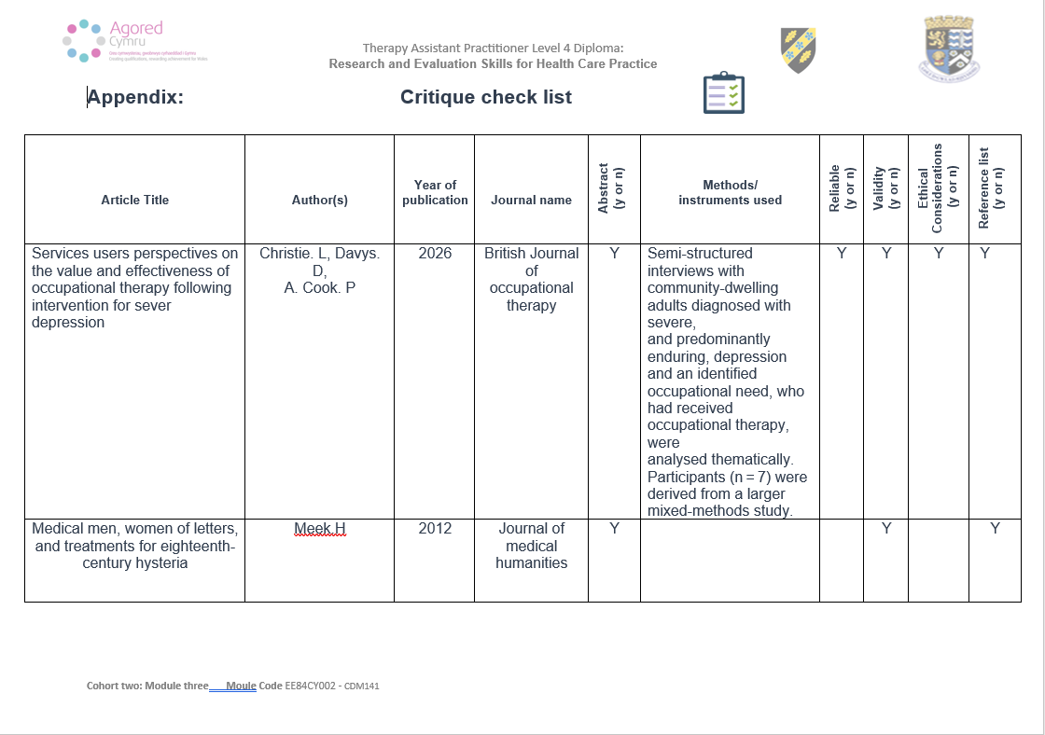
Appendix 1


