

A Study about building a secure home network

by
William Thomas

Supervisor: Dr John Rees
Second Marker: Dr Kapilan Radhakrishnan

Project submitted as part of the requirements for the award of BSc(Hons) Computer Networks and Cybersecurity

April 2018

Declaration of Originality

I, ............................................(FULL NAME)………………………………… declare that I am the sole author of this Project; that all references cited have been consulted; that I have conducted all work of which this is a record, and that the finished work lies within the prescribed word limits.

This work has not previously been accepted as part of any other degree submission.

Signed: .............................................

Date: ...............................................

FORM OF CONSENT

I ............................................(FULL NAME)………………………………… hereby consent that my Project, submitted in candidature for the B.Sc.(Hons) Computer Networks degree, if successful, may be made available for inter-library loan or photocopying (subject to the law of copyright), and that the title and abstract may be made available to outside organisations.

Signed: .............................................

Date: ...............................................

Abstract –
This paper explores the hypothesis that securing a home network should be taken seriously as without it, is the user’s data truly protected. The experiments provide an in-sight on how an attacker can approach the network can perform such attacks or how the network administrator can adapt security measures to the network or network clients and prevent these attacks from even happening. Research was gathered throughout the project underlining the reasons for why we should all focus on improving the security aspect of our home networks. The project offers a range of aims and objectives which were set by the author to complete throughout the project which would give the reader a better in-sight of the project entirely. One of the aims was to compare a standard home router to a custom router which not many people think there would be a huge difference not just in compatibility but security features such as more security settings which can be implemented.

Table of Contents –
Contents
Abstract – 3
Table of Contents – 4
Chapter 1 – 6
1.1 Introduction – (1) (2) 6
1.2 Aims – 7
1.3 Objectives – 8
1.4 Background Information – (3) 8
Chapter 2 – 9
2.1 Introduction – 9
2.2 Background Research – (3) (4) 9
2.3 Research Areas – (5) (6) 11
2.4 Research Paper 1 (Attacking) – (7) 11
2.5 Research Paper 2 (Attacking) – (8) 12
2.6 Research Paper 3 (Attacking) – (9) 12
2.7 Research Paper 4 (Securing) – (10) 12
2.8 Research Paper 5 (Securing) – (11) 13
2.9 Research Paper 6 (Securing) – (12) 13
2.10 Research for devices – (2) (13) 14
2.11 Standard Router vs Custom Router – (22) 15
2.12 Tables/Figures – 15
2.13 Research used for the project – 17
2.14 Conclusion – 18
Chapter 3 – 19
3.1 Introduction – 19
3.2 Research Methodology – 19
3.3 Experimental-Based Project – 20
3.4 Conclusion – 22
Chapter 4 – 23
4.1 Introduction – 23
4.2 Project Scenario – 23
4.3 Design 1 – 23
4.4 Design 2 – 31
4.5 Design 3 – 37
4.6 Design 4 – 38
4.7 Experiment-based project – 38
4.8 Survey-based Project – (21) 39
4.9 Conclusion – 42
Chapter 5 – 43
5.1 Introduction – 43
5.2 Evaluation – 43
5.3 Conclusion – 43
Chapter 6 – 44
6.1 Introduction – 44
6.2 Summary of the project – 44
6.3 Conclusion – 44
Chapter 7 – 45
7.1 Introduction – 45
7.2 What was learnt from the project – 45
7.3 Benefits learnt from the project – 45
7.4 Conclusion – 45
8.1 References – 46
9.1 Appendices – 49

Chapter 1 –

1.1 Introduction – (1) (2)
The project focuses on building a secure home network by adapting physical or logical security to the network. All the techniques used for building the secure home-based network could be added into a larger scale network such as for an organization. A computer network consists of a device (computer, smart phone or even a laptop) connected to a router which then relays the information to the outside world mostly known as the ISP (Internet Service Provider). The ISP will provide the home network’s router internet access via the cabling setup such as by using Fibre connections or Dial-Up. Computer Networks are growing at an unbelievable rate wither it is a home network, company network or even an offline test network. The network could be small or large depending on the location and use of the network. Research will be conducted, and relevant information will be gathered to gain a better understanding of the exploits of a home network and what measures others have put in-place to prevent those sorts of attacks.

The project will have a physical area and a survey-based area. The physical network that will be created for wireless hacking which will give the writer more of an understanding on what a hacker could do without even connecting to the network and how easy it is to disrupt it. Once demonstrated the physical network or a clone of the physical network will be modified to reject the wireless attacks and prevent disruption on the network. The network will be focused on preventing those wireless attacks and many other attacks, which could possibly happen. The chosen attack is a standard wireless attack, which can be easily setup and does not require any special hardware to perform.

The project will use a range of different hardware to complete the aims/objectives necessary such as using a standard broadband router and exploiting the weaknesses and the devices connected to the router will be mobile devices, PCs and a standard router, which is given by any ISP. A standard broadband router has been chosen for this project, as it is very common for households to use. The Attacker will be using a chipboard called NodeMCU which will be used for WIFI penetration testing to test the network security of a standard home broadband router. The NodeMCU board allows the attacker to disrupt the wireless network. Kali Linux will be used for a separate attack on the network.

The project will use some networking tools software, which will scan the network for possible threats such as open ports, firewall is turned off and unknown devices connected to the network. These tools can be used from a laptop or a smart phone.

The project has a survey-based aspect to it for gathering information on the number of users who use the pre-configured ISP router for security and who adds the extra layers of security. The Survey will be created in Google Survey as its online, fast responses and the data is saved online to analyse anytime. (1)

Security is important for any networking device as it stores information. The most security should be placed on the router as it’s the gateway for traffic coming in and out, but some security must be added on the clients of the network due to them possibly being infected with a malware/Trojan which tends to happen on laptops or mobile devices as they get infected on another network and spread through each network after being infected.

Kali Linux was chosen as the author has a vast understanding of the OS and the OS was created for penetration testing of any network using a local connection or remote connection. Kali Linux is a free open source OS.

Attack 1 (Wireless 1 to 1) (NodeMCU) –
The NodeMCU attack will target a single router and a single device. The NodeMCU device will not be connected to the network and will start scanning the WIFI names in the area. It will select the target network and a scan will start which will start listing the connected devices to that network and listing their MAC addresses which can be used to send deAuth packets to the device causing it to disconnect from the network until the NodeMCU device wireless program has stopped and allowed that device access back onto their network.

Attack 2 (Wireless 1 to All) (Kali Linux) –
This Kali Linux attack will target the whole network and obtain the actual wireless password for the locked network. The program will list the locked networks in the area and the user will select the target network. Once selected all the devices on the network will be disconnected and a fake access point will be listed which is a clone made by the program, but it will be open for all users to connect. Once the user has connected or users they are prompted and redirect on the device they are using to a webpage saying (company) has locked your network due to verification failed. To reactivate please enter your WIFI password. The program will compare the password entered to the actual network to see if it works. If it works, then the targeted network works again and if the password does not work then a password invalided will display on the user forcing them to re-enter a password until it is correct.
(Kali Linux will never be connected to any network).

To summarise chapter 1 of the project, NodeMCU will be used to launch a de-auth attack onto a network and the OS Kali Linux will be used to gain the password to the network. (2) Once the network has been attacked, the router can be configured to prevent many types of wireless attacks and configured the attack will be performed again but this time it would fail as the router would have the countermeasures in-place. The survey will be used to gain an understanding of how many users use the given ISP router or buy their own router and if they use the pre-configured router, settings or make changes to them.

1.2 Aims –
The report focuses on these aims –

- To compare the security aspects of a home broadband router or buying a custom router.
- To understand the ordinary practice of wireless internet users in setting up and configuring off-the-shelf routers

1.3 Objectives –
Objective 1 – (Attacking)
- To exploit the current state of a home network.
- To deny the users access to their home broadband router-using wireless attacks only.
Objective 2 – (Securing)
- To adapt changes which fixes the exploits found on the home network
- To create two physical network simulations –
- Simulation 1 will use a standard ISP router secure measures to attempt to protect itself against the attack.
- Simulation 2 will use additional security measures such as encrypting wireless traffic on the network.

Objective 3 – (Survey-Based)
- To create an online survey to gather necessary information on the type on router model used and if any extra security measures have been configured rather than using the standard.

1.4 Background Information – (3)
Computer Networks have been rapidly growing over many years in the UK for example back in 2006 the UK had a percentage of 57% home networks which either were using fibre connection or dial-up and recently in 2017 that percentage which was taken back in 2006 (57%) has moved up to 90%. (3) The demand for home-based networking is high and many homeowners are demanding it. There are thousands of home networks and the author believes that there are more than 50% of the home-based networks, which are still using the pre-configured settings by the ISPs.

Chapter 2 –

2.1 Introduction –
This section is research based. The section will provide information on the research conducted for the project, where the research was obtained and how the author deemed relevant information to use for the project.

2.2 Background Research – (3) (4)
Security is important for all network whether it’s home-based or company-based as all data should be private and confidential. Security measures need to be updated constantly as attackers tend to use malicious methods to gain access to the systems that the security couldn’t prevent for example if the home-based network was running outdated security software on the router which prevented a simple backdoor or exploit and the latest patch wasn’t downloaded then the attacker could use this method and gain access into the network. Security should always be a key-factor when dealing with a network with highly important and sensitive data.

Security can come in two forms when dealing with networks and these are software-based security and hardware-based security.

Security software can be placed on several devices in the network for example the software can be placed on a windows machine where a firewall will check incoming and outgoing traffic via the LAN for malicious traffic and then warn the user or block the traffic if pre-configured rules are set. The device could have more than one security software enabled on it, so the windows machine could also have an anti-virus which scans the PC’s internal hard disks for common or uncommon viruses that might have found its way on the system and then remove the virus before any more harm to the system has been caused. Security software can be placed on the router to protect the network in-which it blocks un-common traffic for example each router a person uses comes with a set of pre-defined ports in-which some are open, and some are closed. The closed ports stop network traffic from going in and out which can stop malicious applications from sending traffic, but the open ports are normally 80 http and 443 https which the router will filter to make sure no un-authorized packet can make it inside the network. (3)

Security hardware is a separate device placed in-side the network which can be used as an extra layer of security such as the security hardware could be running a firewall different from the other devices with more rules defined. The security hardware can use a deep packet inspection tool which will scan each packet that passes through the device and block the traffic. The device can also be configured to warn the user if unauthorized traffic has been detected. The hardware device will scan the source MAC address, the destination MAC address, the incoming IP address, the outgoing IP address and the ports that they may be using such as port 24000. (4)

Recommended security for each client device on the network –
Each device should have its own anti-virus which will scan the device for viruses/threats to the system or network. The anti-virus could be free or paid and its software based. Each OS has its own version of an anti-virus such as android would use Lookout Security as it’s a free/paid anti-virus software and it automatically scans new files downloaded to the device and warns the user of the threat before removal and will even warn the user if the publisher has been reported in the past with viruses in its software. (14) Windows machines could use the default anti-virus which comes pre-installed onto the system under the name windows defender. Windows defender was created by Microsoft and is upgraded weekly by Microsoft to stop malicious files from doing harmful actions to the machine which could make it slow, log the user’s actions or delete/lock the users files stored on the machine. An anti-virus on each machine is highly recommended. (15)

Devices connected to the network should each have its only firewall including the router. Windows machines will have a default firewall built-in which will allow the user to allow or block applications on the system from accessing the network/internet. (16) Smart phones under the android operating system can install a firewall application from the google play store which will allow them to allow or block applications from using the network. Some of the firewalls for android might require that the android device to be rooted which allows the firewall to gain more permissions on the device and block more services such as default system applications. All routers should come pre-installed with its own firewall and should be turned on by default with default settings. The firewall on a router can block or open ports for applications, can allow the user to setup a DMZ server which allows the user to open all ports on the one device on the network without causing the rest of the network harm or the user could configure the firewall to block sites/services. The user should not rely on just the router firewall alone as that would just be one layer of protection and if that layer gets bypassed then the attacker would be able to roam free around the network.
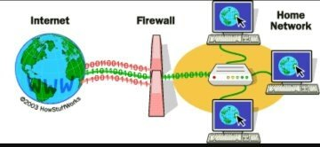(17)

A VPN also known as a Virtual Private Network allows the user to have encrypted access to the outside world for example the VPN can be installed onto a windows machine and then tunnelled via the router to a VPN server then out to the internet site. The VPN would allow the user to have encrypted traffic, so an attacker can not see the network packets unless decrypted was used which could take a lot of time depending on the encryption level of the VPN. The VPN would hide the real identity of the home network user for example instead of the website seeing the home IP address of your home network connection they could see the IP address of the VPN server you are connected to so if any malicious person were to find the IP due to a website hack they would have a log of the VPN Server IP address and not the home network one. This provides an extra layer of protection as it stops the attacker from performing a denial of service attack onto your network which would shutdown the internet connection to the outside world. VPNs are recommended when connecting to a public hotspot or using the internet on sites on which you do not trust such as a foreign site.
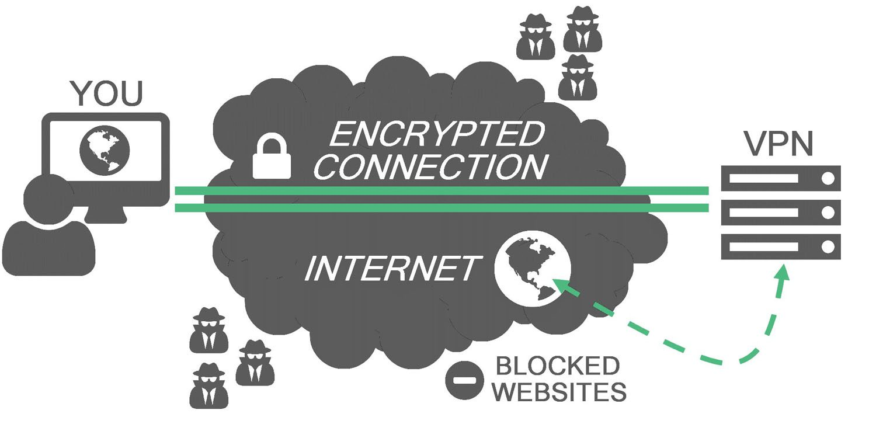(18)

2.3 Research Areas – (5) (6)
The author conducted the research by himself and have used online journals and books from the IEEE website, which is a trusted site as all the information has been validated by external verifiers and then published. (5) Research has also been conducted in the UWTSD Swansea Campus Library where books are stored and not available online. (6) The author has used information given throughout the computer networks course such as revisiting old modules such as the Internet security module to gather information written on the PowerPoints or other areas within the module.

2.4 Research Paper 1 (Attacking) – (7)
Paper Title – A New Local Area Network Attack through IP and MAC Address Spoofing. (7)
Written by – Shashi Shaw
This research paper talks about how to perform and cover up the malicious attacks on the network. The paper talks about some security problems once being connected to the network either it’s a home network, college network or work network. Each network has its exploits, and the author has listed a few of those exploits that will work on all networks once you are connected. The first attack the author has listed is using a MAC spoof to hide the identify of the machine you are running the attack from on the network or trying to gain access to a certain part of the network which might have a MAC address filter which the attacker can bypass. The second attack is a shutdown remotely command which allows the attack to enter any network IP address on the network or PC name into a shutdown prompt and force that pc to shutdown repeatedly which could cause problems as the machine might have important data open which would not save. It could also target the company’s servers or home appliances depending where the network attack is taking place and shut them all down. The third attack which is very dangerous is an advanced IP scanner which maps out the network for the attack, so they can see the number of devices connected, the information such as the device model and MAC address they have or even scan that device for any open ports which the attacker could exploit. The paper also talks about how these sorts of attacks can be stopped/prevented on a network which are creating a complex password, disable old user accounts and disabling the file and printing services on the network which will stop all the IP scans which will be hard for the attacker to gain information.

2.5 Research Paper 2 (Attacking) – (8)
Paper Title – Hacking the House Chapter 2. (8)
Written by – Stuart Lipoff
This report is based on a home IoT doorbell hack. The report explains how an IoT device can be used to hack into the network and cause harm for example the IoT doorbell is an outside device and easy to access for people to use. The device could be hacked into remotely as its setup using a wireless connection and IoT devices such as a doorbell never have much security or get outdated quickly which could be exploited and the attacker could use an exploit to gain access to the network. IoT devices are connected to an IoT server. If the hacker hacks into the IoT device, they could send malicious commands across the network or to the IoT server on which they can enable or disable functions on another IoT devices. Home security could be added to prevent this sort of attack such as adding encryption on the devices so that any malicious packets that travel the network would just get discarded by the end device as it doesn’t match the encryption format used.

2.6 Research Paper 3 (Attacking) – (9)
Paper Title – Test for penetration in WI-FI network: Attacks on WPA2-PSK and WPA2-enterprise (9)
Written by – Tamara Radivilova and Hassan Ali Hassan
This paper explains why WPA2-enterprise is more secure than the regular WPA2-PSK. The reasons behind this are that WPA2-PSK uses the same pre-shared key for all its devices so if the encryption key for that network were to leak out then anyone could connect to the network and upload malware to the computer systems on it or launch a denial of service attack to it. WPA2-Enterprise doesn’t follow the method of using one WPA2 encryption key as it’s a key for each user session for example when connecting to the network the user must enter their personal information from the company such as employee id number and a password to connect successfully to the network. Therefore, this method is more secure as it allows the IT staff to manage the user access to the network. The report briefly talks about methods in-which can be used to attack any networks using WPA2-PSK or WPA2-Enterprise protocol. The report states that a dictionary attack on WPA2-PSK would be efficient since the AP of the network is public but the attack would not be effective against a WPA2-Enterprise network.

2.7 Research Paper 4 (Securing) – (10)
Paper Title – Biometrics for home networks security (10)
Written by – Imran Ansari and Ahmad Qutbuddin
This report recommends that biometrics should be added to the home devices for better protection against hackers. Hackers tend to use a password cracking software which will run a brute force password attack or directory attack which will run a series of words and letters against a username to gain access to the system and then the network. The authors of this paper have written about adding biometrics would be a major increase in security as trying to crack a fingerprint, DNA or eye pattern would take longer than 10 years to crack which would increase the time from around a few months when using a regular password. Biometrics listed for securing the home devices and network are as follows DNA, Voice, Iris, Ear form, Facial geometry. Vein Patterns and fingerprint. The fingerprint biometric has already been added many different types of smartphones. It’s a major security boost for the devices that instead of entering a password to confirm the transaction on the smartphone you can just use your fingerprint. Using a biometric on highly important devices/servers is recommend as its way more secure than using a password.

2.8 Research Paper 5 (Securing) – (11)
Paper Title – Detection of De-Authentication DoS attacks in Wi-Fi Networks
Written by – Mayank Agarwal
This report focuses on de-authentication problems within the 802.11 protocol for example 802.11 doesn’t offer encryption from end to end devices which causes problems and allows hackers to intercept the wireless traffic. This report provides information on a security protocol called 802.11w which came out back in 2009 and was only ever implemented on cisco routers. The reason for this is due to the lack of interest of adapted the 802.11w protocol. 802.11w protocol protects the management frames between the network devices such as the de-auth packets so unauthorized packets trying to de-auth the device would just be discarded as 802.11w uses encryption which will know the difference between encrypted management frames and non-encrypted management frames. Companies would buy cisco equipment which would come with 802.11w support to stop the de-auth attacks but only if the client device also supported the 802.11w. The attacks against the normal 802.11 protocol weren’t as big of a problem to defend against back then since not many people knew how to perform such an attack and the attack would only affect a small account of users for example like 3 home users on the network who use a wireless connection. The report explains how de- authentication packets can be used on a network to disrupt wireless traffic from the device to the router or access point. The attacker can send de- authentication packets to one or many devices at a time causing the whole network to collapse. The de- authentication attack only effects WIFI connected devices. The report listed some suggestions to use when trying to prevent this sort of attack. De- authentication attacks can cause major problems as if a network is heavily wireless dependent then the network would be rendered useless. The report was written in the year 2015 so the attack should be fixed by all routers including an ISP router. This sort of attack should be prevented by default by all types of routers since it’s been active a number of years. A de- authentication attack will be created for the project to understand if the ISP router used if affected.

2.9 Research Paper 6 (Securing) – (12)
Paper Title – Overview of Romania 802.11 Wireless Networks Security
Written By – Cristian L. Leca
This report explains the differences over several years between the wireless network protocols such as WPA2-PSK and WEP. This report contains statistics on the number of users who use regular network security on their network such as 2% of the world’s population have an open network so anyone can join and access the LAN devices or wireless devices connected also or even access the internet if the access point has been configured correctly. 5% of networks in the world still use the old protocol WEP which has been reported less-secure than the rest due to the easy encryption it has which is 128bit also known as 104bit (26 Hex Character). WPA is used 7% of the world’s network population which is more secure than an open network or even WEP. WPA2/Mixed has a huge percentage which is 86% of the world’s network. WPA2 uses a 128bit encryption which makes it harder to decrypt/crack which is why it’s the most popular and recommended out of the ones listed. Wireless networks should always be upgraded to the latest protocol to prevent attacks from getting in to the network, but most networks still use the protocol WEP which is some cases can be suitable if it’s setup in remote locations with no neighbours like a farm. WEP could also still be used due to the client devices not supporting anything newer such as WPA2 or even the router itself might not support anything other than WEP.

2.10 Research for devices – (2) (13)
Device 1 (NodeMCU) (13) – NodeMCU is a chipboard which allows the user to implement lua script lines onto which then configures the board to do a series of commands. The NodeMCU board in-which the project will be using will be flashed with custom firmware in-which will allow the user to perform wireless penetration testing such as de-auth the entire network or even beacon spam the networks in the area. This device doesn’t require a lot of power and can be very effective which making it a great tool for WIFI penetration testing.

Device 2 (Laptop using Kali Linux) (2) – A laptop using the OS called Kali Linux will provide penetration tools for ethernet or WIFI. The OS will allow the attack to scan for open ports on the network, view any online devices on the network and find their MAC address in-which the OS can then use to spoof to hide the attack locations.

Device 3 (A Router) – A home network router will be used to perform the project as it has a low security rate than using a cisco router with extra layers of security. The router is the gateway to the internet for the household and controls the network between the devices connected to it so if the attack were to attack the router and slow it down then the whole network would become affected.

Device 4 (Smartphone) – A smartphone will be used to connect to the router in-which the attacking devices will attempt to disrupt the connection or perform another sort of attack.

Backup Devices –
Device 5 (Computer) – A computer can be used as a hotspot in-which the WIFI card becomes an access point for other wireless devices to connect to and use the internet via the machines ethernet port or secondary wireless card. This device will be considered as a backup device if the router fails.

If the NodeMCU fails, then the Kali Linux device will be used to perform the tasks in-which the NodeMCU failed at. The Kali Linux can run similar attacks to the NodeMCU making it a great backup method for if it fails.

2.11 Standard Router vs Custom Router – (22)
Standard Router – (ISP Router) | Custom Router – (Nighthawk Router)
Low-end hardware | High-end hardware
Low-end security | High-end security
Not many features | Tons of features
Not much support | 24/7 live chat support
Can withstand 20 devices or less | Can withstand 80 devices or less

A standard given ISP router comes with low-end hardware and low-end security protocols as it’s a free router which comes with the ISP package. The router offers WPA2-PSK encryption and can reach fibre speeds. ISP’s tend to replace the router if problems occur instead of attempting to fix the box over a live chat. The standard router can support 4k streaming for 1 to 2 devices if the network doesn’t have a heavy-load of users such as 10 devices connected and if the standard router’s hardware can support whilst not many can.

The custom router can support 4k streaming on all devices, support gigabit connection speeds and receive the latest firmware upgrades to patch any bugs. The firmware update can also implement more security patches and options for the device. The custom router can support many devices streaming at once since a custom router tends to come with a dual-core processor instead of a single core. An example of a custom router would be the Nighthawk R7800. This router can support MU-MIMO which allows each wireless device connected to maintain the same network speed rather than a device waiting for the data from the router whilst being a queue. Without MU-MIMO each wireless device must wait for their turn to request and send data to the router or from the router as the number of antennas on the router are limited and this is the case on all standard routers but on custom routers they tend to have many antennas to support MU-MIMO. Each custom router has dual layer firewalls which double check the packets and have NAT filtering options. Custom routers can have guess networks to allow guests to connect to the router and use the internet but have no access to the other devices connected to the network such as the smart TV or NAS system.

The most important security aspect from these two devices is that a VPN must be installed on each client device on the standard router network but if using a custom router then the VPN can be installed on the router which will enforce all the network traffic to be tunnelled via that VPN and ensuring high level of protection against denial of service attacks and IP lookups.

2.12 Tables/Figures –
Network Statistics Table (World Figures) –
Open Networks | 2%
WEP | 5%
WPA only | 7%
WPA2 or mixed | 86%

These figures show that WPA2 security has been adapted to many number of computer networks over the years as it’s the latest security protocol and it has a higher bit encryption rate than the others.

WEP vs WPA2-PSK Table –
WEP | WPA2-PSK
Can be cracked in minutes | Can be cracked in months/years
128-bit encryption | 128-bit encryption
Outdated | Newer than WEP
Supported on all devices | Supported on devices newer than 2005
When dealing with network security for any network whether it’s home-based or company-based they should always use the newer technology methods and in this case it’s WPA2-PSK as it’s more beneficial to protect the users network with the higher encryption level, less likely to be cracked in sooner than the other protocols. WPA2-PSK is a standard and should be compatible with all devices made after 2005.

WPA2-PSK vs WPA3 –
WPA2-PSK | WPA3
Can be cracked in months/years | Cam be cracked in several years
128-bit encryption | 192-bit encryption
Newer than WEP | Newer than WPA2-PSK
Supported on devices newer than 2005 | Supported on devices newer than 2019

WPA3 fixes all the problems that WPA2 had which were the management packets were not encrypted and that the 128-bit takes way less time to crack since most machine these days have a high amount of CPU power which can be used to crack the 128-bit encryption than the 192-bit encryption. WPA2 might remind active for a few years when WPA3 comes out since all devices must be upgraded/changes to support WPA3 in-which many users will not upgrade their devices straight away.

802.11w – 802.11w came out in the year 2009. It has only been adapted into most cisco routers and a few other devices and the reason for this is because the router and device/client would have to have a certain type of chipset that would support the 802.11w protocol. 802.11w was made to fix the management frames problem when WPA2 first came out but it never became a huge deal back then and since a lot of devices and routers were just installing/releasing their products with the regular WPA2 most companies deemed 802.11w not a big deal.

WPA3 – WPA3 will be released in the year 2019 and it will fix the problems that WPA2 had which were not protecting the management frames which allowed an attacker to disrupt the wireless connection on the network. WPA3 comes with a higher bit encryption level which means that the attacker will have a harder time trying to brute force the network password. WPA3 offers end to end encryption on all its devices for example each device that connects to the router would have its own one to one encryption in-which other devices cannot see. An attacker could attempt to decrypt the packets, but this would take a large amount of time. WPA3 will stop man-in-the-middle attacks since the devices are end-to-end encrypted.

2.13 Research used for the project –
Research paper one offered many various scanning methods to obtaining the MAC addresses of the devices on the network including the router network. This will help the project as obtaining the router and device MAC addresses or even their IP address is important information to obtain as it allows you to be certain of the target device the attack will be against. This paper will allow the author to understand how to scan for the router mac address in which he can attempt the de-authentication attack and the password attack to obtain network access or disrupt wireless network access.

Research paper two talks about how an IoT device can be exploited and used to obtain access to the IoT server which can cause harm to the network such as running unnecessary tasks on devices, overloading the devices or even slowing the network down as sending too many requests. The author can adapt the areas of this research project into the second attack of the project as it’s quite similar. The second attack focuses on sending malicious network data to the network devices for information and the password information which is like what paper 2 does when it’s sending malicious network data to the IoT server on the network or another IoT devices.

Paper three explains the differences between WPA2-PSK and WPA2-enterprise which are the two latest network security protocols. WPA2-PSK is widely used for home networking whilst WPA2-enterprise is used for organisations. WPA2-enterprise is more secure than WPA2-PSK as the passkey is different for each user making it harder for the attacker to gain access into the network. The research gathered from this report helps the author understand how each of the protocol works and how they can be adapted into the project later on.
Research paper four is how to add more security to the computer systems on the network to prevent it from being used by malicious people with unauthorised access. The research paper talks about adding biometrics to the computer systems and smart devices connected to the network which allows them to become way more secure than using a password. Some biometrics have already been adapted to smart phones such as fingerprint and voice recognition. The author found this this research paper interesting and it can be a great way of protecting data inside a home network or company network. When securing the network you must also secure the devices connected to that network as the devices tend to be the bigger problem as they could be filled with malware if the wrong file is downloaded and if it’s a smartphone any other network they connected to in the past could of uploaded a malware to it so adding securing to the devices such as an anti-virus would help. Someone could break into the house and attempt to access the information on the device such as company records or banking information saved on the home computer but using a biometric and encryption it makes it impossible for the intruder to gather any information.

Research paper five explains how a de-authentication attack can cause major problems to a computer network for example it can disrupt the wireless network traffic causing the devices useless. The research paper explains what measures should be taken in trying to prevent this sort of attack. The author found this paper interesting as it’s an important attack to patch on all systems/routers as it can cause major downtime on all networks. If the network doesn’t have any sort of protection against this attack, then why it hasn’t been adapted to the router or access point yet. This paper was written in the year 2015 which means that this attack should be patched by all routers including ISP routers to offer the best protection against hackers. The author will be using a de-authentication attack for the project and adapting changes to router to prevent this sort of attack. The author will document the information on how this attack can be stopped and if it’s already stopped.

Research paper six explains the differences between WEP and WPA2-PSK encryption and why it’s important to always stay up to date. When building or deciding to upgrade the networking devices it’s best to install a device with the latest networking capabilities which in this case is using WPA2-PSK for protection. The report also states that WPA2-PSK has been the most implemented security protocol around the global.

2.14 Conclusion –
This section talks about 3 attacking computer network reports and 3 securing computer reports. From this section a list of methods have been provided for example when dealing with the attacking side of project the attacker must learn about the network before they can begin their attack such as what channel the network is broadcasting on, if there are any ports open on the network or even if the network is using an old encryption type like WEP which is not secure anymore and can be hacked in under a year. The securing side of the research section explains about adding extra layer of security not just to the network device but to the end devices too such as a fingerprint sensor to stop people from brute forcing or guessing the password. This section also explains that several security features could have been implemented over the years such as the 802.11w protocol to stop the management frames from being attacked. The section also has a list of devices which will be used for the project. The section has also stated that the project will have backup devices in-case the primary device fails. WPA3 offers the network a huge boost in security by protecting the packets from the client to the router. WPA3 has an even higher encryption level than the previous WPA2-PSK.

Chapter 3 –

3.1 Introduction –
This section explains the research methodology in-which will be used for the project. It will also list the reasons behind choosing that methodology such as the advantages and disadvantages. This section will also give the reader a better in-sight of how the project will be under-taken throughout. The methodology that was used is the research onion which has important information on each layer.

3.2 Research Methodology –
For this project the author will use the research onion to outline each layer of the project and giving the reader a better in-sight into how the project developed along the way.

The research onion is a popular research methodology as it outlines the key important areas when doing research. The research onion was created back in 2007 by a person called sanders. Each layer displays the stage of the research process. Each step is important as it helps the research for the project develop. The research onion works by working from the outer layers towards the inner layer. The research onion helps with planning and carrying out the research. Layer one which is the research philosophy layer has three options which are positivism, Realism and Interpretivism. Layer two has two options which are Deductive and Inductive. Layer three has six options which are Experiment, Survey, Case-Study, Grounded Theory, Ethnography and Action Research. Layer four has two options cross sectional and longitudinal. Layer five has five options which are sampling, secondary data, observation, interviews and questionnaires.

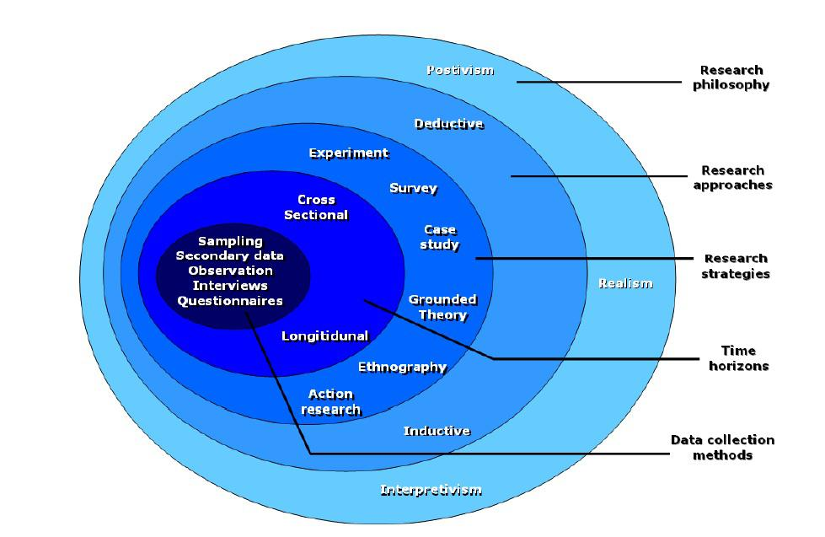

The layers in-which the project falls into are – Positivism, Deductive, Experiment, Multi-Method, Cross Sectional, Observation and Questionnaires.

- Positivism – This allows the researcher to create a body of research which can be replicated by other researchers, so they can receive the same results. Positivism was chosen as it relates to the aspect of creating the experiment or experiments which could then be re-built in the future by following the methods in-which it was created.

- Deductive – This allows the researcher to start with a list of questions or a statement in-which the research sets out to find the answer to it. Deductive was chosen because the project is based on home security and the project aims to secure the projects in-which the project must ask the questions what exploits can be found on a home network and what software or hardware can be used to stop the exploit.

- Experiment – Experimental designs are used to gain data in-which can be used for research for the project. The project has an experimental base to it as experiments will be carried out to attack/secure the home network from threats.

- Multi-Method – This method is used when the research uses both quantitative and qualitative data, but the research has an outlook from one point of view which is the authors. The project has been written and created by one person so multi-method has been chosen.

- Cross-Sectional – This allows the research to analyse qualitative and quantitative research as they measure an aspect or behaviour from a single point in time. Cross-Sectional has been chosen as the experiments must be tested multiple times against various hardware to ensure that the results are the same.

- Observation – Observation will be used when doing the experiment to gather as much information as possible to ensure that all results are correct, and the equipment is working correctly.

- Questionnaire – A Questionnaire will be used to gather information on how many home users adapt additional security to their home network and how many home users use the default configuration when using their home network. This will create a based line of how many users could be affected by possible threats.

3.3 Experimental-Based Project –
- What is your experimental hypothesis?
To attack and secure the home network by using a list of wireless penetration tools in-which can disrupt the home network causing it to either slow down or shut down all wireless communication and then adapt security to the network to stop the wireless exploits. The wireless penetration tools allow the attack to shutdown the connection between the client device and router device, retrieve the network password by making the client device connect to a rouge AP and tricking the client into entering the network password or using a beacon spam attack which will create a bunch of access points in the area with a bunch of random access point names or the same access point name as the network in-which the attack will be against which will cause the user to see thirty or more home networks in their area with the same router name as them also using the same channel which can cause problems for wireless traffic. The experiment will adapt technology in-which the author believes can prevent these sorts of attacks and reference some new technology which will become a standard in all devices which will prevent these sorts of attacks by default.

- What hardware are you using?
The hardware for which the project will be using are as follows –
  - NodeMCU – The chipboard will utilise WIFI penetration tools in-which will be used to attack the network and cause disruption causing the network to slow down to stop.

  - Laptop/PC with Kali Linux OS – Kali Linux will be used on a device as a backup method if the NodeMCU fails. Kali Linux can provide additional attacks which can be used against the network.

  - Smartphone 1 – The first smartphone will be used to connect and utilise the NodeMCU remotely.

  - Smartphone 2 –The second smartphone will act as a target device connected to the home network.

  - Router/Access Point – An access point / router will be used to utilise a home network with a smart phone connected wirelessly.

- What software are you using?
  - NodeMCU – Custom Software known as de-authentication package which has WIFI penetration tools.
  - Laptop/PC – Kali Linux OS which is based on attacking software.

- Is your experiment valid? Why?
  - The experiment is valid as it’s in a controlled environment and a high percentage of users have a home network router or a custom router in-which these attacks can attempt to penetrate and disrupt the network causing it to slow down or stop working for a single device or all connected devices.

- How did you conduct the experiment?
  - The NodeMCU board which was controlled by the smartphone selected the network known as the home network and launched a series of attacks against it in-which caused the connection of the home network to stop working and disconnect the smartphone which was connected to it. The smartphone cannot reconnect to the home network unless the NodeMCU stops the attacks against it. The NodeMCU also launched an attack which cloned the router’s name and channel information and created thirty or more clones of it which appeared on all devices in the area causing the smartphone to connect to the wrong device and slowing down the network of the router as the packets would start getting lost due to the interference of the devices all using the same channel to broadcast to their devices. The experiment was conduced in a home environment and inside a company environment in-which the device only targeted the network it wanted to disrupt.

3.4 Conclusion –
To conclude this section of the report the author has listed the hardware and software in-which will be used to conduct the project. This section has also provided an image of the research onion and written a small example of the method chosen from each layer and how it adapts to the project.

Chapter 4 –

4.1 Introduction –
The section will provide designs of which the project will be laid out for the experiments to give the reader an idea of how the experiments were conducted and where each device was placed when utilising the experiments for the project. This section will provide information on the steps in-which the design will be carried out for example device will utilise this function which will cause device two to stop working.

4.2 Project Scenario –
More than 80% of UK households have a network connection which provides network access to the internet. Each network has different set-ups and different devices attached to it. The household router could be a standard router which comes free with an ISP package with their pre-configured settings or the household could have their own custom router with more advanced features and configurations. The objective for the design is to attack the network using a wireless router setup against a standard home router with the default configuration used as it’s mostly used in households across the UK and it’s been recommend using by all ISPs around the UK.

4.3 Design 1 –
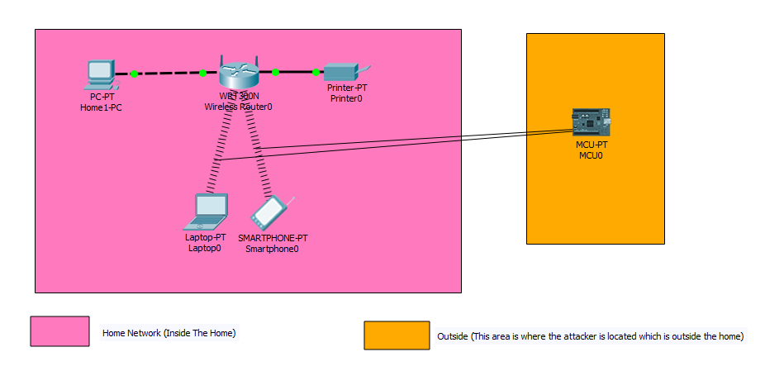
Design 1 shows a basic setup of a home network which has one computer, one printer, one laptop and one smart phone connected. The attacker is outside the home scanning for a list of networks in the area. The attacker sees the home network popup on their network scanner and choose the home network to target. The attacker can now launch a series of attacks against the home network and the attacker doesn’t even need the network password to launch these attacks which is dangerous.

The attacker has used a chipboard called NodeMCU which has been flashed with a custom firmware to support the WIFI penetration techniques. An Image below has been taken by the author showing what the NodeMCU board looks like –
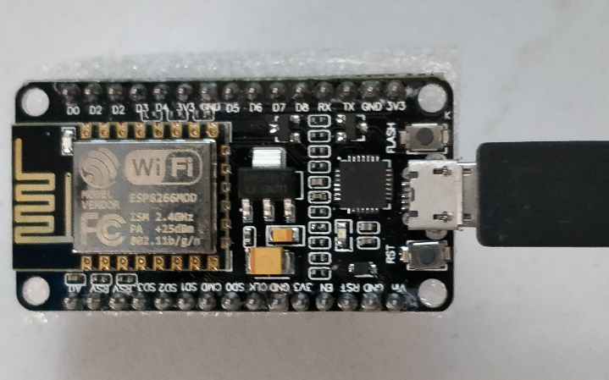

Once the board has been configured from the computer (installed the custom firmware with WIFI penetration tools) the attacker can connect the smartphone to the NodeMCU board via a WIFI connection. The NodeMCU will act as an access point to allow a smart phone or another wireless device to connect to allow it to be remote controlled. (19)
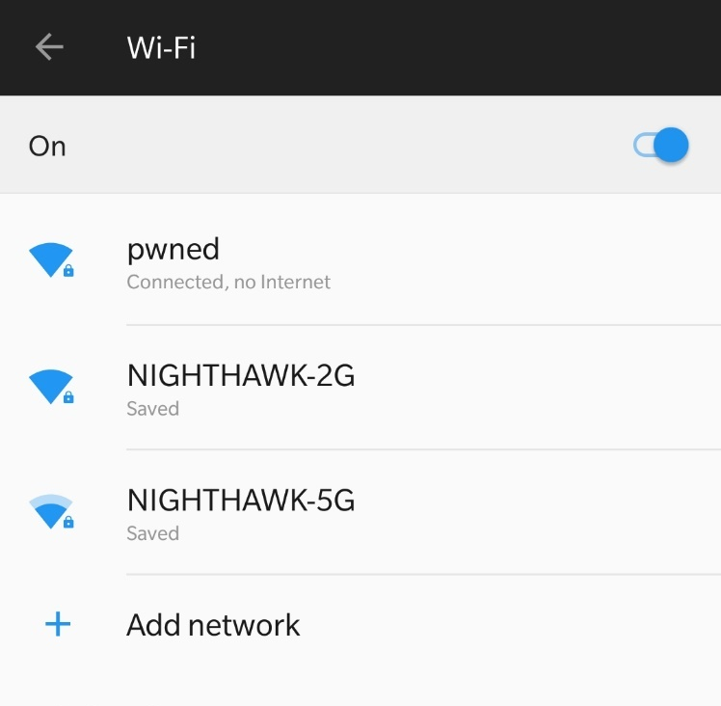
Once the smartphone has been connected to the NodeMCU the attacker can open a browser and enter the IP address of the NodeMCU which is 192.168.4.1.
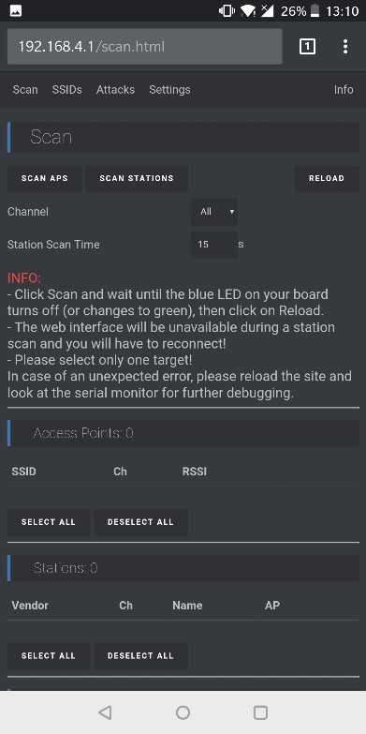

The attacker must select the scan AP option on the webpage which will initialise the NodeMCU to scan for all access points in range of the device and then list them on the webpage for the hacker to select from.
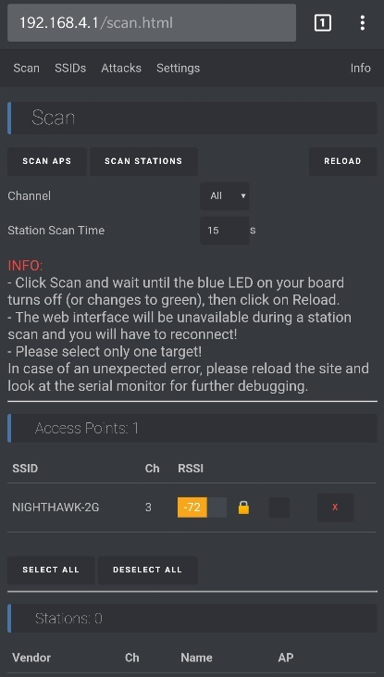

Once the network has been selected from the list of access points the attacker can proceed on towards the SSID page.

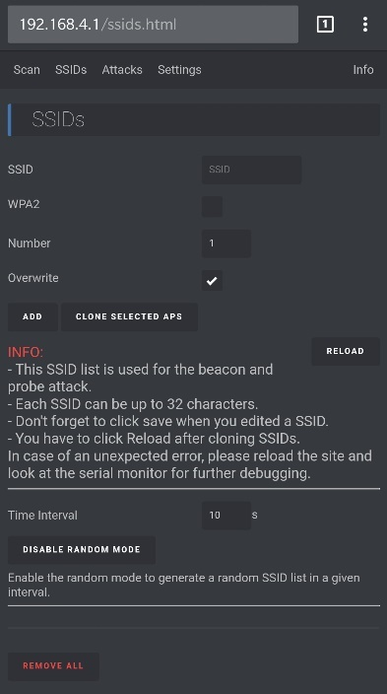

The attacker can clone the selected access point in-which they can create muiltple of the same access point. The clone can also use the same WIFI channel as the actual access point causing the actual network to slow down or become unstable.

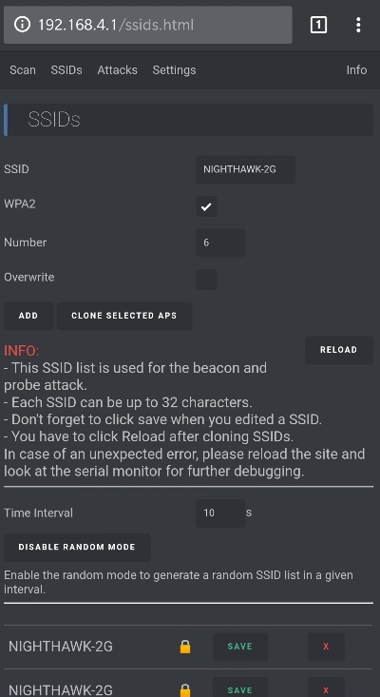

The access point has been cloned and a list of the same network has been displayed at the bottom of the page. The device could also create random access points instead of cloning the device which would display as random characters and numbers with some secured networks and some non-secured networks.
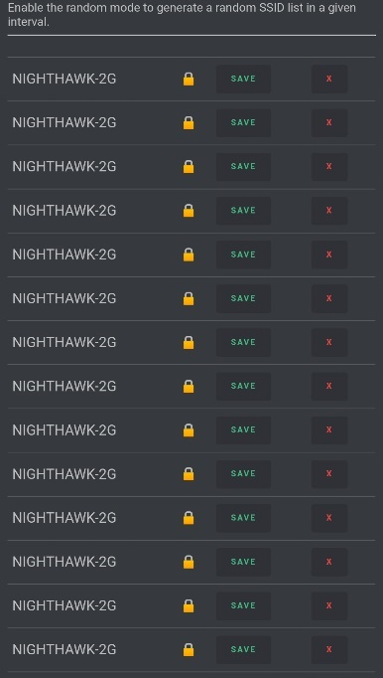

The image above is the cloned access point. The access point has been cloned multiple times, so it can be broadcasted for all devices in the area to find and cause the actual network to slow down or stop working.
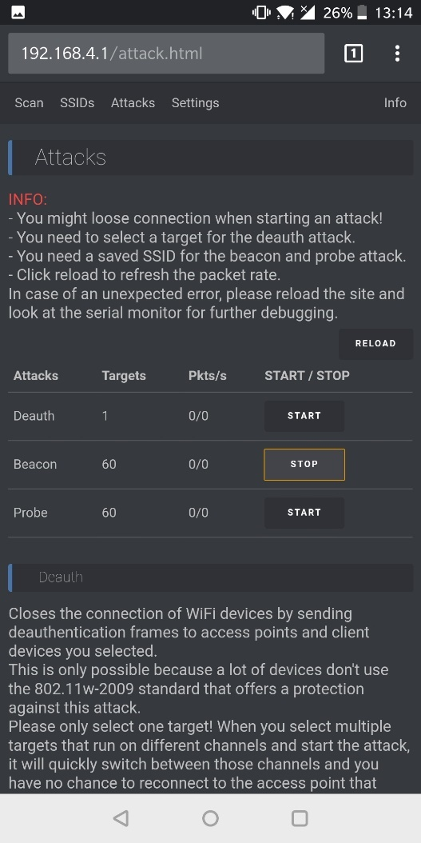

The attacker can move to the attacks page in-which they can select the beacon attack to launch all the cloned networks and broadcast them to all devices in range.

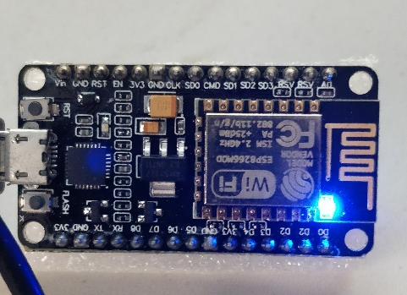

Whilst an attack is launched the NodeMCU will indicate to the attacker that it has begun with a blue light constantly on until the attack has been stopped.

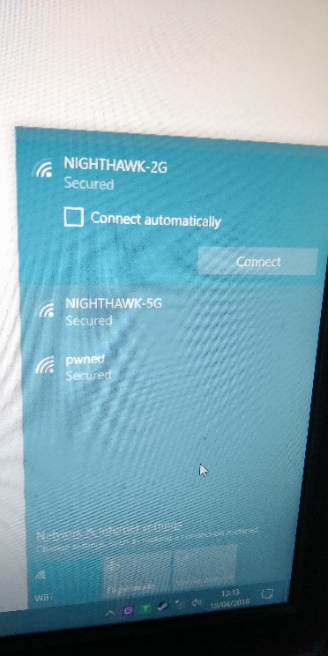
This image has been taken before the beacon has begun.



This image has been taken after the beacon attack has begun.

The NodeMCU can also perform a de-authentication instead of doing a beacon attack for example –


A user in the home network must be connected to the router on a device in-which they are using. The user has connected to NIGHTHAWK which is currently their home network’s access point’s name.
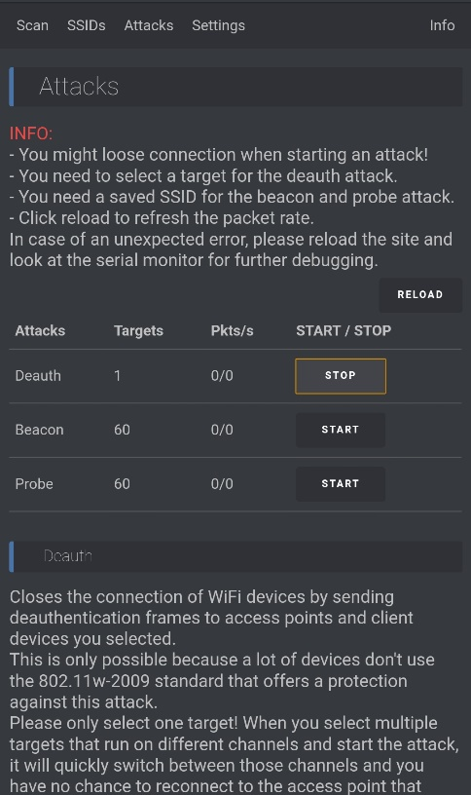

The attacker has selected the network which was done in previous images, so they can now proceed to the attacks page and select the deAuth attack.

The attack can stop all wireless traffic on the network, so each connected device will become disconnected and cannot reconnect to the network unless the deAuth attack has been stopped.

4.4 Design 2 –
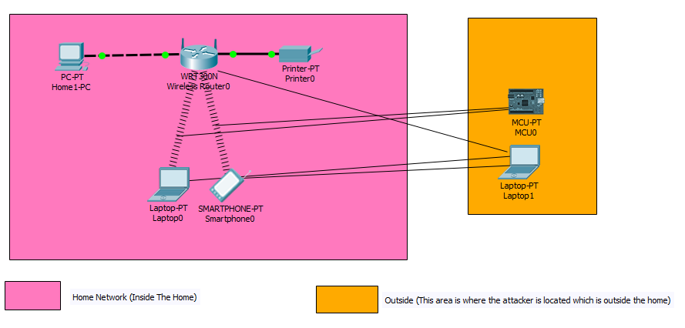
Design 2 is a more advanced attack in-which the NodeMCU can be used with Kali Linux or the attack can run from a solo device which is the Kali Linux device. The Kali Linux can scan for all access points in the area and stop a client device in the area from having working internet which is a 1 to 1 attack or the Kali Linux attack can be used to trick the user into getting them enter their WIFI password which will allow the attacker to see it and gain access to the network. The attack works but stopping the actual access point from working and tricking the user into connecting into a rouge access point with a webserver setup. The user will be greeted with a webpage stating that the router needs additional verification to restore the internet connection. The network key entered from the user will be checked against the real access point and if the key is valid then the user will be automatically reconnected to the actual network but if the network key does not match then the user will have to enter the password until it’s valid.

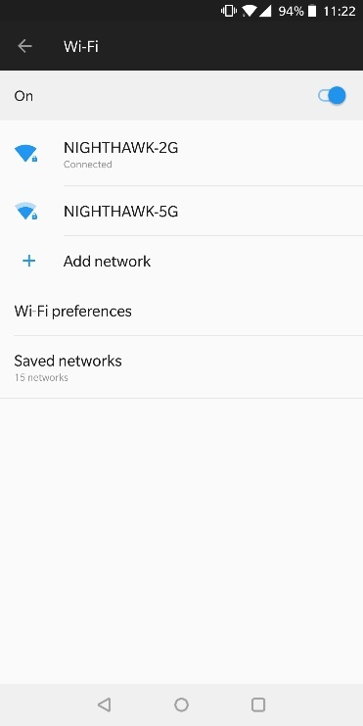

A smartphone has been connected to the network to simulate an actual user being connected to a home network.
Code 1 –
- Ifconfig
- Ifconfig wlan0 down
- Aireplay-ng -9 wlan0

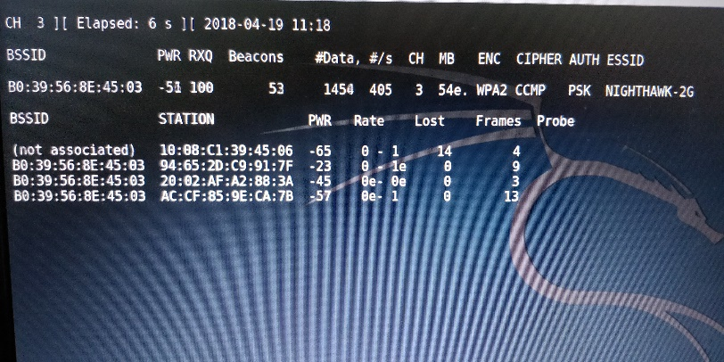

All networks in the area will be listed in the first section for example the only network which was found during the experiment was NIGHTHAWK-2G. The software lists information about the network such as the number of devices connected in the second section. The channel in-which the router is using and the authentication the router has in-place.

Code 2 –
- Airodump-ng -c ___ --bssid ____ -w psk wlan0
- Aireplay-ng -0 0 -a ______ -c _____ wlan0

The first line of the code selects the network for example –
-c means the channel in-which the router is broadcasting on.
-bssid means the MAC address of the router.

The second line of code starts the attack against a selected device –
-a means the MAC address of the router.
-c means the MAC address of the client device connected to the router.

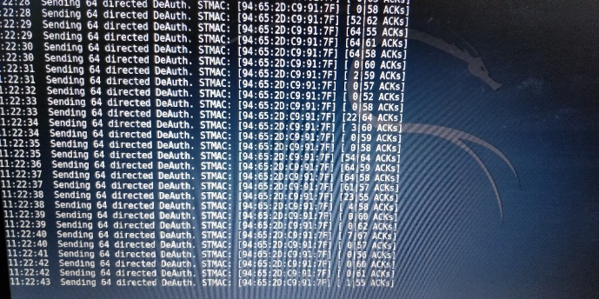
The software will start to send de-auth packets to the client device whilst pretending to be the router to ensure the connection is dropped.
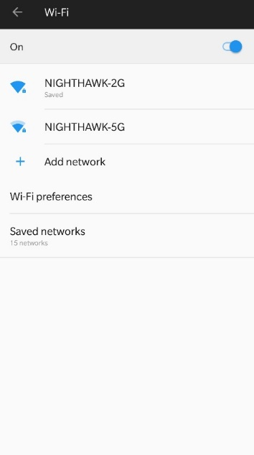
The connection to the router on the client has been lost as the de-auth packets have been received by the client device. The client device cannot re-attach to the network until the attack has stopped.

Another attack using the same method can be used to retrieve the network password –
Code 1 –
- Git clone https://github.com/PNPtutorials/Fluxion (20)
- Ls
- Cd Fluxion
- Ls
- ./Installer.sh
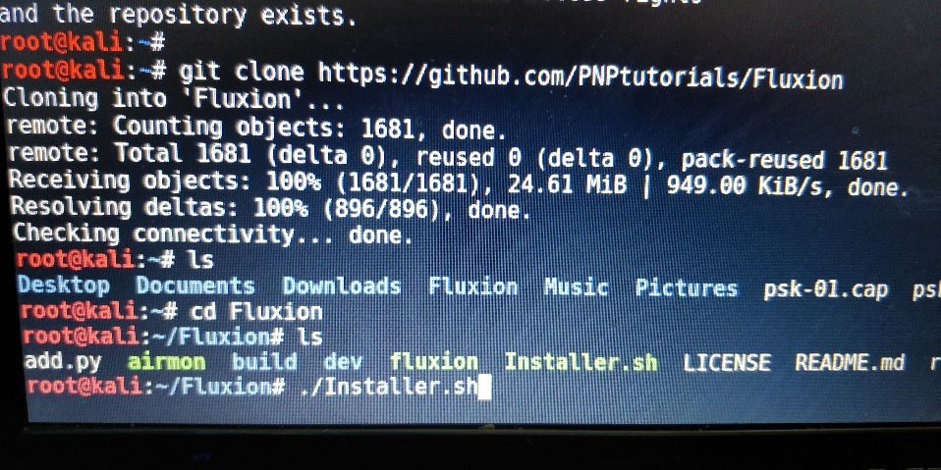

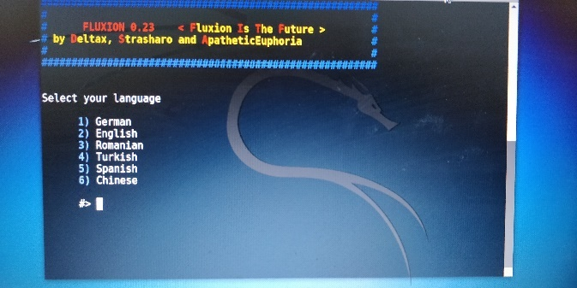
Number 2 was selected from the list (English).

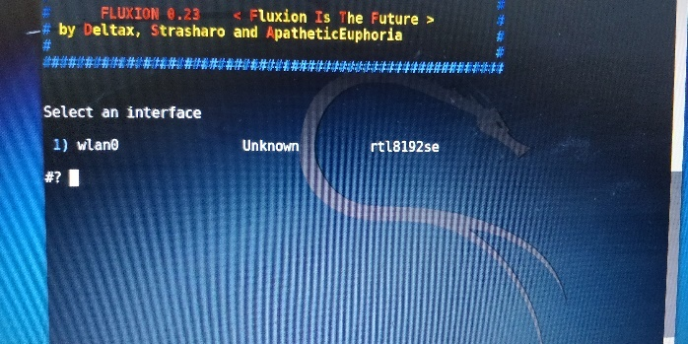
Number 1 was selected as it’s the only interface card available.

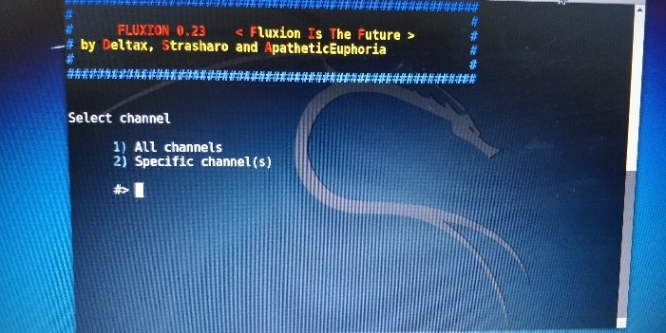
Number 1 was selected to scan for all networks in the area.

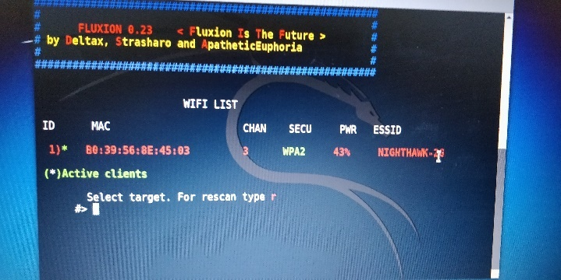
There is one network in the area and it has been listed in the program. The program has listed information such as the network name, channel and MAC address of the router.

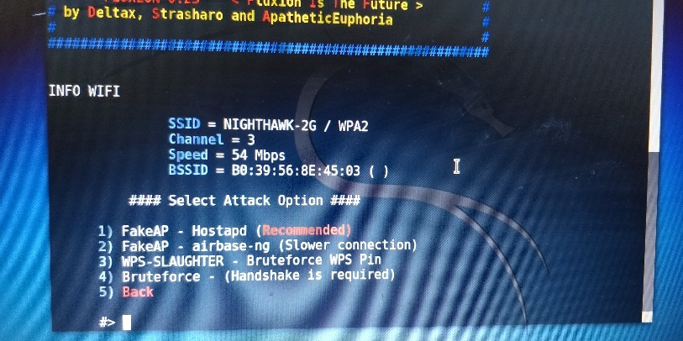
Option 1 was selected to create a fakeAP. The fakeAP will clone the network information such as name and channel and become active.
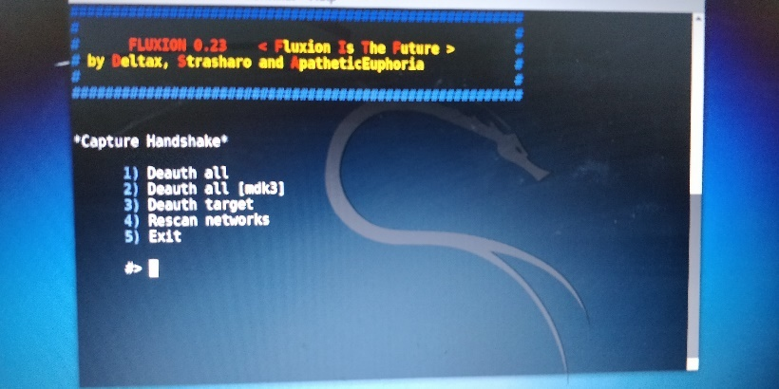
Option 3 was selected to de-auth the network.

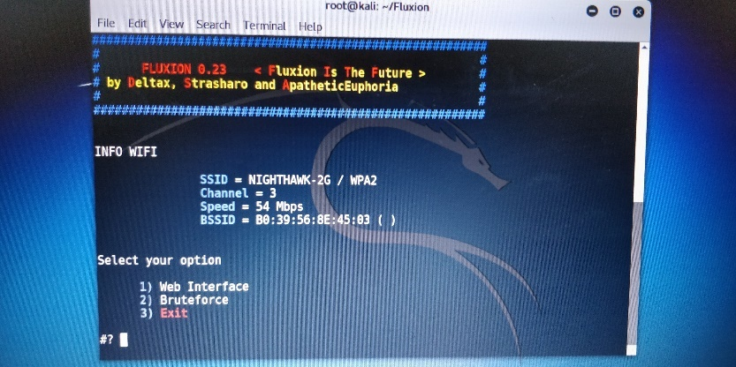
Option 1 was chosen to create a web interface for each client who connect to it.

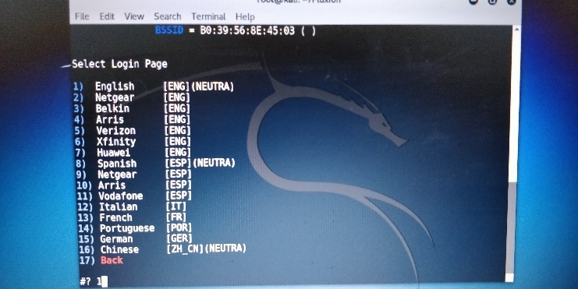
Nighthawk is a Netgear router so option 2 was chosen to make the user believe that the webpage is valid. Option 1 doesn’t brand any ISP on the webpage so it’s more common to use.
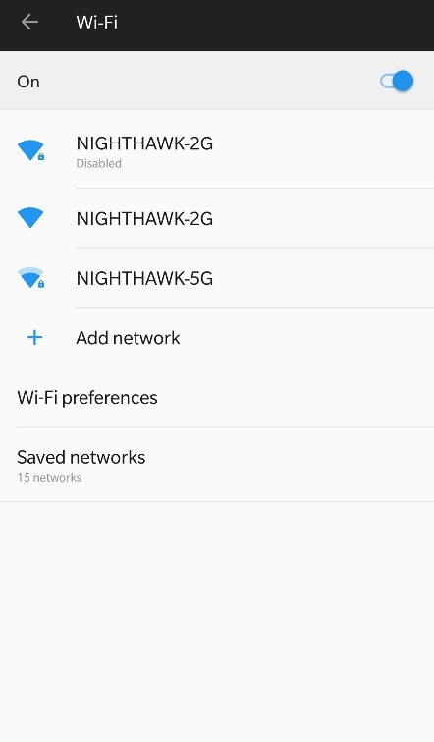
The access point has been disconnected by the software, so the client cannot reconnect. Another network is broadcasting with the same information as the home network which is the fake access point.

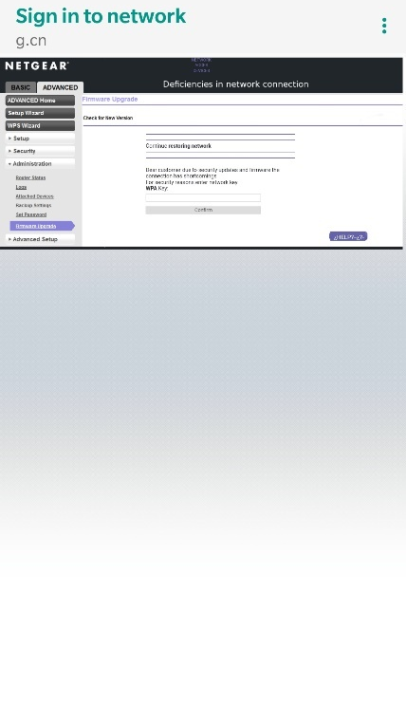
The webpage has opened on the client device asking for the user to re-enter the network password. If the password is valid then the user will be automatically connected back to the actual access point without them knowing but if the password is incorrect they must re-enter the password.

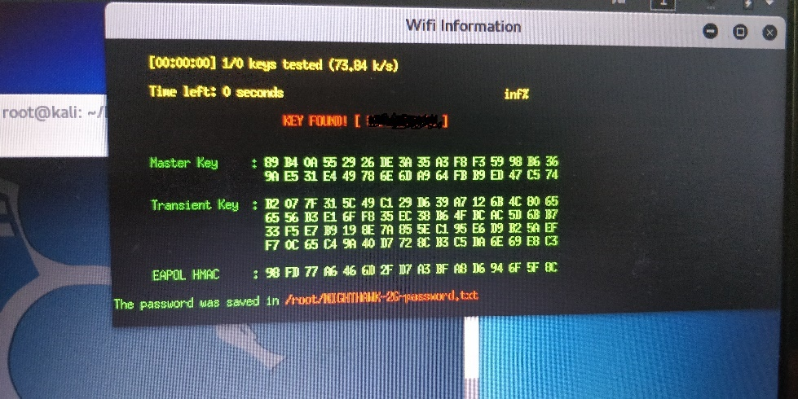
The user has entered the correct password and the attacker has saved the password into a .txt file so they can keep a log the network name and password, so they can connect later. The password has been crossed out in the image because the network password for this network is a real password so to protect the network the network password has been crossed out.

4.5 Design 3 –
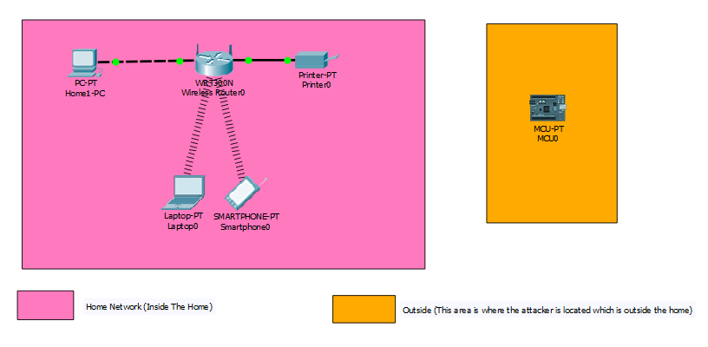
Design 3 is about securing against these attacks without adding additional security such as paying for hardware or software to be implemented. The owner of the network can disable the broadcast function on the router to ensure that any network scans will not allow the network to appear. This will stop all attackers in the area from finding the network and launching attacks against it. This method is highly recommended. The method is compatibly on all devices and all the home user must do different is when adding the wireless device to the network they must enter the network name and network password.

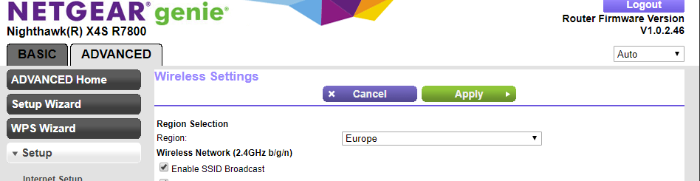
The network for which the attacks took place on had the broadcast SSID option enabled.

4.6 Design 4 –
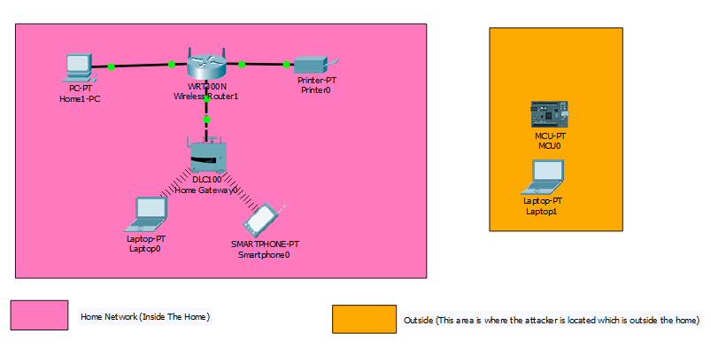
This design was created to secure the wireless network by adding another router or access point to the main router which has 802.11w technology which encrypts the management frames for all the wireless devices that are connected. This will stop all rouge attackers from sending malicious packets to the devices. This method compared to design 3 uses tons of money and takes a lot of time to setup as it’s more for advanced users so it’s not recommended.

4.7 Experiment-based project –
- What were the results –
  - Design 1 – The NodeMCU found the network and launched a de-authentication attack which stopped all WIFI devices on the network to stop working and launched a beacon attack which cloned and created multiple access point names to confuse the user and slow down the network. Results – Successful.
  - Design 2 – The Kali Linux OS was used to perform a simple de-authentication attack in-which they could continue onto making a clone of the user’s access point with a fake webpage tricking the user into entering their WIFI password to gain access into their network. Results – Successful.
  - Design 3 – The user can change the broadcasting information on the router to stop all network scans in the area to find the users network and launch a series of attacks. Results – Successful.
  - Design 4 – The user can adapt 802.11w technology into their network by buying additional router to support the technology and buying additional client devices that support 802.11w. Results could not be carried out since the equipment was too expensive and research has been gathered from numerus sources in chapter 2 to support the theory that it would work.

- Were the results expected?
- Design 1 – The expected outcome was that the attack would work against the network. The attack did indeed work. The outcome was a success.
- Design 2 – The expected outcome was that the attack would work if the first attack worked since a part of this attack ensures that design 1 works and it did. The attack worked, and the outcome was a success.
- Design 3 – The expected outcome was that this method could prevent attacks from hackers since the network could not be detected and the outcome was that it worked.
- Design 4 – The expected outcome was that the 802.11w technology would stop attackers disrupting the wireless connection on the network but the experiment could not be tested due to cost issue, but research suggests from chapter two that the soul purpose of the 802.11w technology was to block such an attack.

4.8 Survey-based Project – (21)
- What were the results –
- Question 1 –
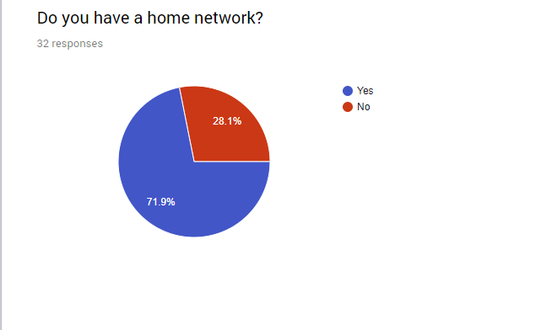
The pie chart represents the amount of people who answers yes or no to the question which was asked. The question answers the person doing the survey do they own a home network in-which case will determine if the project is relevant to them.

- Question 2 –
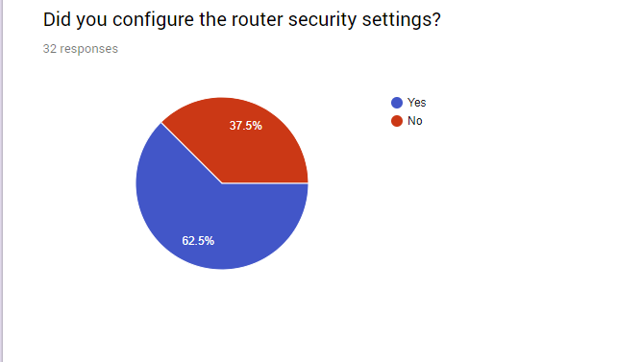
The amount of people said that they do change their settings such be a much higher number as it’s a security problem to use pre-configured security such as the pre-configured WIFI password which the company could still have on file and if it were to be leaked out into the public then the network could be at risk.

- Question 3 –
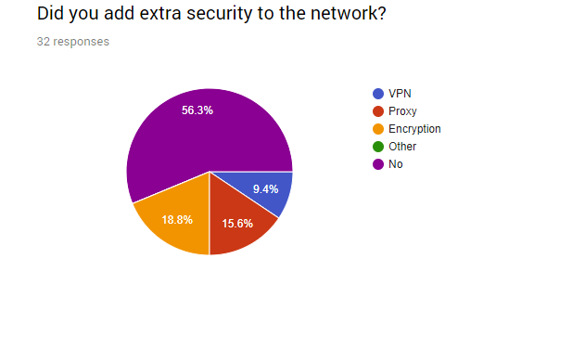
The amount of additional security that a network needs since so many networks have no to little security which causes so many networks to get hacked. This pie chart shows that the amount of people who did not use VPN’s, Proxies or even encryption is low. This number show be way higher, and it can cause many more networks to stay alive.

- Question 4 –
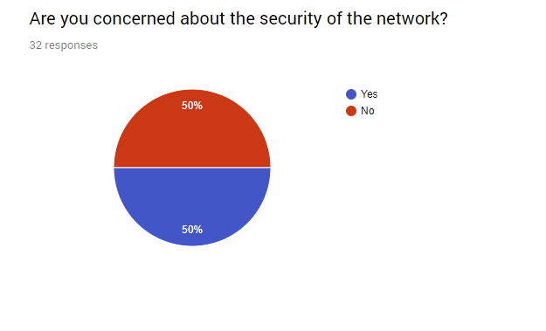
The amount of people who aren’t concerned about the security of their network is high and this number should be way lower as security is a huge factor when dealing with networks as it’s about is my information/data safe.

- Question 5 –
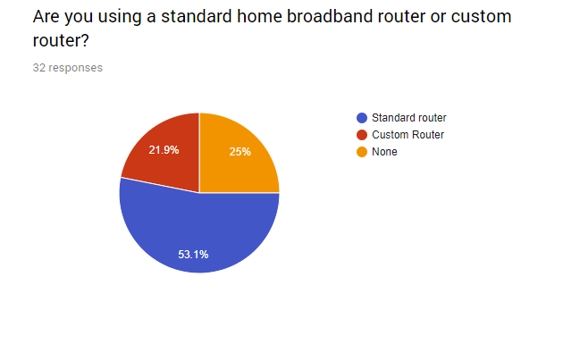
More users tend to use the standard router and this maybe the case due to the standard router coming free with all packages from the ISP they chosen. The custom router would imply they went out looking for a custom router to add more security or more features to the network such as IP routing support.

- Expected outcomes –
  - Question 1 – Expected outcome yes.
  - Question 2 – Expected outcome no.
  - Question 3 – Expected outcome no.
  - Question 4 – Expected outcome no.
  - Question 5 – Expected outcome standard router.

4.9 Conclusion –
To summarise this section of the project the author has provided a topology for each design and provided a list of code/commands which was used for each design for the reader to gasp on how to perform such an attack. The first two designs are about attacking the network from two different devices such as the first states that a NodeMCU was used to disrupt the network whilst design 2 explains that a laptop with a WIFI penetration operating system was used to gather information from the user to gain the network password so they can connect and perform more attacks but this time from the inside. Design 3 explains how these attacks could be stopped by a simple click of a button, but no-one has configured their routers to do so. Design 4 explains that there is a type of hardware in-which can be used to prevent this attack which costs millions and comparing it to design 3 it looks too advanced and not needed. The expected outcomes matched what the author initially thought. The project is experimental-based and survey-based since most of the project will be creating experiments to attack and secure the network whist research will be gathered from a survey which the author created.

Chapter 5 –

5.1 Introduction –
This section will be about evaluation on the project such as what conclusions can be drawn from the data and was the aims and objectives met. This section will also provide information on what the author could have done differently.

5.2 Evaluation –
- What conclusions can be drawn from your data?
  - Each attack was a success, so the data girthed from those attacks are extremely important as the exploits on the router cause a major problem wireless side of the network. The defending the network against these attacks had proven difficult but it can be done with minimal effort if the user is willing to not broadcast the access point. The major conclusion from this project is that people need to take network security more seriously as it’s important to add more security than the basic ones or pre-configured ones.

- Did you meet your objectives?
  - Most of the objectives for the project had been met expect for simulation 2 where cost was a major factor to project the network. New network devices such as Cisco Routers and Cisco Client devices would need to be purchased to allow the sort of protocols needed to protect the network from these attacks unless the user was willing to follow simulation 1 which was disabling the broadcasting access point or if the user was willing to wait another year for WPA3 to be released which fixes the problem.

- Did you meet your aims?
  - Both aims were met.

- Were the results from the previous chapter expected?
  - Most of the results were expected except the number of users from the survey who claim to not have much interest in security for their network and that most of the users still use the pre-configured settings.

- If the project was done again what would you have done differently?
  - If the author had taken this topic again the author would have taken the attacks into another level for example the author would have adapted Wireshark to the conclusion so once the packets were received to de-authenticate the device Wireshark would show on the device the packet being received. This would have provided an excellent idea of adding more detail towards the attack.

5.3 Conclusion –
This section has given the reader an insight on how the author could have done the project differently if the project was done again and if the author’s initial thoughts of the project turned out like he thought such as when more users claim to use pre-configured settings for their network. Many conclusions can be taken from the project such as it doesn’t take much cost wise to attack a network, but it costs a lot to secure the network from the attack.

Chapter 6 –

6.1 Introduction –
This section is a summary of the whole project. This section will tie-up any loose ends from the previous chapters.

6.2 Summary of the project –
The project has been about securing a home network in-which aims, and objectives have been set to provide goals to complete throughout the project. Both aims have been completed during the project and they were both completed in chapter 2 which is the research section since the aims were research based. The objectives were completed throughout the project so there isn’t a set section for all of them. The project offers methods of attacking a router using a NodeMCU board or using Kali Linux OS such as performing a de-authentication attack, beacon attack or even a fake access point attack to gain the network password. The project also offers information on how to prevent these attacks, which were either free or paid options. The report references other reports which are security-based from the IEEE website which has been verified and published. The report has given the reader information on security hardware compared to security software, WEP compared to WPA2-PSK and a standard router compared to a custom router. The report contains information on how the experiment can be copied for example the report contains images on how the devices were laid out, set-up and used. Chapter 4 provides the reader a step by step guide on how to clone the experiment using the code provided at each step (image). To summarize the report the author has provided information to complete all aims and most objectives expect the fourth due to high level of cost but the information for that experiment has been tested by another user and the information has been provided in the design section.

6.3 Conclusion –
To conclude this section of the report the author has provided a summary of the whole project such as if the aims and objectives were met throughout the project, if the experiment offered results in-which the author hoped for and the necessary information for the reader to clone the experiment such as the code, layout and devices used.

Chapter 7 –

7.1 Introduction –
This section will reflect the whole project to give the reader some in-sight into what information can be learnt from the project and how that information can be beneficial now or beneficial in the future.

7.2 What was learnt from the project –
The report offers tons of information but the most interesting information from the report is that how easy it is for an attacker to perform such attacks and how these attacks and damage the whole network such as shutting down the wireless services on the network rendering them useless. The author has learnt that it doesn’t take much knowledge to perform some based security measures such as changing the wireless passcode or turning the wireless broadcast mode off to stop attacks from finding the network. The project has offered information on the amount of people still use the older security protocol WEP around the world which doesn’t offer much protection against attackers. Each device should have its own security measure, so it acts as another layer of protection to prevent attacks such as security measures on the network devices (router or switch) and the network clients (computers or phones). The author stated in chapter five that if they had taken the project again they would implement Wireshark into the experiments which would allow the author to gather more results such as the type of packets being received from the attacker, the packet size and the protocol in-which the packet is being received such as TCP or UDP. The author has implemented a survey aspect to the project which allowed them to gather more research on the amount of networks which could be vulnerable these to attacks.

7.3 Benefits learnt from the project –
The project offers a range of benefits such as a list of security measures which should be in-place on all networks to provide protection from all angles such as installing a VPN on the router will filter all network traffic to that VPN server to prevent the real IP from being leaked and having a denial of service attack performed, an anti-virus on all devices which will scan all incoming file transfers to stop the virus from being opened and infecting the machine and the network or even installing a firewall on the router and client devices to have a dual layered firewall to prevent bad packets from being received on the devices. The major benefit of the project is that it shows a wide range of attacks and how these attacks can be performed either from a small device which can fit in the attacker’s pocket or from a large device like a laptop which can stop all wireless traffic and gain access to the network.

7.4 Conclusion –
To conclude this section the author has provided information on how the report can be beneficial to the reader and himself.

Chapter 8 –

8.1 References –

Number | URL – | Type – | Date/Time Accessed –
1 | https://www.google.co.uk/forms/about/ | Website  (Google Survey) | 10/02/2018  15:47
2 | https://www.kali.org/ | Website  (Kali Linux) | 10/02/2018  18:51
3 | https://ieeexplore-ieee-org.ezproxy.uwtsd.ac.uk/document/6987569/ | H. H. AlBreiki and Q. H. Mahmoud, "Evaluation of static analysis tools for software security," 2014 10th International Conference on Innovations in Information Technology (IIT), Al Ain, 2014, pp. 93-98. | 13/02/2018  14:56
4 | https://ieeexplore-ieee-org.ezproxy.uwtsd.ac.uk/document/5364834/ | D. Arturo, L. Romaña, K. Takemori, S. Kubota, K. Sugitani and Y. Musashi, "Towards the Design of Hardware Based Security Device and Communication Implementation," 2009 Second International Conference on Intelligent Networks and Intelligent Systems, Tianjin, 2009, pp. 250-252.  doi: 10.1109/ICINIS.2009.70 | 13/02/2018  15:21
5 | https://www.ons.gov.uk/peoplepopulationandcommunity/householdcharacteristics/homeinternetandsocialmediausage/bulletins/internetaccesshouseholdsandindividuals/2017 | Website  (Government website on the growth of home networking.) | 11/02/2018  11:14
6 | http://www.uwtsd.ac.uk/library/our-libraries/-owen-library---swansea/ | UWTSD Owen Library | 13/02/2018  18:01
7 | http://ieeexplore.ieee.org.ezproxy.uwtsd.ac.uk/document/7164728/ | S. Shaw and P. Choudhury, "A new local area network attack through IP and MAC address spoofing," 2015 International Conference on Advances in Computer Engineering and Applications, Ghaziabad, 2015, pp. 347-350. | 13/03/2018  13:19
8 | http://ieeexplore.ieee.org.ezproxy.uwtsd.ac.uk/document/7450782/ | S. Lipoff, "Hacking the House Chapter 2: The Boston VoIP doorbell," in IEEE Consumer Electronics Magazine, vol. 5, no. 2, pp. 44-48, April 2016. | 13/03/2018  13:51
9 | https://ieeexplore-ieee-org.ezproxy.uwtsd.ac.uk/document/8095429/ | T. Radivilova and H. A. Hassan, "Test for penetration in Wi-Fi network: Attacks on WPA2-PSK and WPA2-enterprise," 2017 International Conference on Information and Telecommunication Technologies and Radio Electronics (UkrMiCo), Odessa, 2017, pp. 1-4. | 13/03/2018  16:47
10 | http://ieeexplore.ieee.org.ezproxy.uwtsd.ac.uk/document/5443235/ | I. S. Ansari and A. S. Qutbuddin, "Biometrics for home networks security," 2009 IEEE Student Conference on Research and Development (SCOReD), UPM Serdang, 2009, pp. 136-138. | 13/03/2018  17:21
11 | http://ieeexplore.ieee.org.ezproxy.uwtsd.ac.uk/document/7379187/ | M. Agarwal, S. Biswas and S. Nandi, "Detection of De-Authentication DoS Attacks in Wi-Fi Networks: A Machine Learning Approach," 2015 IEEE International Conference on Systems, Man, and Cybernetics, Kowloon, 2015, pp. 246-251.  doi: 10.1109/SMC.2015.55 | 13/03/2018  17:56
12 | https://ieeexplore-ieee-org.ezproxy.uwtsd.ac.uk/document/8166386/ | C. L. Leca, "Overview of Romania 802.11 wireless networks security," 2017 9th International Conference on Electronics, Computers and Artificial Intelligence (ECAI), Targoviste, 2017, pp. 1-4. | 13/03/2018  19:49
13 | http://www.nodemcu.com/index_en.html | NodeMCU | 13/03/2018  19:49
14 | https://www.lookout.com/uk | Lookout | 01/04/2018  08:03
15 | https://support.microsoft.com/en-gb/help/17464/windows-defender-help-protect-computer | Windows Defender | 01/04/2018  08:24
16 | https://support.microsoft.com/en-us/help/4028544/windows-turn-windows-firewall-on-or-off | Windows Firewall | 01/04/2018  09:19
17 | https://qph.fs.quoracdn.net/main-qimg-b115c1a9d3c8b9f4fc3be597a5d2bbb1.webp | Firewall Image | 01/04/2018  09:19
18 | https://9to5mac.files.wordpress.com/2017/09/what-is-vpn-how-it-works-need-of-vpn.jpg?quality=82&strip=all&w=1500 | VPN Image | 01/04/2018  09:19
19 | https://github.com/spacehuhn/esp8266_deauther | NodeMCU De-auth Firmware. | 01/04/2018  15:32
20 | https://github.com/pnptutorials/fluxion | Fluxion | 01/04/2018  15:36
21 | https://goo.gl/forms/N6Ate527uFVjCmJw1 | Google Survey | 01/04/2018  17:30
22 | https://blog.securifi.com/replace-your-isp-modem | Securifi Blog | 01/04/2018  19:57
23 | http://www.netgear.co.uk/home/products/networking/wifi-routers/R7800.aspx | Nighthawk R7800 | 01/04/2018  21:32

Chapter 9 –

9.1 Appendices –

Gantt chart –

The Gantt chart shows the allocated time slots of each task within the project. The Gantt chart offers the reader an in-sight on how the project time allocation was planned and carried out.

