DBA Quantitative Research Methods

Investigating the Antecedents and Consequences of Creative Deviance among UK Early-Career Hybrid Professionals

Student Name: Nguyen Ngoc Quynh Tran
Student Number: 2433797
Module No: LCDB7011
Number of words: 7950

Table of Contents
Chapter 1: Introduction 5
1.1 Background and Research Problem 5
1.2 Research Gap and Rationale 5
1.3 Aim, Research Questions and Objectives 6
1.4 Intended Contribution and Report Structure 6
Chapter 2: Critical Literature Review and Conceptual Framework 8
2.1 Creative deviance and the authorisation boundary 8
2.2 Obsessive work passion and perceived error-management climate 9
2.3 Political skill and incident-specific digital enactment 10
2.4 Innovative and relational consequences 11
2.5 Hybrid context, competing explanations and research gap 12
2.6 Conceptual framework and hypotheses 13
Chapter 3: Research Methodology 14
3.1 Research philosophy and design 14
3.2 Population, eligibility and sampling 14
3.3 Procedure, ethics and achieved sample 15
3.4 Questionnaire development and expert review 15
3.5 Measures and scoring 16
3.6 Data preparation and SPSS strategy 17
3.7 Methodological limitations 18
Chapter 4: Data Analysis and Findings 19
4.1 Sample and Incident Characteristics 19
4.2 Measurement Quality 20
4.3 Zero-Order Correlations 22
4.4 H1: OWP × EMC Predicting Creative Deviance 24
4.5 H2 and H2a: Creative Deviance × DPSE Predicting IWB 25
4.6 H3 and H3a: Creative Deviance × DPSE Predicting Relational Strain 26
4.7 Summary of Hypothesis Testing 26
Chapter 5: Discussion 28
5.1 Interpretation of the Findings 28
5.2 Theoretical Contribution and Implications 29
5.3 Practical Contribution and Implications 30
5.4 Limitations and Future Research 30
Chapter 6: Conclusions and Recommendations 32
6.1 Conclusions 32
6.2 Evidence-Informed Recommendations for Practice 33
References 34
Appendix A. Supplementary Figures 41
Appendix B. Participant-Facing Survey Questionnaire 43
Participant Information 43
Eligibility 44
Selecting One Focal Incident 45
Relationship Before the Decision 47
Obsessive Work Passion 48
Perceived Error-Management Climate 48
Creative Deviance 49
General Political Skill 50
Digital Political Skill Enactment During the Focal Incident 51
Focal-Idea Innovative Work Behaviour 52
Focal-Manager Relational Strain 53
Incident Communication and Practice Context 53
Exploratory Generative-AI Context 55
Background Information 56
Closing Information 58

List of Abbreviations
Abbreviation | Meaning
CD | Creative deviance
CI | Confidence interval
DPSE | Digital Political Skill Enactment
EMC | Perceived error-management climate
HC3 | Heteroskedasticity-consistent standard error estimator, type 3
IWB | Innovative work behaviour
OLS | Ordinary least squares
OWP | Obsessive work passion
PSI | Political Skill Inventory
SE | Standard error
SPSS | Statistical Package for the Social Sciences
VIF | Variance-inflation factor

Abstract
Creative deviance arises when employees continue developing an idea after a manager has explicitly refused to authorise further work. This persistence may preserve innovative potential while creating authority, resource and relational risks. This study examined a conditional model with two outcomes among UK professionals at early career stages working in hybrid arrangements. A retrospective critical incident survey administered in a single wave yielded 81 submissions, of which 75 were eligible. Hierarchical ordinary least squares regression assessed the fit of the model and incremental explained variance, while HC3 robust standard errors provided the primary basis of coefficient inference. Perceived error management climate conditioned the association between obsessive work passion and creative deviance, which became more positive as climate increased. At mean Digital Political Skill Enactment (DPSE), creative deviance was positively associated with innovative work behaviour relating to the focal idea. The interaction was significant under HC3 inference but narrowly missed significance under conventional inference and became less precise after research panel exclusion. Creative deviance was not significantly associated with relational strain after adjustment, and DPSE did not provide the proposed relational buffer. The findings support governed reconsideration routes but not encouraging unauthorised work, inferring causality or treating incident-specific political enactment as a validated capability.
Keywords: Creative deviance, Obsessive work passion, Error management climate, Innovative work behaviour, Digital political skill, Hybrid work

Chapter 1: Introduction

1.1 Background and Research Problem
Organisations cannot authorise every employee idea because stopping development may reflect strategic fit, evidence, timing, resources, regulation or information security constraints. The challenge intensifies when an employee remains convinced of an idea’s value and continues despite explicit non-authorisation. Creative deviance describes this situation. It occurs when an employee continues developing an idea despite a clear instruction from the manager to stop, rather than merely disagreeing or pursuing innovation in general (Mainemelis, 2010; Lin et al., 2016).
Creative deviance is neither inherently valuable nor inherently harmful. It may preserve a rejected idea while consuming resources and challenging managerial authority. In hybrid work, continued activity can be reframed, coordinated and made visible across digital channels and face to face exchanges. Technology perceptions and coordination matter for workplace relationships and idea production (Wu et al., 2023; Gibbs et al., 2024), but this evidence does not explain what happens after the decision to stop idea development is made.

1.2 Research Gap and Rationale
The evidence is fragmented across three dimensions. First, existing explanations draw on evidence from different levels and contexts. Obsessive work passion provides a persistence mechanism, while error management conditions may shape its expression (Vallerand et al., 2003; van Dyck et al., 2005). Xu et al. (2026) connected these elements in Chinese R&D settings, but team culture and an employee’s perception of a specific incident are not interchangeable.
Second, the availale research has not examined innovative and relational outcomes together within the same rejected-idea incident. Studies of bootlegging and creative deviance report links with innovation-related outcomes (Criscuolo et al., 2014; Li et al., 2025), but they do not assess innovative work behaviour for the same rejected idea. Social undermining, ostracism and leader silence indicate relational costs (Shukla et al., 2024; Wang, 2023; Wen et al., 2025), but none of these measures strain with the manager who rejected the idea. These differences mean that earlier findings cannot be applied directly to the outcomes investigated here.
Third, Political Skill Theory concerns general capability, not what an employee enacted after a particular decision (Ferris et al., 2005; Munyon et al., 2015). DPSE captures incident-specific practices and is treated as a study-specific index rather than a validated trait or assumed safeguard.
No reviewed study combines these elements within one incident where a manager explicitly refused further idea development among UK early career hybrid professionals. Early career status and hybrid work are contextual boundaries, not uniform explanations. The study therefore evaluates this configuration without treating findings from related constructs, countries or different analytical levels as direct validation.

1.3 Aim, Research Questions and Objectives
The study examines a conditional model with two outcomes within incidents of managerial non-authorisation reported by UK early career hybrid professionals. The main question asks what pattern of associations characterises the predictor and outcome relationships within these incidents.
RQ1 examines how perceived error management climate conditions the association between OWP and creative deviance. RQ2 examines the association between creative deviance and focal idea innovative work behaviour (IWB), and whether DPSE conditions it. RQ3 examines the association between creative deviance and focal manager relational strain, and whether DPSE conditions it.
RO1 tests the OWP and creative deviance association across levels of perceived error management climate. RO2 evaluates the creative deviance and IWB association and whether DPSE strengthens it. RO3 evaluates the creative deviance and relational strain association and whether DPSE attenuates it. RO4 integrates findings and translates their evidential boundaries into implications for organisational practice and future doctoral research.

1.4 Intended Contribution and Report Structure
The intended theoretical contribution connects a relationship that varies with percieved context with innovative and relational outcomes from the same incident, while distinguishing general political capability from incident-specific enactment. The practical contribution informs structured reconsideration processes, governance safeguards and communication practices without assuming that unauthorised work should be encouraged or that political enactment removes relational risk. Chapter 2 develops the conceptual framework and hypotheses. Chapter 3 explains the methodology. Chapter 4 reports the findings. Chapter 5 interprets their theoretical and practical implications. Chapter 6 presents conclusions and evidence-based recommendations.

Chapter 2: Critical Literature Review and Conceptual Framework

2.1 Creative deviance and the authorisation boundary
Creative deviance begins where ordinary disagreement ends. Mainemelis (2010) defines it as the continued development of an idea after a legitimate authority instructed the employee to stop. This definition separates an idea’s authorisation status from its eventual quality. Lin et al. (2016) reinforce this boundary by examining how leaders’ responses relate to later creative deviance and creative performance. Wang et al. (2025) focus on what may happen before creative deviance occurs. Across a three-wave study and an experiment, rejection was linked to creative identity threat, particularly when employees strongly identified with a creative role. This threat was associated with further unauthorised pursuit. Rejection may therefore stop an idea or strengthen determination to prove its value.
Creative deviance differs from related behaviours. Bootlegging involves unofficial innovative activity that can occur without prior managerial rejection (Criscuolo et al., 2014; Globocnik et al., 2022). Constructive deviance is voluntary behaviour that violates significant organisational norms to benefit the organisation or its members (Galperin, 2012). Creative deviance is narrower because it requires continued development after an explicit managerial instruction to stop (Mainemelis, 2010; Lin et al., 2016). Innovative work behaviour (IWB) does not depend on authorisation status and includes opportunity exploration, idea generation, championing and implementation (de Jong & den Hartog, 2010). Studies using broader deviance or innovation measures are not direct tests of persistence after explicit non-authorisation.
Research instead suggests that the consequences of creative deviance depend on the conditions under which it occurs. Conceptual work frames it as a mixed blessing. It may preserve ideas that formal systems reject too early, while also consuming resources and challenging managerial authority (Shukla & Kark, 2020). Xu et al. (2022) reported an inverted U relationship between authoritarian leadership and creative deviance. Wan et al. (2026) identified two opposing pathways within the same model. Resource integration formed a positive pathway, whereas ego depletion formed a negative one. The unresolved issue is when creative deviance is linked to innovative activity and when it coincides with personal or relational costs.

2.2 Obsessive work passion and perceived error-management climate
The dualistic model distinguishes harmonious from obsessive work passion (OWP). OWP means controlled internalisation. Employees experience internal pressure to continue an activity they value and find it difficult to step away from it (Vallerand et al., 2003). This pressure can be costly. Across two multisource field studies, OWP was linked to emotional exhaustion, although career adaptability weakened the exhaustion pathway to performance (Amarnani et al., 2020). Daily evidence also connected obsessive internalisation with poorer detachment and greater next-day exhaustion. Exhaustion then predicted lower subsequent passion (Bredehorst et al., 2024). Across four occupational groups, job characteristics are differentially related to work passion, showing that context matters (Astakhova et al., 2024). None of these studies investigates persistence following managerial rejection of an idea. OWP can therefore explains why an employee may persist, but not what that persistence produces.
Perceived error-management climate (EMC) may help explain when this persistence becomes creative deviance. Previous studies, however, addresses different forms of error management. Van Dyck et al. (2005) define organisational culture through error communication, analysis, correction and learning. At employee level, Kruse and Wegge (2024) found that employees reporting a more constructive EMC also scored higher on a two-item measure labelled employee innovative performance. Both measures came from the same 2010 survey in one multinational telecommunications company. The outcome concerned general innovation, not creative deviance. Their findings are relevant, but they do not directly support H1.
Evidence from teams is less straightforward. In a randomised study, error-management instructions increased members’ perceptions of EMC in newly formed teams. These perceptions were then related to objective team performance (Horvath et al., 2023). Chen et al. (2022), by contrast, found no direct statistical link between aggregated team EMC and employee creativity rated by supervisors. Their results instead indicated an indirect pathway through workplace gratitude, which was stronger when job satisfaction was low. The relevance of team EMC, therefore, depended on the pathway and outcome considered.
Research involving creative deviance is narrower. In a three-wave Chinese employee study, Guo and Li (2026) connected EMC indirectly to radical creativity through autonomous and controlled motivation. The strength of both indirect relationships varied with remote work, while the direct pathway between EMC and radical creativity did not reach statistical significance. Xu et al. (2026) offer the closest comparison that error-management culture conditioned the relationship between team leaders’ OWP and creative deviance. However, team leaders and organisational culture differ from employee OWP and incident-specific perceived EMC. Other evidence concerns bootleg innovation rather than creative deviance (Wang et al., 2025), or creative climate rather than EMC (Ismail et al., 2024).
The present study focuses on one employee’s retrospective view of the immediate work environment during one rejected-idea incident. It does not measure a shared team climate, organisational culture or a general perception outside the incident. Nor can it establish that a shared climate or culture objectively existed. H1 proposes that OWP will be more strongly related to creative deviance when perceived EMC is higher during the focal incident. This is a boundary test at employee level. It neither replicates team or organisational studies nor treats favourable error-management perceptions as approval of unauthorised work.

2.3 Political skill and incident-specific digital enactment
Political skill is a general capability comprising social astuteness, interpersonal influence, networking ability and apparent sincerity (Ferris et al., 2005). Its reliability is well established, although it varies across samples (Jacobson & Viswesvaran, 2017). Political skill has been associated with IWB among UK junior doctors through role overload (Clarke & Higgs, 2020). Munyon et al. (2015) linked it to work outcomes. Yet, It is not inherently prosocial. Among business salespeople, it supported relationship building and performance but did not directly predict less misconduct by salespeople toward customers, termed customer-directed deviance (Good & Schwepker, 2022).

The PSI captures capability, not what an employee did after an idea was rejected. Kolodinsky et al. (2007) found that supervisors responded differently to a rationality tactic across levels of political skill, and the tactic appeared to backfire when skill was low. The outcomes were supervisor liking and perceived similarity. Put plainly, they concerned how positively the supervisor viewed the employee and how similar the two seemed. The tactic was in person, and neither outcome measured focal manager relational strain.

The Hierarchy of Voice framework argues that rank, communication and inferred motives shape responses to voice (Pfrombeck et al., 2022). However, it is conceptual, and voice is not creative deviance. Di Gangi et al. (2022) linked political skill used through technology to opportunity recognition in MTurk communities. The setting was not hybrid, and DPSE was not tested.

Therefore, DPSE is a formative index developed for this study. Its 12 practices cover interpretation, framing, timing, coalition building and visibility management, and are scored within four digital components adapted from the PSI dimensions. DPSE is not a validated latent trait.

Separating capability from enactment creates two expectations. Framing and coalition building may translate continued idea development into championing and implementation. Interpretation, timing and consistency across channels may reduce hostile attributions. These are theoretical, not established DPSE effects. General political skill remains a benchmark covariate to separate DPSE findings from stable capability.

2.4 Innovative and relational consequences
Evidence for an innovation benefit is substantial but indirect. Bootlegging has been associated with individual innovative performance (Criscuolo et al., 2014), and organisational bootlegging with portfolio newness (Globocnik et al., 2022). Li et al. (2025) indicated that creative deviance mediated the association between empowering leadership and innovation performance. Wan et al. (2026), however, showed that resource integration and ego depletion operate in opposite directions. These studies use creativity, performance or portfolio outcomes rather than focal-idea IWB. The present outcome is narrower: post-decision exploration, generation, championing and authorised implementation concerning the same idea. Creative deviance and IWB may still overlap empirically because both records continued idea-related activity. Their conceptual difference rests on authorisation: creative deviance measures unauthorised continuation, whereas IWB measures the innovation activities that follow.
The relational evidence points in a less favourable direction. Shukla et al. (2024) associated creative deviance with experienced social undermining and found that leader–member exchange weakened that association. Wang (2023) linked constructive deviance with workplace ostracism and identified political skill as a buffer. Wen et al. (2025) connected subordinate creative deviance with leader silence through leader anxiety. Workplace-trust research further emphasises relational dynamics, levels and context (Dirks & de Jong, 2022). Yet undermining, ostracism, silence and trust involve different actors or constructs. None is equivalent to strain with the manager who rejected the idea. They signal possible social costs, not an established effect on that relationship.
The direction of influence also remains uncertain. A strained relationship may precede deviance, and a manager’s response may shape how the employee later reports the incident. Longitudinal evidence from destructive-leadership research shows that conclusions change when prior levels and reciprocal paths are considered (Li et al., 2024). Although the constructs differ, causal direction cannot be presumed. Prior relationship quality is therefore a rival explanation, not a peripheral control. Later authorisation creates another ambiguity. Once approved, ealier unauthorised may be remembered as justified innovation. H2 and H3 test the outcome associations at mean DPSE; H2a and H3a test whether greater enactment strengthens the innovative association and weaken the relational one.

2.5 Hybrid context, competing explanations and research gap
Hybrid work changes how influence is attempted. Organisational social media afford visibility, persistence, editability and association (Treem & Leonardi, 2013), while perceived media richness develops with experience (Carlson & Zmud, 1999). Wu et al. (2023) found that advice ties were less likely to persist when seekers and advisers differed in perceived ease of use. Gibbs et al. (2024) reported that idea submissions fell during hybrid work in a large Indian IT firm, especially in teams with poorly coordinated office presence. Technology perceptions and coordination matter, but these studies neither rank channels nor test DPSE after rejection.

Competing explainations remain. Idea quality may drive persistence and IWB, while prior manager relations may permit disagreement and reduce strain. Several status cues predicted supervisor recognition beyond reported voice, but newcomer status was not robust in the omnibus model (Howell et al., 2015). Newcomers are not equivalent to early-career professionals, and their voice has distinct socialisation dynamics (Dufour et al., 2026). Hornsey et al. (2007) found that newcomer criticism elicited more resistance than criticism from established members, but the experiment does not establish uniform early-career disadvantage across professions. Reports from one source may inflate associations and obscure temporal order.

No reviewed study combines one explicitly non-authorised incident, two parallel outcomes and digitally enacted political skill among UK early-career hybrid workers The contribution lies in this configuration, which connects a context-conditioned path, two incident-level outcomes and enactment beyond general political skill within the same idea episode.

2.6 Conceptual framework and hypotheses
The conceptual framework comprises two connected components examined within the same single-wave survey. In the OWP–EMC component, perceived error-management climate conditions the association between OWP and creative deviance. In the outcome component, creative deviance is associated with focal-idea IWB and focal-manager relational strain, with DPSE proposed as a moderator. Figure 1 summarises these associations. All arrows represent statistical associations rather than causal effects.
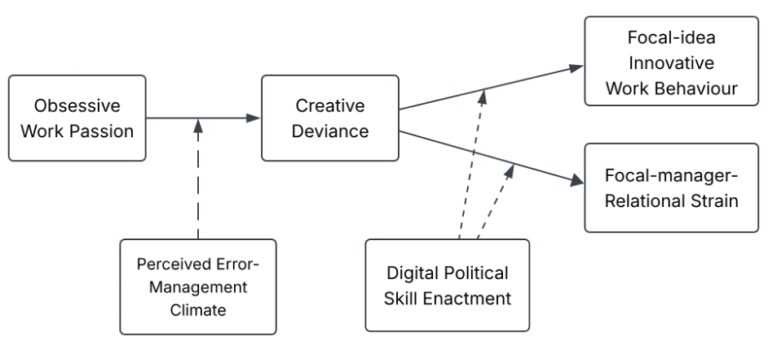

Figure 1. Conceptual framework for the hypothesised associations.

H1. Perceived error-management climate moderates the association between obsessive work passion and creative deviance, such that the association becomes more positive at higher levels of perceived error-management climate.
H2. Creative deviance is positively associated with focal-idea innovative work behaviour.
H2a. DPSE positively moderates the association between creative deviance and focal-idea innovative work behaviour, such that the positive association becomes stronger as DPSE increases.
H3. Creative deviance is positively associated with focal-manager relational strain.
H3a. DPSE negatively moderates the association between creative deviance and focal-manager relational strain, such that the positive association becomes weaker as DPSE increases.

Within Models 2 and 3, creative deviance (CD) coefficients test H2 and H3 at the sample mean of mean-centred DPSE, while the CD × DPSE coefficients test H2a and H3a.

Chapter 3: Research Methodology

3.1 Research philosophy and design
This study adopts a positivist, deductive and quantitative approach. The main research question and its three subquestions concern measurable patterns among defined constructs, while the hypotheses specify associations and interaction effects that can be tested statistically. Focal incidents and reported behaviours are treated as events that can be investigated systematically, although they are accessed through fallible self-reports rather than direct observation. Participant perceptions are therefore analysed as individual-level measures; they are not treated as objective facts about an organisation. Researcher influence was limited through a standardised questionnaire, fixed eligibility rules, predefined scoring and a common analytical procedure. These measures support consistency but cannot remove recall or response bias.

The design is cross-sectional, retrospective and non-experimental. Participants answered with reference to one idea, one manager and one explicit non-authorisation decision. Temporal instructions separated the pre-incident relationship, conditions at the time of the decision and subsequent behaviours and outcomes. All responses were nevertheless collected in one administration. The design estimates sample-specific associations and assesses whether the incident structure and measures operate as intended; it does not establish causal direction, temporal precedence, objective idea quality or the manager’s perspective.

3.2 Population, eligibility and sampling
The target population comprised adults currently working in the UK who were within six years of entering the first paid role they regarded as the start of their longer-term occupational or professional career. At the time of the focal incident, they had to work under a regular hybrid arrangement combining employer/client-location work with work away from that location, supported by digital communication. Eligibility also required an incident within the previous 12 months in which a manager explicitly rejected further development or withheld permission to use work time, resources or organisational channels. Criticism, silence, temporary delay and an invitation to revise did not qualify without explicit non-authorisation.

No sampling frame exists for this narrowly defined population. Recruitment therefore used non-probability, multi-channel purposive and volunteer sampling. The eligible sample comprised 16 respondents recruited through alumni or university networks, 17 through administrator-approved online communities, nine through professional networks, 13 through participant referral and 20 through a third-party research panel. Recruitment source was retained because routes may attract different respondents, and online platforms can vary in data quality (Peer et al., 2022). This establishes neither inferior data from any route nor UK population representativeness.

3.3 Procedure, ethics and achieved sample
The questionnaire was administered through Microsoft Forms. The platform was configured not to record names or email addresses. Participants received study information, provided consent, completed the eligibility checks and selected the most recent qualifying incident. The remaining blocks covered the incident context, pre-incident relationship, focal constructs, communication practices and background characteristics. Respondents were instructed not to identify an employer, manager, client or idea and not to disclose confidential or security-sensitive information.

Data collection was undertaken within the arrangements established for the coursework. A separate institutional ethics application was not completed for this exercise. Participation was voluntary and anonymous, and respondents could leave before submitting their answers. Because responses were anonymous, individual submissions could not be identified for later withdrawal. Any subsequent doctoral study will be subject to the University’s formal ethics and data-protection procedures before recruitment begins.

Data were collected over approximately two months. The analysis was based on the eligible responses available when the dataset was extracted for analysis. The survey produced 81 submissions. Four were outside the specified career-tenure boundary and two did not meet the hybrid-working criterion. After these six responses were removed, 75 eligible cases remained.

3.4 Questionnaire development and expert review
Questionnaire development followed the conceptual framework and the requirement to keep every focal measure tied to the same incident. Established measures were retained where their content matched the construct. Adaptations changed general work referents to the focal idea or manager, converted supervisor ratings to employee self-reports where necessary, and added decision-specific time anchors. Researcher-developed items covered eligibility, incident status, pre-incident relationship conditions, communication practices and DPSE.

Before data collection, two professionals whose backgrounds matched the target population reviewed the questionnaire through direct and Teams-based discussion. Their feedback led to changes in item wording and survey instructions. Guidance treats content review as one stage of validation (Hinkin, 1998; Boateng et al., 2018). The review improved comprehensibility but was not psychometric validation. Neither reviewer entered the analytical sample.
The questionnaire also contained contextual incident-practice and generative-AI items. Only incident visibility was reported descriptively; none of these contextual items entered the hypothesis tests.

3.5 Measures and scoring
Table 1. Study Measures, Scoring and Model Roles
Construct | Items | Source | Scoring | Model role
Obsessive work passion | 7 | Vallerand et al. (2003) | 1–7 item mean | Predictor, H1
Perceived error-management climate | 16 | Adapted from van Dyck et al. (2005) | 1–7 item mean | Moderator, H1
Creative deviance | 8 | Scale reported by Lin et al. (2016); eight-item form validated by Shukla et al. (2024) | 1–5 item mean | Outcome H1; predictor H2–H3
General political skill | 18 | Ferris et al. (2005) | 1–7 item mean | Benchmark covariate
Digital Political Skill Enactment (DPSE) | 12 | Researcher-developed formative index | Four component means, averaged with equal weight | Moderator, H2a/H3a
Focal-idea IWB | 10 | Adapted from de Jong and den Hartog (2010) | 1–5 item mean | Outcome H2/H2a
Focal-manager relational strain | 4 | Adapted from Spector and Jex (1998) | 1–5 item mean | Outcome H3/H3a

In this study, EMC denotes the respondent’s retrospective perception of error handling in the immediate environment surrounding the focal incident. The score was not aggregated and therefore does not establish a shared team climate or organisational error-management culture.

Reflective measures were scored as item means, with higher values indicating more of the construct. Adaptation limits direct comparability with the original instruments. Pre-incident relationship quality was recorded through a separate global indicator and used only as a contextual covariate; it was not labelled as leader–member exchange or treated as a scale.

DPSE was specified as a formative index because its components were treated as defining practices rather than interchangeable manifestations of a latent trait (Diamantopoulos & Winklhofer, 2001). Twelve practices were mapped equally across digital social astuteness, digital interpersonal influence, digital networking and cross-channel sincerity/visibility management. “Did not do this” represented zero enactment; “not applicable” represented missing data. Items were averaged within each component before the four component scores were averaged. Equal weighting was a transparent study-specific scoring decision rather than an empirically validated weighting scheme. The study assesses the behaviour of this scoring rule in the achieved sample but does not claim that DPSE has been validated.

3.6 Data preparation and SPSS strategy
All quantitative analysis was conducted in IBM SPSS Statistics (SPSS), as required by the assessment brief. Screening covered consent and eligibility, duplicate responses, routing consistency, out-of-range values, attention checks, missingness and implausibly rapid completion where timing information was available. Screening preceded hypothesis assessment. Descriptive analysis reported participant and incident characteristics, frequencies for categorical variables, and means, standard deviations and observed ranges for continuous variables.

Internal consistency of the reflective measures was assessed using Cronbach’s alpha. Alpha was treated as evidence of internal consistency, not construct validity or unidimensionality (McNeish, 2018). The separation of creative deviance and IWB was examined because both concerned the same idea. Selected questionnaire features—including distinct block instructions, time anchors and construct-specific referents—were intended to reduce some common-method cues, but they could not eliminate common-method risk in a retrospective single-source design (Podsakoff et al., 2003). Harman’s single-factor test was not used to infer that common-method bias was absent because the test does not reliably distinguish research designs with different levels of common-method risk (Howard et al., 2024).

The hypotheses were examined using three hierarchical moderated-regression models. Continuous predictors were mean-centred before product terms were created. Model 1 regressed creative deviance on OWP, perceived climate and their interaction. Model 2 regressed focal-idea IWB on creative deviance, DPSE and their interaction, with general political skill retained as a benchmark. Model 3 used focal-manager relational strain as the outcome and additionally controlled pre-incident relationship quality. Hybrid intensity, career tenure and recruitment source were retained for specified contextual or rival-explanation roles rather than automatic inclusion (Bernerth & Aguinis, 2016). All hierarchical models were estimated by ordinary least squares (OLS). Given N=75, HC3 heteroskedasticity-consistent standard errors (SEs) and confidence intervals (CIs) provided the primary coefficient-level inference because finite-sample simulations recommend HC3 for samples of 250 or fewer (Long & Ervin, 2000); conventional OLS statistics evaluated model fit and changes in explained variance. Where OLS and HC3 led to different hypothesis decisions, both were reported. A research-panel-exclusion sensitivity analysis removed the 20 respondents recruited through the third-party research panel, leaving N=55; the final models were then re-estimated using the same specifications. With 75 cases, interaction estimates were expected to be imprecise and treated as preliminary.

3.7 Methodological limitations
The design is limited by retrospective single-source reporting, non-probability recruitment and a sample that provided limited precision for detecting modest interaction effects. Adapted measures may not retain the full properties of their original versions, while DPSE requires independent development and validation. These constraints bound the findings to associations within the achieved sample; their implications for future research design are considered in Section 5.4.

Chapter 4: Data Analysis and Findings

Chapter 4 reports the achieved sample, measurement evidence, zero-order correlations and three moderated-regression models. As specified in §3.6, OLS statistics describe model fit and changes in explained variance, while HC3 standard errors provide the primary coefficient inference.

4.1 Sample and Incident Characteristics
The analytical sample contained 75 eligible UK early-career hybrid professionals retained from 81 submissions. Four submissions fell outside the career-tenure boundary and two did not satisfy the hybrid-work criterion. No analysis variable contained missing information. The sample was concentrated in the younger age bands: 48.0% were aged 18-24 and 34.7% were aged 25-29. Forty respondents selected Man and 35 selected Woman. Most participants were employed full-time (77.3%). Private-sector representation was highest (37.3%), followed by professional services and technology (24.0% each). Figure 2 presents the full demographic and employment profile.
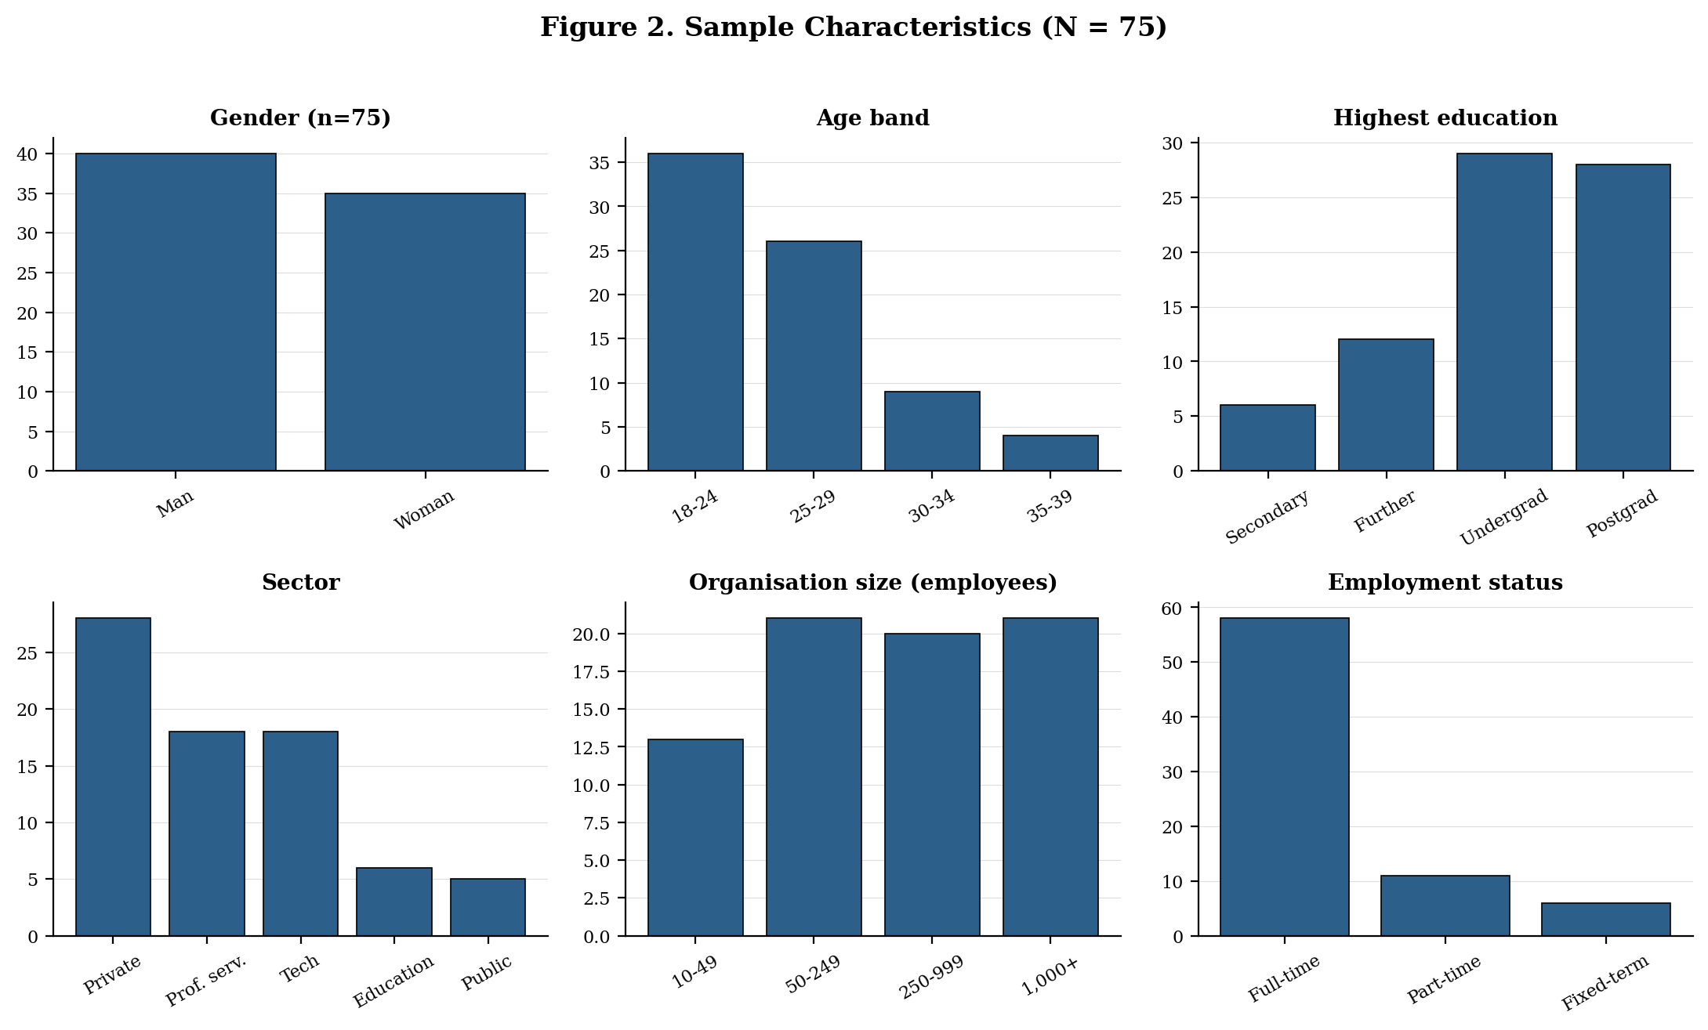
Figure 2. Sample characteristics (N=75): gender, age band, highest education, sector, organisation size and employment status.
Figure 3 summarises the work context and focal incident. Hybrid intensity was concentrated at two and three days per week away from the employer or client location, while 57 respondents (76.0%) held no line-management responsibility. Recruitment comprised alumni or university networks (n=16), online communities (n=17), professional networks (n=9), referrals (n=13) and a third-party research panel (n=20). Continued idea development was at least partly visible in 58 cases (77.3%). The first subsequent action occurred within one month in 64 cases (85.3%), including 11 respondents who acted on the same day.
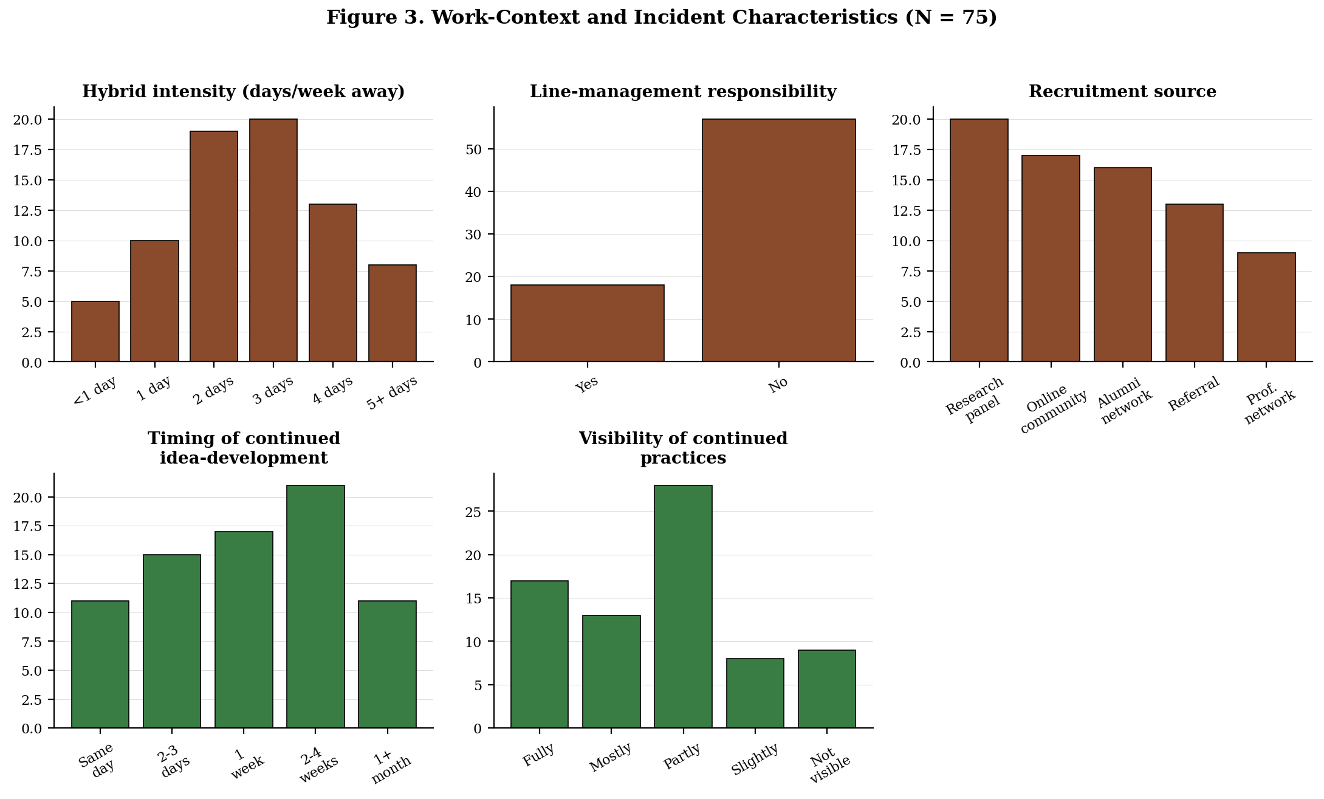
Figure 3. Work-context and focal-incident characteristics (N=75): hybrid-working intensity, line-management responsibility, recruitment source, timing and visibility.

4.2 Measurement Quality
Table 2 reports descriptive statistics and reliability evidence. Internal consistency was high across the six reflective measures, with Cronbach’s α ranging from .903 for relational strain to .989 for perceived EMC. The high coefficients for perceived EMC and general political skill indicate score consistency, not unidimensionality (McNeish, 2018). Digital Political Skill Enactment (DPSE) was specified as an equal-weight formative index of four component means. Alpha was not calculated because internal consistency is not an appropriate criterion for formative indicators (Diamantopoulos & Winklhofer, 2001).

Table 2. Descriptive Statistics and Reliability Estimates for Study Variables (N=75)
Variable | M | SD | Min | Max | Items | Cronbach’s α
Obsessive work passion (OWP) | 3.61 | 1.44 | 1.29 | 7.00 | 7 | .967
Perceived error-management climate (EMC) | 4.56 | 1.60 | 1.31 | 6.94 | 16 | .989
Creative deviance (CD) | 2.99 | .90 | 1.50 | 5.00 | 8 | .945
General political skill | 4.66 | 1.31 | 1.11 | 6.94 | 18 | .986
Digital Political Skill Enactment (DPSE) | .76 | .33 | .17 | 1.75 | 12 | N/A
Focal-idea IWB | 3.07 | 1.00 | 1.30 | 5.00 | 10 | .963
Relational strain | 2.57 | .95 | 1.00 | 4.50 | 4 | .903

The reflective composites were retained in their specified forms. Creative deviance contained eight items, focal-idea IWB contained ten and relational strain contained four. OWP, perceived EMC and general political skill contained seven, 16 and 18 items, respectively. Reliability was considered alongside scale composition and was not used to justify item deletion after outcomes had been examined. The DPSE components were also retained as specified.

The observed DPSE range was .17-1.75 on its theoretical 0-4 metric, indicating limited representation of very high enactment. The three outcomes shared a 1-5 response metric. Creative deviance ranged from 1.50 to 5.00, focal-idea innovative work behaviour (IWB) from 1.30 to 5.00 and relational strain from 1.00 to 4.50. Figure 4 displays their distributions. No observation fell beyond the standard boxplot fences based on 1.5 times the interquartile range.
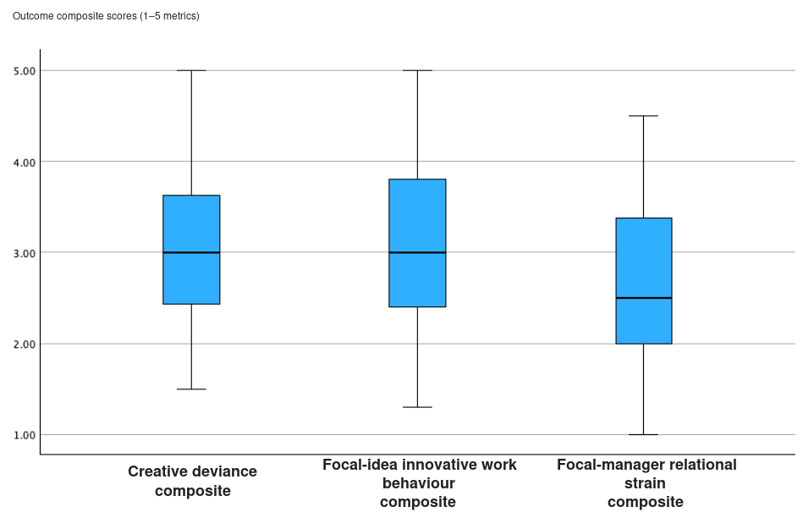
Figure 4. Distribution of creative deviance, focal-idea IWB and focal-manager relational strain.
Because creative deviance and focal-idea IWB concerned the same rejected idea and overlapping post-rejection period, their 18 items were examined using principal-axis factoring with Promax rotation. The matrix was suitable for factor analysis, KMO=.941, Bartlett’s χ²(153)=1255.84, p<.001. The two-factor extraction accounted for 71.06% of variance. IWB pattern coefficients ranged from .687 to .910 and creative-deviance coefficients from .675 to .873; no displayed pattern cross-loading reached .30. The factors were strongly related, r=.641. The results therefore showed distinguishable but closely related item clusters and did not establish complete construct independence.

Factor separation did not remove common-method risk because all measures came from one respondent in one administration. Final-model diagnostics indicated no substantive multicollinearity or influence concerns. Variance-inflation factors (VIFs) did not exceed 1.89, the maximum Cook’s distance was .094 and no standardised residual exceeded an absolute value of 3. HC3 standard errors were applied consistently to coefficient inference without removing cases or changing the model specification by outcome.

4.3 Zero-Order Correlations
Table 3 presents the two-tailed zero-order Pearson correlations. Creative deviance was positively associated with obsessive work passion (r=.350, p=.002), perceived error-management climate (EMC; r=.378, p<.001), DPSE (r=.599, p<.001), focal-idea IWB (r=.640, p<.001) and relational strain (r=.313, p=.006), but not with general political skill (r=.079). DPSE and focal-idea IWB were positively related (r=.484, p<.001), while general political skill was positively associated with focal-idea IWB (r=.351, p<.01). Pre-incident relationship quality was negatively related to relational strain (r=-.346, p<.01). Obsessive work passion and perceived EMC were effectively unrelated (r=.026).
Table 3. Zero-Order Correlations Among Study Variables (N=75)
Variable | 1 | 2 | 3 | 4 | 5 | 6 | 7 | 8 | 9
OWP | -
EMC | .026 | -
CD | .350** | .378*** | -
PSI | .051 | .131 | .079 | -
DPSE | .217 | .224 | .599*** | .223 | -
IWB | .284* | .252* | .640*** | .351** | .484*** | -
Strain | .131 | .100 | .313** | -.182 | .188 | .070 | -
Pre-rel. quality | .058 | -.164 | -.032 | .113 | -.037 | .124 | -.346** | -
Career tenure | .275* | .063 | .218 | -.208 | .017 | .032 | .150 | -.150 | -

Note. Pearson correlations are two-tailed. * p<.05, ** p<.01, *** p<.001. CD = creative deviance; DPSE = Digital Political Skill Enactment; EMC = perceived error-management climate; IWB = innovative work behaviour; OWP = obsessive work passion; PSI = Political Skill Inventory.
Further correlations were modest. OWP and perceived EMC were each positively associated with focal-idea IWB (r=.284, p<.05 and r=.252, p<.05, respectively), whereas neither was significantly related to relational strain. DPSE was weakly related to relational strain (r=.188) and to general political skill (r=.223), with neither coefficient reaching the stated significance thresholds. These patterns provided descriptive context for the covariate-adjusted tests without changing the hypothesis criteria.

Zero-order correlations were descriptive and did not determine hypothesis decisions. Figures A1–A3 present the focal bivariate relationships.

4.4 H1: OWP × EMC Predicting Creative Deviance
Model 1 included mean-centred OWP, mean-centred perceived EMC and their product term, with hybrid intensity, career tenure and recruitment source as controls. Research-panel recruitment formed the omitted reference category. The final hierarchical OLS model explained 46.5% of the variance, R²=.465, adjusted R²=.390, F(9,65)=6.27, p<.001. Adding the OWP × EMC term increased R² by .123, corresponding to f²=.230.

Under the primary HC3 inference, the OWP × EMC interaction was positive and statistically significant, b=.143, SE(HC3)=.038, p<.001, 95% CI [.067,.219]. The OWP slope was non-significant at low EMC (b=-.111, p=.272), positive at median EMC (b=.179, p=.010) and strongest at high EMC (b=.410, p<.001). Figure 5 presents the fitted values at the 16th, 50th and 84th percentiles of EMC.

Johnson-Neyman analysis identified boundaries at centred EMC values of -2.939 and -.113. The OWP slope was significantly negative below -2.939, an extreme region containing 5.3% of the sample; it was non-significant across the intermediate region and significantly positive above -.113. The panel-exclusion analysis (N=55; b=.164, p<.001). H1 was supported as a crossover association rather than a uniformly positive amplification effect.
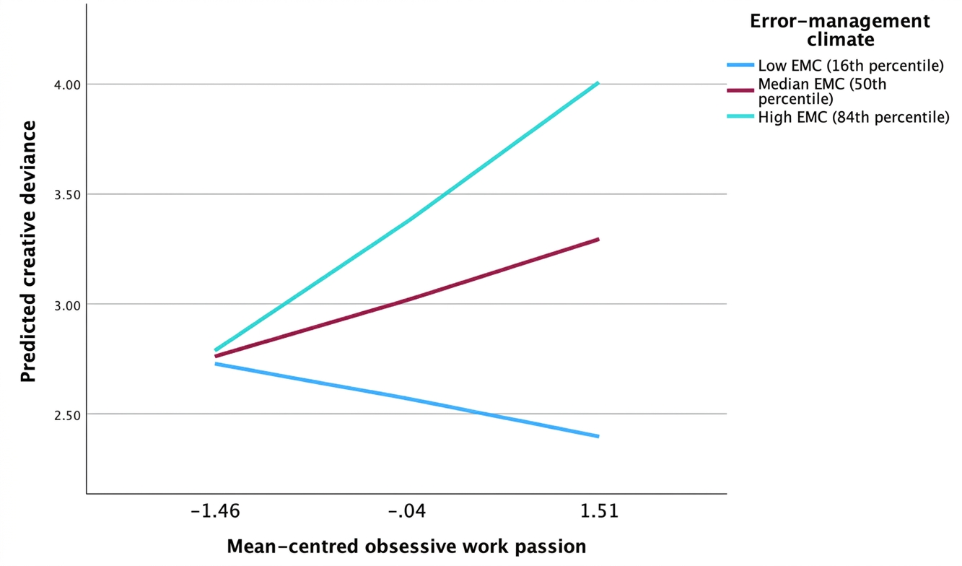
Figure 5. Predicted creative deviance by obsessive work passion at the 16th, 50th and 84th percentiles of perceived error-management climate, adjusted for hybrid intensity, career tenure and recruitment source.

4.5 H2 and H2a: Creative Deviance × DPSE Predicting IWB
Model 2 included mean-centred creative deviance, mean-centred DPSE and their product term, controlling for general political skill, hybrid intensity, career tenure and recruitment source. The final hierarchical OLS model explained 54.4% of IWB variance, R²=.544, adjusted R²=.472, F(10,64)=7.63, p<.001. At mean DPSE, creative deviance was positively associated with focal-idea IWB under the primary HC3 inference, b=.609, SE(HC3)=.147, p<.001, 95% CI [.315,.903]. H2 was supported.

The creative deviance × DPSE interaction added .028 to R², corresponding to f²=.061. The interaction was narrowly non-significant under conventional OLS, b=.622, SE=.314, p=.052, 95% CI [-.005,1.249], but statistically significant under the primary HC3 inference, SE(HC3)=.290, p=.036, 95% CI [.043,1.201]. The shared point estimate reflects the same fitted coefficient, while the different standard errors and intervals reflect the two approaches to estimating uncertainty.

Conditional creative-deviance slopes were .346 (p=.090), .605 (p<.001) and .812 (p<.001) at low, median and high DPSE, respectively. Figure 6 displays these fitted values. The Johnson–Neyman boundary was centred DPSE=-.368, with 17.33% of observations below and 82.67% above the threshold. In the panel-exclusion analysis, the interaction had a similar positive magnitude, b=.629, but HC3 inference was imprecise, p=.126. This reflected reduced precision rather than a reversal. H2a was supported under primary HC3 inference and was sensitivity-qualified.
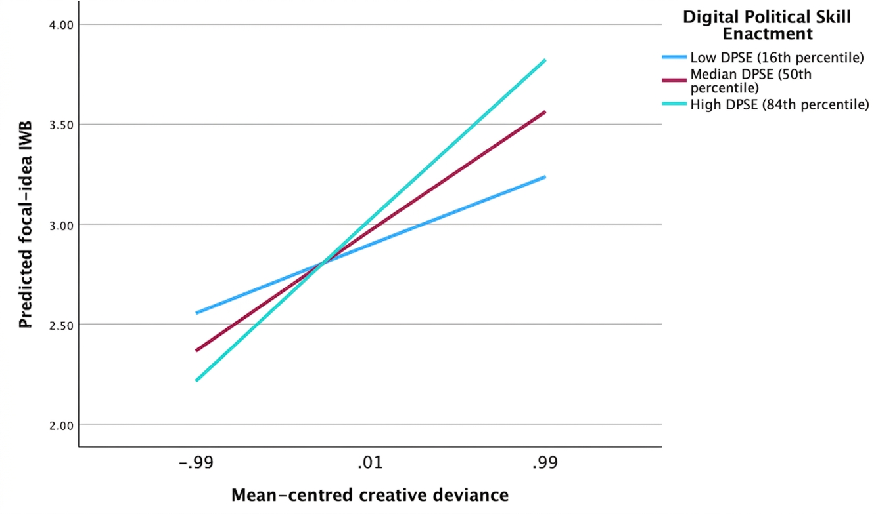
Figure 6. Predicted focal-idea innovative work behaviour by creative deviance at the 16th, 50th and 84th percentiles of Digital Political Skill Enactment, adjusted for hybrid intensity, career tenure, recruitment source and general political skill.

4.6 H3 and H3a: Creative Deviance × DPSE Predicting Relational Strain
Model 3 included mean-centred creative deviance, mean-centred DPSE and their product term, controlling for general political skill, hybrid intensity, career tenure, recruitment source and pre-incident relationship quality. The final hierarchical OLS model explained 28.4% of the variance, R²=.284, adjusted R²=.159, F(11,63)=2.27, p=.021. The interaction increment was .013, corresponding to f²=.018.

At mean DPSE, the creative-deviance coefficient was positive but imprecise under HC3 inference, b=.288, SE(HC3)=.159, p=.075, 95% CI [-.030,.606]; H3 was not supported. The creative deviance × DPSE interaction was also non-significant, b=.403, SE(HC3)=.347, p=.250, 95% CI [-.291,1.097]. Its positive sign was opposite to the hypothesised buffering direction; H3a was not supported. Pre-incident relationship quality was the clearest adjusted predictor under HC3 inference, b=-.262, p=.016.

The significant omnibus test describes the complete predictor set and does not imply support for the focal coefficients. The panel-exclusion estimates led to the same decisions for H3 (N=55; b=.257, p=.121) and H3a (b=.372, p=.405). Because the interaction confidence interval included zero, Figure A4 is retained in Appendix A for descriptive pattern inspection only and is not presented as evidence of moderation.

4.7 Summary of Hypothesis Testing
Table 4 consolidates hierarchical OLS model fit, HC3 focal inference, interaction magnitude and hypothesis decisions. H1 and H2 were supported. H2a was supported under the primary HC3 specification and sensitivity-qualified. H3 and H3a were not supported. The same focal terms were used across all three models, and overall model fit was distinguished from coefficient-level hypothesis tests. All findings are reported as associations from the analysed cross-sectional sample.

Table 4. Summary of Hierarchical Moderated-Regression Models and Hypothesis Decisions
Model / hypothesis | Primary focal evidence | Hierarchical OLS model fit | Interaction magnitude | Decision
Creative deviance / H1 | OWP × EMC: b=.143, SE(HC3)=.038, p<.001, 95% CI [.067,.219] | R²=.465; adjusted R²=.390; F(9,65)=6.27, p<.001 | ΔR²=.123; f²=.230 | Supported
Focal-idea IWB / H2, H2a | CD: b=.609, SE(HC3)=.147, p<.001, 95% CI [.315,.903]. CD × DPSE: b=.622; OLS p=.052; HC3 p=.036, 95% CI [.043,1.201] | R²=.544; adjusted R²=.472; F(10,64)=7.63, p<.001 | ΔR²=.028; f²=.061 | H2 supported; H2a supported under the primary HC3 specification; sensitivity-qualified
Relational strain / H3, H3a | CD: b=.288, SE(HC3)=.159, p=.075, 95% CI [-.030,.606]. CD × DPSE: b=.403, SE(HC3)=.347, p=.250, 95% CI [-.291,1.097] | R²=.284; adjusted R²=.159; F(11,63)=2.27, p=.021 | ΔR²=.013; f²=.018 | H3 and H3a not supported
Note. Model fit and changes in R² are from hierarchical OLS models. Focal coefficient tests use HC3 standard errors. H2a was supported under the primary HC3 specification but remained sensitivity qualified. CD = creative deviance; DPSE = Digital Political Skill Enactment; EMC = perceived error-management climate; IWB = innovative work behaviour; OLS = ordinary least squares; OWP = obsessive work passion.

Chapter 5: Discussion

5.1 Interpretation of the Findings
The findings reveal uneven support. Perceived error-management climate conditioned the relationship between obsessive work passion (OWP) and creative deviance. Creative deviance was positively related to focal-idea innovative work behaviour reported after the decision. However, the adjusted analysis established neither a relationship with focal-manager relational strain nor the proposed buffering role of Digital Political Skill Enactment (DPSE). The innovative pathway therefore received clearer support than the anticipated relational cost.
H1 was supported. The relationship between OWP and creative deviance became more positive as perceived EMC increased, but the negative OWP slope appeared only in an extremely low EMC region containing 5.3% of the sample. EMC therefore did not strengthen persistence uniformly. The crossover instead suggests that the relationship depended on perceived context. This interpretation aligns broadly with evidence connecting error-management conditions to innovation-related activity, although prior studies concern employee innovativeness, indirect creativity pathways or Chinese R&D teams rather than the present incident-level relationship (Kruse & Wegge, 2024; Chen et al., 2022; Xu et al., 2026). The result is a boundary finding rather than a replication. No causal conclusion follows because all three variables were recalled by the same respondent. Reverse direction, consistent reporting and retrospective appraisal therefore cannot be ruled out.
H2 produced the clearest outcome finding. At mean DPSE, creative deviance was positively related to focal-idea IWB. This is consistent with arguments that unauthorised continuation may preserve prematurely rejected ideas and with evidence linking creative deviance or bootlegging to innovation outcomes (Mainemelis, 2010; Criscuolo et al., 2014; Li et al., 2025). Unlike broader outcomes in prior work, both measures concerned the same rejected idea. Yet creative deviance and IWB, although distinguishable, were strongly correlated at r = .641 and captured activity reported by the same person after the same decision. Shared source, timing and behavioural content may therefore partly account for the result. The finding demonstrates co-occurrence, not that non-authorisation improved idea quality or caused innovation.
H2a met the primary HC3 criterion, but support varied across specifications. The conventional OLS interval narrowly included zero, and excluding research-panel respondents reduced precision. The creative deviance and IWB relationship was stronger at median and higher DPSE. This pattern is compatible with earlier reasoning about political capability, enacted influence and target responses, but the supporting studies did not examine incident-specific DPSE in hybrid manager relationships (Kolodinsky et al., 2007; Pfrombeck et al., 2022; Di Gangi et al., 2022). Given DPSE’s restricted range, H2a is provisional and does not establish DPSE as a general digital capability.
H3 and H3a were not supported. Creative deviance correlated positively with relational strain before adjustment, but its HC3 interval included zero after accounting for the full model and pre-incident relationship quality. Findings concerning social undermining, ostracism and leaders’ authoritative silence do not necessarily transfer to strain with the manager who rejected the idea (Shukla et al., 2024; Wang, 2023; Wen et al., 2025). Pre-incident relationship quality was the clearest adjusted predictor, suggesting that relationship history may matter more than unauthorised continuation alone. The DPSE interaction was imprecise and positive, contrary to the proposed buffer. This does not show that DPSE damages relationships. It shows that the expected protection was not observed, so DPSE cannot be presented as a relational safeguard in this sample.

5.2 Theoretical Contribution and Implications
The theoretical contribution follows from the results. The supported crossover positions incident-specific perceived EMC as a boundary around the relationship between OWP and creative deviance. It does not position a favourable climate as endorsement of unauthorised work. The contrasting outcomes add a second contribution. Creative deviance was related to focal-idea IWB but did not show an adjusted relationship with focal-manager strain, showing that innovative and relational consequences are distinct paths rather than opposite ends of one continuum. This absence of support does not eliminate relational risk. Finally, distinguishing general political capability from incident-specific enactment creates a useful analytical separation. The qualified H2a result encourages further examination of enacted practices, whereas the unsupported H3a result prevents DPSE from being treated as a validated extension of Political Skill Theory or a relational safeguard.

5.3 Practical Contribution and Implications
The practical implication concerns how organisations manage a decision to stop idea development. The findings support treating that decision as a governance point requiring a clear explanation and a bounded route for reconsideration. They do not support encouraging unauthorised work or presuming that rejection reflects managerial failure. Where renewed review is possible, organisations may provide a formal resubmission route and state what evidence or changed conditions would justify reconsideration while keeping authorisation explicit. The DPSE findings do not justify treating skilful framing, timing or coalition building as substitutes for permission. Because the proposed relational buffer was not observed, communication practices also cannot be assumed to remove relationship risk. These implications favour transparent governance over informal tolerance, but they are cautious responses to the evidence rather than interventions tested by this study.

5.4 Limitations and Future Research
The single-wave, retrospective design relied on one reporting source. The 75 non-probability cases were concentrated in younger groups, limiting transferability and interaction precision. Panel exclusion reduced the sample to 55, weakening H2a precision. Self-reports cannot establish the manager’s rationale, objective idea quality, resource use or organisational value. The design cannot determine whether strain preceded or followed pursuit.
Measurement imposes further limits. Perceived EMC captured one respondent’s incident-specific appraisal, not a shared climate demonstrated through agreement and aggregation. It cannot support a team or organisational climate effect. Incident appraisal may also have shaped both EMC reports and accounts of creative deviance. Creative deviance and focal-idea IWB were distinguishable but shared the same respondent, incident and time frame. DPSE had a restricted range. Review by two professionals improved comprehensibility but did not provide independent content validation or replicated predictive evidence.
Future research should preregister a larger, more diverse sample, conduct a priori power analysis (Faul et al., 2009), separate predictors and outcomes over time, and combine employee reports with manager or peer assessments and objective idea milestones. Because status cues may shape supervisors’ recognition of voice, manager-matched designs should test whether employee expression and target recognition also differ here, while recognising that voice is not creative deviance (Howell et al., 2015). Repeated relationship measures and vignettes could examine direction and audience interpretation. DPSE requires independent content validation and replication before its scores inform practice.
Chapter 6: Conclusions and Recommendations

6.1 Conclusions
This study examined associations surrounding creative deviance within manager-unapproved idea incidents reported by UK early-career hybrid professionals. The findings were conditional and asymmetric. The relationship between OWP and creative deviance varied with perceived EMC, while creative deviance showed a clearer relationship with focal-idea IWB than with focal-manager relational strain. These conclusions concern the achieved sample and do not show that unauthorised continuation was beneficial, causal or representative of the wider UK workforce.
RQ1 asked whether perceived EMC conditioned the relationship between OWP and creative deviance. The supported crossover showed that OWP had no uniform relationship with continued idea development. The relationship became more positive as perceived EMC increased, while the negative estimate appeared only in an extremely low climate region. This identifies perceived EMC as a boundary around persistence, not as endorsement of deviance.
RQ2 investigated creative deviance, focal-idea IWB and the conditioning role of DPSE. At mean DPSE, creative deviance was positively related to IWB. H2a met the primary HC3 criterion, but its conventional OLS interval narrowly included zero and panel exclusion reduced precision. The moderation finding is therefore sensitivity-qualified. It neither establishes DPSE as a general digital capability nor shows that continued work improved idea quality or organisational value.
RQ3 addressed focal-manager relational strain and the proposed DPSE buffer. Neither H3 nor H3a was supported after adjustment. Pre-incident relationship quality was the clearest adjusted predictor, and the expected protective DPSE interaction was not observed. The creative-deviance estimate was compatible with both zero and a positive relationship. The result therefore does not establish the proposed association, but neither does it demonstrate an absence of relational risk.
Together, the findings connect context-dependent persistence with two outcomes from the same incident. They provide a bounded basis for further doctoral investigation and cautious governance, not a licence for unauthorised work.

6.2 Evidence-Informed Recommendations for Practice
Organisations could pilot a bounded reconsideration route for declined ideas. A stop decision could record the decision owner, the reason for non-authorisation and the conditions that would justify review. It should also distinguish final prohibition from temporary deferral or an invitation to revise. This structure may reduce ambiguity without implying that every rejected idea deserves further investment.
Where reconsideration is authorised, it could be structured as a limited experiment. Scope, resources, data access, review dates, success criteria and stop conditions should be agreed in advance. Safety, confidentiality, regulatory, financial and information-security requirements take priority. Continued activity outside the agreed terms should not be normalised as innovation practice.
Managers may combine openness to challenge with clear accountability. They can explain the evidence behind a decision and identify an approved escalation route while retaining authority over work time and organisational resources. This recommendation reflects the conditional climate finding but does not assume that increasing perceived error tolerance will cause better ideas or greater creative deviance.
Employees should use authorised resubmission channels to present new evidence, revised assumptions and proportionate test requests. Framing, timing and stakeholder consultation may improve clarity, but they do not replace permission or protect against relational damage. If the decision is unchanged, the authorised stop point should be respected.
Relationship history also deserves attention when disagreement is managed. Organisations could pilot a neutral reviewer or documented escalation step where an employee-manager relationship is already weak. These recommendations are cautious governance responses, not tested interventions. Their effects should be evaluated through transparent organisational measures before wider adoption.

References
Amarnani, R. K., Lajom, J. A. L., Restubog, S. L. D., & Capezio, A. (2020). Consumed by obsession: Career adaptability resources and the performance consequences of obsessive passion and harmonious passion for work. Human Relations, 73(6), 811–836. https://doi.org/10.1177/0018726719844812
Astakhova, M. N., McKay, A. S., Doty, D. H., & Wooldridge, B. R. (2024). Does one size fit all? The role of job characteristics in cultivating work passion across knowledge, blue-collar, nonprofit, and managerial work. Human Resource Management, 63(3), 443–462. https://doi.org/10.1002/hrm.22210
Bernerth, J. B., & Aguinis, H. (2016). A critical review and best-practice recommendations for control variable usage. Personnel Psychology, 69, 229–283. https://doi.org/10.1111/peps.12103
Boateng, G. O., Neilands, T. B., Frongillo, E. A., Melgar-Quiñonez, H. R., & Young, S. L. (2018). Best practices for developing and validating scales for health, social, and behavioral research: A primer. Frontiers in Public Health, 6, 149. https://doi.org/10.3389/fpubh.2018.00149
Bredehorst, J., Krautter, K., Meuris, J., & Jachimowicz, J. M. (2024). The challenge of maintaining passion for work over time: A daily perspective on passion and emotional exhaustion. Organization Science, 35(1), 364–386. https://doi.org/10.1287/orsc.2023.1673
Carlson, J. R., & Zmud, R. W. (1999). Channel expansion theory and the experiential nature of media richness perceptions. Academy of Management Journal, 42(2), 153–170. https://doi.org/10.5465/257090
Chen, L., Guo, Y., Song, L. J., & Lyu, B. (2022). From errors to OCBs and creativity: A multilevel mediation mechanism of workplace gratitude. Current Psychology, 41, 6170–6184. https://doi.org/10.1007/s12144-020-01120-5
Clarke, N., & Higgs, M. (2020). Political skill and role overload as antecedents of innovative work behavior in the public sector. Public Personnel Management, 49(3), 444–469. https://doi.org/10.1177/0091026019863450
Criscuolo, P., Salter, A., & Ter Wal, A. L. J. (2014). Going underground: Bootlegging and individual innovative performance. Organization Science, 25(5), 1287–1305. https://doi.org/10.1287/orsc.2013.0856
de Jong, J. P. J., & den Hartog, D. N. (2010). Measuring innovative work behaviour. Creativity and Innovation Management, 19(1), 23–36. https://doi.org/10.1111/j.1467-8691.2010.00547.x
Diamantopoulos, A., & Winklhofer, H. M. (2001). Index construction with formative indicators: An alternative to scale development. Journal of Marketing Research, 38, 269–277.
Di Gangi, P. M., McAllister, C. P., Howard, J. L., Thatcher, J. B., & Ferris, G. R. (2022). Can you see opportunity knocking? An examination of technology-based political skill on opportunity recognition in online communities for MTurk workers. Internet Research, 32(4), 1041–1075. https://doi.org/10.1108/INTR-03-2021-0175
Dirks, K. T., & de Jong, B. (2022). Trust within the workplace: A review of two waves of research and a glimpse of the third. Annual Review of Organizational Psychology and Organizational Behavior, 9, 247–276. https://doi.org/10.1146/annurev-orgpsych-012420-083025
Dufour, L., Maoret, M., & Montani, F. (2026). Balancing newcomer social integration and voice during organizational socialization: A longitudinal study of antecedents, consequences and boundary conditions. Journal of Occupational and Organizational Psychology, 99, e70097. https://doi.org/10.1111/joop.70097
Faul, F., Erdfelder, E., Buchner, A., & Lang, A.-G. (2009). Statistical power analyses using G*Power 3.1: Tests for correlation and regression analyses. Behavior Research Methods, 41, 1149–1160. https://doi.org/10.3758/BRM.41.4.1149
Ferris, G. R., Treadway, D. C., Kolodinsky, R. W., Hochwarter, W. A., Kacmar, C. J., Douglas, C., & Frink, D. D. (2005). Development and validation of the Political Skill Inventory. Journal of Management, 31(1), 126–152. https://doi.org/10.1177/0149206304271386
Galperin, B. L. (2012). Exploring the nomological network of workplace deviance: Developing and validating a measure of constructive deviance. Journal of Applied Social Psychology, 42(12), 2988–3025. https://doi.org/10.1111/j.1559-1816.2012.00971.x
Gibbs, M., Mengel, F., & Siemroth, C. (2024). Employee innovation during office work, work from home and hybrid work. Scientific Reports, 14, 17117. https://doi.org/10.1038/s41598-024-67122-6
Globocnik, D., Peña Häufler, B., & Salomo, S. (2022). Organizational antecedents to bootlegging and consequences for the newness of the innovation portfolio. Journal of Product Innovation Management, 39(5), 717–745. https://doi.org/10.1111/jpim.12626
Good, M. C., & Schwepker, C. H., Jr. (2022). Business-to-business salespeople and political skill: Relationship building, deviance, and performance. Journal of Business Research, 139, 32–43. https://doi.org/10.1016/j.jbusres.2021.09.035
Guo, W., & Li, Y. (2026). Turning errors to breakthroughs: Dual motivation pathways linking error management climate to radical creativity. European Journal of Innovation Management, 29(1), 326–343. https://doi.org/10.1108/EJIM-12-2025-1655
Hinkin, T. R. (1998). A brief tutorial on the development of measures for use in survey questionnaires. Organizational Research Methods, 1(1), 104–121. https://doi.org/10.1177/109442819800100106
Hornsey, M. J., Grice, T., Jetten, J., Paulsen, N., & Callan, V. (2007). Group-directed criticisms and recommendations for change: Why newcomers arouse more resistance than old-timers. Personality and Social Psychology Bulletin, 33(7), 1036–1048. https://doi.org/10.1177/0146167207301029
Horvath, D., Keith, N., Klamar, A., & Frese, M. (2023). How to induce an error management climate: Experimental evidence from newly formed teams. Journal of Business and Psychology, 38, 763–775. https://doi.org/10.1007/s10869-022-09835-x
Howard, M. C., Boudreaux, M., & Oglesby, M. (2024). Can Harman’s single-factor test reliably distinguish between research designs? Not in published management studies. European Journal of Work and Organizational Psychology, 33(6), 790–804. https://doi.org/10.1080/1359432X.2024.2393462
Howell, T. M., Harrison, D. A., Burris, E. R., & Detert, J. R. (2015). Who gets credit for input? Demographic and structural status cues in voice recognition. Journal of Applied Psychology, 100(6), 1765–1784. https://doi.org/10.1037/apl0000025
Ismail, I. R., Martin, F. F., Teng, H.-C., & Nor, K. M. (2024). Role of creative climate, manager attitude, and financial constraint on creative deviance at workplace. International Journal of Academic Research in Business and Social Sciences, 14(3), 15–29. https://doi.org/10.6007/IJARBSS/v14-i3/20817
Jacobson, R. K., & Viswesvaran, C. (2017). A reliability generalization study of the Political Skill Inventory. SAGE Open, 7(2), 1–17. https://doi.org/10.1177/2158244017706714
Kolodinsky, R. W., Treadway, D. C., & Ferris, G. R. (2007). Political skill and influence effectiveness: Testing portions of an expanded Ferris and Judge (1991) model. Human Relations, 60(12), 1747–1777. https://doi.org/10.1177/0018726707084913
Kruse, P., & Wegge, J. (2024). A constructive error management culture promotes innovation and corporate social responsibility: A multi-level analysis in 10 countries. German Journal of Human Resource Management, 38(2), 111–139. https://doi.org/10.1177/23970022231226318
Li, P., Yin, K., Shi, J., Damen, T. G. E., & Taris, T. W. (2024). Are bad leaders indeed bad for employees? A meta-analysis of longitudinal studies between destructive leadership and employee outcomes. Journal of Business Ethics, 191, 399–413. https://doi.org/10.1007/s10551-023-05449-2
Li, X., Cheng, C., & Yang, S. (2025). Why not go the usual way? Empowering leadership, employees’ creative deviance and innovation performance. Management Decision, 63(3), 780–802. https://doi.org/10.1108/MD-12-2023-2358
Lin, B., Mainemelis, C., & Kark, R. (2016). Leaders’ responses to creative deviance: Differential effects on subsequent creative deviance and creative performance. The Leadership Quarterly, 27(4), 537–556. https://doi.org/10.1016/j.leaqua.2015.09.001
Long, J. S., & Ervin, L. H. (2000). Using heteroscedasticity consistent standard errors in the linear regression model. The American Statistician, 54(3), 217–224. https://doi.org/10.1080/00031305.2000.10474549
Mainemelis, C. (2010). Stealing fire: Creative deviance in the evolution of new ideas. Academy of Management Review, 35(4), 558–578. https://doi.org/10.5465/amr.35.4.zok558
McNeish, D. (2018). Thanks coefficient alpha, we’ll take it from here. Psychological Methods, 23(3), 412–433. https://doi.org/10.1037/met0000144
Munyon, T. P., Summers, J. K., Thompson, K. M., & Ferris, G. R. (2015). Political skill and work outcomes: A theoretical extension, meta-analytic investigation, and agenda for the future. Personnel Psychology, 68(1), 143–184. https://doi.org/10.1111/peps.12066
Peer, E., Rothschild, D., Gordon, A., Evernden, Z., & Damer, E. (2022). Data quality of platforms and panels for online behavioral research. Behavior Research Methods, 54, 1643–1662. https://doi.org/10.3758/s13428-021-01694-3
Pfrombeck, J., Levin, C., Rucker, D. D., & Galinsky, A. D. (2022). The hierarchy of voice framework: The dynamic relationship between employee voice and social hierarchy. Research in Organizational Behavior, 42, 100179. https://doi.org/10.1016/j.riob.2022.100179
Podsakoff, P. M., MacKenzie, S. B., Lee, J.-Y., & Podsakoff, N. P. (2003). Common method biases in behavioral research: A critical review of the literature and recommended remedies. Journal of Applied Psychology, 88(5), 879–903. https://doi.org/10.1037/0021-9010.88.5.879
Shukla, J., & Kark, R. (2020). Now you do it, now you don’t: The mixed blessing of creative deviance as a prosocial behavior. Frontiers in Psychology, 11, 313. https://doi.org/10.3389/fpsyg.2020.00313
Shukla, J., Bennett, R., Folger, R., & Kark, R. (2024). Disobeying the leader: Creative deviance as a mechanism between psychological ownership and social undermining. Journal of Leadership & Organizational Studies, 31(1), 5–24. https://doi.org/10.1177/15480518231226093
Spector, P. E., & Jex, S. M. (1998). Development of four self-report measures of job stressors and strain. Journal of Occupational Health Psychology, 3(4), 356–367. https://pubmed.ncbi.nlm.nih.gov/9805281/
Treem, J. W., & Leonardi, P. M. (2013). Social media use in organizations: Exploring the affordances of visibility, editability, persistence, and association. Communication Yearbook, 36(1), 143–189. https://doi.org/10.1080/23808985.2013.11679130
Vallerand, R. J., Blanchard, C. M., Mageau, G. A., Koestner, R., Ratelle, C., Léonard, M., Gagné, M., & Marsolais, J. (2003). Les passions de l’âme: On obsessive and harmonious passion. Journal of Personality and Social Psychology, 85(4), 756–767. https://doi.org/10.1037/0022-3514.85.4.756
van Dyck, C., Frese, M., Baer, M., & Sonnentag, S. (2005). Organizational error management culture and its impact on performance: A two-study replication. Journal of Applied Psychology, 90(6), 1228–1240. https://pubmed.ncbi.nlm.nih.gov/16316276/
Wan, P., Zheng, J., Lyu, C., & Zhang, X. (2026). Enabling or burdening? The double-edged impact of creative deviance on employee innovation performance. Leadership & Organization Development Journal, 47(1), 150–170. https://doi.org/10.1108/LODJ-02-2025-0139
Wang, Q., Zhang, X., Zhang, N., & Su, J. (2025). Error management climate, psychological security, and employee bootleg innovation behavior: The moderating role of risk-taking traits. Frontiers in Psychology, 16, 1538584. https://doi.org/10.3389/fpsyg.2025.1538584
Wang, Y. (2023). The impact mechanism of constructive deviance on workplace ostracism: The roles of political skill and workplace friendship. Current Psychology, 42, 23323–23331. https://doi.org/10.1007/s12144-022-03419-x
Wang, Y., Luo, J., & Hu, W. (2025). Proving my creativity: When and why leaders’ idea rejection leads to employees’ creative deviance? Personality and Individual Differences, 233, 112881. https://doi.org/10.1016/j.paid.2024.112881
Wen, S. S., Zhang, L., Zhang, K., & Ouyang, M. (2025). The more creative, the more silent? The effect of subordinates’ creative deviance on leader silence. Leadership & Organization Development Journal, 46(1), 53–65. https://doi.org/10.1108/LODJ-04-2023-0171
Wu, Y. J., Antone, B., DeChurch, L., & Contractor, N. (2023). Information sharing in a hybrid workplace: Understanding the role of ease-of-use perceptions of communication technologies in advice-seeking relationship maintenance. Journal of Computer-Mediated Communication, 28(4), zmad025. https://doi.org/10.1093/jcmc/zmad025
Xu, J., Li, Y.-Z., Zhu, D.-Q., & Li, J.-Z. (2022). “Lubricant” or “stumbling block”?: The paradoxical association between team authoritarian leadership and creative deviance. Frontiers in Psychology, 13, 835970. https://doi.org/10.3389/fpsyg.2022.835970
Xu, J., Xu, Y., & Liu, S. (2026). Obsessive work passion, creative deviance, and team radical innovation: Moderation of error management culture. Humanities and Social Sciences Communications. Advance online publication. https://doi.org/10.1057/s41599-026-08054-6
Zhang, Q., Wang, X.-H., Nerstad, C. G. L., Ren, H., & Gao, R. (2022). Motivational climates, work passion, and behavioral consequences. Journal of Organizational Behavior, 43(9), 1579–1597. https://doi.org/10.1002/job.2661

Appendix A. Supplementary Figures
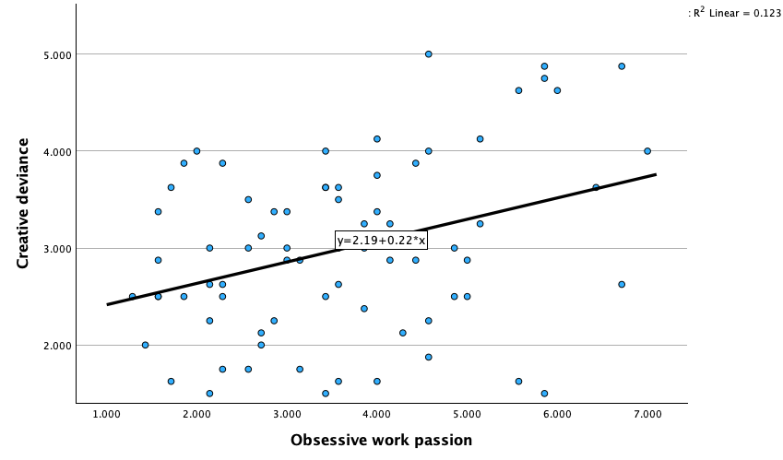
Figure A1. Bivariate association between obsessive work passion and creative deviance, unadjusted for covariates or error-management climate (r=.350, p=.002, R²=.123).
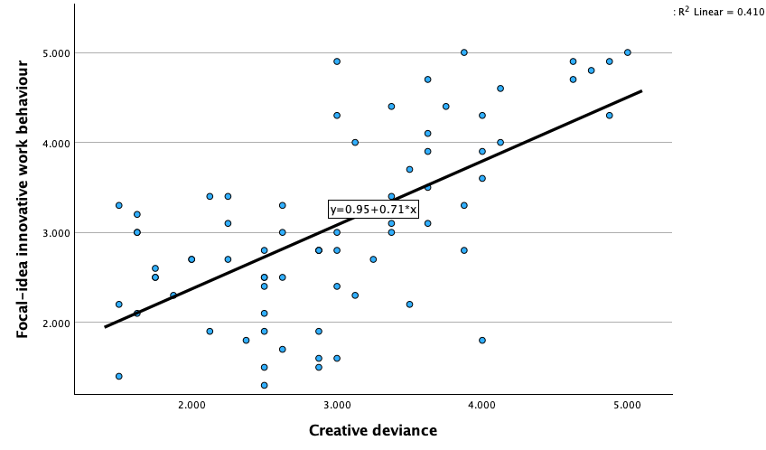
Figure A2. Bivariate association between creative deviance and focal-idea innovative work behaviour, unadjusted for covariates or Digital Political Skill Enactment (r=.640, p<.001, R²=.410).
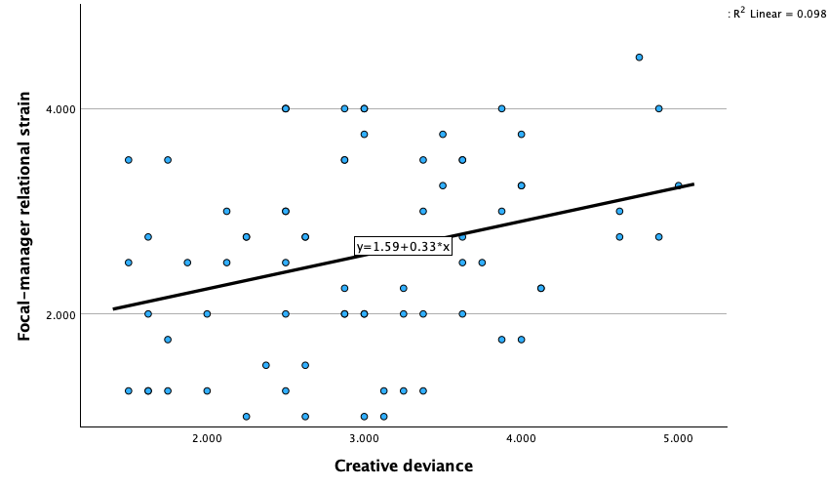
Figure A3. Bivariate association between creative deviance and focal-manager relational strain, unadjusted for covariates or Digital Political Skill Enactment (r=.313, p=.006, R²=.098).
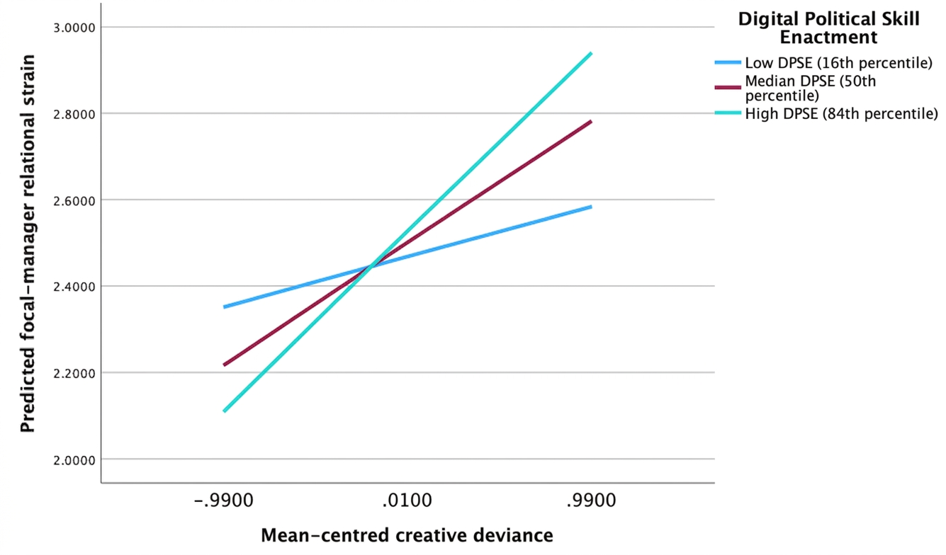
Figure A4. Predicted focal-manager relational strain by creative deviance at low, median and high Digital Political Skill Enactment. The interaction was non-significant (p=.250); the figure is descriptive only.

Appendix B. Participant-Facing Survey Questionnaire

Participant Information
You are invited to take part in a doctoral research study about how early-career professionals respond to one work-related idea that a manager did not authorise for further development. The study focuses on one incident, communication practices, continued idea-related activity, innovative work behaviour, and the working relationship with the manager involved.
Participation is voluntary. You may skip non-essential questions or leave the survey before submitting it without penalty. Because the preferred survey is anonymous, it may not be possible to identify and delete your response after submission.
Do not provide the name of an employer, manager, colleague, client, product, system, project, or idea. Do not paste confidential information, security-sensitive information, generative-AI prompts or outputs, code, files, or business data. This research does not advise or encourage anyone to breach organisational, regulatory, safety, financial, information-security, confidentiality, or managerial controls.
The survey asks about a manager-unapproved idea and workplace interactions. Some questions may feel uncomfortable. You may choose “Prefer not to answer” where available or skip non-required questions.
CONSENT_1. I confirm that I am aged 18 or over. [Required]
☐ Yes
☐ No
CONSENT_2. I have read and understood the participant information above. [Required]
☐ Yes
☐ No
CONSENT_3. I understand that participation is voluntary and that I can leave before submitting my response. [Required]
☐ Yes
☐ No
CONSENT_4. I understand the confidentiality limits and agree not to enter identifying, confidential, security-sensitive, or proprietary information. [Required]
☐ Yes
☐ No
CONSENT_5. I consent to take part in this research. [Required]
☐ Yes
☐ No

Eligibility
ELIG_1. Are you currently working in the United Kingdom? [Required]
☐ Yes
☐ No
ELIG_2. When did you begin the first paid role that you regarded as the beginning of your longer-term occupational or professional career? [Required]
☐ Within the past 12 months
☐ More than 1 year and up to 2 years ago
☐ More than 2 years and up to 3 years ago
☐ More than 3 years and up to 4 years ago
☐ More than 4 years and up to 5 years ago
☐ More than 5 years and up to 6 years ago
☐ More than 6 years ago
☐ Not sure
☐ Prefer not to answer
ELIG_3. At the time of the incident you will report, did your regular work arrangement include both (a) work at an employer or client location and (b) work away from that location, with digital communication used to coordinate work? [Required]
☐ Yes
☐ No
☐ Not sure
ELIG_4. Within the previous 12 months, did you experience at least one work-related idea for which a manager explicitly rejected further development or explicitly withheld permission to use work time, resources, or organisational channels? [Required]
☐ Yes
☐ No
☐ Not sure
ELIG_5. Can you answer without naming or identifying an organisation, manager, colleague, client, product, system, project, or idea, and without disclosing confidential or security-sensitive information? [Required]
☐ Yes
☐ No
ELIG_6. Are you directly employed, managed, assessed, or supervised by the researcher conducting this study? [Required]
☐ Yes
☐ No
☐ Not sure
ELIG_7. Have you previously taken part in the expert review or cognitive-interview testing of this questionnaire? [Required]
☐ Yes
☐ No
☐ Not sure

Selecting One Focal Incident
If more than one incident qualifies, select the most recent qualifying incident. If two occurred at approximately the same time, select the one you remember most clearly. Think about one idea, one managerial decision, and one focal manager throughout the remainder of the survey.
INC_1. Which statements describe what the focal manager explicitly communicated? Select all that apply. [Required]
☐ The manager explicitly instructed me to stop developing the idea.
☐ The manager explicitly rejected further development of the idea.
☐ The manager explicitly withheld permission to use work time for the idea.
☐ The manager explicitly withheld permission to use organisational resources for the idea.
☐ The manager explicitly withheld permission to use organisational communication or approval channels for the idea.
☐ The manager asked me to revise and resubmit the idea.
☐ The manager temporarily delayed or deprioritised the idea.
☐ The manager criticised the idea but did not clearly reject further development.
☐ The manager did not respond.
☐ None of the above.
INC_2. How long ago did the focal manager communicate this decision? [Required]
☐ Less than 1 month ago
☐ 1 to less than 3 months ago
☐ 3 to less than 6 months ago
☐ 6 to 12 months ago
☐ More than 12 months ago
☐ Not sure
☐ Prefer not to answer
INC_3. At the time of the incident, approximately how many days in a typical working week did you work away from an employer or client location?
☐ Less than 1 day
☐ 1 day
☐ 2 days
☐ 3 days
☐ 4 days
☐ 5 or more days
☐ Varied too much to estimate
☐ Prefer not to answer
INC_4. Which description best matches what happened after the decision?
☐ I stopped idea-related activity immediately after the decision.
☐ I continued for a period and later stopped.
☐ I continued until formal authorisation was later granted.
☐ I continued and the idea remains unauthorised.
☐ I am unsure whether later authorisation was granted.
☐ Prefer not to answer.
INC_5. Was formal authorisation for the focal idea later granted?
☐ Yes
☐ No
☐ Not sure
☐ Prefer not to answer
INC_6. If authorisation was later granted, approximately how long after the original decision did this occur?
☐ Less than 1 week
☐ 1 to less than 4 weeks
☐ 1 to less than 3 months
☐ 3 to 6 months
☐ More than 6 months
☐ Not applicable
☐ Not sure
☐ Prefer not to answer
INC_7. Do you currently still work with or report to the focal manager?
☐ Yes
☐ No
☐ Not sure
☐ Prefer not to answer

Relationship Before the Decision
The following two questions concern your working relationship with the focal manager before they communicated the decision about the focal idea.
PRE_REL_QUALITY. Before the focal manager communicated this decision, how would you rate the overall quality of your working relationship with them?
☐ Very poor
☐ Poor
☐ Neither poor nor good
☐ Good
☐ Very good
☐ Prefer not to answer
PRE_REL_TENSION. Before the focal manager communicated this decision, how often did you experience tension or disagreement in your working relationship with them?
☐ Never
☐ Rarely
☐ Sometimes
☐ Often
☐ Very often
☐ Prefer not to answer

Obsessive Work Passion
Thinking about how you generally felt about your work at the time of the focal incident, indicate how strongly you agree or disagree with each statement.
Response scale
1 Strongly disagree | 2 Disagree | 3 Slightly disagree | 4 Neither agree nor disagree | 5 Slightly agree | 6 Agree | 7 Strongly agree

OWP1. I could not live without my work.
OWP2. The urge to work was so strong that I could not help myself.
OWP3. I had difficulty imagining my life without my work.
OWP4. I was emotionally dependent on my work.
OWP5. I had a difficult time controlling my need to work.
OWP6. I had an almost obsessive feeling toward my work.
OWP7. My mood depended on being able to work.

Perceived Error-Management Climate
Thinking about your immediate work environment at the time of the focal incident, indicate how strongly each statement applied.
Response scale
1 Strongly disagree | 2 Disagree | 3 Slightly disagree | 4 Neither agree nor disagree | 5 Slightly agree | 6 Agree | 7 Strongly agree

EMC1. In my immediate work environment, errors were treated as useful for improving work processes.
EMC2. After an error, people thought through how to correct it.
EMC3. After an error occurred, it was analysed thoroughly.
EMC4. If something went wrong, people took time to think it through.
EMC5. After making a mistake, people tried to analyse what caused it.
EMC6. People thought carefully about how an error could have been avoided.
EMC7. An error provided important information for continuing the work.
EMC8. Errors pointed to what could be improved.
EMC9. When mastering a task, people could learn a great deal from their mistakes.
EMC10. When an error occurred, people usually knew how to rectify it.
EMC11. When an error was made, it was corrected immediately.
EMC12. Although mistakes occurred, people did not lose sight of the final goal.
EMC13. When people could not correct an error by themselves, they turned to colleagues.
EMC14. If people could not continue their work after an error, they could rely on others.
EMC15. When people made an error, they could ask others for advice about how to continue.
EMC16. When someone made an error, they shared it with others so that the same mistake would not be repeated.

Creative Deviance
Source and adaptation. The items were adapted to a single focal incident from items 2–9 of the nine-item scale reported by Lin et al. (2016) and validated in eight-item form by Shukla et al. (2024). Wording, referent, time frame and response scale were adapted.
For this block only, consider the period after explicit non-authorisation and before later authorisation, definitive cessation, or today, whichever came first. Indicate how strongly you agree or disagree.
Response scale
1 Strongly disagree | 2 Disagree | 3 Neither agree nor disagree | 4 Agree | 5 Strongly agree

CD1. During my work time, I thought about how to improve the focal idea after the focal manager had rejected or stopped it
CD2. Although the focal manager asked me to stop developing the focal idea, I continued to work on it.
CD3. In addition to ideas approved by the focal manager, I put effort into improving the focal idea by gathering information and trying again.
CD4. I used some of my work time to develop the focal idea after the focal manager rejected it.
CD5. I did not give up on the focal idea after it had been rejected.
CD6. I improved the focal idea during my working hours after it had been rejected.
CD7. Although the focal manager stopped the idea, I worked on an improved version of it.
CD8. Using some of my work time or organisational resources, I continued working on the focal idea after it had been rejected.
CHECK_1. To help confirm that the questionnaire is displaying correctly, please select “Slightly agree” for this statement.
☐ Strongly disagree
☐ Disagree
☐ Slightly disagree
☐ Neither agree nor disagree
☐ Slightly agree
☐ Agree
☐ Strongly agree

General Political Skill
The following statements concern how you generally act at work. Indicate how strongly you agree or disagree.
Response scale
1 Strongly disagree | 2 Disagree | 3 Slightly disagree | 4 Neutral | 5 Slightly agree | 6 Agree | 7 Strongly agree

PSI1. I spend a lot of time and effort at work networking with others.
PSI2. At work, I know many important people and am well connected.
PSI3. I am good at using my connections and networks to make things happen at work.
PSI4. I have developed a large network of colleagues and associates at work whom I can call on for support when I really need to get things done.
PSI5. I spend a lot of time at work developing connections with others.
PSI6. I am good at building relationships with influential people at work.
PSI7. It is important that people believe I am sincere in what I say and do.
PSI8. When communicating with others, I try to be genuine in what I say and do.
PSI9. I try to show a genuine interest in other people.
PSI10. I always seem to instinctively know the right thing to say or do to influence others.
PSI11. I have good intuition or savvy about how to present myself to others.
PSI12. I am particularly good at sensing the motivations and hidden agendas of others.
PSI13. I pay close attention to people’s facial expressions.
PSI14. I understand people very well.
PSI15. It is easy for me to develop good rapport with most people.
PSI16. I am able to make most people feel comfortable and at ease around me.
PSI17. I am able to communicate easily and effectively with others.
PSI18. I am good at getting people to like me.

Digital Political Skill Enactment During the Focal Incident
Thinking only about what you did after the focal manager’s decision, indicate the extent to which you carried out each practice through digital or cross-channel communication. “Did not do this” means the practice was available but you did not undertake it. Use “Not applicable” only when the practice or opportunity genuinely did not arise.
Response scale
0 Did not do this | 1 To a small extent | 2 To some extent | 3 To a great extent | 4 To a very great extent | Not applicable | Prefer not to answer

DPSE_SA1. I reviewed the manager’s message and other available cues to understand the reasons behind the decision.
DPSE_SA2. I considered how different stakeholders might interpret continued work on the focal idea.
DPSE_SA3. I assessed which communication channel and timing would be most appropriate before raising the focal idea again.
DPSE_II1. I adjusted how I framed the focal idea to address the manager’s stated concerns.
DPSE_II2. I selected digital, face-to-face, or combined channels based on the response I was seeking.
DPSE_II3. I adapted the level of detail, tone, or timing of my communication to the audience.
DPSE_NA1. I sought advice from people who had relevant expertise or organisational knowledge.
DPSE_NA2. I identified credible people who could help me evaluate or strengthen the focal idea.
DPSE_NA3. I coordinated with supportive contacts before requesting renewed consideration of the focal idea.
DPSE_AS1. I communicated my reasons for pursuing the focal idea consistently across digital and face-to-face channels.
DPSE_AS2. I was transparent about what I had and had not done in relation to the focal idea.
DPSE_AS3. I managed the visibility of the focal idea without misrepresenting my actions or intentions.

Focal-Idea Innovative Work Behaviour
Following the focal manager’s decision, how often did you engage in each activity in relation to the focal idea? For implementation items, include activity only when it was authorised.
Response scale
1 Never | 2 Rarely | 3 Sometimes | 4 Often | 5 Always

IWB1. I paid attention to issues related to the focal idea that were not part of my daily work.
IWB2. I considered how the focal idea or related work could be improved.
IWB3. I searched for new working methods, techniques, or instruments relevant to the focal idea.
IWB4. I generated original solutions to problems connected with the focal idea.
IWB5. I found new approaches for carrying out tasks related to the focal idea.
IWB6. I tried to make important organisational members enthusiastic about the focal idea.
IWB7. I attempted to convince people to support the focal idea.
IWB8. I systematically introduced elements of the focal idea into work practices when this was authorised.
IWB9. I contributed to implementing the focal idea when this was authorised.
IWB10. I put effort into developing new things connected with the focal idea.

Focal-Manager Relational Strain
The following questions concern your interactions with the focal manager after they communicated the decision about the focal idea.
Response scale
1 Less than once per month or never | 2 Once or twice per month | 3 Once or twice per week | 4 Once or twice per day | 5 Several times per day

STRAIN1. How often did you get into arguments with the focal manager?
STRAIN2. How often did the focal manager yell at you?
STRAIN3. How often was the focal manager rude to you?
STRAIN4. How often did the focal manager do things that you considered nasty or unpleasant?

Incident Communication and Practice Context
PRACTICE_CHANNEL. Which channels did you use after the decision in relation to the focal idea? Select all that apply.
☐ Face-to-face conversation
☐ Video meeting
☐ Telephone or audio call
☐ Email
☐ Work messaging or team-chat platform
☐ Shared document or collaboration space
☐ Formal workflow, ticketing, or approval system
☐ Presentation or meeting with multiple attendees
☐ I did not communicate further about the focal idea
☐ Prefer not to answer
PRACTICE_TIMING. When did you first take any further action related to the focal idea after the decision?
☐ The same day
☐ Within 2-3 days
☐ Within 1 week
☐ Within 2-4 weeks
☐ More than 1 month later
☐ I took no further action
☐ Not sure
☐ Prefer not to answer
PRACTICE_AUDIENCE. With whom did you communicate about the focal idea after the decision? Select all that apply.
☐ The focal manager
☐ A colleague at a similar level
☐ A more senior manager
☐ A technical or subject-matter expert
☐ A mentor, sponsor, or trusted adviser
☐ A formal governance, risk, compliance, security, or approval function
☐ A client or external stakeholder where authorised
☐ No one
☐ Prefer not to answer
PRACTICE_COALITION. Did you seek support from other people before asking for the focal idea to be reconsidered?
☐ Yes
☐ No
☐ I did not ask for reconsideration
☐ Not sure
☐ Prefer not to answer
PRACTICE_VISIBILITY. How visible was your continued idea-related activity to the focal manager?
☐ Not visible
☐ Slightly visible
☐ Partly visible
☐ Mostly visible
☐ Fully visible
☐ I did not continue
☐ Not sure
☐ Prefer not to answer

Exploratory Generative-AI Context
Do not enter the name of a tool, prompts, outputs, code, or business information.
AI_1. After the focal manager’s decision, did you use a generative-AI tool in relation to the focal idea?
☐ Yes
☐ No
☐ Not sure
☐ Prefer not to answer
AI_2. Was the generative-AI tool approved for this type of use by your employer or client?
☐ Yes
☐ No
☐ There was no clear policy or I did not know
☐ Not applicable
☐ Prefer not to answer
AI_3. Did you disclose the generative-AI use to the focal manager or another relevant authorised party?
☐ Yes
☐ No
☐ Partly
☐ Not applicable
☐ Prefer not to answer
AI_4. What broad types of assistance did you use generative AI for? Select all that apply.
☐ Searching for or summarising information
☐ Brainstorming alternatives
☐ Structuring an argument or proposal
☐ Drafting or editing text
☐ Analysing data
☐ Creating code or technical material
☐ Creating visual material
☐ None of these
☐ Not sure
☐ Prefer not to answer
CHECK_2. For this quality-check item, please select “Sometimes.”
☐ Never
☐ Rarely
☐ Sometimes
☐ Often
☐ Always

Background Information
DEM_AGE. What is your age group?
☐ 18-24
☐ 25-29
☐ 30-34
☐ 35-39
☐ 40-49
☐ 50 or over
☐ Prefer not to answer
DEM_GENDER. How do you describe your gender?
☐ Woman
☐ Man
☐ Non-binary
☐ Prefer to self-describe without entering text
☐ Prefer not to answer
DEM_EDU. What is the highest level of education or occupational training you have completed?
☐ Secondary education or equivalent
☐ Further education, apprenticeship, or vocational qualification
☐ Undergraduate degree or equivalent
☐ Postgraduate taught degree or equivalent
☐ Doctoral degree or equivalent
☐ Other or mixed route
☐ Prefer not to answer
DEM_SECTOR. Which broad sector best describes your current work?
☐ Public sector
☐ Private sector
☐ Third sector, charity, or non-profit
☐ Education or research
☐ Health or social care
☐ Professional or business services
☐ Technology, digital, or engineering
☐ Creative or cultural industries
☐ Other broad sector
☐ Prefer not to answer
DEM_ORGSIZE. Approximately how many people work in your organisation?
☐ 1-9
☐ 10-49
☐ 50-249
☐ 250-999
☐ 1,000 or more
☐ Not sure
☐ Prefer not to answer
DEM_STATUS. What is your current employment status?
☐ Full-time employee
☐ Part-time employee
☐ Fixed-term employee
☐ Apprentice or trainee
☐ Self-employed or contractor working within an organisation
☐ Other
☐ Prefer not to answer
DEM_MANAGER. Do you currently have formal responsibility for managing or supervising other people?
☐ Yes
☐ No
☐ Prefer not to answer
RECRUIT_SOURCE. How did you access this survey? [Required]
☐ Alumni or university network
☐ Professional network or association
☐ Administrator-approved online community
☐ Referral from another participant
☐ Approved third-party research panel
☐ Other approved recruitment route
☐ Prefer not to answer

Closing Information
Thank you for taking part. Please review your answers before selecting Submit. Do not add identifying or confidential information. Employers, managers, gatekeepers, and professional bodies will not receive individual responses.

