My name is Nicolae Cosmin Mataru , born in 04 February 1991. Originally from Romania, I like summer , I like to play football and video games. My hobby is gym , sport and to watch movies.
I work for MotorClean like Team Ladder at kia and Hyundai in Wolverhampton, I like what I do at my job, I have a great team with me and we like to do the best all time at work.

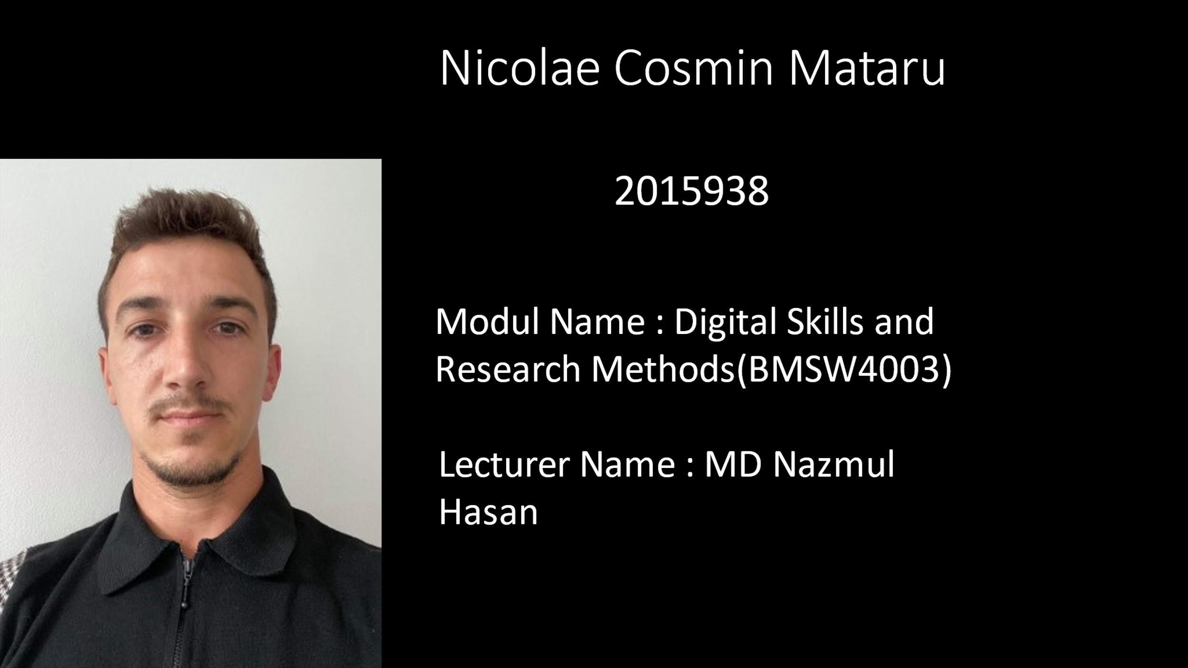
Grit was defined as ‘’perseverance and passion for long – term goals’’ by psychologist Angela Duckworth and colleagues, who extensively studied grit as personality trait.
They observed that individuals high in grit where able to maintain their determination and motivation over long periods despite experiences with failure and adversity.

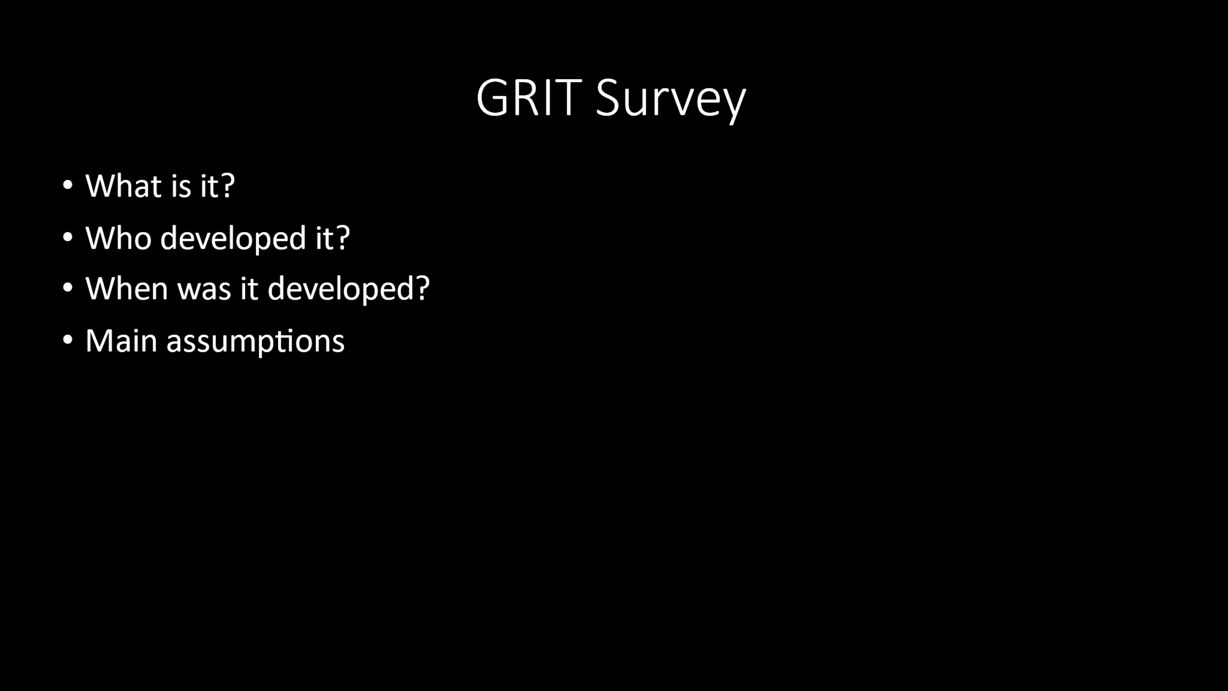

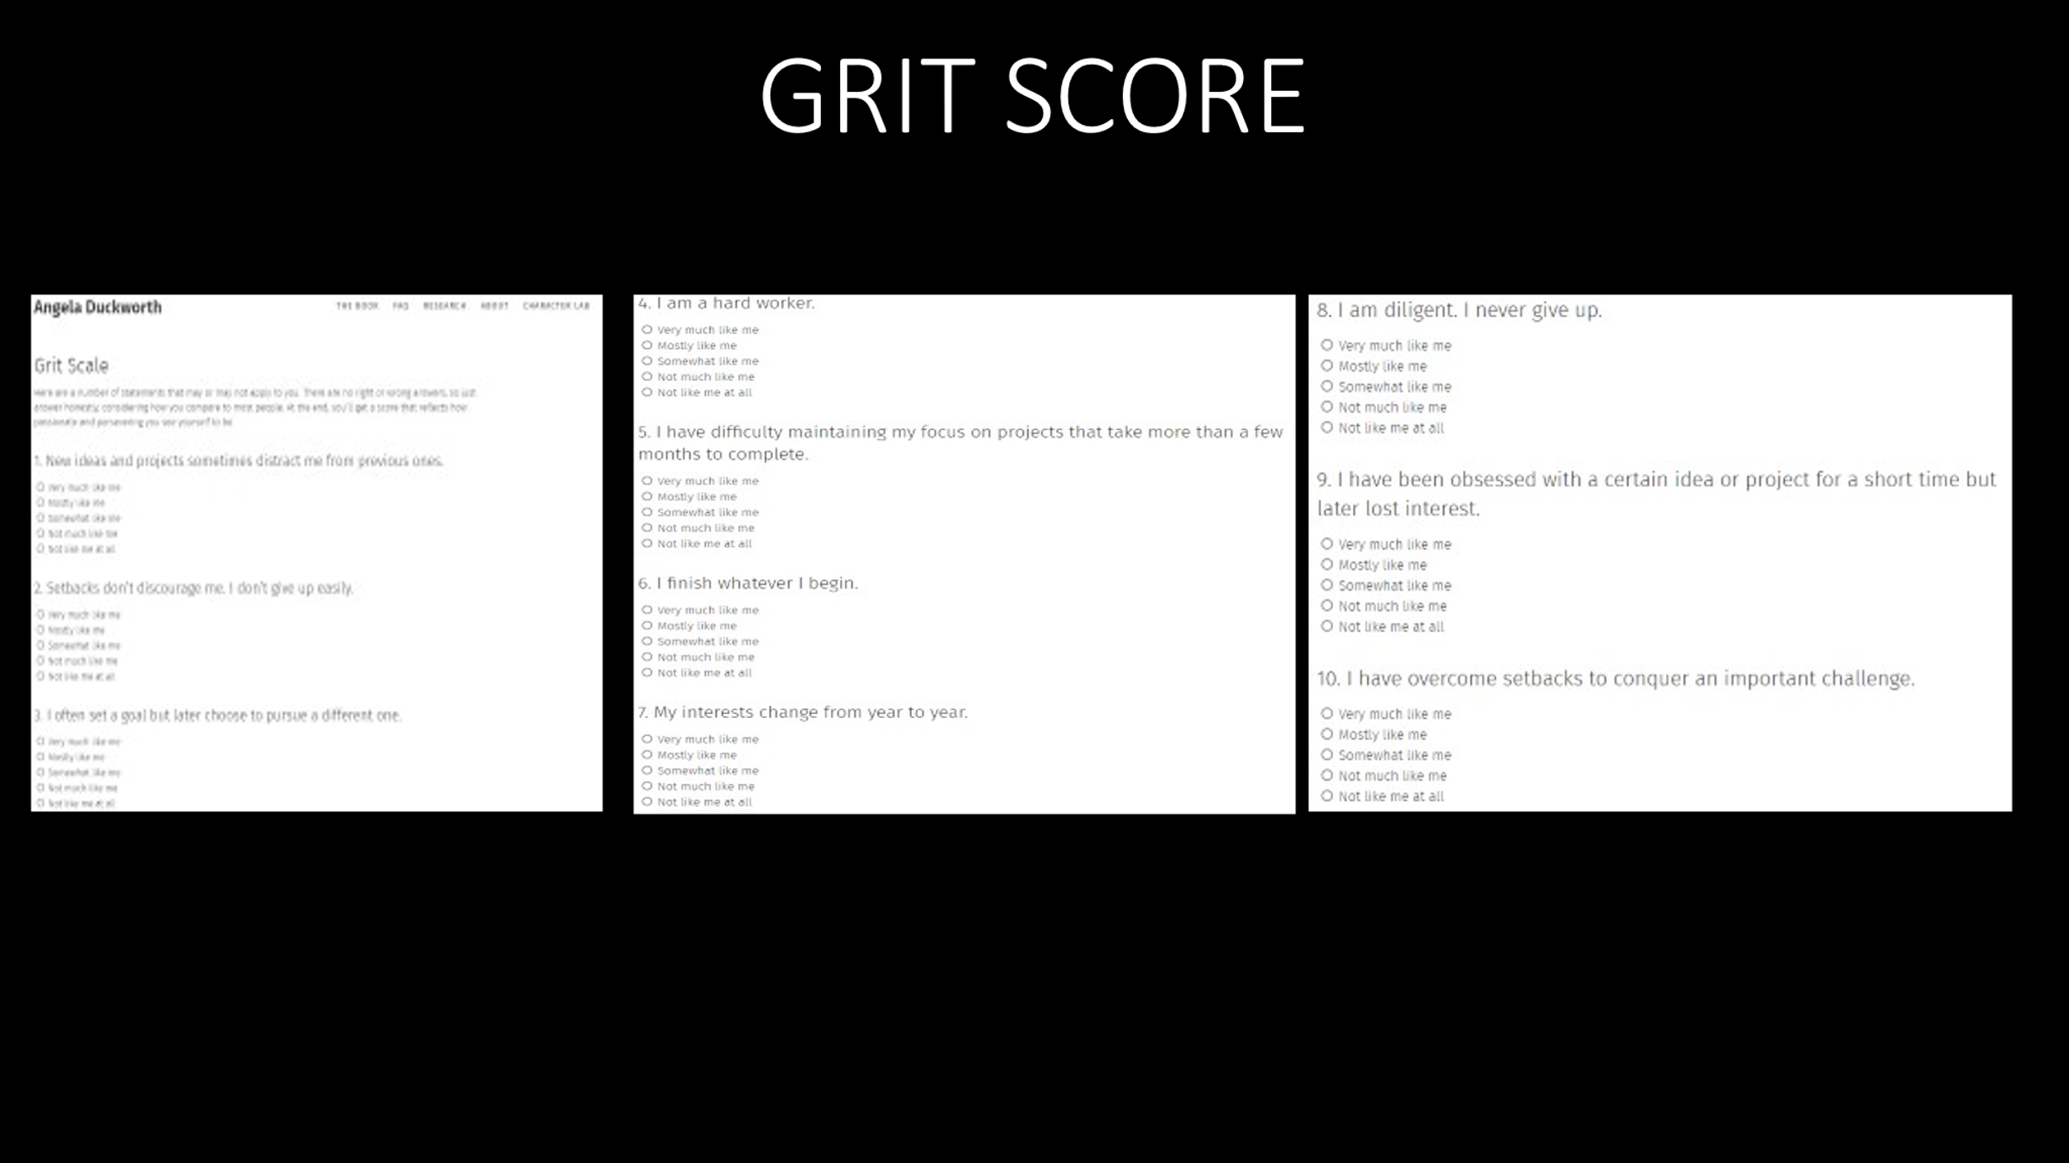

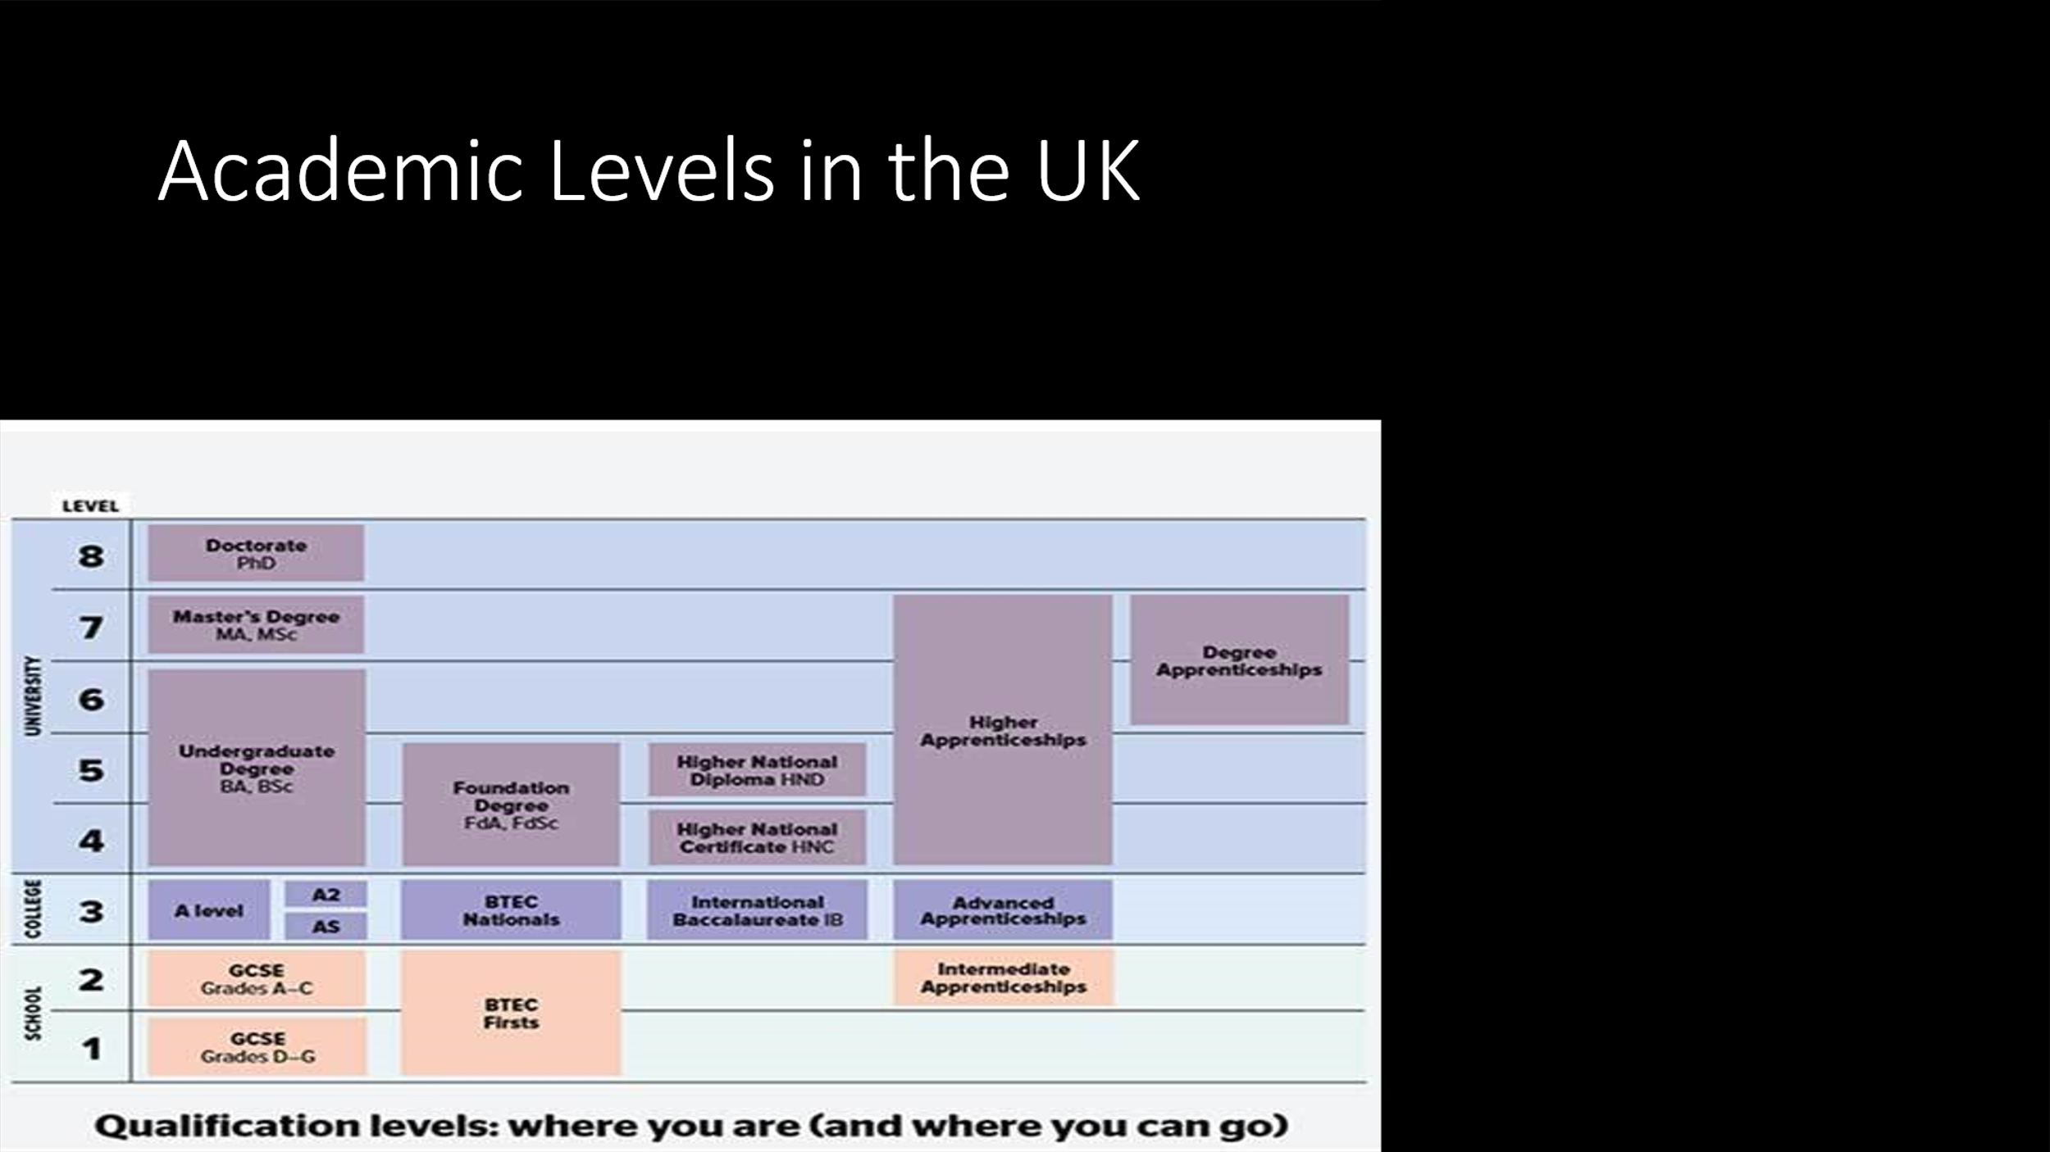
Within the framework of the International Standard Classification of Education (ISCED), levels of education are an ordered set of categories, intended to group educational programmes in relation to gradations of learning experiences and the knowledge, skills and competencies which each programme is designed to impart. Levels of education are therefore a construct based on the assumption that education programmes can be grouped into an ordered series of categories. These categories represent broad steps of educational progression in terms of the complexity of educational content. The more advanced the programme, the higher the level of education. The ISCED 2011 classification consists of nine levels of education, namely: early childhood education (level 0); primary education (level 1); lower secondary education (level 2); upper secondary education (level 3); postsecondary non-tertiary education (level 4); short-cycle tertiary education (level 5); bachelor’s or equivalent level (level 6); master’s or equivalent level (level 7); doctor or equivalent level (level 8).

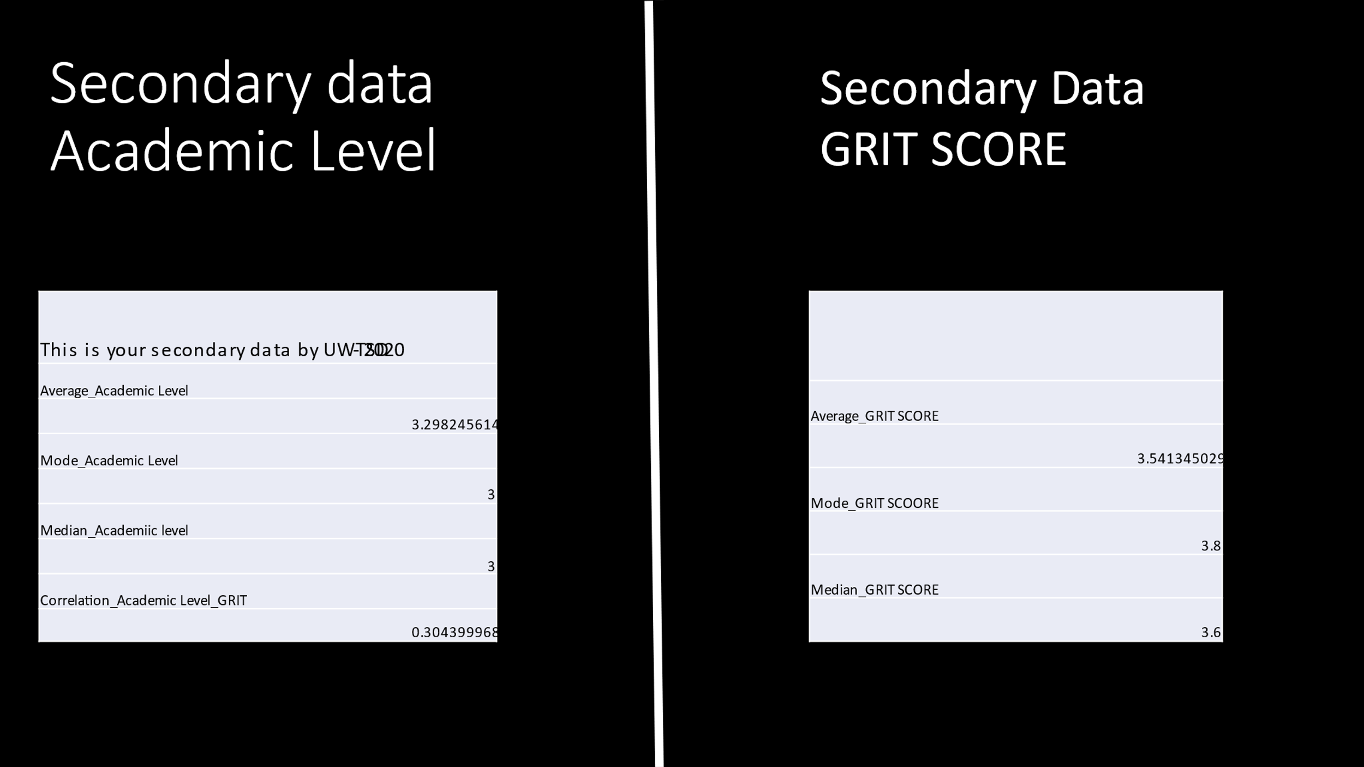

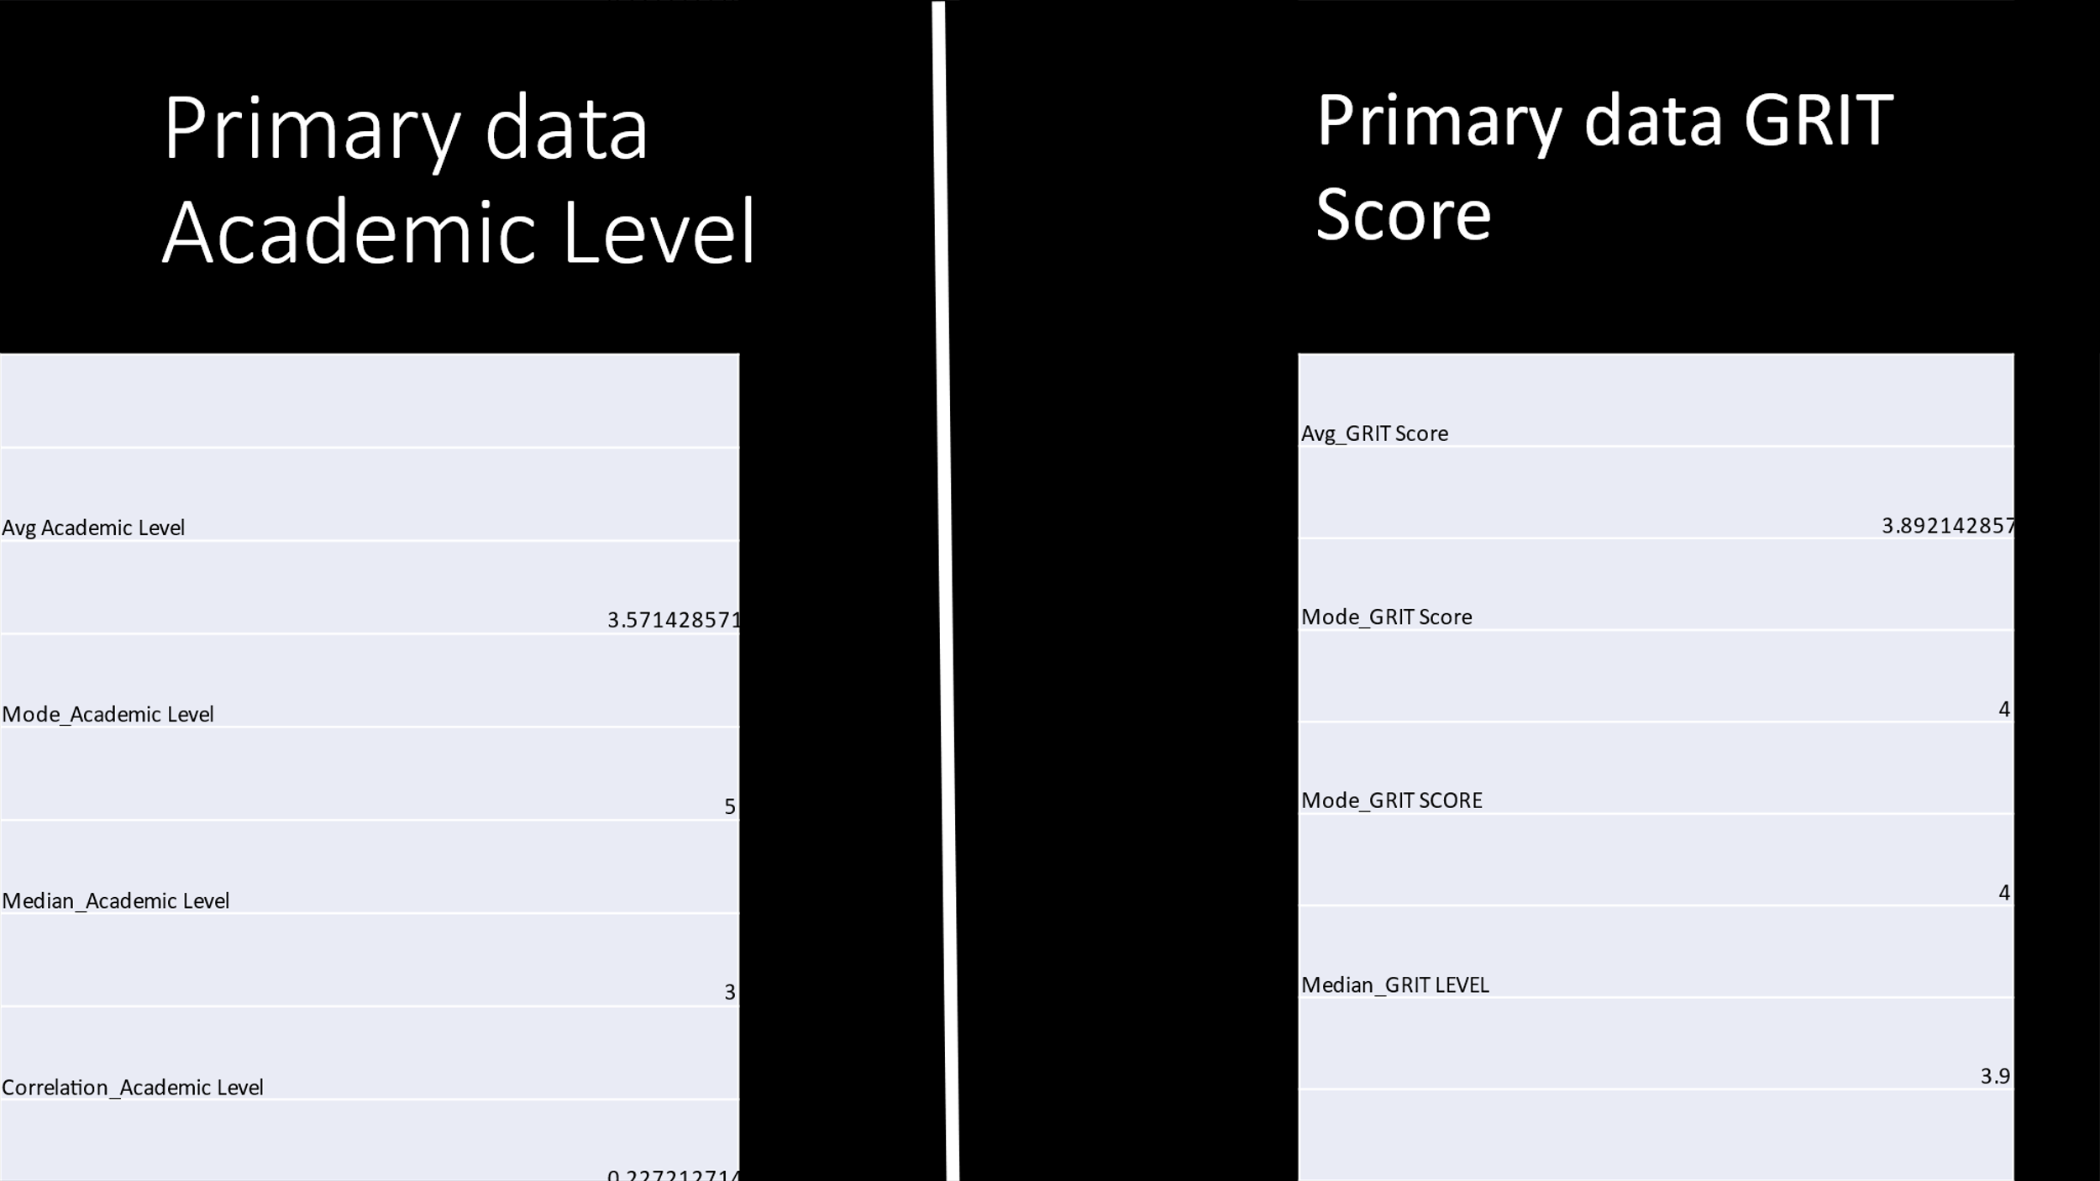

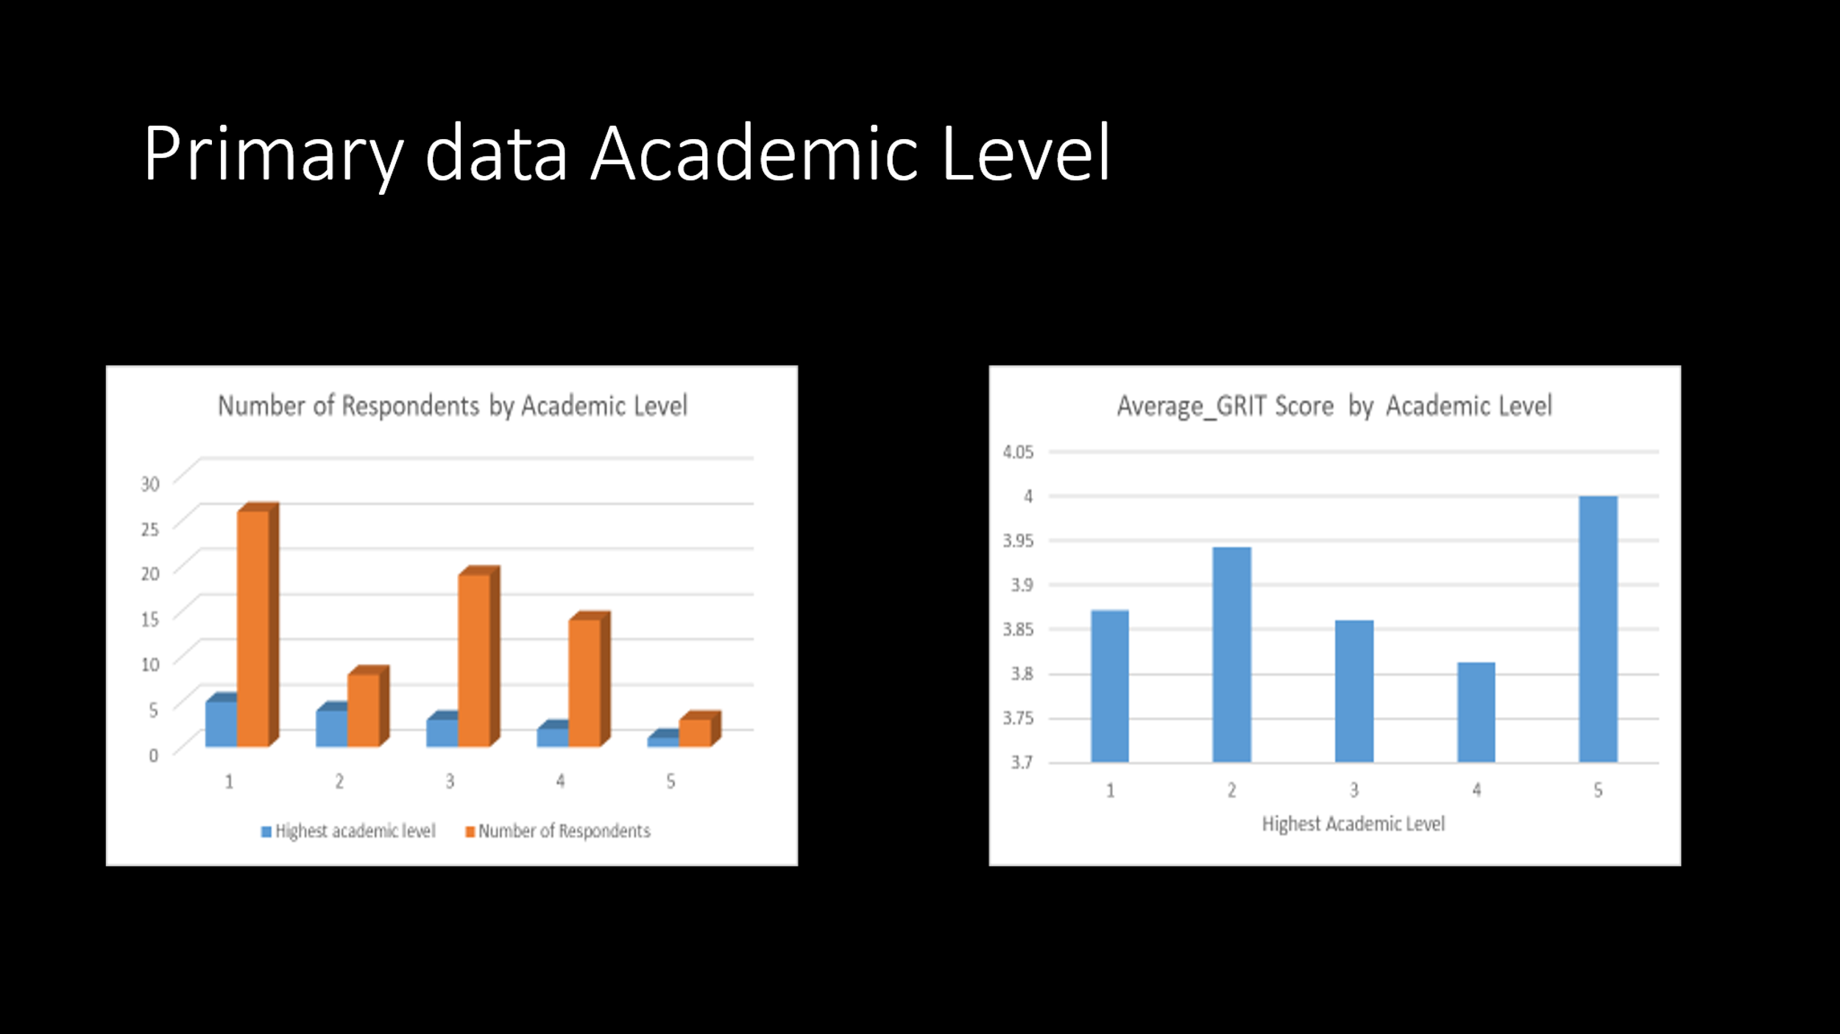

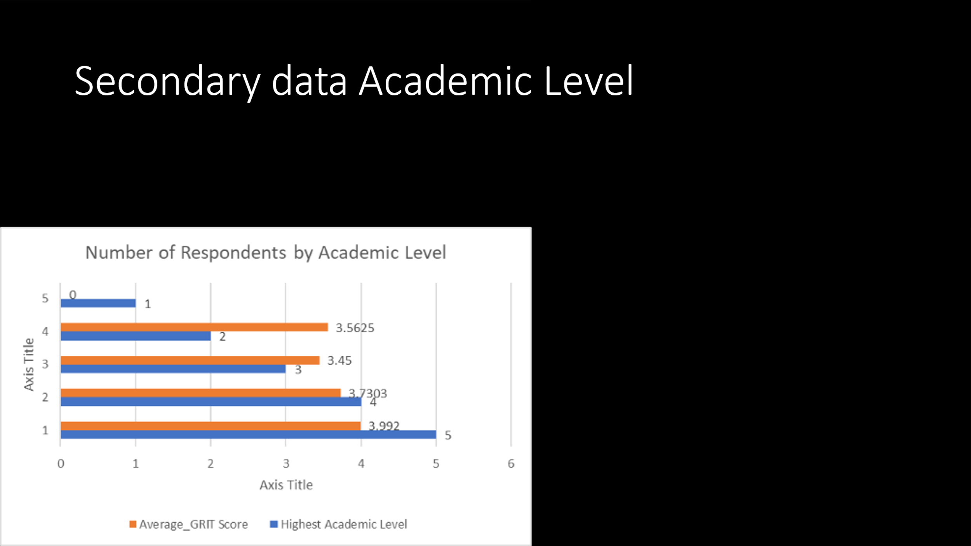

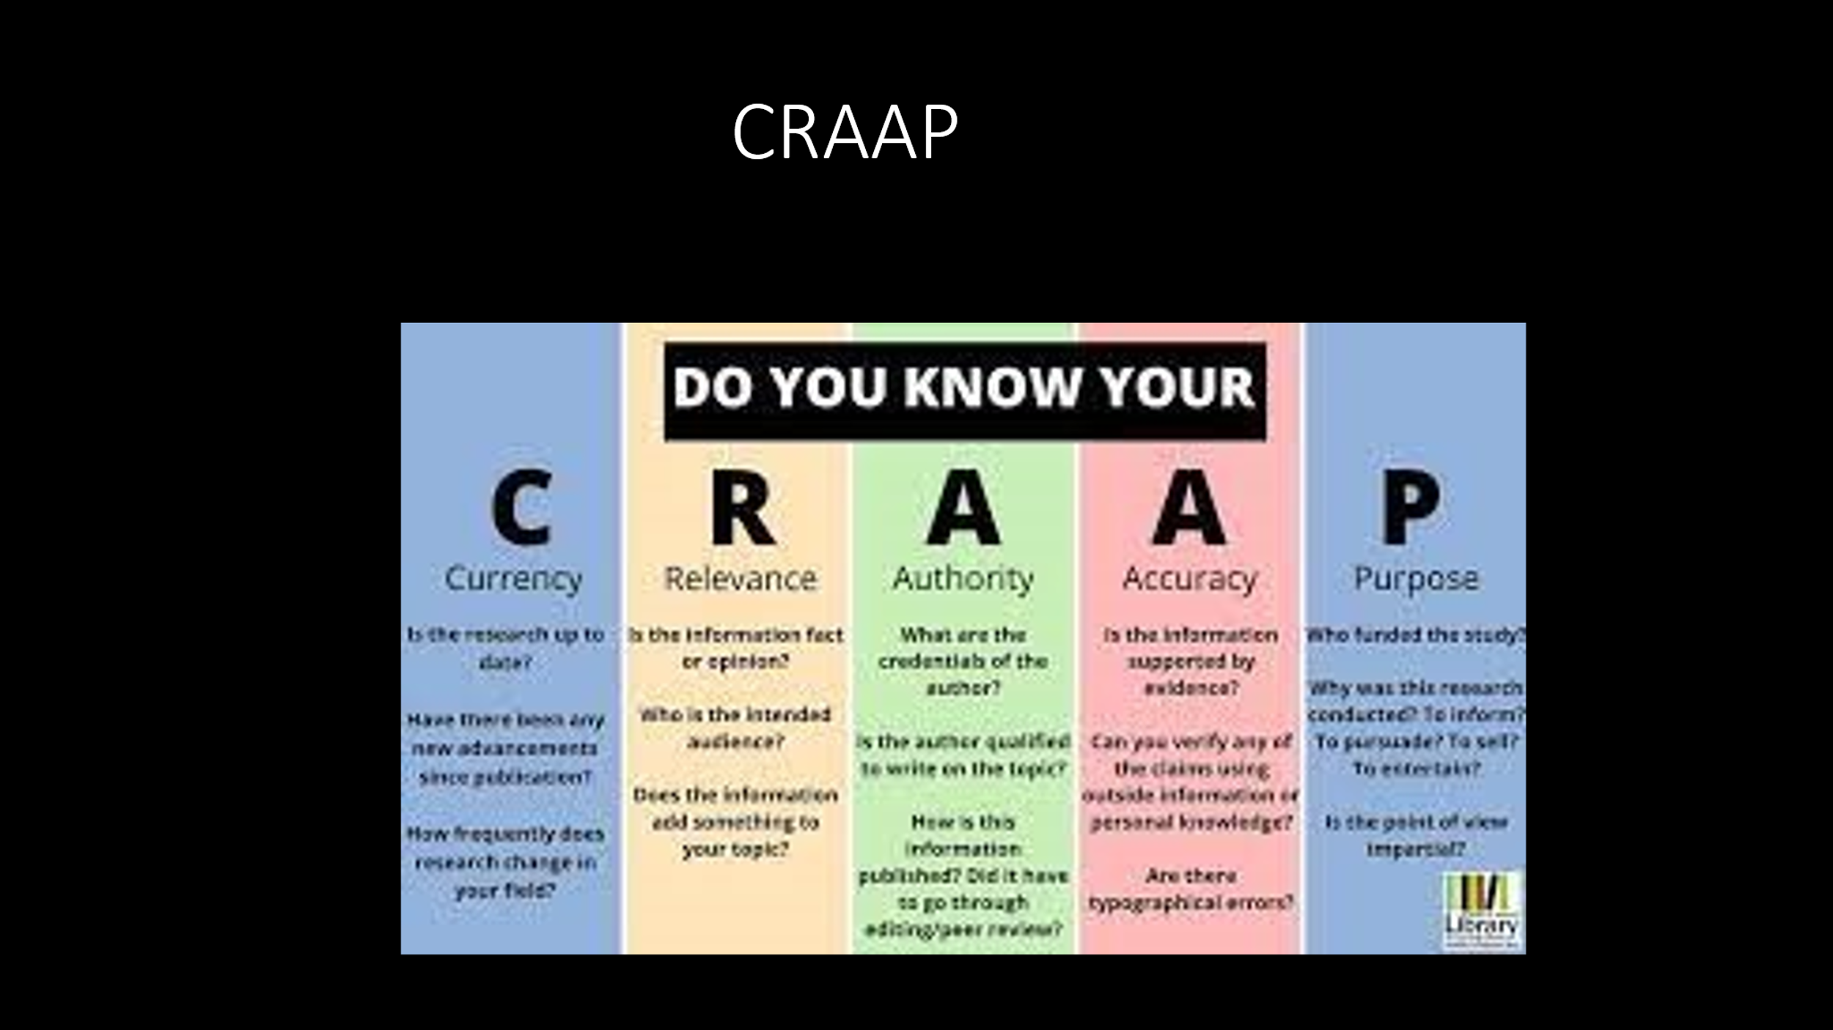

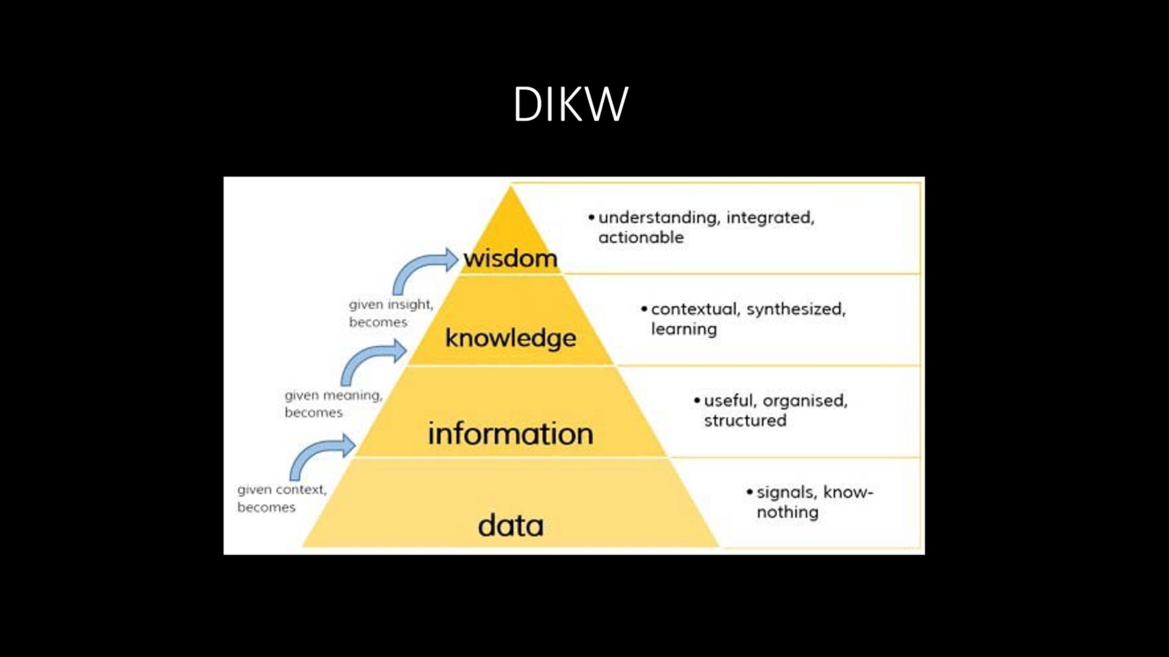
The DIKW Pyramid represents the relationships between data, information, knowledge and wisdom. Each building block is a step towards a higher level - first comes data, then is information, next is knowledge and finally comes wisdom. Each step answers different questions about the initial data and adds value to it. The more we enrich our data with meaning and context, the more knowledge and insights we get out of it so we can take better, informed and data-based decisions.



