

A Hybrid Machine Learning Approach for Insider Threat Detection - Using Behavioural Feature Aggregation

Name: Rezaul Haque
ID: 2507164
Module Code: ACFA7004

Table of Contents
1 Introduction 3
1.1 Context and Background 3
1.2 Research Problem Statement 4
1.3 Research Aim 4
1.4 Research Objectives 5
1.5 Significance of the Research 5
2 Literature Review 6
2.1 Scope and Purpose 6
2.2 Supervised Machine Learning Approaches 6
2.3 Unsupervised and Anomaly-Based Detection Methods. 7
2.4 Hybrid and Ensemble Approaches. 7
2.5 Temporal and Sequential Modelling. 8
2.6 Privacy, Explainability, and Risk Semantics. 8
2.7 Literature Overview/Positioning. 9
3 Research Design and Methodology 9
3.1 Research Approach and Design Framework 9
3.2 Research Strategy and Method 10
3.3 Artefact Design and System Architecture 11
3.4 Data Analysis and Evaluation 12
3.5 Research Materials 13
3.5.1 Data Source and Collection 13
3.5.2 Ethical Considerations 13
3.5.3 Software Tools and Libraries. 13
3.5.4 Hardware Requirements 14
4 Expected Outcomes and Limitations 14
4.1 Anticipated Results 14
4.2 Limitations 15
5 Project Timeline 15
References 17

Introduction

Context and Background
Insider threat detection is at the crossroads of cybersecurity and applied machine learning, and is one of the most technically challenging and impactful issues in modern information security. An insider threat is a type of threat that occurs when a person with authorised access to organisational systems (a current employee, former employee, contractor, or business partner) misuses the access to cause harm, either through data exfiltration, sabotage, theft of intellectual property, or through fraud [1]. In contrast to external attacks, in which attackers must first break through perimeter defences, insider threats act entirely within the trust boundary of the organisation, and so provide attackers not only with access credentials and contextual knowledge of key assets, but also with an organisational structure that provides a clear sense of direction and structure to the attacker. A sustained and accelerating research interest in this field is identified with a sustained and accelerating number of peer-reviewed publications in this field during the period 2015 to 2025 [1].
The economic and reputation impacts of insider threats are very high. According to Prasad, Nayak, and Krishna, insider incidents constitute about 30% of all data breaches, which remains consistently high despite increasing organisational investment in cybersecurity infrastructure [2]. This is further complicated by digital transformation: as remote working becomes a standard, cloud-hosted systems and environments that allow employees to bring their own device become standard, the amount and heterogeneity of behavioural log data generated by employees has grown exponentially, making manual monitoring approaches operationally infeasible [3]. Koli et al. show the magnitude of such a challenge by reporting that modern AI-based insider risk management systems must be able to handle up to ten million log events per day and dynamically adjust to changing behavioural baselines [3].
Two main research directions have surfaced recently with the emergence of various advances. Monitored machine learning algorithms -such as Random Forest, XGBoost and Support Vector Machines -have shown to have good detection results when used on labelled data sets which contain logs of annotated insider activities [2]. Parallel to this, unsupervised anomaly detection algorithms, including Isolation Forest, One-Class SVM, and autoencoders based on reconstruction errors models have been developed to detect deviations to learned normal behaviour without using labelled training data, which is often unavailable in real-world organisational contexts [4].

Research Problem Statement
The main technical issue that impelled this study is the long-standing inefficiency of single-model solutions when used to detect insider threats. Trained on labelled data, supervised classifiers are vulnerable to extreme class imbalance - genuine insider incidents are uncommon compared to normal user behaviour - and are susceptible to overfitting on scenarios during training that are not generalised to new attack patterns [5]. Although effective at learning normal behaviour, anomaly detection methods have high false positive rates due to their inability to reliably differentiate between truly malicious deviations and benign anomalies such as business travel, role changes or unusual project demands [5]. Tian et al. also note that the available methods are usually effective at identifying abnormal users, but fail to provide sufficient information on the particular threat scenario, which is a significant weakness to security operations teams that need actionable information [5].
Another structural gap relates to the incorporation of the temporal dynamics of behaviour and classification confidence. Attackers of insider threats do not often engage in one-time attacks; malicious behaviour is more likely to build up over time, and manifest itself through gradual deviations of an established user baseline [6]. The authors Yi and Tian find that previous methods of hybridization have failed to adequately address data granularity - that is, how time window over which behavioural properties are aggregated materially influences the discriminative power of downstream classifiers [6]. Thi et al. go further to criticize the systems that are in place by indicating that the modern systems hardly consider integrating standardised behavioural risk indicators and risk semantics into one unified framework [7]. All these convergent limitations create a clear research gap: the lack of empirically validated hybrid machine learning model that combines supervised classification and unsupervised anomaly detection with weekly temporal behavioural feature aggregation, a weighted fusion mechanism to a single insider risk score, and systematic comparative evaluation against model baselines.

Research Aim
To design, develop, and evaluate a hybrid machine learning framework for insider threat detection that combines supervised classification and unsupervised anomaly detection with temporal behavioural feature aggregation, producing a unified risk score and demonstrably outperforming standalone model baselines on the CERT Insider Threat Dataset r4.2.

Research Objectives
The following four objectives operationalise the above aim:
Objective 1: To critically analyse existing supervised and anomaly-based machine learning approaches for insider threat detection, identifying methodological gaps in hybrid model design and temporal feature aggregation strategies.
Objective 2: To preprocess and aggregate multi-dimensional behavioural features from the CERT Insider Threat Dataset r4.2 on a weekly temporal basis, encompassing login frequency, file access patterns, email behaviour, and device usage anomalies.
Objective 3: To design and develop a hybrid detection artefact comprising parallel supervised classification (XGBoost, Random Forest) and anomaly detection (Isolation Forest, Autoencoder) components integrated through a weighted fusion layer that generates a unified insider risk score per user per week.
Objective 4: To evaluate and compare the performance of the hybrid artefact against standalone model baselines using Precision, Recall, F1-Score, ROC-AUC, and False Positive Rate, and to assess the measurable impact of weekly temporal aggregation on detection performance.

Significance of the Research
This study has its importance both in its academic and practical dimension. Academically, it will provide an empirically validated hybrid model to a literature that, although it has been demonstrated individually that each of the different methods has its advantages and disadvantages, lacks a rigorous comparative evaluation of how their systematic integration with temporal behavioural aggregation works out to their benefit or their detriment. This research offers practical advice to practitioners who are developing next-generation user behaviour analytics systems, by empirically showing whether a hybrid architecture with temporal aggregation can replicate such gains.

Literature Review

Scope and Purpose
The literature review focuses on studies that research machine learning-based insider threat detection published between 2021 and 2026, and four thematic areas: supervised classification methods, unsupervised and anomaly-based detectives, hybrid and ensemble architectures, and temporal and sequential modelling. Peer-reviewed journal articles, conference papers, and doctoral theses, as well as vetted preprints by IEEE, Elsevier, MDPI, Springer, Scientific Reports, and arXiv are used as sources. The aim is to generalise the state of the field, summarise convergent findings, highlight methodological contradictions, and define the concrete gap that the proposed research will address.

Supervised Machine Learning Approaches
The use of supervised machine learning to detect insider threats has resulted in a well-established and mature body of evidence. A comparative study of Decision Tree, Random Forest, and XGBoost classifiers on behavioural log data on CERT dataset find that XGBoost produces about 98% accuracy in complex insider threat scenarios compared to the other two classifiers [10]. According to a statistical comparison of fifteen settings of the neural network in TensorFlow (using a modified version of CERT r4.2) reports that the best-performing model achieves 0.9804 accuracy with only ten risk indicators, near a Random Forest baseline of 0.9835, with differences across settings confirmed as statistically significant by KruskalWallis tests [11].
Nevertheless, the restrictions of the purely supervised approaches are always reported. Prasad, Nayak, and Krishna, who classify CERT behavioural features into eight categories (time, user, file, email, logon, USB, project, and device) and apply SMOTE to reduce the effects of class imbalance, admit that, despite the 99.8% accuracy on email-related features, the approach relies on offline feature engineering with limited capacity to support time- or sequence-dependent relationships among user actions [2]. The AdaBoost method used by Sarraf has an accuracy of 98.0 per cent, and an AUC of 0.98 in a zero-trust architecture but without temporal modelling and explainability features needed by modern deployment [4]. The common drawback in these studies: vulnerability to class imbalance, overfitting, and poor generalisation to novel attack patterns, is driving the complementary application of anomaly detection methods.

Unsupervised and Anomaly-Based Detection Methods.
Unsupervised approaches to the label scarcity issue by training representations of normal behaviour and scoring deviations respectively. Purohit et al. show that a model, based on continuous wavelet transform, discrete-time Fourier transform and autoencoder reconstruction error, achieves 95% detection accuracy on the CICIDS 2017 dataset, establishing that reconstruction-error-based anomaly detection is scalable across cybersecurity applications [12]. Park et al. generalize this result with a CNN-BiLSTM autoencoder on network packet data, finding 98.1% accuracy and 98.3% F1-score using reconstruction-loss thresholding, and demonstrating that temporal feature extraction via BiLSTM can significantly improve anomaly discrimination compared to fully connected autoencoder baselines [13].
Although these are good results, the nature of the anomaly detectors has a structural weakness: the high false positive rates caused by the inability to distinguish between the truly malicious deviations and the legitimate anomalies as a result of the change of roles, project demands, or unusual working patterns. Yi and Tian show that the choice of outlier scoring function and the time granularity with which the aggregation window is time-varying are critical parameters that have been systematically understudied by previous research [6].

Hybrid and Ensemble Approaches.
The most recent research frontier is the convergence of supervised and anomaly-based methods into hybrid architectures. Results with Dure hybrid AI pipeline Dure has consistently shown better results with hybrid AI pipelines, which combine Isolation Forest and Local Outlier Factor to first label anomalies and then train and test subsequent models [14]. According to Kausar et al. evidence-gated SIEM variant, which combines multi-agent simulation, behavioural forensics, trust-adaptive thresholds, and Isolation Forest achieves an actor-level F1-score of 0.933 and zero false positives per run, which demonstrates that carefully engineered fusion mechanisms can achieve near-perfect accuracy when run under controlled conditions [15].
Boobalan et al. suggest a weighted ensemble risk scoring model that combines Isolation Forest, Bi-LSTM, GCN, Z-score deviation and rule-based components, with SHAP being used to provide explainability and a graduated response tier system - LOW, MEDIUM, HIGH, and CRITical - to security operations prioritisation [8]. Although prototype-based, not fully tested on a large scale, this framework proposes the conceptual architecture which the current research aims to operationalise and test empirically. The combination of these hybrid studies points towards the most important finding that the design choice that has been least systematically empirically investigated is the fusion mechanism, i.e. how the classification probability and the anomaly score are combined and weighted.

Temporal and Sequential Modelling.
An increasing literature highlights the time aspect of user behaviour as a key to improving detection accuracy. The temporal dynamics of behaviour Insider actors usually exhibit a gradual increase in deviation to their expected baseline in comparison with systems that model the temporal dynamics of behaviour. Elbasheer and Akinfaderin introduce the User-Based Sequencing Transformer pipeline that has an accuracy of 96.61% and a recall of 99.43% and an AUROC of 95.00% on CERT r4.2, which demonstrates that sequential user modelling can substantially improve detection over tabular and conventional autoencoder baselines [16]. Yumlembam et al. introduce explicit activity graphs, implicit feature-similarity graphs, GCN embeddings and Bi-LSTM temporal modelling on CERT r5.2 and r6.2, and report AUC values of 98.62 and 88.48 respectively, which confirms that relational and temporal anomalies do require architecturally distinct yet jointly trained components [17]. Application of PatchTST to CERT r4.2 has an upper performance bound of time-series foundation model methods [18].
Conversely, the ITDSTS model by Tian et al. also involves a Transformer encoder with multi-head attention and daily serialisation of user behaviour, which reports about 5% better result over an LSTM and GCN baseline, but it cannot be applied to other settings where the types of attacks are not pre-determined by security analysts [5]. This body of work confirms that weekly temporal aggregation, although not as fine-grained as approaches based on daily aggregation, provides a better signal to detect slowly developing behavioural patterns.

Privacy, Explainability, and Risk Semantics.
New studies deal with issues of deployment other than crude detection performance. Thi et al. build on a RiskScore-guided GNN that integrates knowledge graphs, sequence-based standards of behaviour, and relational context, demonstrating outperformance of graph-based and sequence-based baselines on CERT r4.2 and establishing that risk-semantics-aware frameworks are more interpretable by security analysts [7]. Adeduro et al. show that federated learning with differential privacy and SHAP / LIME explainability achieve F1-scores of 0.88 on CERT and 0.86 on BETH and provide formal privacy guarantees, which is a state-of-the-art performance benchmark that the current research uses to contextualize itself rather than directly copy it due to its scope of performance constraints of MSc level [9].

Literature Overview/Positioning.
The analyzed literature provides the three convergent conclusions. First, supervised methods perform exceptionally well on benchmarks based on CERT, but are structurally limited by class imbalance and poor generalisation to rare insider events. Second, anomaly detection techniques are used to complement supervised classifiers but yield unacceptably high false positive rates when applied alone. Third, hybrid methods are always better than single-method models, but the actual design of the fusion mechanism, how classification probability and anomaly score are combined and weighted, and the choice of the time window used to aggregate the time-dependent patterns of this feature has not been experimentally controlled as variables in a systematic comparative evaluation on the CERT benchmark. This study fills that gap by formulating a hybrid framework where the aggregation window, fusion weighting, and model selection are considered explicit design parameters, which are evaluated with respect to standalone baselines under same experimental conditions with statistical significance testing.

Research Design and Methodology

Research Approach and Design Framework
This study follows a positivist research philosophy, which is consistent with the assumption that insider behaviour is real, observable and measurable phenomenon, and that cause and effect relationships can be formulated between the design and performance outcomes of detection systems [22]. It uses a deductive research method: the study is started with pre-defined theoretical and empirical propositions - that supervised classifiers and anomaly detectors are individually constrained but complementary - and designs controlled experiments that test whether their hybrid combination with time aggregation can yield significant performance improvements that are both measurable and statistically significant [22].
The general research design is based on the Design Science Research (DSR) framework suggested by Peffers et al. that organize the technical research around six sequential phases: problem identification, objective definition, artefact design and development, demonstration, evaluation, and communication of results [20]. The right framework is DSR since the research goal is to build and test a new artefact - the hybrid detection pipeline - as a contribution to the knowledge and practice. Figure 1 shows how each of the DSR phases relates to the activities of this specific research as well as the loop of iterative refinement between Phases 3 and 5.
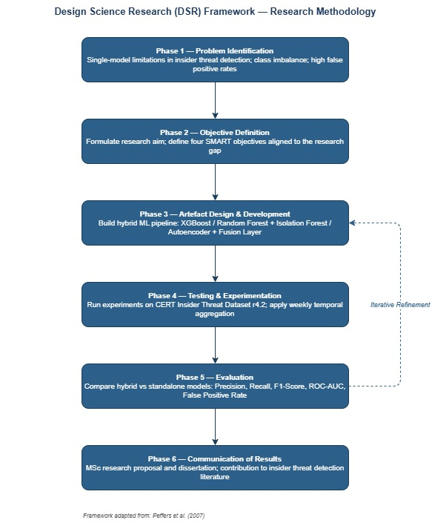
Figure 1: Design Science Research (DSR) Framework applied to this study (adapted from Peffers et al. [20])

Research Strategy and Method
The research design is experimental in nature whereby controlled development and testing of the hybrid detection artefact is carried out on a standardised set of data under specified conditions. This approach allows making strict causal attributions: the difference in performance in the hybrid model and in standalone baselines can be attributed to the design of the fusion mechanism and the selection of aggregation window instead of variation in data, preprocessing or evaluation procedures [22]. The method used in the research is quantitative, with Precision, Recall, F1-Score, ROC-AUC, and False Positive Rate as the main evaluation criteria, which are suitable since the use of insider threats is a measurable phenomenon, and CERT data offers a standardised environment to conduct controlled comparison.

Artefact Design and System Architecture
The artefact that is proposed is a hybrid machine learning detection pipeline written in Python. As per the system architecture of Figure 2, the pipeline will be a four-stage, sequential processing of information. The first stage includes ingesting and preprocessing raw log files out of the CERT r4.2 dataset: missing values are imputed with Min-Max scaling, numerical features are normalised using Min-Max scaling, and imbalanced class representation between insider and normal user data is corrected with SMOTE. The user activity is then aggregated on non-overlapping seven-day windows, providing a weekly behavioural profile per user of cumulative measures such as frequency of logins, counts of off-hours access, number of file access, email sendto receive ratio, and events of device connection [2].
The second stage is supervised feature engineering that removes the most discriminative features of the aggregated profiles of the week. The third stage, is a two parallel detection stream, where Stream A uses XGBoost and Random Forest classifiers, and the output is a classification probability score, which is the likelihood that a given weekly user profile is associated with an insider [10]; Stream B uses Isolation Forest and an Autoencoder and the output is an anomaly score, which is the likelihood that a given weekly user profile matches an insider [6]. The fourth step uses the Hybrid Fusion Layer which is the combination of the Stream A classification probability and the Stream B anomaly score through a weighted summation to obtain a single insider risk score per user per week. The optimisation of fusion weights will be done through cross-validation on the training partition, with the fusion weighting between supervised and anomaly components being a tunable hyperparameter that must be determined empirically and not a priori.

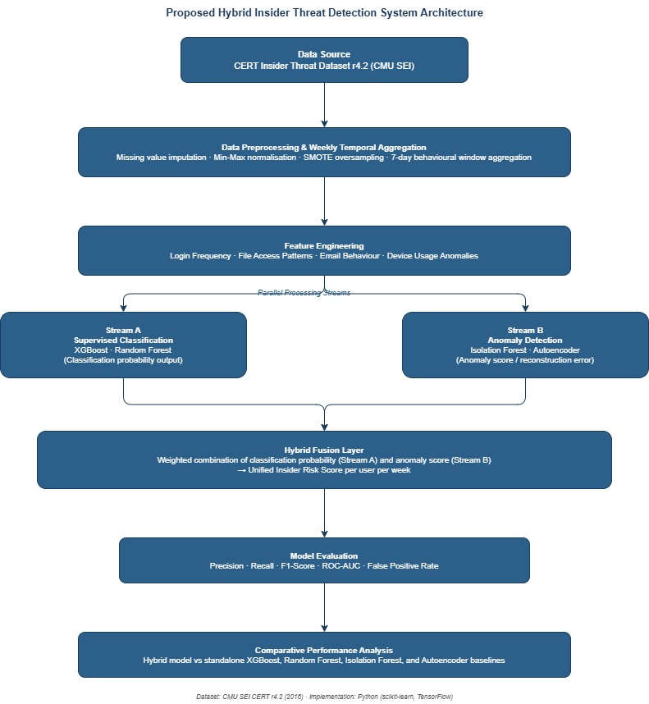
Figure 2: Proposed Hybrid Insider Threat Detection System Architecture

Data Analysis and Evaluation
A held-out test set of 20% of the CERT r4.2 data will be evaluated using a model; this test set will be stratified to maintain the distribution of the classes across the 70 annotated insider scenarios. The main evaluation measures are Precision (portion of flagged users who are in reality genuine insiders) Recall (portion of genuine insiders successfully identified), F1-Score (harmonic mean of Precision and Recall), ROC-AUC (area under the receiver operating characteristic curve) and False Positive Rate. The hybrid model will be compared to four standalone baselines: XGBoost alone, Random Forest alone, Isolation Forest alone, and Autoencoder alone. Kruskal-Wallis tests followed by Dunn post-hoc comparisons will be used to statistically determine the statistical significance of performance differences, which is also consistent with the evaluation methodology used by Walter [11], confirming the observed improvements are not due to random variation across the experimental runs.

Research Materials

Data Source and Collection
The key source is the CERT Insider Threat Dataset v4.2, that is created by the Software Engineering Institute at Carnegie Mellon University [21]. This dataset is a simulated, yet research-validated, simulation of organisational behaviour logs indicating 70 insider scenarios of 4 threat sub-types. CERT r4.2 is the de facto standard used in the research of insider threats and has been used in the majority of studies reviewed in this proposal [2], [5], [6], [10], [14], [16], [17], [18], [19], and is thus the appropriate choice to ensure that the same work that has been conducted previously can be compared. There will be no human subjects in the primary data collection part of the research; the research will purely use this publicly available synthetic dataset.

Ethical Considerations
Since the synthetic data publicly available to be used in this research does not contain any personal data of any research participant, there is no direct risk of privacy violation, re-identification, or injury to research participants. There is however one larger ethical consideration, namely any model derived on CERT data, when generalised to actual deployment, may be used to monitor employees in a manner that implicates the privacy and dignity rights of employees in the workplace. In that spirit, this study is carried out strictly in the form of an academic evaluation exercise, and the researcher pledges to responsible disclosure of not only the capabilities, but also the known limitations of the proposed artefact. The ethics approval will be done through the normal research ethics review process by the university before the experimental work can be done.

Software Tools and Libraries.
It will be implemented in Python 3.11 using the following libraries: scikit-learn (v1.4 or above) to use the Random Forest, Isolation Forest, SMOTE using imbalanced-learn and all evaluation metrics, XGBoost (v2.0 or above) to use the gradient-boosted tree classification, TensorFlow 2.x to use the Autoencoder neural network component, and pandas and NumPy to use the data preprocessing, temporal aggregation, and matrix operations components. The main development and documentation environment will be Jupyter Notebook, and the version control will be addressed with Git.

Hardware Requirements
The experimental pipeline will be executed on a regular laptop or desktop computer with at least 16 GB of RAM. Once the CERT r4.2 dataset has been preprocessed/aggregated on a weekly basis, it becomes a manageable tabular dataset, which does not require GPU acceleration to run XGBoost, Random Forest, or Isolation Forest components. Training of autoencoders can be accelerated with the help of a GPU in case it is available but is independent of it. No cloud computing infrastructure or high performance computing infrastructure is needed and as a result, the research is completely replicable under the limitations of standard student hardware.

Expected Outcomes and Limitations

Anticipated Results
It is expected that the hybrid structure will perform better than all standalone baselines on all the main evaluation scales, but the most significant improvements will be in Recall and False Positive Rate - the two dimensions in which the single-model approaches are most susceptible to structural constraints. It is hypothesised that the weighted combination of supervised classification probability and anomaly score will recover insider cases missed by the supervised classifier alone and at the same time filters false alerts produced by the anomaly detector alone. The seven-day time aggregation window is expected to enhance signal stability compared to more granular data, like daily or per-event, in line with the findings of Yi and Tian regarding the significance of data granularity in hybrid insider threat systems [6]. Provided this is confirmed, the study will deliver: a reproducible Python implementation of the hybrid pipeline compared to known baselines; and empirical evidence of the optimal fusion weighting of supervised and anomaly components, to inform practitioners who are designing next-generation user behaviour analytics systems.

Limitations
A number of constraints are accepted. Although CERT r4.2 dataset is widely used, it is synthetic and therefore may not fully capture the statistical characteristics of real-life organisational log data, limiting the extrapolability of any results. The seven-day aggregation window is a priori chosen depending on the current literature and might not be the most optimal to all four threat sub-types existing in the dataset. The risk of overfitting the weighting scheme to CERT-specific features that do not necessarily apply in other benchmark datasets are in place by the fusion weighting optimisation through cross-validation. Lastly, the Autoencoder component creates computational overhead which can limit the viability of the research contribution in resource-constrained environments, but this is a known limitation, not a barrier to the validity of the research contribution.

Project Timeline
The project is to be undertaken within a span of twelve weeks after submission of this proposal, covering all the stages of Design Science Research cycle up to submission of final dissertation. The first two weeks will be used in completion of literature review and finalisation of experimental design. Weeks 2-3 discuss CERT r4.2 acquisition of the dataset, preprocessing, and calibration using SMOTE. Week 3-4 is about feature engineering and validation of the seven-day temporal aggregation process. Week 4-6 discusses standalone model development and hyperparameter optimization. Weeks 67: Hybrid Fusion Layer with cross-validation weight optimisation. Weeks 7-9 will perform the entire experimental assessment including testing of statistical significance. Iterative DSR pipeline refinement between Phases 3 and 5 are also a part of Week 9. The 9-11 weeks will discuss the dissertation writing, with the final week (12) will be devoted to the final revision and submission of the dissertation.

Task | W1 | W2 | W3 | W4 | W5 | W6 | W7 | W8 | W9 | W10 | W11 | W12
Literature Review Completion
Dataset Acquisition & Preprocessing
Feature Engineering & Temporal Aggregation
Standalone Model Development
Hybrid Fusion Layer Development
Experimental Evaluation & Statistical Testing
Iterative Refinement (DSR Loop)
Dissertation Writing & Documentation
Final Review & Submission

References
[1] H. K. Ofori et al., “Application of Machine Learning and Deep Learning Techniques for Enhanced Insider Threat Detection in Cybersecurity: Bibliometric Review,” Symmetry, vol. 17, no. 10, p. 1704, 2025, doi: 10.3390/sym17101704.
[2] P. S. S. Prasad, S. K. Nayak, and M. V. Krishna, “Insider Threat Detection Using Behavioural Analysis through Machine Learning and Deep Learning Techniques,” Int. Res. J. Multidiscip. Technovation, vol. 7, no. 2, pp. 74-86, 2025, doi: 10.54392/irjmt2527.
[3] L. Koli, S. Kalra, R. Thakur, A. Saifi, and K. Singh, “AI-Driven IRM: Transforming Insider Risk Management with Adaptive Scoring and LLM-Based Threat Detection,” arXiv preprint arXiv:2505.03796, 2025.
[4] G. Sarraf, “Behavioral Analytics for Continuous Insider Threat Detection in Zero-Trust Architectures,” Int. J. Res. Anal. Rev., vol. 8, no. 4, pp. 596-602, 2021.
[5] T. Tian, C. Zhang, B. Jiang, H. Feng, and Z. Lu, “Insider Threat Detection for Specific Threat Scenarios,” Cybersecurity, vol. 8, no. 17, 2025, doi: 10.1186/s42400-024-00321-w.
[6] J. Yi and Y. Tian, “Insider Threat Detection Model Enhancement Using Hybrid Algorithms between Unsupervised and Supervised Learning,” Electronics, vol. 13, no. 5, p. 973, 2024, doi: 10.3390/electronics13050973.
[7] V. D. Thi, T. T. Duc, T. V. Nguyen, and H.-M. P. Luong, “Insider Threat Detection Using Knowledge Graphs and RiskScore-Guided Graph Neural Networks,” Eng. Technol. Appl. Sci. Res., vol. 16, no. 2, pp. 33712-33721, 2026, doi: 10.48084/etasr.17187.
[8] P. Boobalan, R. S., M. V. M. Lakshmi, and I. A. EK, “Explainable AI-Driven Insider Threat Detection and Data Loss Prevention Framework for Hybrid Work Environments,” Int. Res. J. Eng. Technol., vol. 13, no. 4, pp. 602-607, 2026.
[9] O. Adeduro, O. Josh-Falade, and A. Mesioye, “Proactive Insider Threat Detection Framework: An Explainable AI and Behavioral Analytics-Driven Approach,” Journal of Future Artificial Intelligence and Technologies, vol. 2, no. 4, 2026, doi: 10.62411/faith.3048-3719-307.
[10] J. Sivarani, R. B. Reddy, C. S. Sreeja, R. K. Priya, and S. Munendra, “An Efficient Machine Learning Framework for Behavioral Insider Threat Detection with Comparative Analysis of Ensemble Methods,” Int. Jr. of Hum. Comp. & Int., 2026, doi: 10.5281/zenodo.18836210.
[11] W. H. Walter, “Insider Threat Detection Using Neural Networks: A Statistical Comparison of the CERT Insider Threat Database,” D.Eng. praxis, George Washington University, 2025.
[12] R. Purohit, S. Kumar, S. Sayyad, and K. Kotecha, “Time-Frequency Analysis and Autoencoder Approach for Network Traffic Anomaly Detection,” MethodsX, vol. 14, p. 103228, 2025, doi: 10.1016/j.mex.2025.103228.
[13] H. Park, D. Shin, C. Park, J. Jang, and D. Shin, “Unsupervised Machine Learning Methods for Anomaly Detection in Network Packets,” Electronics, vol. 14, no. 14, p. 2779, 2025, doi: 10.3390/electronics14142779.
[14] J. R. D. S. Dure, “Enhancing Insider Threat Detection Through A Hybrid Approach Using Different Artificial Intelligence Techniques,” M.Sc. thesis, CCT College Dublin, 2025.
[15] F. Kausar, A. Muallem, N. S. Sattar, and M. Z. Kurdi, “Integrating Multi-Agent Simulation, Behavioral Forensics, and Trust-Aware Machine Learning for Adaptive Insider Threat Detection,” arXiv preprint arXiv:2601.04243, 2026.
[16] M. Elbasheer and A. Akinfaderin, “User-Based Sequential Modeling with Transformer Encoders for Insider Threat Detection,” arXiv preprint arXiv:2506.23446, 2025.
[17] R. Yumlembam, B. Issac, S. M. Jacob, L. Yang, and D. Krishnan, “Insider Threat Detection Using GCN and Bi-LSTM with Explicit and Implicit Graph Representations,” IEEE Trans. Artificial Intelligence, 2025.
[18] J. A. Castro, “Insider Threat Detection Using Time Series Foundation Models: A Transformer-Based Behavioral Analytics Approach,” D.Eng. praxis, George Washington University, 2026.
[19] X. Ye et al., “Research on Insider Threat Detection Based on Personalized Federated Learning and Behavior Log Analysis,” Scientific Reports, vol. 15, p. 19214, 2025, doi: 10.1038/s41598-025-04029-w.
[20] K. Peffers, T. Tuunanen, M. A. Rothenberger, and S. Chatterjee, “A design science research methodology for information systems research,” Journal of Management Information Systems, vol. 24, no. 3, pp. 45-77, 2007.
[21] Carnegie Mellon University Software Engineering Institute (CMU SEI), “CERT Insider Threat Dataset v4.2,” 2016. [Online]. Available: https://resources.sei.cmu.edu/library/asset-view.cfm?assetid=508099
[22] M. Saunders, P. Lewis, and A. Thornhill, Research Methods for Business Students, 5th ed. Harlow, UK: Pearson Education, 2009.

