Programme: Master of Business Administration
Module: International Business Concepts
Module code: LCMB7034

Student Name: Dhruv Sanjaykumar Patel
Student ID: 2431083@student.uwtsd.ac.uk
Table of Contents
1.0 Introduction 3
2.0 Benefits and challenges of Apple’s International operations 4
2.1 Company can be designated an MNC/TNC 4
2.2 Nature of the company’s global operations 4
2.3 Different entry modes used by Apple in entering the different international markets 6
2.3.1 Dominant entry mode for Apple 7
2.4 Key benefits obtained by the company from its international operations 8
3.0 Way the OLI factors (Ownership, Location, and Internalisation) impact the international market entry mode for Apple in Ethiopia 11
3.1 Ownership 11
3.2 Location 12
3.3 Internalisation 13
4.0 Cultural Differences and Their Impact on Apple’s Entry into Ethiopia 15
4.1 Power Distance: Hierarchy, Decision-Making, and Apple’s Control Structure 15
4.2 Individualism vs. Collectivism: Marketing, Brand Positioning, and Customer Experience 16
4.3 Motivation Toward Achievement: Performance Orientation and Consumer Aspirations 16
4.4 Uncertainty Avoidance: Risk Tolerance and Customer Comfort 17
4.5 Long-Term Orientation: Short-Term Focus and Market Development Timing 18
4.6 Indulgence vs. Restraint: Lifestyle, Spending Patterns, and Brand Experience 18
5.0 Three SOP Adjustments Required for Apple’s Successful Entry into Ethiopia 20
5.1 SOP Adjustment 1: Establish a Centralised Government–Industry Interface Protocol 20
5.2 SOP Adjustment 2: Localised Trust-Building and After-Sales Reliability Framework 20
5.3 SOP Adjustment 3: Inclusive Pricing, Financing and Value-Communication Strategy 21
Conclusion 23
References 24

1.0 Introduction
This report analyses the international business environment of Apple Inc. with a case study of considering its possibility to expand its business to Ethiopia which is one of the fastest growing emerging economies in Africa. The strategy through innovation-based R&D and over-the-world supply chain, coupled with the high-end branding, is what makes Apple a leading global multinational corporation. Ethiopia is a special case with its own context based on fast urbanisation, the growing digital penetration, and efforts by the government to empower the telecommunication and manufacturing industry as the company finds its way into new markets outside the mature Western and Asian markets. This report will discuss the advantages and problems of global operation of Apple, the entry strategy, as well as the application of the OLI framework to determine what is strategic at Apple about entering Ethiopia and the cultural, institutional, and operational changes needed to achieve success in the long term.

Figure 01: Apple Logo
Source: (Substack , 2025)

2.0 Benefits and challenges of Apple’s International operations

2.1 Company can be designated an MNC/TNC
In 2024, Apple Inc. is able to be called a multinational/transnational corporation due to the fact that the corporation generates about US $391 billion in revenues worldwide and about 17 percent of this revenue is generated in Greater China alone, the rest being distributed in Europe, Americas, and Asia-Pacific (Soltani, 2025). It has more than 100 plus countries including emerging economies of operation, it has R&D and manufacturing centres all over the world and it has integrated global supply chains, depicting cross-border presence and transnational organisation.
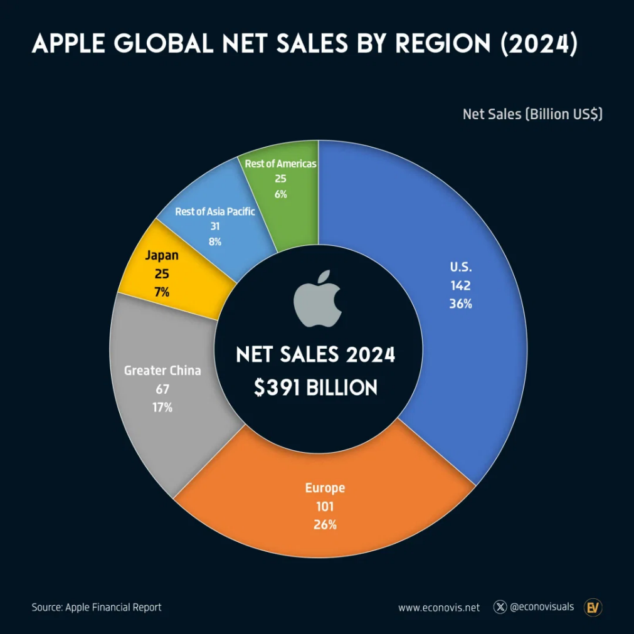
Figure 02: Apple Global Net Sales by Region (2024)
Source: (Voronoi App, 2025)

2.2 Nature of the company’s global operations
Research and development
Location R&D is distributed all over the world with Apple having major centres in California, Munich, Beijing and Haifa specialising in silicon engineering, AI, modem development, and security technologies. Apple has spent US 31.37 billion in R&D in fiscal 2024, making it the leading company in the development of custom chips and spatial computing (Macro Trends, 2025).Its multi-regional R&D ecosystem is the driver of innovation and quicker integration of devices and services.
Sourcing
The sourcing network of Apple is located in Taiwan, China, Japan, U.S., and South Korea, which comprise approximately 98 percent of its procurement requirements (Young, 2023). The company has tailored-made parts, which are usually supplied by specialised single supplier which makes the company vulnerable to price and capacity risks, yet giving it high performance and good quality control.
Production
The production network of Apple is experiencing a significant change in geography. The phone assembly in India amounted to 44 percent of the total bound to the U.S. by the middle of 2025, compared to 13 percent last year, showing diversification on the part of Apple (BusinessWorld, 2025). The increased Indian plants of Foxconn and Tata, which is a part of an estimated US22 billion yearly production capacity, helps in this transition, and Vietnam still increases the production of the MacBook and AirPods (Derrick, 2025).
Sales
Apple Inc.'s Q2 2025 net sales were $95.36 billion, including iPhone, Mac, iPad, wearables, and services. The graphic below shows that the iPhone accounts for 56% of Apple's quarterly sales, which is why entering new areas like Ethiopia is crucial to worldwide demand. Services make up 21%, indicating the growing relevance of digital platforms like iCloud and the App Store, which may be enlarged as internet availability in Ethiopia rises. The distribution, together with Mac (7%), iPad (7%) and Wearables (9%), shows that Apple must boost product uptake beyond mature markets (Six Colors, 2025).

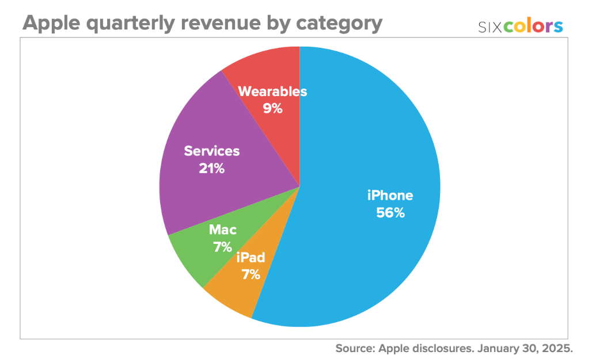
Figure 03: Apple Quarterly Revenue by Category 2025
Source: (Six Colors, 2025)
Financing
Apple has one of the largest cash reserves in the world and in the first quarter of 2025, Apple had cash and marketable securities totalling approximately US 158 billion, and funds are overseen by internal capital markets and global treasury, which are used to allocate the funds towards research and development, production, and expansion (Elad, 2025). To promote the international expansion strategy, the company has foreign-exchange exposure, tax jurisdiction, and the international issuance of debt.

2.3 Different entry modes used by Apple in entering the different international markets
Exporting
Apple also has a tendency of exporting finished goods of their main manufacturing centres to other countries that do not produce them locally. To illustrate, the Europe region generated US 24.92 billion ,26.6% of the total in revenues in Q3 2024 most of which were through devices manufactured in other countries and then through exports (Nasdaq, 2024). Export gives Apple the chance to penetrate markets fast with a comparatively small risk of investment, but it has limited local control and adjustment.
Joint Venture / Strategic Alliance
In India, Apple has strengthened relationship with local players: in January 2025 Tata Electronics bought a 60 % stake in Pegatron Technology India which manufactures an iPhone assembly plant on its behalf rather than directly owning it directly outside of India (Reuters, 2025). The mode diversifies the risk and offers local intelligence, but Apple should share control and observe brand/quality.
Acquisition / Wholly-Owned Subsidiary
Acquisitions have enabled Apple to gain the technology, distribution, or country level control. The company has invested approximately US $32.5 billion in acquisitions since 1997, which allows it to expand quickly in new markets or capabilities (history tools, 2025). An example of this is buying or setting up wholly owned shops in strategic markets, which will provide Apple with complete management of its brand and retail experience though at a greater expense and risk.
Greenfield Investment / Foreign Direct Investment (FDI)
Apple has been putting a lot of investments towards setting up its own business in the new markets. It has the idea of Make in India that implies the mass FDI with India becoming an export centre and not just a domestic market (Strategy Boffins, 2024). Greenfield investment is the most controlled and long term commitment but it takes so much time and capital to achieve success.

2.3.1 Dominant entry mode for Apple
The prevailing entry strategy by Apple is the Foreign Direct Investment (FDI) in the form of wholly owned subsidiaries, which is suitable and appropriate in the context of Apple having the absolute control of the product quality, brand experience, data control, and the integration of the entire ecosystem. In contrast to franchise or licencing, Apple maintains ownership of its flagship retail outlets, local subsidiaries, and digital service operations in the foreign markets, which ensure that the customer experience is standardised, and proprietary technology is not compromised. This is one of the strategies that help it to sustain its high-end branding by offering the same price, safe payment options, and uninterrupted after-sale services. The selective presence of Apple in global markets confirms its goals of high-control FDI, out of 272 stores in the U.S., 45 in Mainland China, but just 2 in India (Upadhyay, 2023). Apple has shown growth only in those markets where it can have complete control over its operations and the ecosystem. This limited retail presence is useful in supporting the argument that Apple favors wholly owned subsidiaries over low control entry modes such as franchising or licensing.
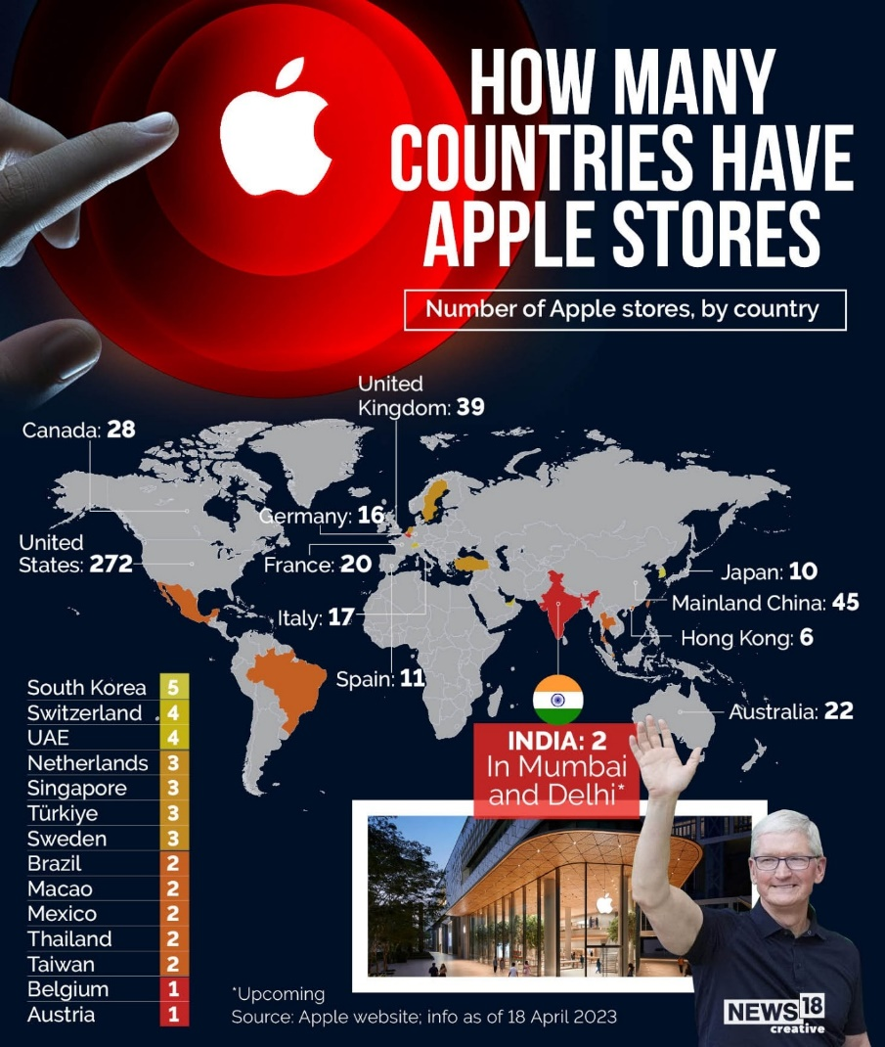
Figure 04: Global Distribution of Apple Retail Stores by Country (2023)
Source: (News18.com, 2025)

2.4 Key benefits obtained by the company from its international operations
Table 1
Benefit | Description
Revenue Diversification | Global sales help Apple to become less reliant on one market. In 2024, the company received US 172.2 billion in non-American-based markets, which is 44 percent of the total revenue ( Apple Inc., 2024a).
Global Supply-Chain Efficiency | Apple enjoys the distributed supply base in Asia, Europe, and the Americas. By 2024, 151 out of the top 200 suppliers of Apple are outside the U.S. reducing the cost of components and raising the efficiency of operations (Apple Inc., 2024b).
Access to Global Innovation Talent | Apple improves innovation by taking advantage of R&D centres in various countries. Its Munich Silicon Design Centre, among others, has a workforce of 2,000+ engineers, which reinforces the wireless and silicon engineering of Apple (Apple Newsroom, 2024a).
Expansion of Services Revenue Globally | The international business of Apple increases the recurrent revenue base. The Services revenue of Apple increased to a record high of US $85.2 billion in FY2024, which is due to the uptake of iCloud, Apple Music, and App Store internationally (Apple Newsroom, 2024).
Risk Mitigation Through Geographic Diversity | Apple minimises geopolitical and regulatory risks through decentralisation of manufacturing in many regions. By 23 percent of the iPhones to be exported to foreign markets were produced outside China, primarily in India and Vietnam (Bloomberg, 2024).

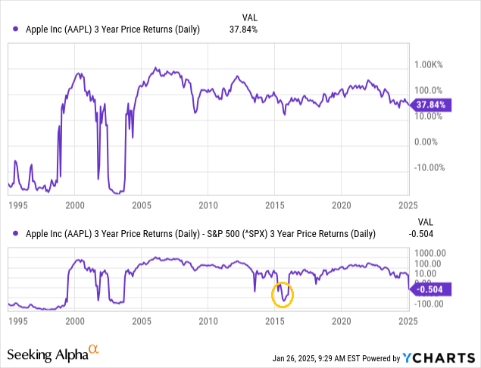
Figure 05: Apple’s 3-Year Price Return Performance vs. S&P 500
Source: (Seeking Alpha, 2025)
The globalisation strategy by Apple avoids shocks in the region, with its 3 year moving returns being higher than the S&P 500. In 2024, Apple survived the global supply chain challenges with a cumulative foreign presence return of 37.8% (Franke, 2025). This reveals that regional diversification is a strategic way of risk mitigation.

3.0 Way the OLI factors (Ownership, Location, and Internalisation) impact the international market entry mode for Apple in Ethiopia

3.1 Ownership
One of the key points of entry into Ethiopia in the future would be ownership benefits that Apple has gained due to its international expansions. The global brand equity of Apple evidenced by its 2024 annual revenue of US$ 390.8 billion makes it one of the most valuable brands in the world (Curry, 2025). The company has a proprietary ecosystem, such as its own silicon, for example M-series chips, iOS platform, international services network and highly controlled retail experience, which Apple has unique properties that cannot be easily replicated by the local Ethiopian competitors. Moreover, it is paramount that Apple can successfully control its supply chain on a global basis and possesses the necessary skills in scaling up the manufacturing and logistic activities to operate globally to effectively implement new systems in the new markets. These capabilities ensure the internalisation of critical functions that ensure quality and consistency as well as reduce the dependence of Apple on the local partner knowledge. Ethiopia is one of those countries which are striving to enhance their digital infrastructure and it is predicted that the number of internet users in this country will exceed 28.6 million by the year 2025 (Ethiopia, 2021).The ownership benefits would enable Apple to utilise its integrated hardware-software-services framework to influence the behaviour of the local market. The resources create barriers to imitation and generate sustainable competitive advantage and this is the reason why Apple favours wholly-owned entry mode as opposed to licencing or franchising. Therefore, the ownership assets not only make entry easy, but also dictate the optimum mode (FDI) by being able to have total control of operation, branding, and technological standards in Ethiopia.
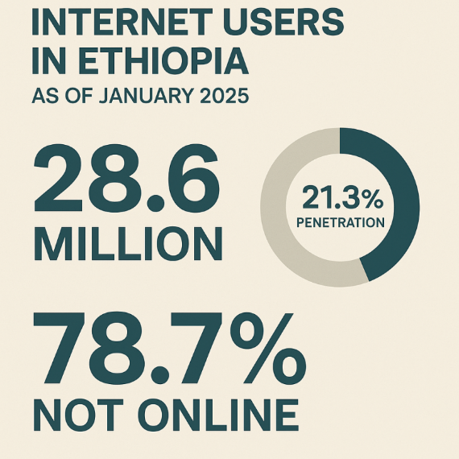
Figure 06: Internet Users and Penetration Rate in Ethiopia (January 2025)
Source: (Edesa, 2025)

3.2 Location
Ethiopia has some strong location specific opportunities, that are consistent with the international expansion strategy of Apple. To begin with, the current mobile connectivity situation in Ethiopia is developing at a high pace: in early 2024 the nation registered 77.39 million active mobile connexions, or approximately 60.4 percent of its population, which points to the increasing digital adoption (Kemp, 2024a). Secondly, regulatory transparency and infrastructure investment have been enhanced by the Digital Ethiopia 2025 strategy of the government and recent liberalisation of telecoms (Gilbert, 2024b). Third, the country has a positive demographic situation in Ethiopia: approximately 128 million people in 2024 and a median age of only 18.9 years (Kemp, 2024b). All these attributes give Apple a place with high growth potential especially in devices, services and digital ecosystems and infrastructure upgrades give possibilities of new manufacturing or assembly sites. In addition, the relatively low smart phone penetration with increasing internet usage in Ethiopia provides first mover opportunity to high-end brands. Indicatively, internet penetration in early 2024 is only 19.4% and therefore, it means that the potential is substantial (Freedom House, 2024). The Ethiopian 4G and 5G connexion growth, which is projected to increase to over 60 percent in 2029, compared to an estimated 17 percent as of 2024, is also a positive indication of the location advantage of Apple, as more individuals will be able to purchase advanced devices (Gilbert, 2024a). Therefore, the compounding features of increasing digital connectivity, a young demographic, and reforming regulatory structure in Ethiopia add up to a location advantage, which is an ideal place to make a strategic foreign investment by Apple. This kind of investment can ride the growth before the competitors can flood the market, which would make apple not only a high end brand in gadgets, but also a platform provider in new sub-Saharan Africa.
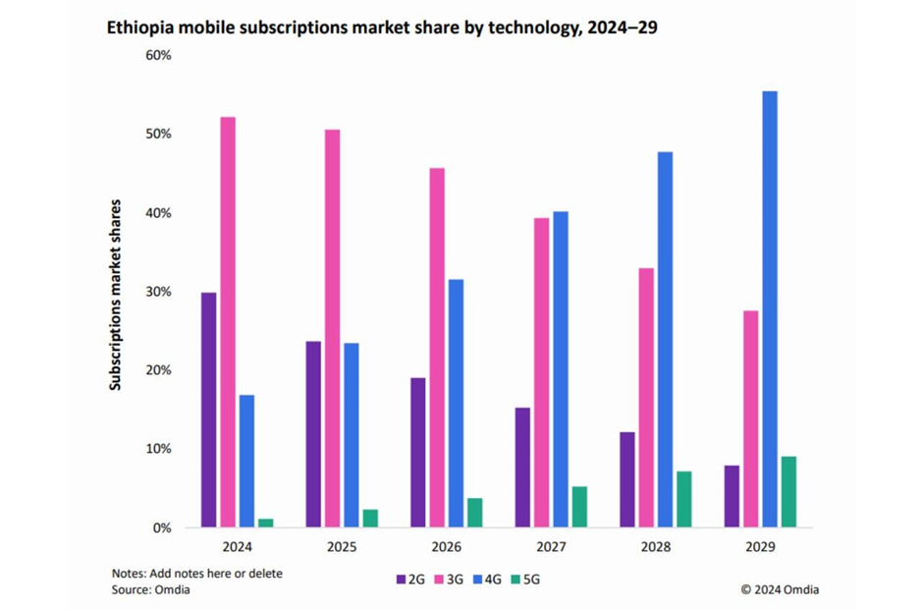
Figure 07: Ethiopia Mobile Subscription Trends by Network Technology
Source: (Connecting Africa, 2024)

3.3 Internalisation
The choice of internalisation of core activities instead of outsourcing is a hallmark of the global strategy of Apple and would be a very strong factor in its market penetration in Ethiopia. The internalisation will enable Apple to secure its closely-knit hardware-software ecosystem and control innovation, data privacy, and customer experience. On a global scale, Apple operates its own digital platform: currently, the company has more than 2.2 billion active devices across the world, which is why it is necessary to directly govern the services, including the App Store and iCloud, instead of assigning them to third parties (Clover, 2024). In Ethiopia, internalisation is even more strategically applicable due to the fact that institutional and technological environments are in the process of development. In Ethiopia, manufacturing value added represents about 4.4% of the GDP in 2022, meaning that there are low levels of local services in the area of high-technology electronics assembly, which makes outsourcing production and contract manufacturing less viable (Acquia, 2022).
Through the strategy of internalisation by establishing retail subsidiaries, service centres, and its controlled distribution network, which is one plan that Apple has employed the firm can maintain consistency regarding the authenticity of their products, the pricing strategy, their customer service, and their technological standards. Moreover, there is internalisation through which Apple can protect valuable user data that is considered the most important in markets that are yet to fully develop, especially regarding their data protection laws. Apple needs to internalise its operations as opposed to outsourcing it to Ethiopia. This has been attributed to the fact that in 2024, Ethiopia was ranked as the thirteenth-highest nation in the GDP growth that stood at 6.2 percent (IMF, 2023). Due to the rapid development of the macroeconomic environment, the demand in the high quality digital services is rising, and it is thanks to this that the redirection of distribution, retail, and post-sales services becomes a subject of intense interest. Apple can convert the benefits of ownership into high operational performance and can in turn support a high-control entry mode like Foreign Direct Investment (FDI) by utilizing the strategic choice.
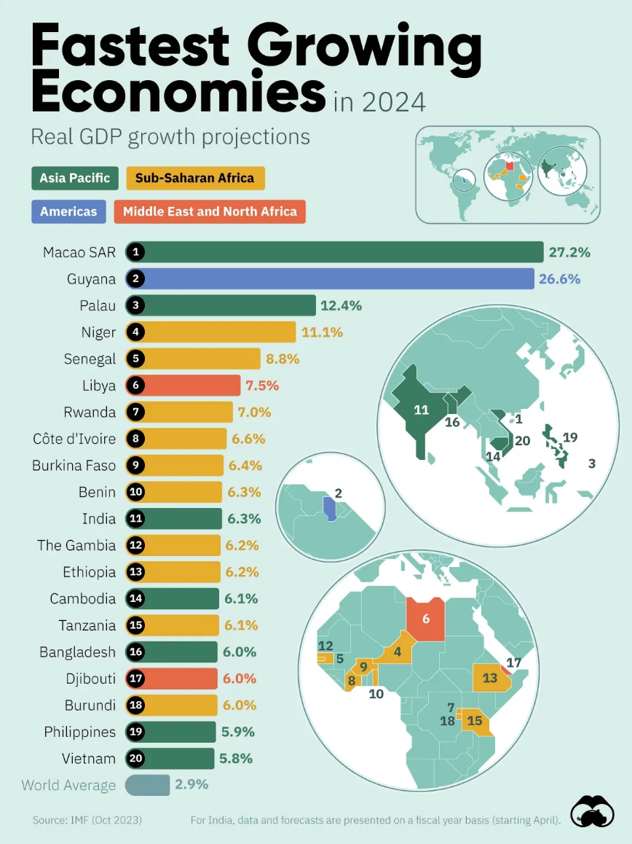
Figure 08: Fastest Growing Economies In 2024
Source: (Visual Capitalist, 2023)

4.0 Cultural Differences and Their Impact on Apple’s Entry into Ethiopia
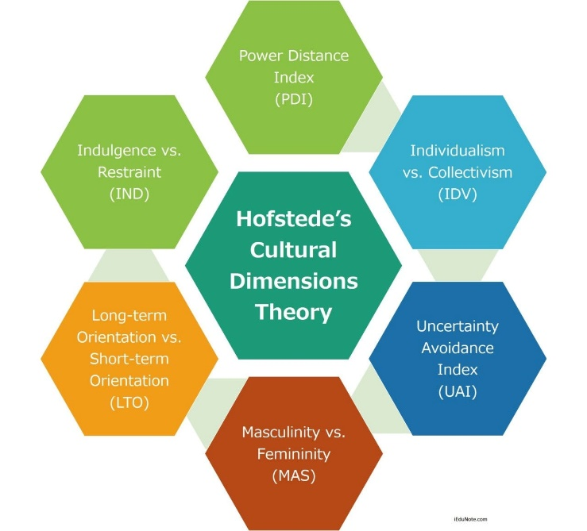
Figure 09: Hofstede Cultural Dimension Theory
Source: (iEduNote, 2020)

4.1 Power Distance: Hierarchy, Decision-Making, and Apple’s Control Structure
The high Power Distance gap between Ethiopia (70) and the USA (40) poses structural consequences to Apple about the entry strategy. The high score is consistent with the political environment in Ethiopia in which the Varieties of Democracy (2024) scores the country 10/10 on the executive dominance in the policy making process, indicating a strongly centralised model of government. On the same note, according to the World Bank (2025a), more than 52 percent of formal-sector jobs fall in the government sector, and it continues to support the central role of the state in the economic coordination. Apple will not be able to depend on decentralised negotiations that characterise the U.S. in such a hierarchy-focused environment. Rather market entry should focus on a top-level interaction with ministries, telecommunications authority, and regulatory agencies, through a formal communication channel. Such setting reinforces the strategic imperative of a high-control entry channel, which makes sure that Apple has the control over the situation without infringing the authority-based institutional standards in Ethiopia.
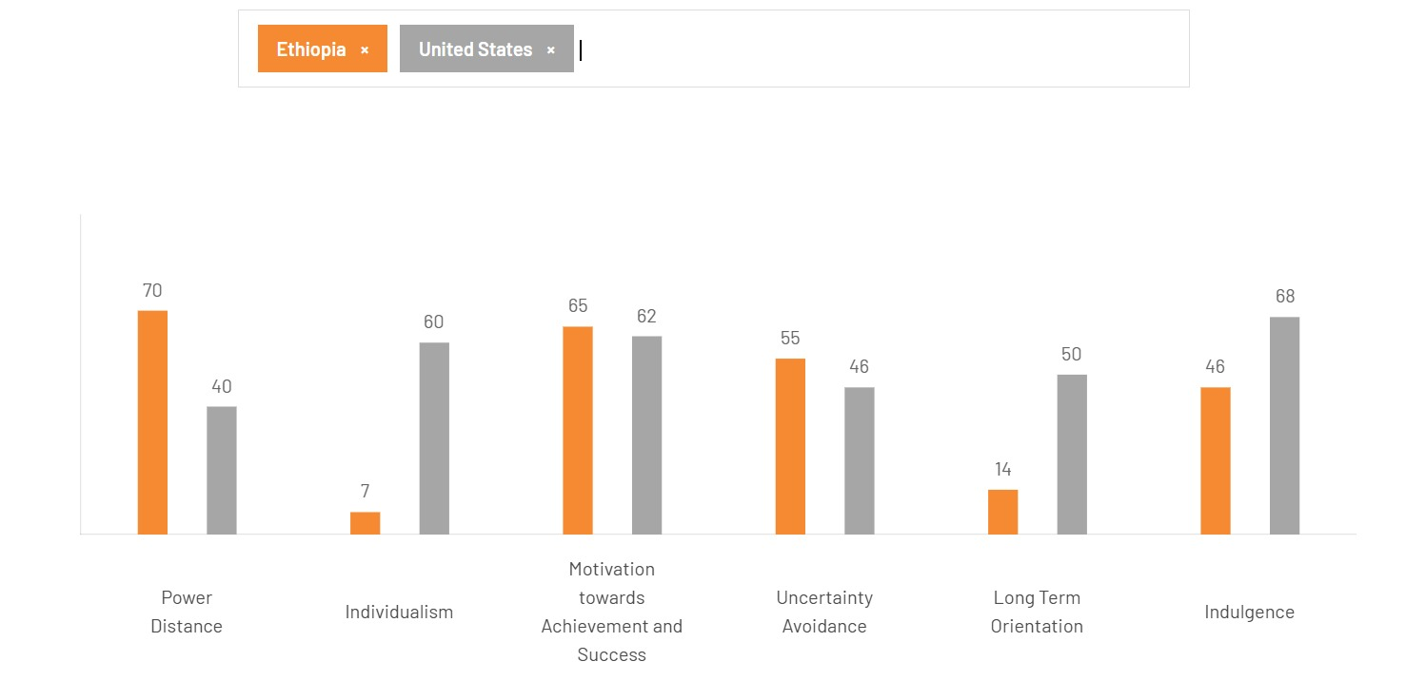
Figure 10: Hofstede Cultural Dimension Scores for Ethiopia and the United States (2024)
Source: (Hofstede, 2025)

4.2 Individualism vs. Collectivism: Marketing, Brand Positioning, and Customer Experience
The low score of Individualism of Ethiopia (7) when compared to the high score of USA (60) has direct strategic implications to Apple. The collectivism culture of Ethiopia focuses on family demands, community belonging and community cohesion. This is demonstrated in the population trends like where the average number of persons in an Ethiopian household is 4.6 persons, which supports consumption habits that are group oriented (World Bank, 2020). The U.S. marketing that focuses on personal empowerment and individual creativity that Apple has been having would not be able to cope without adapting. In order to thrive in Ethiopia, Apple will need to rebrand its business in terms of focusing on family connectivity, shared learning, and community development whereby, the brand messages no longer emphasise individual innovation but communal progress. The collectivist cultures are very dependent on trust, socialisation, and interpersonal trust, i.e. Apple has to invest in relationship-based distribution alliances, communal technology programmes, and culturally bound retailing experience. Such adaptations enhance legitimacy and enhance the acceptance of the market.

4.3 Motivation Toward Achievement: Performance Orientation and Consumer Aspirations
The near overlap between the Motivation Towards Achievement score (65) in Ethiopia and the 62 in USA is an indication that the two cultures cherish success and upward mobility but they do so in different ways. The Ethiopian ethic of achievement is closely associated with educational growth and the professional mobility, which is identified by the swift rise in the tertiary enrolment rate in Ethiopia, which grew to 16.5 percent as of 2023 (UNESCO, 2025). This results in a young, aspirational consumer target who are in need of products that will be symbolic of competency and modernity. In the case of Apple, this situation allows the company to strategically position its devices as academic performance enhancers, digital skills and entrepreneurial developmental products, and not luxurious lifestyle products. Collaboration with Ethiopian universities, coding programmes, and innovation centres would appeal to young people who are focused on gaining an achievement and wish to be globally competitive. The focus on education, productivity, and digital empowerment will allow Apple to integrate into the Ethiopian aspiration development storey and increase its market adoption in the long run.

4.4 Uncertainty Avoidance: Risk Tolerance and Customer Comfort
The Uncertainty Avoidance score of 55 when compared to that of the USA of 46 depicts a relatively high uncertainty avoidance characteristic that requires transparency, orderliness, and predictability. This is in accordance with consumer behaviour patterns that indicate that 65 percent of shoppers in Ethiopian urban areas like brands that have express warranty and repair guarantees (Nielsen, 2025). In the case of Apple, it translates to success in Ethiopia being pegged on the perceived risk that is reduced by providing good after sales services, clear product information, and easy access to customer care. The growth of telecom market in Ethiopia, whereby USD 776.3 million was realised in 2025 and USD 897.4 million is expected to be realised in 2030 enhance network reliability (Mordor Intelligence, 2025). This upgraded digital infrastructure will lower consumer risk perceptions and this will enable Apple to offer stable iCloud, App Store, and device-support services. To mitigate the risks of counterfeit devices and to create trust, Apple must thus focus on the development of authorised service centres, certified repair networks and distributors that will be reliable. Stability is supported through regular software upgrades and reliable performance- which these cultures rank highly as far as moderate- uncertainty cultures are concerned. Focusing on reliability and systems of structured support, Apple can make customers feel more comfortable, minimise the barriers to adoptions and raise long-term loyalty.
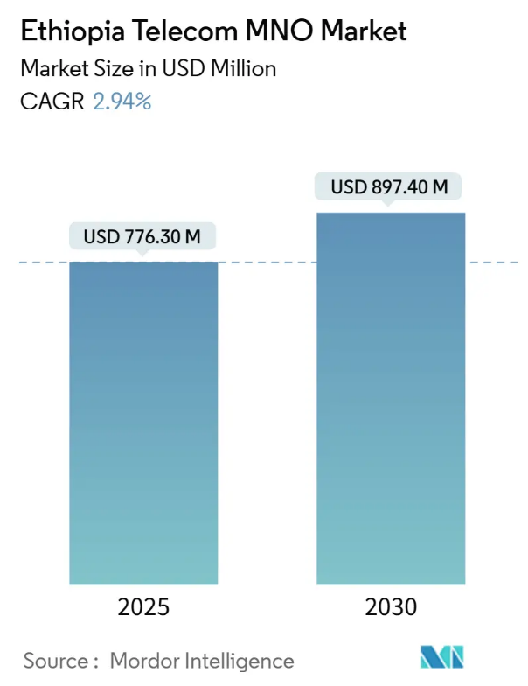
Figure 11: Ethiopia Telecom MNO Market Size
Source: (Mordor Intelligence, 2025)

4.5 Long-Term Orientation: Short-Term Focus and Market Development Timing
The score of Ethiopia in Long-Term Orientation is very low (14) which means that Ethiopians prefer tradition, an immediate need, and a short term decision-making process, as compared with the USA future oriented score at 50. This cultural trend is also echoed in the economic sense: the gross domestic savings rate in Ethiopia amounts to just 22% of the GDP (World Bank, 2025b), which indicates the inability of the population to plan their investments at a longer horizon. In the case of Apple, this implies that Ethiopian customers use lower prices and instant utility over the value of devices in the long-term and the ecosystem. Consequently, Apple should launch instalment plans, equipment programmes and refurbished devices that are aligned to the budgets of the customers in order to cater to the short-term spending habits. Marketing should focus on short-term practical advantages, such as communication, education, work productivity, and not on long-term integration of the ecosystem. The alignment with short-term orientation of Ethiopia will increase its adoption and decrease the barriers to entry based on price.

4.6 Indulgence vs. Restraint: Lifestyle, Spending Patterns, and Brand Experience
The USA has a score of 68 Indulgence and Ethiopia has a moderate score of 46 in Indulgence meaning that the priorities of consumer lifestyle vary significantly. The U.S. consumers are easily induced into buying the high end and fun-based products, whereas the Ethiopian consumers, which is the more reserved cultural orientation, places emphasis on utility, family needs, and practical value. Ethiopia's rapid digital payment system evolution—from the National Payment Strategy in 2021 to global investor opening in 2023 reduces consumer uncertainty and boosts formal transaction trust (Shega, 2025). Institutional innovations that allow secure payment mechanisms make premium companies like Apple more acceptable in somewhat dangerous situations. Customers trust warranty, repair, and digital services like iCloud and the App Store.
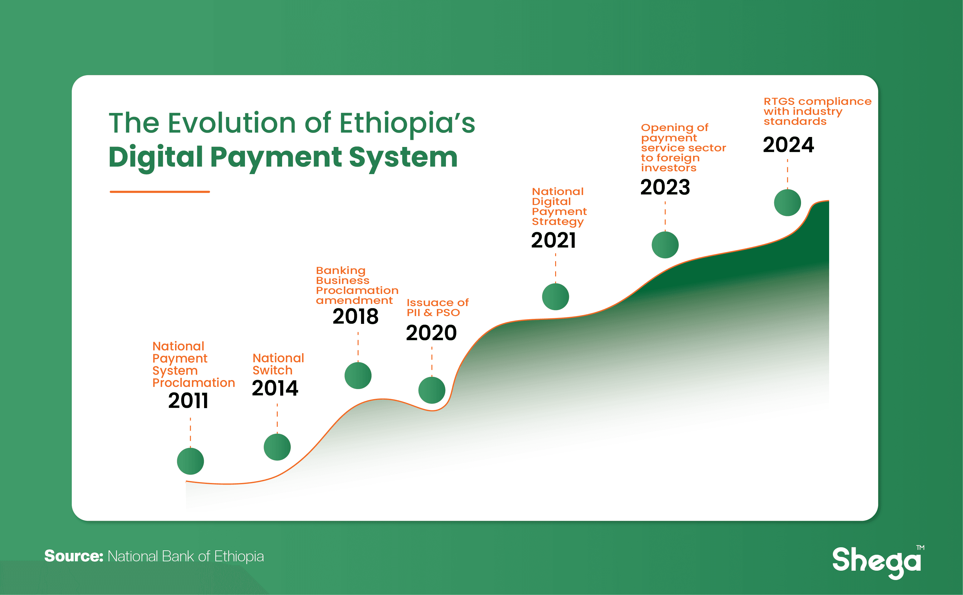
Figure 12: Evolution of Ethiopia’s Digital Paymnet System
Source: (Shega, 2025)
In the case of Apple, it will require a repositioning of the brand storey as an indulging lifestyle to a more practical empowerment with an emphasis on educational applications, productivity capabilities, and connectivity within families. Branding in line with the restraint values of Ethiopia will enhance adoption and longevity of cultural appeal.

5.0 Three SOP Adjustments Required for Apple’s Successful Entry into Ethiopia

5.1 SOP Adjustment 1: Establish a Centralised Government–Industry Interface Protocol
An important SOP adaptive intervention in the Apple entry in Ethiopia is institutionalisation of a Centralised Government - Industry Interface Protocol, as this is typical of the OLI analysis, and with the high Power distance cultural environment of Ethiopia. The system of authority in Ethiopia is very centralised and the ministries and state-owned enterprises especially telecommunications enterprise, digital infrastructure, and trade have a high level of gate keeping control over the access of the market (GSMA, 2024). The U.S. operational trends of Apple, with the preference of decentralisation of engagements and multi-stakeholder bargaining, do not fit in with the hierarchical demands of Ethiopia.
This SOP has to map out formal engagement channels, where the formalised communication would be initiated by senior Apple officials as opposed to the regionally based teams or interim consultants. Any negotiations touching the entry of the market such as licencing, data hosting rights, registration of the devices, spectrum-related negotiations of the services and opening of retail/service centres must be done in a rigid top-down approval strategy. Meetings should be arranged with the right ranks including state ministers, directors-general, and high-level regulators because according to the Ethiopian institution culture, senior representation is considered an aspect of legitimacy and respect. It is also recommended that the SOP has a Regulatory Intelligence Unit, which will be in charge of policy changes in the country like Digital Ethiopia 2025, National ICT policies, and telecom regulatory updates. This makes the Ethiopian subsidiary of Apple keep in line with the national development objectives- significant in keeping long-term stability and goodwill between it and the governments.
Lastly, decision-making procedures need to be changed, to include longer approval process, in which Ethiopia is characterised by a formal bureaucratic process. The internal operation timelines of Apple that have usually been streamlined to be efficient will need the localisation of Ethiopia to avoid lapses in compliance or negligent implementation (Abera, 2025). The institutionalisation of a culturally compatible, authority-consistent protocol enhances both the legitimacy of Apple, political risk, and a high-entry mode of control by the company, as found in its OLI-driven preference to internalise and safeguard its owners.

5.2 SOP Adjustment 2: Localised Trust-Building and After-Sales Reliability Framework
A second significant SOP change should react to the cultural orientation of Ethiopians towards moderate, high collectivist norms, and expectations in the market of reliability. Apple SOPs in the global stage, which is targeted at mature markets with established service ecosystems, presupposes the high levels of consumer trust, transparent supply chains and authorised repair ranges that are widely available (Scanlan, 2024). However, in Ethiopia consumers emphasise on warranty clarity, predictable support, interpersonal trust, and post purchase reassurance much higher.
Based on this, Apple needs to design a unique Trust-Building and After-Sales Reliability Framework to Ethiopia. The formation of Apple-certified service centres, trained local technicians, and soft warranty claim procedures should be formalised in this SOP. The existence of faked devices in Ethiopia is raising the perception of consumer risk, so the SOP must be provided with anti-counterfeit checking at the point of sale and embedded device authentication to the customers (Piao et al., 2025).
With high levels of collectivism, Ethiopian customers are quite dependent on word of mouth and social networks. Apple ought to incorporate community-based forms of touchpoints in its SOP like local demonstration centres, Apple trained ambassadors in colleges and technology belts, and community organisation presence. These actions capitalise on the trust at the level of the group to hasten adoption. Moreover, SOP should institutionalise the idea of multilingual customer service, as they acknowledge the need to consider cultural requirements of personalised and accessible communication. This is important since the quality of the service and interpersonal respect largely determine brand loyalty in the collectivist societies.
The SOP, in operation, must embrace longer consultation periods, more articulate technical reports, and less complicated troubleshooting processes to minimise ambiguity among those who are new to the usage of the premium devices. The alignment between the culture of Ethiopia and after sales reliability enhances brand confidence and contributes to the internalisation advantage of Apple, in that, the standards of service quality are maintained in accordance with global needs of Apple and accommodating to the local needs.

5.3 SOP Adjustment 3: Inclusive Pricing, Financing and Value-Communication Strategy
A third SOP change must be grounded on low Long-Term Orientation and moderate Indulgence score of Ethiopia which is counterbalanced to answer the spending behaviour, which is immediate utility-oriented as compared to long-term investment. The conventional Apple luxury pricing approach cannot easily be re-packaged and re-positioned immediately to Ethiopia where short-term basis of affordability are dominant factors in adoption (tskinner, 2024). Apple, consequently, must institutionalise a Financing, Value-Communication SOP, which is an inclusive Pricing, institutionalised to the Ethiopian consumer psychology.
Such SOP will involve the manner in which cooperation is to be made with local banks, microfinance organisations, and telephone companies to offer instalment plans, financing of devices on instalment plans and pay overtime plans. Ethiopia is already digitalizing the banking sector and Apple has an opportunity to leverage on the mobile money innovation and adoption of fintech to reduce their savings ability to individuals with middle purchase behaviors. The other area that Apple should include in its SOP is the refurbished apple certified device programme which will give an opportunity to reduce the entry point as quality here can be regulated. Value communication is also going to be altered. Ethiopia marketing must focus on functional value education, productivity, family communication, entrepreneurship, rather than lifestyle-based communications in USA as it fits the culture of low expenditure correctly. The SOP must thus be those that would ensure that advertisement should be localised and there are liaisons with schools and colleges where the iPad and MacBooks would be promoted as a symbol of progress and not as a symbol of status. The pricing SOPS should include tier product bundling devices, learning applications, and cloud storage and productivity tools as a way of providing the benefit in practice. The pricing should be clear in terms of communication since Ethiopian customers are sensitive to the problem of financial surprises. Adding culturally specific pricing and value-delivery procedures to formal SOPs, Apple can enjoy a more penetrative degree in Ethiopia and reduce the cultural barriers based on the short-run economy, attributing the affordability to other, more significant meanings.

Conclusion
The analysis shows that in order to be successful in entering Ethiopia, Apple must have a high level of alignment between its global competencies and the institutional and cultural dynamics of the new market of Ethiopia. The OLI analysis shows that Apple has strong ownership advantages which would favour a high-control entry mode, whereas the centralised control and rapid development of digital industry in Oman and Ethiopia would require systemic government intervention and extensive internalisation activities to achieve an effective market entry. The Hofstede dimensions cross-cultural analysis showed that Ethiopia was very different to USA, especially in Power Distance, Individualism, Long-Term Orientation, and Indulgence. Such gaps compel Apple to re-tune its presumptions regarding consumer behaviour, bargaining dynamics and the articulation of value. The short-term orientation of the Ethiopian spending culture, the hierarchical system of government and socialism as a collective are aspects that require culturally specific strategies which focus on governmental intervention, development of trust in the community and the use of price manipulation techniques. The insights would lead to operational adjustments that can be implemented in the suggested enhancement of the SOPs, such as a centralised government interface protocol, more robust efforts to build trust, better after-sales service, and pricing and financing policy inclusiveness. Together they help Apple to reduce the risk of entry, increase institutional credibility, and match its value offering and the norms of the Ethiopian society. When these measures are successfully implemented, Apple will be poised to achieve sustainable growth in the long-term in the growing digital economy of Ethiopia.

References
Abera, M., 2025. Impact of digitalization: a qualitative study on impact of digitalization within organizations in Ethiopia (Doctoral dissertation, Technische Universität Wien).
Acquia (2022). SUMMARY OF COMMISSIONED STUDY ETHIOPIA UNITED NATIONS DEVELOPMENT PROGRAMME ETHIOPIA. [online] Available at: https://files.acquia.undp.org/public/migration/et/c0c6943bb218f7890b51f5ae27375fb3b41ccd23ccd512eaf2a53939e52c161b.pdf [Accessed 18 Nov. 2025].
Apple Inc. (2024a) Form 10-K Annual Report 2024. Available at: https://d18rn0p25nwr6d.cloudfront.net/CIK-0000320193/6d5e8b08-1795-4bc0-8ca6-0f8d9adf3386.pdf (Accessed:15 Nov).
Apple Inc. (2024b) Apple Supplier List 2024. Available at: https://www.apple.com/supplier-responsibility/pdf/Apple-Supplier-List.pdf (Accessed: 10 Nov).
Apple Inc. (2025) Condensed consolidated financial statements, three months ended March 29, 2025, 29 March. Available at: https://www.apple.com/newsroom/pdfs/fy2025-q2/FY25_Q2_Consolidated_Financial_Statements.pdf (Accessed:11 Nov ).
Apple Newsroom (2024a) Apple Unveils Expanded Munich Silicon Design Center. 28 February. Available at: https://www.apple.com/newsroom/2024/02/apple-unveils-expanded-munich-silicon-design-center/(Accessed: 8 Nov).
Apple Newsroom (2024b) Apple Reports Fourth Quarter Results. 1 November. Available at: https://www.apple.com/newsroom/2024/11/apple-reports-fourth-quarter-results/ (Accessed: 11 Nov).
Bloomberg (2024) Apple Increases iPhone Output Outside China as Supply Chain Diversifies. 27 March. Available at: https://www.bloomberg.com/news/articles/2024-03-27/apple-increases-iphone-output-outside-china (Accessed: 5 Nov).
BusinessWorld (2025) ‘Apple Shifts US iPhone Production Primarily To India, Vietnam Supplies Other Devices’, 5 August. Available at: https://www.businessworld.in/article/apple-shifts-us-iphone-production-primarily-to-india-vietnam-supplies-other-devices-566165 (Accessed:2 Nov).
Clover, J. (2024). Apple Now Has More Than 2.2 Billion Active Devices Worldwide. [online] MacRumors. Available at: https://www.macrumors.com/2024/02/01/apple-2-2-billion-active-devices/.
Connecting Africa. (2024). Ethiopia’s telecoms liberalization makes progress – Omdia. [online] Connectingafrica.com. Available at: https://www.connectingafrica.com/connectivity/ethiopia-s-telecoms-liberalization-makes-progress-omdia.
Curry, D. (2025). Apple Statistics (2025). [online] Business of Apps. Available at: https://www.businessofapps.com/data/apple-statistics/.
Derrick, M. (2025) ‘Apple’s Manufacturing Shift Fuels India’s iPhone Growth’, Technology Magazine, 12 May. Available at: https://technologymagazine.com/it-procurement/apple-pivots-to-india-with-expected-us-22bn-output (Accessed:14 Nov ).
Edesa, J. (2025). How Will Ethiopia’s New Stock Market Impact Local Investors? [online] Emerging Markets Today. Available at: https://emergingmarkets.today/how-will-ethiopias-new-stock-market-impact-local-investors/ [Accessed 18 Nov. 2025].
Elad, B. (2025). Apple Statistics 2025: Revenue, Devices & Services. [online] SQ Magazine. Available at: https://sqmagazine.co.uk/apple-statistics/.
Ethiopia (2021). Internet in Ethiopia. [online] Wikipedia. Available at: https://en.wikipedia.org/wiki/Internet_in_Ethiopia.
Franke, P. (2025). Apple: Weakest Adjusted Share Price Performance Since 2015-16. [online] Seeking Alpha. Available at: https://seekingalpha.com/article/4752471-apple-weakest-adjusted-share-price-performance-since-2015-16.
Freedom House (2024). Ethiopia: Freedom on the Net 2024 Country Report | Freedom House. [online] Freedom House. Available at: https://freedomhouse.org/country/ethiopia/freedom-net/2024.
Gilbert, P. (2024a). Ethiopia’s telecoms liberalization makes progress – Omdia. [online] Connectingafrica.com. Available at: https://www.connectingafrica.com/connectivity/ethiopia-s-telecoms-liberalization-makes-progress-omdia.
Gilbert, P. (2024b). Ethiopia’s telecoms liberalization makes progress – Omdia. [online] Connectingafrica.com. Available at: https://www.connectingafrica.com/connectivity/ethiopia-s-telecoms-liberalization-makes-progress-omdia.
GSMA (2024). Driving Digital Transformation of the Economy in Ethiopia Opportunities, policy reforms, and the role of mobile. [online] Available at: https://www.gsma.com/about-us/regions/sub-saharan-africa/wp-content/uploads/2024/10/GSMA_Ethiopia-Report_Oct-2024_v2.pdf.
History Tools (2024) Apple Acquisitions and Mergers: A Complete Overview. Available at: https://www.historytools.org/resources/apple-acquisitions-mergers (Accessed:4 Nov ).
history tools (2025). Apple Acquisitions & Mergers - History Tools. [online] History Tools. Available at: https://www.historytools.org/resources/apple-acquisitions-mergers.
Hofstede, G. (2025). Country Comparison Bar Charts - Geert Hofstede. [online] Geert Hofstede. Available at: https://geerthofstede.com/country-comparison-bar-charts/.
iEduNote (2020). Hofstede’s Cultural Dimensions Theory - iEduNote.com. [online] iEduNote.com. Available at: https://www.iedunote.com/hofstedes-cultural-dimensions-theory/.
Kemp, S. (2024a). Digital 2024: Ethiopia. [online] DataReportal – Global Digital Insights. Available at: https://datareportal.com/reports/digital-2024-ethiopia.
Kemp, S. (2024b). Digital 2024: Ethiopia. [online] DataReportal – Global Digital Insights. Available at: https://datareportal.com/reports/digital-2024-ethiopia.
Macro Trends (2025) Apple Research and Development Expenses 2010-2024 | AAPL. Available at: https://www.macrotrends.net/stocks/charts/AAPL/apple/research-development-expenses (Accessed:3 Nov)
Mordor Intelligence (2025). Ethiopia Telecom MNO Market Size, Share, 2025-2030 Outlook. [online] Mordor Intelligence. Available at: https://www.mordorintelligence.com/industry-reports/ethiopia-telecom-mno-market [Accessed 18 Nov. 2025].
Nasdaq (2024) Unlocking Apple (AAPL): International Revenues – Trends, Surprises, and Prospects. Available at: https://www.nasdaq.com/articles/unlocking-apple-aapl-international-revenues-trends-surprises-and-prospects (Accessed:7 Nov).
News18.com (2025). [online] News18.com. Available at: https://images.news18.com/ibnlive/uploads/2023/04/whatsapp-image-2023-04-19-at-11.18.02.jpeg [Accessed 18 Nov. 2025].
Nielsen (2025). Nielsen Global Connect | Nielsen Global Media. [online] www.nielsen.com. Available at: https://www.nielsen.com/.
Piao, Z., Park, S., Rha, J.S. and Yoon, J., 2025. Consumer recognition of service and product attributes in smartphone rivalries: Z. Piao et al. Service Business, 19(3), p.21.
Reuters (2025) India’s Tata Electronics Acquires 60% Stake in Pegatron Technology India. 24 January. Available at: https://www.reuters.com/technology/indias-tata-electronics-acquires-60-stake-pegatron-technology-2025-01-24 (Accessed: 6 Nov).
Scanlan, A.M., 2024. Creating standard operating procedure (SOP) videos using multi-angle smotsTM cameras and an iPad: a step-by-step guide.
Seeking Alpha (2025). Apple: Weakest Adjusted Share Price Performance Since 2015-16. [online] Seeking Alpha. Available at: https://seekingalpha.com/article/4752471-apple-weakest-adjusted-share-price-performance-since-2015-16.
Shega (2025). The Dangers of Ethiopia’s P2P-Driven Digital Economy. [online] Shega.co. Available at: https://digitalfinance.shega.co/insights/articles/the-dangers-of-ethiopia-s-p2-p-driven-digital-economy [Accessed 18 Nov. 2025].
Six Colors (2025). Apple’s reports record revenue for Q1 2025 (with charts). [online] Six Colors. Available at: https://sixcolors.com/post/2025/01/apples-reports-record-revenue-for-q1-2025/.
Soltani, E. (2025).Apple Global Net Sales by Region (2024). [online] Voronoiapp.com. Available at: https://www.voronoiapp.com/technology/-Apple-Global-Net-Sales-by-Region-2024-5143? [Accessed 10 Nov. 2025].
Strategy Boffins (2024) Apple’s Strategic Investment in India. Available at: https://www.strategyboffins.com/strategy_journal/apples-strategic-investment-in-india/ (Accessed:12 Nov).
Substack (2025). Welcome To Zscaler Directory Authentication. [online] Substackcdn.com. Available at: https://substackcdn.com/image/fetch/.
tskinner (2024). Mobile devices: counterfeit. [online] Mobile Policy Handbook. Available at: https://www.gsma.com/solutions-and-impact/connectivity-for-good/public-policy/mobile-policy-handbook/consumer-protection/counterfeit-mobile-devices/ [Accessed 18 Nov. 2025].
Unesco (2025). [online] Unesco.org. Available at: https://www.uis.unesco.org/en.
Upadhyay, B. (2023). Apple Store Count Worldwide: 272 In US, 45 In China And More. [online] News18. Available at: https://www.news18.com/tech/apple-store-count-worldwide-272-in-us-45-in-china-and-more-7583191.html.
Varieties of Democracy (2023). V-Dem. [online] v-dem.net. Available at: https://v-dem.net/.
Visual Capitalist (2023). IMF Projections: Fastest Growing Economies in 2024. [online] Voronoiapp.com. Available at: https://www.voronoiapp.com/Economy/IMF-Projections:-Fastest-Growing-Economies-in-2024-215 [Accessed 12 Nov. 2025].
Voronoi App (2025). [online] Voronoiapp.com. Available at: https://www.voronoiapp.com/_next/image?url=https%3A%2F%2Fcdn.voronoiapp.com%2Fpublic%2Fimages%2F27185320-10b5-47fa-a95b-7c8f63912ae8.webp&w=1080&q=85 [Accessed 17 Nov. 2025].
World Bank (2020). Ethiopia | Data. [online] Worldbank.org. Available at: https://data.worldbank.org/country/ethiopia.
World Bank (2025a). World Bank Open Data. [online] World Bank. Available at: https://data.worldbank.org/.
World Bank (2025b). World Bank Open Data. [online] World Bank. Available at: https://data.worldbank.org/.
Young, J. (2023). 18 major companies tied to the apple supply chain. [online] Investopedia. Available at: https://www.investopedia.com/articles/investing/090315/10-major-companies-tied-apple-supply-chain.asp.

