Parse PagilaDB from SQL to JSON

- Install VSCode onto your computer.

- Download and install Node.js onto your computer. Go to url https://nodejs.org/en and click the green button, once downloaded, follow the instructions for installing. This can also be downloaded through the terminal using curl for MAC or winget for Windows.

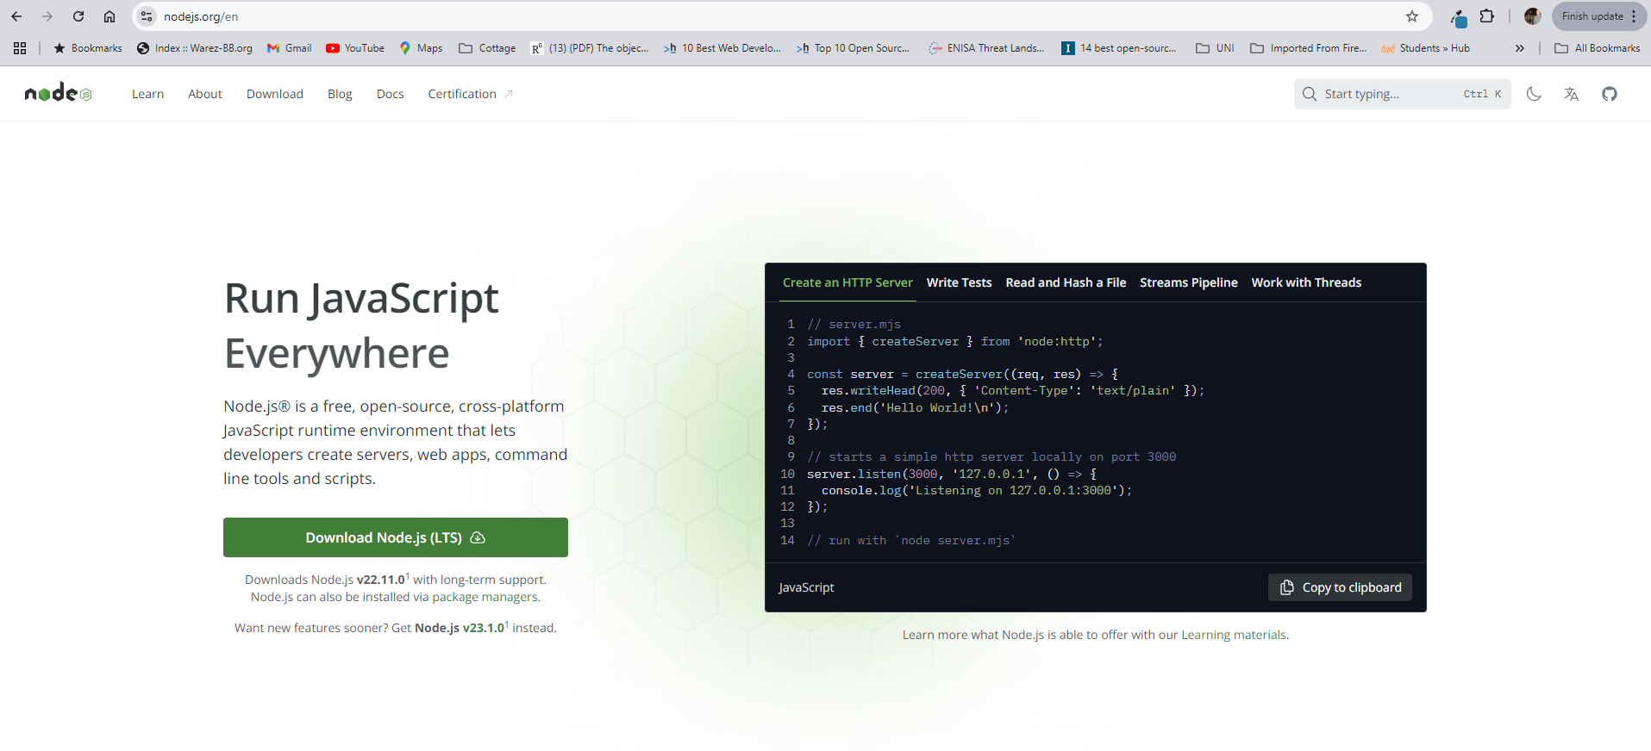
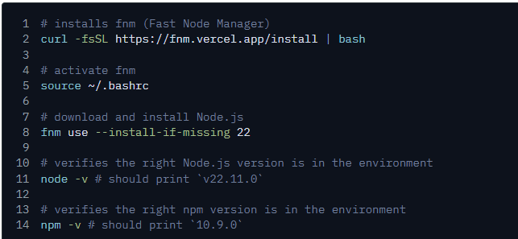
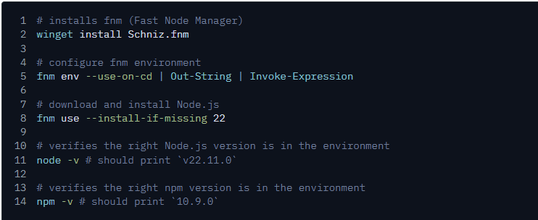

- Create a folder in a location of your choice on your computer. This can be done using a terminal in the chosen parent folder. Using a Bash terminal, mkdir is the command needed to create a folder, ‘sql-to-json’ is the name I gave to the folder. Choose a name of your choice.
- From the terminal, use cd command into the folder.

- Initialise the folder for Node.js by running npm init -y in your terminal in the folder you created and changed into.

- Install the ‘pg’ package using Node Package Manager – ‘npm install pg’. This will support the use of PostgreSQL in VSCode.
- Install the ‘fs’ package using Node Package Manager – ‘npm install fs’. This will allow you to save the Json data to a file through VSCode.
Both of these commands will show an output in the terminal to tell you the amount of files / packages downloaded and will tell you the install went ok.

- Install the ‘Json’ package in the same way using Node Package Manager – ‘npm install json’. This will allow you to create the Json data string through VSCode and read it properly.
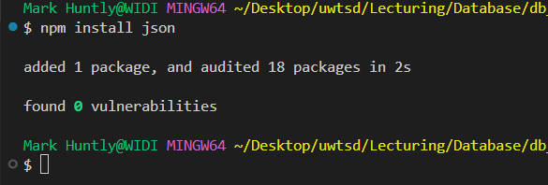
- Open VSCode (if you haven’t already) and open the folder you created.
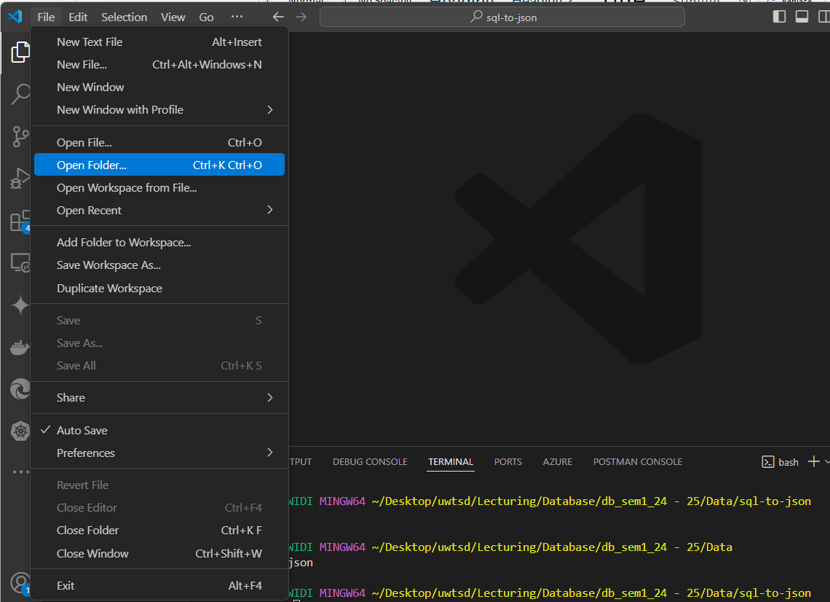

- Inside the opened folder, click the add file icon and call it something like ‘parse-to-json’ The name doesn’t really matter. The file will open in your editor window.
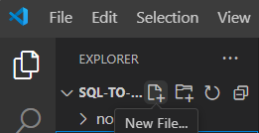

- We are now going to write some JavaScript. First thing we need to do is set up the environment and make sure that we are able to use ‘pg’ and ‘fs. We do this by using the require() function and declaring two constants.
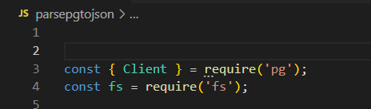

- Now set up the connection to PostgreSQL make sure you use your database name for the Pagila database in PostgreSQL and that you replace {Your password here} with your actual PGAdmin / PostgreSQL password. Keep the speech marks though.

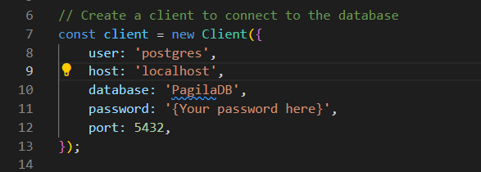

- Now create a function to capture the data and parse it to Json. The function name is fetchTablesAndData(). We will be using a try / catch method to try the function and if it doesn’t work, catch the error to let us know.
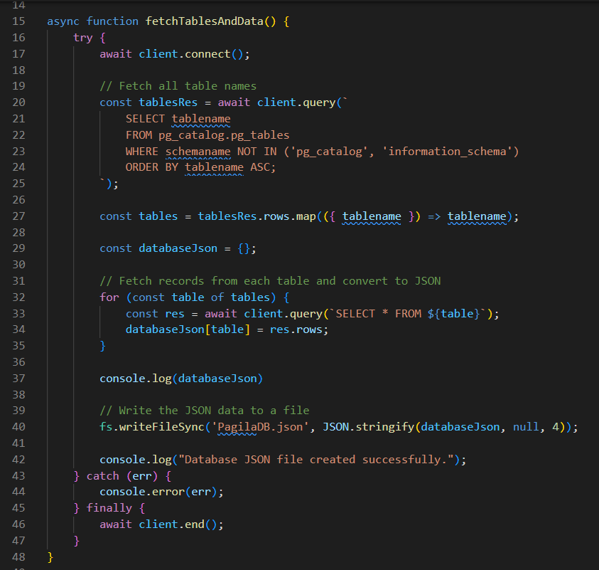

- We try the connection and we use ‘await’ on the connect() function for the client variable, we set up for our connection.
- We then create a new variable ‘tablesRes’ that will capture the data from the query we send. ‘await client.query() is the function we wrap around out SQL query which will get us the names of the tables. Notice the use of tilda (`) – the key just under esc, top left of a Windows keyboard.
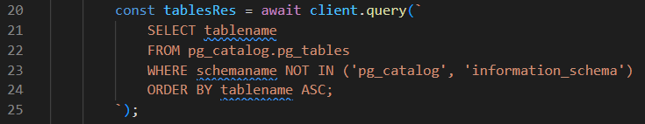
- Create a variable called ‘tables’ and capture the data from the query.
- We crate a new variable called 'databaseJson’ that will be used to capture the data in the tables.
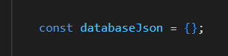
- Create a ‘for loop’ to capture the data from each table in turn.
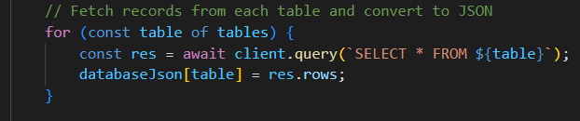
- We can now wrte the Json to file using fs with the writeFileSync() function and the JSON.stringify() function to convert the data in the variable ‘databaseJson’ We also give the name of the file we want to save as an argument, in my case ‘PagilaDB.json’, you can name it as you wish.
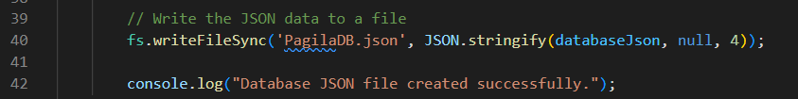
- We also put out a message to show it completed successfully to the console.
- We use the CATCH to capture any errors and report them back.
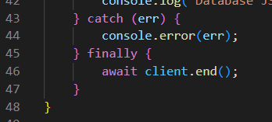
- Finally we use the ‘await’ and the end() function for ‘client’ to close the connection to PostgreSQL.
- The last thing to do is call the function and check your folder on completion for the Json file.
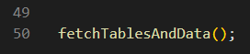

- Open the newly created file in VSCode and inspect the Json. Compare the PostgreSQL database structure and format to the Json format.

