

Programme Name: Master of Business Administration
Module Code and Name: Marketing Management (LCMB7024)

Submission Title: Brand Extension for Nothing Technology Limited into the Smart AR Glasses Market

Lecturer Name: Laila Maazouz, Dian Mayasari
Student Name & ID:
Word Count: 2489
Submission Date:

Table of Contents
1.0 Element 1: Brand Extension 2
1.1 Overview of the Company 3
1.2 Brand Extension 3
1.3 Emerging Trends and Market Appeal 3
1.4 Alignment with Sustainability 3
2.0 Element 2: STDP Analysis 3
3.0 Element 3: Marketing Mix 6
4.0 Element 4: Reflection 11
4.1 Experience of developing the brand extension 11
4.2 Experience of Poster preparations 11
4.3 key skills, knowledge, and insights gained and personal and professional development 11
4.4 Future aspects 12
References 12
Appendix 17

1.0 Element 1: Brand Extension

1.1 Overview of the Company
Nothing Technology Limited was founded by Carl Pei and it is a London-based company which aims to redefine consumer electronics with the help of their transparent and minimalist design. Nothing as per Mohammed (2025) removes tech related complexity which helps them to create products like Nothing Phone 2, Ear (a) which focuses on user experiences that helps to remove barriers between people and technology.

1.2 Brand Extension
The Nothing AR Smart Glasses in the current era represented a wearable augmented reality which features a lightweight and transparent frame and the integrated ‘Glyph’ notification interface. The AR Smart Glasses follows research by Sanni (2024) and provides information without interacting with mobile screens and the AI-driven voice controls helps to offer a functional but high fashionable tech accessory.

1.3 Emerging Trends and Market Appeal
Consumers in the modern era as mentioned by ET Online (2026) shift toward ‘glanceable’ tech and AI-native devices and Nothing AR meets the expectation of less screen time and more environmental presence with the slim design that appeals to Gen Z and young professional who seeks ‘quite tech’ and that prioritizes productivity over complexity.

1.4 Alignment with Sustainability
Nothing technology is committed toward carbon neutrality and for that reason the AR Glasses utilizes recycled aluminum and recycled plastic components. The modular design as per Schmidt et al. (2022) used here allows for easier battery replacement and also helps to extend the life of the product. The minimalist and plastic free packaging also reduces environmental impact significantly and the decision attracts eco-conscious demographics.

2.0 Element 2: STDP Analysis
This part forms a Segmentation, Targeting, Differentiation, and Positioning (STDP) analysis of the proposed Nothing AR Smart Glasses “(suggesting a planned launch in the first half of 2027)” (Gadgets360.com, 2026). It looks at the major parts of the market, the most appropriate target market, competitive differentiation, and clear positioning strategy to facilitate effective brand extension and market success within the wearable technology market.
Segmentation
Market segmentation is very important in establishing a customer group according to the specific variables of segmentation. A proposal of AR smart glasses by Nothing four major bases of segmentation are utilized:
- Geographic segmentation targets the urban and metro Politian areas like London, New York and Mumbai, and on this process the rate at which they accept technology is very high (Bhattacharjee and Sharma 2023). These are very well-connected online regions with some more tech-conscious populations, which are totally best suited to launch new high-tech wearable apps. So, the developed and emerging markets are also targeted because there are growing aspects of demand for smart devices.
- Demographic segmentation will encompass that age between 20-35 years, and this will largely involve the young people's workforce and students in colleges and universities (Jetha et al. 2022). The whole group is moderate to high disposable income, and they are more ready to invest in new technology. The whole process shows the level of their education and their jobs also contribute to the increased awareness and acceptance of the augmented reality (AR) products.
- Psychographic segmentation shows some important aspects to the lifestyle and personality of the characteristics. The target customers were early adopters, innovations oriented, and design conscious (Roadkasamsri et al. 2024). They appreciate minimalism process of design and some smooth user experience which shows this aligns ell with the brand identity of Nothing. These are consumers who will tend to choose products that depict their lifestyle, which is modern and tech-savvy.
- Behavioral segmentation is a main process which is totally based on the perception of the products and benefits regarding their usage. The main targeted demographic is often owning some of the new effective smart gadgets, and this totally relies on coincidence and effective multi-tasking processes and important aspects of efficiency. There are several methods regarding brand conscious and important factors for the loyal and effective brands which have some unique experiences.
Targeting
The main targeted customers for the company Nothing AR smart glasses is young urban limited professionals aged between 20-35 years who are very conscious about technologies and active participants of the digital eco systems (Business-standard.com, 2026). The people who work in corporate and creative industries in the technological industries and students in higher education are also included in these important groups. This markets segment is targeted because of good purchasing power, innovation interest as well as early adopters. These customers often carry smartphones, wearables, and AI based technologies with them, which makes them more inclined to using AR technologies. Their taste in trendy and minimalistic products is in the line with the brand identity of Nothing. By targeting this group, the whole brand will be in a positive position to build their strong presence in the entire market and optimize the adoption rates and customer retention rates in the long-term process.
Differentiation
Nothing AR Smart Glasses will be competing with Apple Vision Pro, Meta smart glasses, and Samsung wearable devices in a highly competitive market of the smart wearable technology. The products that these competitors are targeting are mostly up-market, feature-process, and given their complexity, are sometimes even complicated. It has nothing unique in terms of design, affordability, and usability (Sagepub.com, 2022). The product will have a minimalist and transparent design that will strengthen the brand, unlike that of the competitors. Moreover, the glasses should be light in their weight and have a usual use, as compared to larger models. There are some important methods of pricing strategy which are more affordable and many people could go and buy their things. This process of differentiation is a method for the competitive strategy framework process in which the company needs to analyze their position and provides some low-cost technologies to the market for consumers.
Positioning
The positioning determines the perceptions of the whole products in the minds of the consumers (He and Zhang, 2022). Nothing AR smart glasses is a product that will be marketed as a luxurious, easy to use and affordable augmented reality of the products which to be sued in daily life. The complete brand will focus on establishing a sense of innovation and simplicity which will distinguish the entire brand image among complicated and costly options. The whole product should be viewed as both functional and fashionable gadgets and to be attractive to contemporary consumers who care only about their technology and style. This is a positioning strategy that gives strength to the identity of the brand of Nothing and improves customer relationships.
Positioning statement: To meet the requirements of the tech-minded young employees, Nothing AR Smart Glasses provides a slim, cost-effective, and easy-to-use AR experience, in contrast to the expensive and overly complicated models, with the merging of minimalistic design with realistic everyday application.

3.0 Element 3: Marketing Mix
This aspect uses the 7Ps marketing mix in the suggested Nothing AR Smart Glasses. It is a critical analysis of how the product, price, place, promotion, people, process, and physical evidence strategies can be in line with the brand extension to support market entry, customer experience, and competitive advantage in the smart wearable technology market.
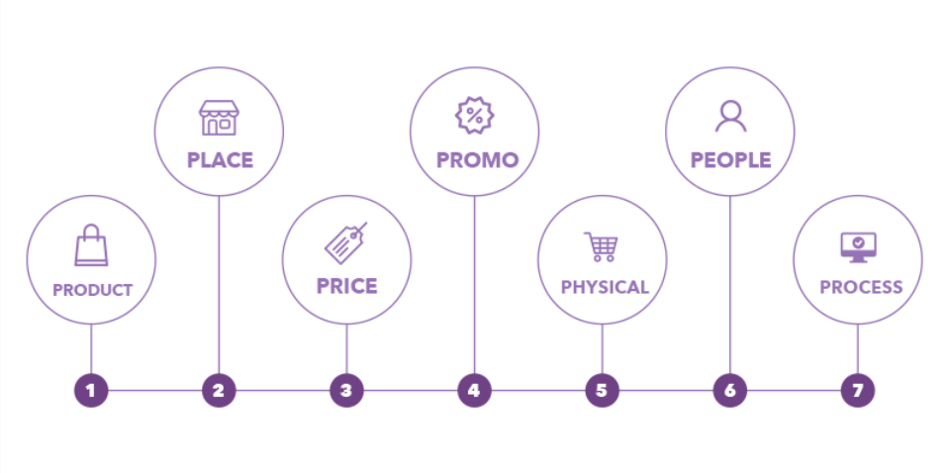
Figure 1: 7P’s marketing mix
(Source: Ventureharbour.com, 2026)
Product
The product component stays on the design and functionality of the suggested AR smart glasses by Nothing. The product will have augmented reality (AR) support which provides real-time notifications, voice-controlled, and smooth integration with smart phones. The brand identity is represented by a simplistic and clear design which can attract design-informed customers. With the product level theory, the core benefit is convinced and increased connectivity, and the actual product is AR smart glasses with new features, and the augmented product is software updates and warranty on the product and its support (French and Zylkin 2024). This strategy is justified because this improves the customer's value and satisfaction. The product strategy sustains and works with the overall brand extension strategy by keeping Nothing focused on its concepts of innovation, simplicity, and aesthetic design. It also makes the product stand out among others in terms of usability and practicality in day-to-day life, thus making sure the market has been well accepted (Bushell, 2022).

Price
The Pricing Strategy that the Nothing AR Smart Glasses will use will be Penetration Pricing Strategy where the product will be launched at a relatively low cost compared to other premium wearable brands like Apple and other high-end brands (Croma.com, 2026). It is a strategy that will enable the company to appeal to a more diverse customer base as well as achieve a quick market share. This report is justified because the target market is comprised of young professionals who want to have innovative technologies that are not costly. Nothing has the ability to lower the barriers to adoption by providing a lower price point and stimulate trial among the first adopters. The pricing strategy is consistent with the general brand extension one as it helps in strengthening the positioning of the brand as a convenient premium option.
Place
The place element will be distribution channels where the product will be distributed to the customers. Nothing will have a direct distribution strategy which will sell the AR smart glasses on its official website and e-commerce like Amazon as well as on several; retailers store in large cities (Uk.investing.com, 2026). This strategy justified because online channels have access to all parts of the whole world and are convenient whereas brick and mortar stores are a physical retail shop where customers view products, which can be viewed by them first. Emphasis on the metropolitan cities will guarantee reach to technology-intensive customers who will readily embrace the use of wearable devices. This distribution strategy supports the overall brand extension strategy because it gives the most effective product availability in high demand locations and yet the brand experience is under control (Florido-Benítez, 2022). It is also scalable and enables good market penetration, which is very crucial in launching a new product.

Promotion
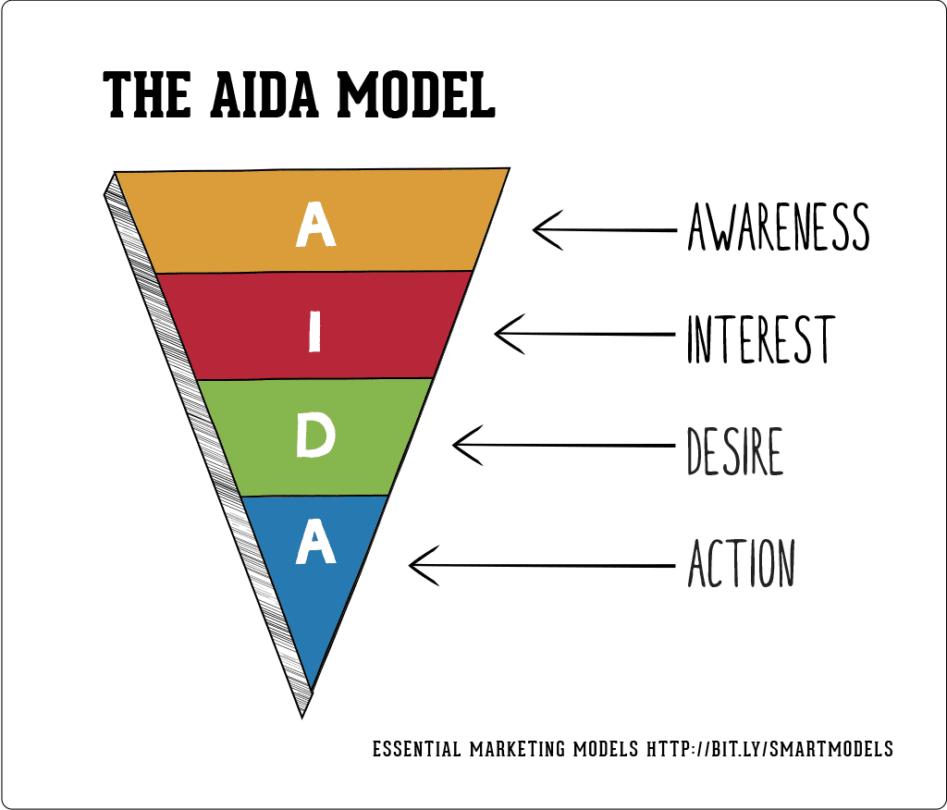
Figure 2: AIDA Model
(Source: Smartinsights.com, 2025)
Promotion is an important tool for creating awareness and creating demand, and a Digital Marketing Strategy employing social media as a promotional tool and influencer marketing as well as online advertisements will be applied to nothing (Yevseitseva et al. 2022). Product features will be presented with the help of tech influencers and YouTuber reviewers to create credibility. Promotional activities will be directed by the AIDA Model (Attention, Interest, Desire, Action) (Smartinsights.com, 2025). Attention will be won with social media content, interest will be cultivated through product demonstrations, desire will be elicited through unique design and affordability, and limited time offers will involve action. The promotional plan is in line with and will support the overall brand extension plan in strengthening innovation, involving the target customer satisfactorily, and creating a high level of brand awareness in the competitive market.

People
The people's aspect comprises all the people encountering the delivery of the product and customer experience. The Service Marketing Theory supports this approach and points out that employee behavior is important influencing customer perceptions. This plan is justified since a good relationship with customers improves satisfaction, trust, and loyalty. Since AR products are complex in their technological aspect, expert guidance is required to get user adoption. The people's strategy is dependent and supplementary to the general brand extension strategy since it provides the customer with a smooth experience and enhances the brand reputation of quality and innovation.
Process
The process element is the way that the product is received and made available by the customers. Nothing will be established by quick buying process with its websites and mobile services, and it will be very easy to navigate and to have a secure payment option and the delivery of the product will take the shortest time to deliver. The AR glasses which will comes at 2027 is straight towards technology adaptation and surrounded by easy-to-follow guidelines and integration of the apps (Tuomi et al. 2023). The customer management strategy will be implemented to achieve uniformity in all touchpoints. This entire strategy is totally limited to be appropriated since by making a smooth and efficient process customers minimize their efforts and boost their satisfaction levels. The process strategy is compatible with the overall brand extension strategy as it does guarantee convenience levels, enhance the user experience, and promote long-term customer engagement.
Physical Evidence
Physical evidence is anything that is material that will help in the brand's image, and it will not highlight anything with premium, yet minimalistic packaging, in line with its transparent design philosophy. This is the application of the Brand Identity Theory, and the visual aspect takes a pivotal role in the development of customer perception (Han et al. 2023). A good visual identity will assist in making the product stand out in a competitive market. The key brand extension strategy is in line with the general brand extension strategy because it reinforces brand consistency, perceived quality, and the memorable experience of the customer.

4.0 Element 4: Reflection

4.1 Experience of developing the brand extension
To develop the brand extension for Nothing technology into the AR smart glasses category was a rigorous exercise in the alignment between innovation with the brand identity of Nothing technology limited. This process required an in-depth analysis where Nothing can maintain its transparent aesthetic into a wearable that can compete with the market leaders like Apple. I found challenges in this phase but this phase also was rewarded for me as I was able to justify a pricing strategy while I maintained a premium brand perception. I by following Huntjens (2024) also balanced technical specifications with the 7Ps marketing mix which helped me to understand the complexity of a high-growth tech company. The experience for me has highlighted the importance of ‘strategic fit’ and help me to ensure that the new product should only not just exist but it also should strengthen the promise of Nothing to remove barriers between people and technology.

4.2 Experience of Poster preparations
The preparation of the poster is an important lesson in visual communication and towards marketing and for that reason I as guided by Gumber (2023) focus on a clean layout that could mirror the minimalist philosophy of Nothing and it can show the transparent design and unique value proposition of the device. The data from a complex STDP and Marketing Mix into the visual format requires selective priority towards information and here I have utilized AIDA model which helps me to ensure that the poster can attract attention with the images before anyone can see the affordability and the style of the product.

4.3 key skills, knowledge, and insights gained and personal and professional development
The major skills I gained during the work on the brand extension are research, analytical thinking, and strategic planning. I also gained knowledge from marketing theories such as STDP and the 7p’s and on this I gained some insights on how theory may apply to a real-life business scenario to customer requirements and comparative strategy (Froemke et al. 2022).
Such skills and knowledge have played a great role in my personal and professional enhancements. My confidence and critical thinking as discussions making skills have improved in these important times. In career related activities, the marketing strategy now understanding will aid me in doing future business activities more effectively and strategically in future.

4.4 Future aspects
In the upcoming days, I will improve this in future studies by researching further with more academic sources to boost my study (Al Husaeni et al. 2024). My deficiency will be working on critical assessment capabilities since I will evaluate various strategies and be able to justify decisions better. Moreover, I will find a way of better managing my time to give myself adequate time to revise and refine. Another area I will focus on is how I present and communicate my ideas which should be more confident and understandable in writing as well as in visual presentations.

References
Al Husaeni, D.F., Al Husaeni, D.N., Nandiyanto, A.B.D., Rokhman, M., Chalim, S., Chano, J., Al Obaidi, A.S.M. and Roestamy, M., 2024. How technology can change educational research? Definition, factors for improving quality of education and computational bibliometric analysis. ASEAN Journal of Science and Engineering, 4(2), pp.127-166. https://ejournal.upi.edu/index.php/AJSE/article/download/62045/23994
Bhattacharjee, S. and Sharma, M., 2023. Polycentric Urbanism and the Growth of New Economic Hubs in Mumbai, India. In Urban Commons, Future Smart Cities and Sustainability (pp. 169-186). Cham: Springer International Publishing. https://www.researchgate.net/profile/Sujayita_Bhattacharjee/publication/371011109_Polycentric_Urbanism_and_the_Growth_of_New_Economic_Hubs_in_Mumbai_India/links/67c69efe207c0c20faa044b9/Polycentric-Urbanism-and-the-Growth-of-New-Economic-Hubs-in-Mumbai-India.pdf
Bushell, C., 2022. The impact of metaverse on branding and Marketing-A study of how individuals and celebrities use metaverse as a brand extension, and the implications for marketing. Available at SSRN 4144688. https://papers.ssrn.com/sol3/Delivery.cfm?abstractid=4144688
Business-standard.com, 2026, Nothing may enter smart wearable category next year with AI smart glasses, Available at: https://www.business-standard.com/technology/tech-news/nothing-may-enter-smart-wearable-category-next-year-with-ai-smart-glasses-126040100841_1.html [Accessed on: 30th March 2026]
Croma.com, 2026, Nothing plans AI-powered smart glasses to rival Meta Ray-Ban, Available at: https://www.croma.com/unboxed/nothing-plans-ai-powered-smart-glasses-to-rival-meta-ray-ban#:~:text=Nothing%20AI%20smart%20glasses%20launch,Buy%20now [Accessed on: 30th March 2026]
ET Online (2026). Why your next smartphone upgrade might not be a phone at all. [online] The Economic Times. Available at: https://economictimes.indiatimes.com/industry/cons-products/electronics/why-your-next-smartphone-upgrade-might-not-be-a-phone-at-all/articleshow/129868844.cms [Accessed 2 Apr. 2026].
Florido-Benítez, L., 2022. International mobile marketing: a satisfactory concept for companies and users in times of pandemic. Benchmarking: An International Journal, 29(6), pp.1826-1856. https://www.emerald.com/bij/article-pdf/29/6/1826/3314304/bij-06-2021-0303.pdf
French, S. and Zylkin, T., 2024. The effects of free trade agreements on product-level trade. European Economic Review, 162, p.104673. https://www.tomzylkin.com/uploads/4/1/0/4/41048809/product-level_trade__slides-_december_9_2022_.pdf
Froemke, R., Insanally, M., Albanna, B., Toth, J., DePasquale, B., Fadaei, S., Gupta, T., Kuchibhotla, K. and Rajan, K., 2022. Contributions and synaptic basis of diverse cortical neuron responses to task performance. https://www.researchsquare.com/article/rs-1628084/latest.pdf
Gadgets360.com, 2026, Nothing Reportedly Developing AI-Powered Smart Glasses, Earbuds as Part of Multi-Device Push, Available at: https://www.gadgets360.com/wearables/news/nothing-ai-powered-smart-glasses-earbuds-development-report-11295600/amp [Accessed on: 30th March 2026]
Gumber, S., 2023. Minimalism in design: A trend of simplicity in complexity. Journal of Visual and Performing Arts, 4(2), pp.357-365. DOI: 10.29121/shodhkosh.v4.i2.2023.539
Han, C.M., Nam, H. and Swanepoel, D., 2023. Perceived brand localness of foreign brands and its impacts on brand trust and purchase intentions in developing countries in Asia: a social identity theory perspective. International marketing review, 40(6), pp.1297-1324. https://www.emerald.com/imr/article-pdf/40/6/1297/1207283/imr-05-2022-0130.pdf
He, J. and Zhang, F., 2022. Dynamic brand positioning: a firm-customer synergistic strategy of brand meaning cocreation in a hyperconnected world. European Journal of Marketing, 56(10), pp.2774-2803. https://www.emerald.com/ejm/article-pdf/56/10/2774/2811474/ejm-10-2021-0813.pdf
Huntjens, D.T., 2024. Exploring Best Practices for Rapid Internationalizing B2B Software-as-a-Service SMEs. Industrial Engineering and Innovation Sciences. https://pure.tue.nl/ws/portalfiles/portal/334081604/Master_Thesis_Didier_Huntjens.pdf
Jetha, A., Nasir, K., Van Eerd, D., Gignac, M.A., Martin Ginis, K.A. and Tompa, E., 2022. Inclusion of young people with disabilities in the future of work: forecasting workplace, labour market and community-based strategies through an online and accessible Delphi survey protocol. BMJ open, 12(7), p.e055452. https://bmjopen.bmj.com/content/bmjopen/12/7/e055452.full.pdf
Mohammed, S. (2025). The Nothing Phone Saga: A Business Strategy Case Study. [online] Medium. Available at: https://shahmm.medium.com/the-nothing-phone-saga-a-business-strategy-case-study-97d1494a168e.
Roadkasamsri, V., Teekalee, A., Asana, U., Noulnim, P., Sungvondee, A. and Li, Y., 2024. Interdisciplinary approach to design-led innovation for eco-friendly customer-centric clothing entrepreneurs. International Journal of Professional Business Review: Int. J. Prof. Bus. Rev., 9(3), p.14. https://dialnet.unirioja.es/descarga/articulo/9371252.pdf
Sagepub.com, 2022, Predicting Smartphone Brand Loyalty Using Four-Stage Loyalty Model, Available at: https://journals.sagepub.com/doi/10.1177/21582440221099295 [Accessed on: 30th March 2026]
Sanni, B., 2024. Augmented Reality-Enhanced User Experience with AI-Driven Contextual and Personalized Overlays. https://www.researchgate.net/profile/Babatunde-Sanni-2/publication/386374960_Augmented_Reality-Enhanced_User_Experience_with_AI-_Driven_Contextual_and_Personalized_Overlays/links/674f1dcea7fbc259f1aa3e0b/Augmented-Reality-Enhanced-User-Experience-with-AI-Driven-Contextual-and-Personalized-Overlays.pdf
Schmidt, S., Clausen, J., van der Auwera, R., Klapp, O., Schmerler, R., Löffler, D., Werner, M.J. and Block, L., 2022. Novel battery module design for increased resource efficiency. World Electric Vehicle Journal, 13(10), p.177. https://doi.org/10.3390/wevj13100177
Smartinsights.com, 2025, The AIDA model, Available at: https://www.smartinsights.com/traffic-building-strategy/offer-and-message-development/aida-model/ [Accessed on: 30th March 2026]
Tuomi, I., Cachia, R. and Villar-Onrubia, D., 2023. On the futures of technology in education: Emerging trends and policy implications. Publications Office of the European Union, 10, p.079734. https://www.virtualrealityvet.com/assets/dosyalar/1706545082.pdf
Uk.investing.com, 2026, Nothing Technology plans AI glasses release amid device expansion - Bloomberg, Available at: https://uk.investing.com/news/company-news/nothing-technology-plans-ai-glasses-release-amid-device-expansion--bloomberg-93CH-4587093 [Accessed on: 30th March 2026]
Ventureharbour.com, 2026, The Marketing Mix: Building a Strategy With the 7Ps, Available at: https://ventureharbour.com/marketing-mix/ [Accessed on: 30th March 2026]
Yevseitseva, O., Liulchak, Z., Semenda, O., Järvis, M. and Ponomarenko, I., 2022. Digital-marketing as a modern tool for promotion of goods and services in social networks. Financial and credit activity: problems of theory and practice. https://test.knutd.edu.ua/bitstream/123456789/20584/1/Digital_marketing_as_a_modern_tool_for_promotion_of_goods_and_services_in_social_networks.pdf

Appendix


