

Student Name: Ishika George Christian
Student ID: 2530966

Module Name:International Marketing Principles and Practices
Module Code: IBC LCMB 7026

Lecturer’s Name:Dr .Tushara Balendran

Topic –International Marketing Strategies of Chanel

Introduction
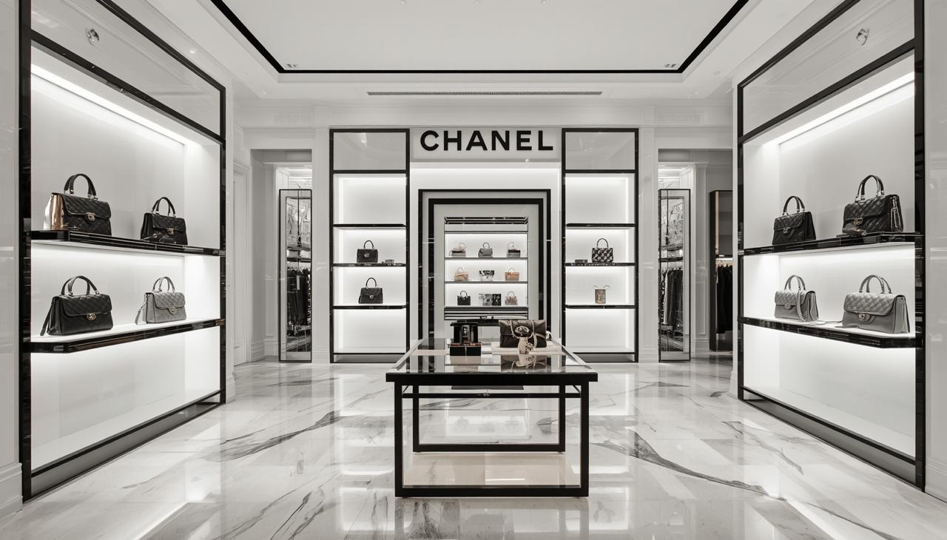
(Image created by Own)
This report critically examines Chanel’s international marketing strategy through a comparative analysis of France, its home market, and Japan, an important international market. It evaluates the political, economic, social, technological, environmental and legal environments using PESTEL, followed by comparison of cultural characteristics using Hofstede’s framework. The report then analyses Chanel’s segmentation, targeting and positioning (STP) and compares its marketing mix across the seven Ps: product, price, place, promotion, people, process and physical evidence. It subsequently evaluates Chanel’s market-entry strategy in Japan, considers ethical issues, develops strategic recommendations, and concludes with a Gibbs reflective account of the research and analytical process.
Company Background
Chanel is a privately owned French luxury house founded by Gabrielle “Coco” Chanel in Paris in 1910, when she opened her first hat boutique under the name Chanel Modes (Chanel, 2026). The company subsequently expanded into couture, fragrance, beauty, leather goods, jewellery and watches, developing a global reputation for creativity, craftsmanship and exclusivity (Fédération de la Haute Couture et de la Mode, 2026). Chanel’s contemporary strategic direction remains strongly connected to its heritage while pursuing innovation and responsible growth. Rather than publishing a conventional corporate mission statement, Chanel articulates its purpose through exceptional creation, excellence and a commitment to making a positive and lasting impact (Chanel, 2026a). Its sustainability ambition emphasises restoring nature, protecting the climate, advancing circularity and supporting dignity and opportunity, particularly for women (Chanel, 2026b). This combination of heritage, creativity, exclusivity and responsibility provides the foundation for examining Chanel’s marketing strategies in France and Japan.

- PESTEL Analysis – Introduction
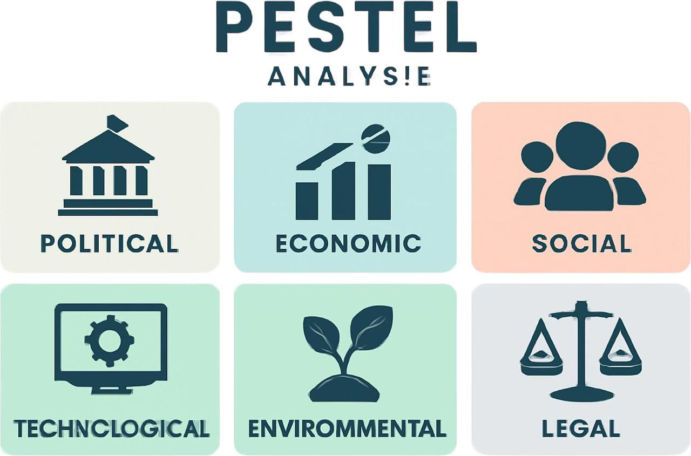
(Image created by Own)

PESTEL analysis provides a structured framework for assessing the macro-environmental forces that can influence an organisation’s international marketing decisions. For Chanel, comparing France and Japan is particularly relevant because differences in national environments can affect consumer demand, brand communication, retail operations and strategic responsiveness. This section critically evaluates the political, economic, social, technological, environmental and legal factors shaping Chanel’s marketing environment in both markets. Rather than treating the factors independently, the analysis compares their relative opportunities and risks and considers their implications for Chanel’s international marketing strategy. This provides a basis for understanding how the brand can maintain global consistency while responding appropriately to market-specific conditions.
  - Political Factors France – Favourable
France offers a **moderately favourable political environment** for Chanel due to its strong institutional stability, well-developed regulatory systems and globally recognised luxury industry ecosystem. As Chanel’s home market, France provides strategic advantages through government support for creative industries, fashion heritage protection and luxury tourism development.
However, recent political conditions reflect **increased fiscal pressure and policy uncertainty**, which may influence long-term business planning. The OECD highlights that political fragmentation and fiscal consolidation efforts in France are contributing to reduced economic confidence and potential regulatory adjustments in taxation and labour policy (OECD, 2026). For Chanel, this creates exposure to changes in corporate taxation, employment regulation and sustainability compliance requirements. Despite these challenges, France remains a critical strategic base because of its global leadership in luxury goods and strong institutional protection of intellectual property. Therefore, while the environment is supportive, Chanel must continuously

adapt to evolving fiscal and regulatory conditions to maintain competitiveness (OECD, 2025; OECD, 2026; World Bank, 2025).
Japan – Favourable
Japan provides a **favourable political environment** for Chanel due to its stable governance, predictable regulatory framework and consistent policy support for international trade and investment. The Japanese government has actively promoted foreign direct investment through simplified administrative procedures and investment facilitation systems, improving market accessibility for global luxury brands. According to the OECD, Japan maintains relatively low formal barriers to inward FDI and continues to enhance its attractiveness to multinational enterprises (OECD, 2026). However, foreign firms may still face **bureaucratic complexity and culturally embedded business practices**, requiring strong local partnerships and market adaptation. For Chanel, this is particularly important as luxury retail success depends on regulatory compliance, brand protection and strong relationships with local stakeholders. Overall, Japan’s political stability and openness to global business create a supportive environment, although operational complexity requires careful strategic management (OECD, 2026; Ministry of Economy, Trade and Industry Japan, 2025; World Bank, 2025).

.2 Economic Factors

France –Favourable

France provides a **moderately favourable economic environment** for Chanel because it combines a sophisticated consumer market, strong tourism infrastructure and an internationally established luxury-goods ecosystem. However, economic growth remains relatively modest. The OECD projects French GDP growth of **0.7% in 2026**, following growth of 0.9% in 2025, while inflation is expected to increase from 0.9% in 2025 to approximately 2.1% in 2026 (OECD, 2026). For Chanel, subdued economic growth and reduced purchasing power could constrain discretionary luxury consumption, particularly among aspirational consumers. Nevertheless, Chanel's highly differentiated brand equity and premium positioning provide some protection because its core customers are less dependent on everyday economic conditions than mass-market consumers.
France's strong luxury tourism and concentration of high-end retail also provide important opportunities for Chanel to capture international spending. Therefore, economic conditions remain supportive of Chanel's premium strategy, although weaker growth and inflation require careful management of pricing, consumer value and operating costs (OECD, 2026).

Japan –Favourable

Japan presents a **moderately favourable economic environment** for Chanel, supported by resilient domestic demand, improving wages and an established luxury-consumption culture. The OECD reports that Japan's real GDP grew by approximately **1.2% in 2025** and is projected to grow by **0.7% in 2026**, while inflation is projected at around **2.0% in 2026** (OECD, 2026). Rising nominal wages and stronger domestic consumption can support demand for discretionary products, creating opportunities for Chanel to deepen engagement with Japanese luxury consumers. However, inflation and higher energy costs can reduce real purchasing power, while Japan's ageing population and labour shortages create longer-term structural pressures on economic growth.

Currency movements are also strategically important because exchange-rate fluctuations can influence the affordability of imported luxury products and tourist purchases. Consequently, Japan remains attractive for Chanel, but the brand must protect its premium price positioning while monitoring affordability, currency volatility and changing consumer spending patterns (OECD, 2026; OECD, 2025).

Social Factors
France – Favourable
France provides a **favourable social environment** for Chanel because luxury, fashion and craftsmanship are deeply embedded within the country's cultural identity. Chanel benefits from strong consumer recognition of French luxury heritage and from Paris's position as a global fashion destination. International tourism also creates an important customer base for luxury brands; France experienced continued growth in tourism activity during 2025, strengthening opportunities for high-end retail and experiential consumption (OECD, 2025; Atout France, 2026). At the same time, demographic ageing and changing consumer expectations are reshaping the French market.
Consumers increasingly place greater importance on sustainability, authenticity and responsible consumption, meaning luxury brands face growing pressure to demonstrate social and environmental responsibility. For Chanel, this creates an opportunity to strengthen its heritage-based storytelling while connecting craftsmanship with contemporary values. However, the brand must avoid relying solely on historical prestige and should continue engaging younger consumers through relevant experiences and digital communication. Overall, France's cultural association with luxury remains a significant social advantage, although changing values require Chanel to balance heritage with modern consumer expectations.

Japan – Moderately Favourable

Japan offers a **moderately favourable social environment** for Chanel because consumers demonstrate strong appreciation for quality, craftsmanship, attention to detail and established luxury brands. These characteristics provide a strong cultural fit with Chanel's emphasis on exclusivity, craftsmanship and heritage. However, Japan presents a distinctive demographic challenge because of its rapidly ageing and declining working-age population. The OECD reports that Japan's
working-age population declined from 87.3 million in 1995 to 73.7 million in 2024, while the old-age dependency ratio increased substantially over the same period (OECD, 2025). This demographic shift may reduce the size of younger consumer cohorts over the long term, but it also creates opportunities for Chanel to serve affluent mature consumers through personalised products, beauty, fashion and relationship-based retail experiences. In addition, changing digital behaviour requires Chanel to maintain culturally appropriate online engagement alongside its traditional boutique experience. Therefore, Japan's social environment offers strong opportunities through its appreciation of luxury and quality, but demographic ageing means Chanel should adopt a broader, multi-generational approach to segmentation and customer engagement.

Hofstede’s Cultural Dimensions Framework

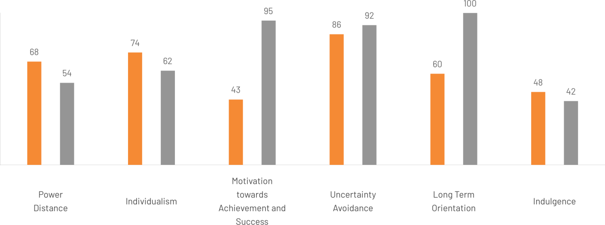
Hofstede’s Cultural Dimensions Framework provides a structured approach for examining how national cultural values can influence consumer behaviour, communication, decision-making and international business practices. The framework considers six dimensions: **Power Distance, Individualism versus Collectivism, Masculinity versus Femininity, Uncertainty Avoidance, Long-Term versus Short-Term Orientation, and Indulgence versus Restraint**. In this report, the framework is applied to compare **France and Japan** and assess how cultural differences may influence Chanel’s consumer expectations, luxury perceptions, communication style, relationship management and marketing adaptation. The comparison is particularly relevant because France reflects Chanel’s heritage and home-market identity, whereas Japan represents an important international luxury market with distinctive cultural characteristics. However, Hofstede’s dimensions should be interpreted as broad national-level tendencies rather than fixed characteristics of every consumer, as contemporary research identifies limitations in applying national cultural scores to individual behaviour (Bianchini and Lasheras Sancho, 2025; Taras, Steel and Kirkman, 2023). Therefore, the framework is used alongside market evidence to develop more context-sensitive implications for Chanel’s international marketing strategy.

Source from Google
https://www.theculturefactor.com/country-comparison-tool

Power Distance

France scores on Power Distance, indicating a relatively hierarchical culture where authority, status and formal structures are accepted. For Chanel, this may support communication that reinforces heritage, craftsmanship and the authority of the Maison, particularly through prestigious boutique environments and knowledgeable sales advisors. However, Chanel should avoid assuming that hierarchy automatically determines individual consumer behaviour.

Japan scores indicating an intermediate level of Power Distance. Although hierarchy and status remain important, Japanese organisations often emphasise consensus and consultation across different levels. For Chanel, this suggests that luxury communication should combine prestige with personalised, attentive relationship-building. Chanel can therefore maintain its global brand symbolism while adapting customer interactions towards respectful consultation rather than overtly authoritative communication. Overall, France may support stronger status-oriented brand cues, whereas Japan may require greater emphasis on trust, consultation and service quality. This distinction is particularly relevant to Chanel’s premium retail experience.

Individualism

indicating a strongly individualistic culture where personal independence and self-expression are valued. For Chanel, this supports positioning luxury products as expressions of individual identity, personal achievement and refined taste, particularly among consumers seeking distinctive fashion and lifestyle choices.

Japan scores, indicating relatively individualistic characteristics, although Japanese individualism differs from Western patterns and remains influenced by situational group relationships. For Chanel, this suggests opportunities to emphasise personal style while maintaining respectful, relationship-oriented customer experiences. Consequently, Chanel can combine individual self-expression with personalised service, craftsmanship and exclusivity to strengthen consumer engagement in the Japanese luxury market (Hofstede Insights, 2025).

Motivation towards Achievement and Success

France scores, indicating a relatively cooperation-oriented culture that values quality of life, consensus and social wellbeing. For Chanel, this supports positioning luxury around craftsmanship, creativity, refinement and quality rather than overt competitive achievement, while maintaining its prestigious French heritage.

Japan indicating a highly achievement-oriented culture characterised by competition, excellence and a strong pursuit of perfection. This aligns closely with Chanel’s emphasis on craftsmanship, meticulous quality and exceptional service. Chanel can therefore strengthen its Japanese positioning through superior craftsmanship, attention to detail and exclusive experiences that communicate achievement, prestige and excellence (Hofstede Insights, 2025).

Uncertainty Avoidance

France indicating a high level of uncertainty avoidance where consumers and organisations generally value structure, planning and detailed information. For Chanel, this supports clear communication regarding product quality, craftsmanship, authenticity and service standards. Providing reliable information can strengthen consumer confidence in the luxury purchase process.

Japan indicating a very high level of uncertainty avoidance, with strong preferences for predictability, preparation and risk reduction. This aligns closely with Chanel’s emphasis on quality, consistency and meticulous craftsmanship. Chanel can therefore strengthen consumer trust through detailed product information, exceptional service, authenticity assurance and carefully managed purchasing experiences. These characteristics support Chanel’s premium positioning and reinforce perceptions of reliability and excellence (Hofstede Insights, 2025).

Long-Term Orientation
France , indicating a pragmatic, future-oriented culture that balances established traditions with adaptation and perseverance. For Chanel, this supports combining its strong French heritage with continuous innovation, allowing the brand to preserve iconic identity while responding to changing luxury consumer expectations.

Japan indicating an exceptionally long-term-oriented culture that values perseverance, continuity and sustainable development. This aligns strongly with Chanel’s emphasis on enduring craftsmanship, product quality and long-term brand heritage. Chanel can therefore reinforce Japanese consumer relationships through timeless designs, exceptional craftsmanship, product longevity and personalised services that encourage lasting loyalty. This cultural alignment supports Chanel’s ability to position luxury as an enduring investment rather than short-term consumption (Hofstede Insights, 2025).

Indulgence

France, placing it relatively close to the middle between indulgence and restraint. For Chanel, this suggests that luxury consumption can be associated with enjoyment and lifestyle, but consumers may also expect sophistication, moderation and social appropriateness. Chanel can therefore emphasise refined experiences rather than excessive consumption.

Japan indicating a more restrained culture where self-control, social expectations and modesty influence consumption behaviour. For Chanel, this supports marketing centred on craftsmanship, quality and discreet prestige rather than overt displays of indulgence. Personalised service and carefully designed luxury experiences can strengthen engagement while respecting Japanese expectations of propriety and consideration for others (Hofstede Insights, 2025).

Advantages and Disadvantages of Hofstede’s Cultural Dimensions Framework

when comparing France and Japan as the two markets demonstrate notable differences
    - Advantages of Hofstede’s Cultural Dimensions Framework
A key strength of Hofstede’s Cultural Dimensions Framework is that it provides a structured method for comparing national cultures and understanding how cultural values influence communication, consumer behaviour, decision-making and marketing strategies (Minkov and Kaasa, 2022). For **Chanel**, the framework is particularly useful in analysing differences in Power Distance, Individualism, Achievement Orientation, Uncertainty Avoidance, Long-Term Orientation and Indulgence. These dimensions can guide Chanel in adapting customer communication, service delivery and brand experiences while maintaining a consistent global identity. For example, Japan’s relatively high Uncertainty Avoidance and Long-Term Orientation align with Chanel’s emphasis on craftsmanship, quality, reliability and product longevity. In contrast, France’s cultural characteristics can support greater emphasis on individual expression, creativity and fashion heritage. Therefore, Hofstede offers Chanel a valuable foundation for developing culturally informed international marketing strategies.

Disadvantages of Hofstede’s Cultural Dimensions Framework
Despite its usefulness, Hofstede’s Cultural Dimensions Framework has several limitations. One major criticism is that it can **overgeneralise national cultures**, assuming that individuals within the same country share similar values and behaviours (McSweeney, 2002). This may be problematic for **Chanel**, as luxury consumers in France and Japan can differ significantly according to age, income, lifestyle and personal preferences. Furthermore, Hofstede’s original research was largely based on employees from a single multinational organisation, raising concerns about the representativeness of the findings across different populations and industries (McSweeney, 2002).
Cultural values can also evolve over time because of globalisation, digitalisation and changing consumer attitudes, whereas Hofstede’s dimensions may appear relatively static (Minkov and Kaasa, 2022). Therefore, Chanel should use Hofstede alongside **market research, consumer insights and other cultural frameworks** rather than relying on it as a standalone decision-making tool.

  - Technological Factors

France – Favourable
France provides a favourable technological environment for Chanel through advanced digital infrastructure, e-commerce development and increasing adoption of digital technologies.
Digitalisation influences how consumers discover, evaluate and engage with luxury brands, creating opportunities for Chanel to integrate digital communication with its established boutique experience. The OECD highlights digital transformation, e-commerce, AI and cybersecurity as important drivers of business competitiveness (OECD, 2025a; OECD, 2025b). Chanel can therefore strengthen personalised communication, customer relationship management and omnichannel experiences while maintaining exclusivity. However, increased digital dependence creates cybersecurity, data-protection and authenticity risks. Consequently, Chanel should adopt technology selectively to enhance, rather than replace, its high-touch luxury experience.

Japan – Favourable
France provides a favourable technological environment for Chanel through advanced digital infrastructure, widespread internet connectivity, sophisticated e-commerce platforms and increasing business adoption of artificial intelligence (AI). Digitalisation has transformed how luxury consumers discover, evaluate and purchase products, creating opportunities for Chanel to integrate digital channels with its traditional boutique experience. The OECD identifies digital transformation, e-commerce, AI and cybersecurity as important drivers of innovation and business competitiveness (OECD, 2025a; OECD, 2025b). Chanel can therefore use technologies such as data analytics, personalised digital marketing, virtual experiences and customer relationship management to improve engagement and develop stronger omnichannel experiences. Social media and digital storytelling can also communicate Chanel’s heritage and craftsmanship to younger, digitally connected consumers. However, greater technological dependence increases exposure to cybersecurity threats, data-protection requirements and counterfeit or unauthorised online products. Therefore, Chanel should adopt technology selectively, ensuring digital innovation strengthens personalisation and accessibility without weakening exclusivity, authenticity and the high-touch luxury experience.

  - Environmental Factors

France – Moderately Favourable

France provides moderately favourable environmental environment for Chanel because sustainability has become increasingly embedded in national and European business expectations. France is pursuing ambitious climate objectives, including carbon neutrality by 2050, while businesses face increasing pressure to reduce emissions, improve resource efficiency and strengthen environmental transparency. For Chanel, these developments create both opportunities and challenges. The regulatory environment can increase the cost and complexity of sourcing, packaging, manufacturing and reporting, particularly for a luxury group operating across international supply chains. However, sustainability can also strengthen Chanel’s differentiation because the House has already established initiatives focused on climate, nature and circularity.
Chanel aims to achieve **net-zero greenhouse-gas emissions across its value chain by 2040** and is developing initiatives to extend product lifecycles and reduce environmental impacts (Chanel, 2026a; Chanel, 2026b). Therefore, France's environmental environment is strategically significant: compliance is necessary, but stronger sustainability performance can also reinforce Chanel's reputation for quality, longevity and responsible luxury.

Japan – Moderately Favourable

Japan provides a moderately favourable environmental environment for Chanel because the country has strengthened its commitment to a net-zero, circular and nature-positive economy. The OECD

reports that Japan has made progress in reducing greenhouse-gas emissions, energy use and waste while increasing investment in clean-energy transition and the circular economy (OECD, 2025). The country's environmental policy also encourages greater private-sector participation in biodiversity conservation and corporate climate action. These developments create opportunities for Chanel to strengthen sustainable sourcing, circular product initiatives and environmental communication within its Japanese operations. However, Japan continues to face challenges associated with a carbon-intensive energy mix, resource circularity and biodiversity pressures, meaning businesses are likely to experience increasing expectations to improve environmental performance (OECD, 2025). For Chanel, environmental responsibility is therefore not simply a compliance issue but an element of luxury value: durable products, repair services and responsible materials can reinforce the perception of long-term craftsmanship. Chanel's **CHANEL & moi** services, which include repair, alteration and restoration, provide a relevant example of how circularity can be integrated into the luxury customer experience (Chanel, 2026b). Overall, Japan offers opportunities for Chanel to align sustainability with its established emphasis on durability and craftsmanship, although continued investment will be required to meet evolving environmental expectations.

  - Legal Factors

France – Moderately Favourable Legal Environment – France
France provides a favourable legal environment for Chanel through strong consumer protection, intellectual-property rights and product-safety regulations. French and EU laws require Chanel to maintain product quality, transparent communication and effective after-sales services (Service-Public.fr, 2025; European Commission, 2026). Increasing EU sustainability and product-safety requirements also strengthen expectations for traceability and responsible business practices (European Commission, 2025). Strong intellectual-property protection is particularly important for Chanel because its brand name, designs, logos and creative assets are key competitive advantages. However, complex regulations can increase compliance costs and reduce flexibility in pricing, digital marketing and distribution. Overall, France offers Chanel a secure legal environment that protects both consumers and brand assets, although continuous investment in compliance and governance is necessary.

**Japan – Favourable**

Japan provides a **favourable legal environment** for Chanel because it has established consumer-protection, intellectual-property and trademark frameworks that support reputable international brands. The Japan Patent Office has continued to strengthen the country's trademark system, including reforms introduced in 2024 that relaxed certain registration requirements involving personal names, reflecting the needs of industries such as fashion where designers' and founders' names can form important brand assets (Japan Patent Office, 2025). This is strategically relevant to Chanel because protection of distinctive trademarks and brand identity is essential in a luxury market where counterfeiting can damage both revenues and perceived exclusivity. Japanese consumer-protection requirements also require businesses to provide appropriate information and avoid misleading commercial practices. However, Chanel must ensure that its global marketing, e-commerce activities, product claims and customer-data practices comply with Japanese requirements rather than simply transferring European practices into the market. Consequently, Japan's legal framework provides a relatively stable foundation for Chanel, while localisation of compliance remains important for protecting the brand and maintaining consumer trust.

Similarities and Differences between France and Japan: PESTEL
France and Japan present several similarities for Chanel. Both provide relatively stable and developed business environments, strong technological infrastructure, sophisticated luxury consumers and established legal systems. Both countries are also strengthening environmental policies, creating increasing expectations for sustainable sourcing, responsible production and transparent business practices. These conditions support Chanel’s premium positioning, although they require continuous regulatory compliance and investment in sustainability and digital capabilities (OECD, 2025; Chanel, 2026).
However, important differences exist. France benefits from its direct association with Chanel’s heritage, Parisian fashion and the wider European luxury ecosystem, whereas Japan offers strong consumer appreciation of craftsmanship but faces greater demographic ageing and long-term population pressures (OECD, 2025). France also operates within the EU regulatory framework, while Japan has its own national regulatory requirements. Consequently, Chanel can maintain greater standardisation in France but needs stronger local adaptation in Japan, particularly in customer service, digital engagement and sustainability communication. Overall, both markets are attractive, but their different macro-environments require a balance between global consistency and local responsiveness.

References

Comparative STP Analysis of Chanel in France and Japan

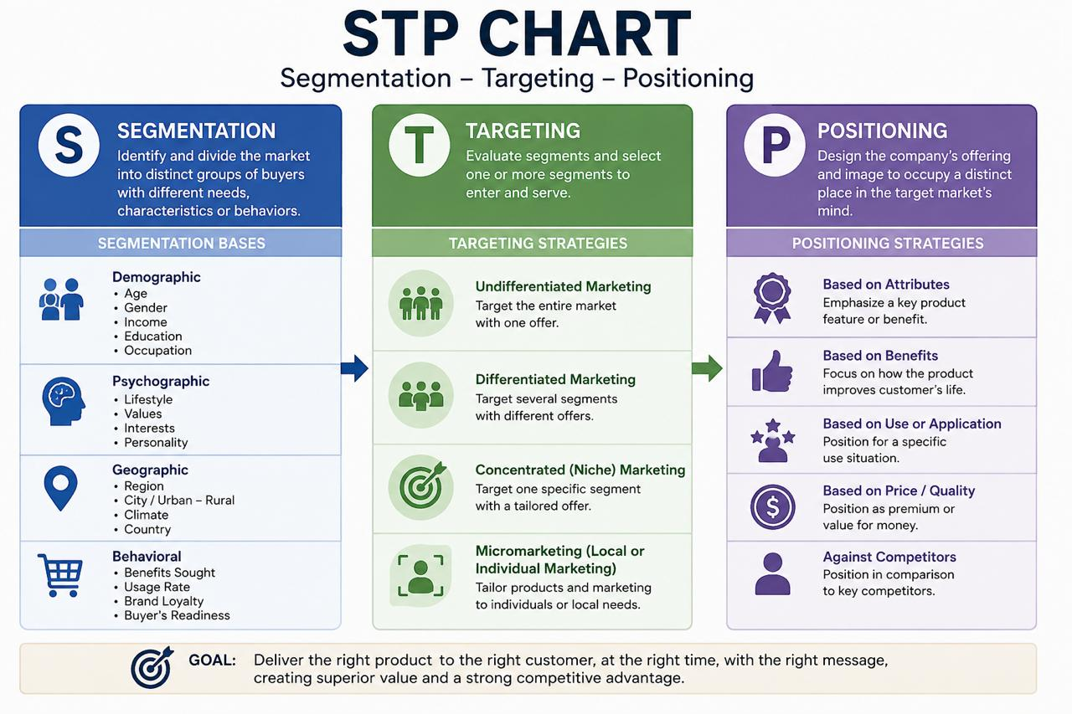
(Image created by Own)

Segmentation, Targeting and Positioning (STP) enables international organisations to identify meaningful consumer groups, select strategically attractive segments and establish distinctive positions in consumers' minds. For luxury brands, STP must be managed carefully because excessive standardisation can reduce local relevance, while excessive adaptation may weaken global brand identity. Chanel therefore needs to balance international consistency with market-specific responsiveness across France and Japan. This is particularly important given Chanel's return to growth in 2025, when revenues increased by 2% to US$19.3 billion, supported by creative momentum, investment in client engagement and renewed demand for new collections (Chanel, 2026a).

Segmentation
Chanel can segment consumers in France and Japan using demographic, geographic, psychographic and behavioural variables. However, because Chanel operates within the luxury market, income alone is insufficient to explain purchasing behaviour. Factors such as lifestyle, personal identity, desired exclusivity, brand attachment, perceived authenticity and customer experience are also important. Research indicates that brand authenticity is particularly important in luxury markets, meaning consumers may value genuine heritage and credibility alongside functional product attributes (Carpenter and Goldstein, 2022).

Demographic Segmentation
In France, Chanel can focus on affluent consumers, high-net-worth individuals, established professionals, fashion-conscious consumers and younger luxury buyers. Paris is particularly significant because France has a globally recognised position in fashion, luxury goods, perfume and cosmetics, with Paris acting as an important international fashion centre (Atout France, 2025).
Chanel's own Haute Couture heritage is closely connected to Paris, with its couture activity centred at 31 Rue Cambon since 1915 (Chanel, 2026b). Therefore, Chanel can target consumers who value French luxury heritage, craftsmanship, creativity and personal expression.
In Japan, Chanel can target affluent professionals, established luxury consumers, younger high-income consumers and customers seeking prestigious international brands. Japan's ageing population makes mature consumers an important segment, while younger affluent consumers remain strategically relevant for long-term brand development. The OECD reports that Japan's working-age population declined from 87.3 million in 1995 to 73.7 million in 2024, demonstrating the country's significant demographic shift (OECD, 2025). Chanel should therefore avoid treating Japanese consumers as one homogeneous group and instead differentiate segments according to age, income, lifestyle and digital engagement.

Geographic Segmentation
Geographic segmentation is particularly relevant to Chanel because luxury consumption and luxury retail are strongly concentrated in major metropolitan and tourism centres. France's international reputation in fashion and luxury makes Paris an especially significant location for Chanel, while Japan's major metropolitan centres provide concentrated opportunities for premium retail and experiential consumption (Atout France, 2025).
In France, Paris represents the central luxury ecosystem, combining fashion, tourism, cultural heritage and premium retail. Chanel's Parisian identity provides an important competitive advantage because its Haute Couture heritage remains physically centred at 31 Rue Cambon, making Paris an important part of the brand's authenticity and heritage proposition (Chanel, 2026b).

In Japan, Tokyo, particularly Ginza, is a strategically important luxury location. Chanel's official Ginza flagship includes fashion, handbags, accessories, watches and fine jewellery, while the building also houses CHANEL NEXUS HALL and CHANEL & moi – Les Ateliers. CHANEL NEXUS HALL provides cultural programming, while CHANEL & moi provides specialist care and repair services (Chanel, 2026c; Chanel, 2026d).
This demonstrates that Chanel's Japanese geographic strategy is not simply about distribution. Premium locations function as part of the overall brand experience, combining retail, culture, service and after-sales engagement.

Psychographic Segmentation
Psychographically, Chanel can appeal to consumers motivated by self-expression, status, craftsmanship, heritage, creativity, exclusivity and personal identity. These characteristics are consistent with the role of authenticity in luxury consumption, where consumers may distinguish established luxury brands through credible heritage, craftsmanship and brand meaning (Carpenter and Goldstein, 2022).
French consumers may be particularly responsive to Chanel's French heritage, creativity and cultural symbolism. Chanel's Haute Couture heritage, craftsmanship and Parisian location provide strong resources for communicating authenticity and creative authority (Chanel, 2026b).
Japanese consumers can be targeted through attributes such as craftsmanship, quality, precision and personalised service. This creates a strong strategic fit with Chanel's luxury proposition. The brand's Japanese boutiques provide personalised welcomes and fashion-advisor services, while CHANEL & moi offers tailored care, repair and alteration services, allowing Chanel to extend the customer relationship beyond the initial transaction (Chanel, 2026c; Chanel, 2026d).
Research on luxury authenticity confirms that authenticity is particularly important in distinguishing genuine luxury brands from businesses that simply adopt luxury characteristics (Carpenter and Goldstein, 2022). Chanel's heritage can therefore be treated as a strategic marketing asset, rather than merely historical information.

Behavioural Segmentation
Behavioural segmentation for Chanel considers purchase frequency, purchasing occasions, brand loyalty, preferred product categories, spending levels, gifting behaviour, digital and boutique engagement, interest in limited editions and use of after-sales services. In France, Chanel can target consumers purchasing for personal expression, fashion, social occasions and enduring luxury value. In Japan, segmentation can place greater emphasis on personalised service, craftsmanship, relationship-based purchasing and long-term product ownership. Chanel's Japanese boutiques provide appointments and personalised fashion-advisor support, while CHANEL & moi provides care, repair and alteration services (Chanel, 2026c; Chanel, 2026d). Consequently, behavioural segmentation can support long-term customer relationship management beyond the initial purchase.

Targeting

Chanel should adopt a differentiated targeting strategy, rather than treating France and Japan as identical markets. This approach allows the House to maintain its global luxury identity while adapting the customer experience to different market conditions and consumer expectations.

France
In France, the primary target should remain affluent and luxury-oriented consumers who value French heritage, creativity, craftsmanship and exclusivity. However, Chanel should also develop carefully managed relationships with younger luxury consumers because attracting new generations is important for maintaining long-term brand relevance. Chanel's 2025 performance provides evidence that new creative direction can attract first-time customers: Reuters reported that new collections under Matthieu Blazy generated strong demand and attracted consumers who had not previously purchased Chanel (Reuters, 2026).
The strategic challenge is therefore to attract new consumers without reducing scarcity. Chanel should increase relevance through creativity and carefully curated experiences rather than through mass-market distribution or excessive promotional activity.

Japan
In Japan, Chanel should target affluent consumers who value craftsmanship, quality, French heritage, personalised service and exclusivity. A secondary target can include younger digitally engaged luxury consumers who discover products and brand stories through digital channels before moving into physical boutique experiences. Japan's demographic structure also makes mature affluent consumers strategically relevant, given the country's rapidly ageing population (OECD, 2025).
The Japanese targeting strategy should therefore be relationship-oriented rather than purely transaction-oriented. Chanel's existing Japanese boutique model supports this approach through appointments, personalised fashion-advisor interactions and CHANEL & moi after-sales services (Chanel, 2026c; Chanel, 2026d).

Positioning
Chanel maintains a globally consistent positioning based on French heritage, creativity, craftsmanship, exclusivity and timeless luxury, but the emphasis can be adapted between France and Japan. This approach is supported by Chanel's continuing investment in craftsmanship, client engagement and creative development (Chanel, 2026a).

France
Chanel can be positioned as an authentic symbol of French luxury and Parisian creativity. Its historical association with Gabrielle Chanel, Haute Couture and 31 Rue Cambon provides strong evidence for this positioning. Chanel describes its Haute Couture as an ongoing balance between excellence and creativity, with craftsmanship continuing to be developed at its Paris ateliers (Chanel, 2026b).

Japan

In Japan, Chanel should retain its French identity but emphasise craftsmanship, precision, longevity, personalised service and cultural sensitivity. This recommendation is supported by Chanel's Japanese retail model, which incorporates personalised fashion-advisor services and product-care facilities (Chanel, 2026c; Chanel, 2026d).
This represents an important international marketing principle: Chanel should not attempt to become a Japanese brand in Japan. Instead, it should remain recognisably French while communicating its value through attributes that are strategically relevant to Japanese consumers.

Suggested Perceptual Map
Chanel should be positioned towards high exclusivity and strong heritage, while maintaining sufficient contemporary relevance to attract younger luxury consumers. This positioning is strategically appropriate because Chanel's heritage provides authenticity, while its recent creative development demonstrates the importance of remaining contemporary. Its 2025 growth was supported by new designs that attracted new customers while retaining demand for established Chanel codes (Reuters, 2026; Carpenter and Goldstein, 2022).

Comparative 7Ps Marketing Mix of Chanel in France and Japan
Chanel's marketing mix demonstrates the importance of combining global brand consistency with selective local adaptation. Unlike mass-market businesses, Chanel's 7Ps should not be evaluated primarily through sales volume and price competition. Instead, the central objective is to protect desirability, exclusivity, craftsmanship and customer experience while responding to different market environments. Chanel's 2025 financial results demonstrate this strategic emphasis, with revenue reaching US$19.3 billion, alongside substantial investment in brand activities, client engagement and savoir-faire (Chanel, 2026a). This suggests that the marketing mix is increasingly centred on long-term brand equity rather than short-term sales maximisation.

Product
Chanel operates across several luxury categories, including fashion, handbags, shoes, accessories, watches, fine jewellery, fragrance and beauty. This broad portfolio allows the House to serve different luxury consumption needs while maintaining a coherent brand identity (Chanel, 2026a). In France, the product strategy can strongly emphasise Parisian heritage, craftsmanship and creative innovation. Chanel's Haute Couture history is closely connected to Paris, particularly 31 Rue Cambon, strengthening the authenticity and heritage associated with its products (Chanel, 2026b). This provides an important basis for communicating craftsmanship and French luxury. (chanel.com)
In Japan, the core global product identity can remain consistent while the surrounding customer experience is locally adapted. Chanel's Ginza boutique offers ready-to-wear, handbags, small

leather goods, shoes, accessories, eyewear, watches and fine jewellery, demonstrating the breadth of its Japanese luxury offering (Chanel, 2026c). Therefore, Chanel does not necessarily need substantial product adaptation; instead, it can adapt how products are presented, explained and experienced according to local expectations.
Chanel should also continue strengthening product longevity through CHANEL & moi, which provides care, repair and alteration services. Chanel describes these services as designed to provide lasting attention to its creations throughout their life (Chanel, 2026d). This is strategically valuable because product durability can reinforce both luxury value and sustainability, allowing Chanel to associate responsible consumption with craftsmanship rather than compromising its premium positioning.

Price
Chanel follows a premium/prestige pricing strategy, with price functioning as both an economic mechanism and a signal of exclusivity and brand value. In luxury markets, pricing can contribute to perceptions of scarcity and prestige, meaning significant discounting may conflict with the symbolic value of the brand. Chanel therefore needs to justify premium prices through distinctive design, craftsmanship, quality and customer experience.
In France, premium pricing is supported by Chanel's strong association with French luxury, heritage and craftsmanship. However, broader economic uncertainty means that price increases need to remain consistent with consumers' perceptions of value. In Japan, premium pricing can similarly reinforce exclusivity, although currency movements can affect the relative affordability of luxury goods for domestic consumers and international visitors.
Chanel's 2025 financial results indicate continued investment in brand activities and client engagement alongside its positive financial performance (Chanel, 2026a). The company invested approximately US$2.395 billion in brand activities, including client engagement, demonstrating that Chanel continues to invest in the factors that support long-term brand value.
Therefore, Chanel should avoid relying on frequent promotional discounting and instead strengthen perceived value through craftsmanship, exclusivity, service, creativity and product longevity.
This approach is particularly important because excessive price increases can create consumer resistance and potentially weaken perceived value within the luxury market (Reuters, 2024). (reuters.com)

Place
Place is one of Chanel's strongest competitive advantages because its boutiques function not only as distribution points but also as physical manifestations of the brand. In France, Paris provides Chanel with an important luxury ecosystem combining fashion, heritage, tourism and premium retail. Chanel's historical connection to Paris strengthens the symbolic importance of its physical retail environment (Chanel, 2026b). (chanel.com)
In Japan, Tokyo, particularly Ginza, is strategically important for Chanel's luxury retail presence. Chanel's Ginza location combines fashion, handbags, shoes, accessories, watches and fine jewellery with additional experiential services. The building also contains CHANEL NEXUS HALL, which hosts exhibitions and cultural programmes, and CHANEL & moi Les Ateliers, which provides specialist care and repair services (Chanel, 2026c).

Therefore, Chanel's place strategy is not simply about making products available. The boutique acts as brand theatre, where architecture, service, cultural activity, product presentation and after-sales care contribute to the overall perception of luxury. This is particularly important in Japan, where Chanel can differentiate itself through a highly curated physical experience rather than competing through broad distribution.

Promotion
Chanel uses an integrated promotional approach involving fashion shows, cultural and celebrity ambassadors, social media, digital storytelling, editorial content, experiential events, boutique experiences and product launches. These activities allow Chanel to maintain a consistent global identity while communicating different aspects of the brand according to market context.
In France, promotion can strongly leverage Parisian heritage, fashion authority, creativity and the House's historical connection with French culture. In Japan, Chanel should maintain the same global creative identity while using culturally appropriate communication and carefully curated digital engagement.
Recent academic research demonstrates that luxury brands increasingly use social media to communicate sustainability. Eastman et al. (2024) found that consumer responses to luxury brands' sustainability posts depend on combinations of communication characteristics and the way sustainability information is presented. This suggests that Chanel should not simply increase promotional volume; instead, it should focus on credible, visually strong and carefully curated storytelling.
Consequently, Chanel should use digital platforms to build desirability and engagement, rather than treating them purely as high-volume sales channels. This is particularly important for maintaining exclusivity while reaching younger digitally engaged luxury consumers.

People
People are particularly important to Chanel because employees directly influence the luxury customer experience. In France, Chanel advisors should demonstrate strong knowledge of French heritage, fashion, craftsmanship, product history and styling, enabling them to communicate the House's authenticity and expertise effectively. In Japan, customer-facing employees should additionally demonstrate culturally appropriate communication, attentive listening, patience, product expertise, personalised consultation and consistently high service standards.
Chanel's Japanese Ginza boutique explicitly promotes a personalised welcome with a Fashion Advisor, while its services include appointments and personalised assistance with care, repair and alteration enquiries (Chanel, 2026c). This demonstrates that employees are an important part of Chanel's value proposition rather than simply a delivery mechanism.
Therefore, employee capability represents a significant competitive advantage. For Chanel, the employee is effectively part of the product experience because the quality of personal interaction can influence how consumers perceive exclusivity, expertise and authenticity.

Process
The purchasing process should communicate exclusivity and quality from initial discovery through purchase and after-sales service. Chanel's Japanese digital and boutique systems allow

customers to arrange appointments and receive personalised assistance, supporting a more controlled customer journey (Chanel, 2026c).
This creates an omnichannel process, in which consumers can discover products and information digitally before transitioning into personalised physical boutique experiences. For Chanel, this is particularly valuable because digital convenience can be combined with the human interaction expected from luxury retail.
France can adopt a similar model while maintaining the distinctive Parisian boutique experience. Chanel should therefore continue developing digital tools, but technology should remain a support mechanism for luxury service rather than a replacement for human interaction. This approach protects the experiential character of luxury while responding to changing consumer expectations.

Physical Evidence
Physical evidence is crucial for Chanel because luxury value is communicated through both tangible and intangible cues. Important physical evidence includes boutique architecture, packaging, product presentation, brand identity, materials, lighting, employee presentation, cultural spaces and digital interfaces. These elements collectively shape consumers' perceptions of quality, authenticity and exclusivity.
Chanel's Ginza location provides a strong example of this strategy. Alongside fashion, handbags, watches and fine jewellery, the location incorporates CHANEL NEXUS HALL, which hosts cultural programmes, and CHANEL & moi Les Ateliers, which provides specialist product-care and repair services (Chanel, 2026c).
Consequently, the Chanel boutique becomes more than a place to purchase products; it functions as a cultural and experiential destination. This is strategically important because the physical environment reinforces the symbolic value of the products and differentiates Chanel from brands competing primarily through digital convenience.

Similarities and Differences between France and Japan
Chanel maintains a consistent global identity in both France and Japan through its emphasis on heritage, craftsmanship, creativity, exclusivity and premium quality. Chanel's 2025 results demonstrate continued investment in brand activities, client engagement and savoir-faire, supporting the importance of maintaining a consistent global luxury proposition (Chanel, 2026a).
However, implementation should differ between the two markets. France provides the cultural foundation for Chanel's Parisian identity and allows the House to emphasise heritage, fashion authority, creativity and French craftsmanship. Japan, by contrast, provides an environment in which personalised service, detailed product care and experiential retail can be particularly important. Chanel's Ginza model demonstrates this through personalised fashion-advisor service, cultural programming and specialist product-care facilities (Chanel, 2026c).
Therefore, the difference is not that Chanel requires completely different products in the two markets. Instead, the greatest adaptation should occur in service, communication, customer relationship management and experiential retail. This supports a strategy of global standardisation of the core brand identity combined with selective local responsiveness, allowing Chanel to remain recognisably French while making the customer experience relevant to each market.

Market Entry Strategy: Chanel in Japan
Chanel's Japanese market strategy should be evaluated in terms of control, brand protection, localisation and long-term relationship building. For luxury brands, maintaining control over the customer experience is particularly important because the retail environment, service quality and brand presentation contribute to perceived exclusivity and authenticity. Chanel's 2025 results also demonstrate the importance of long-term investment, with the House investing US$2.395 billion in brand activities, including client engagement, alongside continued investment in savoir-faire and capital expenditure (Chanel, 2026a).
Unlike a mass-market company that may rely extensively on licensing or broad distribution, Chanel's current Japanese presence demonstrates a high-control retail and brand-experience approach. Its Japanese boutiques provide curated collections, appointments, personalised Fashion Advisor support and CHANEL & moi care services. The Ginza boutique, for example, offers fashion, handbags, shoes, accessories, watches and fine jewellery alongside personalised services (Chanel, 2026b).
This approach is strategically appropriate for Chanel because high control enables the House to manage product presentation, customer service, boutique environment, brand storytelling, exclusivity and after-sales experienceconsistently. Chanel's Japanese boutiques explicitly describe a personalised welcome with a Fashion Advisor and provide appointment-based services, illustrating how the physical retail environment is integrated with relationship management (Chanel, 2026b).
The main advantage is therefore brand control. Directly managed or closely controlled retail environments can allow Chanel to protect the consistency of its luxury proposition while developing deeper customer relationships. This is particularly relevant because Chanel's 2025 strategy emphasised client engagement and investment in the House's long-term brand development rather than short-term commercial performance alone (Chanel, 2026a).
However, a high-control strategy also requires significant investment in property, employees, training, service delivery and customer experience. Chanel's 2025 financial results demonstrate the scale of this commitment, with US$1.449 billion in capital expenditure and US$2.395 billion invested in brand activities, including client engagement (Chanel, 2026a). Therefore, while the strategy provides strong control over brand equity, it also creates substantial fixed and operating costs.
Overall, a high-control market strategy is appropriate for Chanel in Japan because the brand competes through exclusivity, craftsmanship and customer experience rather than mass distribution. The Japanese boutique model demonstrates how Chanel can preserve its global identity while adapting service delivery and relationship management to local market expectations (Chanel, 2026b).

Ethical Issues Related to Chanel's Marketing Mix in Japan
Ethical marketing requires Chanel to balance commercial objectives with responsibilities towards consumers, employees, suppliers, communities and the environment. This is particularly important for a global luxury company because its environmental and social practices can influence brand reputation as well as stakeholder trust. Chanel's current sustainability framework focuses on nature and climate, circularity, dignity and opportunity, and women's autonomy (Chanel, 2026c).

Ethical Issue 1 – Sustainability and Circularity
A positive ethical practice concerns Chanel's investment in circularity and product longevity. CHANEL & moi provides care, repair, restoration and alteration services designed to help consumers preserve Chanel creations throughout their lifecycle. In Japan, Chanel states that its repair services are intended to preserve products for longer, while certain handbags and chain wallets purchased from April 2021 are covered by a five-year repair guarantee (Chanel, 2026d).
This is particularly relevant to the Product, Process and Physical Evidence elements of the marketing mix. Rather than treating a luxury purchase as a short-term transaction, repair and restoration can encourage longer product ownership and reinforce the perception that Chanel creations are designed to be valued over time. Recent academic research identifies circular economy and sustainability as increasingly important issues in luxury fashion consumer behaviour, although research also highlights the need for further understanding of how consumers respond to these initiatives (Gasulla Tortajada et al., 2024).
Consequently, Chanel can potentially turn product longevity into a source of competitive differentiation. Sustainability becomes connected to the traditional luxury values of craftsmanship, durability and care rather than being presented as a separate corporate activity.

Ethical Issue 2 – Environmental Impact
Luxury fashion remains associated with environmental impacts arising from materials, manufacturing, energy use, transportation and end-of-life processes. Chanel recognises these challenges within its sustainability strategy and has established a goal of achieving net-zero greenhouse-gas emissions across its value chain by 2040 (Chanel, 2026c). Chanel also reports initiatives relating to responsible sourcing and circularity; for example, more than 90% of its gold sourcing in 2024 was recycled gold with Responsible Jewellery Council Chain of Custody certification (Chanel, 2026e).
However, a critical issue remains: sustainability claims need to be supported by measurable progress, transparent reporting and credible evidence. Recent research identifies growing consumer awareness of the environmental consequences of luxury consumption and highlights the increasing importance of circular-economy strategies within luxury fashion (Gasulla Tortajada et al., 2024). Therefore, Chanel must ensure that sustainability communication reflects substantive operational progress rather than becoming primarily a promotional message.

Critical Evaluation
Chanel demonstrates meaningful progress through its circularity initiatives, climate commitments and responsible supply-chain governance. Its 2025 Modern Slavery Statement explains that the company introduced an ESG due-diligence task force in 2025 and continued developing supply-chain governance mechanisms. It also identifies risks involving modern slavery, forced labour, child labour and other human-rights issues across the value chain (Chanel, 2026f).

Nevertheless, Chanel must ensure that sustainability communication remains connected to the environmental and social impacts of luxury production. Ethical marketing therefore requires evidence-based transparency rather than simply sustainability-themed communication. This is particularly important because sustainability can create both reputational opportunities and risks if consumer expectations are not matched by measurable corporate performance (Gasulla Tortajada et al., 2024).

Recommendations

Recommendation 1 – Develop a Japan-Specific Luxury Clienteling Strategy
Chanel should strengthen personalised clienteling in Japan by integrating digital customer insights with boutique-based relationships. Appointment systems, personalised product recommendations, private previews and after-sales communication should be connected into a coherent customer journey. This recommendation is consistent with Chanel's existing Japanese boutique model, where customers can arrange appointments and receive personalised support from Fashion Advisors (Chanel, 2026b).
The recommendation also aligns with Chanel's wider strategic emphasis on client engagement. In 2025, the House invested US$2.395 billion in brand activities, including client engagement, demonstrating that customer relationships remain an important element of its long-term strategy (Chanel, 2026a). Chanel should therefore develop a Japanese clienteling system that moves beyond individual transactions towards long-term relationship management and customer lifetime value.

Recommendation 2 – Position Circularity as Luxury Longevity
Chanel should expand communication around repair, restoration and product longevity, particularly through CHANEL & moi. Chanel already provides repair, restoration and care services in Japan, including tailored services designed to preserve its creations over time (Chanel, 2026d).
This would allow Chanel to address sustainability without weakening its luxury proposition. Rather than presenting sustainability as a sacrifice or reduction in consumption, Chanel can communicate the idea that true luxury is designed to last. This positioning is supported by recent research identifying circularity and sustainability as increasingly relevant areas within luxury fashion consumer behaviour (Gasulla Tortajada et al., 2024).

Recommendation 3 – Attract Younger Japanese Consumers without Mass-Market Democratisation
Chanel should develop curated digital storytelling for younger Japanese luxury consumers while maintaining scarcity and exclusivity. The communication should focus on craftsmanship, creative

processes, heritage, behind-the-scenes storytelling, limited digital experiences and carefully selected cultural collaborations. Research on sustainability communication in luxury also indicates that the manner in which brands communicate through social media can influence consumer responses, suggesting that content quality and credibility are more strategically important than simply maximising communication volume (Eastman et al., 2024).
The objective should therefore not be maximum digital reach. Instead, Chanel should pursue high-quality engagement with strategically valuable consumers, ensuring that digital communication strengthens desirability without turning the brand into a mass-market proposition.

Recommendation 4 – Maintain Premium Pricing but Strengthen Value Communication
Chanel should protect its premium pricing strategy rather than compete through frequent discounting. However, it should communicate the value supporting premium prices through craftsmanship, materials, repairability, personalised service and creative investment. Chanel's 2025 results show that the House continues to invest significantly in brand activities and savoir-faire, providing evidence that value creation extends beyond the physical product itself (Chanel, 2026a).
This is particularly important because luxury consumers evaluate products through both functional and symbolic dimensions. Chanel's heritage, craftsmanship and authenticity should therefore remain central to price justification, while repair and after-sales services can strengthen the perception of long-term value.

Conclusion
This report has critically examined Chanel’s international marketing environment and strategy by comparing **France and Japan** using PESTEL, Hofstede’s Cultural Dimensions, STP and the 7Ps marketing mix. The findings show that both markets offer significant opportunities, but their different political, economic, social, technological, environmental and cultural conditions require
**selective adaptation rather than complete standardisation** (Chanel, 2026a).
France represents Chanel’s **heritage, cultural legitimacy and Parisian luxury identity**, while Japan offers strong opportunities through its appreciation of craftsmanship, precision, personalised service and long-term product care. Chanel’s Japanese boutiques demonstrate this through Fashion Advisor services, appointments and CHANEL & moi care and repair services (Chanel, 2026b; Chanel, 2026d).
Therefore, Chanel should adopt a **“global core, local experience” strategy**, maintaining consistent brand heritage, creativity, craftsmanship and exclusivity while adapting customer service, digital engagement, sustainability communication and relationship management to Japanese expectations. Continued investment in clienteling, circularity and controlled digital engagement can strengthen long-term competitiveness without weakening luxury scarcity and authenticity. Chanel’s 2025 results, including **2% revenue growth to US$19.3 billion**, demonstrate the importance of balancing brand desirability with long-term investment (Chanel, 2026a).
Overall, Chanel’s competitive advantage lies in combining **heritage, craftsmanship, exclusivity, personalised service and innovation** into a consistent yet locally responsive luxury experience.

Gibbs Reflective Cycle – Reflective Account
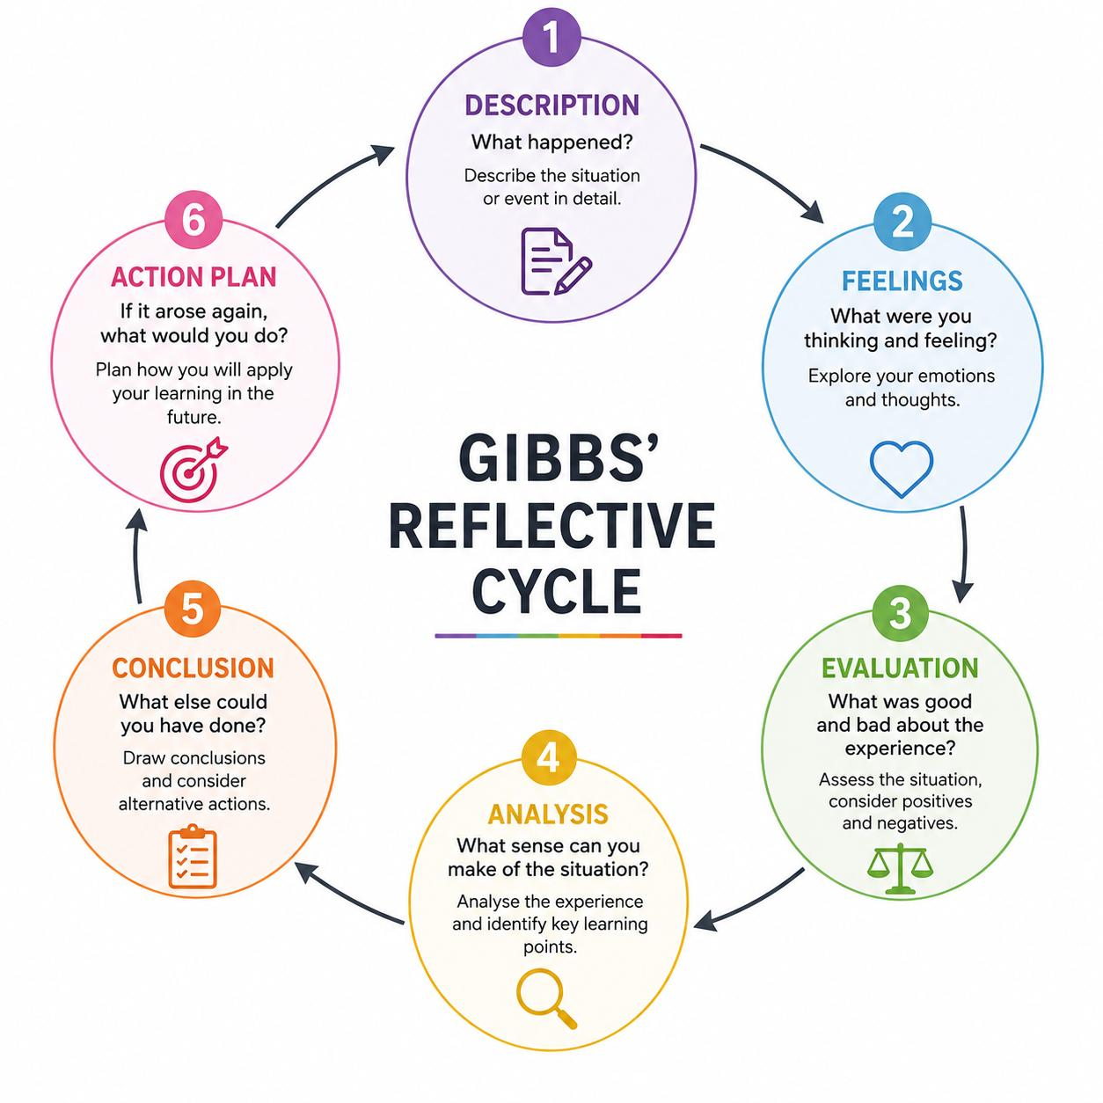
(Image created by Own)

Description
For this assignment, I researched Chanel's international marketing environment by comparing France and Japan using PESTEL, Hofstede's Cultural Dimensions Framework, STP and the 7Ps marketing mix. I also examined Chanel's Japanese market presence, ethical responsibilities and future strategic opportunities. The research involved consulting academic literature, Chanel's corporate and sustainability information, OECD evidence and contemporary business sources. This process required me to move beyond simply describing Chanel and instead evaluate how environmental, cultural and consumer differences can influence international marketing decisions. The use of multiple analytical perspectives was particularly valuable because luxury marketing depends not only on product attributes but also on authenticity, brand meaning and customer experience (Carpenter and Goldstein, 2022).

Feelings
Initially, I found international marketing analysis challenging because I was familiar with marketing concepts but had less experience applying them to a luxury brand across two culturally different countries. I initially expected the frameworks to provide relatively straightforward answers.
However, as the research progressed, I realised that the same cultural or economic characteristic could create both opportunities and risks for Chanel. This encouraged me to approach the assignment more critically and question whether a strategy that works in France would necessarily be equally effective in Japan. I also became more aware that cultural frameworks should be treated as analytical guides rather than definitive explanations of individual consumer behaviour.

Evaluation
One positive aspect of my research was that using multiple frameworks helped me develop a more comprehensive understanding of Chanel. PESTEL helped me examine external environmental forces, while Hofstede encouraged me to consider differences in national cultural tendencies. STP and the 7Ps then enabled me to connect these environmental and cultural findings with practical marketing decisions. However, I also recognised the limitations of relying too heavily on a single framework. Hofstede's dimensions provide useful national-level comparisons, but they should not be interpreted as describing every individual within a country. Recent research demonstrates that cultural dimensions can be useful analytical variables but their influence may differ according to the context being examined (Nagy and Konyha Molnarne, 2022). Therefore, I learned that cultural frameworks should be combined with current market research and consumer evidence.

Analysis

The research demonstrated that international marketing involves more than adapting advertising or products; it also includes **service, retail experience, communication, digital engagement, customer relationships and sustainability**. I learned that Chanel’s competitive advantage comes from maintaining a consistent global identity while selectively adapting the customer experience to local expectations. This highlighted the importance of authenticity and heritage in luxury branding (Carpenter and Goldstein, 2022).

The research also changed my understanding of exclusivity. I initially associated exclusivity mainly with high prices, but Chanel’s personalised appointments, boutique experience, storytelling and CHANEL & moi repair services demonstrate that exclusivity can be created through the **complete customer journey**. Sustainability and product longevity can further strengthen luxury value (Gasulla Tortajada *et al.*, 2024).

Finally, I learned the importance of **current and primary evidence**, particularly Chanel’s corporate and sustainability reports, which helped me connect marketing theory with the company’s actual strategic practices.

Conclusion
Overall, the research process improved my ability to critically apply international marketing theories to a real organisation. I learned that frameworks should be used as analytical tools rather than automatic explanations. PESTEL helped me understand the external environment, Hofstede highlighted potential cultural differences, while STP and the 7Ps allowed me to translate these findings into strategic marketing implications. Comparing France and Japan also showed me that successful international marketing requires a balance between global consistency and local responsiveness. Most importantly, I learned that luxury marketing involves more than products and prices; authenticity, service, experience, relationships and sustainability can all contribute to competitive advantage (Carpenter and Goldstein, 2022; Gasulla Tortajada et al., 2024).

Action Plan
In future academic and professional work, I will begin research earlier and develop an evidence matrix linking each strategic claim to a credible source. I will prioritise recent academic research, government data and primary company evidence while using theoretical models critically. I will also compare alternative interpretations before reaching conclusions rather than accepting the first explanation that appears convincing. Most importantly, I will aim to connect theoretical analysis with measurable managerial implications rather than treating analytical models as separate sections. I will also ensure that future research distinguishes clearly between evidence, interpretation and personal judgement. This approach should improve the academic quality of my future work and strengthen my ability to make evidence-based international marketing decisions.

References – Harvard style

Chanel (2026) 1910s: Opening of “Chanel Modes”. Available at: Chanel official website (Accessed: 11 August 2026).
Chanel (2026a) Legal statement and modern slavery report. Available at: Chanel official website (Accessed: 11 August 2026).
Chanel (2026b) Our sustainability ambition. Available at: Chanel sustainability website (Accessed: 11 August 2026).
Fédération de la Haute Couture et de la Mode (2026) CHANEL. Available at: FHCM – Chanel (Accessed: 11 August 2026).
OECD (2025) OECD Economic Outlook, Volume 2025 Issue 1: Tackling Uncertainty. Paris: OECD Publishing. Available at: OECD Economic Outlook 2025 (Accessed: 11 August 2026).
OECD (2026) OECD Economic Surveys: France 2026. Paris: OECD Publishing. Available at: OECD Economic Surveys: France 2026 (Accessed: 11 August 2026).
OECD (2026) OECD Economic Surveys: Japan 2026. Paris: OECD Publishing. Available at: (Accessed: 11 August 2026).
OECD (2025) OECD Economic Outlook, Volume 2025 Issue 2. Paris: OECD Publishing. Available at: (Accessed: 11 August 2026).
OECD (2026) OECD Economic Surveys: France 2026. Paris: OECD Publishing. Available at: (Accessed: 11 August 2026).
OECD (2026) OECD Economic Surveys: Japan 2026. Paris: OECD Publishing. Available at: (Accessed: 11 August 2026).
Minkov, M. and Kaasa, A. (2022) ‘Do dimensions of culture exist objectively? A review of the literature on cultural dimensions and their measurement’, Cross Cultural & Strategic Management, 29(3), pp. 445–473.
Taras, V., Steel, P. and Kirkman, B.L. (2023) ‘Comparative evaluation of seven instruments for measuring values comprising Hofstede’s model of culture’, Journal of World Business, 58(1), 101386.
Bianchini, M. and Lasheras Sancho, M. (2025) SME digitalisation for competitiveness: The 2025 OECD D4SME Survey. OECD SME and Entrepreneurship Papers, No. 68. Paris: OECD Publishing. Available at: (Accessed: 11 August 2026).
Chanel (2026) Chanel Limited financial results for the year ended 31 December 2025. London: Chanel Limited. Available at: (Accessed: 11 August 2026).
OECD (2025a) The 2025 OECD definition of e-commerce and guidelines for interpretation. Paris: OECD Publishing. Available at: (Accessed: 11 August 2026).
OECD (2025b) Digital trade. Paris: OECD. Available at: (Accessed: 11 August 2026).
Chanel (2026a) Chanel’s sustainability ambition. Available at: Chanel Sustainability (Accessed: 11 August 2026). ¾

Chanel (2026b) Investing in circularity. Available at: Chanel – Investing in Circularity (Accessed: 11 August 2026). ¾
OECD (2025) OECD Environmental Performance Reviews: Japan 2025. Paris: OECD Publishing. Available at: OECD Environmental Performance Reviews: Japan 2025 (Accessed: 11 August 2026).
European Commission (2025) Guidelines on the application of the EU General Product Safety legislative framework by businesses. Brussels: European Commission. Available at: European Commission – General Product Safety Regulation(Accessed: 11 August 2026). ¾
European Commission (2026) Sustainable consumption: consumer rights and guarantees. Brussels: European Commission. Available at: European Commission – Sustainable Consumption (Accessed: 11 August 2026). ¾
Japan Patent Office (2025) First trademark registration made under the consent system. Tokyo: Japan Patent Office. Available at: Japan Patent Office – Trademark Reform (Accessed: 11 August 2026). ¾
Service-Public.fr (2025) Achat d'un produit: garantie légale de conformité. Paris: Direction de l'information légale et administrative. Available at: Service-Public.fr – Legal Guarantee of Conformity (Accessed: 11 August 2026).
Chanel (2026) CHANEL Limited financial results for the year ended 31 December 2025. London: Chanel Limited. Available at: Chanel 2025 Financial Results (Accessed: 11 August 2026). ¾
OECD (2025) OECD Environmental Performance Reviews: Japan 2025. Paris: OECD Publishing. Available at: OECD Environmental Performance Reviews: Japan 2025 (Accessed: 11 August 2026).
¾
OECD (2026) OECD Economic Surveys: Japan 2026. Paris: OECD Publishing. Available at: OECD Economic Surveys: Japan 2026 (Accessed: 11 August 2026). ¾
Atout France (2025) France – the undisputed benchmark for fashion, luxury goods, perfume and cosmetics. Paris: Atout France. Available at: Atout France – Fashion and Luxury in France (Accessed: 11 August 2026).
Carpenter, G. and Goldstein, G. (2022) ‘Legitimately luxurious: The importance of authenticity to luxury brands’, Business Horizons, 65(5), pp. 631–642. Available at: Kellogg School of Management – Legitimately Luxurious(Accessed: 11 August 2026).
Chanel (2026a) CHANEL Limited Financial Results for the Year Ended 31 December 2025. London: Chanel Limited. Available at: CHANEL 2025 Financial Results (Accessed: 11 August 2026).
Chanel (2026b) The History of CHANEL Haute Couture. Paris: CHANEL. Available at: CHANEL Haute Couture History (Accessed: 11 August 2026).
Chanel (2026c) CHANEL GINZA. Tokyo: CHANEL. Available at: CHANEL Ginza (Accessed: 11 August 2026).
Chanel (2026d) CHANEL & moi – Les Ateliers. Tokyo: CHANEL. Available at: CHANEL & moi – Les Ateliers Tokyo(Accessed: 11 August 2026).

OECD (2025) OECD Employment Outlook 2025: Japan. Paris: OECD Publishing. Available at: OECD Employment Outlook 2025 – Japan (Accessed: 11 August 2026).
Reuters (2026) ‘Chanel returns to growth as Blazy's designs win over new shoppers’, 19 May. Available at: Reuters – Chanel returns to growth (Accessed: 11 August 2026).
Chanel (2026a) CHANEL Limited Financial Results for the Year Ended 31 December 2025. London: Chanel Limited. Available at: CHANEL Financial Results 2025 (Accessed: 11 August 2026).
Chanel (2026b) The History of CHANEL Haute Couture. Paris: CHANEL. Available at: CHANEL Haute Couture History (Accessed: 11 August 2026).
Chanel (2026c) CHANEL GINZA. Tokyo: CHANEL. Available at: CHANEL Ginza (Accessed: 11 August 2026).
Chanel (2026d) CHANEL & moi: Care, repair and alteration services. Tokyo: CHANEL. Available at: CHANEL & moi(Accessed: 11 August 2026).
Eastman, J.K., Shin, H., Jain, V. and Wang, X. (2024) ‘Determinants of positive consumer affect toward luxury brands’ social media posts on sustainability: A fsQCA approach’, Journal of Business Research, 183, 114871. Available at: Journal of Business Research (Accessed: 11 August 2026).
Reuters (2024) ‘Luxury labels bulk up on lower-priced goods to appeal to middle-class shoppers’, 20 December. Available at: Reuters (Accessed: 11 August 2026).
Chanel (2026a) CHANEL Limited Financial Results for the Year Ended 31 December 2025. London: Chanel Limited. Available at: CHANEL 2025 Financial Results (Accessed: 11 August 2026).
Chanel (2026b) CHANEL Ginza – CHANEL Boutique. Tokyo: CHANEL. Available at: CHANEL Ginza Boutique(Accessed: 11 August 2026).
Chanel (2026c) CHANEL's Sustainability Ambition. Paris: CHANEL. Available at: CHANEL Sustainability Ambition(Accessed: 11 August 2026).
Chanel (2026d) CHANEL & moi – Care and Services. Tokyo: CHANEL. Available at: CHANEL & moi (Accessed: 11 August 2026).
Chanel (2026e) CHANEL's Commitment to Investing in Circularity. Paris: CHANEL. Available at: CHANEL Circularity(Accessed: 11 August 2026).
Chanel (2026f) Modern Slavery Statement 2025. London: Chanel Limited. Available at: CHANEL Legal Statement and Modern Slavery Report (Accessed: 11 August 2026).
Eastman, J.K., Shin, H., Jain, V. and Wang, X. (2024) ‘Determinants of positive consumer affect toward luxury brands’ social media posts on sustainability: A fsQCA approach’, Journal of Business Research, 183, 114871.
Gasulla Tortajada, E., Moreira, A., Duarte, P. and Silva, S. (2024) ‘Circular economy and sustainability in luxury fashion consumer behavior: A review and research agenda’, International Journal of Consumer Studies, 48, e13089. Available at: Wiley Online Library (Accessed: 11 August 2026).

Carpenter, G. and Goldstein, G. (2022) ‘Legitimately luxurious: The importance of authenticity to luxury brands’, Business Horizons, 65(5), pp. 631–642. Available at: Kellogg School of Management (Accessed: 11 August 2026).
Gasulla Tortajada, E., Moreira, A., Duarte, P. and Silva, S.C. (2024) ‘Circular economy and sustainability in luxury fashion consumer behavior: A review and research agenda’, International Journal of Consumer Studies, 48, e13089. Available at: Wiley Online Library (Accessed: 11 August 2026).
Nagy, S. and Konyha Molnarne, C. (2022) ‘The effects of Hofstede's cultural dimensions on pro-environmental behaviour: How culture influences environmentally conscious behaviour’. Available at: arXiv (Accessed: 11 August 2026).

