a. Using Coredata to save data locally (my example: SaveDetails)

In this app, we will get the user to enter their name, then save it locally. We will then retrieve it for use when we run the app in the future.

1. Set up a project that uses CoreData:

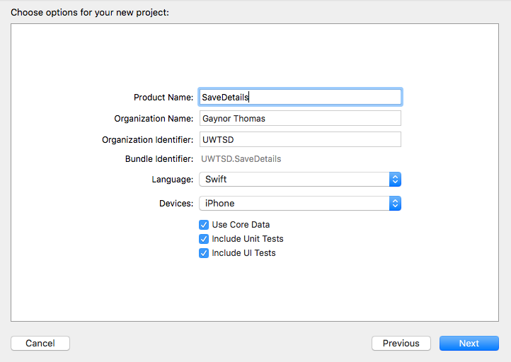

When you look at your project, you'll see that there is an extra file - .xcdatamodeld file.

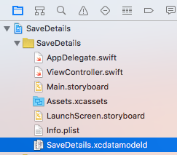

2. Imagine that we have an app, and we want to greet the user by name in it. We don't want to trouble the user to enter their name each time. So we want them to enter their name on the first run, and store it locally. Then we can retrieve it in the future and use it each time they run the app.

Set up a couple of labels and a text box:

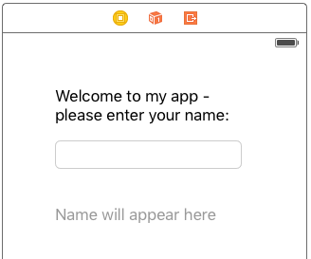

We will use the label at the bottom later, so make it hidden for now:

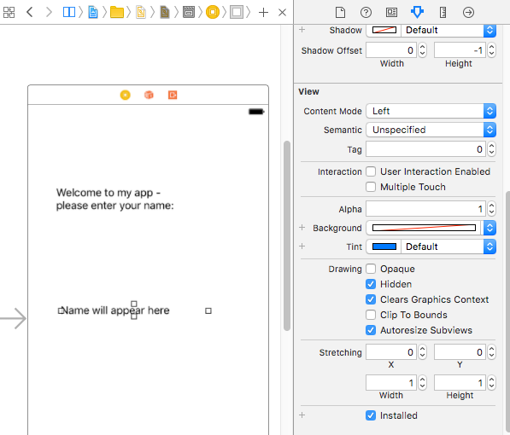

3. Put a Save button in as well:

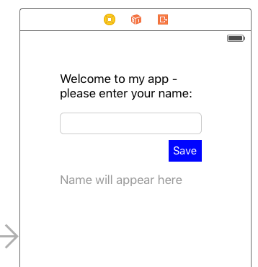

4. Link the two labels, the Save button and the TextField as outlets to the ViewController as usual:

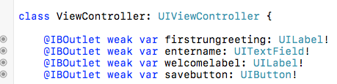

5. Next, we need to set up a place to save our data. Go to .xcdatamodeld file.

Add an entity and rename it "UserDetails"

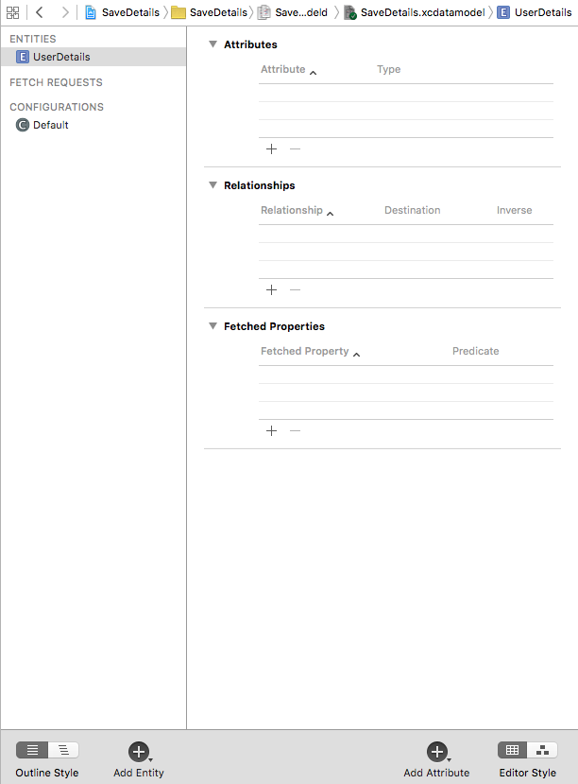

6. Next, add an Attribute (I've called mine username) and set it as a String. This is where our data will be stored.

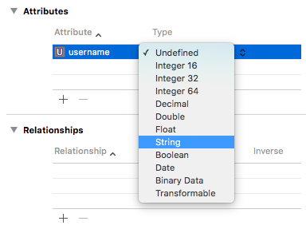

7.Next, go to Editor Create NSManagedObject Subclass…
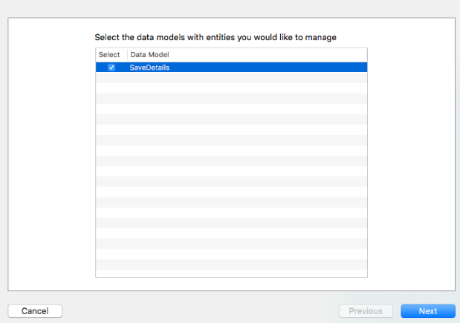

We only have one Entity (UserDetails) so tick it and hit Next:

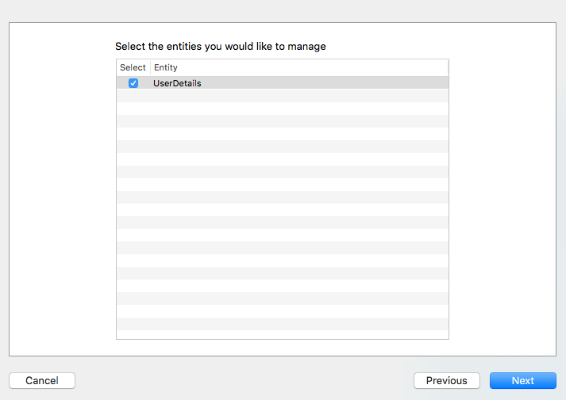

8. Click "Create"

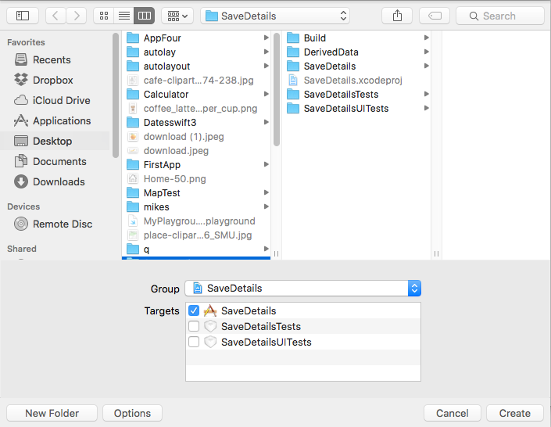

This creates two new files in our Project:

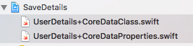

The properties one sets up the Attributes as NSManagedObjects (ie we can access them from code)

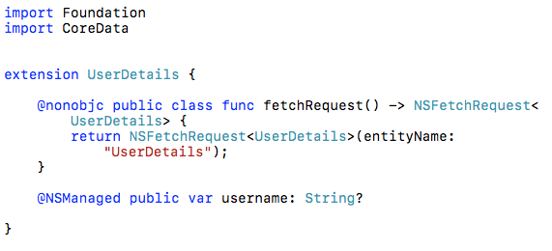

The other is a class for the Entity:
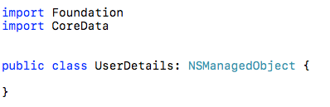

9. Set up an Action on the Save button:

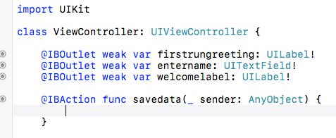

10. Now we will write the code required to save the text entered in the TextBox into our CoreData storage.

Add the following to the ViewController class in ViewController.swift:

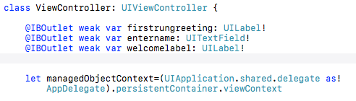

and add import CoreData at the top

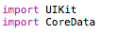

11. Now add to the savedata function as follows:

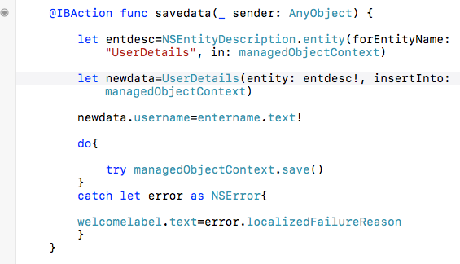
save the data in CoreData
get name entered by user from text box
newdata is object of UserDetails

We cannot actually see anything on the screen at this point but the data has (hopefully!) been saved. If you look on the Debug Navigator, you can see that the Disk is doing something when you press Save

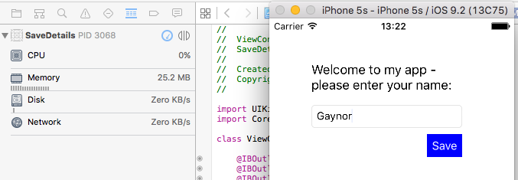

12. Now that the name is saved. When we load the app in the future, we want to check if there is a name there, and if it is, read it back.

We will do this on viewDidLoad() :

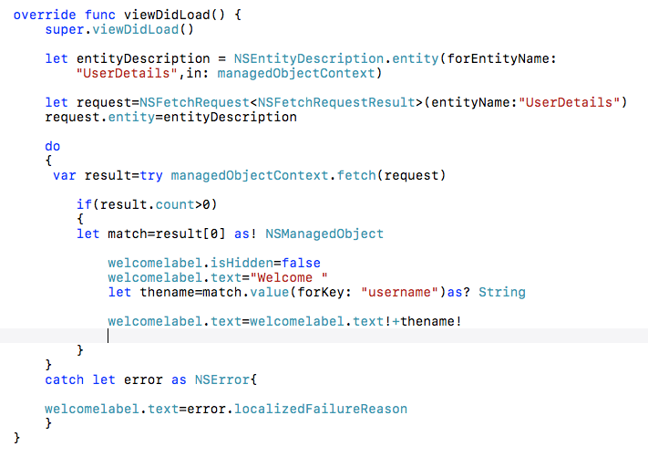
make welcome label visible
get username from the data
get first element from array (more on this later)
get data
specify entity we are using

Currently our app looks as follows:

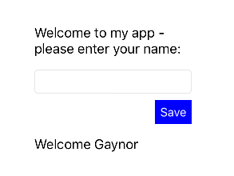

13. Obviously we don't need the textbox etc after the first run, so make them hidden if a name is found:

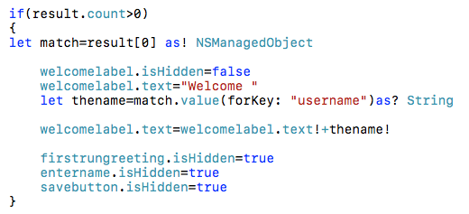

and tidy the app up a bit:

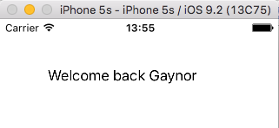

You may notice that if you tried adding a name a few times, only one is retrieved from result[0]. The rest have been placed in higher elements of an array.

NOTE: For testing purposes we may need to remove the data already stored. Make a Delete All button and attach the following code to it:

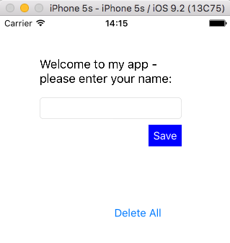

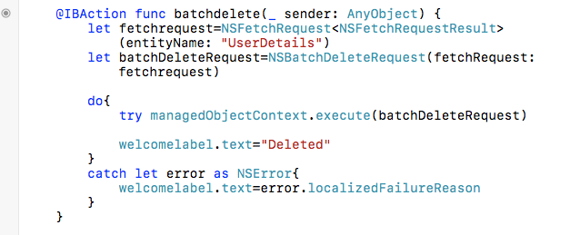

A bit of tidying up (make things visible/invisible where appropriate), and we're done.

