
Student name: | Zahraa bi | Student ID number: | 2419631
Programme: | Certificate of Higher Education Skills for the Workplace (Health & Social Care)
Module: | Introduction to Health and Social Care
Module code: | Debra Odeh | Contribution to Overall Module Assessment (%): | 50%
Lecturer: | Dr Raheela Sheikh | Internal Verifier: | Dr Besty Jose
Assignment Title: | Portfolio – Two Tasks | Word count (or equivalent): | 1,500 words Equivalent

Table of Contents
Introduction 3
Origins of the NHS 3
Present Organization and Operation. 4
Conclusion 4
References 5

Introduction
The National Health Service (NHS) is one of the greatest social reforms in British history created to provide free universal healthcare at the point of delivery. In this essay, the historical background of the NHS and its formation under the post war environment and its current organisation form and concerns is critically outlined. Its engagement with different perspectives highlights to the long-term principles of the NHS and how it dynamically can meet the current health demands.

Origins of the NHS
The development of the NHS in 1948 was informed by the post-World War II Britain socio-political intent on equality and welfare reform. In the Britain and Beveridge,Report (1942), the term disease was one of the five social evils which were to be eradicated and a fully-fledged system of health protection jointly funded by national insurance was proposed (Beveridge, 1942). Labor Health Minister Aneurin Bevan brought this vision to life with the National Health Service Act (1946) that created a tax-funded institution that provides healthcare to everyone, irrespective of their income (Ham, 2022).
Most importantly, the NHS was established during a period when professional associations, especially the British Medical Association (BMA), was against the idea of the state taking control of the practice of doctors (Klein, 2019). A political compromise by Bevan to have general practitioners (GPs) as independent contractors influenced the way the NHS was run in the decades to come (Gorsky, 2008). Universality, equity and free access, upon which the institution was based, were radical, defying class dichotomous differences in health. But researchers like Webster (2002) maintain the earlier allocation of resources had been biased to support hospital-based services at the expense of preventive community health, entrenching structural disparities that are still present. The NHS was, therefore, a political compromise as well as a social victory, a compromise of idealism and political realism.

Present Organization and Operation.
The NHS has developed to be a complex devolved system after having been a centralised one, and with the four countries of the UK, England, Scotland, Wales and Northern Ireland, having their own health policy (Greer, 2016). The Integrated Care Systems (ICSs) supervise NHS England national strategy, commissioning, and performance, which organize primary, secondary, and tertiary care (NHS England, 2022). These ICSs are designed to foster provider, local authority, and voluntary sector collaboration to enhance population health outcomes.
Primary Care provided by GPs, pharmacists, and dentists is a first point of contact at the operational level, with Secondary Care (hospital and specialist services) and Tertiary Care (highly specialized treatment) providing an increasing level of expertise (The King’s Fund, 2023). The NHS is challenged in profound ways, in spite of its vast reach. Importantly, long-term resource underfunding, shortage of workforce, and the ageing population have increased the pressure on resources (Buchan et al., 2017). The pandemic also highlighted system vulnerabilities, especially the integration of mental health and social care. More recent reforms, including the Health and Care Act (2022) seek to decentralize decision-making and promote so-called place-based care; however, critics believe that marketisation and outsourcing may compromise equity and continuity. Thus the complexity of the NHS structure that promotes flexibility results in disjointed service provision and unequal quality services across the regions.

Conclusion
Since the NHS began after the war as a token of social solidarity up to its current form as an enormous, decentralized network, the NHS has been a pillar of British welfare. Its founding principles of equality and universality remain intact but structural and fiscal pressures still threaten its survival. Balancing between the central control and local autonomy is needed not only to preserve its original ethos, but to address the demands of the 21st century.

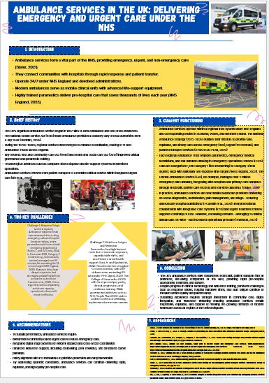

References
Buchan, J., Charlesworth, A., Gershlick, B. and Seccombe, I., 2017. Rising pressure: the NHS workforce challenge. Health Foundation, 17.
Britain, G. and Beveridge, W.H.B.B., 1942. Social insurance and allied services: Report. Macmillan Company.
Gorsky, M., 2008. The British National Health Service 1948–2008: A review of the historiography. Social History of Medicine, 21(3), pp. 437–460.
Greer, S.L., 2016. Devolution and health in the UK: Policy, politics, and outcomes. Policy Studies, 37(1), pp. 1–16.
Ham, C., 2022. Governing the health and care system in England.
Klein, R., 2019. The New Politics of the NHS: From Creation to Reinvention. 8th ed. London: CRC Press.
The King’s Fund (2023) Integrated care systems explained. [Online] Available at: https://www.kingsfund.org.uk (Accessed: 5 October 2025).
Webster, C., 2002. The National Health Service: A political history. 2nd ed. Oxford: Oxford University Press.
NHS England, 2022. What are Integrated Care Systems (ICSs)? [Online] Available at: https://www.england.nhs.uk/integratedcare/ (Accessed: 5 October 2025).

