Asthma Information Booklet

Name: Nabeela Begum
Student Number: 2216501
Module Name: Community Care and Management of Longer-term Conditions
Module Code: LCH7003
Assignment Title: Component 1 Information Booklet
Lecturer: Dr Aishat Bakre

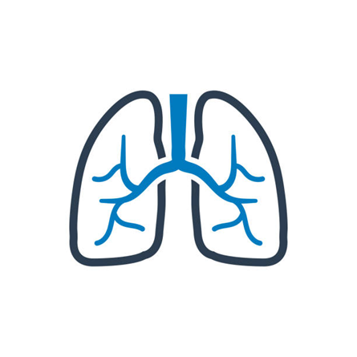
A Guide for Patients, Families and Carers in the UK
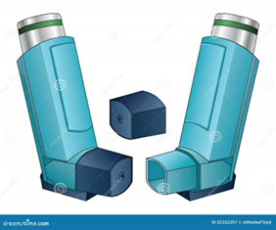

Contents Page:

Definition, Burden and Risk Factors………………………………………………..3-4
Impact of Asthma and Evidence-Based NHS Treatments………………………..4-6
Theoretical Perspectives and Models (UK and International)……………………6-8
Local and National Health and Social Care Agendas……………………………..8-9
Recommendations for Person-Centred Care and Self-Management……………9-11
Reference List………………………………………………………………………....12-15

DEFINITION, BURDEN & RISK FACTOR

Definition
Asthma is a long-term condition that affects the airways, the small tubes that carry air in and out of the lungs (Asthma and Lung UK, 2023). In people with asthma, these airways become inflamed and over-sensitive, sometimes tightening and producing extra mucus. This narrowing can cause wheezing, coughing, breathlessness, and chest tightness, which may come and go over time (Global Initiative for Asthma, 2024; National Health Service, 2025). Asthma can begin at any age, and while many people control it well with treatment, some experience ongoing symptoms or sudden flare-ups, known as asthma attacks (National Institute for Health and Care Excellence, 2024). The purpose of this booklet is to enhance understanding of asthma’s impact and to explore how evidence-based management, policy implementation, and patient-centred practice contribute to improved outcomes.
Burden and prevalence (Global and UK)
Asthma is a primary global health concern. It affects around 260–340 million people worldwide, making it one of the most common chronic respiratory conditions (Global Burden of Disease, 2020; World Health Organisation, 2023). Although most people live everyday lives with the correct management, asthma causes a large number of hospital admissions and preventable deaths, particularly in countries where access to inhalers is limited (Bloom et al., 2022).
In the United Kingdom, asthma remains a widespread condition. Approximately 5.4 million people are currently receiving treatment, including over one million children (Asthma and Lung UK, 2023; Office for National Statistics, 2024). The UK has one of the highest asthma rates in Europe. It records several hundred deaths each year, many of which are thought to be avoidable through better education, inhaler technique, and self-management (Royal College of Physicians, 2014). People living in deprived areas, those exposed to poor housing, cold or damp environments, and those living near heavy traffic or industrial areas are more likely to experience severe symptoms and hospital visits (UK Health Security Agency, 2024).
Aetiology (Causes) and Risk Factors
Asthma develops as a result of a combination of genetic, environmental, and lifestyle factors. Not everyone with the same risk factors will develop asthma, but specific influences increase the likelihood of symptoms or attacks (Dharmage et al., 2019).
Common risk factors include:
Studies show that genetics significantly influence susceptibility to asthma. Children with one or both parents who have asthma or allergic conditions such as eczema or hay fever are more likely to develop the condition themselves (Holloway et al., 2010; Martinez, 2016). This genetic predisposition is linked to immune system variations that lead to overreactive airway responses.
Environmental allergens are among the most well-documented risk factors. Exposure to house dust mites, pet dander, mould spores, and pollens can trigger airway inflammation in sensitised individuals (Defra, 2021). Continuous exposure may lead to persistent symptoms and increased medication use.
Respiratory viral infections, particularly in early childhood, are another major cause. Rhinovirus, respiratory syncytial virus (RSV), and influenza infections can damage airway tissue and promote chronic inflammation (Jackson et al., 2013). Children who experience severe viral wheezing episodes are at greater risk of developing long-term asthma.
Tobacco smoke, including both active smoking and second-hand exposure, is a strong and preventable risk factor. Cigarette smoke irritates the airway linings and reduces lung function, while passive exposure in the home increases asthma incidence in children by up to 50 per cent (UK Committee on Toxicity, 2020; Burke et al., 2012). Evidence also suggests that vaping aerosols can worsen asthma control in adolescents.
Obesity is another modifiable risk factor that has been linked to asthma in both adults and children. Excess body weight can reduce lung capacity and increase airway inflammation through hormonal and metabolic changes (Wills, 2021).
Psychological stress and poor mental health can exacerbate asthma by triggering airway constriction and increasing inflammatory responses (Lu et al., 2012). People with anxiety or depression are more likely to report frequent symptoms and poorer control.
Finally, certain medicines can trigger or worsen asthma in some individuals. Non-selective β-blockers, used for heart conditions, and painkillers such as aspirin or non-steroidal anti-inflammatory drugs (NSAIDs) may cause airway narrowing in sensitive patients (Nwaru, 2016; NICE, 2022). Patients should always inform healthcare professionals of their asthma before starting any new medication.
IMPACT OF ASTHMA
Physical Impact (Individuals and Families)
Asthma can have a significant physical impact on the person affected. Common symptoms such as wheezing, coughing, chest tightness, and shortness of breath can interrupt sleep, limit physical activity, and reduce energy levels (GINA, 2024). Severe or poorly controlled asthma may lead to exacerbations, where the airways become so narrow that urgent medical attention is needed (NICE, 2024). Over-reliance on a blue reliever inhaler can be a warning sign of poor control. In chronic or severe cases, long-term inflammation can cause permanent airway changes, known as fixed airflow limitation (Postma et al., 2015).
Family members and caregivers may also experience physical strain. Parents of children with asthma often lose sleep due to nighttime monitoring (Koinis-Mitchell et al., 2014). At the same time, adult carers may experience fatigue or stress-related symptoms due to the constant vigilance required to prevent attacks.
Psychological Impact (Individuals and Families)
Asthma affects both emotional well-being and physical health. Living with a long-term condition can cause anxiety about attacks, fear of breathlessness, and frustration over daily medication routines (Yorke et al., 2010). Children may feel embarrassed about using inhalers in front of their peers or anxious about participating in physical activities. Adolescents, in particular, can experience low self-esteem or denial, leading to missed doses and poor control (Lu et al., 2012).
Caregivers also face a psychological burden. Parents and family members often report chronic stress, hypervigilance, and feelings of guilt when a child’s symptoms worsen. Constant monitoring of medication schedules and symptoms can lead to emotional exhaustion and sleep deprivation. These effects can impact family dynamics, with stress sometimes leading to tension or anxiety in the household (Koinis-Mitchell et al., 2014). Recognising and supporting caregiver wellbeing is therefore essential to holistic asthma management.
Social Impact (Individuals and Families)
Asthma can also affect social life, relationships, and finances. Missed school days and time off work are standard, which can lead to educational or employment challenges (Sadatsafavi et al., 2014). Some families may struggle with additional expenses, such as travel to appointments, medication costs, and home environment modifications to reduce triggers like damp or mould.
The social burden also extends to caregivers, who may experience social isolation due to the need for constant vigilance, restricted travel, or disrupted routines (HSE, 2023). Parents often avoid social events or holidays for fear of flare-ups, especially if their child has severe asthma. For adults, the condition can impact career opportunities, particularly in workplaces where exposure to dust, chemicals, or stress exacerbates symptoms.
Evidence-based Treatments
Asthma treatment within the NHS follows a stepwise approach, as recommended by BTS/SIGN (2019), NICE (2024), and GINA (2024). The treatment plan is individualised based on symptoms and severity.
The NICE NG80 guideline, which has now been updated and replaced by NG245, provides a stepwise model tailored to symptom frequency and control, recommending initiation with low-dose inhaled corticosteroids (ICS) for mild persistent asthma, progressing to ICS/LABA combinations as symptoms worsen (NICE, 2024). For individuals with uncontrolled symptoms, NICE (2023) advises the use of long-acting beta-agonists (LABA) or leukotriene receptor antagonists (LTRA), or referral for biologic therapies (e.g., omalizumab, mepolizumab).
The Global Initiative for Asthma (GINA, 2024) adopts a similar approach, placing greater emphasis on as-needed low-dose ICS/formoterol as first-line therapy, even for mild asthma, to reduce the risk of exacerbations associated with the overuse of short-acting beta-agonists (SABA). This reflects a significant shift in global asthma management philosophy, recognising that airway inflammation is present even in mild disease (WHO, 2023). Both frameworks advocate regular monitoring, patient education, and personalised care plans, reinforcing shared decision-making between clinicians and patients.
Pharmacological Treatments
Asthma pharmacotherapy is divided into two categories: relievers (bronchodilators) and preventers (anti-inflammatories). Relievers, such as short-acting beta-agonists (SABAs), provide rapid symptom relief by relaxing airway smooth muscle, while preventers, such as inhaled corticosteroids (ICS), target inflammation to reduce the risk of long-term exacerbations (British National Formulary, 2024). Combination inhalers containing ICS/LABA improve adherence and are recommended for patients with moderate-to-severe asthma.
Biologic therapies, including anti-IgE (omalizumab) and anti-IL-5 agents (mepolizumab, benralizumab), have transformed the management of severe asthma that is unresponsive to conventional therapy (NICE, 2013). These treatments target specific inflammatory pathways, improving symptom control and reducing hospital admissions. However, they are costly and require assessment by respiratory specialists to ensure cost-effectiveness and appropriate use within NHS pathways (NHS England, 2023).
THEORETICAL PERSPECTIVES AND MODELS (UK AND INTERNATIONAL)
Understanding asthma through care models
The management of asthma, like many long-term conditions, benefits from structured frameworks that promote consistency, collaboration, and empowerment. Two of the most influential models guiding asthma care are the House of Care (HOC) model, used in the UK, and the Chronic Care Model (CCM), developed internationally. According to Coulter et al. (2013), both focus on improving quality of life, self-management, and the relationship between healthcare professionals and patients, but from slightly different perspectives.
The House of Care (HOC) (The UK Model)
NHS England developed the House of Care model to provide a person-centred structure for managing long-term conditions such as asthma. The model is based on the idea that effective care depends on several interlinked elements working together, like the parts of a house (NHS, 2014).
In the HOC model, the foundations represent the organisational systems that support the delivery of coordinated and evidence-based asthma services (The King’s Fund, 2013). These systems include electronic asthma registers, structured review processes, and an integrated IT infrastructure that enable consistent monitoring and follow-up across primary care.
National guidelines such as NICE (2024), BTS/SIGN (2019), and GINA (2024) are embedded within these frameworks to ensure that diagnosis, treatment, and review are based on current evidence. Commissioning arrangements, clinical governance, and data-led quality improvement programmes provide the structural stability needed for equitable and efficient asthma care (NHS, 2014).
The walls symbolise the collaborative relationship between healthcare professionals and patients. On one side, skilled professionals such as GPs, asthma nurses, and pharmacists provide education, medication reviews, and regular assessments. On the other hand, informed and engaged patients actively participate in self-management by following their Personal Asthma Action Plan (PAAP), attending annual reviews, and recognising early symptoms of deterioration (Pinnock et al., 2011). Through shared decision-making, both parties work in partnership to optimise control, prevent exacerbations, and maintain confidence in managing the condition (Coulter et al., 2013; NICE, 2021).
The model's roof represents the commissioning and leadership structures that ensure adequate resources, policies, and pathways are in place. Leadership from Integrated Care Systems (ICSs) and Primary Care Networks (PCNs) facilitates joined-up working between general practice, community pharmacies, and secondary care teams. These structures also support training, audit, and policy implementation in line with the NHS Long Term Plan (2019) and Core20PLUS5 framework, ensuring that asthma care is sustainable and inclusive. By linking clinical priorities with funding and strategic oversight, the roof ensures that services remain consistent, high-quality, and accessible to all populations (NHS England, 2021).
Together, these three elements of the House of Care create a cohesive framework for asthma management. The model transforms care from being reactive to proactive, ensuring that patients are supported, professionals are equipped, and the wider system is aligned to deliver continuous, person-centred asthma care across the NHS.

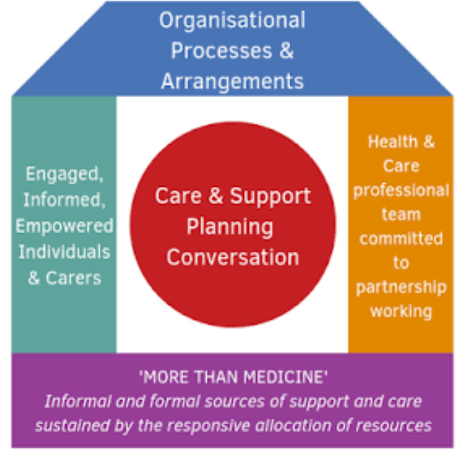
(Health and Social Care Alliance Scotland, 2023)

The Chronic Care Model (CCM) (The International Model)
The Chronic Care Model (CCM), developed by Wagner et al. (2001) in the United States, provides a global framework for improving outcomes in chronic disease management.
It identifies six essential components for effective care:

- Self-management support
- Decision support
- Delivery system design
- Clinical information systems
- Health system organisation
- Community resources
According to Grudniewicz et al. (2023), in asthma, this model emphasises proactive rather than reactive care. It encourages structured follow-ups, care coordination, and team-based practice, where nurses, pharmacists, and doctors each play a defined role. Decision support tools, such as NICE or GINA guidelines, help ensure that treatment follows best evidence. At the same time, information systems, like electronic asthma registers, enable clinicians to track trends, adherence, and risk (NHS Digital, 2024).
Modern developments in the Chronic Care Model (CCM) highlight the use of digital health tools such as remote monitoring and mobile apps to support asthma self-management. These technologies help track symptoms, improve adherence, and enhance communication between patients and clinicians. The CCM also aligns with NHS goals for data-driven, proactive care, using digital systems to identify patients at risk of poor control and improve long-term outcomes (Baiardini et al., 2022; NHS Digital, 2023).
The CCM also values community involvement, supporting outreach programmes, education campaigns, and local clean air initiatives that complement clinical care (WHO, 2023). By connecting the health system with community-level support, the CCM helps patients and families manage asthma more effectively at home.
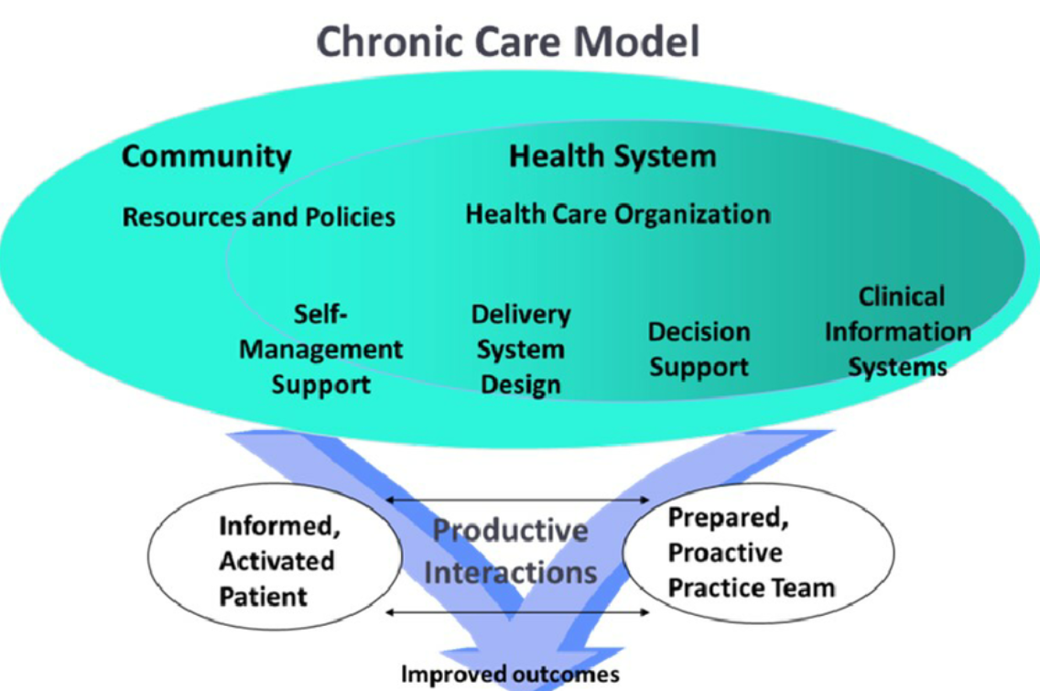
(Figure 1. The Chronic Care Model, 2024)
Comparing the models
Both the House of Care (HOC) and Chronic Care Model (CCM) offer complementary frameworks for effective asthma management. However, they differ in focus. The House of Care is more person-centred and tailored to the UK’s NHS context, with emphasis on shared decision-making and personalised care planning (Coulter et al., 2013). The Chronic Care Model offers a broader systems perspective, integrating data, multidisciplinary teams, and policy-level coordination (Wagner et al., 2001).
When applied together, these models create a balanced strategy that combines individual self-management with organisational coordination. This integrated approach enhances treatment adherence, reduces hospital admissions, and supports sustainable, equitable asthma care across both primary and community settings.
LOCAL AND NATIONAL HEALTH AND SOCIAL CARE AGENDAS
The policy background
Asthma care in the UK is shaped by a range of national and local health policies aimed at improving prevention, early diagnosis, and long-term management. These frameworks ensure that people with asthma receive consistent, high-quality care, regardless of their location (NHS England, 2019). They also encourage services to work together across health and social care, placing patients and families at the centre of decision-making.
National policies and strategies
The following are the key strategies, guidelines, and initiatives influencing asthma care today.
The NHS Long Term Plan (2019) sets out commitments to improve care for people with long-term conditions. It focuses on personalised care, digital access, and prevention, ensuring everyone has a shared decision-making plan and access to structured reviews.
The Quality and Outcomes Framework (QOF) provides incentives for GP practices to maintain asthma registers, review patients annually, check inhaler technique, and update Personal Asthma Action Plans (PAAPs) (NHS England, 2024).
The updated NICE (2024) asthma guideline replaces several previous NICE technology appraisals and diagnostics guidance documents. This unified asthma pathway brings together national recommendations for diagnosing, monitoring, and managing asthma in adults, young people, and children. It aims to improve diagnostic accuracy, support better asthma control, and reduce the risk of severe attacks through consistent, evidence-based care.
The National Review of Asthma Deaths (NRAD) highlighted that most asthma deaths are preventable, calling for improved inhaler technique checks, adherence monitoring, and communication between patients and clinicians (RCP, 2016; Levy, 2015).
The NHS Core20PLUS5 initiative (2021) targets health inequalities by improving access to care for deprived populations and those with additional vulnerabilities. This is especially relevant since asthma prevalence and mortality are higher in low-income and high-pollution areas (NHS England, 2021; PHE, 2019).
Environmental and sustainability agendas
Environmental policy has become increasingly linked to respiratory health. The Environment Act (2021) legally binds the UK government to reduce harmful air pollutants, such as nitrogen dioxide (NO₂) and particulate matter (PM₂.₅), which can worsen asthma (Defra, 2021).
The UKHSA (2023) indoor air quality guidance encourages local authorities, landlords, and healthcare teams to address damp and mould, key asthma triggers in homes.
The Greener NHS Programme (2023) promotes sustainable healthcare practices, such as reducing the environmental impact of inhalers. Dry-powder inhalers (DPIs) or soft-mist inhalers (SMIs) can sometimes replace traditional metered-dose inhalers (MDIs) if clinically suitable (NHS England, 2023). Patients are encouraged to discuss eco-friendly options during asthma reviews without compromising control.
Local implementation through Integrated Care Systems (ICSs)
At a local level, Integrated Care Systems (ICSs) bring together NHS organisations, local authorities, community services, and voluntary groups to plan and deliver joined-up asthma care (NHS England, 2022). The aim is to ensure that each community has consistent access to asthma reviews, diagnostic testing, and education programmes.
ICSs work with local Public Health teams and Primary Care Networks (PCNs) to:
- Promote early diagnosis and reduce emergency admissions.
- Run school and community awareness campaigns about triggers and inhaler use.
- Provide targeted support for deprived or high-risk families.
- Develop pathways for severe asthma services, linking GP practices to specialist hospital clinics.
These local systems enable professionals to easily share information and coordinate care across services, ensuring that patients receive timely reviews and consistent advice regardless of where they access support.
RECOMMENDATIONS FOR PERSON-CENTRED CARE AND SELF-MANAGEMENT (INCLUDING END OF LIFE CARE)
Person-centred care and shared decision-making
Asthma management is most effective when it is tailored to each individual and their unique needs. Person-centred care encourages patients and families to become active participants in managing the condition rather than passive recipients of care (Coulter et al., 2013; NICE, 2021). This means that healthcare professionals should begin by exploring what matters most to the patient, for instance, being able to sleep through the night, enjoy physical activity, or reduce hospital visits.
Shared decision-making ensures that treatment choices, inhaler preferences, and adherence issues are discussed openly so that patients fully understand their condition and the purpose of each medicine (Adams, 2007). This collaborative approach helps individuals recognise triggers, manage symptoms, and take ownership of their asthma.
A Written Personal Asthma Action Plan (PAAP) should always be agreed upon and regularly updated. This plan provides simple “traffic light” instructions explaining what to do if symptoms worsen and when to seek medical help (Pinnock et al., 2011). Copies should be shared with family members, carers, schools, and workplaces to ensure that everyone involved in the person’s care understands what actions to take.
The inhaler technique must be reviewed at every appointment to confirm that the patient is using their device correctly, as poor technique is a common cause of inadequate asthma control (Price et al., 2013). Preventer inhalers, such as inhaled corticosteroids or combination inhalers, should be taken consistently even when symptoms are absent to reduce airway inflammation and prevent exacerbations (BTS/SIGN, 2019).
Monitoring and Review
Patients should be encouraged to monitor their asthma by keeping a symptom diary or a peak flow record, which can help identify early signs of worsening control. Trigger avoidance is another essential component of care; healthcare teams should provide practical advice on reducing exposure to smoke, allergens, mould, and occupational irritants while promoting clean indoor air and healthy environments (RCP, 2016; UKHSA, 2023).
Lifestyle interventions such as gentle exercise, weight management, and a balanced diet can further improve lung function and overall well-being (Platts-Mills, 2021). In addition, mental health support should not be overlooked, as anxiety or depression can worsen asthma control, so clinicians should screen for emotional distress and refer for psychological help where appropriate (NICE, 2022).
Community pharmacists play a vital role in ongoing monitoring, providing Medicines Use Reviews (MURs) and New Medicine Service (NMS) consultations to reinforce adherence and identify issues with side effects or device handling (Royal Pharmaceutical Society, 2023). These initiatives align with the NHS's focus on person-centred, preventative care to reduce exacerbation rates and hospital admissions.
Empowering families and caregivers
Families and caregivers are central to asthma management and should be treated as active partners in care. Education for family members should include how to use inhalers correctly, recognise early warning signs, and respond to asthma attacks (Dharmage et al., 2019). Providing carers with clear, written emergency plans builds confidence and reduces fear during flare-ups. Involving caregivers in discussions about treatment and lifestyle adjustments can also improve adherence and shared understanding.
Caring for someone with asthma can be stressful, particularly when symptoms are unpredictable or severe. Healthcare teams should therefore recognise and address caregiver wellbeing by offering access to counselling, respite opportunities, or carer support groups (Asthma and Lung UK, 2023). This reinforces the importance of a family-centred approach, where both the person with asthma and their caregivers receive support for physical, mental, and social well-being.
Even with reasonable control, asthma can worsen suddenly, so families must know what to do in an emergency. Patients and carers should be able to recognise red-flag symptoms such as severe breathlessness, inability to speak complete sentences, or bluish lips, which indicate the need for immediate medical help (NICE, 2024). If symptoms do not improve after reliever use, emergency services (999) should be contacted without delay.
Integrating Palliative and End-of-Life Considerations
While most patients live well with asthma, a small proportion experience severe, treatment-resistant disease that can become life-limiting. Palliative care should be considered for individuals with frequent hospitalisations, severe breathlessness, or declining lung function. Integrating respiratory palliative care into MDTs ensures that patients receive compassionate, dignified support, including symptom control, psychological care, and advanced care planning (NICE, 2021).
Effective communication between clinicians, patients, and their families is crucial for aligning care goals and ensuring informed decisions. This aspect of care is often overlooked but reflects the highest standard of person-centred practice, respecting autonomy and quality of life even at advanced stages of disease.

Final message
Asthma remains one of the most prevalent long-term conditions in the United Kingdom and continues to place a significant burden on individuals, families, and the healthcare system. By understanding their medicines, following their action plan, and attending regular reviews, they can stay well and enjoy everyday life with confidence. If they ever feel unsure, they can contact their pharmacist, GP, or asthma nurse; help is always available. This booklet has demonstrated that effective asthma management requires more than pharmacological treatment; it demands an integrated approach that combines clinical excellence, patient empowerment, and health equity.

Reference List
Adams, R.J., Smith, B.J. & Ruffin, R.E. (2007) ‘Impact of asthma self-management education on morbidity’, Patient Education and Counselling, 68(2), pp. 141–150.
Asthma and Lung UK (2023) Asthma facts and statistics. Available at: https://www.asthmaandlung.org.uk/ (Accessed: 7 October 2025).
Bloom, C.I., et al. (2022) ‘Global asthma mortality and hospital admissions: trends, inequalities and unmet need’, Thorax, 77(4), pp. 365–373.
Baiardini, I., et al. (2022) ‘RAPP-Children: a new tool for assessing quality of life in patients with asthma and rhinitis’, Clinical & Experimental Allergy, 50(6), pp. 662-671.
British Thoracic Society / Scottish Intercollegiate Guidelines Network (BTS/SIGN) (2019) British guideline on the management of asthma: a national clinical guideline. Edinburgh: SIGN. Available at: https://www.sign.ac.uk/assets/sign158.pdf (Accessed: 1 October 2025).
Burke, H., Leonardi-Bee, J., Hashim, A. et al. (2012) ‘Prenatal and passive smoke exposure and incidence of asthma and wheeze: systematic review and meta-analysis’, Thorax, 67(11), pp. 941–948.
British National Formulary (BNF) (2024) British National Formulary – Asthma and Chronic Obstructive Pulmonary Disease. London: BMJ Group and Pharmaceutical Press. Available at: https://bnf.nice.org.uk/ (Accessed: 15 October 2025).
Coulter, A., Roberts, S. & Dixon, A. (2013) Delivering better services for people with long-term conditions: building the House of Care. London: The King’s Fund. Available at: https://www.kingsfund.org.uk/publications/delivering-better-services-people-long-term-conditions (Accessed: 10 October 2025).
Defra (2021) Environment Act 2021 (air quality provisions). Available at: https://www.legislation.gov.uk/ukpga/2021/30/contents/enacted (Accessed: 29 September 2025).
Dharmage, S.C., Perret, J.L. & Custovic, A. (2019) ‘Epidemiology of asthma in children and adults’, Frontiers in Paediatrics, 7, 246.
Global Burden of Disease Study (GBD) (2020) Global Burden of Disease Study — asthma estimates. Available at: https://ghdx.healthdata.org/gbd-results-tool (Accessed: 1 October 2025).
Global Initiative for Asthma (GINA) (2024) Global Strategy for Asthma Management and Prevention. Available at: https://ginasthma.org/2024-report/ (Accessed: 1 October 2025).
Grudniewicz, A. et al. (2023) 'Operationalising the Chronic Care Model with Goal-Oriented Care,' Patient, 16(6), pp. 569–578. https://doi.org/10.1007/s40271-023-00645-8.
Holloway, J.W., Yang, I.A. & Holgate, S.T. (2010) ‘Genetic susceptibility to asthma and allergy’, Clinical & Experimental Allergy, 40(8), pp. 1044–1053.
HSE (2023) Asthma at work — occupational asthma. Available at: https://www.hse.gov.uk/asthma/ (Accessed: 10 October 2025).
Jackson, D.J., et al. (2013) ‘Rhinovirus infections and childhood asthma’, Journal of Allergy and Clinical Immunology, 131(2), pp. 486–494.
Jenkins, C., Costello, J. & Hodge, L. (2004) ‘Aspirin-exacerbated respiratory disease’, BMJ, 328, pp. 434–436.
Koinis-Mitchell, D. et al. (2014) ‘Asthma, quality of life and family burden’, Journal of Asthma, 51(6), pp. 590–597.
Lu, Y. et al. (2012) ‘Asthma and anxiety/depression: a bidirectional association’, Journal of Epidemiology and Community Health, 66(7), pp. 650–656.
Levy, M.L. (2015) 'The national review of asthma deaths: what did we learn and what needs to change?' Breathe, 11(1), pp. 14–24. https://doi.org/10.1183/20734735.008914.
Martinez, F.D. (2016) ‘Early-life origins of chronic obstructive and allergic airway disease’, Journal of Allergy and Clinical Immunology, 138(1), pp. 16–27.
National Health Service Digital (2024) Quality and Outcomes Framework (QOF) data – Asthma. Available at: https://digital.nhs.uk/data-and-information/publications/statistical/quality-and-outcomes-framework-achievement-prevalence-and-exceptions-data/ (Accessed: 8 October 2025).
NHS England (2014) House of Care – building blocks for personalised care. Available at: https://www.england.nhs.uk/publication/house-of-care/ (Accessed: 8 October 2025).
NHS England (2019) The NHS Long Term Plan. Available at: https://www.longtermplan.nhs.uk/publication/nhs-long-term-plan/ (Accessed: 1 October 2025).
NHS England (2021) Core20PLUS5 – reducing health inequalities. Available at: https://www.england.nhs.uk/about/equality/equality-hub/core20plus5/ (Accessed: 10 October 2025).
NHS England (2022) Personalised care: shared decision making. Available at: https://www.england.nhs.uk/personalisedcare/shared-decision-making/ (Accessed: 17 October 2025).
NHS England (2023) Delivering a Net Zero NHS: inhaler sustainability and patient choice. Available at: https://www.england.nhs.uk/greenernhs/a-net-zero-nhs/ (Accessed: 17 October 2025).
NHS England (2025) Asthma. Available at: https://www.nhs.uk/conditions/asthma/ (Accessed: 25 September 2025).
National Institute for Health and Care Excellence (NICE) (2024) Overview | Asthma: diagnosis, monitoring and chronic asthma management (BTS, NICE, SIGN) | Guidance | NICE. Available at: https://www.nice.org.uk/guidance/ng245 (Accessed: 21 September 2025).
NICE (2013) Omalizumab for treating severe persistent allergic asthma (TA278). Available at: https://www.nice.org.uk/guidance/ta278 (Accessed: 10 October 2025).
NICE (2021) Shared decision making (NG197). Available at: https://www.nice.org.uk/guidance/ng197 (Accessed: 5 October 2025).
NICE (2022) Depression in adults: treatment and management (NG222). Available at: https://www.nice.org.uk/guidance/ng222 (Accessed: 15 October 2025).
NICE (2023) Tezepelumab for treating severe asthma (TA880). Available at: https://www.nice.org.uk/guidance/ta880 (Accessed: 11 October 2025).
Nwaru, B.I. et al. (2016) ‘Overuse of short-acting β2-agonists and risk of exacerbations in asthma’, European Respiratory Journal, 47(6), pp. 1736–1744.
Office for National Statistics (ONS) (2024) Deaths registered involving asthma – England and Wales. Available at: https://www.ons.gov.uk/ (Accessed: 29 September 2025).
Public Health England (PHE) (2019) Health matters: air pollution. Public Health England. Available at: https://www.gov.uk/government/publications/health-matters-air-pollution/health-matters-air-pollution (Accessed: 27 September 2025).
Pinnock, H. et al. (2011) ‘Systematic review of personalised asthma action plans’, Primary Care Respiratory Journal, 20(1), pp. 9–23.
Platts-Mills, T.A.E. et al. (2021) ‘Indoor allergens and asthma development’, Journal of Allergy and Clinical Immunology, 148(1), pp. 1–12.
Postma, D.S. et al. (2015) ‘Fixed airflow limitation in asthma: mechanisms and implications’, Lancet Respiratory Medicine, 3(4), pp. 347–355.
Price, D. et al. (2013) ‘Inhaler competence in asthma: common errors and training implications’, NPJ Primary Care Respiratory Medicine, 23, pp. 141–146.
Royal College of Physicians (RCP) (2016) Every breath we take: the lifelong impact of air pollution. London: RCP. Available at: https://www.rcplondon.ac.uk/projects/outputs/every-breath-we-take-lifelong-impact-air-pollution (Accessed: 11 October 2025).
Sadatsafavi, M. et al. (2014) ‘The economic burden of asthma’, Allergy and Asthma Proceedings, 35(6), pp. 406–412.
The King’s Fund (2013) 'Supporting people with long-term conditions: what is the house of care? ', 2 October. Available at: https://www.kingsfund.org.uk/insight-and-analysis/blogs/supporting-people-with-long-term-conditions-care (Accessed: 17 October 2025).
UK Committee on Toxicity (COT) (2020) Health effects of e-cigarettes – respiratory considerations. Available at: https://www.gov.uk/government/publications/e-cigarettes-health-risks-of-vaping/ (Accessed: 1 October 2025).
UK Health Security Agency (UKHSA) (2023) Indoor air quality, damp and mould: health risks and actions. Available at: https://www.gov.uk/government/publications/indoor-air-quality-damp-and-mould-health-risks-and-actions (Accessed: 15 October 2025).
Wagner, E.H., Austin, B.T. & Von Korff, M. (2001) ‘Organising care for patients with chronic illness’, Milbank Quarterly, 79(4), pp. 579–612.
WHO (2023) ‘Asthma: key facts’. World Health Organisation. Available at: https://www.who.int/news-room/fact-sheets/detail/asthma (Accessed: 7 October 2025).
Wills, T.A., Soneji, S.S., Choi, K. & Jaspers, I. (2021) ‘E-cigarette use and respiratory symptoms in adolescents’, Chest, 159(1), pp. 197–205.
Yorke, J., Fleming, S.L. & Shuldham, C. (2010) ‘Psychological interventions for adults with asthma: a review’, Chronic Respiratory Disease, 7(4), pp. 213–220.

