Title
Dissertation Proposal

Name: Jason Kostromin
Student Number: P151355
Course title:
BA (Hons) Photography in the Arts
Word count: 1933
Tutor's name: Paul Duerinckx
Introduction

In this dissertation proposal I will explore 3 keywords or themes that I can apply to my dissertation in my final year. The 3 topics that I have identified are social identities, control of individuals through technology and sociology of social media. I will briefly analysis each keyword and explain the direction of my interest of the keyword to move carry forward for deeper analysis and critic within my dissertation.

Social Identities

Social identity theory:

“Tajfel and Turner social identity theory explains that part of a persons concept of self comes from the groups to which that person belongs. An individual does not just have a personal self hood, that multiple selves and identity is associated with their affiliated groups. A person may act differently in varying social contacts according to the groups they belong to, which might include the sport team they follow, their family, their country of nationality, and the neighbourhood they live in, among many other possibilities.” (David, 2015)

A person’s identity can change with whatever group they become part of they are moulded by the personalities and culture that exists within that group that they choose to belong to. This means a person will have multiple identities in the different groups that they belong to and a person groups will normally change over time. An example of this, is a person who’s profession is in the banking sector will change character while socialising with work colleagues after work then will act differently when he goes to a football match with his old school mates.



(Dreamtime, 2018)
(Back, 2018)
Within society we naturally form groups to socialise in. Within our lives we connect with multiple groups, like sports groups, family groups, social groups and work groups. We also change groups during our life due to different circumstances like marriage, having children, losing or gaining weight.

Social identity theory can be very positive for us, as an individual being part of a group can make you feel good because of positive feedback from the group, a sense of belonging, your mind being occupied by the positive network you are surrounded by.
Although on the negative side of this theory, is that groups can give you a false sense of confidence outside of the group and other people that are not part of that group may not be so praising with there words.

Within society we naturally form groups to socialise in. You have in groups and out groups. An example of this is, two rival cycling groups in the same area, if you belong to one that would be an in group and within this group everyone exaggerates how much better their group is than the rival group. People in the in group praise each other and this shows loyalty to the group which enhances the group as a whole, they always talk positive about their group and talk negative about the out group.



(Cafeteros Cycling club, 2018)
(Swansea Wheelers Cycling Club, 2014)
When the individual is outside of the group their confidence may be lower and they may not be as good as they think because there in group has exaggerated their performance and praises. Also if you become friends with someone from the out group you could be outside from that social circle the in group.
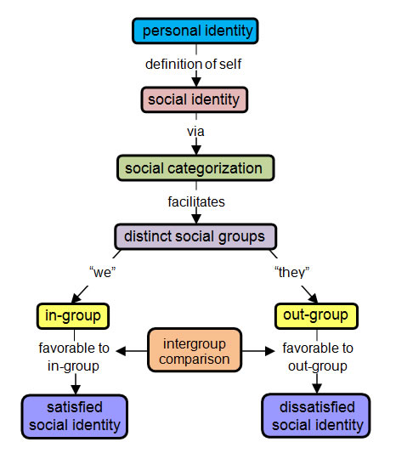
In my practical work I have followed the work of Cindy Sherman and have created multiple different identities of myself through my photographic practise.

I will use this diagram to act as a framework for my dissertation in the keyword social identity. Respond to my dissertation proposal question I will analyse all the categories and there impact on our lives.
(Age-of-the-sage.org, 2018)

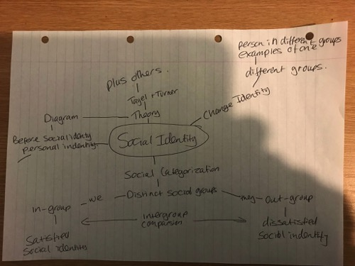
This is an initial brainstorm that I have created to highlight the areas of investigation for my dissertation.

Control of individuals through technology
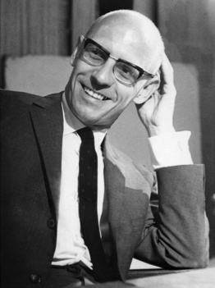
In this section I will look at how surveillance through technology changes ones behaviour. One of the first theorists to analyse this theory was Michel Foucault, he developed a theory around surveillance called disciplinary power.
(Totally Histories, 2018)

“Disciplinary power (surveillance) is now everywhere and everyone is subjected to it, most of the examples are the use of CCTV in public spaces; but disciplinary power is also at work, in schools through the use of electronic registers and reports, we can see it in workplaces through the use of performance monitoring and we can even see it in our personal lives, both pregnancy and childhood are highly monitored by the healthcare professionals and social workers for example, and most of us just except this as normal.” (Thompson, 2018)

Foucault was one of the first theorists to develop a theory about surveillance, this theory was developed to watch the public as a whole in built-up areas of cities and towns through the use of CCTV. Technology has advanced to such a degree that we now carry personal technology devices that allows us to be watched within our everyday lives.
(Colourbox, 2018)

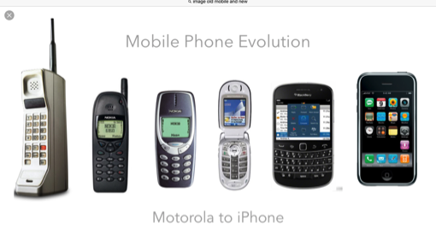
The most used technological device is the mobile phone and it is used worldwide. The mobile phone was initially used for making phone calls to and from people close to you and many started using the mobile phone in case of an emergency. Mobile phones have developed very gradually and now have become pocket computers that we have all got used to slowly over time and are now the norm.
(Mazedon, 2018)
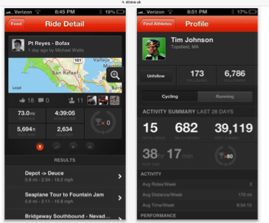
The use of the simple mobile phone has changed it is no longer just used for just a conversation or simple text we will use it in our everyday lives and download apps, for example, cyclists use an app called Strava, that monitors your speed, heart rate and the places on the map where you have been, this information is then stored on the app on the leaders board.
(Erneut Sicherheitsprobleme mit Strava, 2018)


There are also very good cameras built-in to these phones which when you take a photograph they also take the GPS reading of where the picture was taken.
(Friedl, 2018)

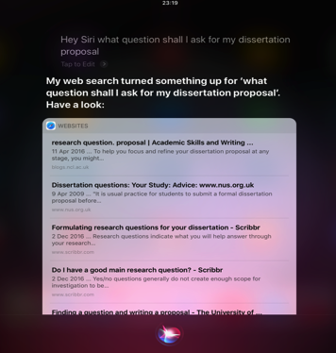
There is also a listening device called Siri on the Apple phone, this application listens out for keywords and will respond with answers to your questions. Siri is also listening to any conversations that you have with someone while you have your phone on you, there is every possibility that you can be listened to by the state.
(Siri, 2018)

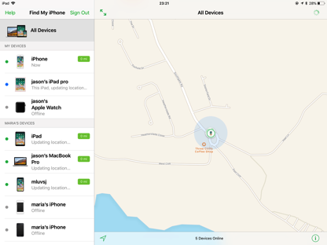
With so many different applications and tools on the phone now, they can be very easily tracked or hacked by the state or a third party, for example, if you committed a crime and you speed off in your car, you could be tracked through GPS on your phone to alert the authorities of your location.
(Find Friends, 2018)

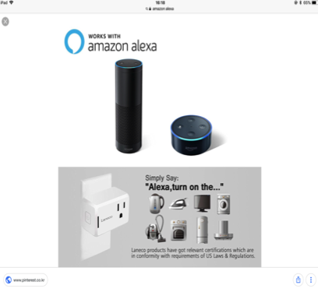
Technology in personal surveillance has increased dramatically in the last few years we have been blinded by the benefits of technology devices and we do not concentrate on the fact that we can be listened to 24 hours a day seven days a week within the our personal homes. These devices go from applications within our mobile phones, computers, iPads with applications like Siri, to music speaker devices like Amazon echo with the application of Alexa. Alexa has been widely advertised on the television to help us in our daily lives, with such a range of purposes. So the companies have been very clever in advertising this gadget, as the latest must have device to have in your household at the moment. When people purchase this speaker they are blinded by the positive interactions that this application can provide and people fail to realise the full implications of the device and its ability to listen to you 24 hours a day seven days a week in your own personal space.
(Pinterest, 2018)
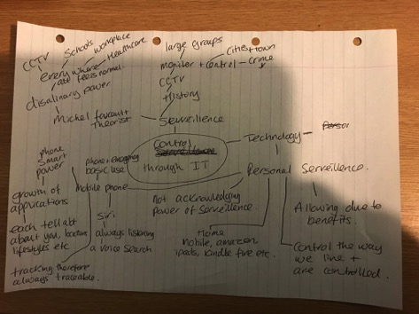
I have interest in the surveillance state and its affect on individuals, I have outlined areas of this within my site specific exhibition and in my creative research assignment. Within my dissertation I will look at how these technological gadgets will have control over the way we live and us giving consent to be watched in our every day lives. I have completed an initial brainstorm ready for my dissertation.

Sociology of social media
“Websites and other online means of communication that are
used by large groups of people to share information and to develop social and professional contacts”
(dictionary.com, 2018)

Social media is an online virtual space that allows people to share information about themselves to an audience of there choosing. Social media is accessed from websites and applications on your mobile phone, notebook or computer. Social media started many years ago with basic websites like Bebo that was mainly used by the young and has evolved to well known websites like Facebook, Twitter and Instagram. It is extremely rare to come across someone that has never or does not have a social media account.
(Mishra, 2018)
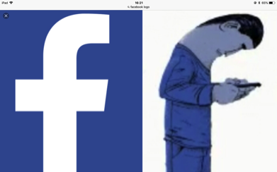


(Langshaw, 2018)

User sign up to social media sites for various initial reasons, such as to communicate with others, to be part of the online community, ensuring they are not left out and to share information about there own lives.

In my dissertation, I would like to analyse the impact that social media has on its users, I will look at the initial positive reasons then go into looking at symbolic interactionists, conflict theory and dysfunction theory.

Most users sign up to Facebook, as they will feel it will be positive to their lives and a place they can share positive experiences that happen throughout life. This gives the user self confidence and reassurance of who they are within their online groups.

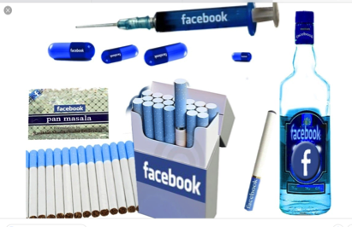
When users sign up to social media sites they miss calculate how the use of the site will impact their lives. Many users become addicted to going onto the social media site as they do not want to miss out on any information or they want positive feedback on their shared information that they have posted. By being addicted to checking your social media site a persons concentration becomes fragmented, therefore you are unable to fully concentrate on other tasks that need to be completed, an example of this is, as I am doing this work my mobile phone is constantly flashing and pinging to get my attention that I have Facebook messages. My mind will not switch off to the alerts until I have read the incoming alerts, therefore it is a distraction from the work required.

Once a person becomes addicted to a social media website or application it can then have a negative affect on a persons mind, this can range from feelings of loneliness to bullying this can then lead to anxiety and depression.
(Yildirimturk, 2018)

This area is of great interest to me, I enjoy learning about its effects on our lives, and it is also very current. In my dissertation I will analyse the effects that social media has on a person both positive and negative and how it effects and controls a persons behaviour.
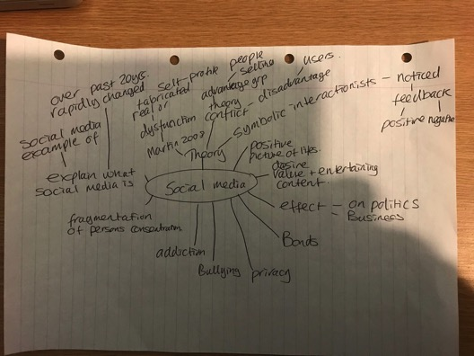
This is a brainstorm that I have created to outline the areas to be explored within my dissertation.

Conclusion
I have great interest in all three topics within this proposal and would like to further investigate the topics within my dissertation. I would like to direct the chosen topics to show how they have an effect on our daily lives and change the way we live and think. I have included my initial brainstorming maps to show the areas of interest going forward into my dissertation and hope to further elaborate on these when investigating my dissertation. Through careful analysis of my chosen topics and direction I would like to investigate, I have decided on the following question for my dissertation:

“How are we moulded as individuals through society and the impact that developing technology and social media has on us”

REFERENCE LIST
- Age-of-the-sage.org. (2018). Social Identity Theory - Tajfel and Turner 1979. [online] Available at: http://www.age-of-the-sage.org/psychology/social/social_identity_theory.html [Accessed 7 May 2018].
- Back, S. (2018). England football fans drinking beer and cheering at a pub in Brighton during the World Cup 2010. [image] Available at: https://www.alamy.com/stock-photo/england-football-fan-drinking-beer.html [Accessed 6 May 2018].
- Colourbox (2018) CCTV Camera or surveillance operating on street and building at night. (2018). [image] Available at: https://www.colourbox.com/image/cctv-camera-or-surveillance-operating-on-street-and-building-at-night-image-11946844 [Accessed 6 May 2018].
- Cohn, J. (2018). Sociology and Social Media. [online] CompuKol Communications. Available at: https://www.compukol.com/sociology-and-social-media/ [Accessed 6 May 2018].

- David L. (2015). Social Identity Theory (Taifel, Turner). [online] Learning Theories, https://www.learning-theories.com/social-identity-theory-tajfel-turner.html. [Accessed 6 May 2018].

- Dictionary.com. (2018). the definition of social media. [online] Available at: http://www.dictionary.com/browse/social-media [Accessed 7 May 2018].

- Dreamtime (2018). Young office workers toasting with beer at pub. [image] Available at: https://www.dreamstime.com/royalty-free-stock-photo-young-office-workers-toasting-beer-pub-group-happy-clinking-looking-each-other-smiling-image40069545 [Accessed 6 May 2018].
- Erneut Sicherheitsprobleme mit Strava. (2018). [image] Available at: http://ralfs-technik-kiste.de/erneut-sicherheitsprobleme-mit-strava/ [Accessed 6 May 2018].

- Foucault, M. (1991). Discipline and Punish. 2nd ed. London: Penguin Books.
- Friedl, J. (2018). Accessing Yahoo! Maps from Adobe Lightroom. [image] Available at: http://regex.info/blog/2007-12-22/667 [Accessed 6 May 2018].
- Gaitho, M. (2018). What is the real impact of social media?. [online] Simplilearn.com. Available at: https://www.simplilearn.com/real-impact-social-media-article [Accessed 6 May 2018].
- GETTI (2018). Wetherspoons is to close all its social media accounts with immediate effect. [image] Available at: https://www.express.co.uk/news/uk/946628/Pub-chain-Wetherspoons-shuts-down-all-social-media-accounts [Accessed 6 May 2018].

- Heywood, A. (2017). Political ideologies. 6th ed. [Place of publication not identified]: Palgrave macmillan.
- Langshaw, M. (2018). Bebo founder Michael Birch resumes ownership of service. [image] Available at: http://www.digitalspy.com/tech/news/a494890/bebo-founder-michael-birch-resumes-ownership-of-service/ [Accessed 6 May 2018].
- Mishra, R. (2018). Facebook logo’s true meaning will freak you out!. [image] Available at: http://www.india.com/buzz/facebook-logos-true-meaning-will-freak-you-out-897784/ [Accessed 6 May 2018].
- Mazedon (2018). Motorola to iPhone. [image] Available at: http://www.blog.mazedon.com/phone-evolution-001/ [Accessed 7 May 2018].
- pinterest (2018). Works with Amazon Alexa. [image] Available at: https://www.pinterest.co.uk/pin/829295718854971850/?autologin=true [Accessed 6 May 2018].
- Sociologyguide.com. (2018). Sociology of Social Media. [online] Available at: http://www.sociologyguide.com/sociology-of-social-media/ [Accessed 6 May 2018].

- Steyerl, H. (2018). DUTY FREE ART. 1st ed. [S.l.]: VERSO BOOKS.

- Thompson, K. (2018). Foucault – Surveillance and Crime Control. [online] ReviseSociology. Available at: https://revisesociology.com/2016/09/21/foucault-surveillance-crime-control/ [Accessed 6 May 2018].

- Totally History. (2018). Michel Foucault Biography - Life of French Philosopher. [online] Available at: http://totallyhistory.com/michel-foucault/ [Accessed 6 May 2018].
- Vaughan, G. (2018). Henri Tajfel | Biography, Theories, & Facts. [online] Encyclopedia Britannica. Available at: https://www.britannica.com/biography/Henri-Tajfel [Accessed 5 May 2018].
- Yildirimturk, H. (2018). Social Media Becoming An Addiction?. [image] Available at: https://www.affordablewebdesign.com/social-media-becoming-an-addiction/ [Accessed 7 May 2018].

