

BMSW4001_BIRM
Academic and Employability Skills
Task 1 – Academic writing

Contents
Task 1 - Academic Report 3
Introduction 3
Different ways of motivating employers 4
Pay 5
Recognition and awards 6
Additional holiday 8
Good working condition 8
Conclusion 10
References 11

Introduction
Employee motivation is considered as an intrinsic and internal drive to take necessary actions and efforts that can aid in getting work-related activities done (Bertelsen, 2020). In an organisation, the psychological forces that determine the employer’s level of effort, behaviour and persistence, willingness to expend energy to achieve organisational goals is known as employer’s motivation. Success in the workplace depends on motivated employers and motivation can be created in the employers through various things. This report intends to discuss different ways of motivating the staff. Having a clear understanding of what drives the motivation of each employer is critical in the organisation.

Different ways of motivating employers
Every employer in organisational is different and they are motivated by different factors. It is vital to balance the motivations of the diverse team to achieve the best results through the employers. Every entrepreneur and business leader needs to be able to balance the motivations of the employers by having deep insights about the ways that can aid in driving the motivations of the employers. Brandon Lewis, President of Lewis Revenue Group has stated that every individual is different and different things motivate them (Baňka and Jamdagni, 2021). He has stated that the first step the business leaders can take to motivate their team effectively is to get a deep understanding of every employer in the team and get insights about the things that make them tick and feel good about work. Then the leaders need to leverage the findings to create a strategy that can motivate the employers to do great work. Performance and great work of the individual are directly linked with the organisational environment that motivates its employers through every aspect possible (Fargus, 2021).
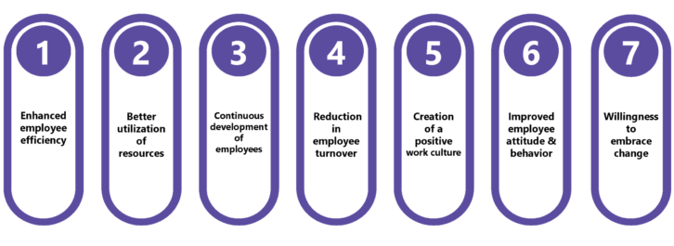
Figure 1: Benefits of employee motivation (Grant, 2022).
According to Smith and Rupp (2003), in a complex and dynamic environment, employee motivation, organisational structure, resistance to change, trustful relationship, employee empowerment, organizational strategy play an empirical role in enhancing organisational performance. In terms of building strong relationships, Orpen (1997) has stated that the better the relationship between the leaders and employers’s the more the employers feel motivated to work hard and committed to their organization (Demmke, Hammerschmid and Meyer, 2008). Luthans and Stajkovic (1999) have stated different types of things that also help to motivate the employers and make them more committed and the things include advancement of human resources through providing monetary incentives, rewards and setting modified organizational behaviour (Harrison, Soars and Soars, 2018). Some of the other ways of motivating employers are as follows.

Pay
Pay is an important general motivator that enhances organisational performance. Salary of the employers and motivation goes hand in hand. Because good salary helps the employers to meet their basic needs which allow the employers to engage more in their organisational work (Philpot, Curnick, Soars and Soars, 2013). Indeed, after conducting the first meta-analysis of motivational interventions, it has been proven that pay is the most effective motivator. According to Locke, Feren, McCaleb, Shaw, and Denny (1980), pay is the crucial incentive that is high in its instrumental value and no other motivational technique or incentive can even come close to this about increasing employee motivation (O'Boyle, 2017). Likewise, Malina and Selto (2001) have also conducted a case study in a corporate setting about the positive motivation of employers by using the balanced scorecard (BSC) method (Janson, 2020). In the case study, it has been found that good pay is a positive motivation that provides greater organisational outcomes. This factor can be linked with Maslow's theory in which the hierarchy of needs of the employers has been provided in a pyramid shape. According to Maslow's theory, the basic needs of employers need to be met to enhance organisational performance.
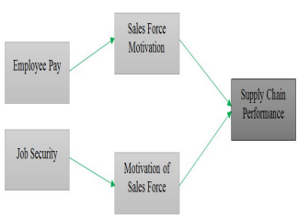
Figure 2: Payment influences sales force motivation (Simonson, 2020).
An individual can only move on to addressing the higher-level needs after their basic needs are met and the basic needs of the employers can be met by providing standard pay. Individuals' Physiological needs can be met through quality payment (Post and Koenders, 2019). Food and water, clothing and shelter, sufficient rest, overall health are the most basic human survival needs that can be adequately fulfilled if employees are given appropriate pay. After meeting the basic needs employers can feel the motivation to work harder for the organisation as the organisation is taking care of the individual’s basic needs. Besides workers are more likely to perform according to their potential if they are happy with the payment they are receiving. Individuals receiving high compensation feels the urge to please the employer to retain the position or even get the higher position to get a higher payment.
According to the research conducted by ADP, the UK workforce is more motivated by pay rather than any other country in Europe. ADP surveyed 2000 workers across Italy, Germany, France, Netherlands, and the UK that revealed that about 62% of UK employees have stated that pay is the primary reason that motivates them to go to work. In other European countries, it has been found that about 49% of the employees are motivated by payment (Vinten, 2022). Individuals who are paid highly are more satisfied with the organisation and are highly engaged with the organisational goals. The behaviour of the employees can also be driven through high-level payment. Goal-directed behaviour is expected by providing expected payment to the employees which can aid in enhancing organizational performance. However, studies have found that the power of pay to motivate employees ends very quickly. Some studies say after a week an employee receives the payment, the motivation ends. The studies have shown that the prospect of receiving money is a strong motivator in terms of changing the behaviour of the employee but pay itself is not enough as employees require to be recognized, contribute to the team and develop their skills.

Recognition and awards
According to Candi et al. (2013), the employee wants recognition for their contribution in the workplace and this is why growing recognition of the opportunities need to be created. Recognition and awards enhance the motivation of the employees highly and they’re level of wiliness to work harder. The productivity and performance of the employees can be increased dramatically by providing recognition to the employees in the workplace. Recognizing the employee's work all the time rather than just working for the first time ultimately reinforces the behaviour of the employee. Confronting to Mahazril et al. (2012), awards and recognition increase employee motivation. He also added communication with the process that is also relatable as good communication helps the employee to understand the different organisational projects better. Easy comprehension then leads to motivating the employers to get their work done. Moreover, providing recognition and awards to their contribution also enhance their self-esteem, confidence, engagement and motivation to work harder on the next project.
Fredrick Herzberg-Hygiene Theory can be linked with the recognition and awards of the factors that influence employee motivation. Frederick Herzberg has carried out research to determine the factors that satisfy and dissatisfy the employees (Bertelsen, 2020). In his studies, the main factor that contributes to employee motivation is recognition, awards, achievement, growth, advancement, responsibility and the work itself. These factors are the result of the employee completing their task successfully and then receiving self-motivation which helps them to be more engaged and increases the organisation's performance. Frederick Herzberg has also researched the hygiene factors that do not motivate employers but the absence of these factors shows dissatisfaction in the employers. The hygiene factors include salary, peer relations, supervisor quality, policies and rules, working conditions and job security. Uzonna (2013) has expressed worry that money is thought to be the only motivating factor but money alone cannot provide enough incentive to motivate employees (Baňka and Jamdagni, 2021). Awards and recognition drive employee motivation at a fast pace. This, therefore, indicates that the organisation needs to look beyond pay, wages and money and include recognition and different awards to motivate the employees to work hard to achieve organisational goals.
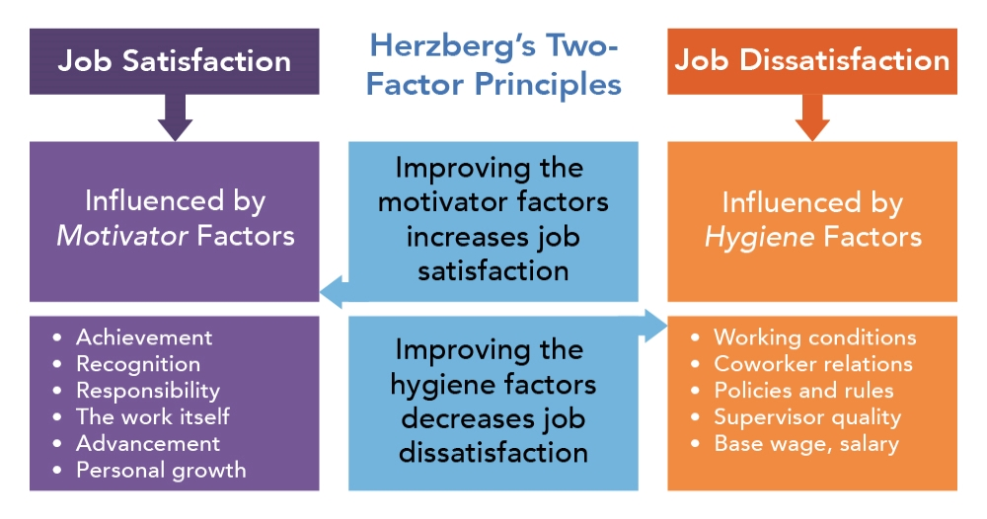
Figure 3: Fredrick Herzberg-Hygiene Theory (O'Boyle, 2017).
In terms of awarding or recognizing the employees, there is not much need to be done. A simple thank you or well done can help to motivate the employees to a great extent. However, if the employees bring success to the organisation then recognising and acknowledging the hard work of the employees is a must. Besides, the employees can also be provided with rewards, promotions, appreciation, monetary incentives or more can be provided so that not only the particular employee who succeeded get motivated but also other employees can get the motivation of being rewarded and work harder (Demmke, Hammerschmid and Meyer, 2008).

Additional holiday
It is crucial to provide additional holidays to employers. There is a wide range of benefits of providing additional holidays in terms of motivating employers. The engagement of the employers can be increased and as the disengaged employers cost money, organisations need to provide different facilities in the additional holidays (Fargus, 2021). Besides, the human body is programmed in a way that can not handle stress greater than its peak amount (Janson, 2020). Exceeding the limit can make one feel exhausted and emotionally drained and in this term, additional holidays can help out the employers to recharge themselves again and get motivated to work harder. A study has been carried out by Muze (2014) about motivation and its impact on employees’ performance. The study intended to solely investigate the ways organisations are motivating the employees and evaluate the performance of the employees in goal attainment (Grant, 2022). The findings of Muze’s study indicated that organisations that are aware of the employee’s right of having additional holidays and the benefits of additional holidays in increasing organizational efficiency are being succeeded (Harrison, Soars and Soars, 2018). Besides, holidays make the employees relieve stress, minimizes risks of falling sick, make them less burned out which helps them to focus more and increase productivity (Post and Koenders, 2019).

Good working condition
According to Jung and Kim (2012), good work conditions drives the commitment of the employee to the organisation and increase job satisfaction (Philpot, Curnick, Soars and Soars, 2013). Work conditions that are secure, safe and have a positive environment can increase the work performance of the employees as they will be motivated to try to give their best. Cheng et al. (2013) concluded that evidence has found that good working conditions are highly related to the health and mind of the employees. Good working condition helps the employee to be sound and healthy both physically and mentally and this allows them to be more motivated in the organisational workplace. On the other hand, poor working conditions are often physically and mentally demanding and only provoke negative performance. As the employees do not feel motivated and always feel exhausted, their work quality degrades with it. A good working environment always focuses on building a strong relationship because the better the relationship between the leaders and employers’s the more the employers feel motivated to work hard and committed to their organization. In every good working condition, a complex and dynamic environment needs to be created in which organisational structure, resistance to change, trustful relationship, employee empowerment, organizational strategy play an empirical role in enhancing the organisational performance (Simonson, 2020). A good working condition also focuses on keeping every other factor included to motivate the employees such as providing good payment to the employees, flexible working hours, additional holidays, positive behaviour and recognizing and awarding the employees.
Challenges of motivating employees
One of the main reasons for employee motivation being a challenging job is different employees' different needs, beliefs, values and attitudes and backgrounds. But not all organisations are aware of diversity and different ways of motivating their employees. The pay gap between genders is also challenging to mitigate (O'Boyle, 2017). Creating a good working environment is also costly and organisations face different difficulties to manage all the needs of the employees.
Recommendation
The best way to motivate staff is to create a good working condition for them that is diverse in nature and provide all the necessities that employees need. In good working conditions, the employees are provided flexible working hours, good wages, professional training, recognition, awards and more. All of these factors can be achieved by establishing good working conditions and these factors can work as great motivators.

Conclusion
Different ways of motivating the employees have been discussed in this report. Every employee has their motivating factors and organisational leaders need to assess them and take an effective motivational strategy that will increase employee performance (Vinten, 2022). From the discussion, it can be recommended that organisations need focus on developing good working conditions. Because the good working environment is the best motivator as this factor includes other motivating attributes including good wages, positive relationships, flexible working hours, additional holidays, recognition, awards and good training to develop the personal and professional growth of the employers.

References
Baňka, P. and Jamdagni, K., 2021. Reflection. London.
Bertelsen, B., 2020. Everything you need to know about employee motivation. London.
Demmke, C., Hammerschmid, G. and Meyer, R., 2008. Measuring individual and organisational performance in the public services of EU member states. Maastricht: European Institute of Public Administration.
Fargus, P., 2021. Measuring and improving employee motivation. London: Financial Times Prentice Hall.
Grant, P., 2022. The effort-net return model of employee motivation. New York: Quorum Books.
Harrison, R., Soars, L. and Soars, J., 2018. Academic skills. Oxford: Oxford University Press.
Janson, S., 2020. Leader--what to do now?. London.
O'Boyle, I., 2017. Organisational performance management in sport. London: Routledge.
Philpot, S., Curnick, L., Soars, L. and Soars, J., 2013. Academic skills. Oxford: Oxford University Press.
Post, G. and Koenders, L., 2019. Academic Skills for Interdisciplinary Studies. Amsterdam: Amsterdam University Press.
Simonson, L., 2020. Everything you need to know about motivational factors. London.
Vinten, G., 2022. Improving organisational performance. Bradford, England: Emerald Group Pub.

