Name: Mathis Villa

Student Number: 2501611

WORKSHEET 1 – TESTING (Using Variables)

- Original code:
Surname = input("Please enter your surname ")

print("please enter your first letter of your National Insurance number")
userinput1 = input()

print("Please enter your second letter of your National Insurance number")
userinput2 = input()

print("Now please enter your first number of your National Insurance number")
userinput3 = int(input())

while userinput3 >= (10):
print("not a valid number")
print("try again please")
userinput3 = int(input())

print("Now please enter your Second number of your National Insurance number")
userinput4 = int(input())

while userinput4 >= (10):
print("not a valid number")
print("try again please")
userinput4 = int(input())

print("Now please enter your third number of your National Insurance number")
userinput5 = int(input())

while userinput5 >= (10):
print("not a valid number")
print("try again please")
userinput5 = int(input())

print("Now please enter your fourth number of your National Insurance number")
userinput6 = int(input())

while userinput6 >= (10):
print("not a valid number")
print("try again please")
userinput6 = int(input())

print("Now please enter your fifth number of your National Insurance number")
userinput7 = int(input())

while userinput7 >= (10):
print("not a valid number")
print("try again please")
userinput7 = int(input())

print("Now please enter your six number of your National Insurance number")
userinput8 = int(input())

while userinput8 >= (10):
print("not a valid number")
print("try again please")
userinput8 = input()

print("Now please enter your Last letter of your National Insurance number")
userinput9 = input()

print (" is your National Insurance Number",userinput1, userinput2, userinput3, userinput4, userinput5, userinput6, userinput7, userinput8, userinput9, ("?") )
userinput9 = input()
if userinput9 == "no":
print ("try reentering it")

else:
Age = int(input("Please enter your age"))
while Age <= (0) or Age >= (110):
print ("not valid age")
print("try again please")
Age = input()

WorkingHours = int(input("Please enter your number of working hours per week"))
while WorkingHours >= (168) or WorkingHours <=(0):
print("not a valid number")
print("try again ")
WorkingHours = input()

else:
print("Cool all good", Surname )

- Code Testing

For each test below, run your code and enter the values provided. Present a screenshot of the programme running. Did the programme behave correctly or did it do something unexpected, and if so, why?

Surname:
- Enter JONES.
- Leave blank
- Enter A
- Enter 123

National Insurance Number:
- Enter PE534121B
- Leave blank
- Enter AB11223344556677 (ie too long for National Insurance number format)
- Enter 22PE4088A (ie wrong format)

Age
- Enter 34
- Enter 150
- Enter -4
- Enter a letter

Number of working hours per week:
- Enter 37.5
- Enter 150
- Enter 0
- Enter -2

Fill in a box for each test above. You should present 16 separate boxes, 1 for each test. (Note: the first two boxes are provided as a template)

Test:
Surname i. Enter JONES

Screenshot(s) of output:
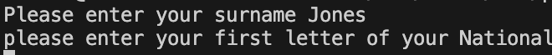

Yes, after running the code, it can be seen that it works as expected and is both syntactically and logically correct. After entering the name “Jones”, it correctly moves on to the next question. One simple improvement that would make this more professional would be to add a semicolon after the word “surname”.
Result: Did the programme behave as expected ie syntactically and logically correct?
YES

Test:
Surname ii Leave blank

Screenshot(s) of output:
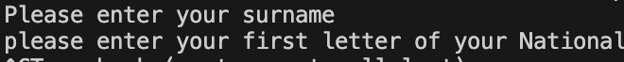

No, after testing the code, it did not behave as expected, as no validation was added for the surname option. As a consequence, when a user tried entering a blank space, the code did not detect anything wrong and let the user go to the next question. To fix this, adding a simple userinput1 == "" would stop this error from occurring again.
Result: Did the programme behave as expected ie syntactically and logically correct?
NO

Continue the rest of the tests below. (Copy and paste a box for each one)

Test:
Surname iii Enter A

Screenshot(s) of output:
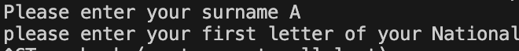

Similarly to the previous testing, no, the code did not behave as intended. The code allows you to enter a single letter, which is not appropriate. After some research, to fix this, adding a len(userinput1) > 1 would stop people from entering one letter, and it will only accept answers with words greater than two letters. However, it could be argued that in some countries, such as Korea, some people have surnames such as “O”, which is only one letter.
Result: Did the programme behave as expected ie syntactically and logically correct?
NO

Test:
Surname IV: Enter 12

Screenshot(s) of output:
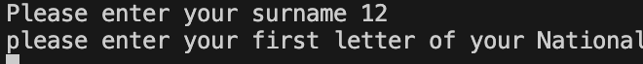
After testing, the code did not behave as expected, as after entering the number 12, the programme moves on to the next question. After doing some research, to fix this, an .isalpha() statement has been added so the programme will only accept letters and not numbers, as no surname contains a number.
Result: Did the programme behave as expected ie syntactically and logically correct?
NO

National Insurance Number:
Test:
i. Enter PE534121B

Screenshot(s) of output:
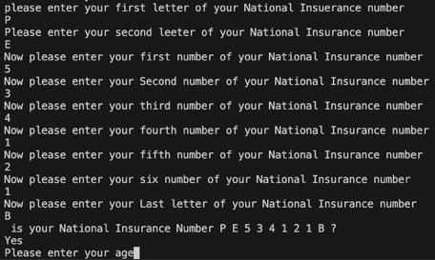

For this section of the code, I decided to take another approach, where the user has to type the letters and numbers one by one, which reduces the chance of entering the wrong format. After testing, the programme behaved appropriately when trying to enter a valid National Insurance number of PE534121B. After entering their number, the programme displays the user input so it can be visually checked; if the user answers with yes, it moves to the next question, and if no, it gives the user another chance to type in their National Insurance number.
Result: Did the programme behave as expected ie syntactically and logically correct?
YES

Test:
ii. Leave blank

Screenshot(s) of output:
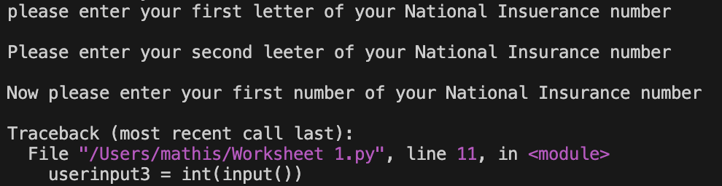

After testing, the code did not behave as expected. When the user tried to enter a blank answer for the first three parts of the National Insurance number, the code shut down. While, on one hand, this is positive, as the programme did not allow invalid information to be entered, which fulfils the task. On the other hand, more validation for the first question, which asks for the first letter of the National Insurance number, could have been added, in order to check whether the answer is blank. Lastly, the reason for the code shutting down at the end is because of a user input syntax issue. By adding a simple == "" statement, this will tell the programme to reject any blank responses.
Result: Did the programme behave as expected ie syntactically and logically correct?
NO

Test:
iii. Enter AB11223344556677

Screenshot(s) of output:
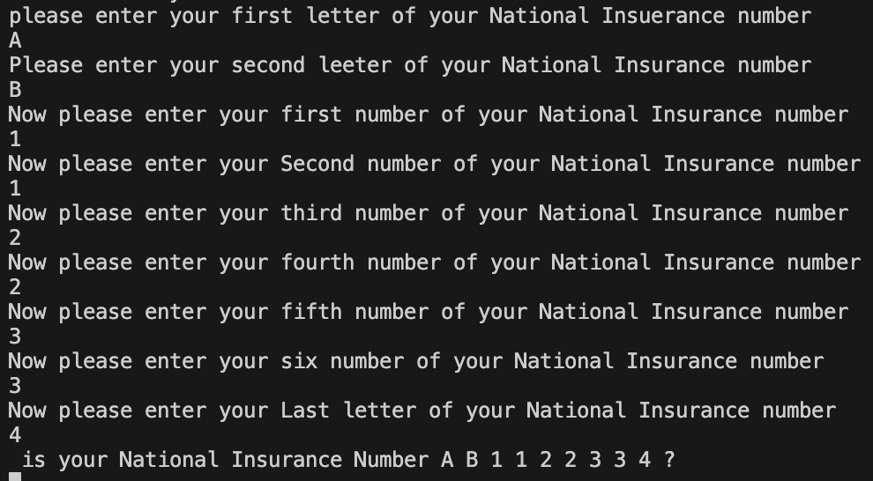

After attempting to enter an overly long National Insurance number, the programme accepted the first nine characters only. Therefore, it can be said that the programme did not work as intended, as it accepted an incorrect National Insurance number. This is a problem because the programme should only accept an input that matches the correct length and format. To fix this issue, validation should be added to the final letter of the code, which would reject a number instead of a letter which would therefore prevent users from entering too many characters. After some research, the most effective solution is to use an .isalpha() check, which ensures that only letters are accepted and any numbers are rejected.
Result: Did the programme behave as expected ie syntactically and logically correct?
NO

Test:
iV . Enter 22PE4088A

Screenshot(s) of output:
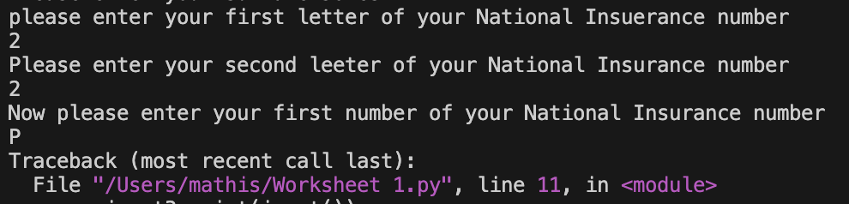

After testing, the code did not allow the user to enter the number 22PE4088A, as validation had been added to the number part of the National Insurance number, which shuts down the code if two digits are keyed in. This is good if validation such as .isalpha(), which only accepts letters and rejects numbers, was added at the first statement which demands the first letter of the National Insurance number. This would therefore not allow the user to enter 2 instead of a letter.
Result: Did the programme behave as expected ie syntactically and logically correct?
NO

Age:
Test:
i. Enter 34

Screenshot(s) of output:
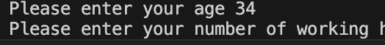

After testing the code by entering the age of 34, the programme worked as expected and went on to the next and final question.

Result: Did the programme behave as expected ie syntactically and logically correct?
YES

Test:
ii. Enter 150

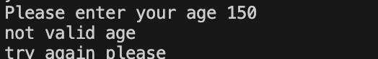
Screenshot(s) of output:

By entering an age of 150, the code did not allow this and told the user that this is not a valid age, giving the user another chance to enter a valid age. This is because validation has been added, where the user cannot enter a number below 0 or above 110.
Result: Did the programme behave as expected ie syntactically and logically correct?
YES

Test:
iii. Enter -4

Screenshot(s) of output:
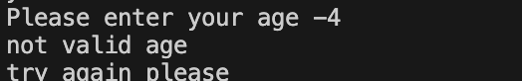

Similarly to the previous testing, when trying to enter an age below 0, in this case -4, the programme realises this is not a valid age and does not allow the user to log this information, giving the user another opportunity to type a valid age. This is because of validation that does not allow the user to enter a number below 0.
Result: Did the programme behave as expected ie syntactically and logically correct?
YES

Test:
Iv: Enter a letter

Screenshot(s) of output
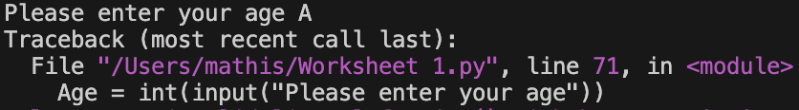

Lastly, when the user tried to enter a letter instead of a number, the programme shut down, as it had been told to only accept numbers. While this is good, as it mitigates the risk of entering misinformation, validation such as .isalpha() would not allow any letters to be typed in and would only accept numbers.
Result: Did the programme behave as expected ie syntactically and logically correct?
NO

Number of working hours per week:

Test:

i. Enter 37.5

Screenshot(s) of output
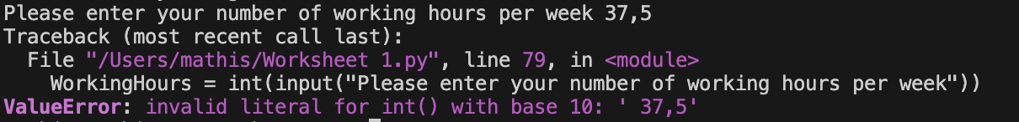

After testing, the programme rejected any number with a decimal point. In this case, the programme did not behave as expected. This is largely due to the fact that I used int(input), which only accepts whole numbers. Instead, using a float would resolve this issue and would allow numbers with decimals to be entered.

Result: Did the programme behave as expected ie syntactically and logically correct?
NO

Test:
ii. Enter 150

Screenshot(s) of output

After entering the number 150, the code accepted it and gave the user the output “Cool all good” with the username that has been provided at the start. While 150 hours may seem like a large number, the limit in the code is 168, as a human can technically only work a maximum of 168 hours in a week although this is unlikely. In the future, reducing this number may be better, as it is very unlikely that someone would work 168 hours.
Result: Did the programme behave as expected ie syntactically and logically correct?
YES

Test:
iii. Enter 0

Screenshot(s) of output
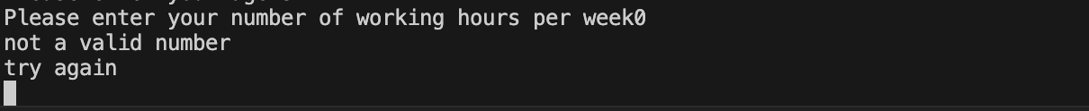

After testing and entering the value of 0, the programme behaved as expected and rejected the number 0, asking the user to type in another valid number. This is due to validation which has been implemented to reject numbers below 0 / negative numbers.

Result: Did the programme behave as expected ie syntactically and logically correct?
YES

Test:

iv. Enter -2

Screenshot(s) of output

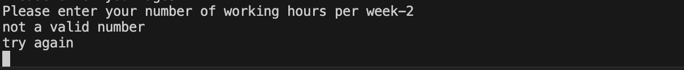

Lastly, when a user tries to enter a value below 0, such as -2, the programme rejects the input because of validation inside a loop. The user then has another opportunity to enter a valid answer. This therefore shows that the programme behaved as expected.

Result: Did the programme behave as expected ie syntactically and logically correct?
YES

- Consider the results of the above tests and revisit your code in order to solve the problems. (Note: you may not be able to solve all of them, but solve as many as you can.)

Paste your revised code here:

[Copy and paste your revised code here – note, do not use a screenshot]

Surname = input("Please enter your surname ")
while Surname == "" or len(Surname)< 3:
print("Not a valid Surname")
Surname = input ("Try again")

print("Please enter the first letter of your National Insurance number")
userinput1 = input()
while userinput1 == "" or len(userinput1) > 1 or userinput1.isalpha() == False:
print("wrong it has to be one Letter")
userinput1 = input("try again")

print("Please enter the second letter of your National Insurance number")
userinput2 = input()
while userinput2 == "" or len(userinput2) > 1 or userinput2.isalpha() == False:
print("wrong it has to be one Letter")
userinput2 = input("try again")

print("Now please enter your first number of your National Insurance number")
userinput3 = int(input())
while userinput3 >= 10 or userinput3 < 0:
print("not a valid number")
print("try again please")
userinput3 = int(input("try again"))

print("Now please enter your Second number of your National Insurance number")
userinput4 = int(input())
while userinput4 >= 10 or userinput4 < 0:
print("not a valid number")
print("try again please")
userinput4 = int(input("try again"))

print("Now please enter your third number of your National Insurance number")
userinput5 = int(input())
while userinput5 >= 10 or userinput5 < 0:
print("not a valid number")
print("try again please")
userinput5 = int(input("try again"))

print("Now please enter your fourth number of your National Insurance number")
userinput6 = int(input())
while userinput6 >= 10 or userinput6 < 0:
print("not a valid number")
print("try again please")
userinput6 = int(input("try again"))

print("Now please enter your fifth number of your National Insurance number")
userinput7 = int(input())
while userinput7 >= 10 or userinput7 < 0:
print("not a valid number")
print("try again please")
userinput7 = int(input("try again"))

print("Now please enter your six number of your National Insurance number")
userinput8 = int(input())
while userinput8 >= 10 or userinput8 < 0:
print("not a valid number")
print("try again please")
userinput8 = int(input("try again"))

print("Now please enter your Last letter of your National Insurance number")
userinput9 = input()
while userinput9 == "" or len(userinput9) > 1 or userinput9.isalpha() == False:
print("wrong it has to be one Letter")
userinput9 = input("try again")

print (" is your National Insurance Number",userinput1, userinput2, userinput3, userinput4, userinput5, userinput6, userinput7, userinput8, userinput9, ("?") )
userinput10 = input()
if userinput10 == "no":
print ("try reentering it")

else:
Age = input("Please enter your age")
while Age.isdigit() == False or int(Age) == "" or int(Age) >= 110 or int(Age) <= 0 :
Age = input("try again")

WorkingHours = float(input("Please enter your number of working hours per week"))
while WorkingHours >= (140) or WorkingHours <=(0) or WorkingHours == "":
print("not a valid number")
print("try again ")
WorkingHours = float(input())

else:
print("Cool all good", Surname )

