Task 1: Step-by-Step for “UX Designer” (Computing Role)
Essential Skills for a UX Designer
As a User Experience (UX) Designer, an individual aims to design digital interfaces that are easy to use, accessible, and enjoyable. The combination of professional and academic skills is needed to work well in this role. Communication and collaboration are key in that UX Designers liaise closely with the developers, clients and end-users in order to translate the requirements and introduce the design ideas [1]. Good research and analytical abilities will allow the designer to obtain user feedback and perform usability tests and translate data into design choices. Evidence-based design is followed with the help of academic skills like critical thinking and reflective practice that promote reiteration and assessment of prototyping and similar activities [2]. Visual literacy and creativity are also vital to enable the designers to create wireframes, storyboards, and prototypes that are reasonably functional and appealing [4]. Lastly, the digital literacy and adaptability provide the understanding of the current design tools, such as Figma or Adobe XD or Miro, as well as being willing to learn new technologies within a rapidly developing industry [3]. Academic study in conjunction with teamwork and project experience is what creates a foundation for a successful UX career. With the help of analytical thinking and empathy in conjunction with design thinking, a UX Designer will be able to find novel solutions that will not only increase user satisfaction but also make people more employable in the computing industry.
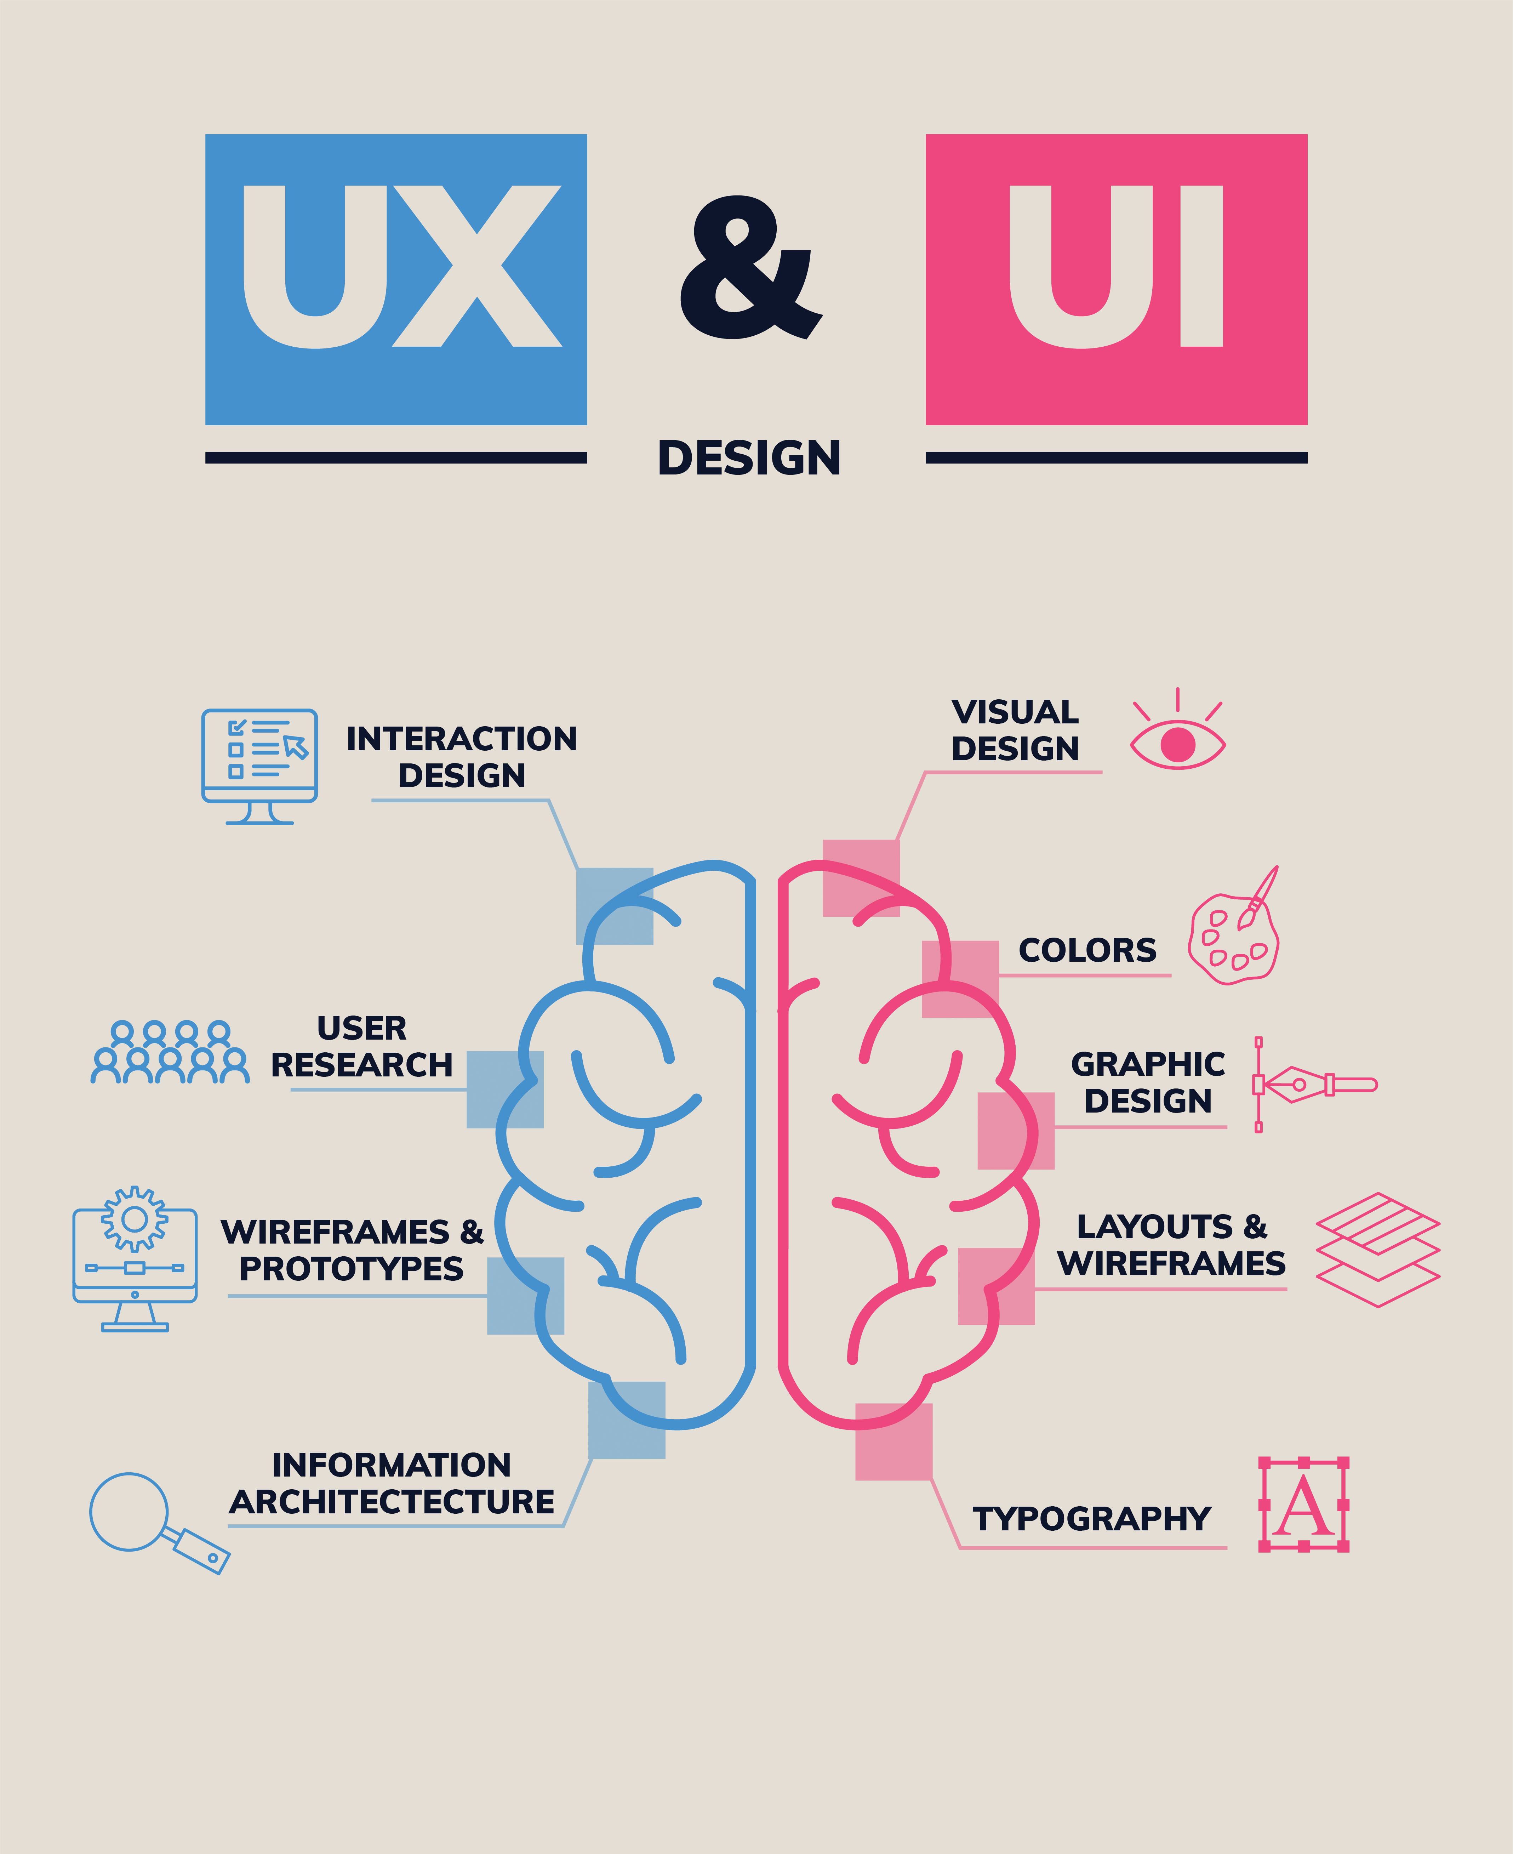
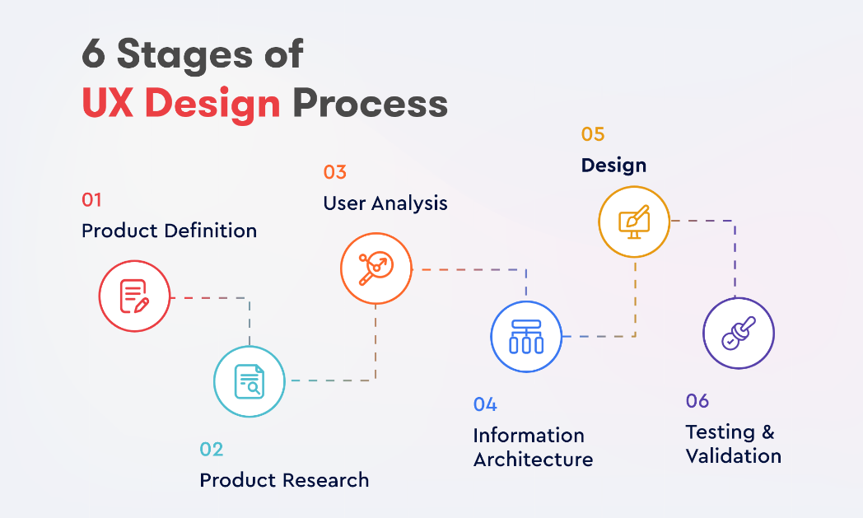
IEEE Reference List
[1] CareerFoundry, “What Is UX Design? A Definition & Guide,” CareerFoundry, Mar. 18, 2021. [Online]. Available: https://careerfoundry.com/en/blog/ux-design/what-is-user-experience-ux-design-everything-you-need-to-know-to-get-started/. [Accessed: Nov. 10, 2025].
[2] S. Kaur, Ultimate UI/UX Design for Professionals: Create Impactful, User-Centric Designs with Research and Collaboration Techniques for Seamless Responsive Web Interfaces. Birmingham, U.K.: Packt Publishing, 2024. [Online]. Available: https://www.google.co.in/books/edition/Ultimate_UI_UX_Design_for_Professionals/wyRIEQAAQBAJ?hl=en&gbpv=0. [Accessed: Nov. 10, 2025].
[3] R. Unger and C. Chandler, A Project Guide to UX Design: For User Experience Designers in the Field or in the Making, 3rd ed. San Francisco, CA: New Riders, 2023. [Online]. Available: https://www.google.co.in/books/edition/A_Project_Guide_to_UX_Design/wsHWEAAAQBAJ?hl=en&gbpv=0. [Accessed: Nov. 10, 2025].
[4] Å. Stige, E. D. Zamani, P. Mikalef, and Y. Zhu, “Artificial intelligence (AI) for user experience (UX) design: a systematic literature review and future research agenda,” Information Technology & People, vol. 37, no. 6, pp. 2324–2352, 2024. [Online]. Available: https://ntnuopen.ntnu.no/ntnu-xmlui/bitstream/handle/11250/3110180/AI+UX+revision+08062023.pdf?sequence=1. [Accessed: Nov. 10, 2025].
Reflection
My Turnitin similarity score was “X%”, and this was largely because I used a standard assessment template among many students. Beyond this, the majority of writing has been my writing, although certain technical and academic terminology inherently looks like to already existing sources. In order to raise the score next time, I will pay more attention to the effective paraphrasing of the ideas, summarisation of the concepts in a more personal way, and reference to the quotations or definitions. I will also go through the similarity report more critically before I submit the report to ensure that all the similar text is justified or altered where feasible.
According to the Generic Assessment Criteria, my score would be 80 out of 100. In my opinion, the work demonstrates a good interaction with the related literature, good knowledge of the subject matter, and excellent writing skills. Room to be improved still exists, especially in polishing my analytical arguments and further critical assessment of the arguments raised. As I continue to work on these areas and gain increased autonomy and understanding, I believe that my submissions and the academic depth of the work presented can get even better.

