Luke Evans

BIT

Managing People & Change

Due 10/01/2019

Contents
Luke Evans 1
BIT 1
Managing People & Change 1
Due 10/01/2019 1
Introduction to Change and Change Management 3
Organisation of choice 3
SLEPT Analysis 3
Change Management for Google 4
The Changing Nature of Google 4
Internal and External Change Drivers 4
Lewin’s Force field Analysis 5
Chosen area of relevant change 5
Implementation of Lewin’s force field analysis for chosen area of change at Google 5
Evaluation of Relevant Change Management Theories and Strategies 7
Kotter’s 8-Step Process 7
Comparison of Lewin’s Force field analysis and Kotter’s 8 Stage Process 7
Case Study for Kotter’s 8 stage Process 7
Contemporary Leadership 7
Recommendation of a Change Management Strategy for Google 8
Evaluation and Key Findings 8
Bibliography 9
Appendix 12

Introduction to Change and Change Management
Change is to make something different; so in the context of an organisation, they would be bringing something new into the work place environment [1].
Change Management is how we compose ourselves or others for change. Individuals are different and all adapt to change in different ways, however, different styles and methods of change implementation can assist with minimal resistance. Change management is necessary for organisations to strive towards success through changes made. Organisational change management is how a company would go about introducing change to their employees. It involves identifying who the change will effect in the organisation and taking actions towards ensuring that those individuals are communicated with and taken into account [2].

Organisation of choice
The chosen organisation for this report will be ‘Google’. This is a company who has undergone a dramatic amount of change since the company started. Google started out as a company that focussed on their online search engine which is still the main choice for users to this day and their e-mail service called G-mail [3].

SLEPT Analysis
A SLEPT analysis will be used for Google to have an overview of the Organisation to identify recent changes to the use of technology and computing [4].
- Social & Customer analysis – One changing factor that may affect Google is that a lot more internet searches are coming from mobile phones which indicate a decrease in the use of traditional desktops and laptops which were the primary way of accessing Google. Google to combat this have decided to use their resources to branch out into a new market and make their own phone to compete not only in the mobile phone market but to ensure the users are using Google as a search engine. Google are not well known for their customer communication so this may become an issue, especially the more markets they partake in [5].
- Legal analysis – Legal costs may increase for Google as they traverse further into experimental fields. An example of Google entering these fields is them testing their automobiles; they attempted to test their ‘Self-driving car’ on public roads and failed to declare anything about the test to the government [6].
- Economic & Competition/Market analysis – Google is obviously in competition with the largest companies in the world like Apple and Amazon because they’re all so massive in comparison to all other organisations. They are all trying to find new ways to earn money and get ahead of each other which will induce a lot of change and development. Google is also expanding their competition by entering new markets with their own new products; well established companies in certain market fields will compete with Google for their spot and customers.
- Political analysis – Brexit might be a political factor that Google needs to consider. The uncertainty of Brexit leaves many questions over a lot of businesses that are involved with Britain.
- Technological analysis – Google stays ahead of most technological wise through persistence of technology innovation and development. They have made great strides in Artificial Intelligence, Virtual Reality, and 3D printing development and have begun to implement it into the company. Google has also innovated Data mining to implement into the company; due to them owning the most used search browser across the entire planet, they can extract data on just about anything they desire and they will use that to their advantage to make decisions. They have created a new smart watch and added to the list of markets they are a part of, but not only that, they have their employees wear them to ensure they are healthy so their productivity is at its peak [7].

Change Management for Google
Google work a lot on Change Management when implementing a change. They have researched further into the possibility to improve upon their current methods of Change Management. After a survey, they revealed that ‘50%’ of employees didn’t understand why the change was being made in the first place. This vital set of data can now allow Google to help employees learn and adjust through communication. They now answer a lot of employee’s questions through simple communication. They explain the change to the employees by expressing things such as, ‘Why’ the change is being made, ‘What’ the change will do and ‘Who’ it will impact [8].

The Changing Nature of Google
Google is one of the largest and most well known companies in the world. They also have a net worth of £645.9 billion and can afford to experiment and branch out into different markets which is exactly what they have done [9]. The more Google grows, the more it seems that they want to try release more products to gain even more customers and this has happened many times. A vast development of technological advances seems to be the main changes being made from within Google. Google even make changes towards their nature of work; they’re changing the way their employees do and work across the company [10]. There’s a possibility that Google may be one of the large companies to predict the 6th Kondratiev and act upon it using their technological capabilities to enhance technology over all for the world [11].

Internal and External Change Drivers
Internal change drivers are factors within an organisation such as systems, events and people that influence the decision to undergo change. Internal change tends to be under the control of the organisation and their decision to implement it. An example of an internal change driver that Google has had would be when they discovered why their staff were not happy with change which triggered a change in itself. They introduced a meeting system for their staff which were either in the café’s or offices so the executives at Google to communicate with their staff over any company issues [12].
External change drivers are factors outside of an organisation. This can include anything in the company’s external environment such as, threats, opportunities, strengths and weaknesses. A company will almost be pushed towards change due to the ever changing external environment.
An example of Googles external change drivers would be when they faced legal pressure from multiple sources like the department of justice and The Chinese government to sensor certain results on their search engine. This would be considered a threat to Google and would definitely induce change throughout the organisation to relieve the pressure [13].
Another example of an external change driver for Google would be when they discovered that Amazon, one of their competitors for one of the biggest organisations in the world, had surpassed them as the most searched for online tool. This is an external threat to Google which likely sent widespread change through the organisation [14].

Lewin’s Force field Analysis
Lewin’s Force Field analysis shows what the significance of factors are and how they can induce change. On one side, there are the driving forces that are pushing for change and on the other side there’s the restraining forces that will encourage resistance to the change. Lewin’s force field models are created by organisations to clearly show each side for them to come to the conclusion of either push for change, or not. Each factor will be given a number to total its significance regarding the change and all numbers will be added up once the model is complete; this is to see whether the change is viable by viewing which side scored higher [15]. See Screenshot 1 in the Appendix for an example of Lewin’s Force field analysis diagram.
Steps are taken throughout this process of attempting to implement change which includes creating Lewin’s force field diagram. The number of steps can vary between different companies, but it tends to be a maximum of 7.
- Step 1 - Describing the plan or proposal for change.
- Step 2 – Identify the forces for the change.
- Step 3 - Identify the forces against the change.
- Step 4 - Assign scores to each force/factor.
- Step 5 - Create a force field analysis diagram.
- Step 6 – Analyse the results and apply accordingly.
- Step 7 – Document the potential strategies that can be used to overcome barriers for the change.

Chosen area of relevant change
The chosen area of recent change that Google has made is within the company is the technological advancement and implementation of Artificial intelligence. Google have created their own suite called “Cloud AutoML” which is multiple pre-trained systems which can allow for easier AI usage. Not only will this technology improve Google’s efficiency using Artificial Intelligence but it may revolutionise the way AI is used across the planet. Before sharing it with the rest of the world, Google would have had to implement this change throughout the company first [16]. Google are now using AI in so many different ways; for example they can use it to prevent illegal fishing. Their AI can do this through methods that include processing huge amounts of data to “learn” [17].

Implementation of Lewin’s force field analysis for chosen area of change at Google
Now Lewin’s force field analysis will be applied to the chosen area of change for Google and will be put through a step by step process.
First of all, the proposal for change will be the implementation of their online suite called Cloud AutoML which will enhance the use and efficiency of AI. Employees will need to learn how to use it in order to be productive while using AI technology for work.
Next, to identify the forces for change; a push for AI would improve the efficiency of Google and its employees. It would also eventually lead to the improvement of the AI industry as well as the overall economy. AI could also tempt in new potential staff members so they can work with this new technology with guidance; this would mean that Google can pick up the best qualified people before other big companies offer them a job. There is the possibility that the use of AI within the company and the prospect of working more efficiently will encourage more people to invest in the organisation.
Now to identify the forces against change; this will cost Google money to install as well as teach their staff how to use it. There is always the chance that the current staff at Google could resist the change and new technology completely. There’s also the pressure from the part of the public that are very wary and sceptical of AI technology [18].
Each factor will have to be scored out of 5 and then inserted into a force field analysis diagram.
Forces for Change:
- Improves company efficiency – 4
- Improves the AI industry - 2
- Boosts the economy - 2
- New keen, potentially skilled staff members - 4
- New investors - 5
Forces against Change:
- Public scepticism of AI technology - 3
- Cost of installation - 2
- Cost of staff training – 2
- Staff Resistance - 4
See Screenshot 2 in the Appendix for full Force field analysis Diagram.
The diagram shows that the change is viable (17-11) and Google can now look towards applying this knowledge.

Evaluation of Relevant Change Management Theories and Strategies
This evaluation will decipher which change management theories and strategies would help with reducing resistance to change. Lewin’s change management model is “One of the most popular approaches”. This strategy involves splitting the process into three stages of change management; unfreeze, make changes and refreeze. Essentially this theory involves viewing how things are done first, implementing change afterwards and then back to normal with the implemented changes [19].

Kotter’s 8-Step Process
The following steps represent what Kotter’s process for Leading Change (Change Management) consists of [20]:
- Step 1 – Create urgency
- Step 2 – Form a powerful Coalition
- Step 3 – Create a Vision for Change
- Step 4 – Communicate the Vision
- Step 5 – Remove Obstacles
- Step 6 – Create short-term wins
- Step 7 – Build on the change
- Step 8 – Institute the change

Comparison of Lewin’s Force field analysis and Kotter’s 8 Stage Process
See Screenshot 3 in the Appendix for Kotter’s 8 stage process.
Despite their differences, they are both used by companies for one reason and that is to implement change. Lewin’s weighs each side of the argument to come to a conclusion to see if change is viable, whereas, Kotter’s focusses on the leadership side when the go ahead for change has been given. Kotter’s 8 steps is more focussed on how leadership can adapt to the change to inevitably help with the whole process [21].

Case Study for Kotter’s 8 stage Process
This case study show an example of Kotter’s 8 stage Process being used by a company to help with the change initiative [22]. While the company implemented the process, they observed the success of it over the time of change. The firm in question used the 8-step process as a guideline while being aware of their own targets. According to the study, certain steps were not properly executed, such as lack of communication with their staff, which led to the resistance of change. The results show that due to one step not being carried out correctly, the following steps were affected as a consequence.

Contemporary Leadership
A recommendation for a style that would structure and lead a successful process of change would have to be charismatic leadership. This style of leadership is linked to the “inspiration, charm and high self-confidence” of an individual. The style can be applied to Google where the majority of employees are going to be creative thinkers that will respond well to an attitude which can motivate them [23].

Recommendation of a Change Management Strategy for Google
For a company like Google, using Lewin’s force field analysis diagram would be the best way to find out whether a specific change is likely. Meanwhile, while implementing change, Google should use Kotter’s 8-step process to ensure that their leadership holds up when transitioning their staff into this new change. The leadership style that they should implement for change is charismatic leadership. It would also benefit Google from using Lewin’s change management model as a guideline when applying change.

Evaluation and Key Findings
There are a number of different ways that change can be implemented through an organisation. This report discovered how organisations use Lewin’s force field analysis model to check if a change is viable. It also shows different change management theories and contemporary leadership/management theories that can be implemented into an organisation to assist with the change. These theories can be very helpful with having smooth transitions of change or lowering resistance to change throughout the company.

Bibliography

[1] | “Change,” Oxford Dictionary, [Online]. Available: https://en.oxforddictionaries.com/definition/change. [Accessed 28 December 2018].
[2] | “What is Change Management?,” prosci, [Online]. Available: https://www.prosci.com/resources/articles/what-is-change-management. [Accessed 28 December 2018].
[3] | “Google Net Worth 2019,” Celebs Net Worth Today, 2019. [Online]. Available: https://www.celebsnetworthtoday.com/bio-wiki-2018-2019-2020-2021/other/google-net-worth-5353/. [Accessed 28 December 2018].
[4] | “PESTLE Analysis of Google (Alphabet),” Pestle Analysis, 19 November 2015. [Online]. Available: https://pestleanalysis.com/pestle-analysis-of-google-alphabet/. [Accessed 28 December 2018].
[5] | M. Mace, “Google Logic: Why Google does the things it does the way it does,” The Guadian, 9 July 2013. [Online]. Available: https://www.theguardian.com/technology/2013/jul/09/google-android-reader-why. [Accessed 9 December 2018].
[6] | T. Adams, “Where is Google taking us?,” The Guardian, 5 July 2015. [Online]. Available: https://www.theguardian.com/technology/2015/jul/05/google-taking-us-california-innovations-driverless-cars. [Accessed 28 December 2018].
[7] | R. Wong, “Google's redisigned Wear OD might make smartwatches worth buying again,” Mashable UK, 29 August 2018. [Online]. Available: https://mashable.com/article/google-wear-os-redesign-smartwatches/?europe=true#WU3Pv_wHjZqI. [Accessed 28 December 2018].
[8] | S. Mautz, “Want to Better Manage Change in Your Workplace? Learn From Google and Start With These Questions,” Inc., 2 August 2018. [Online]. Available: https://www.inc.com/scott-mautz/google-is-revolutionizing-how-to-manage-change-starting-with-these-4-questions.html. [Accessed 28 December 2018].
[9] | M. Mavdiya, “How much is Google worth?,” Daily Mail, 30 July 2018. [Online]. Available: https://www.dailymail.co.uk/sciencetech/article-6007635/How-Google-worth.html. [Accessed 28 December 2018].
[10] | N. Kolakowski, “Google Pouring $50 Million into 'Changing Nature of Work',” Dice, 1 August 2017. [Online]. Available: https://insights.dice.com/2017/08/01/google-50-million-changing-nature-work/. [Accessed 28 December 2018].
[11] | J. B. Moody and B. Nogrady, The Sixth Wave: How to Succeed in a Resource-limited World, ReadHowYouWant.com, 2010.
[12] | “External and Internal Environment of Google,” lacgoe, [Online]. Available: https://lacgoe.wordpress.com/external-and-internal-environment-of-google/. [Accessed 28 December 2018].
[13] | “Google's External and Internal Analysis Essay,” CRAM, [Online]. Available: https://www.cram.com/essay/googles-external-and-internal-analysis/PKCUCFE2SC. [Accessed 28 December 2018].
[14] | S. Hartzell, “How Internal and External Factors Drive Organisational Change,” Study.com, [Online]. Available: https://study.com/academy/lesson/how-internal-and-external-factors-drive-organizational-change.html. [Accessed 28 December 2018].
[15] | E. H. Sabri, A. P. Gupta and M. A. Beitler, “Lewin's Force Field Analysis,” in Purchase Order Management Best Practises: Process, Technology and Change Management, J. Ross Publishing, 2006, pp. 196-197.
[16] | J. Snow, “10 Breakthrough Technologies 2018 (AI for Everybody),” TechnologyReview, [Online]. Available: https://www.technologyreview.com/lists/technologies/2018/?fbclid=IwAR2bwtk0MUsBhzt06M62Iw6LiNqGJasBAk8YzxSpU0NwadyDrivyNYmOkOY. [Accessed 29 December 2018].
[17] | B. Marr, “The Amazing Ways Google Uses Artificial Intelligence And Satellite Data To Prevent Illegal Fishing,” Forbes, 9 April 2018. [Online]. Available: https://www.forbes.com/sites/bernardmarr/2018/04/09/the-amazing-ways-google-uses-artificial-intelligence-and-satellite-data-to-prevent-illegal-fishing/#200e829a1c14. [Accessed 29 December 2018].
[18] | A. Lath, “Pros and Cons of Artificial Intelligence,” BBN Times, 18 September 2018. [Online]. Available: https://www.bbntimes.com/en/companies/pros-and-cons-of-artificial-intelligence. [Accessed 29 December 2018].
[19] | B. Mulholland, “8 Critical Change Management Models to Evolve and Survive,” Process.st, 24 July 2017. [Online]. Available: https://www.process.st/change-management-models/. [Accessed 29 December 2018].
[20] | “Kotter's 8-Step Change Model,” MindTools, [Online]. Available: https://www.mindtools.com/pages/article/newPPM_82.htm. [Accessed 29 December 2018].
[21] | “8-Step Process,” Kotter, [Online]. Available: https://www.kotterinc.com/8-steps-process-for-leading-change/. [Accessed 29 December 2018].
[22] | H. K. Magnúsdóttir, “Implementing Strategy Using the Kotter 8-Step Change Process:,” Reykjavík University, June 2018. [Online]. Available: https://skemman.is/bitstream/1946/31387/1/MSC-Helga%20Kristin%20Magnusdottir-June%202018.pdf. [Accessed 29 December 2018].
[23] | “Analysis of Contemporary Leadership Theories,” UK Essays, 5 December 2016. [Online]. Available: https://www.ukessays.com/essays/management/analysis-of-contemporary-leadership-theories-management-essay.php. [Accessed 29 December 2018].
[24] | [Online]. Available: https://www.odi.org/sites/odi.org.uk/files/odi-assets/embedded-images/forcefield.gif.
[25] | [Online]. Available: https://www.kotterinc.com/wp-content/uploads/2016/12/8-steps-2-e1508515045824.png.

Appendix
Screenshot 1 [24]:
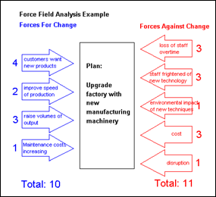
Screenshot 2:
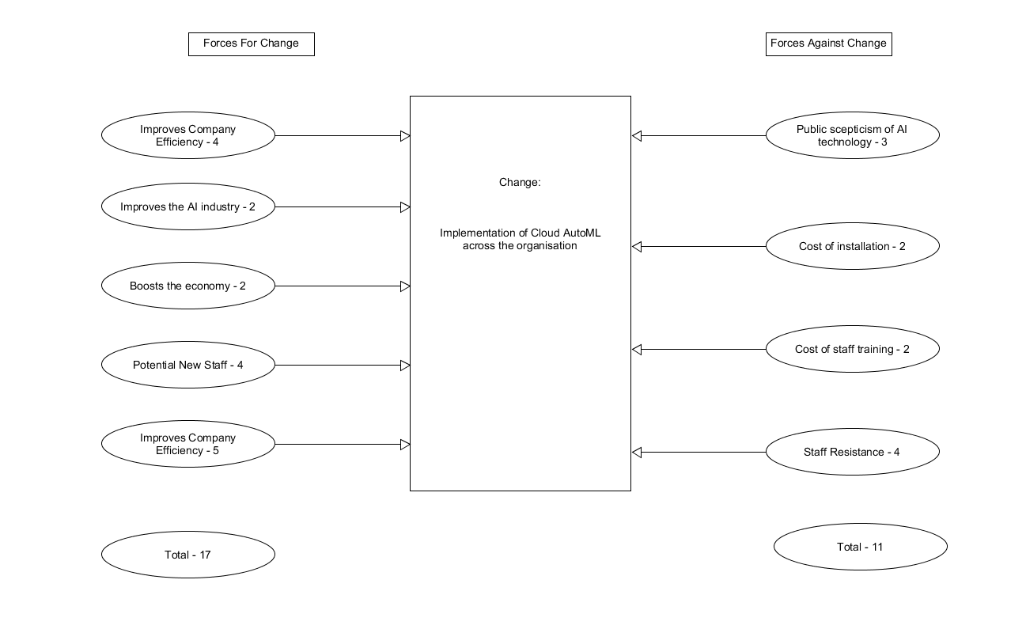

Screenshot 3 [25]:


