Report on Recruitment, Selection and Onboarding and its scope of Improvements in Google

Course: MBA (Master of Business Administration)
Module: Human Resource Management (BMMB7007)

Lecturer: James Moore
Report Produced by: Syed Asad Husain Zaidi (Student ID: 2213561)

Executive Summary
The most important responsibility in managing its gamut of operations lies within the Human Resources function.
“Recruitment, Selection and Onboarding” as the vital priority area for Google in this report and critically analyse why this is my chosen priority area, the current weaknesses in these functions and the impact its negative implications have on Google.
Behavioural science largely impacts the recruitment and selection procedures. It affects the external factors, recruiting managers and human resource professionals. Recruitment in any organisation is preparing a pool of candidates who are deemed to be suitable for the position or match most closely to the job description, taking their past experiences as on the reference points. Google deploys advances HR analytics and advance Applicant Tracking Systems (ATS) to prepare the recruitment pool of the suitable candidates.
Furthermore, selection is carried out using behavioural methods and often structured interviews. Candidates are also subjected to stress situations to test their calibre. The various tests and questionnaires strategies in addition to stereotypical Interviews, deployed by Google includes Psychometric Tests (Cognitive & Personality assessments etc.) and Assessment centers (Task Completion oriented methodology) which gives a strong prediction of candidate’s performance.
Google is a stalwart if we talk about recruitment. It uses advanced HR analytics to hire people across domains. It is shaping the way how other companies should do hiring as Google is hiring people at a bolstering pace every quarter.
A proper analysis of the “Recruitment, Selection and Onboarding” strategies of the Google is done in the main body part, with a special focus on the internal recruitment strategies followed by google as its main tool in creating a pool of talented candidates which is kept for its future vacancies.
Post the main analysis, there are precise conclusions, in line with the overall Human Resource strategy of Google which are having an open cohort and scope for improvements. The conclusions are then followed by realistic recommendations which specifically focuses on improvement of HR function in “recruitment, selection and onboarding” priority area. Any disadvantages and risks concerning these suggestions are properly considered and duly written within each recommendation, with a conclusive ending of this report followed by references appended at the last.

Contents
Executive Summary 2
1. Introduction 4
2. Overview 4
3. How does HRM operates in Google? 5
4. The Google Strategy Story – Bird’s Eye View 5
5. Recruitment at Google 5
5.1. Disruptive Recruiting Technology Model of Google 6
5.2. Deep diving into the recruitment culture of Google 6
5.3. The 20% work concept (Sullivan, 2006) 7
6. Selection Strategy at Google 8
6.1. WOW Tools 9
7. Onboarding in Google 9
8. Conclusions, with scope of Improvement 10
9. Recommendations 10
References 12

Figures:
Fig. 1.1 Google Timeline ------------------------------------------------------------------------------------------------ 5
Fig. 1.2 Selection Strategy ---------------------------------------------------------------------------------------------- 8
Fig. 1.3 Recruitment Tools ---------------------------------------------------------------------------------------------- 8
Fig. 1.4 Onboarding at Google --------------------------------------------------------------------------------------- 10

Introduction
Google was revamped in 2015 under the portfolio of Alphabet Inc. It was basically done so that it can take more independent management decisions and foray towards more risky investments for example Life Sciences etc. “Alphabet is about businesses prospering through strong leadership and independence” – Larry Page (Stumbles, 2017). In this report, the way Google’s Recruitment, Selection and Onboarding is done and why this priority area needs improvement. Google uses a mix of internal and external recruitment strategies but focusses more on ways to internally recruit talents (Lombardo, 2017).

Overview
Google was initially known as BackRub, created by Larry Page while he was a graduate student studying computer science at Stanford in 1995. There, he met Sergey Brin, another computer science student. While Page started researching the Web's linking practises, the two remained in contact. To create a new type of search engine, Page came up with a technique that would scan the internet to find out which pages were linked to others (Verge Staff, 2018). Google was officially born in 1998 by the same duo Larry Page and Sergey Brin to market “Google Search” which was the most trending web-based search engine of that time (Vise, 2007).
Sergey and Brin broke the initial stereotypes and had unimaginable talent. Google originated initially from Artificial Intelligence and the duo friends used “tradition” in consensus with the company. Google’s mission was to “streamline world’s information and make it easy and accessible to everyone” (Girard, 2006, p. 11).
Initially as the name suggested Backrub, it was able to critically analyze backlinks that directed towards a particular website. Then they developed a system of ranking the search pages popularly called the “Page Rank” which gave the search results some priority and relevance (Scott, 2008, p.7). They have gone an extra mile to create an index of approximately 25 billion websites, which further includes about 17 million images and 1 billion messages to UseNet groups (Downes, 2007, p. 657-667).
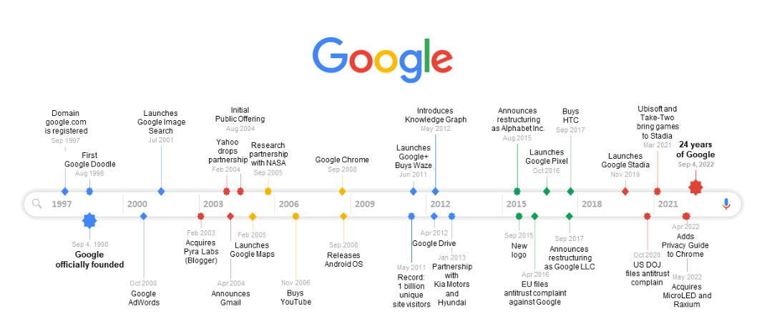
(Fig1.1: Source: Office Timeline Blog)

How does HRM operates in Google?
Google uses a horizontal structure with a transformational leadership style that triggers employee motivation (StudyCorgi, 2023). There usually has a HR Director called the People officer (McNeill, 2020), who is the head of the human resources (Sullivan, 2006). Google’s Human Resources is a portfolio of internal and external recruitment strategies. The company uses internal recruitment as its main tool which involves promotions, transfers, intern/trainees for its Human resources fulfilment (Lombardo, 2017).

The Google Strategy Story – Bird’s Eye View
Google follows generic strategy which focus of differentiation rather than specialisation. It has an umbrella of products which it offers to almost everyone around the world as it gives a broad market scope. The entire strategy of google is predominantly based on Michael Porter’s model (Thompson, 2019). I have taken “Recruitment, Selection and Onboarding” as the priority area which has a scope for improvement, the current shortfalls, and the effect of these shortfalls on the performance and productivity of Google is analysed. Recruitment and Selection is an important, complex and diverse constituent of Human resources management (Rozario et al., 2019)

Recruitment at Google
Recruitment is attracting a pool of candidate into a drive for fulfilling positions (CIPD, 2022a). Google discreetly uses the quiet hiring strategy. This is an orthodox yet a fantastic recruitment strategy (Main, 2022). The quiet hiring process takes into consideration or gives priority to internal staff first and then looks over to those people who have started to take their work to a next level and have begun taking more responsibilities as defined in their key performance indicators. Eventually this whole system indirectly saves recruitment costs and entails the employees to strive more for the roles they want to fork for (Main, 2022).
Googles’ success is hugely related to its high-quality human resources and advances HR analytics that it uses to make its recruitment process more qualitative (Lombardo, 2017). If we deep dive into the Goggle’s culture, we can evidently see that Laszlo Block, who was the Head People’s officer at google, has said that the People Operations comprises of two components – Science and Human Resources and google looks at everything from the point of view of data and analytics (McAfee et al., 2012).
There was a Project Oxygen at google spearheaded by the People and Innovation Lab (PiLab), which analysed questions assisting employees to successfully transition into better managers. (Tran, 2017, p. 6). Google usually follows a hiring strategy in which a candidate must be passed by a hiring committee, rather than a single HR. All the members of the committee need to agree with the candidate’s potential to give a final go through (Umoh, 2018).

Disruptive Recruiting Technology Model of Google
The talent management in Human Resources is no longer a “war for talent” (Michaels et al., 2001, p.1). The war for talent model says that Company X hires a top-notch employee from Company Y and Company Y hires a top-notch employee from Company X. The resulting situation is never a win-win for both the companies. Now the recruitment focuses on retaining best employees and creating compelling experiences for them at the workplace (Claus, 2019, p. 208). Disruptive technology is a new or upgraded technology that disrupts the status quo and makes existing technology obsolete. The disruptive technologies in Computer Science such as artificial intelligence, cloud computing, data science etc. has enough potential to create jobs in the future (Nagaraj, 2020, p. 504).

Deep diving into the recruitment culture of Google
Google has achieved something which no other organisation has ever dares to achieve. Google has a ratio of 14:1, which means that there is 1 Recruiter available for every 14 candidates (Sullivan, 2006). In only some years google has developed, which we can easily categorize it as a “recruiting machine”. Although google does not have the best sales and marketing strategy, nor they are the best at used of metrics as far as other companies are concerned, but still they have been able to create the first recruiting culture. The recruiting culture not only reforms the Human Resources function but also entire company ranging from top directors to entry level employees. Due this, the recruiting culture the HR function has become as league and have transformed the way the employees work so that they can stop the attrition of the best talents and knowledge bases (Sullivan, 2006)

The 20% work concept (Sullivan, 2006)
Whilst other companies, try to attract people and exceptional talents by making attractive an fair changes in the monetary compensation structures as well as clubbing various other perks with the job role, but Google on the other hand follows the strategy of making the Job description more interesting and viable so that it is enough to attract the superior pool of knowledge and manpower from the market. What Google refers to as “20% work”, is the crucial component of changing the nature of work, in such a manner that the work or job description itself becomes attractive and acts as a force for retention, innovation and incentives. The founders of google and HR director Stacy Sullivan have customised each job description and the components of work so that each if the employees are.
- Working seemingly on their areas of interests.
- Feeling valued as they are also value adding to the organisation.
- Thriving in an environment of continuous challenges.
- Continuous and upgraded learning atmosphere.
This literally gives employees one day a week on working and researching on the projects on their own, duly supported by the organisation. Every company wants to hire people who are top of the notch and have an exceptional set of talents. Talent is an art and there must me enthusiasm and voluntary work available for the employees. Google, Apple, Dell, and Netflix are having 40% more productive workforce as compared to the other similar companies which attracts a skilled set of top tier employees (Vozza, 2017). Google has always created a unique corporate environment when it has recruited top talents from the prestigious universities of the world. The difference is the good workplace culture which makes some organisations to work for and makes others as nightmares (West, 2016).
Googles recruitment culture has been completely revamped by the way of HR Analytics. As these decisions are data oriented, hence more practical, and effective in forecasting decisions related to people management in Google (McNeill, 2020). The Human resources team of google, which is now known as People Operations team, use advanced HR data analytics to measure the key performance indicator of employees. They use the analytics innovatively and work on feedback mechanism from the employees rather than a pragmatic leadership style (McNeill, 2020).
Human resources are the vital part of any organisation, which is usually less focussed in smaller organisations and has received lesser attention which has led to the widening of the gap between practices followed in the organisation versus their size (Mothafar et al., 2022). For any organisation strategic recruitment plays a vital role and planned interview strategy is still relevant and highly suited for a recruitment drive (Shafique, 2012). Those who are searching for a new job, keep organisational culture at top of their preferences (Schmidt and Rosenberg, 2014).
As already discussed, google uses a mix of Internal and External recruitment strategies (Vejaratnam, 2022). Internal Strategies which include internal promotions, transfers, intern/trainee progression, etc. which has led to an overall decrease in the recruitment costs. The external recruitment methods include the educational institutions, in which they remain in direct touch with the prospective interns/employees through the institution and job adverts which it usually places on it careers website and hence it maintains a pool of talented individuals, who are ready to join Google (Optimum1, 2018; Lombardo, 2017)

Selection Strategy at Google
Google’s overall selection strategy can be depicted from the diagram below:
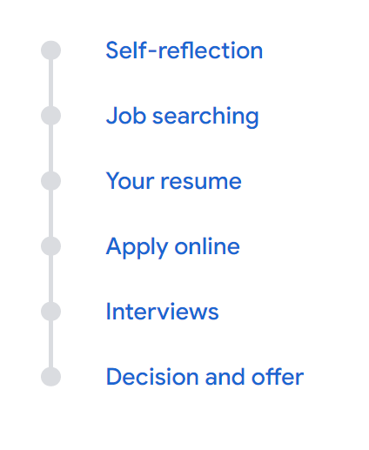
(Fig. 1.2: Source: https://careers.google.com/how-we-hire/)
And if we further deep dive, the selection process can be broken into two parts:

WOW Recruitment Tools

Basic HR Recruitment Function/Recruitment Tools
Standard Recruiting Tools
Fig. 1.3: Recruitment Tools

WOW Tools
Google has often used exceptionally advanced recruiting tools, that has targeted the correct set of required candidates.
Types of WOW Recruiting Tools (Linh, no date)
- AdWords: Google uses its own AdWords tool to target prospective passive candidates. This method is usually helpful for hard-to-find candidates for typical roles in the organisation. Although Google AdWords has been outperformed by Facebook Ads as AdWords does not has the demographic characteristics, which Facebook has, hence the targeting is many times ineffective using AdWords (van Gelder et al., 2019)
- Contests: This method is usually effective for hiring software engineers. For example, the Google “Code Jam” is an online content writing tool which attracts approximately 7500 people each year. Thus, contests are IT based innovation solutions that attract submission from the candidates, and which can be further evaluated for their suitability for the role and to spread the word of mouth for the company (Haller et al., 2011)
- Brain Teasers: Basically, used to attract programmers by the creative use of mathematics-based tests.
- Friends of Google: This tool creates a list of people who are interested in Google products, but not importantly interested in working for Google.
The Standard Recruiting tools use the traditional methods such as Employee Referrals, College Recruitment, Professional Networking, Human Resource recruiter training etc. It may involve Short Virtual Chats, Assessments, Structured Interviews, Project Work and even Open-ended questions (Google Careers, no date)

Onboarding in Google
Onboarding is usually the process of welcoming the recruits, helping them settle in and ensure that they have the adequate knowledge and support system to perform the role (CIPD, 2022b). New hires, also called the Nooglers are assigned a Peer or a buddy and hence they are acquainted even before they join the company. The buddy meets the new hires on Day 1 and shows them around so that they can get acquainted with the atmosphere (Zavvy, no date)

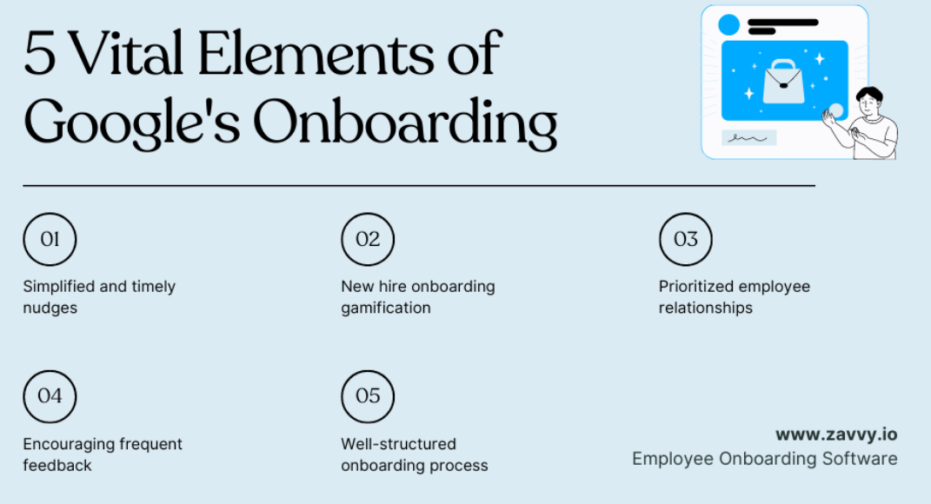
(Fig: 1.4: Source: https://www.zavvy.io/hr-examples/employee-onboarding-at-google)

Conclusions, with scope of Improvement
- Based on the analysis above, Google follows a “quiet” recruitment strategy and a mix of internal and external selection methods. They primary modus operandi of Google is Internal Selection Procedures, which include Internal Job Postings, Internal transfers, Intern/Trainee identification procedures with less emphasis on external recruitment.
- Google Follows advance HR Analytics to Manage and Maintain its vast talent pool, who are ever ready to join it. Google has gradually shifted from traditional HR operations to AI based recruitment. With the use of AI, there is a significant automation of difficult processes, which were previously done by humans manually (Abuladze, 2023).
- The onboarding in Google, assigns a mentor to the new hire, to make the process of acclimatization easier and extract maximum productivity from the new hire.

Recommendations
Based on the conclusions of this report, there is a significant scope of improvement in identified “recruitment, selection and onboarding” priority area:
Firstly, due to the dominant “quiet, discreet and internal” recruitment policy of Google the diversity, intercultural sensitivity or more importantly the balance “mix of employees” is greatly impacted. This policy should be revamped, and more inclusivity should be penetrated the organisation by deploying external recruitment procedures by hiring people from different backgrounds outside the organisation with methods like – Assessments, Psychometric Tests, Structures Interviews etc.

Secondly, Google has a large network of temporary external recruiters and agencies who are responsible for fetching talents from outside the organisation. This network is usually not well equipped, qualified and have low intellect in terms of identifying suitable candidates. This responsibility of these external recruiters should be taken over by permanent HRs in the company or the loyal and high performing recruiters should be given a permanent position in the company so that they can have a certainty on their future and can perform without the mindset of a mere “commission agent.”
Thirdly, there is huge focus on young talent for various positions. This deters and discourages experienced and senior professionals from applying for openings. There should be a separate program which should cater for experienced professionals and again a second separate scheme for senior professionals where, jobs should be tailored according to their age group and experience. This in turn will bring more loyal employees, reducing the training costs as they are already experienced and ultimately reducing attrition compared to young people, who hop jobs quickly.
Fourthly, Google has been using advanced HR analytics such as Artificial Intelligence to automate its recruitment. Although this strategy is good, but still the automated system does not have a human brain and it might kick out the deserving candidates even before getting a face-off with an in-person HR. So apart from having an Applicant Tracking System (ATS), Google should also have a manual procedure for highly specialized roles like Data Scientists, Business Analysts, Senior Software Developers etc.
Lastly, Google should have more non-technical roles concerning Corporate Social Responsibilities, Law, Customer Service. Job descriptions and criteria should be more clear and less automated, to avoid any biased and subjective decision making with more orientation programs for new hires and that too in a much practical way.

References
Abuladze, L. (2023) ‘SYNERGIC EFFECT OF GAMIFICATION AND ARTIFICIAL INTELLIGENCE IN THE PROCESS OF RECRUITING AND SELECTING CANDIDATES’. pp.1-12 Available at: https://bit.ly/41YuHtP (Accessed: 10th March 2023)
CIPD. (2022a) Recruitment: An Introduction. Available at: https://www.cipd.co.uk/knowledge/fundamentals/people/recruitment/factsheet#7034 (Accessed: 10th March 2023)
CIPD. (2022b) Induction Available at: https://www.cipd.co.uk/knowledge/fundamentals/people/recruitment/induction-factsheet#gref (Accessed: 10th March 2023)
Claus, L., (2019). ‘HR disruption—Time already to reinvent talent management’. BRQ Business Research Quarterly, 22(3), pp.207-215. Available at: https://journals.sagepub.com/doi/pdf/10.1016/j.brq.2019.04.002 (Accessed: 8th March 2023)
Downes, P. (2007) ‘Power Searching’. British Dental Journal, 202, pp. 657-667. Available at: https://www.nature.com/articles/bdj.2007.477 (Accessed: 7th March 2023)
Girard, B. (2009) The Google Way. San Francisco: No Starch Press. Available at: https://gestionhumana2010.files.wordpress.com/2010/03/the_google_way_-_how_one_company_is_revolutionizing_management_as_we_know_it_apr_2009.pdf (Accessed: 7th March 2023)
Google Careers, (no date) Our Hiring Process. Available at: https://careers.google.com/how-we-hire/ (Accessed: 10th March 2023)
Haller, J.B., Bullinger, A.C. and Möslein, K.M., (2011). ‘Innovation contests: an IT-based tool for innovation management. Business & Information Systems Engineering,’ 3, pp.103-106. Available at: https://link.springer.com/article/10.1007/s12599-011-0147-7 (Accessed: 10th March 2023)
Linh, N. (no date) WLP Case Study: Google Recruiting Tools “Wow” Recruiting Tools. Available at: https://www.academia.edu/8989873/WLP_Case_Study_Google_Recruiting_Tools_Wow_Recruiting_Tools (Accessed: 9th March 2023)
Lombardo, J. (2017) Google’s HRM: Recruitment, Selection, Retention Available at: https://panmore.com/google-hrm-recruitment-selection-retention (Accessed: 8th March 2023)
Main, K. (2022) Inc. Hiring Available at: https://bit.ly/3JpKFWh (Accessed: 8th March 2023)
McAfee, A., Brynjolfsson, E., Davenport, T.H., Patil, D.J. and Barton, D., (2012). ‘Big data: the management revolution’. Harvard business review, 90(10), pp.60-68. Available at: https://www.tarjomefa.com/wp-content/uploads/2017/04/6539-English-TarjomeFa-1.pdf (Accessed: 8th March 2023)
McNeill, M. (2020) How 5 Successful Companies Are Using HR Analytics Available at: https://bit.ly/3LfHWjQ (Accessed: 10th March 2023)
Michaels, E., Handfield-Jones, H. and Axelrod, B., (2001). The war for talent. Harvard Business Press. Available at: https://bit.ly/3l32W2r (Accessed: 8th March 2023)
Mothafar, N.A., Khokhar, M., Zehra, N., Khaskhelly, F.Z., Mirza, M.H. and Rafique, M.A., (2022). ‘Aligning Organization And Human Resource Management Practices For Business Strategy’. Journal of Positive School Psychology, pp.236-248. Available at: https://bit.ly/3Fh9v8t (Accessed: 10th March 2023)
Nagaraj, S.V., (2020). ‘Disruptive technologies that are likely to shape future jobs’. Procedia Computer Science, 172, pp.502-504. Available at: https://www.sciencedirect.com/science/article/pii/S1877050920314940 (Accessed: 9th March 2023)
Optimum1. (2017). Understanding the Different Recruitment Models. Available at: https://optimumrecruitment.co.uk/2018/08/29/understanding-the-different-recruitment-models/ (Accessed: 10th March 2023)
Rozario, S.D., Venkatraman, S. and Abbas, A., 2019. ‘Challenges in recruitment and selection process: An empirical study’. Challenges, 10(2), p.35. Available at: https://www.mdpi.com/2078-1547/10/2/35 (Accessed: 10th March 2023)
Schmidt, E. and Rosenberg, J. (2014) How google works. Hachette UK. Available at: https://drive.google.com/file/d/1ev3hc5Ur_q7ibUHKEozNWgAMWUPOyYB5/view?usp=sharing (Accessed: 10th March 2023)
Scott, Virginia A. (2008) Google. Connecticut: Greenwood Press. Available at: https://bit.ly/3JlOL1O (Accessed: 7th March 2023)
Shafique, O., (2012). ‘Recruitment in the 21st Century’. Interdisciplinary journal of contemporary research in business, 4(2), pp.887-901. Available at: https://papers.ssrn.com/sol3/papers.cfm?abstract_id=2325900 (Accessed: 10th March 2023)
StudyCorgi. (2023). Google HR Practices & Google HRM. Available at: https://studycorgi.com/google-company-strategic-human-resources-management/ (Accessed: 10th March 2023)
Stumbles, T. (2017) History of Google Timeline. Updated on July 19, 2022. Available at: https://www.officetimeline.com/blog/google-history-timeline (Accessed: 8th March 2023)
Sullivan, J. (2006) A Case Study of Google Recruiting. Available at: https://drjohnsullivan.com/articles/a-case-study-of-google-recruiting/ (Accessed: 9th March 2023)
Thompson, A. (2019) Googles’ generic strategy (Porter’s)& Intensive growth strategies. Available at: https://bit.ly/3F5oWkc (Accessed: 8th March 2023)
Tran, S.K., (2017). ‘GOOGLE: a reflection of culture, leader, and management.’ International Journal of Corporate Social Responsibility, 2, pp.1-14. Available at: https://link.springer.com/article/10.1186/s40991-017-0021-0 (Accessed: 7th March 2023)
Umoh, R. (2018) Top Google recruiter: Google uses this ‘shocking’ strategy to hire the best employees. Available at: https://www.cnbc.com/2018/01/10/google-uses-this-shocking-strategy-to-hire-the-best-employees.html (Accessed: 8th March 2023)
van Gelder, M.M., van de Belt, T.H., Engelen, L.J., Hooijer, R., Bredie, S.J. and Roeleveld, N., (2019). ‘Google AdWords and Facebook ads for recruitment of pregnant women into a prospective cohort study with long-term follow-up’. Maternal and Child Health Journal, 23, pp.1285-1291. Available at: https://link.springer.com/article/10.1007/s10995-019-02797-2 (Accessed: 10th March 2023)
Vejaratnam, N., Peng, T.S., Ramlie, N.M.M.N., Harlina, E., Paramsivam, T. and James, S.D., (2022) ‘Recruit, Train and Evaluate Human Capital: A case study in Google.’ Empirical Economics Letters, 21(1), pp. 1-10. Available at: https://www.researchgate.net/profile/Nava-Ratnam-2/publication/366005106_Recruit_Train_and_Evaluate_Human_Capital_A_case_study_in_Google/links/638d6dd42c563722f23c62cc/Recruit-Train-and-Evaluate-Human-Capital-A-case-study-in-Google.pdf (Accessed: 7th March 2023)
Verge Staff (2018) Google turns 20: How an internet search engine reshaped the world. Available at: https://www.theverge.com/2018/9/5/17823490/google-20th-birthday-anniversary-history-milestones (Accessed: 7th March, 2023)
Vise, D. (2007) The Google Story, Strategic Direction, Vol. 23 No. 10. Available at: https://www.emerald.com/insight/content/doi/10.1108/sd.2007.05623jae.001/full/html (Accessed: 7th March, 2023)
Vozza, S. (2017) Why Employees At Apple And Google Are More Productive. Available at: https://www.fastcompany.com/3068771/how-employees-at-apple-and-google-are-more-productive (Accessed: 9th March 2023)
West, M. (2016) Ideo: The 7 Most Important Hires For Creating A Culture Of Innovation. Available at: https://www.fastcompany.com/3059062/from-ideo-7-people-you-need-to-create-a-culture-of-innovation (Accessed: 9th March 2023)
Zavvy (no date) How Google Onboards New Hires (And How You Can Easily Replicate It) Available at: https://www.zavvy.io/hr-examples/employee-onboarding-at-google (Accessed: 10th March 2023)

