

LOCATION: Swansea | LLEOLIAD: abertawe
LEVEL 5 | LEFEL 6
EXAMINATION PERIOD | CYFNOD ARHOLIADAU
May 2018 | Mai 2018

MODULE CODE: M6X01113
WAN
TIME: 2 HOURS

Name :

Student ID :

Date & Time :

This is an individual practical lab-test, held under examination conditions. You will be assigned two Switches and three Routers; you should configure these devices based on the given specifications.

This paper is marked out of 90.

Topology
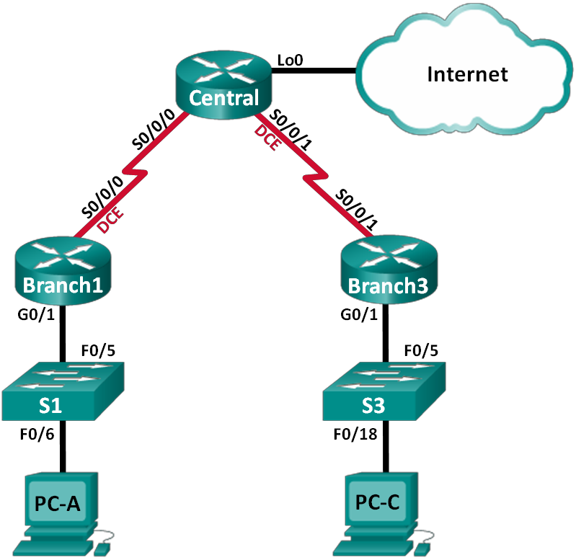

Addressing Table

Device | Interface | IP Address | Subnet Mask | Default Gateway
Branch1 | G0/1 | 192.168.1.1 | 255.255.255.0 | N/A
 | S0/0/0 (DCE) | 10.1.1.1 | 255.255.255.252 | N/A
Central | S0/0/0 | 10.1.1.2 | 255.255.255.252 | N/A
 | S0/0/1 (DCE) | 10.2.2.2 | 255.255.255.252 | N/A
 | Lo0 | 209.165.200.225 | 255.255.255.224 | N/A
Branch3 | G0/1 | 192.168.3.1 | 255.255.255.0 | N/A
 | S0/0/1 | 10.2.2.1 | 255.255.255.252 | N/A
PC-A | NIC | 192.168.1.3 | 255.255.255.0 | 192.168.1.1
PC-C | NIC | 192.168.3.3 | 255.255.255.0 | 192.168.3.1

Task 1: Cable the network as shown in the topology. (8 Marks)
Before proceeding, have your cabling verified by the examiner.
Instructor Sign-off: ______________
Task 2: Configure basic settings for each router. (25 Marks)
- Disable DNS lookup.
- Configure the device name.
- Encrypt plain text passwords.
- Create a message of the day (MOTD) banner warning users that unauthorized access is prohibited.
- Assign class as the encrypted privileged EXEC mode password.
- Assign cisco as the console and vty password and enable login.
- Set console logging to synchronous mode.
- Apply the IP addresses to Serial and Gigabit Ethernet interfaces according to the Addressing Table and activate the physical interfaces.
- Set the clock rate to 128000 for DCE serial interfaces.
- Create Loopback0 on the Central router to simulate access to the Internet and assign an IP address according to the Addressing Table.
- Copy the running configuration to the startup configuration.

Task 3: Configure routing. (12 Marks)
- Enable single-area OSPF on the routers and use a process ID of 1. Add all the networks, except 209.165.200.224/27 into the OSPF process.
- Configure a default route to the simulated Internet on the Central router using Lo0 as the exit interface and redistribute this route into the OSPF process.

Task 4: Configure the PCs. (6 Marks)

Assign IP addresses and default gateways to the PCs according to the Addressing Table.

Task 5: Change the serial encapsulation to PPP. (10 Marks)
- Change the encapsulation on the serial interfaces, of each of the routers, from HDLC to PPP.

Task 6: Configure PPP CHAP authentication for the link between the Central router and the Branch1 and Branch 3 routers.
- Configure the username for CHAP authentication and a password of cisco. (12 Marks)

Task 7: Verify Layer 3 connectivity. (10 Marks)

Routers | Result

PC-A to PC-C

PC-A to Branch1

PC-A to Central

PC-A to Branch3

PC-A to Internet

PC-C to PC-A

PC-C to Branch3

PC-C to Central

PC-C to Branch1

PC-C to Internet

Task 8: (7 Marks)
- Why is preferable to use PAP over CHAP?

Submission Requirement
On each device, issue the following commands and capture the configurations. Save the file as devicename_surname_Pno.txt.

show run
show ip protocols
show ip ospf neighbor
show ip route ospf
show ip ospf interface

All documentation for your solution should be submitted via USB.
It is your responsibility that you copy all the outputs and files correctly.

