Enhancing Health and Wellbeing Using Digital Skills

(BMDS7001)

Reflective account – Multi stakeholder working
2113358

Word count 1640

Reflection is an important part of personal development and growth for health and social care professionals. There is an emphasis on self-directed learning and personal responsibility which is underpinned by reflective practice (Davies, 2012).Reflective practive allows individuals to identify what went well and what areas need improvement in a given situation. However, fundamentally reflection is futile without it leading to action (Sibiya, Govinder, & Mahlanze, 2015) and therefore reflective practice should underpin all health and social care to ensure the highest quality outcomes are achieved for patients (Tanguay, 2020).
For the purposes of this essay I have chosen to use Gibb’s Reflective Cycle (figure 1) as a self-reflection tool for its ability to enable systematic, methodical reflection which suits my personal preferences. Gibb’s Reflective Cycle leads an individual through six stages. I often avoid reflecting on my own feelings within a learning experience preferring to focus on any positive outcomes. Gibbs Cycle ensures all components are considered.
This reflection explores how my experiences of stakeholder engagement would underpin multi and inter-disciplinary stakesholders to design and implement a digital solution to support the Tobacco Control Delivery Plan (2022) (Welsh Government, 2021)
Figure 1 Gibbs Reflective Cycle 1988
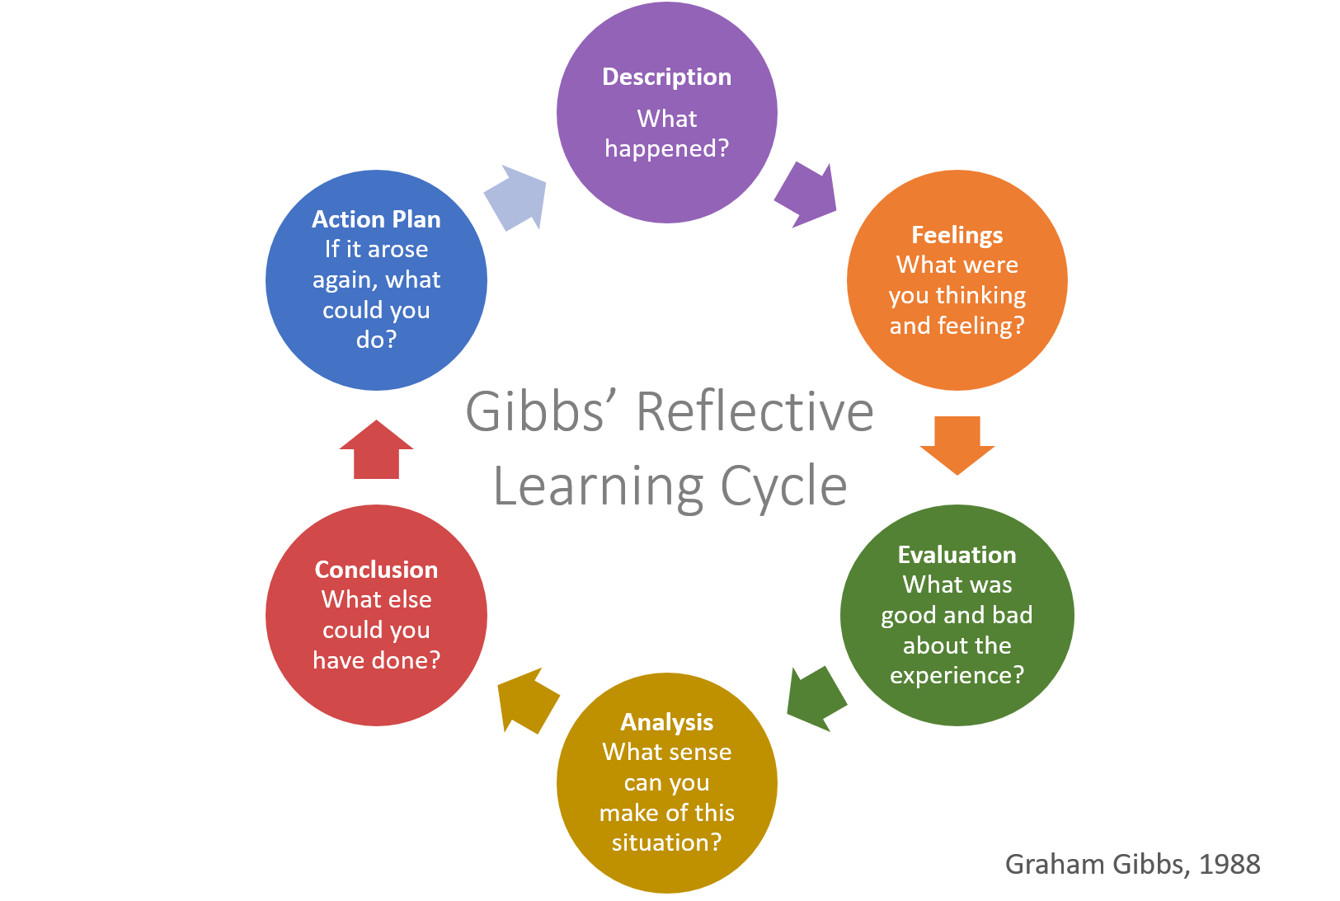

Description
The Tobacco Control Delivery Plan 2022 (Welsh Government, 2021) describes the plans to reduce the prevalance of smokers in Wales to less than 5%. Wales‘ smoking cessation services, ‘Help Me Quit’, currently provide support for 12 weeks including 6 weeks of behaviour change therapy and 6 weeks of nicotine replacement therapy.
There are a number of digital applications to support smoking cessation. These are generic and costly. In order to support smoking cessation in the age group 25-34 years I proposed a digital application that offers a personalised experience. The client would have direct access to their ‘Help Me Quit’ practitioner via a bespoke smoking cessation programme. (Zhihui, Xitao, & Jianxia, 2017) (Frewer, et al., 1998) (Lolich, et al., 2019) (Abdelrahman, et al., 2020)Practitioners would have a dashboard to enable remote monitoring and support of clients, as well as efficient objective data collection.
To support the design and build of the bespoke digital application and dashboard I identified a number of stakeholders that would be included and reviewed their level of interest in the project and level of influence (figure 2).
Figure 2 Stakeholder Map
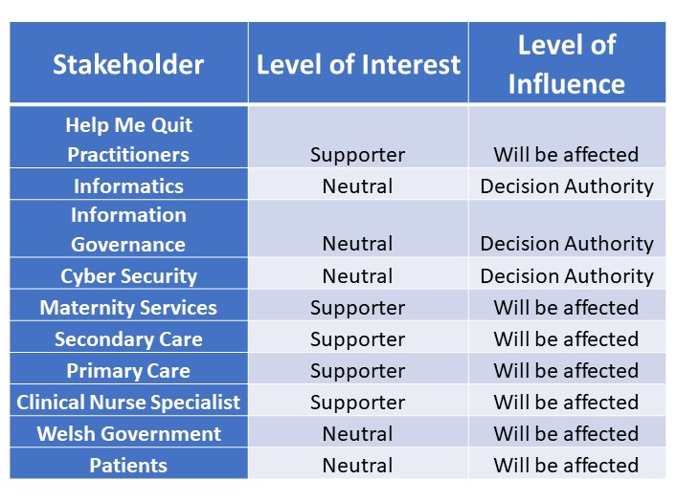

Feelings
I have managed several projects in the past which have required stakeholder engagement including implementing a remote monitoring system for care home residents. This was an exciting initiative that I had been keen to support for some time. I was left disappointed due to the failed stakeholder engagement which led to project failure. I felt frustrated that the service did not embrace the benefits of using digital technology during a time when remote monitoring was increasingly necessary during the context of a global pandemic. I think that my excitement drove me to focus on the digital solution and abandon early stakeholder engagement. I believe that others within the team felt confused by the introduction of digital technology at a time of significant pressure and change within health and social care. I observed their feelings of apathy towards the project which deflated my own enthusiasm. Stakeholders demonstrated disappointment that the solution was to support and supplement their offer to care homes rather than to reduce workload.
Given my feelings of despondency, it would be easy to have been put off engaging stakeholders to consider digital solutions. However, as an individual who focuses on learning opportunites I used the experience as a vehicle of change. I felt strongly that early stakeholder engagement in a project would be criticial to its success and this has become evident in a more recent project I have managed utilising wearable devices as part of a falls prevention scheme. Early stakeholder engagement led to stakeholders taking ownership of the project and led to timely project implementation. Obstacles were overcome through stakeholder passion and determination. Recognising the success that early stakeholder engagement had on the project led to me feeling relief that I could achieve project success. I also felt excited, not by my own success but by the enthusiasm and engagement of others resulting in positive outcomes for patients quality of life.
Early stakeholder engagement in a project is well documented as being a risk management strategy (Walker, 2008) which reflects my own experience. However, stakeholder mapping and engagement can lead to risk of bias which can be mitigated by considering interest and influence (Varvasovsky & Ruairí, 2000)
Evaluation and Analysis
My engagement with stakeholders for projects has been varied. I am creative and innovative in my approach to engagement. For example, in one multi-agency project I placed questions in balloons and stakeholders popped a balloon and answered the question. Occasions where I have embraced this creative streak I have has seen my most successful engagement in projects and stakeholders have remained engaged and interested throughout the life cycle of the project.
I have identified that when I introduce or implement a digitial solution there is a tendency for me to engage well with staff at the early stages but this can peter out as the project progresses. This could be in part a reflection of my own personality where I enjoy the excitement of a new initiative.
I have recognised that individuals have varying attitudes, capabilities and confidence in using digital technology. In health and social care it is often considered a low priority and hindrance to patient care and therefore stakeholders are reluctant to put the effort into troubleshooting possible issues which may arise during the implementation stage (Lolich, et al., 2019).
One of the challenges with stakeholder engagement I have encountered in numerous projects within multi-agency health and social care is that often innovation and transformation are expected to be delivered alongside individual and team day jobs without ringfenced capacity to support these initiatives. This can lead to stakeholders disengaging from the process (Ward, et al., 2008) and has also influenced my own capacity to progress a project or an idea at the pace needed to sustain momentum.
One of my strengths is my ability to network across organisations and identify key individuals who can support the development of a digital improvement. This has proved to be extremely beneficial as I have been able to integrate these networks with learning opportunities. As such, I am well versed in some of the cyber security and information governance requirements needed prior to procuring or developing a digital solution. This has given me confidence to question and challenge digital platform providers and provided information governance and cyber security teams with assuarance when I broach them with an idea or concept and thus ensures their commitment to a project from its inception. (NHS Wales, 2022) recommends the need for early support from information governance and cyber securtiy in implementing digital solutions within health care.
I have noticed that across agencies there are often differing priorities and perspectives when it comes to digital solutions. This was particularly evident on one project I managed to implement an intelligent electronic scheduling and monitoring system. Local authority stakeholders were enthused by the project and embraced a more efficient way of working whereas Health Board employees were more resistant to introducing what they viewed as a redundant solution with little added value. This led to some individuals taking a backseat during working group meetings and others being particularly outspoken. This was challenging to manage at times and smaller task and finish groups were needed to ensure that all individuals had an opportunity to express and share their views. Understanding and using a framework to manage the various personalities within a group may have been beneficial in ensuring inclusivity for all stakeholders (Herbert-Read, 2017). A clear governance structure would also have enabled escalation of issues and provided updates on project progress in line with (Too & Weaver, 2014) recommendations for project governance frameworks.
Conclusion
There have been many learning points from my personal experience that align with what the literature says about stakeholder engagement best practice. One of the key learning points for me has been the need to engage with stakeholders early and ensure and maintain a robust communication plan (Butt & Savolainen, 2016). This ensures that it is clear what outcomes will be expected and maintains momentum (Bourne, 2015). There is also a need to ensure that there are communication feedback structures in place. This allows all stakeholders to have the opportunity to participate inclusively to prevent groupthink mentality (Bang, 2017).
In terms of my own self development and learning, a critical learning point for me has been to ensure that I am clear about my own role in project management and enforce expectations and boundaries. On occasion, I have become too invested in supporting the operational implementation of the project due to my own tendency towards people pleasing and a reluctance to say ‘no’, particularly when I have the skillset to support. In order to develop this skill within myself I have sought mentorship from more senior and experienced project managers within my organisation. It would also be beneficial to explore coaching to unpick and understand how I can be more assertive in saying no and maintaining role boundaries.
Action Plan
Based on my previous experience, new learning and reflections I have been able to ensure there is an action plan in place whereby a sustainable stakeholder engagement plan is in place in developing and implementing a bespoke smoking cessation digital application for smokers aged 25-34 year olds.
This action plan can be seen below (Figure 3)
Figure 3 Action Plan
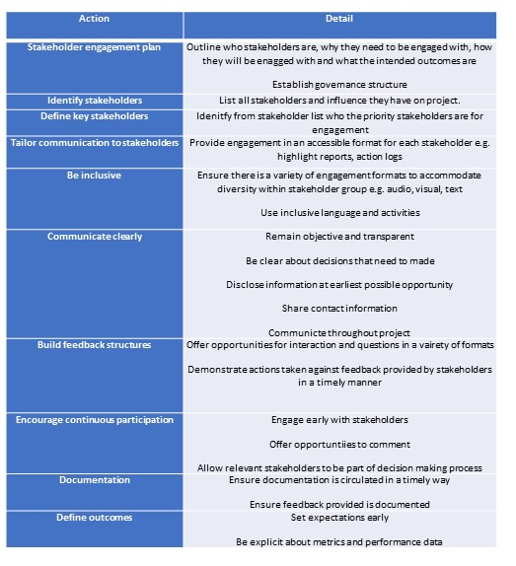
Whilst this action plan outlines the steps I would take to manage an upcoming project for smoking cesstion. Reflection also dictates that there are personal outcomes and an action plan based on my learning needs (Sibiya, et al., 2015). This action plan is outlined below (Figure 4)
Figure 4 Learning needs
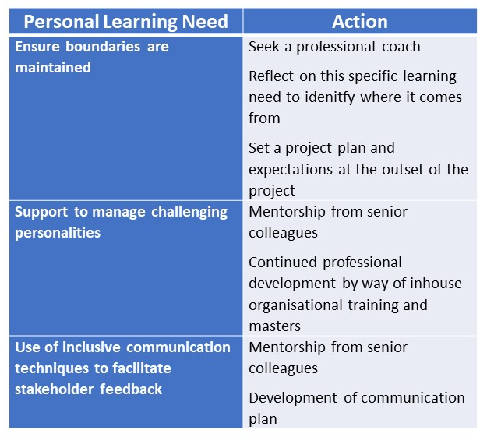

References
Abdelrahman, N. G. et al., 2020. Brain health:Attitudes towards technology adoptation in older adults. Healthcare, 23(1).
Argyris, C., 1991. Teaching smart people how to learn.. Havard Business Review., 69(3), pp. 99-109.
Bang, D. F. C., 2017. Making better decisions in groups. The Royal Society Open Science , 4(8).
Bourne, L., 2015. The three types of stakeholder communication. PM World, 4(9), pp. 1-5.
Butt, A. & Savolainen, J., 2016. Project change stakeholder communication. International Journal of Project Management, 34(8), pp. 1579-1595.
Davies, S., 2012. Embracing reflective practice. Education for Primary Care, 23(1), pp. 9-12.
Frewer, L. J., Howard, C. & Shepherd, R., 1998. Understanding public attitudes to technology. Journal of risk reseach, 1(3), pp. 221-235.
Gibbs, G., 1988. Learning by doing a guide to teaching and learning methods. London: FEU.
Greggs, V., Holden, R., Lawless, A. & Rae, J., 2018. From reflective learning to reflective practice: assessing transfer. Studies in higher education (Dorchester-on-Thames), 43(7), pp. 1172-1183.
Herbert-Read, J., 2017. Social Behaviour: The personalities of groups. Current Biology, 27(18), pp. 1015-1017.
Hydrie, M. Z. I., Naqvi, S. M. Z. H., Alam, S. N. & Jafry. , S. I. A., 2021. Kolb's Learning Style Inventory 4.0 and its association with traditional and problem based learning teaching methodologies in medical students. Pakistan Journal of Medical Sciences Quarterly; Karachi, 37(1), p. 145.
Lolich, L., Ricco, I., Deusdad, B. & Timonen, V., 2019. Embracing technology? Health and Social care professionals attitudes to development of e-health initiatives in elder care services in Catalonia and ireland. Technology forecasting and Social change, Volume 147, pp. 63-71.
Lolich, L., Ricco, I., Deusdad, B. & Timonen, V., 2019. Embracing technology? Health and Social care professionals' attitudes to the deployment of e-health initiatives in elder care services in Catalonia and Ireland. Elsevier, Volume 147, pp. 63-71.
NHS Wales, 2022. Cyber, information governance and data protection. [Online]
Available at: https://digital.nhs.uk/services/internet-first/internet-first-guidance/cyber-information-governance-and-data-protection-guidance
[Accessed 5 June 2022].
P, L., 2008. Reflecting on events. Emergency Nurse (through 2013), 15(9), pp. 16-8.
Sibiya, M. N., Govinder, S. & Mahlanze, H. T., 2015. Guided reflection a valuable tool for improving undergrauate student nurses levels of reflection teaching and learning in health care professions. African Journal for physical health education, recreation and dance, 21(1), pp. 396-408.
Tanguay, E. H. P. &. M. B., 2020. Reflective Writing for Nursing, Health and Social Work. s.l.:Bloomsbury Publishing.
Too, E. G. & Weaver, P., 2014. The Managment of project management: A conceptual framework for project governance. International journal of project managment, 32(8), pp. 1382-1394.
Varvasovsky, Z. & Ruairí, B., 2000. Stakeholder analysis.. Health policy and planning, 15(3), pp. 338-345.
Walker, D. H. T. B. L. M. &. S. A., 2008. Influence, stakeholder mapping and visualisation.. Construction management and economics, 26(6), pp. 645-658.
Ward, R., Stevens, C., Brentnall, P. & Briddon, J., 2008. The attitudes of health care staff to information technology: a comprehensive review of the research literature. Health information & Libraries Journal, 25(2), pp. 81-97.
Welsh Government, 2021. Tobacco control delivery plan for Wales 2022-2024. [Online]
Available at: https://gov.wales/sites/default/files/consultations/2021-10/tobacco-control-delivery-plan-2022-to-2024.pdf
[Accessed 12 May 2022].
Zhihui, C., Xitao, F. & Jianxia, D., 2017. Gender attitudes toward technology use: A Meta-analysis. Computers & Education, 105(1), pp. 1-3.

