UNIVERSITY OF WALES TRINITY SAINT DAVID
LONDON

Managing People LCBB5004
ASSIGNMENT 2

Report for Employee Engagement

Submitted to: Submitted by:
Dr Olusoyi Richard Ashaye Nadya Zarankova
1914056

Table of Contents

Introduction 3
Reviews the concept and drivers of employee engagement 3
Figure 1. Stages of the typical performance management system 4
Figure 2. Drivers of Engagement 5
Evaluates diagnostic tools to measure the engagement 5
Table 1. Indicator for measuring personal suggestions 7
Constructs an employee value proposition 7
Figure 3. Employee Happiness at Work 8
Conclusions and recommendations 8
References 10

Introduction
The management of employees and their achievements must be carried out by an integrated mix system built on the basis of a managerial approach. An approach that combines modern human resource management measures and considers the imposed changes from the external environment - Covid - 19 situation. The pandemic has shifted the focus of people management by replacing it with a variety of technological solutions - work from home. This to some extent, regulates performance, but in a longer process reduces the feeling of happiness in employees, their sense of belonging to the company and ultimately their productivity. This performance proves crucial for performance management.
Disclosure of the content of the performance management system requires the identification of the main owners of the performance management process. It requires a two-way connection between employees and the objects of their work - consumers and customers of the company. This system must reflect in the most modern way all trends in the management of people's behaviour, taking into account their own needs and providing them with a plan for personal purposes. Thus, their professional happiness, working hours, and sense of corporate belonging, expressed in the organisation's company culture, are highly engaged.

Reviews the concept and drivers of employee engagement
Employee engagement is directly involved in the company's success. That is why managers who manage to motivate their employees to work in such a way as to achieve ultimate success are more than successful. This would be possible only when the personal goals of the employees are closely linked to the strategic goals of the organisation. In other words, every employee must be aware of their role in achieving the ultimate goal. Only in this way they would be sufficiently motivated to work. But in order to achieve this ambitious goal, it is important to achieve some tasks like:
1. A clear definition of employee engagement must be provided, leading to clear understanding and cooperation at all levels;
2. The role of each employee in the organisation should be recognised by providing career development opportunities.
The first task will be considered in two main directions. The definition of practice and the definition of employee engagement in theoretical research environments will be derived.
Prominent authors (Beardwell & Thompson, 2017, p. 416) in the field of human resources argue that the best definition is given by the CIPD Institute for Human Resources Practitioners. According to them, the commitment of employees is:
"A combination of commitment to the organisation and its values plus a willingness to help out colleagues (organisational citizenship). It goes beyond job satisfaction and is not simply motivation. Engagement is something the employee has to offer: it cannot be 'required' as part of the employment contract. "
From this position it is clear that employees must be more than motivated to work. This is the task of their immediate superiors, but human resources managers also come to the rescue. Together with their help, two main things must be achieved, such as:
1. Familiarisation and presentation to employees of the strategic goals of the organisation - the goals should be SMART. The SMART goals include the deadlines for implementation, the content of what needs to be achieved, the resources that the goal will require, indicators for the feasibility of the goals, as well as exactly who should achieve them (Griffin, 2008).
2. Clarify the role of employees and how they are directly involved in achieving these goals. In order to achieve this condition, there must be a clearly established performance management system that is built into the organisational activity. In general, this system is presented in detail in Figure 1 (Torringhton, et al., 2014, p. 200) It is clear from the figure that the performance management system has four main levels.

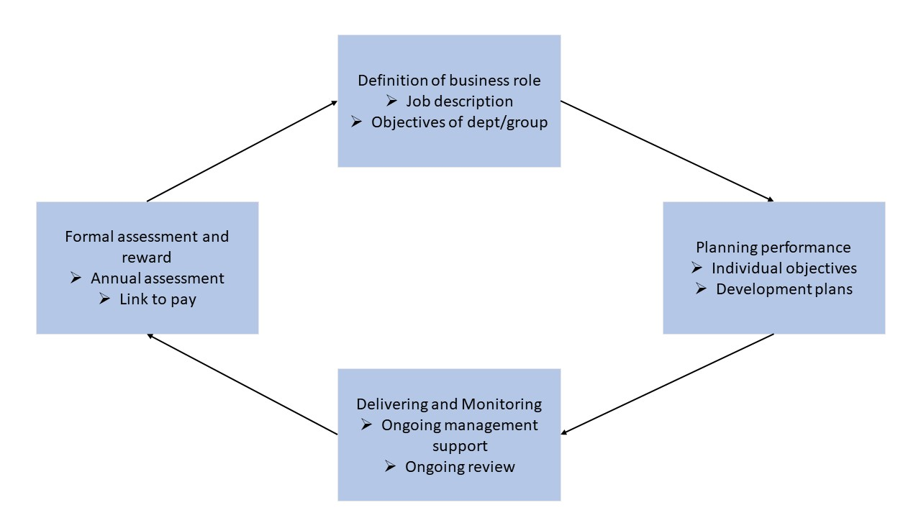

Figure 1. Stages of the typical performance management system

The second task requires that each employee be set immediate goals and objectives that directly reflect the organisational strategic goals. The ability to do this means that employees are assigned to one of the three main dimensions. They are as follows:
- "a physical component ('I exert a lot of energy performing my job');
- an emotional component ('I really put my heart into my job');
- a cognitive component ('Performing my job is so absorbing that I forget about everything else')." (May, et al., 2004).
Ultimately, it is most important to consider the drivers through which the process of supporting and measuring employee performance takes place. These drivers are visible in Figure 2 (Robinson, et al., 2004, p. 22).
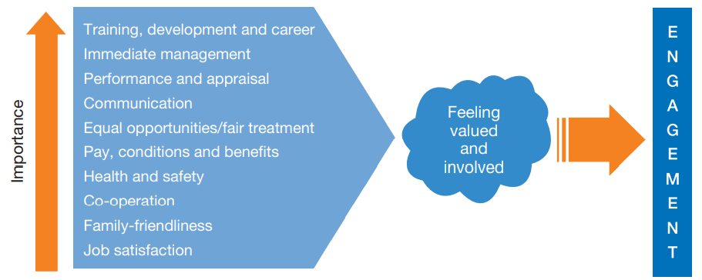

Figure 2. Drivers of Engagement

What has been written so far does not claim to be exhaustive, but it provides a good starting point for revealing the nature of the reasons for employee engagement.

Evaluates diagnostic tools to measure the engagement
To achieve the organisational goals, it is necessary for each employee - following the example of a road map, to clearly set SMART goals. This requirement is related to the ability of employees to be aware of their tasks and the managers who manage them to have clear rules in which to assess what has been achieved so far. This is the only way to answer the questions: Is everything done according to plan? Is it possible that omissions have been achieved? Is it covered the whole activity? Is it possible to set optimal goals?
The answers to the questions asked to require some basic things to be done by the managers. First, a reliable performance management system must be built with a clear structure and functionality. Second, to clearly distinguish the methods by which the performance of workers will be monitored. Third, define criteria for encouragement and penalties. Fourth, to determine in which managerial powers this system will be built - the line managers or the human resources managers.
There are two main approaches to performing these tasks and answering the questions asked. The first approach in which a system for employee engagement is formally built. The activities of managers directly influence this system it is in their competence to create a highly engaged workforce (Beardwell & Thompson, 2017, p. 436). For this purpose, it is necessary to build:
● Align efforts with strategy.
● Empower employees.
● Promote and encourage teamwork and collaboration.
● Help people grow and develop.
● Provide support and recognition where appropriate.
These are the main elements of the engagement management system. In terms of content, they also include: a sustainable work environment, a value culture that reflects the company's policy, effective interaction between the workforce and management, as well as the ability to adequately measure the results achieved.
The second approach is directly related to the development of informal methods for monitoring and evaluation of employee engagement such as:
- Coaching method for managing and evaluating engagement. This is a well-developed method in which managers use a number of techniques and focus on gaining experience for practical skills and abilities (Mind Tools Ltd, 2018).
- Formal monitoring - review / evaluation is required once or twice a year to assess the extent to which the objectives have been achieved. Here both groups - managers and workers need to get information. Managers on employee progress. Employees on organisational goals and possible changes (McDonnell & Gunnigle, 2017).
- Method 360 degree in which information is collected from all possible channels. This is the so-called multi evaluative feedback. Even the employees themselves give their opinion on their work. For the needs of this method it is required to use a full range of sources of information - managers, colleagues, stakeholders, customers, peers (Kanaslan & Iyem, 2016).
A modern indicator for measuring personal suggestions is shown in Table 1 (Armstrong & Taylor, 2014). The table presents a form - an assessment of the development of each person.

Table 1. Indicator for measuring personal suggestions
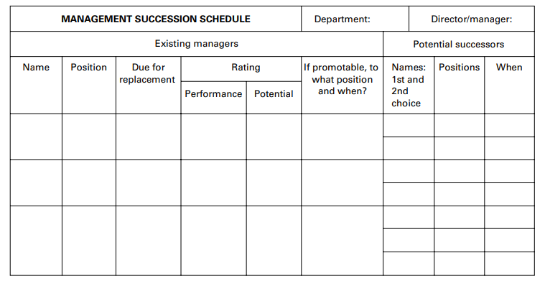
In general, any method that assesses employee performance should provide quantitative or qualitative information on the results achieved. These methods are a combination of both types and provide managers with quantitative and qualitative information. Based on it, decisions are made about the results, penalties and incentives.

Constructs an employee value proposition
The main rewards for achievements in work can be grouped into non-financial (promotion, reputation building among colleagues, social benefits, discounts, additional health and pension insurance) and financial (bonus schemes, extra pay, vouchers). Regardless of the type of rewards, human resource management practitioners are adamant that the best incentives and rewards come from the workers themselves. For example, a person who is 20 years old and starting work for the first time will strive much more for career growth and non-financial incentives, while a person who is 60 years old will be much more satisfied with additional pension and health insurance.
Therefore, it is not wrong to say that efficiency management is directly related to human resources and not human resources management. The involvement of line managers together with human resources managers and the workers themselves in building the performance management system is the basis of recent success and leads to positive results for all three groups.
In 2012, the UK conducted one of the largest surveys of employees in the private and public sectors (MacLeod & Clarke, 2009). Thanks to this study, 11 separate levels are categorised to determine the mental health of employees in the workplace. By setting these levels, employees can be more productive. Those with higher levels of mental health are more productive, efficient and purposeful. People with lower levels of mental health are in exactly the opposite state.
There is a direct link between the happiness of employees and their productivity in the workplace. That is why this index must be constantly measured. As in Figure 3 (Knudsen, 2021), it is possible to see what the index of happiness for 2021 is. It is necessary to take into account the fact that for the last almost two years people have been locked in their homes almost all the time by the Covid pandemic - 19 or had quite restrictive freedoms of movement. This sharply reduces the happiness index.
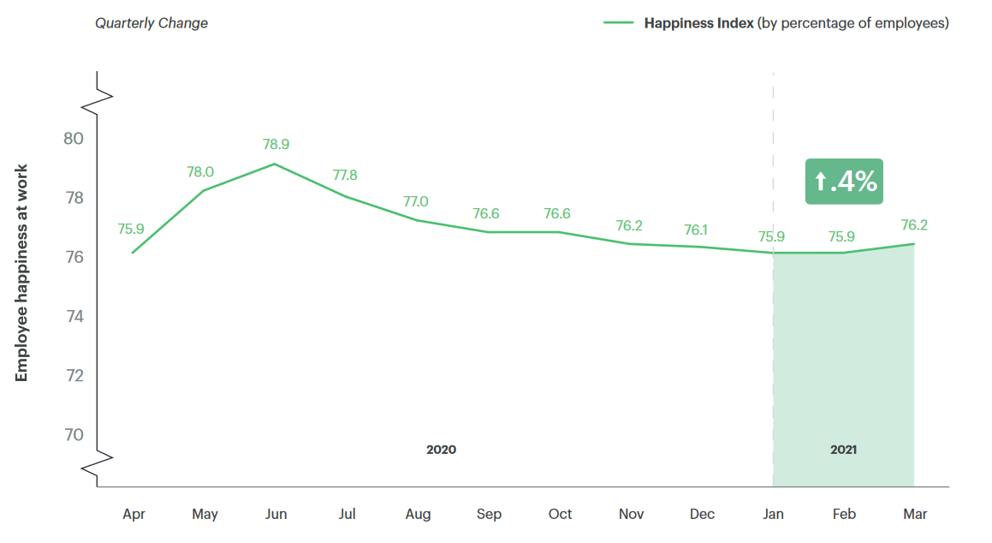

Figure 3. Employee Happiness at Work

On the other hand, it has been proven that employee performance is directly related to customer satisfaction with service (Vance, 2006). In other words, if customers are satisfied and employees are more motivated to work.

Conclusions and recommendations
Managing employee achievement is a process that is related to achieving the end results. In this process, the company's managers must have a very clear idea of ​​the role and responsibilities of each employee. Likewise, employees themselves must have a very clear idea of ​​their personal goals and how they fit into the organisation's strategic goals. On the other hand, one must be aware of who owns the performance management process - line managers or human resources managers. Therefore, a well-established system for managing the achievements of workers to be built by three groups of employees - human resources managers, line managers and workers should comply with the following recommendations:
1. This system must include activities to evaluate each aspect of performance.
2. To assess and prevent the possibilities for conflicts that have arisen, as managers must have a dual role of evaluators but also of executors of rewards and punishments.
3. In addition to individual performance, team performance should be measured. Collective synergy leads to much more effective results than individual work.
4. The individual goals, collective goals and strategic goals of the company must be developed synchronously and not in conflict.

References

Armstrong, M. & Taylor, S. (2014). Armstrong's Handbook of Human Resource Management Practice. 13th ed. London: Kogan Page .
Beardwell, J. & Thompson, A. (2017). HUMAN RESOURCE MANAGEMENT. 8th ed. London: Pearson.
Griffin, R. (2008). Fundamentals of management. 5th ed. Mason: Cengage Learning.
Kanaslan, E. & Iyem, C. (2016). 360 Degree Feedback Appraisal an Effective Way of Performance Evaluation?. International Journal of Academic Research in Business and Social Sciences, May, 6(5), pp. 172-182.
Knudsen, E. (2021). Employee Well-Being Report, London: Glint.
MacLeod, D. & Clarke, N. (2009). Engage for Success, London: Engage for Success.
May, R., Gilson, R. & Harter, . M. (2004). The psychological conditions of meaningfulness, safety and availability and the engagement of the human spirit at work. Occupational and Organisational Psychology, 77(3), pp. 11-37.
McDonnell, A. & Gunnigle, P. (2017). Performance management, London: Research Gate.
Mind Tools Ltd (2018). How to Coach: a Manager's Guide, London: Mind Tools Ltd.
Robinson, . D., Perryman,, S. & Hayday, S. (2004). The Drivers of Employee Engagement Report 408. 1st ed. Brighton: IES.
Torringhton, D., Hall, L. & Taylor , S. (2014). Human Resource Management. Ninth ed. London: Prentice Hall Europe.
Vance, R. (2006). Employee Engagement and Commitment. 1st ed. Washinghton: SHRM Foundation.

