DS 1 Alvin Dos Santos

My Screenshots/Photos

Screenshot/Photo 1
[Insert Photo/Screenshot below]
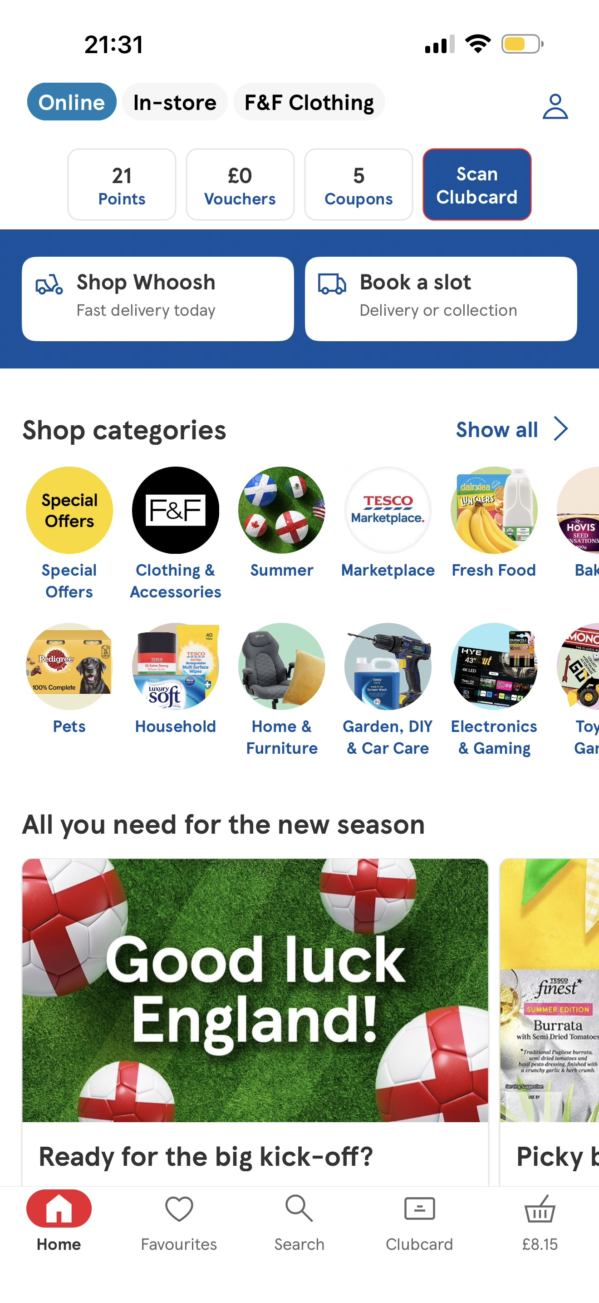
[I use Tesco it is very convenient for my grocery shopping sometimes if I go to the shop I might not get I want so it is easy to order from the Tesco app.

Screenshot/Photo 2
[Insert Photo/Screenshot below]
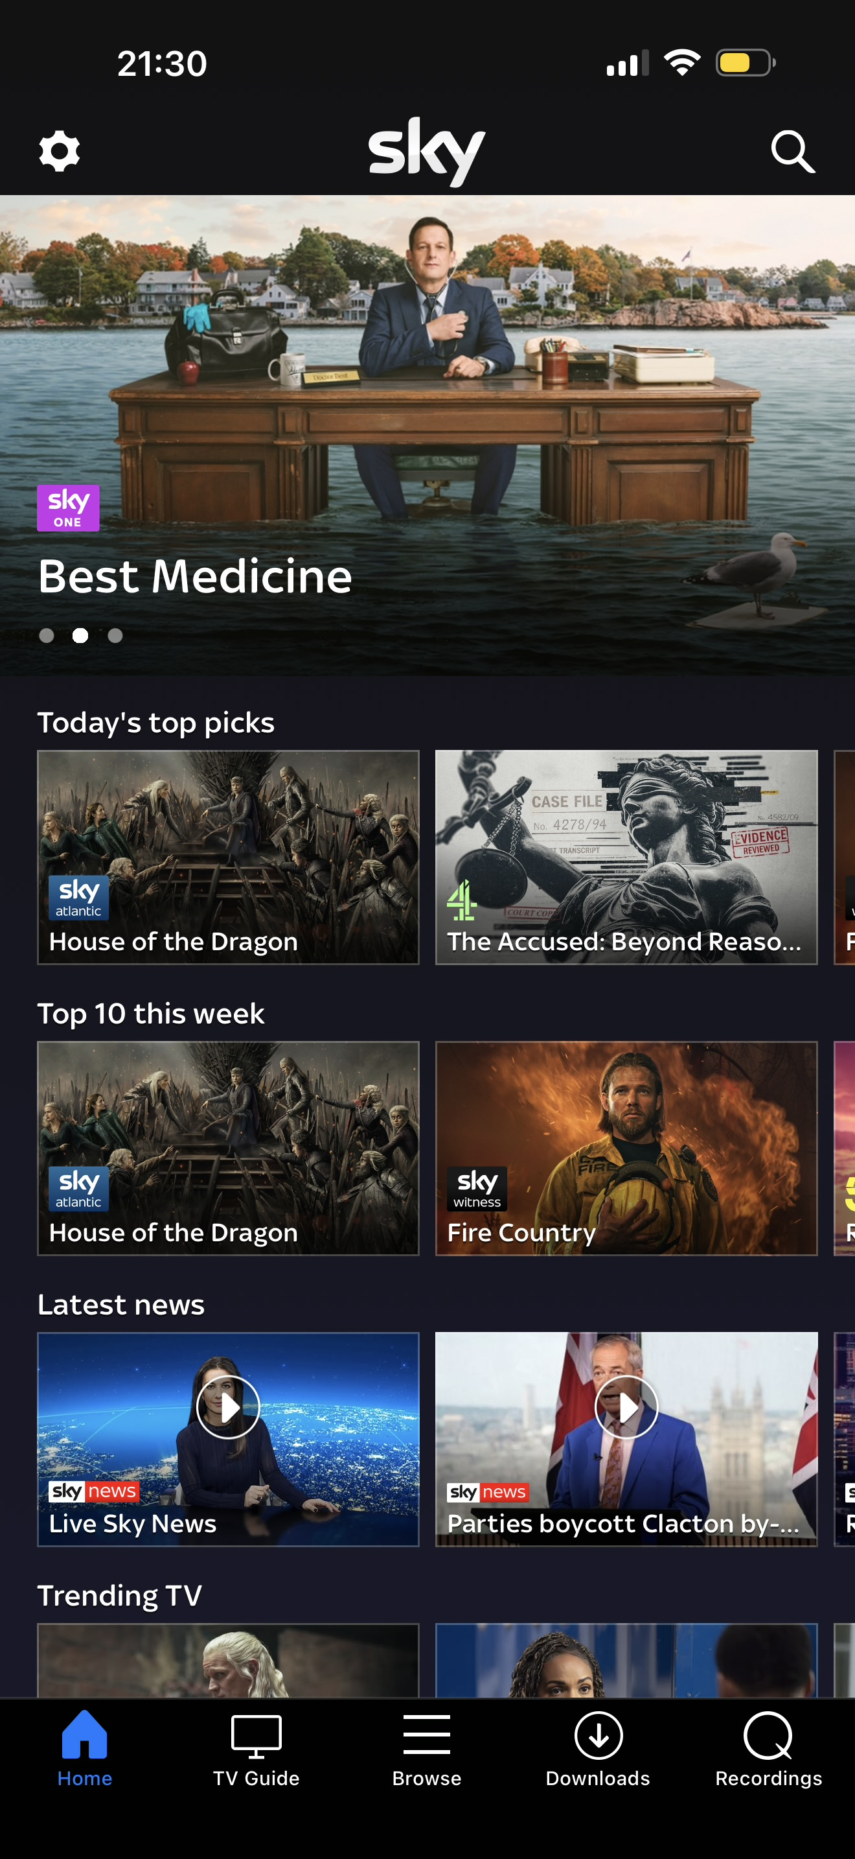
This is sky app that I use to keep up to date when I’m on the go to watch my shows usually I’ll be at home watching my shows but when I’m not at home keeps me updated ]

Screenshot/Photo 3
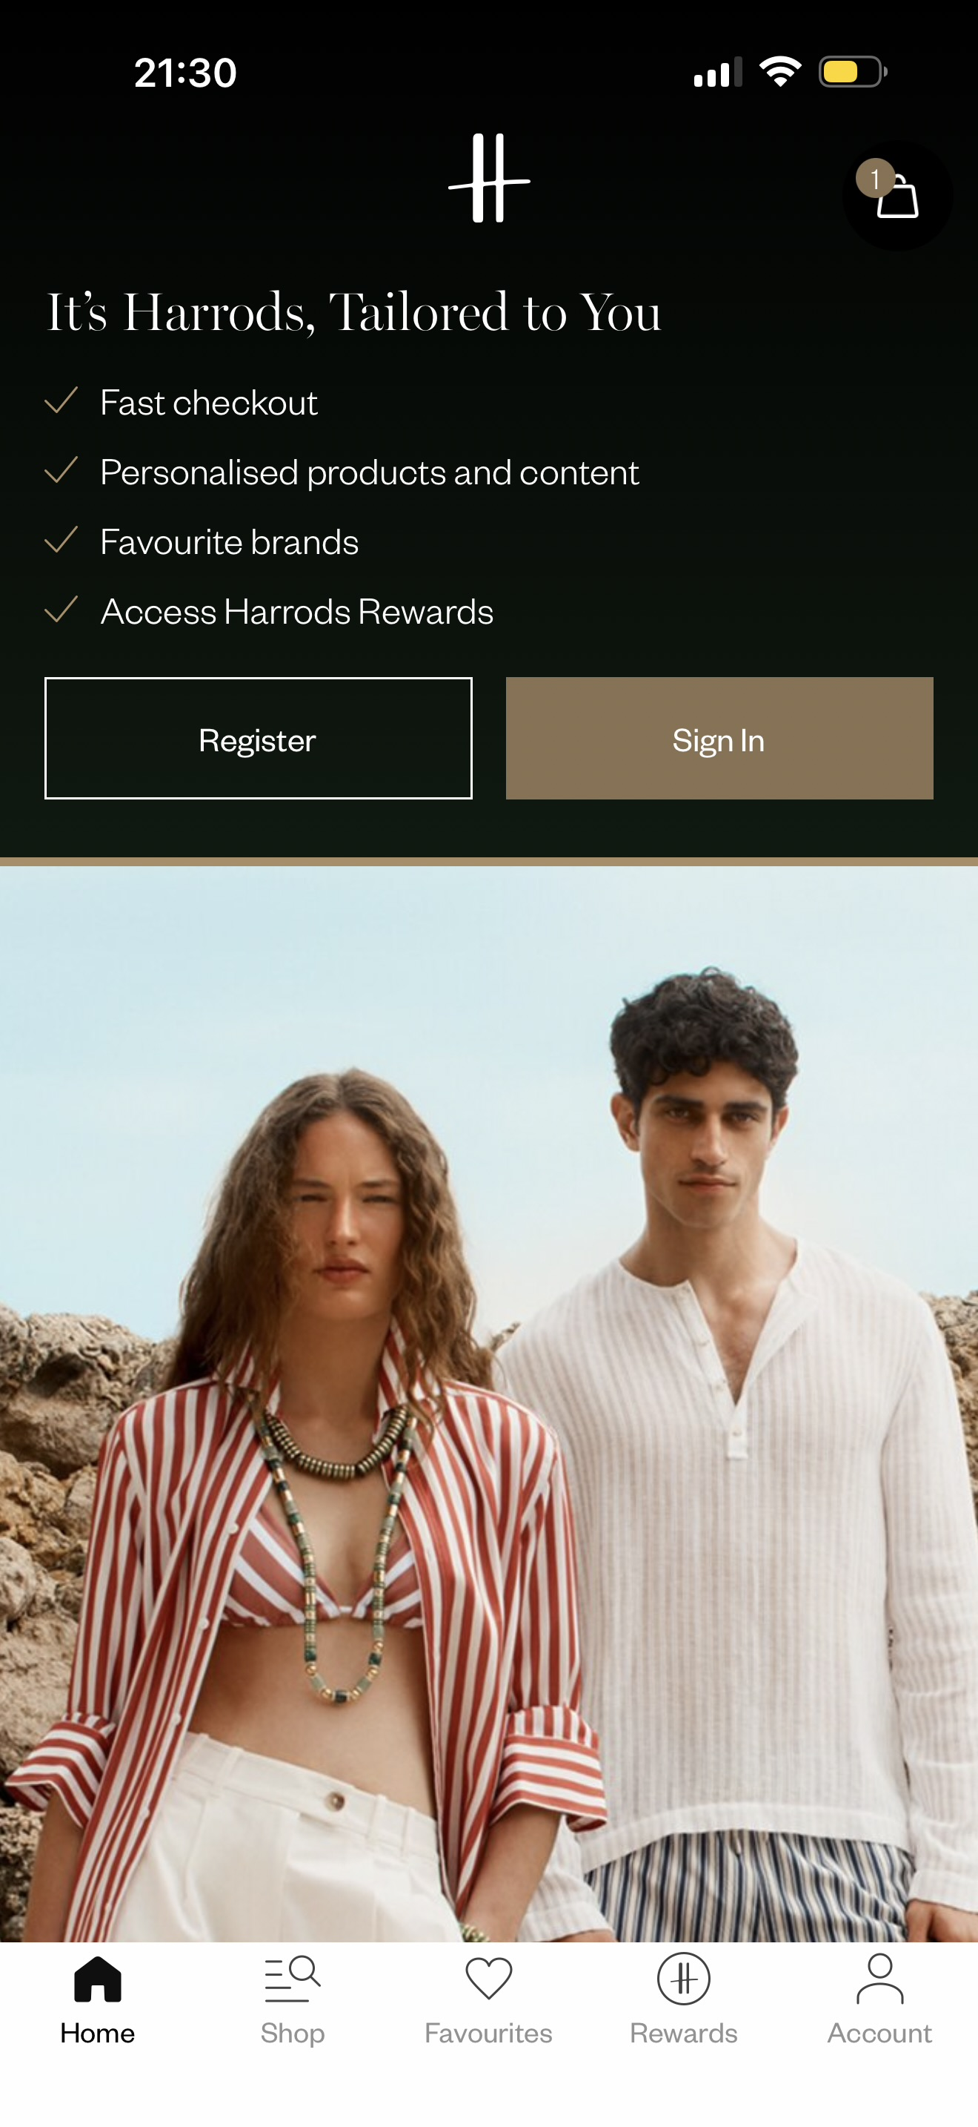
[his is my Harrods app I use to order my clothes I prefer shopping online because I get my Harrods rewards points

[]

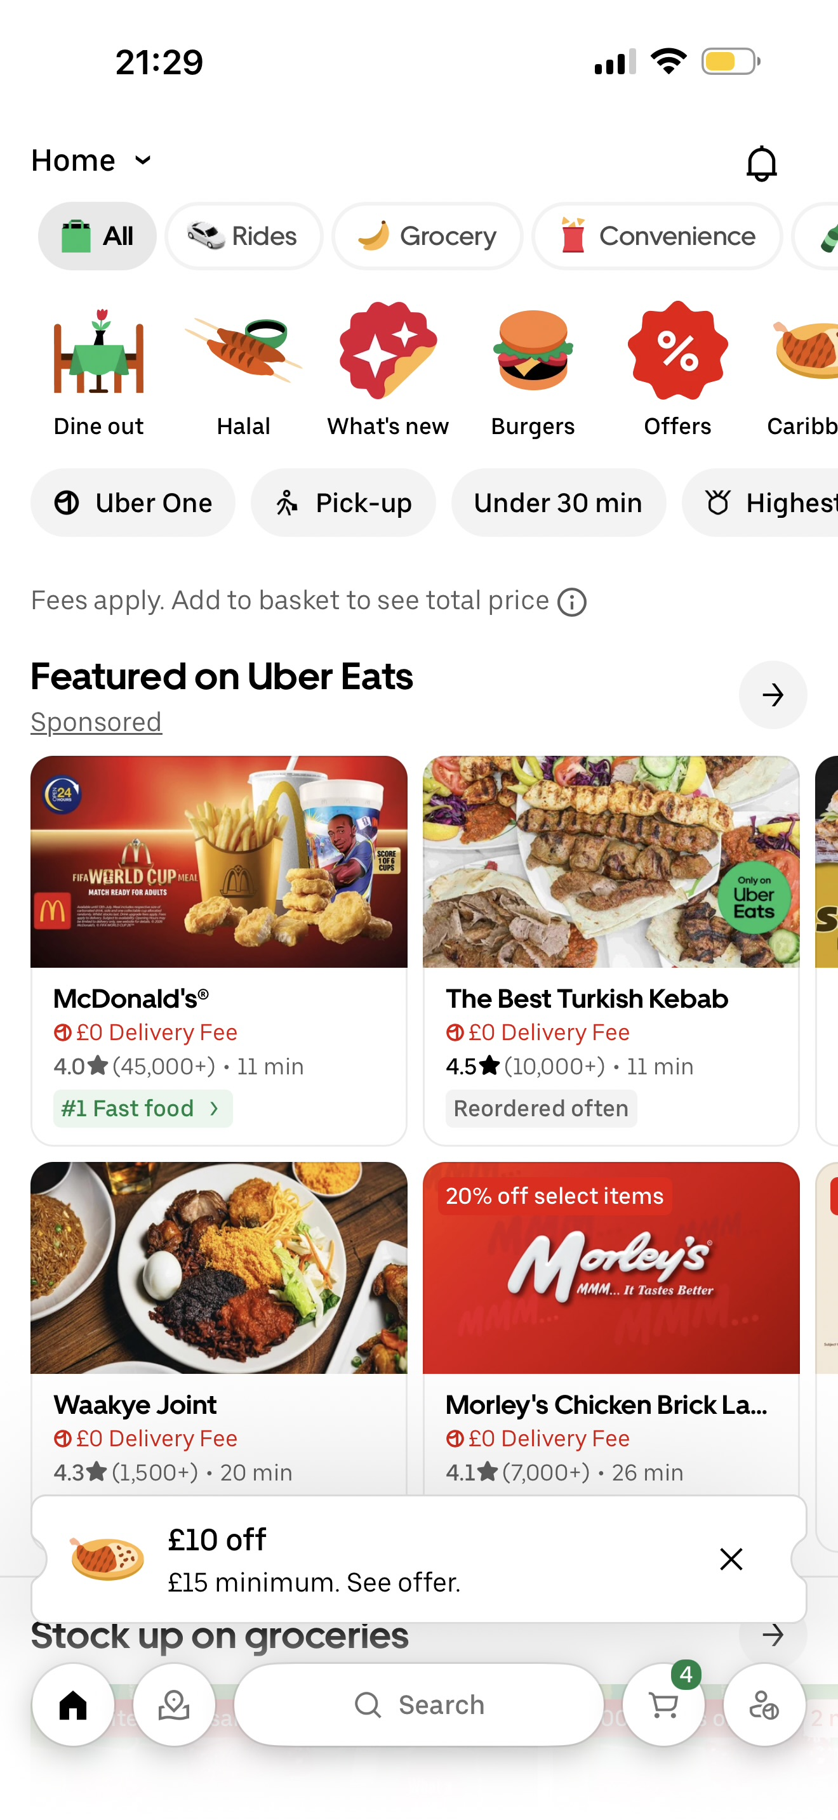
Screenshot/Photo 4
[Insert Photo/Screenshot below]
Before when I used to order taxi I found it a bit difficult to get the drivers to come directly where I am I could also track the driver and see how long he will be

Screenshot/Photo 5
[Insert Photo/Screenshot below]

[Write what this shows of your digital life]

Screenshot/Photo 6
[Insert Photo/Screenshot below]
[Write what this shows of your digital life]

.

You can write more if you want.

