Assignment 1
Alison Barker
Economics of sustainability- the textile industry in the EU

Introduction
The industry that will be discussed in this essay will be the textile industry. It will discuss how the textile industry has in the past affected the environmental and how the UK government are introducing measures to try and change the toxicity of “fast” fashion.
The fashion industry is the second largest polluter in the world, just after the oil industry. (2021) The amount of clothes bought in the EU per person has increased by 40 % in just a few decades, driven by a fall in prices and the increased speed with which fashion is delivered to consumers. (2021) the processes involved in the textile industry are normally felt in other countries that supply the goods not the EU, requiring enormous amounts of water and chemicals, including pesticides for growing raw materials such as cotton. (2021)
In this assignment, there will be an investigation and analysis into the fashion industry, and how it has introduced measures to help influence manufacturers decisions. To help them to choose a more ecological or sustainable approach to manufacturing and where these changes where introduced, as a failed market. In this assignment there will be a development with diagrams as into how the market had changes after the measures were introduced.

Globalisation and the textile industry.
Improvements of the agricultural techniques and practices turned out in a very big increase of production for many areas, supply as foods and raw materials, more efficient industry resulting more profits. (Dissertation titles, 2003) Markets that can produce substantial amounts of raw material at a cheaper cost became the main supplier in this market, select markets and countries came to supply the rest of the world due to globalisation. This graph demonstrates that private cost benefits change over time away from social due to globalisation with cheaper suppliers. From a UK perspective, the market structure is characterised by UK clothing producers relocating to the developing world with most of the clothing consumed in the UK produced in other countries. Defra (2007)
In the graph below we see how demand is increased from these countries (S1 –S2) In this case the blue line moves to the right this shows the increase in the supply. The price is reduced with the movement of the blue line to the right, prices fall from P to P1.

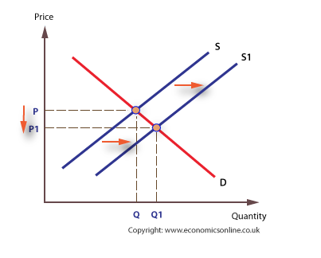

The failure in the textile industry
This trend has brought in profits for the manufacturers, but unfortunately there has been an environmental cost associated. The fashion industry accounts for around 4% of emissions globally.
For one tonne of material to be dyed it takes over 200 tonnes of water, the fashion industry uses 1.5 trillion litres per year, whilst 7500 people in the world do not have access to fresh drinking water.
It is not just the water that is affected by the textile industry, each time synthetic clothing is washed up to 1,900 micro fibres made from plastic and petroleum industry, are released into the water, which escapes into the oceans ending up in the food chain via digestion by fish of micro-organisms.
Greenhouse gas emissions, soil degradation, rainforest destruction (29 Sustainable Fabrics for the Most Eco Friendly Fashion, 2021) is also affected by fast fashion.A family in the western world throws away an average of 30 kg of clothing each year. Only 15% is recycled or donated, and the rest goes directly to the landfill or is incinerated. (2021) even the transport that brings the items and the energy suppliers have a part in this, Carriage of an intermediate product such as raw cotton transportation to the spinning mill, treated fabric from finishing mill to cut-and-sew and after to customer take part in transportation.8 (Toprak and Anis, 2017)

The global fashion industry produced around 2.1 billion tonnes of GHG emissions in 2018, equalling 4% of the global total (Inc., 1982)
This graph shows the failure (marginal social cost) of fast fashion industries including the total of all private and external costs. When looking at the externalities of consumption we assume Marginal Private Cost (MPC) is equal to Marginal Social Cost (MSC), depicted by the blue line below. The red lines below indicate that there is a difference in the Marginal Private Benefit (MPB) and the Marginal Social Benefit (Dietz and Hepburn, 2010)
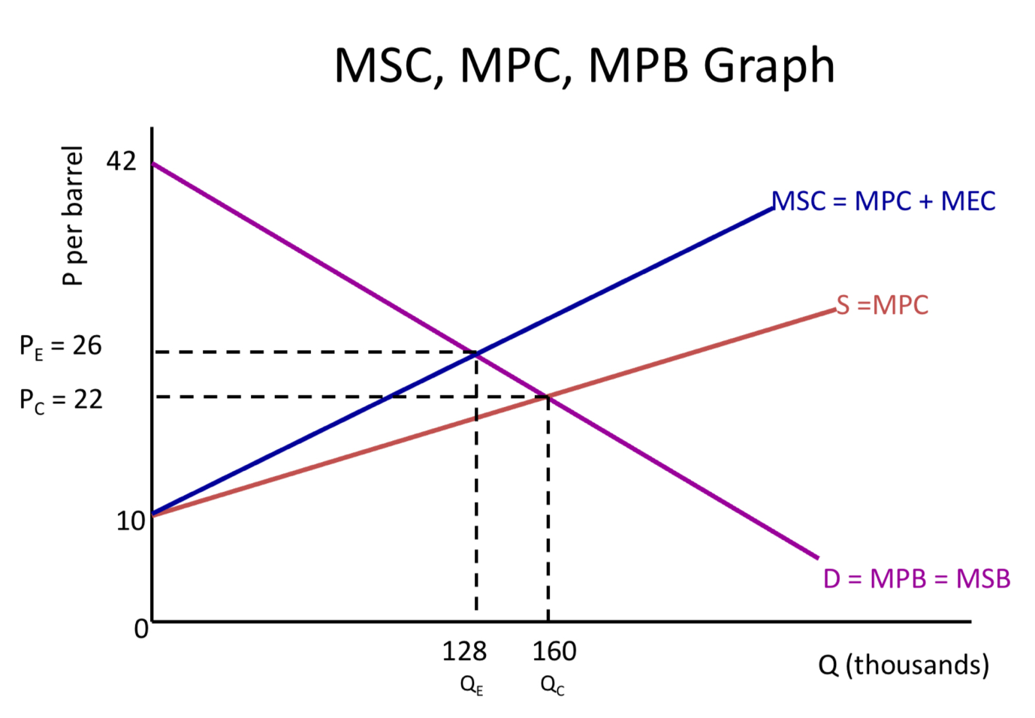
Unfortunately, whilst there is a private benefit in profits there is there are external costs to the environment. Quantities are high and quality is shown to be low. Markets or company's do not unfortunately include the social disadvantages as in ecological costs in their production, market demand was identified only because we implicitly made one critical assumption—those consumers would reveal their willingness to pay (WTP) (callan, 2012)
In the past, many viewed environmental quality as a trade-off with economic growth: Any increase in environmental quality came at a cost or slow-down in economic development prospects. (Qaramah, 2019)
The answer to the problem with the social costs to the environment can be achieved in two ways.
- Command and control, this is a process where laws are introduced No incentive to innovate, does not balance marginal abatement costs (equi-marginal principle), not full internalisation. (Notes de lecture, 2003)
- Market approach an incentive-based controls system.

The changes in the textile industry started In 2018, the EU adopted a circular economy package that will, at the insistence of the European Parliament, for the first time ensure that textiles are collected separately in all Member States, by 2025 at the latest.(2021) designing products in a way that would make re-use and recycling easier (circular fashion), convincing consumers to buy fewer clothes of better quality (slow fashion), and generally steering consumer behaviour towards choosing more sustainable options.

Developments
There have been several alternative proposals on this issue including.
1. Circular fashion. The use of natural materials
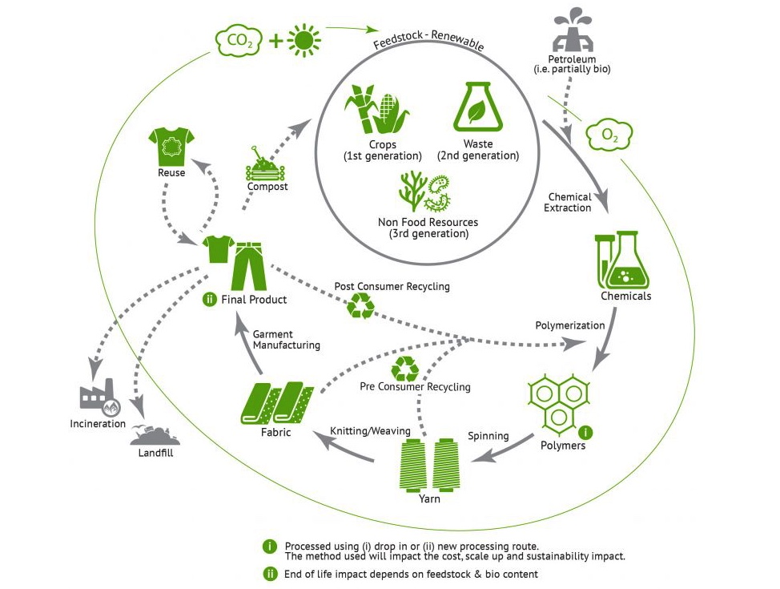

(Home, 2021)
2.The development of new business models for rental of clothing,
3. In the actual design process development of new clothing making it easier to recycle clothing.
4. Convincing consumers to buy fewer clothes of better quality (slow fashion), and steering consumer behaviour towards choosing more sustainable options. (2021)

The UK has introduced a policy to help introduce the change with the help from the Environmental Audit Committee (EAC) investigates the social and environmental impact of disposable ‘fast fashion’ and the wider clothing industry. (Government Reforms Taxation to Reward Sustainable Fashion Companies - SIGHTMODE sustainable fashion, 2021)
In 2017 a report by the Ellen MacArthur Foundation on ‘redesigning fashion’s future’ found that if the global fashion industry continues its current growth path, it could use more than a quarter of the world’s annual carbon budget by 2050. (Government Reforms Taxation to Reward Sustainable Fashion Companies - SIGHTMODE sustainable fashion, 2021)
The report stated The Government should make fashion retailers take responsibility for the waste they create and reward companies that take positive action to reduce waste. A charge of one penny per garment on producers could raise £35 million to invest in better clothing collection and sorting in the UK.
From this report this is one of the reforms that has been implemented already are that the Government reforms taxation to reward fashion companies that design products with lower environmental impacts and reprimand those that do not.
Minskey also suggests that a whole scale change there are productive and cost-effective strategies that can propel the industry towards lower GHG emissions.
One of these changes can be implemented is the introduction of subsidies of electricity supplied to manufacturers of clothing if the materials used are recyclable or from an ethical source. Another name for this is feebates, a system of charges and rebates whereby energy-efficient or environmentally friendly practices are rewarded while failure to adhere to such practices is penalized. (Oxford Languages and Google - English | Oxford Languages, 2021)
In the graph (Pergovian) this is what happens when a feebate, a tax or a subsidy is introduced to a market the private marginal cost pivots at the point of equilibrium. Showing that the socially efficient prices rise slightly to include the tax, the subsidy then brings the private marginal cost down.
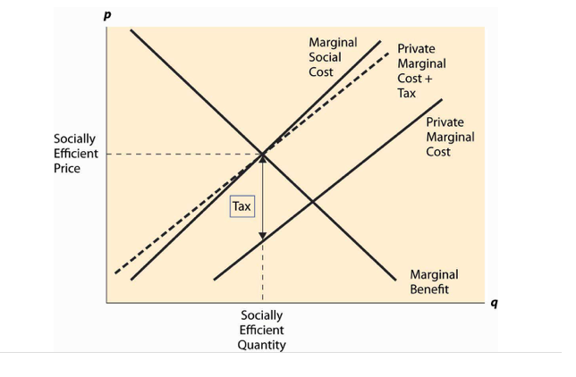
Mckinsey also suggests that for the textile industry to align with the 1.5-degree pathway over the next 10 years (Inc., 1982), restrict global warming to the 1.5 degrees targeted by the Paris Climate Change Agreement. that means embracing accelerated abatement, which is estimated to reduce annual emissions to around 1.1 billion tonnes, around half of today’s figure (Inc., 1982) To date, only around 50 fashion companies have committed to the science-based targets aligned with the agreement.

There is currently a trend of manufacturers, brands, and suppliers of clothing to move towards a more sustainable initiative. With one third of consumers say they are willing to pay more for ethically produced clothing and footwear (TNS Global, 2008). The UK’s ethical fashion industry is currently worth approximately £175 million (Mintel, 2009) and is growing faster than almost any other ethical sector, at 71% per year (Coop 2008) (British Fashion Council, 2021) Spending on ethical clothing increased by 19.9% and Global Organic Textile Standards (GOTS) certified facilities and retailers grew by 10% in 2018.

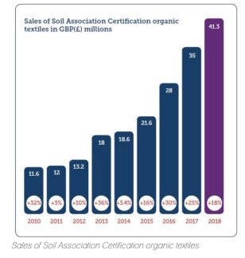

Stakeholders throughout the value chain should be willing to make bold commitments, followed by equally bold actions, transparency, collaboration, and joint investment. (Inc., 1982). Some 50% of fashion executives in a recent opinion poll indicated that sustainability has moved up the agenda in recent months. A rising number of asset and wealth managers have mandates that prioritise companies that pass sustainability thresholds. (Inc., 1982)

Melik Demirel, director of the Center for Research on Advanced Fiber Technologies agrees that getting bio designed clothing into consumer markets may take some time. Production processes would eventually benefit rather than outweigh challenges. Repairing or repurposing textiles and dyes repeatedly, to delay making them into waste, is a primary principle guiding production of bio-based textiles and the nonchemical dyes used to colour them.

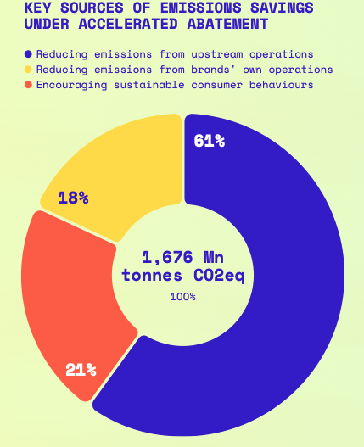
(Inc., 1982)
In Mckinsey chart there is a 18% reduction that can be achieved from the reduction in the brands own operations, 21 % for changing the habits of consumers and the rest is reducing emissions from upstream operations, such things as materials production, preparation, and processing.
Around 90% of the accelerated abatement can be delivered below a cost of around USD50 per tonne of GHG emissions. Around 55% of the actions required will lead to net cost savings on an industrywide basis. (2021)

These types of incentives provided by the Uk government could have an alternative effect on the original cost of the clothing. This could cause a disequilibrium of supply and demand. (Deadweight Loss Definition (3 Examples and Causes) - BoyceWire, 2021) from the original sources with consumers attracted by lower prices, we see an artificial increase in demand in the companies involved with the subsidy scheme in the UK and the fact that the fabrics are desirable. The clothing costs are reduced artificially making a deadweight loss because of a subsidy.

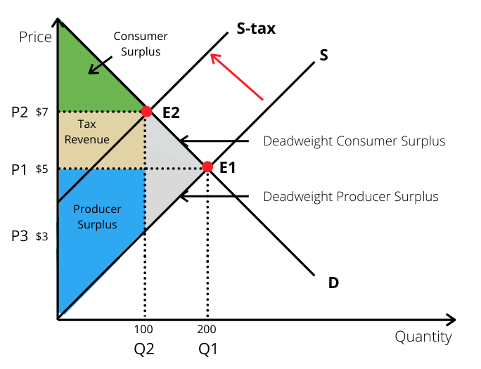
(Deadweight Loss Definition (3 Examples and Causes) - BoyceWire, 2021)

Sustainability
sustainability basically boils down to understanding the impact that we have on the earth, and what we leave for future generations. (2021) What we know through sustainability is that we must preserve the raw materials that are available now for the future generations to come, this can be achieved through sustainable development.
Sustainable development, development that meets the needs of the present without compromising the ability of future generations to meet their own needs” (United Nations General Assembly, 1987) The overall goal of sustainable development (SD) is the long-term stability of the economy and environment (G, 2020) so not just taking long term stability of the environment into consideration but how the economy can work with it.
Different sectors have different approaches.
food beverage and consumer goods have mostly challenged within agriculture and raw material production, processing, packaging, and distribution. There are also other topics such as the reduction of chemical pollution, measure, reduce and report climate exposure, and set measures of accountability for all parties involved in supply chains and the reduction in waste. The education of consumers and the technology involved in moving towards environmental issues.
health care
Centers around patient travel with the introduction of tele health and telecare, energy supplied to hospital, care facilities and production plants, using electricity supplied by renewable energy. Replacing chemical refrigeration units, the development of utensils and medical units to use less power, and generally using more Recyling and develop ways to consumer less raw materials.
Industrial manufacturing
These are to develop more sustainable forms of transport, resource efficient machinery (as above) and the development of renewable energy infrastructure. To develop machinery and processes for farming so less water is used. Again, the development of energy efficient in the home and working environment with recycling and reusing. Collaborating and team lead manufacturing advance sustainable development.
Transportation
Is touched on in the above headings within the transport industries, development of technology to reduce carbon emissions from vehicles, public transport, and industrial transport. Infrastructure is important in this sector, with major development and investment needed to find ways to support multi modular transport solutions.
Energy, natural resources, and chemicals
This includes development of new processes to reduce the use of raw materials, to reduce emissions from chemical and energy suppliers' processes and the replacing of chemicals with bio alternatives. The change in production of energy from fossil fuels to green energy and the infrastructure to accomplish this.
All these headings interlink with the United Nations 17 sustainable development goals (SDG) which were created in 2015 with the agreement of 193 countries.

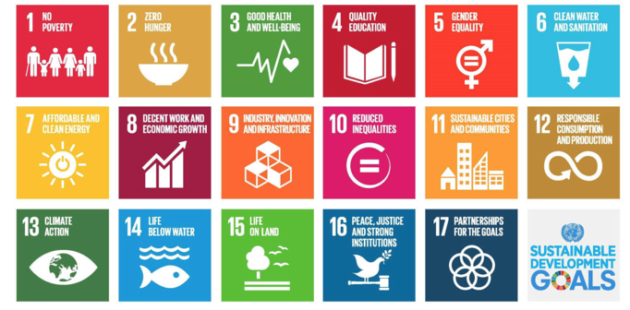

Conclusion
Whilst all this development towards sustainable economics is positive as in Pembrokeshire, like many other areas, the sea is cleaner and there is better quality of life. The Uk and other developed countries have achieved through the process in the past of polluting the environment, this brings up the problem of developing nations.
The infrastructure in developing nations is limited where vast amounts of investment is required to achieve the results developing countries can finance. Also, the trial and error used in trailing new materials and ideas, could potentially put developing nation off, and of course the added time and money involved in training up people to use these new methods could become a disadvantage.
Politics always will play a part in all these types of new methods, and this is a major sticking point for a lot of new processes.
The introduction of the subsidies for large manufacturers of textiles and major strides underway for the fast fashion industry to become more eco-friendly with the introduction of large brands to reusing, recycling and encouraging consumers to participate in the action of recycling or just being more socially aware of where products are produced and the effects that this has on the environment can help massively to change people's habits and perceptions about ecological issues.

References

About biosynthetic fibers. 2021. Home. [online] Available at: <https://aboutbiosynthetics.org> [Accessed 5 May 2021].
Boycewire.com. 2021. Deadweight Loss Definition (3 Examples and Causes) - BoyceWire. [online] Available at: <https://boycewire.com/deadweight-loss-definition-and-examples/> [Accessed 13 May 2021].
Britishfashioncouncil.co.uk. 2021. British Fashion Council. [online] Available at: <https://www.britishfashioncouncil.co.uk/news/197/Tax-Breaks-for-Eco-Fashion-Businesses> [Accessed 9 May 2021].
callan, s., 2012. environment economics and management.
Didaskalia, 2003. Notes de lecture. (23).
Dietz, S. and Hepburn, C., 2010. On Non-Marginal Cost-Benefit Analysis. SSRN Electronic Journal,.
Ellen MacArthur Foundation, A new textiles economy: Redesigning fashion’s future, (2017, http://www.ellenmacarthurfoundation.org/publications).
Europarl.europa.eu. 2021. [online] Available at: <https://www.europarl.europa.eu/RegData/etudes/BRIE/2019/633143/EPRS_BRI(2019)633143_EN.pdf> [Accessed 1 May 2021].
François, J., 2007. Optimizing total system cost by balancing unit cost against real cost. Sealing Technology, 2007(5), pp.11-13.
2021. [online] Available at: <https://www.sustainyourstyle.org/old-environmental-impactshttps://www.sustainyourstyle.org/old-environmental-impacts> [Accessed 8 May 2021].
Inc., M., 1982. McKinsey-rapporten. Massekultur & Medier, 2(6), p.9.
Johnson, E. and Plepys, A., 2021. Product-Service Systems and Sustainability: Analysing the Environmental Impacts of Rental Clothing. Sustainability, 13(4), p.2118.
Languages.oup.com. 2021. Oxford Languages and Google - English | Oxford Languages. [online] Available at: <https://languages.oup.com/google-dictionary-en/> [Accessed 9 May 2021].
MacDonald, R., 2004. JST Press 2003. 412 pp., ISBN: 0691115311 US$29.95 (hardback). The Electronic Library, 22(1), pp.84-85.
Naturespath.com. 2021. [online] Available at: <https://www.naturespath.com/en-us/blog/20-activities-kids-learn-sustainability/> [Accessed 14 May 2021].
Operative Dentistry, 1992. Full Issue PDF. 17(4), pp.1-52.
Polymer Contents, 2003. Dissertation titles. 20(10), pp.653-655.
Qaramah, M., 2019. http://fto.ro/altarul-reintregirii/wp-content/uploads/2020/05/14.-Andrei-PETRACHE-AR3-2019.pdf. Altarul Reîntregirii, (3), pp.149-161.OR: A History20047Roger C. Schonfeld. JSTOR: A History. Princeton, NJ: Princeton University
SIGHTMODE sustainable fashion. 2021. Government Reforms Taxation to Reward Sustainable Fashion Companies - SIGHTMODE sustainable fashion. [online] Available at: <https://sightmode.com/government-reforms-taxation-to-reward-sustainable-fashion-companies/> [Accessed 9 May 2021].
Sustainable Jungle. 2021. 29 Sustainable Fabrics for the Most Eco Friendly Fashion. [online] Available at: <https://www.sustainablejungle.com/sustainable-fashion/sustainable-fabrics/> [Accessed 9 May 2021].
Toprak, T. and Anis, P., 2017. Textile Industry's Environmental Effects and Approaching Cleaner Production and Sustainability: an Overview. Journal of Textile Engineering & Fashion Technology, 2(4).

