Lab: IPv4, Subnetting, VLSM and IPv6 Addressing

This part of lab worksheet require you research and write a report on “Features of IPv6”. You may discuss but not limited to structure, address types, advanced functionalities and security.

NOTE: To complete this part you would need full understanding of Lab 10 to 14.



Using the Network address 172.16.2.0/24, VLSM the network to support the following requirements:
Subnet A: 16 hosts
Subnet B: 2000 hosts
Subnet C: 6 hosts
Subnet D: 500 hosts
Subnet E: 60 hosts
Subnet F: 180 hosts and Serial links between routers

Table 1
Subnet | Network Address | Subnet mask | First Address | Last Address | Broadcast Address
B | 172.16.2.0 | 255.255.255.248 | 171.16.2.1 | 172.16.9.254 | 172.16.9.255
D | 17.16.10.0 | 255.255.255.254 | 172.16.10.1 | 172.16.11.254 | 172.16.11.255
F | 172.16.12.0 | 255.255.255.0 | 172.16.12.1 | 172.16.12.254 | 172.16.12.255
E | 172.16.13.0 | 255.255.255.192 | 172.16.13.1 | 172.16.13.62 | 172.16.13.63
A | 172.16.13.64 | 255.255.255.224 | 172.16.13.65 | 172.16.13.94 | 172.16.13.95
C | 172.16.13.96 | 255.255.255.248 | 172.16.13.97 | 172.16.13.102 | 172.16.13.103
R1 | 172.16.13.104 | 255.255.255.252 | 172.16.13.105 | 172.16.13.106 | 172.16.13.107
R2 | 172.16.13.108 | 255.255.255.252 | 172.16.13.109 | 172.16.13.110 | 172.16.13.111
R3 | 172.16.13.112 | 255.255.255.252 | 172.16.13.113 | 172.16.13.114 | 172.16.13.115

Title: “Features of IPv6”.

Contents
1 Introduction 5
2 Internet Protocol 5
3 Network Layer Communication Protocols 6
4 Conclusions – IPv6 The future 9
5 References 10
6 Appendix 1 11
7 Appendix 2 12

Introduction

To Discuss the Features of IPv6, this paper will first define what an Internet Protocol is, who creates and manages these Protocols together with their introduction and History. It will then discuss in more detail the latest protocol IPv6 why it was introduced, its structure, address formats, its advanced functions and security issues.

Internet Protocol

What is an Internet Protocol

Technologies such as Ethernet provide reliable connection between nodes on the same network, but they do not provide internet connections between networks. For this to happen an addressing structure needs to be in place that will be read by a gateway, bridge or router. [1]

The transmission control protocol (TCP) and Internet protocol (IP) allow the subnets to communicate with one another. The IP Part relates to the network layer of the OSI Model. [1]

The network layers tasks in essence is the end to end transport processes of:-
- Addressing end devices
- Encapsulation
- Routing
- De-encapsulating

Who manages The Protocol

Several Organizations are instrumental in the development of internet protocols, The Internet Advisory Board ( IAB) is the governing Body that sets policy and The Internet Engineering Task Force ( IETF) which looks at rules on Engineering Issues are key players. [2]

Network Layer Communication Protocols

Ipv4

The most well used internet protocol still used in IPv4 this was introduced in 1983 and has a potential 4.3 billion addresses, it was introduced at a time when there were less than 600 hosts on the internet, as such the exhaustion of addresses was never really seen as an issue. [3]

IPv4 still has three major issues:

IP address depletion – IPv4 has a limited number of unique public IPv4 addresses available. Increasing numbers of new IP-enabled devices, the Internet of Things where all appliances have an IP address and the explosion of growth of internet usage in the developing world have increased the need for IP addresses. [4] The IETF predicted IPv4 addresses would run out between 2005 and 2011 and started work on the next generation of protocol in 1994. [3]

Routing tables - A key element of IPv4 is the use of routing tables. These are tables that determine the best path to take between Servers when transporting data packets. With The growth of the Internet the numbers of servers has increased and as such the number of routes and complexity of those routing tables has increased. This impacts on system resources with the new routes consuming more processor and memory resources on the routers. [4]

Lack of end-to-end connectivity – Network Address Translation (NAT) provides a way for multiple devices to share a single public IPv4 address. However, because the public IPv4 address is shared, the IPv4 address of an internal network host is hidden. [4]

Internet Protocol: Ipv6

Due to perceived issues with IPv4 The IETF began development of a successor in the 1994, a working group was formed to establish the next generation standards which was ultimately defined in RFC 2460 and named IPv6, IPv5 was a developmental standard and not a released version [3]

IPV6 Features

A number of features of IPV6 are noted and listed in [5]

- Larger Address Space
- IPv6 uses 4 times more bits to address a device on the Internet. This much of extra bits can provide approximately 3.4×10³⁸ different combinations of addresses.
- Represented by 340 undecillion or 340,000,000,000,000,000,000,000,000,000,000,000,000

- Simplified Header
    - IPv6’s header has been simplified by moving all unnecessary information and options IPv6 header is only twice as bigger than IPv4 provided the fact that IPv6 address is four times longer. Appendix 1 shows a comparison between the 2 protocol header records.
- End-to-end Connectivity
    - Every system now has unique IP address and can traverse through the Internet without using NAT or other translating components.

- Faster Forwarding/Routing
    - Simplified header puts all unnecessary information at the end of the header. The information contained in the first part of the header is adequate for a Router to take routing decisions, thus making routing decision as quickly as looking at the mandatory header.

- IPSec
    - IPsec is a set of protocols for securing Packets in networks, it does this by use of both encryption protocols such as DES, AES, RSA and SHA and by authentication of packet headers, the use of this is deemed mandatory within the IPv6 protocol, as such security should be enhanced if the protocol is utilised.

Structure

IPv6 addresses are 128 bits in length divided into 8 16 bit blocks, these are then converted 4-digit Hexadecimal numbers separated by colons as shown below [6]

Example 2001:0000:3238:DFE1:0063:0000:0000:FEFB

Address types – need bit more here

Unicast

A unicast address specifies a single interface to which packets will be delivered, It is perceived that unicast will be the predominant method for traffic volumes and why more Ipv6 address space is allocated to them. [7], It is a one to one relationship with recipient and the sender

Multicast

A Multicast address identifiers multiple nodes for delivery these packets sent simultaneously it is a one to many relationship. [3]

Anycast

Anycast addresses is a unicast address assigned to several devices. It is only delivered to one the nearest one it being routed on a specified metric to get to the destination as efficiently as possible. [3]

Conclusions – IPv6 the future

Given the revised IPv6 protocol, it could be asked are we all now using it, a cursory glance at IP addresses will tell you that IPv4 is still highly utilized as a protocol.

The Internet society in they report [8] has given some figures which highlights
- Over 25% of all Internet-connected networks advertise IPv6 connectivity.
- Google reports 49 countries deliver more than 5% of traffic over IPv6, with new countries joining all the time.
- Google reports 24 countries whose IPv6 traffic exceeds 15%. [8]

Google monitor data traffic and via [9] as of 24-Nov-2019 28.7% of traffic through Google came Via IPv6 protocols. View Appendix 2 [9]

These figures show the predominant protocol is still IPv4, and as such a co-existence of the two protocols exists.

However the vast majority of mobile devices do use the new protocol and countries such as the BRIC (Brazil, Russia, India, and China) nations and other future developing counties are utilizing the new standards as they implement their digital infrastructure so IPv6 will continue to grow. [8]

References

[1] | W. Buchanan, Mastering Networks, Basingstoke: Macmillan, 1999.
[2] | J. Casad, Sams Teach yourself TCP/IP in 24 hours, Indianapolis, Indiana: Sams Publishing, 2004, p. 17.
[3] | R. Graziani, IPv6 Fundamntals: A straightforward Approach to understanding IPv6, Indianapolis: Cisco Press, 2013.
[4] | C. N. Academy, ntroduction to networks v6: companion guide, Indianapolis: Cisco Press, 2016.
[5] | “https://www.tutorialspoint.com,” 26 11 2019. [Online]. Available: https://www.tutorialspoint.com/ipv6/ipv6_features.htm. [Accessed 26 11 2019].
[6] | S. Hogg, “IPv6 Addressing for Enterprises,” Network world, 7 Nov 2017. [Online]. Available: etworkworld.com/article/3235384/ipv6-address-enterprises-how-to-easier-than-ipv4.html. [Accessed 26 Nov 2019].
[7] | “Understanding IPv4 and IPv6 Protocol Family,” Juniper networks, 12 Sep 2019. [Online]. Available: https://www.juniper.net/documentation/en_US/junos/topics/topic-map/security-interface-ipv4-ipv6-protocol.html. [Accessed 26 Nov 2019].
[8] | internetsociety, “State of IPv6 Deployment 2018,” 6 Jun 2018. [Online]. Available: https://www.internetsociety.org/resources/2018/state-of-ipv6-deployment-2018/. [Accessed 26 Nov 2019].
[9] | Google, “GoogleIpv6,” 26 nov 2019. [Online]. Available: https://www.google.com/intl/en/ipv6/statistics.html. [Accessed 26 Nov 2019].

Appendix 1

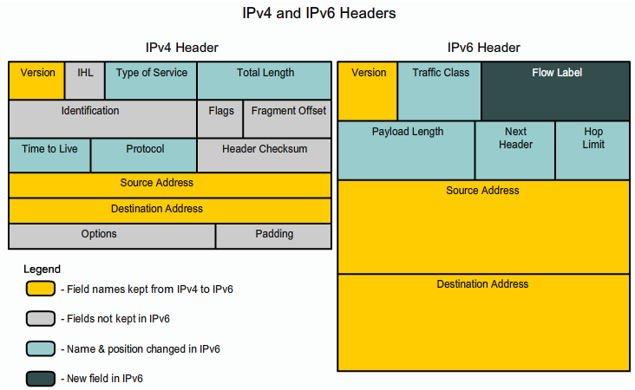
Source: UWTSD Lecture 6 Networks Lecture - Dr Kapilan Radhakrishnan

Appendix 2



