E-Portfolio
Amadeus and plogg
200 on your quiz
200 on agree/disagree
200 on future
200 on your opinion

What travel tribe am I?
After the completion of the Amadeus travel trip quiz, the quiz resulted in a assessment of me being an excited experientialist. An experientialist is described as someone who is open minded with a “try and see” approach to travel. Looking for unique accommodation and travel options to travel purely for the YOLO motto (you only live once) experientialists spend their times looking for new and exciting experiences. Another personality type connected to an experientialist is that they are someone who enjoys learning new languages, volunteering and changing jobs often. According to the infographic, available on the Amadeus, only around 25% of people are excited experientialists with the majority of 43% being pioneering pathfinders. In reality the majority of our group where memory makers, in comparison to only 17% on the infographic and only one member was a pioneering pathfinder (Amadeus, 2023). It is possible that this is due to the industry were entering and the fact that hospitality, tourism and events are all orientated around creating memories for guests. This conclusion is inline with the information on the infographic stating that making memories is the number one most important consideration for travellers when planning trips and excursions
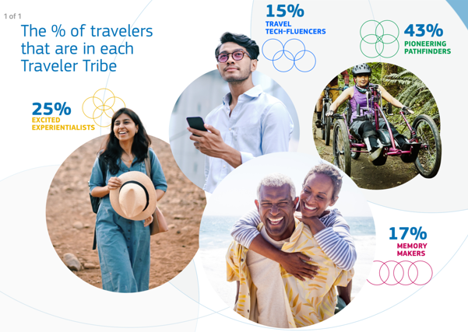
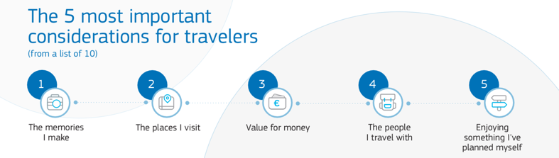

Evaluation of results
There are both points I agree and disagree with in regards to this assessment. The major points that I agree with are that I am open minded, I am always willing to try new things experiences are more important to me than materials. The reason I agree with these three points are due to the fact that I have been brought up on the mantra “you don’t know until you try”, this also means that I am similar to a memory maker as the memories and experiences are one of the more important aspects of travel for me. I do however disagree with a number of points such as the lack of prep and absence of commitment associated with experientialist. I am a planner, I always go on trips with a pre set plan of what who when and where, I am open to adapting these plans but as a girl guider I’ve been taught over the years that preparation is key. I am also someone who is very committed, all of my jobs have lasted at least a year and I also have a number of voluntary commitments that result in travelling being per planned.

The future impact of travel trends
I believe that as the average age of a travel tech-fluencers is under 32, they will have one of the larger impacts on the future of travel. Technology will allow tourism to become easier and more accessible, however one of the biggest concerns in regards to travel is the possibility of cyber attacks becoming more frequent by 2033 with 44% of people having this concern. As well as this another major concern for travellers, and coming in 2nd place with 41% of people having this concern is how safe data is stored due to travel. I also believe that travelling will no longer be relaxation based but exploration based due to the similarity in attributes of the memory makers, excited experiencialists and pioneering pathfinders. All three of these seem to be constantly on the hunt for new experiences and therefore opportunities to create memories whether they are calculated or impulsive. I also believe that previously unexplored countries will become more accessible as the want for exploration and “new” experiences will develop due to the want of adventure by the largest group the pioneering pathfinders.

Impact of tribes on tourism
I agree with the 26% of travellers that believe that travel will be noticeably different yet equally different and similar to what it is today by 2023. I believe that despite the increase in cost of living, as fuel prices are going down and AI is starting to assist with HR that travel will become more accessible. This will be developed through the use of biometrics as well as AI making travel more personalised. As people are looking for adventure more and more I also believe that the tourism industry will become more diverse in its experiences with prior established destinations developing with the changing want of the consumers and new destinations becoming more widely available. The go to destinations will change as local developments of major towns and cities globally increase tourism intrigue. I also agree with the concept that travel will change for the better to allow consumers to travel quicker and in more environmentally sustainable ways. Due to the predicted temperature increase of 2.2% this is highly important to help combat climate change and therefore tourism and travel need to change.
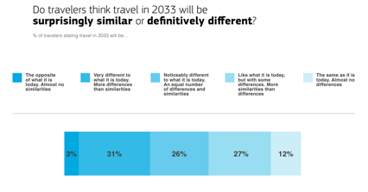
amadeus.com. 2023. Excited experientialist [ONLINE] Available at: https://amadeus.com/en/insights/blog/traveler-tribes-2033-excited-experientialists. [Accessed 20 March 2023].
amadeus.com. 2023. Infographic. [ONLINE] Available at: https://amadeus.com/documents/en/traveler-tribes/infographics/infographic-global-en.pdf [Accessed 20 March 2023].
amadeus.com. 2023. Travel-Tribes. [ONLINE] Available at: https://amadeus.com/documents/en/traveler-tribes/reports/tribes-report-global-en.pdf [Accessed 20 March 2023].

