REPORT
Module Name: Learning in the Digital Era
Module Code: ACCA4025
Assignment Title: Professional Development Plan (PDP)
Student Name: Aqil Hussain
Student Number 2535721
Course Title: CertHE Computing Skills for Workplace

Table of Contents

• Task 1 – Self-evaluation
• Task 2 – PDP
• Task 3 – Unit 4 Topic Summary
• Task 4 – Link for the video presentation

Task 1 – Self-evaluation
- Insert a screenshot of your task answer from your PowerPoint presentation
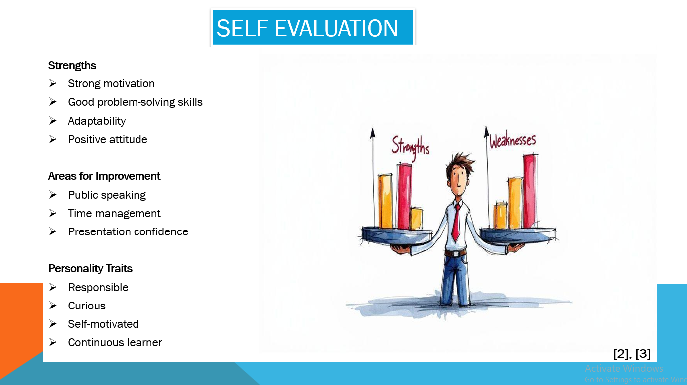

Task 2 – PDP
- Insert a screenshot of your task answer from your PowerPoint presentation
- Insert a screenshot of your PDP from your PowerPoint presentation
- Insert a screenshot showing goal progress engagement from your PowerPoint

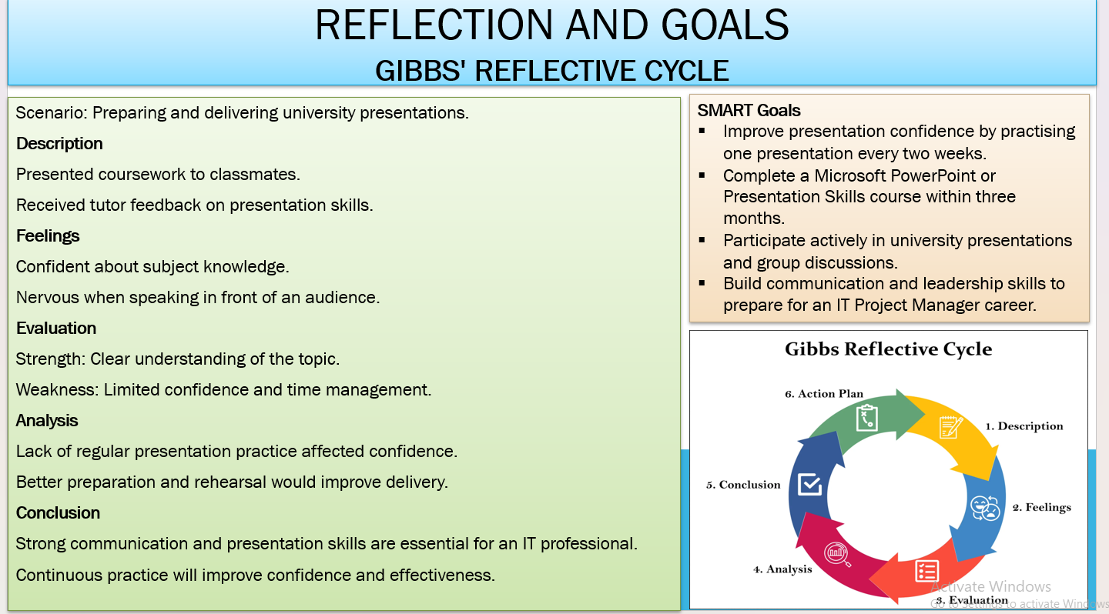
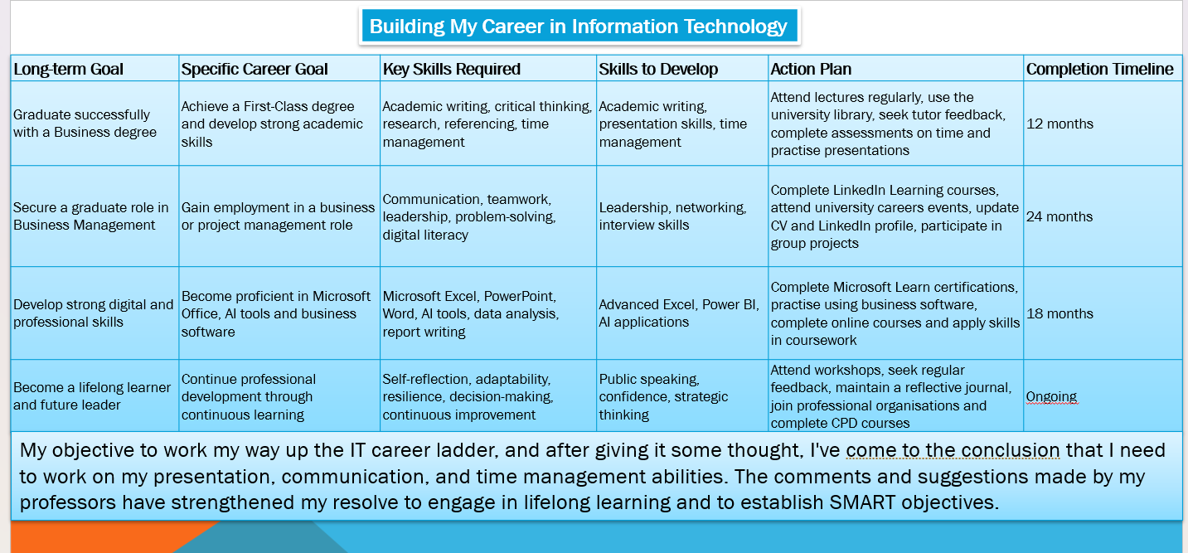

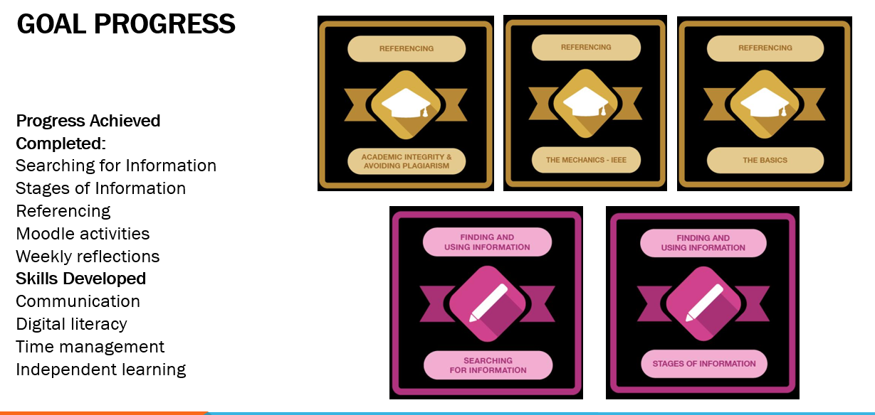

Task 3 – Unit 4 Topic Summary
- Insert a screenshot of your task answer from PowerPoint presentation.
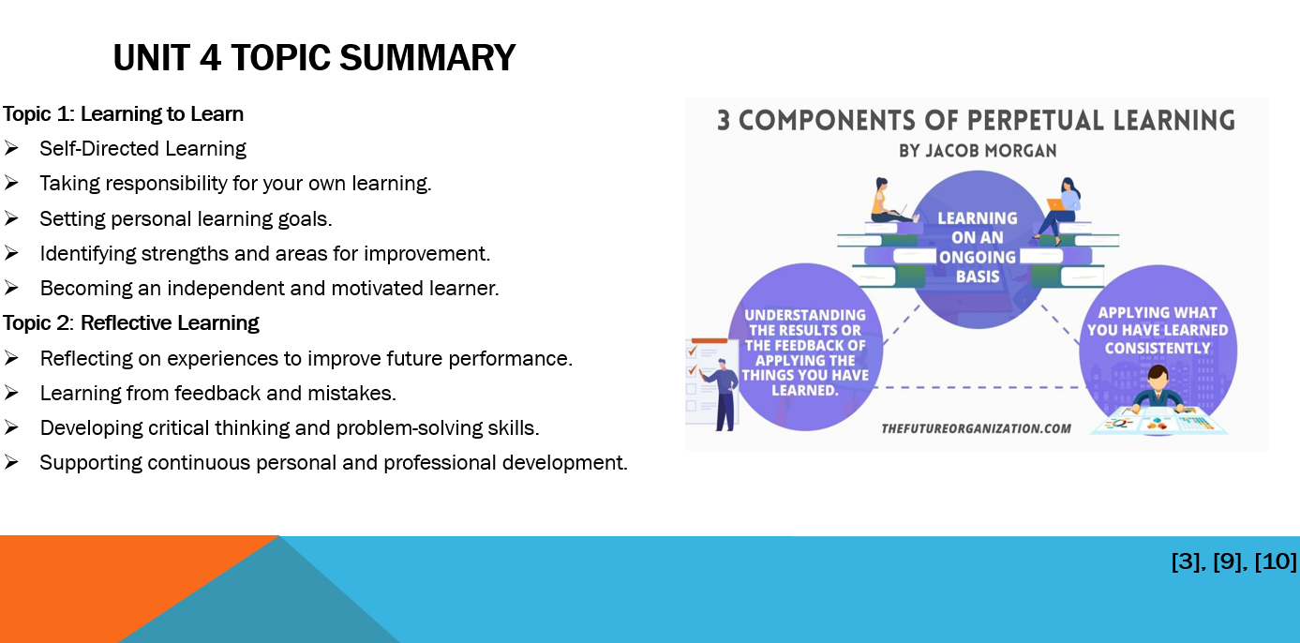

Task 4 – Video Presentation
- Insert the link of your video presentation (please note this should be a public link which can be accessed by your lecturer, module moderator and the external examiner. If you are not sure how to create a publicly available link yourself, it is suggested you come to the lecture in week 10 for in-person presentation in class and your lecturer will help you to record and generate the link)

- Aqil Presentation 3.pptx

https://uwtsd.hosted.panopto.com/Panopto/Pages/Viewer.aspx?id=62a9a14d-b2a4-4707-a7a8-b48d008de634

