  [Cultural Exchange in the Expansion of Clothing Business]  [Junyu Yang] | Abstract  This report explores the complexity of a clothing retailer's expansion into the Asian market, emphasizing the key roles of cultural awareness, relationship building, and effective communication. The analysis underscores the significance of trust as a cornerstone for successful collaborations. Key findings highlight the impact of cultural nuances on business dynamics, urging strategic adaptation. The report concludes with recommendations, including cultural training and strategic flexibility, to navigate the complexities of international business in Asia.  International Business Communication

Executive Summary

The purpose of this report is to discuss the skills required to promote successful international business exchange, while paying attention to the diverse cultures of clothing retailers seeking to enter the Asian market. Through extensive research on cultural and business aspects in international business communication, this report finds that there are different communication styles in the Asian market. According to Hall's cultural model, high context cultures prefer indirect, implicit, and nonverbal communication methods, while low context cultures prefer direct, explicit, and dependent language expression (Shynkaruk et al., 2018). For clothing retailers entering the Asian market, Trompenaar's dimensions provide a framework for understanding and adapting to diverse cultural landscapes (Trompenaars, 1996). In addition to communication methods, trust is also important in driving these Asian markets to achieve effective international business cooperation. It helps to establish business relationships with key stakeholders. However, companies need to be aware that cultural misunderstandings, communication barriers, lack of trust, mismatched expectations, and lack of cultural sensitivity can lead to the failure of these markets. Therefore, in the event of failure, they need to conduct root cause analysis, adapt and learn, make strategic adjustments, and strengthen communication with stakeholders. In this way, they will demonstrate commitment and be able to repair their relationship and trust with consumers. This will also help them establish customer loyalty. By adopting proactive and adaptable methods, retailers can not only effectively solve failure problems, but also transform them into valuable learning experiences. In addition, retailers also need to make significant investments in cultural training, continuous monitoring, and strategic flexibility.

Content Page

Executive Summary 1
1.0. – Introduction 3
2.0 – Main Findings 4
2.1 – International Business Communication 4
2.2 – Skills Requirements 4
2.3 – Methods of Communication 6
2.3.1 - Halls High Low Context 6
2.4 – Effective Communication 7
2.5 – International Culture 7
2.5.1 - Trompenaar’s 7 dimensions to culture 8
2.6 – Importance of Building Relationships 9
2.7 – How to Build Trust 10
2.8 – Failed Relationships 10
3.0 – Conclusion 12
4.0 – Recommendations 13
Appendices 14
References 15

1.0. – Introduction

In the constantly changing business environment where internationalization has become the language of enterprises, effective communication is crucial for the success of any company seeking to go global and establish relationships (Takino, 2020). The purpose of this report is to discuss the skills required to promote successful international business exchange, while paying attention to the diverse cultures of clothing retailers seeking to enter the Asian market. This report aims to provide retailers and their stakeholders with the necessary knowledge and insights to navigate Asia's unique cultural landscape, cultivate strong professional relationships, and ensure seamless communication of information.
This report explores the concepts, basic skills, various communication methods, importance of effective communication, importance of building relationships, factors that lead to relationship failure, definition of culture and its components, Hall's high and low context, Trompenaar's seven dimensions of culture, and how to build trust in retailers in Asia.

2.0 – Main Findings

This section presents the core findings of this report following investigations into the key elements of international business communication, focusing on the skills, methods, and cultural considerations crucial for company's successful entry into the Asian markets.

2.1 – International Business Communication
International business communication is not different from any other form of business communication except that it occurs across borders (Szkudlarek et al., 2020). In the context of international business, international business communication is the exchange of messages and information between individuals, organizations, or entities located in different countries or regions, intending to conduct business activities on a global scale (Khamis and Wahi, 2021). It encompasses various aspects of communication, including verbal and written communication, as well as non-verbal cues, and it plays a crucial role in the success of international business transactions, collaborations, and relationships.

2.2 – Skills Requirements
In international business communication, one of the skills required is cultural sensitivity. It involves the recognition, understanding, and respect for cultural differences existing between parties during any business transaction. According to Hofstede's Cultural Theory which examines cultural differences across countries, this skill is essential to building trust and fostering long-term positive relationships by eliminating possible misunderstanding (Hofstede, 2009). In the case of retailer which seeks to enter Asian markets, this skill requires the retailer to understand, respect, and acknowledge the unique cultural landscape of each Asian market targeted by retailer to ensure that communication aligns with local expectations.
Another skill requirement is language proficiency, which requires businesses to have strong verbal and written communication skills in the languages relevant to the target markets. Language proficiency is useful for clear and accurate communication (Klarin et al., 2021). Proficiency not only involves language fluency but also an understanding of idioms, colloquialisms, and language variations that may exist in different Asian regions.
In this situation, retailer must possess proficient verbal and written communication abilities.
Another important skill in the context of international business communication is the interpersonal skills as they play a vital role in fostering and maintaining positive relationships. These skills entail the ability to forge and sustain connections with individuals from diverse cultural backgrounds (Damnjanovic et al., 2021). Building rapport is essential for successful international business communication. Robust interpersonal abilities facilitate successful collaboration, negotiation, and conflict resolution in diverse cultural contexts. In this context, interpersonal skills encompass networking, team leadership, conflict resolution, negotiation, the demonstration of empathy, and the practice of active listening.
On the other hand, it is essential to pay attention to global business professionalism, etiquette, and uphold a professional attitude when interacting with diverse cultures (Khamis and Wahi, 2021). In this scenario, retailer should be conscious of and comply with the established standards of conduct in international business environments. Understanding and practicing global business etiquette helps in building professional relationships with potential business partners across different regions in Asia. It includes aspects such as greetings, gestures, and appropriate business attire, which differ across cultures.
Emotional intelligence is also a crucial skill across different cultures, especially when considering cultural diversity. It refers to the ability to recognize, understand, manage, and effectively use one's own emotions and the emotions of others (Nguyen et al., 2019). This skill is important in international business communication because it enhances self-awareness, and cultural empathy, builds strong interpersonal relationships, enhances conflict resolution skills, communication flexibility, and motivation. Developing cultural intelligence among employees facilitates smoother interactions with Asian partners and customers.

2.3 – Methods of Communication
Communication methods vary across different cultures as postulated in Edward Hall’s Model of low and high-context cultures. It is one of the dominant theoretical frameworks that is used to navigate cultural differences to build effective intercultural communication (Verluyten, 2020). According to this Edward Hall's proxemics theory proposes that individuals will uphold varying levels of personal space based on both the social context and their cultural origins. In line with the theory, high-context cultures are where much of the communication is implicit and relies heavily on context and non-verbal cues (Shynkaruk et al., 2018). Low-context cultures, on the other hand, emphasize explicit communication, where the message is conveyed primarily through words rather than relying on contextual cues.

2.3.1 - Halls High Low Context
In low-context cultures in Asia such as Singapore, Hong Kong, Malaysia, Taiwan, Philippines, and Sri Lanka direct communication methods are preferred and emphasized. In such countries, the message is explicit, straightforward, and reliant on the spoken or written word. The primary focus is on clearly and precisely communicating information (Qingxue, 2003). Communication is predominantly marked by professionalism, with an emphasis on the task at hand and the accomplishment of specific objectives. People in low-context cultures tend to communicate more directly and may explicitly state their thoughts and expectations. Moreover, communications in these nations are direct, minimizing ambiguity. Typically, individuals in these societies anticipate information to be expressed with clarity and may not heavily depend on contextual cues or shared experiences to interpret messages (Gudykunst et al., 1996). Verbal communication takes precedence, and individuals in low-context cultures may value detailed explanations and clear instructions. The focus is on the content of the message rather than the surrounding context. Individual identity is often more emphasized than group identity and personal achievements and opinions are valued.
In high-context cultures such as Japan, Korea, China, Thailand, India, and Vietnam, communication style is mainly indirect as people may not explicitly express thoughts or feelings, and meaning is often derived from context and relationships. The meaning is embedded in the context, and people are expected to read between the lines (Fakkar et al., 2010). There is a strong emphasis on maintaining group harmony, and individuals may avoid direct confrontation to preserve relationships. Respect for authority and hierarchy is significant, and communication may be influenced by the status and relationship between individuals.
In contrast to cultures that prioritize explicit communication, such as low-context cultures, high-context cultures place emphasis on implicit communication, utilizing non-verbal signals, context, and shared experiences to convey a significant portion of information (Bjornsdottir and Rule, 2021). Facial expressions, body language, and tone of voice carry substantial weight. Silence and pauses are often meaningful, and individuals are attuned to these non-verbal signals.

2.4 – Effective Communication
Ensuring effective communication across Asian markets that comprise both high-context and low-context cultures requires a combination of cultural awareness, adaptability, and effective communication skills (Freeman and Browne, 2004). When navigating through Asian countries, retailer must ensure its staff learn about the cultural values, norms, and communication styles of the cultures they are interacting with as well as comprehend the high-context or low-context nature of the culture. They must pay close attention to verbal and non-verbal cues as well as be open to understanding the underlying messages and emotions behind the words (Freeman et al., 2002). Because of the differences in communication styles, company staff must be adaptable and more attentive to the different communication styles. Most importantly, retailer needs to build cross-cultural training programs for its employees who will be working in selected Asian countries.

2.5 – International Culture
Understanding the context of international culture is important when navigating through international communication. Fons Trompenaars, a Dutch organizational theorist, proposed seven dimensions to analyse and compare cultures, providing valuable insights into how societies approach various aspects of life and work (Trompenaars, 1996). These dimensions help elucidate cultural variations, guiding retailer in building successful relationships in diverse Asian markets.

2.5.1 - Trompenaar’s 7 dimensions to culture
Universalism vs. Particularism
In cultures with a universalistic orientation such as Japan, there is a belief in applying general rules and standards consistently. The focus is on adhering to laws and principles that apply to all (Sato et al., 2010). Particularistic cultures such as China emphasize context and relationships, allowing for flexibility in applying rules based on individual circumstances.
Individualism vs. Communitarianism
Individualistic cultures such as South Korea prioritize personal goals, autonomy, and self-expression. Independence and personal achievement are highly valued (Hillenbrand, 2010). Unlike individualistic, in communitarian cultures such as India, group harmony, loyalty, and collective well-being take precedence over individual interests. Collaboration and teamwork are highly valued.
Specific vs. Diffuse
In specific cultures such as Singapore, there is a clear separation between personal and professional life. Relationships are compartmentalized, and the focus is on specific tasks or goals (Bjornsdottir and Rule, 2021). Diffuse cultures such as Thailand blur the lines between personal and professional relationships. Building trust and rapport is seen as essential before engaging in business transactions.
Neutral vs. Emotional
Neutral cultures such as Japan tend to suppress emotions in professional settings, valuing objectivity and maintaining a calm demeanour (Bjornsdottir and Rule, 2021). On the other hand, emotional cultures such as Indonesia express feelings openly and consider emotions integral to work relationships. Emotional expression is not perceived as a hindrance to professionalism.
Achievement vs. Ascription
Achievement-oriented cultures such as South Korea place emphasis on an individual's accomplishments, skills, and merit. Status is often earned based on performance (Chitty, 2010). In ascription cultures such as Saudi Arabia, status and authority are attributed based on factors such as age, gender, or social connections, irrespective of individual accomplishments.
Sequential vs. Synchronous Time
Cultures that follow sequential time such as Japan prioritize punctuality, deadlines, and a linear approach to tasks (Chitty, 2010). Synchronous time cultures such as Indonesia have a more flexible approach to time, allowing for simultaneous engagement in multiple activities. Relationships and events often take precedence over strict adherence to schedules.
Internal vs. External Control
In cultures with an internal locus of control such as Japan, individuals believe they influence their destinies through their actions and decisions (Hillenbrand, 2010). External control cultures such as Vietnam attribute events and outcomes to external factors such as fate, luck, or societal forces beyond individual control.

2.6 – Importance of Building Relationships
For retailers, building relationships in international business communication is important because it enhances trust and credibility. Trust and credibility are the foundation of successful collaboration in Asian markets, where personal connections often play a significant role in business interactions (Havila et al., 2004). Such relationships will also be important in enhancing effective communication, which is crucial in overcoming language barriers and ensuring that messages are conveyed accurately and in a culturally sensitive manner.
Building relationships is also important for cultural understanding. In Asian markets, where cultural nuances would greatly impact business dynamics, forming personal connections helps navigate cultural differences, demonstrating respect, and avoiding misunderstandings (Racelaet al., 2007). The success in these markets also relies on long-term partnerships. Hence, building relationships fosters commitment and loyalty, essential for enduring collaborations. In Asian cultures, which often prioritize long-term perspectives, investing in relationships aligns with local business values.
Lastly, building relationships will help retailers to adapt to the local preferences of the Asian markets. Understanding the preferences of Asian consumers will allow retailer to tailor its products, services, and marketing strategies to align with the cultural context and consumer expectations, which will contribute to a strong brand image (Gerbasi and Latusek, 2015). Cultivating connections with local partners, suppliers, and customers in Asia helps retailer create a favourable reputation, enhancing brand trust and appeal in the target markets.

2.7 – How to Build Trust
When exploring diverse markets such as Asia, building trust requires a robust cultural awareness and recognizing the importance of hierarchy, respect for elders, and other cultural values that influence trust-building (Gerbasi and Latusek, 2015). Retailer would achieve this through cultural sensitivity training for its staff to ensure they are aware of and respect the cultural norms and practices of the target countries. This will help in avoiding unintentional misunderstandings.
Another way to build trust in diverse Asian cultures is to invest time in getting to know key partners, suppliers, and stakeholders on a personal level before delving into business (Friman et al., 2002). To achieve this, company’ staff would prioritize face-to-face interactions or in-person meetings to establish a personal connection, demonstrate commitment, and build trust more effectively than remote communication.
Lastly, retailer needs to integrate sustainable and ethical business practices that have become common in international business contexts (Friman et al., 2002). Since customers shift their preferences towards sustainable retailers, retailer will build trust in Asian markets by upholding high ethical standards in all business dealings. retailer would demonstrate integrity and a commitment to ethical practices. Demonstrating a commitment to social and environmental responsibility would enhance the brand's reputation and contribute to trust-building.

2.8 – Failed Relationships
Relationships, especially in international business contexts, would face various challenges that may lead to failure (Elenkov and Fileva, 2006). For example, when it comes to cultural understanding, inefficient understanding of the cultural values, norms, and communication styles in the target market would lead to misunderstandings and misinterpretations. If retailer fails to adapt its business practices to align with the cultural expectations of the target market, it may result in unintentional disrespect or offense. Language barriers would hinder effective communication (Johnson et al., 2006). Miscommunications may occur, leading to misunderstandings or the misinterpretation of critical information. Variations in communication styles, such as high-context vs. low-context communication, would lead to confusion and breakdowns in conveying messages accurately. Lastly, cultural insensitivity in marketing campaigns, branding, or product offerings would lead to negative perceptions and harm the relationship with customers.

3.0 – Conclusion

In summary, the triumph of retailer Clothing Retailer in venturing into Asian markets relies on a comprehensive strategy that involves cultural awareness, relationship cultivation, and proficient communication. Essential elements include grasping and adjusting to the subtleties of high-context Asian societies, integrating Trompenaar's cultural dimensions, and emphasizing interpersonal skills. Building trust, a fundamental aspect of successful partnerships necessitates ongoing efforts to navigate potential challenges. Recognizing the intricacies of cross-cultural business, tackling communication hurdles, and actively nurturing relationships positions retailer not just to overcome obstacles but to flourish in the varied and dynamic markets of Asia.

4.0 – Recommendations

In case of any failures in the Asian markets, retailer will first conduct a thorough analysis to identify the root causes of the failures. This way, they will comprehend whether they stem from cultural misunderstandings, communication gaps, operational issues, or other factors. After identifying the contributions of the failures, the company would use the failures as opportunities for learning and adaptation to specific cultural nuances, market dynamics, or business practices. Afterward, retailer will need to make strategic adjustments based on the lessons learned. This could involve refining the market entry strategy, adapting product offerings, or revising communication approaches to better align with local expectations. It should also involve transparent communication with the stakeholders, which will help in restoring trust.

Appendices

Hofstede Dimensions
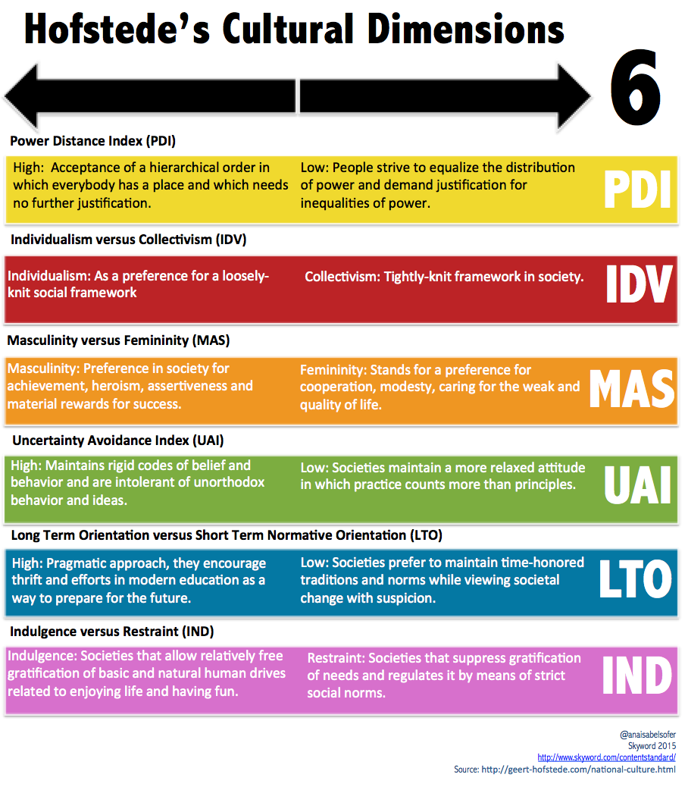

References

Bjornsdottir, R.T. and Rule, N.O., 2021. Perceiving acculturation from neutral and emotional faces. Emotion, 21(4), p.720.
Chitty, N., 2010. Mapping Asian international communication. Asian Journal of Communication, 20(2), pp.181-196.
Damnjanovic, V., Proud, W. and Milosavljevic, M., 2021. Mentoring development at student international business case competitions. EuroMed Journal of Business, 16(2), pp.154-170.
Elenkov, D. and Fileva, T., 2006. Anatomy of a business failure: Accepting the “bad luck” explanation vs proactively learning in international business. Cross Cultural Management: An International Journal, 13(2), pp.132-141.
Fakkar, E., Djahantighi, F.S., Haghighi, M. and abolghasem Mira, S., 2010. Cross-Cultural Strategic Marketing, Approach to Analyze the High-Context and Low-Context Cultures (Edward Hall Model) in Web Development. In Proceedings of the 6th International Strategic Management Conference.
Freeman, S., Vaaland, T. and Browne, E., 2002, December. National culture and its influence on dissolution communication strategies in Western versus Asian business relationships. In Culture and Collaboration in Distribution Networks, The Inaugural Meeting of the IMP Group in Asia, Curtin University, Perth, Western Australia (pp. 1-21).
Freeman, S. and Browne, E., 2004. The influence of national culture on dissolution communication strategies in Western versus Asian business relationships: a theoretical model. Supply Chain Management: An International Journal, 9(2), pp.169-182.
Friman, M., Gärling, T., Millett, B., Mattsson, J. and Johnston, R., 2002. An analysis of international business-to-business relationships based on the commitment–trust theory. Industrial marketing management, 31(5), pp.403-409.
Gerbasi, A. and Latusek, D., 2015. Trust-building in international business ventures. Baltic Journal of Management, 10(1), pp.30-51.
Gudykunst, W.B., Matsumoto, Y., Ting-Toomey, S., Nishida, T., Kim, K. and Heyman, S., 1996. The influence of cultural individualism-collectivism, self-construals, and individual values on communication styles across cultures. Human communication research, 22(4), pp.510-543.
Havila, V., Johanson, J. and Thilenius, P., 2004. International business‐relationship triads. International Marketing Review, 21(2), pp.172-186.
Hillenbrand, M., 2010. Communitarianism, or, how to build East Asian theory. Postcolonial Studies, 13(4), pp.317-334.
Hofstede, G., 2009. Geert Hofstede cultural dimensions.
Johnson, J.P., Lenartowicz, T. and Apud, S., 2006. Cross-cultural competence in international business: Toward a definition and a model. Journal of International Business Studies, 37, pp.525-543.
Khamis, N. and Wahi, W., 2021. Enhancing business communication skills: Action research. International Journal of Asian Social Science, 11(7), pp.355-364.
Klarin, A., Inkizhinov, B., Nazarov, D. and Gorenskaia, E., 2021. International business education: What we know and what we have yet to develop. International Business Review, 30(5), p.101833.
Nguyen, T., White, S., Hall, K., and Bell, R., 2019. Emotional intelligence and managerial communication. Ameriwould Journal of Management, 19(2), pp.54-63.
Qingxue, L., 2003. Understanding different cultural patterns or orientations between East and West. Investigationes Linguisticae, 9, pp.22-30.
Racela, O.C., Chaikittisilpa, C. and Thoumrungroje, A., 2007. Market orientation, international business relationships, and perceived export performance. International Marketing Review, 24(2), pp.144-163.
Sato, Y., Burawoy, M., Chang, M. and Hsieh, M.F., 2010. Are Asian sociologies possible? Universalism versus particularism. Facing an unequal world: Challenges for global sociology, 2, pp.192-200.
Shynkaruk, L., Salata, H. and Danylova, T., 2018. Dialogue of cultures: E. Hall and F. Kluckhohn. Вісник Національної академії керівних кадрів культури і мистецтв, (3), pp.128-133.
Szkudlarek, B., Osland, J.S., Nardon, L. and Zander, L., 2020. Communication and culture in international business–Moving the field forward. Journal of World Business, 55(6), p.101126.
Takino, M., 2020. Power in international business communication and linguistic competence: Analyzing the experiences of non-native business people who use English as a business lingua franca (BELF). International Journal of Business Communication, 57(4), pp.517-544.
Trompenaars, F., 1996. Resolving international conflict: Culture and business strategy. Business strategy review, 7(3), pp.51-68.
Verluyten, S.P., 2020. Cultural biases in intercultural business communication courses and how to avoid them. In Exploring the Rhetoric of International Professional Communication (pp. 191-209). Routledge.

