

Sarah Puntan-Galea [UWTSD student no: 2218593]
Change & Stability Management module: BMMB7000
Lecturer: Dr Marie Pitson
Submission date: Friday 5th May 2023

Case study report on a change within an organisation
‘Click + Collect’
Primark launches its online shopping offering
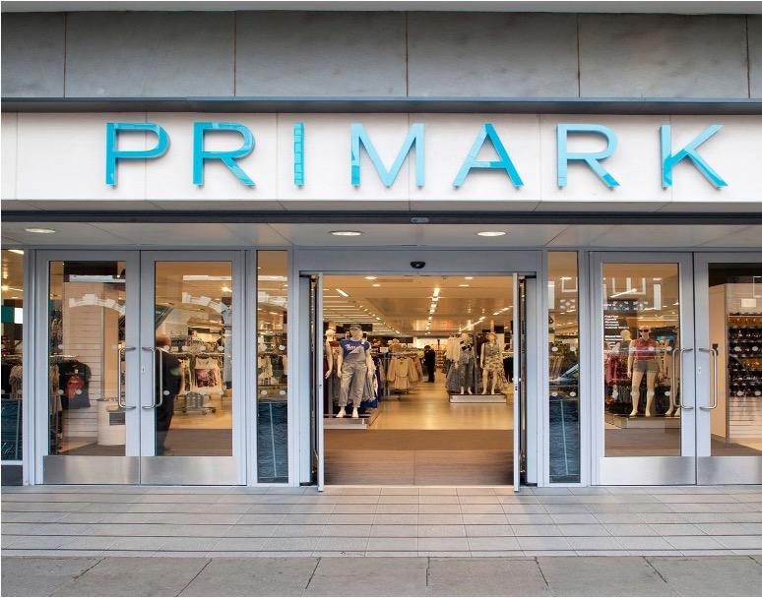

1 Executive summary

Several change models were used in this report to analyse fast fashion retailer Primark’s decision to move online, as the world it operates in started to navigate itself out of lockdown and back to in-store shopping.

The actual change researched, called Click+Collect (which is an ongoing trial and not a full online offering), showed it to be a successful change so far. And how Primark should embrace a full online offering post-trial if it wants to continue its commitment to staying in line with current trends.

And, although Primark did not stay ahead of trends by having a full online shopping offering by the time lockdowns hit, research showed benefits to being late to the table: learning from the pitfalls competitors already fully online are encountering, including the cost of delivery and returns being too high to swallow for a value fashion retailer. So it is recommended Primark should charge for these from the offset, if it chooses to extend its online offering post-trial.

Research in this report also proves predictions of online shopping overtaking in-store shopping in the near future to be mistaken. With customers choosing to physically go shopping when buying value fashion - the cost of living crisis being partly responsible, with value fashion and a day spent shopping on the up.

This also shows the decision not to go fully online during the lockdowns, or after, by Primark’s CEO Paul Marchant, to not be the disaster it initially seemed after Primark’s financial losses during the lockdowns were announced.

The report shows the change analysed to be an emergent change, and very much just testing the waters of an online sales offering due to missing the boat on online sales during the pandemic lockdowns.

Lewin’s Force Field Analysis showed the driving force for Primark to enact the studied change and go online, even in a small trial way, has stronger driving forces behind it than restraining forces. With Kotter’s Eight Steps to Successful Change showing Primark’s move online being very much unfinished and temporary.

But its success is due to the fashion retailer having gone successfully from its ‘current state’ of Primark not being online, to a ‘desired state’ of having a successful online sales offering - even if it is just a trial.

The report also looks at the wider picture of Primark’s reputation for being ahead of the curve in what to wear, not being reflected in other areas - not just being late to go online, but also in treating its overseas staff well, offering vegan and eco-conscious goods, and having a credible sustainability strategy.

In all these areas Primark is moving forward with its online shopping offering cautiously. But with profits up on last year announced at the time of this report being submitted, it seems ‘better late than never’ has yet again proven to be a wise move by a fast fashion retailer which has weathered its £430m financial losses during lockdown (£1bn throughout the pandemic), and will turn it into a learning curve advantage.

Ultimately, the report shows Primark to still be very much at the start of its growth cycle, with another successful change under its belt and recommendations on how to move forward.

Although a full move online would require lots of planning, strategy changes, staff training and buy-in, etc, these are all areas the company has successful previous form in. Either way, this is a company that will remain a value fashion sector leader for the foreseeable future.

2 Contents

Title page
1 Executive summary ………………………………………………… 1
2 Contents …………………………………………………………….. 4
3 Introduction ………………………………………………………….
3a to Primark ………………………………………………………..
3b to change ………………………………………………………..
3c to the change analysing ………………………………………..
4 Going online …………………………………………………………
5 Using change models to analyse the change …………………...
5a PESTLE …………………………………………………………
5b Lewin’s Force Field Analysis ………………………………….
5c Lewin’s Three-stage Theory of Change ……………………..
5d Kotter’s Eight Steps to Successful Change …………………
6 Conclusion and recommendations ……………………………….
7 References ………………………………………………………….

3 Introduction

- 3a) to Primark
Primark is primarily a 'fast fashion’ multinational retail company that labels itself as a “leading international clothing retailer” [primark.com, 2023]. It sells affordable, ‘trendy’ clothing for children and adults, homeware, accessories, beauty products and even sweets.

It was established in 1969 in Dublin, Ireland, as 'Penneys’. However, with that name already registered to a US-based international company, it trades under the name of Primark (Stores Ltd) outside of Ireland [Finn, 2015] [O’Neill, 2014].

Owned by British Associated Foods, Primark’s growth has been slow and steady over the past five decades, even buying the selling-slightly-similar-goods Littlewoods brand in 2005 for £409m - it kept 40 of their stores, selling 79 [Finch, 2005].

Primark is now present in 16 countries after opening a store in Slovakia this year, and “continues to expand across new and existing markets”, with aims to have 530 stores by 2026 [primark.com, 2023].

Its first store outside Ireland opened in Derby, UK, in 1974. Outside the UK, it opened a store in the Spanish capital of Madrid in 2006. It now has stores in 12 other EU countries from Poland to Slovenia [primark.com, 2023]. As well as a flagship US store in Boston which opened its doors in 2015. This was followed by stores in four other American states, and a total of 16 US stores by 2023 [primark.com, 2023].

Its largest store is in the UK city of Birmingham, where it has a whooping five floors of fashion goods for sale across 160,000 feet of retail space, plus a café and barbers. Its second largest store is in Madrid [primark.com, 2023].

As of last year, post-pandemic lockdowns, Primark had 191 stores, 72,000 employees, and a revenue of £5.6m [Wikipedia, 2023] [primark.com, 2023]. Paul Marchant has been its CEO since 2009, who is not a media-hungry leader and could argue he has navigated the company through the COVID-19 storm successfully, especially after results in January of this year show a 15% rise in sales over the Christmas period, and 16% rise in group - Associated British Foods - sales [Davey, 2023].

- 3b) to change
Defined as “the coordination of a structured period of transition from situation A to situation B in order to achieve lasting change within an organisation” [BNET Business Dictionary, 2023], Change Management is the steering through of any change within an organisation.

As the Greek philosopher Heraclitus said: "Change is the only constant." And was true more than 2,000 years ago is just as true today. We live in a world where ‘business as usual’ makes change inevitable in any organisation, due to changing environments out of their control - from customer demands and trends, to advancements in technology and the state of the economy - it needs to be successfully managed for the organisation to not just survive, but to adapt and thrive in today’s fast-moving world.

Businesses who fail to embrace change and stay ahead of the game become out-of-touch, and unable to compete in the current market. Never has this been more important than in 2020 when the pandemic hit. Change was forced upon businesses - some changed, coped, and even thrived, and some stuck their heads in the sand and didn’t. Which is where I believe the change I am analysing fits.

- 3c) to the change analysing
Primark was one such business that didn’t respond immediately to the change consumers demanded of them during the pandemic: To sell their products online. In fact, it took them till November 2022 - more than two and a half years since the first UK lockdown - to launch an online offering.

But why?

Primark’s experienced CEO Paul Marchant - who has an extensive background in leadership roles in the fashion industry, from New Look to River Islands and Topman - has always focused on customer footfall in store, over online clicks. And he believed in sticking to that and riding the pandemic storm. Having had a decade of boosting profitability and securing the Primark brand in a crowded retail market, his decision was not questioned by the Board and stakeholders [pointfranchise.co.uk, 2023].

Because of this, Primark was not set-up to make a swift and seamless shift online, even if it had decided to. And with 189 UK Primark stores temporarily closed between March and July 2020 due to government COVID-19 restrictions [Jolly & Butler, 2020], the fashion supplier reported a sales loss of £430m during the lockdown as a result of the brand being unable to sell its products online [Mattinson, 2020].

This seems to be a mistake, not just because many of Primark’s competitors reported lower financial losses due to being online over the pandemic, but because the shift in customer behaviour from in-store to armchair shopping seems to be here to stay - according to a report by Retail Economics and Eversheds Sutherland, which predicted online clothing sales to overtake in-store in the UK by this year, with the rest of European markets not far behind [econsultancy.com, 2023].

Primark did not start selling its products online during the pandemic for a multitude of reasons, but primarily due to the cost of running the service: from setting-up a website to having to staff warehouse where goods are processed, and a system for both deliveries and returns. The low pricing of Primark’s goods also meant it was hard to make a profit selling online [Nazir, 2022].

4 Going online
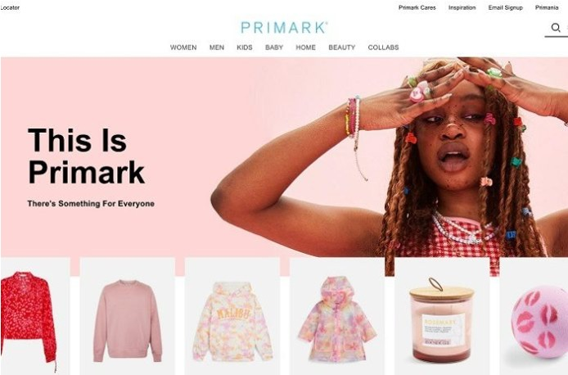

After announcing a total loss of £1bn in sales throughout the pandemic (not just during the lockdowns), Primark finally went online in November 2022 with a ‘Click + Collect’ service only [Baker, 2022] [Nazir, 2022]. This was launched as a kids' products-only trial in 25 UK stores, but the website crashed on launch day [Nanji, 2022] [Simpson, 2022].

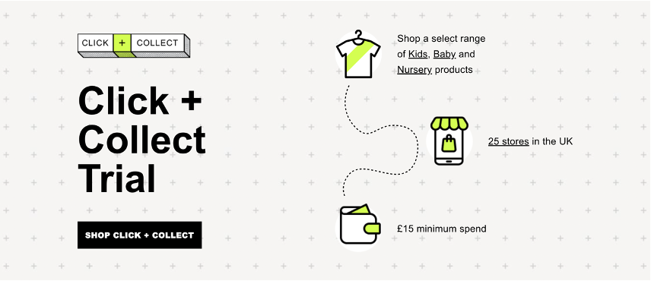
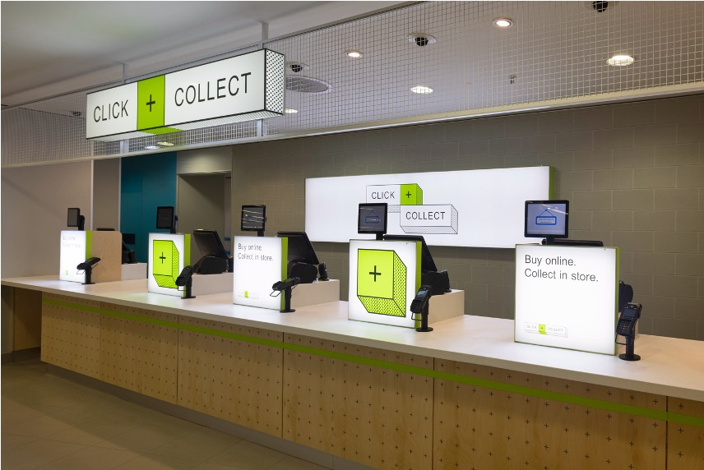
Up-and-running successfully now, it is still too early to get profit figures. Especially because it is still running as a trial. And a limited offering of "the chance to shop an exclusive range of around 2,000 Primark kidswear, baby/nursery products that won’t be available in-store inc. character favourites, multipacks, nursery furniture” in just three areas of the UK [primark.com, 2023]. It shows no sign of increasing its online offering, with some just-published articles reporting low value fashion having an increase in in-store over online shopping [Davey, 2023].

According to one of many definitions cited by Burns [2004, 2009] and explained by Hodges & Gill [2015], I believe Primark’s decision to go online was an ‘emergent change’, due to being a late reaction to their customer’s demand for online shopping and, still in trial mode, will have ongoing adaptations and alterations, which will continue to produce a change that was obviously not in the pre-pandemic organisation’s strategic plan.

I feel this is backed up by Ottaway [1983], due to it displaying signs of how he described emergent change, including: An open-ended process, adjusting to a changing external environment, and a learning process. Although, this type of change will alter if the online offering increases.

5 The change, analysed

- 5a) PESTLE
Before looking at change models, I wanted to do a PESTLE analysis to assess the situation. It is clear that the change of Primark having an online sales offering has been well received and potentially successful due to early inside comments [Rigby, 2022] - but is it too little, too late?

POLITICAL:
Against the backdrop of the pandemic, Primark had to operate within the government’s lockdown regulations (plus their policy and tax system) - which it could not do, due to not having an online offering yet. It could, however, have started one within the regulations, and kept production going.

Now the political landscape is supportive of all UK-businesses having online offerings to help both the company and wider economy to prosper to help turn around the economic downturn brought on by Brexit (weaker pound sterling and uncertainty about trade restrictions with Europe), the pandemic, and mishandling of the UK economy by short-lived UK Prime Minister Liz Truss in September-October 2022 which all affected profit margins - the political instability caused by all the aforementioned, would be important external factors to consider for Primark.

ECONOMIC:
With shops shut due to lockdown, and staff furloughed, the economic cost was going to be far greater for Primark without having an online offering to keep sales going, and money coming in. The pandemic had created poor market performance, and greater dependency on online shopping. Added to the uncertainty in UK business markets just before the pandemic hit due to Brexit, and exchange rate conversions remaining volatile affecting negotiations with suppliers, the economic outlook was and is not positive.

With the online operation up-and-running as a current trial, it would need to be seen if the cost of this is covered by the online sales profit - and if so, how long will it take to be profitable. Although money was lost in the pandemic, if money isn’t going to be made in the long-term, the online sales offering may not be in Primark’s interest. However, with customer footfall lower than in pre-pandemic years, and the future of the high street of a concern, being online reduces the risk for Primark.

Due to the pandemic and current cost of living crisis, consumer habit changes have put pressure on ‘luxury’ items, especially for markets like Primark’s (popular with lower earners) who are being hit the hardest with price rises. The economic risks of this change are low because of the demand, partial offering and trial, but the investment has been made to get it up-and-running, which should be recouped.

SOCIAL:
Primark was under pressure to keep operating during the pandemic, and to keep staff in jobs, but it could have done so if it was operating online. The change analysed of moving online later, still brings a change to roles, whether filled by the recruitment of new staff or re-training members of the current team, to work on the website, and in the warehouse, from packaging, to delivery, and returns.

If jobs are offloaded to lower wage countries, there may be a detrimental backlash as seen in previous media reports of Primark paying their workers in third world countries too little to create their clothes - as well as their working conditions being poor, and hours long [standard.co.uk, 2023].

To think about the change outside of the UK box, to have a global online offering would make sense, if they could go from trial to a full product offering online, with warehouses and delivery systems in all their markets.

The online offering of any kind will not be sustainable if not staffed adequately, with investment in further research done to see if online customers are the same as shop customers to sell the goods demanded, and what the customers want to look at, how they want to order and get their purchases delivered to ensure profitability in all markets like their stores have managed.

TECHNOLOGICAL:
This is where Primark had its issues - although the bought Littlewoods already had a website and online shopping system set-up, so they could have shared skills here. But they didn’t, because staffing is separate. And it took time for a website to be set-up, with all the structure in place: From the ordering, to the warehouse and packaging systems, and delivery. Not having the technological systems in place meant Primark did not get online in time for the lockdowns, losing money, and now have a limited ‘trial’ system, making the retailer look very behind their competition.

What Primark needs to do, is have an online offering that is not just tech-adequate for now, but fit for the future - utilising AI in warehouses, for example. With an appealing presence online - and an app. For smartphones, with fast, easy and seamless ways to order. Ensuring the data storage confidentiality is correct, with consumer rights respected, and analytics storage. The rise in cybercrime risk to data protection and operational stability is high and needs addressing moving forward.

LEGAL:
With the legalities in place, there would have been no barriers for Primark to start online operations during/post-pandemic. And with retailers mostly offering an online shopping option, the legal framework would be straightforward to set-up. However, what about factory staff overseas - what laws must be observed? Primark must not go backwards with the pay and treatment of their foreign workers - especially because they have publicly (via the media and their strategy) admitted fault and pledged to rectify [primark.com]. And new workers in the UK must be paid the National Minimum Wage at least, introducing workplace pensions and observing the modern Slavery Act.

ENVIRONMENTAL:
Click + Collect currently has no delivery service (it works using store pick-up), so it does not have a negative environmental effect. However, how long can Primark not deliver in a post-Pandemic era of the armchair shopper? If introduced post-trial, due to past criticisms, and a newly introduced ‘sustainability strategy’ [primark.com], it is important to source goods ethically - especially if Primark is re-focusing its marketing to a more environmentally-conscious shopper.

However, this will no doubt push up the cost of a ‘value’ retailer which Primark cannot do if this is the very USP of its business. Also, supply-chain disruptions and future pandemics need to be fractured into a wider company strategy moving forward.

- 5b) Lewin's Force Field Analysis

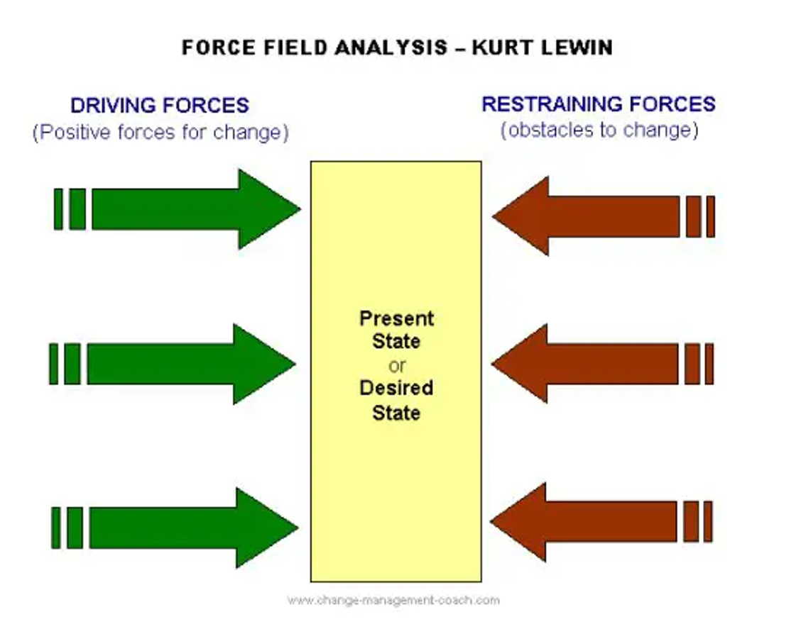
Widely considered in academic circles as the ‘founding father of change management’, Kurt Lewin said: "To bring about any change, the balance between the forces which maintain the social self-regulation at a given level has to be upset" [Lewin, 1948].

Which is why the first change model I used after a PESTLE analysis to analyse Primark’s move online, was Lewin’s Force Field Analysis. A “powerful strategic tool used to understand what's needed for change in both corporate and personal environments” [Connelly, 2023].

What Lewin proposes is that whenever driving forces are stronger than restraining forces, the status quo or equilibrium will change. Meaning, the (driving) forces for change outweigh the resistance, and are the reasons for my investigating this change, and to substantiate my argument. So, successful change is achieved by either strengthening the driving forces, or weakening the restraining forces.

To look at this in more detail, I needed to evaluate forces by scoring between 1 (weak), and 5 (strong). Evaluating the ‘current state’ (Primark not online), to the ‘desired state’ (of having an online sales offering), and future/risk-proofing the company in the event of another pandemic.
Driving forces for the company and staff including:
5) Primark can be bought and worn be anyone, anywhere - making it truly global!
5) Staff can upskill and work from home (which is advantageous if there is another pandemic, and people have responsibilities like a dog and/or children), unlike going to work in a physical store.
5) Going online mirrors the customer’s change in shopping trends - ‘armchair shopper’.
Restraining forces for the company and staff including:
1) The website is not set-up for online ordering, and a new website needs to be developed, although Littlewoods which was bought by Primark is online, so there may be some cost saving due to skill sharing there.
2) The cost of setting-up and running a warehouse and delivery system, from staff training to employing new staff.
4) Companies tend to lose money with online returns, especially package and postage - and low cost and high turnaround goods tend to make it hard to make a profit when selling online.
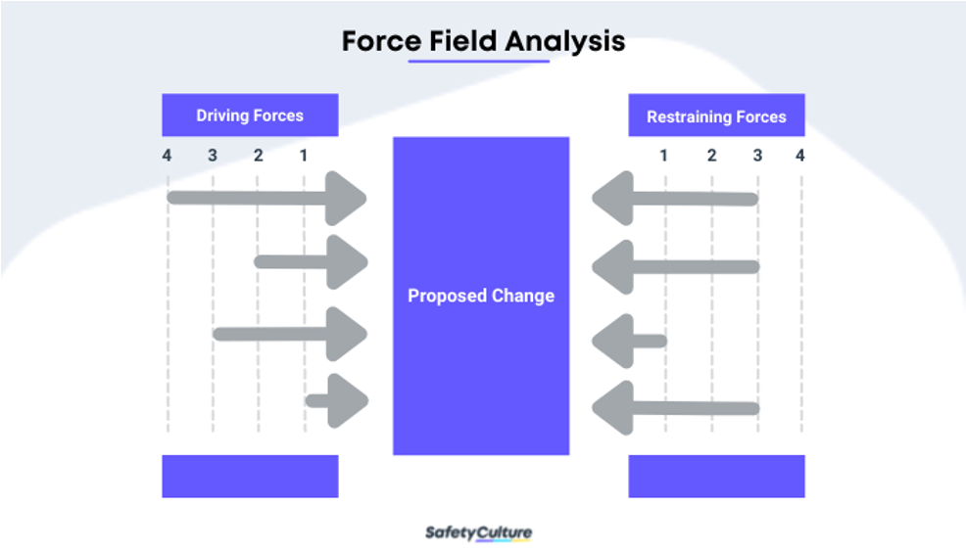
- 5c) Lewin’s Three-stage Theory of Change
Due to word count limitations, I will look at two other change models only briefly. Including the Force Field Analysis, which integrates with Lewin’s Three-stage Theory of Change (unfreeze, change/move, freeze), to work towards unfreezing existing equilibrium, moving towards the desired change, and then freezing the change at the new level so a new equilibrium exists that resists further change [Buchanan & Badham 2008] [Cameron & Green 2015].

Which is what is currently happening with Primark’s move online: the ‘unfreeze’ happened during the end of the pandemic lockdowns - and because the move online is just a trial, it helps ensure the employees are ready for any further change, by being a small entry to the online market (although going online would be a company move most employees are expecting due to Primark being one of the only high street fashion retailers currently not online). Then the ‘change’, when Click + Collect was launched. But the ‘refreeze’ will happen after the trial finishes and a more permanent online offering is instated.
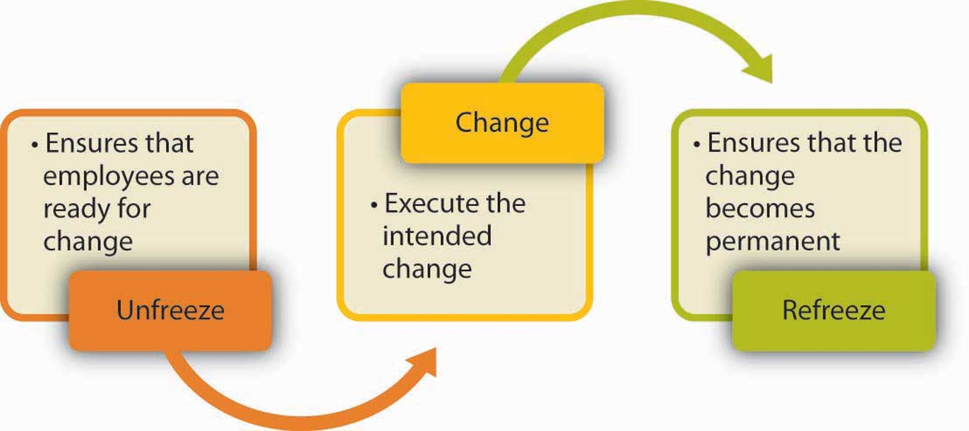

- 5d) Kotter’s Eight Steps to Successful Change
I will just touch on this change model too, because, like Lewin, it is a well-respected tool useful to analyse any change with. Devised by John Kotter, a professor at Harvard Business School and world-renowned change expert, his eight-step change process in his 1995 book ‘Leading change’ has proven to be an effective

And when you look at Primark’s change of going online, it again feels unfinished and temporary. Step 1, Establishing a sense of urgency, occurred during the pandemic. When it officially happened, it is unclear whether Step 2 Creating a guiding coalition and Step 3 Developing a vision and strategy took place to the level it needed too. However, Step 4 Communicating the change vision was done, as was Step 5 Empowering broad-based action. Because it is a trial, we are yet to see whether Step 6 Generating short-term wins, and Step 7 Consolidating gains and producing more change will come to fruition. But Step 8 Anchoring new approaches in the culture, will most certainly happen - online shopping is here to stay worldwide, and primark will have to retain it in a Click + Collect, or more traditional way.

6 Conclusion and recommendations

For this report, I analysed Primark’s decision to go online as a company change - although their online offering remains a limited trial, and not a full online service. Entering the online market happened post-pandemic lockdowns, which many people criticised due it being too late to stop the company having financial losses during the lockdown period where customers could not purchase Primark goods.

Although you cannot turn back the clock and recommend Primark going online earlier, I can recommend that as soon as the Click + Collect trial finishes, and if analysis shows it boosts sales, the company will need to train staff and put the necessary structure and systems in place to have a full online presence.

But either way, due to the delay of going online, and the criticisms that attracted, there has been buy-in from the staff, customers, company shareholders and owners. And because Littlewoods is already online, I feel there is an opportunity there to share skills to get Primark up-and-running online swifter.

However, to conclude after all my research, I have discovered some advantages of Primark not being online already, or having gone online during the lockdown as a reactive change. And maybe this proves CEO Paul Marchant to have been right to delay?

As I write this assignment, more recent reports have shown a recovery in Primarks sales (although still not to pre-pandemic levels, for Primark and the whole sector due to the worldwide cost of living crisis), with customers choosing to return to shopping in-store rather than online for value based fashion [retail-insight-network.com].

Plus, now the company has discovered the negatives its competitors’ are experiencing of having a full online sales presence - including the huge cost of free delivery and returns - Primark could use that intelligence to its advantage if it extends its online presence after the Click + Collect trial ends, offering a safe, planned change.

One option, which many fashion retailer competitors like Zara are now doing, is to charge for delivery and/or returns from the offset. Charging when you have not in the past is making this unpopular with customers (another reason to return to store shopping, so you can try before you buy), but it will not be as unpopular if you start a new service and charge from the offset.

My research using my main change model of Lewin’s Force Field Analysis shows the driving forces of the change were stronger than the restraining forces, which means this was a successful change.

The main positives that came out of my research included: expanding Primark’s reach to global; reducing the staff job loss risk, especially in the likelihood of a future pandemic; and the opportunity to upskill staff, and give them better work conditions (this being especially good, due to previous criticisms of Primark’s treatment of workers in non-european countries). Things the PESTLE analysis and other change models I looked at backed-up.

Ultimately, the fashion retailer went from a ‘current state’ of Primark not being online, to a ‘desired state’ of having a successful online sales offering - even if it is just a trial, where a few stores offer a few items to purchase online, then pick up at the customer’s local store, and it is too early for sales figures, although Primark report “high levels of interest”, I can conclude that this was a successful change and prepares the store for a larger planned change of going fully online [primark.com, 2023].

And if Primark does choose to go online fully, this should be in their company strategy, and planned using various models - especially Kotter’s Eight Step Change Management Model [mindtools.com], which is a process designed to help leaders successfully implement organisational change, focusing on creating urgency in order to make a change happen. It walks you through the process of initiating, managing, and sustaining change in eight steps, including nurturing a new company culture and communicating the vision and strategy internally and externally to understand the change.

Another point to consider, is that by being late going online, turns Primark’s ‘fast fashion’ reputation on its head - it did not mirror trends, like the rise in the ‘armchair shopper’, the way other retailers did, and the way it does with clothing and accessory trends.

That said, it has also been late to the game on eco-conscious shopping. But has eventually addressed this with the launch of vegan foodstuffs in 2018, and its Wellness collection in 2020: 80 eco-conscious products made of organic, sustainable, recycled materials. Part of Primark’s commitment to be more responsible for its footprint [Chiorando, 2018] [Roberts, 2020]. Because the younger generation (majority of Primark shoppers) are rejecting disposable fashion regardless of consequence.

And they also demand the company behaves better with its staff - especially overseas. And that too has been addressed, unveiling Primark’s new ‘sustainability strategy’ which sees Primark being more responsible for its carbon footprint by reducing textile waste and halving CO2 emissions, plus working hard to improve the lives of overseas Primark workers [primark.com] [McDougall, 2009].

Ultimately, in terms of its retail life cycle, Primark is still at the beginning of its growth stage [Findlay & Sparks 2002], and if it makes future changes wisely - from going fully online, to keeping up its good treatment of workers and expanding its eco-conscious products to mirror customer demands - it will mature, regain its pre-pandemic profitability, and research predicts it will continue to be a market leader in the fast fashion sector.

7 References
- BBC [2020] ‘Primark UK stores closing until further notice’: https://www.bbc.co.uk/news/business-51995189 (last accessed: 29 April 2023).
- Baker, F [2022] ‘Primark has finally gone online and shoppers are very excited’. Time Out: https://www.timeout.com/uk/news/primark-has-finally-gone-online-and-shoppers-are-very-excited-111422 (last accessed: 29 April 2023).
- Buchanan, D. A. & Badham, R.J. [2008] ‘Power, Politics and Organisational Change’, 2nd edition, London: Sage Publications
- Cameron, E. & Green, M. [2015] ‘Making Sense of Change Management: A Complete Guide to the Models, Tools and Techniques of Organisational Change’, 4th edition, London: Kogan Page
- Chiorando, M [2018] ‘Budget Chain Primark Starts Selling Vegan Snack Range’. Plant Based News: https://plantbasednews.org/lifestyle/budget-chain-primark-starts-selling-vegan-snack-range/ (last accessed: 29 April 2023).
- Connelly, M ‘Change Management Model’. changemanagementcoach.com: https://www.change-management-coach.com/kurt_lewin.html (last accessed: 29 April 2023).
- Connelly, M ‘Force Field Analysis’. changemanagementcoach.com: https://www.change-management-coach.com/force-field-analysis.html (last accessed: 29 April 2023).
- Davey, J [2023] ‘Primark cautious on 2023 after 'very strong' Christmas’. Reuters: https://www.reuters.com/business/retail-consumer/primark-sales-up-15-christmas-quarter-2023-01-24/ (last accessed 1 May 2023).
- Econsultancy [2001] ‘Stats: How fashion ecommerce has changed since Covid-19’: https://econsultancy.com/stats-how-fashion-ecommerce-has-changed-post-covid-19/ (last accessed 1 May 2023).
- Finch, J [2005] ‘M&S to cash in as Littlewoods disappears’. The Guardian: https://www.theguardian.com/business/2005/aug/08/highstreetretailers.marksspencer?INTCMP=ILCNETTXT3487 (last accessed: 29 April 2023).
- Finn, C [2015] ‘A household Irish name built from humble beginnings’. TheJournal.ie: https://www.thejournal.ie/penneys-business-1957209-Mar2015 (last accessed: 29 April 2023).
- Hodges, J & Gill, R [2015] ‘Typology of Change’ p22, ‘Sustaining Change in Organizations’, Sage Publications.
- Jolly, J & Butler, S [2020] ‘Primark plans to reopen all 153 stores in England on 15 June’. The Guardian: https://www.theguardian.com/business/2020/jun/01/primark-plans-to-reopen-all-153-stores-in-england-on-15-june-covid-19 (last accessed: 29 April 2023).
- Lewin, K [1948] ‘Resolving Social Conflicts’, p46/p47. New York: Harper & Brothers.
- London Evening Standard [2007] ‘The High Street sweatshops: Primark and M&S factories in India 'pay 13p an hour’: https://www.standard.co.uk/hp/front/the-high-street-sweatshops-primark-and-m-s-factories-in-india-pay-13p-an-hour-6610477.html (last accessed 1 May 2023).
- MindTools ‘Kotter's 8-Step Change Model’: https://www.mindtools.com/a8nu5v5/kotters-8-step-change-model (last accessed 1 May 2023).
- Ottaway, R [1983] ‘The Change Agent: A Taxonomy in Relation to the Change Process’, Human Relations (journal), Volume 36, Issue 4 p361-392.
- Retail Insight Network [2023] ‘Primark registers 18% sales growth for 16 weeks to 7 January’: https://www.retail-insight-network.com/news/primark-dec-2022/#:~:text=Primark%20NV&text=Elsewhere%20in%20Europe%2C%20Primark%27s%20sales,Germany%2C%20Spain%20and%20the%20US. (last accessed 1 May 2023).
- Rigby, C [2022] ‘ Primark meets overwhelming levels of interest as it sells online - for in-store collection - for the first time’. Internet Retailing: https://internetretailing.net/primark-meets-overwhelming-levels-of-interest-as-it-sells-online-for-in-store-collection-for-the-first-time/ (last accessed 1 May 2023).
- MacGregor Burns, J [2004] ‘Transforming Leadership: A New Pursuit of Happiness’, 1st edition, New York: Grove Press.
- Martin, B [2019] ‘Meet Paul Marchant, Primark CEO’. Point Franchise: https://www.pointfranchise.co.uk/articles/who-s-the-ceo-of-primark-6235/ (last accessed: 29 April 2023).
- Mattinson, A [2020] ‘Second lockdown costs ABF £430m in lost sales’. The Grocer: https://www.thegrocer.co.uk/results/city-snapshot-second-lockdown-costs-abf-430m-in-lost-sales/651052.article (last accessed: 29 April 2023).
- McDougall, D [2009] ‘Primark in storm over conditions at UK supplier’. The Guardian: https://www.theguardian.com/business/2009/jan/11/primark-ethical-business-living (last accessed: 29 April 2023).
- Michigan State University [2021] ‘What is change management’: https://www.michiganstateuniversityonline.com/resources/leadership/what-is-change-management/ (last accessed: 30 April 2023).
- Nanji, N [2022] ‘Primark finally goes online in new click-and-collect trial’. BBC: https://www.bbc.co.uk/news/business-61863413 (last accessed: 30 April 2023).
- Nazir, S [2022] ‘As Primark sales slump, is it about time it sold online?’. Retail Gazette: https://www.retailgazette.co.uk/blog/2022/01/as-primark-sales-slump-is-it-about-time-it-sold-online/ (last accessed: 30 April 2023).
- O’Neill, L [2014] ‘Why Penneys is no longer our little secret’. Irish Examiner: https://www.irishexaminer.com/lifestyle/arid-20255533.html (last accessed: 30 April 2023).
- Roberts, L [2020] ‘Primark to launch Wellness collection with Boxpark pop-up’. The Industry: https://www.theindustry.fashion/primark-to-launch-wellness-collection-with-boxpark-pop-up/ (last accessed: 30 April 2023).
- Simpson, E [2022] ‘Primark website crashes as click-and-collect launched’. BBC: https://www.bbc.co.uk/news/business-63598525 (last accessed: 30 April 2023).
- The Economist [2015] ‘Faster, cheaper fashion’: https://www.economist.com/business/2015/09/05/faster-cheaper-fashion (last accessed: 30 April 2023).
- you.co.uk [2020] ‘Primark’s new Wellness collection has landed and prices start from just £2’: https://www.you.co.uk/primark-wellness-collection/ (last accessed: 30 April 2023).
- Wikipedia ‘Primark’: https://en.wikipedia.org/wiki/Primark#cite_note-42/ (last accessed: 30 April 2023).

Ends

