Effective Team Working & Communication
(Assessment Component 1)

STUDENT NAME | DENNIS ALDHAIR CALERO ANDRADE
STUDENT NUMBER | 1810249
MODULE NO: | BMSW4002
MODULE TITLE: | EFFECTIVE TEAM WORKING & COMMUNICATION
LECTURER | DR GULNAR ALI

Table of Contents
Introduction 3
Communication and its Importance 3
Employers’ Performance at Communication 5
Ways of Improving Work-place Communication 8
Shannon and Weaver’s Model of Communication 8
Lasswell’s Model of Communication 9
Recommendations 11
Conclusion 12
References 13

Introduction
Team work and communication play major roles in maintaining an effective workplace atmosphere within modern business firms. Communication is a process of exchanging and imparting information through various mediums such as writing, speaking, body-language and so on. Teamwork on the other hand is the method of working within a group in a collaborative manner in order to reach common business goals (Yeomans, and FitzPatrick, 2017). Individuals must acquire these skills in order to remain relevant in the employment-world. In this report the learner will discuss various aspects associated with workplace communication; this discussion will revolve around relevant concepts and theories. The core objective of this report is to find out effective ways of improving employers’ performance and the overall organisational communication.

Communication and its Importance
The Latin term ‘communis’ means, ‘to impart transit or share common information between more than one individual.’ The term communication came from this Latin word and it means, ‘to exchange information through common symbols and systems.’ Communication is the most prominent feature of human civilisation; people used to communicate with one another through cave paintings in the prehistoric era, after that words and letters (scripts) came into existence. Several other mediums have been used by people as means of communication for years; for example smoke signals, carrier pigeons, postal system, news paper, telephone, radio, internet and so on. However all of them depended on the basic mediums of communication, those are verbal words, letters and body language (Adler et al., 2016).
Types of Communication
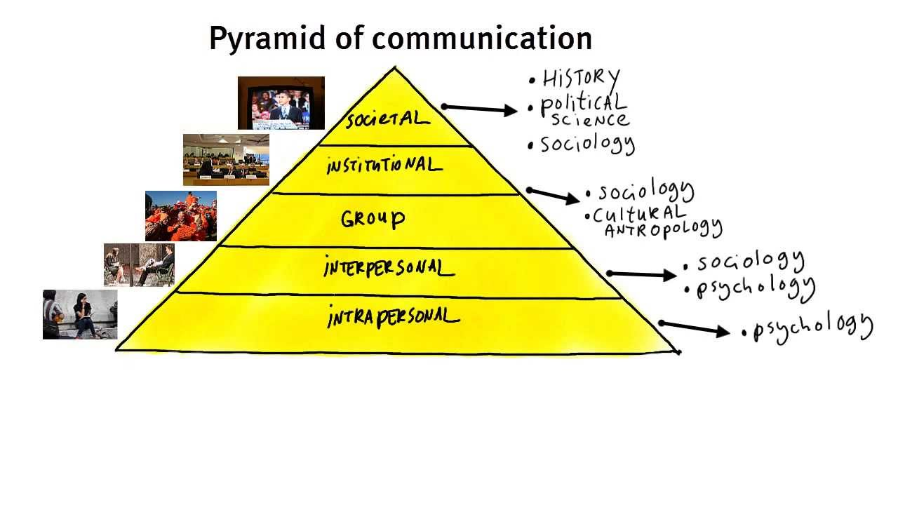
Verbal Communication: in this process people use words, sentences and language to share information with others. It is the easiest and most effective way of communication. Video conference, meetings, presentation, phone calls, inter-personal communication are some examples of verbal communication.
Non-verbal Communication: people can communicate through body language, facial expressions and gestures. This means of communication can be used both intentionally and unintentionally and it conveys significant message about the mental state of the sender.
Written Communication: this type of communication is a form of formal communication. It uses symbols and language to convey messages. Emails, letters, pamphlets, memos are some examples of written communication (Rohde et al., 2017).
Visual Communication: messages can be communicated through visual mediums such as drawings, art, photographs etc. This type of communication can support the other methods of communication in various ways.
Without having an effective communication system sharing of information (facts, emotion, ideas, opinions etc.) is impossible for both employers and employees. The success of an organisation heavily depends on the communication skills of its employers, employees and associated individuals. The purposes that effective communication serves within an organisation are,
- Communication facilitates flow of information among staffs at different level of the organisational hierarchy. Information regarding tasks, responsibilities, organisational objectives, organisational change, performance etc. gets shared through effective organisational communication (Hargie, 2016). Instructions are passed on and decisions are made through this process.
- Organisations recruit employees with varied skills and abilities. Effective communication plays an important role in coordinating the activities of different individuals, cross functional teams and departments.
- Employees learn new skills, organisational culture, values, and new ideas through effective organisational communication.
- Communication helps employees to form strong interpersonal bonds with their colleagues, which is extremely important for developing a healthy work-culture (Melewar et al., 2017).

Employers’ Performance at Communication
Having good communication skill is extremely important as it makes them impactful as an employer. Based on the real life experiences of the learner it can be said that employers mostly emphasise a few aspects of communication, those are,
Clarity: a successful communication is something that involves conveying a message clearly, and ability of the receiver to interpret that information & take necessary actions on it. Employers therefore mostly focus on clarity of the message; communication in this context can be both written and verbal; however employers make sure that their messages are concise and clear in nature. Employers also select different sets of language depending on their purposes and the audiences as all employees are not equally skilled or efficient (Shindryaeva et al., 2019). Employers should also select their languages and voice tone depending on the place of communication (in-person communication, meeting halls etc.) to reach employees more efficiently.
Active Listening: based on the personal experience of the learner it can be said that employers also emphasise their listening skill, since communication is a two-way process, listening skills is an important factor, it enables them to assess the personality of the speaker, ask them further questions and pass on instructions. Employers must possess active listening skills so that they can inspire employees to spontaneously listen to them as well.
Nonverbal Communication: non-verbal communication mostly involves acts like body language, voice tone, eye contact, etc. it has been observed that employers use this process sincerely and they convey important messages through their body languages (Ruck et al., 2017). For example when employers wish to become approachable they demonstrate an open and relaxed body language (legs relaxed, arms open) and use friendly voice tone.
Asking Question: this act helps employers demonstrate whether they are interest in a candidate or not. Employers use different types of questions depending on their level of interest, for example open ended question refers to high level of interest while close ended questions demonstrate low level of interest, visionary questions aim to assess the personality of the speaker, and specific question aims to gather fact based information. Thus employers can use this skill to gather relevant information about their employees and to know them better.
Empathy, Respect and involvement: empathy can be defined as the ability of an individual to understand the thoughts and emotion of others. Involvement on the other hand is all about being present and being accepting. However in most of the cases employers lack these skills, due to power & positional gap, work pressure and several other factors. However these skills play important roles in managing employees successfully. Showing respect to others is the key to developing effective employee-employer relationship. Employers must respect the cultural preferences, values and opinions of the employees. It has also been observed that employers consider this factor as a matter of mere workplace policies; they do not really try to acquire this skill. Employers also need to be careful about handling sensitive information about the employees; they must know how to comment on them or how to refuse commenting on them when required.
Based on the above discussion it can be said that the primary barriers to effective workplace communication are,
- Linguistic Barriers: language is the most important tool of communication. However differences in accent, over use of jargons and inappropriate languages etc. limit the effectiveness of verbal communication within workplace.
- Psychological Barriers: Depression, phobia, speech disorder, lack of confidence, stage fright etc. can affect the overall communication skill of both an employee and an employer.
- Emotional Barriers: lack of emotional intelligence, attitude problems (introvert people) and emotional distance are major reasons that affect employee employer relationship.
- Physical Barriers: physical barriers include lack of equipment (visual aids for example), noise, physical distance etc., however they are removable in nature.
- Cultural Barriers: organisations are becoming globalised day by day; therefore cultural awareness has become important in order for a company to create healthy organisational culture. Lack of cultural awareness is one of the major causes behind disrespectful workplace atmosphere.
- Structural barrier: lack of supervision, transparency and communication mechanism reduce the effectiveness of organisational communication.
- Perception Barrier: people’s perception of single thing varies massively person to person. Thus employers must know their audiences and their level of understanding before communicating with them (Baker, and Warren, 2015).

Ways of Improving Work-place Communication
In order to develop an effective communication system within an organisation, relevant theories and models of communication need to be studied properly.

Shannon and Weaver’s Model of Communication
Shannon and Weaver were mathematician and Scientist respectively. Their model of communication is considered to be the “mother to all communication models.” This theory establishes a clear relationship between the sender and the receiver and also considers the effects of the other elements (noise).

Source: www.communicationtheory.org

- Sender: sender in this model is the source of information, which means sender creates the message, determines which channel of communication should be used, and delivers the message accordingly.
- Encoder: sender is a machine or the sender him/herself who converts the lingual message into signals.
- Channel: this can be defined as the medium that is responsible for sending the information.
- Decoder: it is another machine (or the receiver him/herself) that converts those signals into understandable information.
- Receiver: receiver is the destination; he/she receives the message and provides feedbacks through his/her actions.
- Noise: it refers to all those physical disturbances (people, environment) that prevent the message from reaching the destination (McQuail and Windahl, 2015).
The Shannon Weaver model stats that in order to achieve a successful communication all the above mentioned stages have to be completed properly. For example within a business organisation employers can be the sender, telephone network can be the encoder, mobile network can be the channel, mobile phone can be the decoder and employees can be the receiver. Network problems, missing texts etc. are noise in this case. The entire communication procedure would fail if messages don’t get delivered due to technical problems, meaning of the message gets changed due to semantic problems or the message fails to affect the receiver due to effectiveness problems.

Lasswell’s Model of Communication
The previous model sees communication as a two way process which is extremely effective for in-person communications. However employers do not communicate with people individually always. Thus the Lasswell’s model of one way communication needs to be discussed as well.
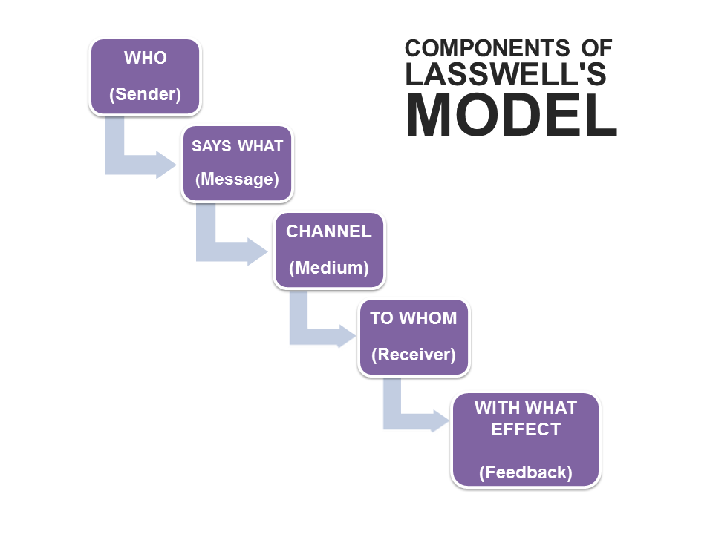
Source: businesstopia.net
Several components are there in Lasswell’s model, those are
- Control Analysis: this model lets the sender of the message to be the controller of the process or the most powerful one.
- Content Analysis: this factor is associated with the core purpose of sending the message. The sender sees the groups of receivers with a stereotypical approach.
- Media Analysis: according to this model the sender should adopt the most influential medium to deliver his/her message.
- Audience Analysis: this component asks the sender to analyse the audiences properly so that they can be manipulated properly.
- Effect Analysis: before starting the process of communication this model tries to assume the ultimate impact of the communication process (Sapienza et al., 2015).

Recommendations
Based on the previous discussion and these two models a few ways of effective organisational communication can be identified which would improve the performance of the employer and the organisation simultaneously.
Creating Effective Culture: Since communication is a process of relationship building and influencing the audience, a culture of trust needs to be established within an organisation. employers must make sure that their words and actions match, they should demonstrate welcoming attitude towards their employees through their body language, voice tone, controlled humour, and appreciation so that employees find them approachable and share important organisation related information with them. Creating a receptive organisational atmosphere (friendly and respectful) will help other employees to communicate with one another more efficiently.
Using Multiple Channels: As mentioned earlier, the level of understanding varies from person to person and the presence of noise can affect a communication process negatively. Thus organisations should use multiple channels to communicate a single message. Moreover the information should be clearly and concise in nature and void of jargons so that no one finds it difficult to understand.
Understanding Employees: in order to create a respectful atmosphere, avoid semantic & perception related barriers and influence employees properly, employers must study and understand them. They should focus on listening to employees, understanding their needs and preferences. It will help the company design effective organisational policies and the employees will feel valued by the organisation which will eventually result into greater employee involvement.
Measuring Effectiveness: the Lasswell model gets criticised because of its ignorance towards effective feedback system. Interpersonal communication should have a feedback system as it is essentially a two-way process (Jurburg et al., 2016). Employers must ask employees (through surveys) whether they have successfully communicated the objectives and business strategies with the employees or not. It will help them identify and fill up their skill gaps.

Conclusion
Communication is extremely important in all aspects of human life. Organisation depends on effective communication to carry out each of their activities. However due to several communication barriers organisations fail to develop effective communication system. Depending on the Lasswell’s and Shannon & Weaver’s models of communication a few recommendation have been in this paper which will help employers improve their communication skills.

References
Yeomans, L. and FitzPatrick, L., 2017. Internal communication.
Adler, R.B., Rodman, G.R. and Du Pré, A., 2016. Understanding human communication (Vol. 10). Oxford University Press.
Rohde, U.L., Zahnd, H. and Whitaker, J.C., 2017. Communications receivers: principles and design. McGraw-Hill Education.
Hargie, O., 2016. The importance of communication for organisational effectiveness.
Melewar, T.C., Foroudi, P., Gupta, S., Kitchen, P.J. and Foroudi, M.M., 2017. Integrating identity, strategy and communications for trust, loyalty and commitment. European Journal of Marketing, 51(3), pp.572-604.
Shindryaeva, I.V., Berezovaya, A.Y., Ovsyannikova, T.V. and Shindryaev, S.O., 2019, March. Organisational communications in the enterprise management system. In IOP Conference Series: Materials Science and Engineering (Vol. 483, No. 1, p. 012059). IOP Publishing.
Ruck, K., Welch, M. and Menara, B., 2017. Employee voice: An antecedent to organisational engagement?. Public Relations Review, 43(5), pp.904-914.
Baker, T. and Warren, A., 2015. The Nine Common Barriers to Communication. In Conversations at Work (pp. 54-74). Palgrave Macmillan, London.
McQuail, D. and Windahl, S., 2015. Communication models for the study of mass communications. Routledge.
Sapienza, Z.S., Iyer, N. and Veenstra, A.S., 2015. Reading Lasswell's model of communication backward: Three scholarly misconceptions. Mass Communication and Society, 18(5), pp.599-622.
Jurburg, D., Viles, E., Tanco, M., Mateo, R. and Lleó, A., 2016. Measure to succeed: How to improve employee participation in continuous improvement. Journal of Industrial Engineering and Management, 9(5), pp.1059-1077.



