Enterprise & Innovation
Group Project

Name: - Sai Harsha Jangili
Student ID: - 1908692
Tech Start-Up

Table of Contents
Introduction: - 3
Development: - 3
Tech start-up: - 3
Trading name: - 3
Legal classification: - 3
Start-up description: - 4
Team members: - 4
Roles and responsibilities: - 5
Mission statement: - 5
Objectives and values: - 6
Objectives: - 6
Values: - 6
Appendix: - 6
Reflection: - 6
Networking: - 7
Team working: - 7
References 8

Introduction: -
This project Facial Image Recognition Neural Network (FIRNN) is about the facial recognition attendance system using a camera or video source at places like universities, colleges, workplaces, banks and any other places for attendance monitoring and security purposes. This document will give an explanation of the Tech start-up for this project which includes legal classification, brief start-up description, roles and responsibilities of the team members in this project, mission statement, objectives and values of this project.

Development: -
Working on this project helped me in developing the technical skills specifically with SQL. Part of our facial recognition system will be using SQL to validate the university student into the register, this was worked on with my team members and I worked on creating a SQL database of information of students building my knowledge. We used many references like watching YouTube videos like how to create a database table and getting comfortable with the language. We did work a lot on it to understand exactly how to use the SQL. Look at the screen shots in appendix 1 for the code example.

Tech start-up: -

Trading name: -
The trading name for this project is FIRNN which means Facial Image Recognition and Neural Network. As this project is mainly about facial recognizing attendance monitoring systems using the neural networks that is why this project is named as facial image recognition neural network (FIRNN) and FIRNN will be the trading name for this project.

Legal classification: -
FIRNN is a limited company where the owners who own it will be the shareholders. FIRNN will be a private limited company which is a type of privately held small business entity where the owner’s liability in the company is limited and it can’t be traded on the stock market. Each share in the company is equal to ownership rights, in a private limited company the profit it makes can be kept after the tax to the government [1] [2].

Start-up description: -
FIRNN is about setting up an advanced level attendance monitoring system in universities to register the student’s attendance when they enter the lecture room and leave the lecture room. The process is to register details and take a picture of his face at the time of enrollment and save the data in the database and use the database to register the attendance. The equipment required will be mainly cameras computers and software to set it up and other general equipment like online storage drives, printers etc. will be included in the budget. FIRNN is not a heavy investment project where more expenditure would be on cameras and computers. Sponsorship for this project will be provided by the university. One year after implementation of FIRNN in the university, if it is successful then in future it can be extended and implemented in many other places like banks, workplaces for security purposes as well. The team FIRNN will be working at its best to provide higher customer satisfaction [3] [4].

Team members: -
FIRNN is a group of 6 members where tasks are equally shared among the members of the group. All the team members contact through email and Microsoft teams any updates regarding the project like group meeting or group presentations will be posted on the Microsoft teams. Any doubts or questions regarding the project the team manager will stay in contact with every group member through emails and makes sure that everyone is clear about what is happening in the project.

Roles and responsibilities: -

Name | Role
Kieran | Project Manager
Sai | Research Analyst
Amelia | Lead Developer
Jake | Developer
Farhan | Business Analyst
Samia | Business Analyst

The above table shows the roles allocated accordingly to each team member in the project.
- The role of a project manager in this project is to plan and direct the work among the group and monitor the work progress in the project.
- The research analyst is to research and analyze the product and present the data required and related to the project.
- The developers will be developing the code and designing the code as per requirement.
- The business analyst examines and analyses the market rate and identify the competitors to the product in the current market.
The project manager makes sure that the work is being done as per the schedule and every team member has got the responsibility to keep the project manager updated if there are any delays in the work, and the project manager reschedules everything and makes changes to the Gantt chart if there will be any delay in delivering the project.

Mission statement: -
The principal aim of this project is to produce an advance level of attendance systems in universities. As there are many manipulations like faking attendance system by scanning other people’s card or signing the register for some other people or leaving the lecture room immediately after signing the register and many other things going on in universities so, with FIRNN it doesn’t let the students to fake their attendance or leave the lecture rooms early before the class finishes, if it works well the universities it can further be extended in future in workplaces like banks and any other companies.

Objectives and values: -

Objectives: -
The main objectives of this project are providing an advanced level of attendance standards, make sure no one fakes up their attendance in universities, schools, and colleges and all the students attend the lectures and know the importance of the attendance, this project is not only for attendance monitoring systems but it can also be used for best security standards in places like banks, prisons etc. FIRNN can also be used in workplaces for the staff attendance monitoring mainly in IT industries [4].

Values: -
The business values that we stand for are:
- Team learning and knowledge sharing
- Excellence
- Integrity and inclusiveness

Appendix: -

Appendix-1

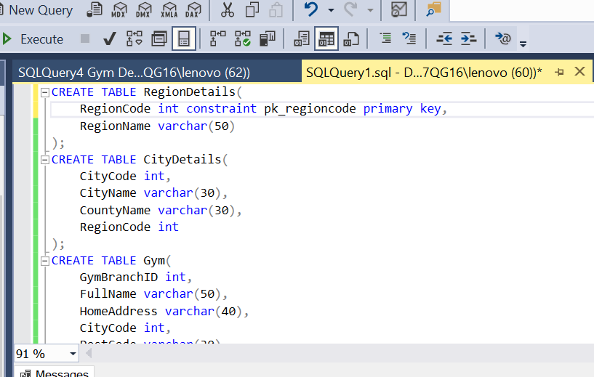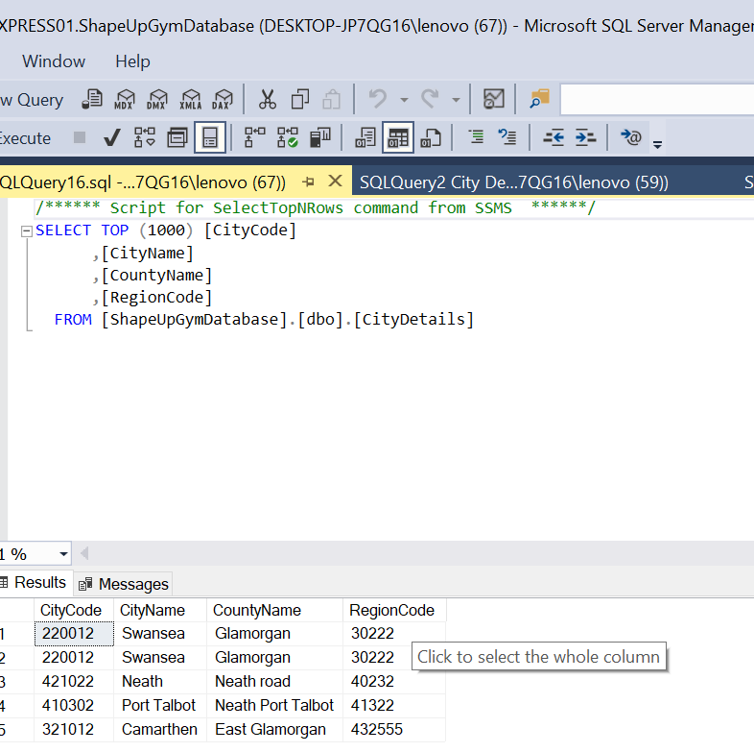

Reflection: -
My role in this project is research analyst, working on this project helped me in developing my team management, teamworking, employability skills. Being a research analyst, I have learned more about the neural networks like kinds of neural networks and what are each type on neural networks used for and how each neural network works. I did talk about the neural networks in our group presentation for this project in semester 1.

Networking: -
I was supposed to attend an event in the university on 12-03-20 but, unfortunately the event was cancelled so, alternatively I watched few YouTube videos related to the topic start-up, the video clearly explains what are the basic principles a startup company should have to build a successful startup. In the videos it says that the main principles are understanding among the group members, how to make the decisions and how to make sure that everyone follows it, make the investors happy to invest on the project. The YouTube links I used are listed in the references section [5] [6].

Team working: -
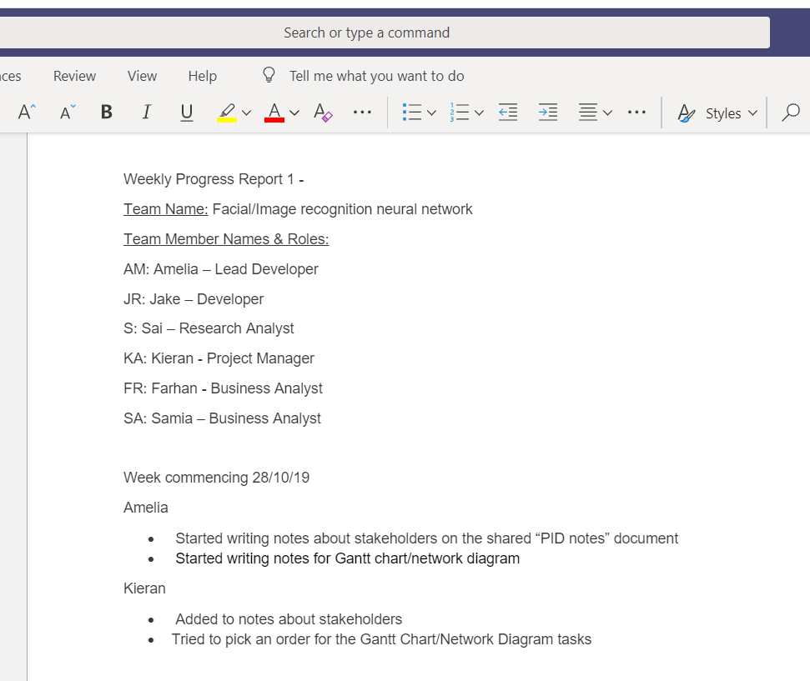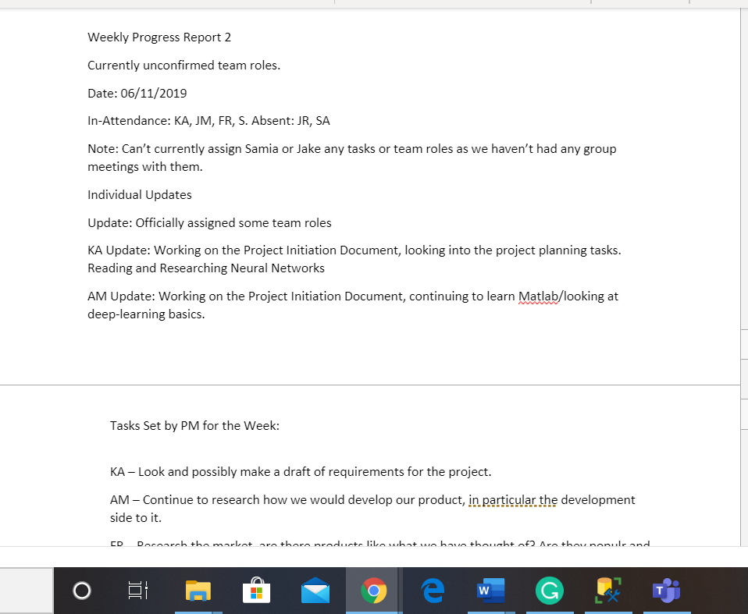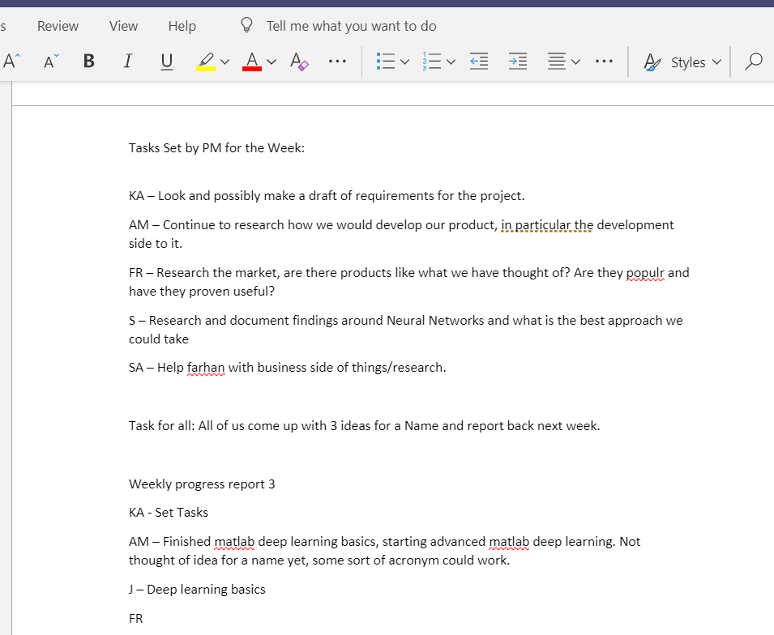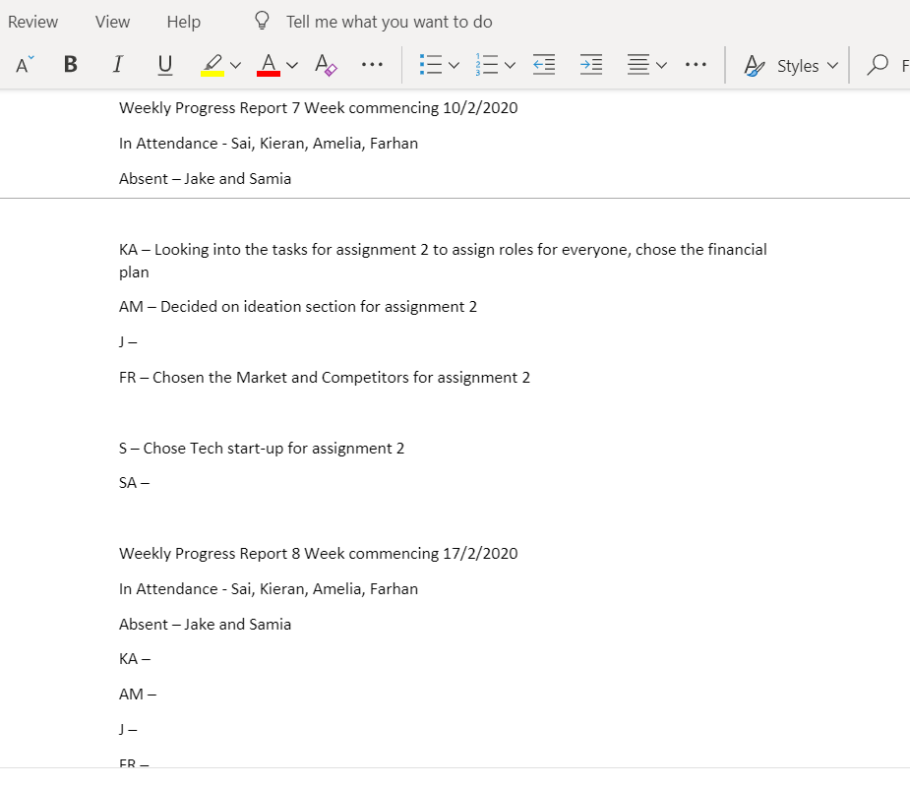
These are few progress sheets for the team FIRNN in which all updates are given and all the group discussions are made.

References

[1] | "Limited companies," Gov.UK, [Online]. Available: https://www.gov.uk/limited-company-formation. [Accessed 19 MAR 2020].
[2] | L. H. J. B. &. T. J. R. Crawford, "Investigation of potential classification systems for projects," Project Management Institute, 14 July 2002. [Online]. Available: https://www.pmi.org/learning/library/investigation-potential-classification-systems-projects-8967. [Accessed 20 Mar 2020].
[3] | M. Grant, "Start-up," Investopedia, 10 Mar 2020. [Online]. Available: https://www.investopedia.com/terms/s/startup.asp. [Accessed 20 Mar 2020].
[4] | "Moodle.UWTSD," [Online]. Available: https://moodle.uwtsd.ac.uk/pluginfile.php/26651/mod_resource/content/1/Course_Documents/Lecture_12_-_15/Example_Business_Plan/Business_Plan_Example.pdf. [Accessed 15 Mar 2020].
[5] | "YouTube," Hubspot, 17 Dec 2018. [Online]. Available: https://www.youtube.com/watch?time_continue=50&v=N-TudvIDKMg&feature=emb_title. [Accessed 20 Mar 2020].
[6] | "YouTube," Hubspot, 3 Oct 2018. [Online]. Available: https://www.youtube.com/watch?time_continue=10&v=roOZtE7iVdg&feature=emb_title. [Accessed 20 Mar 2020].

