Operating System (OS)
Module Name: Computer Architecture and Operating Systems
Module Code: (ACCA4022)
Student Name: Shaheen Miah Chy
Student ID: 2514796
Lecturer Name: Md Shantanu Islam
Submission date: 27.03.2026

CONTENTS
Introduction 2
Key functions of general Operating Systems 2,3
Task Management: 3
Application/Program Management: 3
File/Directory Management: 3,4
Device Management: 4
Security Management: 4,5
Use of Windows OS CLI commands 5
Example 1: 5
Example 2: 6
Example 3: 6
Example 4: 7
Example 5: 7
Example 6: 7,8
Example 7: 8
Example 8: 8,9
Example 9: 9
Example 10: 9,10
Use of Linux OS CLI commands 10
Example 1: 10
Example 2: 10
Example 3: 10
Example 4: 11
Example 5: 11
Example 6: 11
Example 7: 11
Example 8: 12
Example 9: 12
Example 10: 12,13
Use of Windows OS scripts 13
Example 1: 13
Example 2: 14
Use of Linux OS scripts 14
Example 1: 15
Example 2: 15,16
Conclusion 16
References 16,17
​
​
​
​Introduction
This coursework about operating system (OS), which is the most important software running on a computer. This acts as a mediator between the user and the computer hardware, guiding all the hardware and software possessions of the computer structure. It manages computer resources in the way that the CPU, memory, and files. It acts as an connect middle from two points the user and the hardware and performs elementary functions in the way that process, memory, and file management. An operating system helps you communicate accompanying the computer without experienced the programming language. This report contains key functions of general operating system, windows operating system CLI commands, Linux operating system CLI commands, windows os scripts, Linux os scripts.

Key functions of general Operating Systems
Windows is a computer software for basic operation refined by Microsoft. It is a graphical user interface (GUI) placed system that allows users to communicate with their computers and perform diverse tasks. It runs applications and determines a user-friendly interface that allows consumers to perform tasks by connecting directly with the system. The Windows operating system provides different features such as: Users are admitted running program. Users communicate with the computer software for basic operation through able to be seen with eyes parts such as images, casements, cuisines, and a mouse-compelled suggestion. Users can view or sustain their files. Users can create, remove, rename, and move files utilizing the GUI or CLI [1].

Task Management
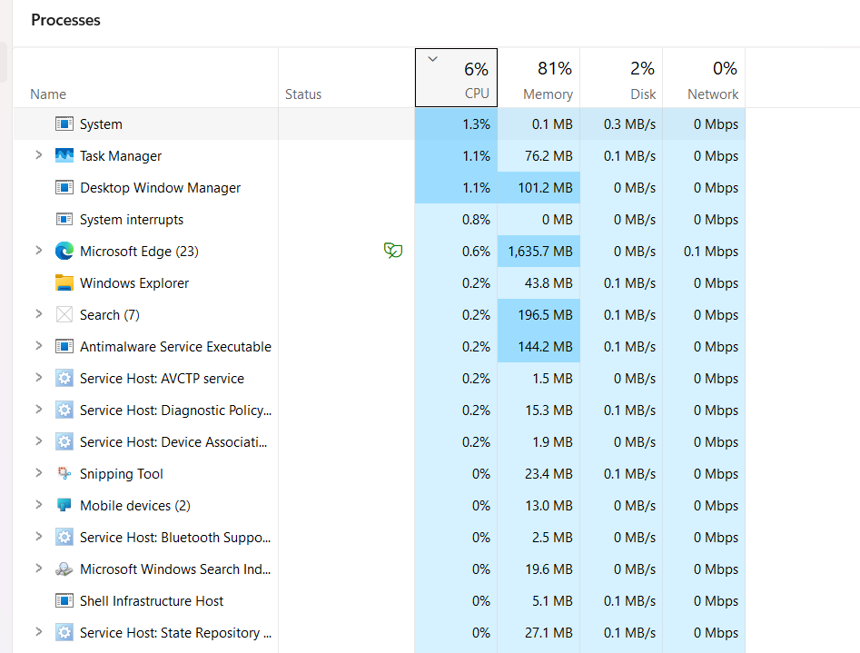
Windows Task Manager is an effective tool for handling system resources and actions. It provides actual-period information about performance, processes, and helps consumers identify and manage programs that are absorbing excessive resources or causing system problems. Task Manager has different tabs in the way that Processes, Performance, App History, Startup Apps, and more, each providing various insights into whole activity. Users can monitor resource custom completely passive requests, manage startup processes, and optimize structure performance. Task Manager also has an effectiveness mode to lower structure resource load, and it can discover suspended Universal Windows Platform (UWP) apps to save processing capacity [2].
​
​Application/Program Management
Running applications on Windows includes a variety of tasks to secure proper placement, configuration, maintenance, and protection. This contains managing licenses, implementing safety protocols, updating apps, and ensuring the right apps are installed on the right devices. Windows 10 supplies tools like the Microsoft Store for directing up-to-date apps and legacy programs, allowing consumers to customize their surroundings according to their choices and needs [3].

File/Directory Management
​File/directory management in Windows is the process of organizing and directing files and folders inside a hierarchic structure. Directories are containers that hold different files, and each guide can hold different directories, creating a tree-like construction popular as a directory tree. File Explorer is the basic tool for directing files and folders, serving users surely guide along route, often over water, constitute, rename, and erase files. This structured approach helps consumers capably locate and accomplish their data, improving overall productivity and data protection [4].

Device Management
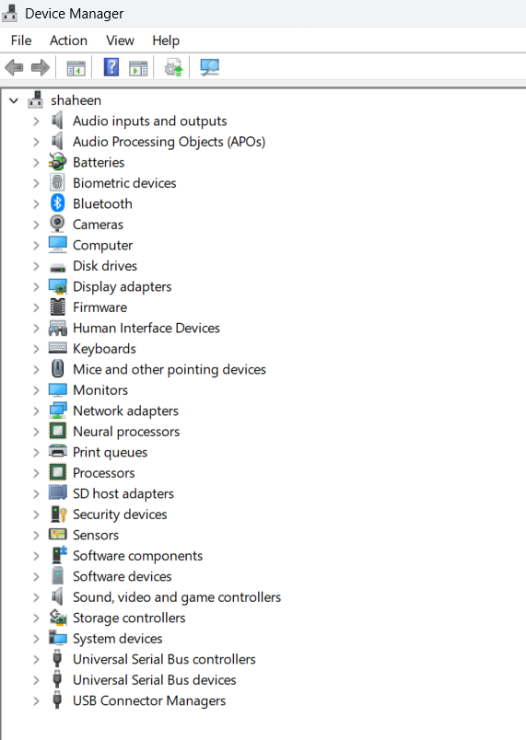
Device Manager is an expansion of the Microsoft Management Console that supplies a fundamental and organized view of all Microsoft Windows-recognized hardware installed on a computer. Hardware devices installed on a computer, in the way that permanent computer memory drives, keyboards, sound cards, USB devices, and more, can be trained through Device Manager. It possibly used to change hardware configuration alternatives, accomplish drivers, cripple and allow hardware, discover conflicts between hardware devices, and more. Device Manager lists devices in separate types to make it smooth for the consumer to find what they are expect. Device Manager can be accessed in different ways versions of Windows, normally from Control Panel, Command Prompt, or Computer Management [5].

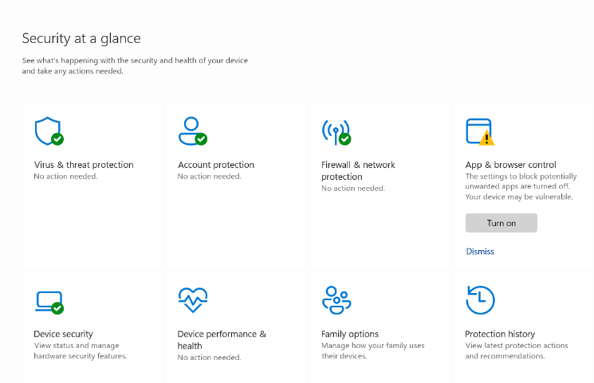
Security Management

Security management in Windows includes configuring and maintaining protection settings to protect the system from dangers, ensure data completeness, and manage consumer access. Windows Security provides a healthy set of security management features through the Security app, that includes tools for antivirus protection, account safety, firewall management, and device security. Windows Security is a included use in Windows 10 and 11 that provides a centralized interface for managing differing security features. It involves tools such as Microsoft Defender Antivirus, that supports real-occasion protection against malware, and Windows Defender Firewall, which helps block unauthorized approach to the system. Regularly reviewing and regulating security settings is owned by maintaining a secure computing atmosphere [6].

Windows OS CLI commands
​The Windows Command Line Interface (CLI) is a strong tool for automating tasks and managing system possessions. It is a document-based interface that admits builders to communicate with software and the operating system by typing commands into a terminal or relieve [7]. A basic benefit of utilizing the CLI is speed. Commands possibly performed much faster than navigating through multiple GUI menus [8].

Example 1
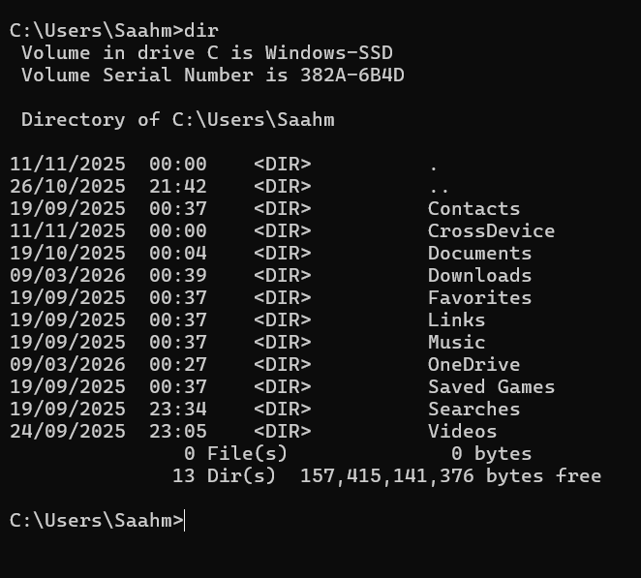

The Purpose of dir command that allows users to view the contents of a file directly from the Command Prompt (CMD). It is frequently used for file management tasks, such as checking file names, sizes, modification dates, and folder structures.
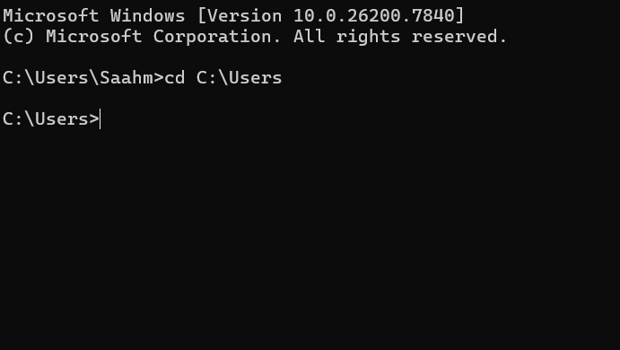
Example 2

​
​
​
​
​
​
​
The cd (change directory) command is second-hand in command-line interfaces to navigate between directories in a file system. It is available on various operating plans, containing Windows, Linux, and computer software for basic operation. Below is a clarification of its arrangement and usage.
​ Example 3
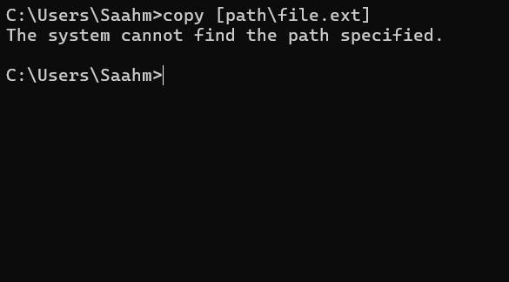

​
​
​
​
​
​The copy command is used to copy individual or more files from one point to another. It allows consumers to create duplicates of files while keeping the original intact. The command is beneficial for support up data or creating multiple documents with the same content.

​

Example 4
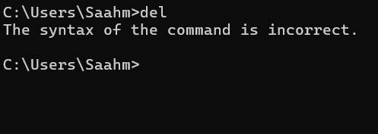
​
​
​
​
​
​

The del command is used to remove one or more files from the file system. It is an alias for the remove command and performs the same actions. The command can erase files from the current directory as well subdirectories, and it can again erase read-only files.

Example 5
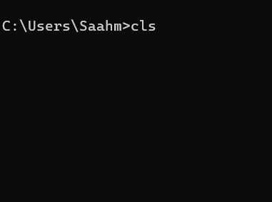

​
​
​

The cls command in the Windows Command Line Interface (CLI) is a command used to clear the screen of all previous text and output.

Example 6
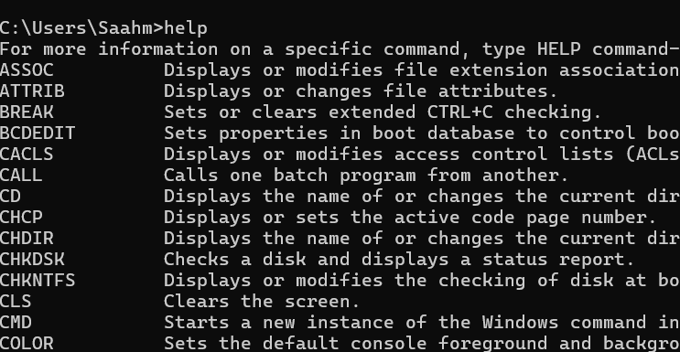

The help command in the Windows is a powerful tool that specifies consumers with detailed information on by what method to use various commands. The command is accessible for Microsoft operating plans and is specifically useful for beginners or those needing an active citation while active in the command line atmosphere.

Example 7
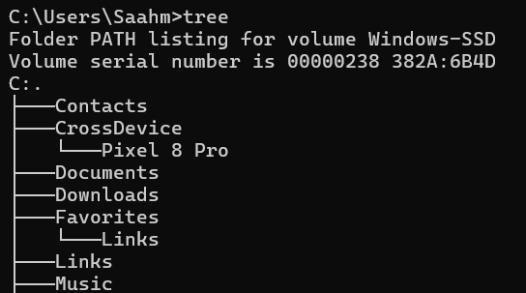

The tree command in Windows Command Prompt is a effective form for visualizing the directory structure of a specified path or stage a tree format. It determines a clear hierarchic view of directory layouts, making it smooth to control and analyse the structure of directories and their subdirectories. The command can be used to display the names of files in each directory.

Example 8
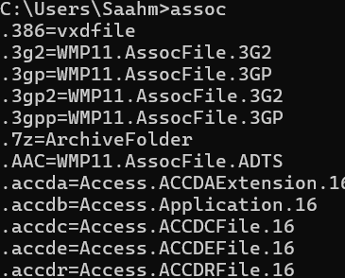

The Assoc command in Windows Command Prompt is used to manage file associations. It allows consumers to view or change by means of what file types open on their system.

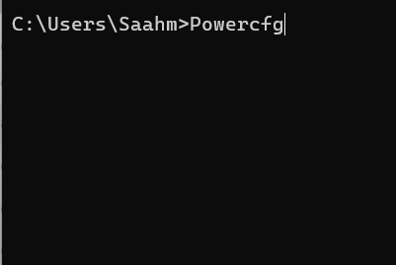
Example 9

Powercfg command-line alternatives allow users to control power plans, control sleep states, and analyse energy efficiency.
Example 10
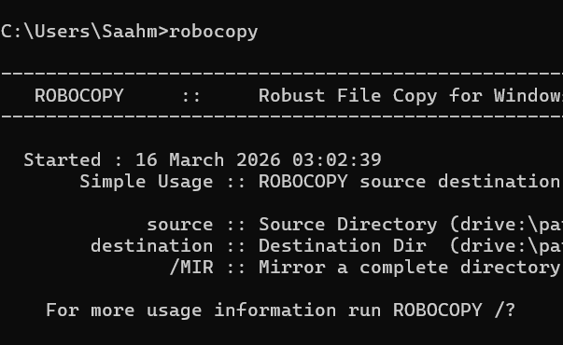
Robocopy is a command-line utility in Windows that allows consumers to copy, replicate, or move files and directories efficiently. It is specifically beneficial for handling complex file copying operations, such as copy complete directories, handling large file sizes, and maintaining file attributes.

Linux OS CLI commands
The Linux command line interface (CLI) supports persuasive forms and uses that increase productivity, facilitate system, and provide effective structure administration. The command line interface (CLI) is a text-placed interface that admits users to communicate following the system software by writing commands. In contrast to the graphical user interface (GUI), the CLI specifies a more direct and effective way to act tasks, making it a endorsed choice for many system administrators and planners. Users’ proposal commands into a terminal, that the structure interprets and executes, providing immediate response or results [9].

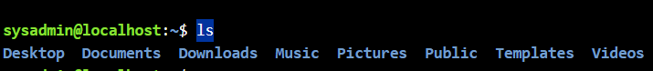
Example 1

The ls command in Linux is used to list files and directories in the current occupied directory or a stipulated course. It is individual of best ordinarily used commands for operating and directing files.
Example 2
To search place, you are now situated inside the filesystem, the pwd command possibly passed down. The pwd command prints the active directory, your current location inside the filesystem.
Example 3
Cd (Change Directory) command is a fundamental form in Linux and Unix-located systems, used to navigate the file system. It allows users to change their current working directory to another directory, permissive effective file and directory management.

Example 4
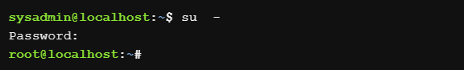
The su command assigns you to temporarily be a part of a various purchaser. It does this by establishing a new architecture. The structure is simply a text guidance comfort that lets you type in commands. By default, if a consumer account is not particularized, the su command will open a new structure as the root consumer, that decides managerial right.

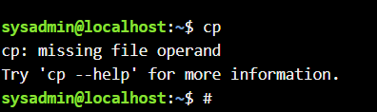
Example 5

The cp command in Linux is used to copy files or directories from one location to another. By default, it overwrites existing files without prompting, but various options can modify this act.
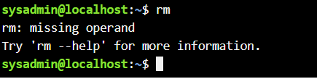
Example 6

The rm command in Linux is used to permanently remove files and directories from the filesystem without moving them to Trash or Recycle Bin. Once performed, recovery is generally not possible outside specialized tools, so caution is advised.
Example 7
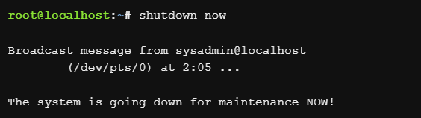

The shutdown command in Linux is used to safely power off, start operating system, or halt the system. It ensures all processes are finished gracefully and notifies logged-in users about the shutdown.
Example 8
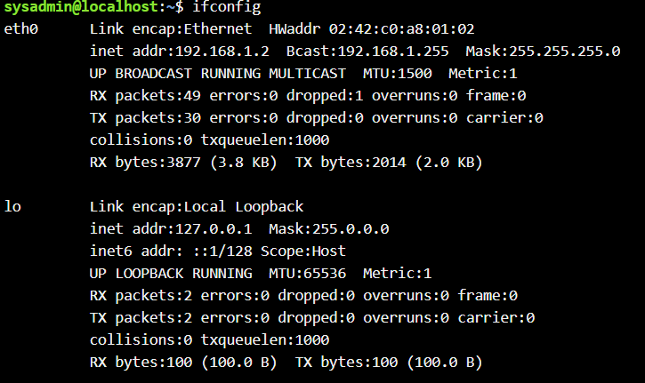
The ipconfig command is a network configuration utility used to manage and display network interfaces in Linux. However, it is not always available by default on modern Linux distributions, as it has been deprecated in Favor of the Ip command from the iproute2 package.
Example 9
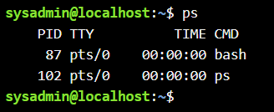
The ps command in Linux is a serviceableness used to display facts about active processes on authority. It supports a snapshot of the current processes, containing analyses such as process IDs (PIDs), CPU usage, memory usage, and the commands that initiated the processes. When you run the PS command, it itself becomes a process during appeal execution.
Example 10
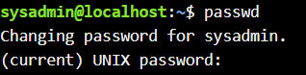
The passwd command in Linux is a powerful serviceableness for managing user passwords and account security. It allows consumers and administrators to change passwords, lock/unlock accounts, set password expiry, and more.

Use of Windows OS scripts
Batch scripting is an effective tool for automating various tasks in the Windows computer software for basic operation. It exists of an order of commands expected performed by a command-line interpreter, stored in a clear text file along the .bat or .cmd extension. Batch scripts are specifically valuable for automating repetitious tasks such as file management, structure presidency, and arrangement updates. They can be used to perform universal Windows-based tasks, coordinate symptomatic commands, and use applications to multiple machines. Although they are not as flexible or secure as up-to-date scripting words ​​such as PowerShell, batch scripts are still relevant for light automation and inheritance workflows (10).
Example 1
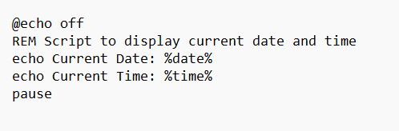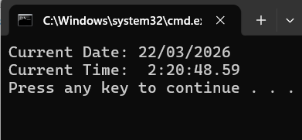

In this example, first stop echoing the command using @echo off for cleaner output. Then set two variables, current Date and current Time, that store the principles ​​of %DATE% and %TIME%, individually. Finally, print these variables to the relieve. The output will display the current date and be present at the format specified for one arrangement's regional settings. This method is active and simple, making it ideal for simple scripts that require the date and period without additional outputting.

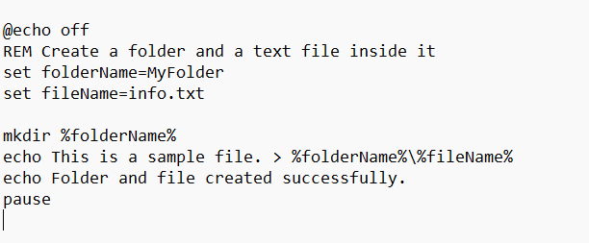
Example 2
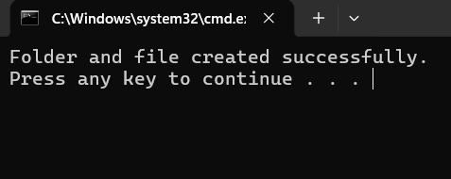

This command generated a folder called 'My Folder' and a text file titled 'information.txt' inside it. The mkdir command generated the file and the echo command creates a message to the data file. The pause command keeps the command prompt open for further work.

BASH scripting and its applications
Bash scripting is the process of automating tasks by writing multiple commands in a file and executing them together. Instead of executing commands one by one, a script admits you to execute all the commands at once. It automates repetitious and time-consuming tasks. Executes different commands directly. Saves opportunity and reduces physical labour. Helps accomplish system operations efficiently. Makes workflow compatible and repeatable. A bash script is a simple basic document file that controls commands that can be performed by the structure. By devising and running a script, you can automatize tasks a suggestion of correction classifying commands manually (11).
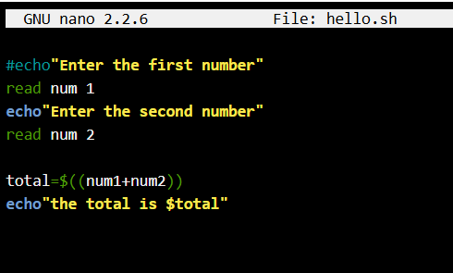
Example 1

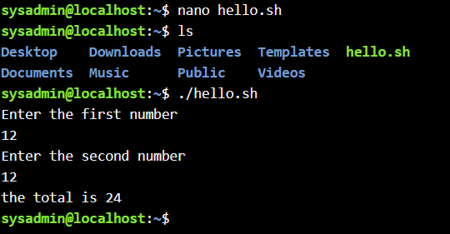

This Bash shell script is an easy interactive program that prompts the user for two number inputs, computes their total, and displays the result. Here I first use this prompt in nano than I took permission to run this as an application by using code chmod +x hello.sh than I put the number and I got result.

Example 2
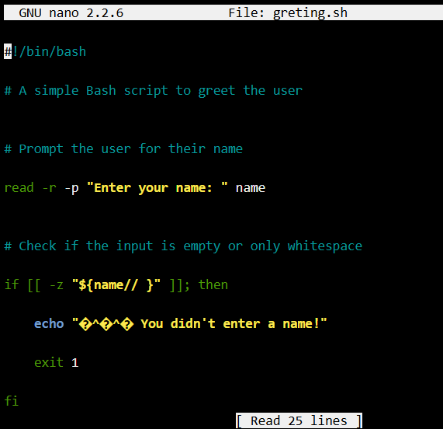

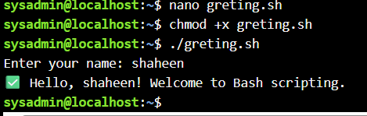
To Prints a greeting message, I used this bash script.

Conclusion
Windows and Linux are two of ultimate common operating systems, each accompanying its own features and benefits. Windows, grown by Microsoft, is popular for its easy-to-use interface and wide software unity, making it suitable for a wide sort of users and applications. Linux, an open-source computer software for basic operation, is well customizable and is chosen by developers and system administrators for its adaptability and control over the computing atmosphere. Both operating systems serve various needs and preferences of consumers; Windows is more appropriate for inexact consumers and trades, while Linux is ideal for developers, servers, and those the one want customization.

References
[1] GeeksforGeeks, “Windows OS Fundamentals,” GeeksforGeeks, Jul. 12, 2025. https://www.geeksforgeeks.org/ethical-hacking/windows-os-fundamentals/
[2] C. Hoffman, “Windows Task Manager: The Complete Guide,” How-To Geek, Oct. 14, 2023. https://www.howtogeek.com/405806/windows-task-manager-the-complete-guide/
‌[3] aczechowski, “Overview of apps on Windows client devices - Windows Application Management,” learn.microsoft.com, Aug. 29, 2023. https://learn.microsoft.com/en-us/windows/application-management/overview-windows-apps
[4] jwmsft, “About Directory Management - Win32 apps,” Microsoft.com, Jan. 07, 2021. https://learn.microsoft.com/en-us/windows/win32/fileio/about-directory-management (accessed Mar. 04, 2026).
[5] Tim Fisher,“What Is Device Manager and It’s Use?,” Lifewire, 2019. https://www.lifewire.com/device-manager-2625860
[6] vinaypamnani-msft, “Windows Security app - Windows Security,” learn.microsoft.com, Jun. 07, 2023. https://learn.microsoft.com
[7] GitHub, “What is a CLI (command-line interface)?,” GitHub, Jul. 07, 2025. https://github.com/resources/articles/what-is-a-cli
[8] seo2, “Understanding CLI: What It Is and How to Use It?,” DEV Community, Dec. 27, 2024. https://dev.to/hexa-home/understanding-cli-what-it-is-and-how-to-use-it-45oo
‌[9] L. Baker, “100 Great and Must-Have CLI Linux Applications - LinuxLinks,” LinuxLinks, Apr. 10, 2023. https://www.linuxlinks.com/100-great-must-have-cli-linux-applications/ (accessed Mar. 16, 2026).
‌[10] L. Giusto, “Batch Scripting: Is it Still Relevant in 2026? | Syncro,” Syncro, Feb. 18, 2026. https://syncrosecure.com/blog/batch-scripting/ (accessed Mar. 22, 2026).
[11] GeeksforGeeks, “Bash Scripting Introduction to Bash and Bash Scripting,” GeeksforGeeks, Apr. 19, 2022. https://www.geeksforgeeks.org/linux-unix/bash-scripting-introduction-to-bash-and-bash-scripting/

