University of Wales Trinity Saint David
Wales Institute of Science and Art


Workshop And Practice ACHA4011

Mohammed Nasir Mahmood
2003929
30/11/2023
Table of Contents
1 Introduction 1
2 Health And Safety 1
3 Engineers’ role in society 2
4 Problem Solving 3
5 Team Structure 4
6 Conclusion 7
7 Personal Development Plan 7
8 References 8

Introduction
This technical report will talk over the considerations, thought processes and the different topics. Health and Safey, Engineers role on society, Problem solving, Team Structures will all be covered and delved into during the report. Health and Safety is vital to safe working. An engineer needs to be responsible and ethical when conducting themselves and problem solving is a critical skill an engineer needs to have to be competent. At the end there will be a personal development plan and a conclusion as the closing sections to the report.

Health And Safety
Health and safety is crucial for all establishments to follow. Health and Safety is there to protect employers and employees benefiting both and keeping the safety and wellbeing of all those involved as the top priority. The definition of health and safety is ‘regulations and procedures intended to prevent injury in workplaces or public environments.’ (safety management services)

In university there are several departments which have heavy machinery similar to what is found at an industry level from 3d printers to a rolling road there is a lot of machinery and tools there for student access. For those studying a motorcycle, motorsport, or automotive course there are a lot of activities that go on practically. Engine stripping is one of those things a group can do. For students to be able to undertake such an activity the relevant laws and health and safety acts need to be assess and complied with in order to ensure safe operation of equipment by staff and students.

Relevant health and safety Acts for this application would be Acts such as, Health and Safety work Act 1974, Workplace (Health, Safety and welfare Regulations) 1992, The Personal Protective Equipment at Work Regulations 1992, The Personal protective Equipment at Work (amendment) regulations 2022.

For this purpose, in relation to PPE the institution is responsible for the handling of the PPE and is responsible for equipping the students with the right PPE for all the practical activities they will engage in over the duration of their course.

PPE stands for personal protective equipment, In the context of the practical modules and exercises the students undertake PPE that will be handed to the will be the following item: Dust coat, Steel Toe cap boots, goggles. Any other equipment is extra but always being prepared is better than being unprepared.

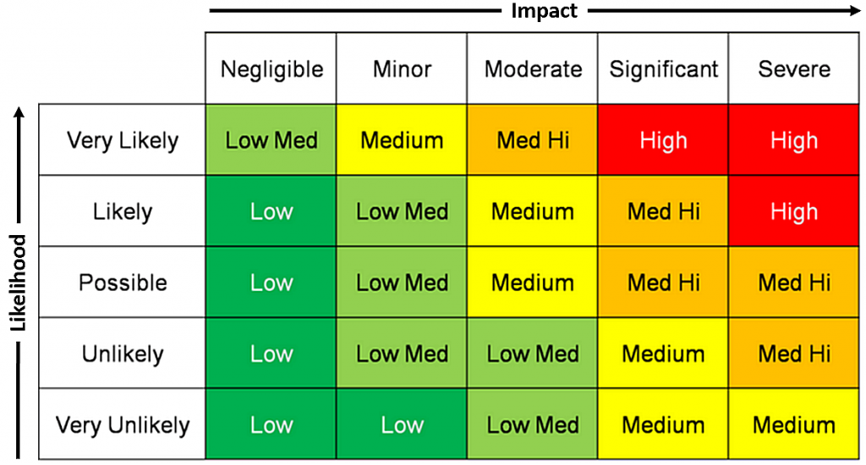

With the engine stripping there is a possibility that a piston may fall out of the engine block as they strip the engine however using this chart, we can assume that impact will be low medium minor there might be damage to the work surface they’re using but no physical harm as all students will be required to wear steel toe cap boots.

Engineers’ role in society
Chartered engineers have the highest qualifications compared to a graduate or apprentice engineer. A chartered engineer is qualified to find and create solutions to problems using technical analysis and advancements in techniques and equipment’s difference between a non-chartered and chartered engineer is that a chartered engineer can take a more leading role in developing or creating new developments for solutions and projects. – remove waffle
For engineers there are codes of conduct that need to be followed to make sure they’re conducting themselves correctly there are various institutions that have a code of conduct here are two.
Engineering councils code of conduct is. 1: Honesty and Integrity,2: Respect for life, law, the environment and public good.3: Accuracy and Rigour,4: Leadership and communication.
The institution for mechanical engineer’s code of conduct is the following. 1: All members will act with care and competence,2: All members shall act with integrity and act in a reliable and trustworthy manner,3: All members shall engage responsibly with the environment.4: All members shall contribute positively to the culture and public perception of the profession and institution.
For a motorsport application using the code of conduct to be more sustainable and environmentally there are considerations that need to be made and things need to be taken into consideration. Such as how motorsport teams’ function and their reliability on certain manufacturing processes, materials, and suppliers. Looking at the code of conduct as a guide, steps can be made to be more sustainable whether that’s running the vehicles on a synthetic fuel that only emits water or changing from using carbon and Kevlar to a more natural resource such as hemp to make components as carbon and Kevlar are non-recyclable materials or changing parts suppliers from across the seas to a local parts manufacturer to stop using cargo and freight to save on carbon footprint.

Problem Solving
Nothing is perfect. Problems always arise as engineers the basis of the role revolves around solving problems and finding solutions. For a mechanical engineer this could be solving an issue with some turbine blades for a hydroelectric power station. Or for a motorsport engineer this could be looking at an overheating issue on a power unit for a racing car.
Three examples will be shown. Figure 3.1 represents problem solving during development. Figure 3.2 Represents how a problem is resolved in a situation where a racing car is in on the market for customer racing. Figure 3.3 Discusses how a supply issue is resolved.
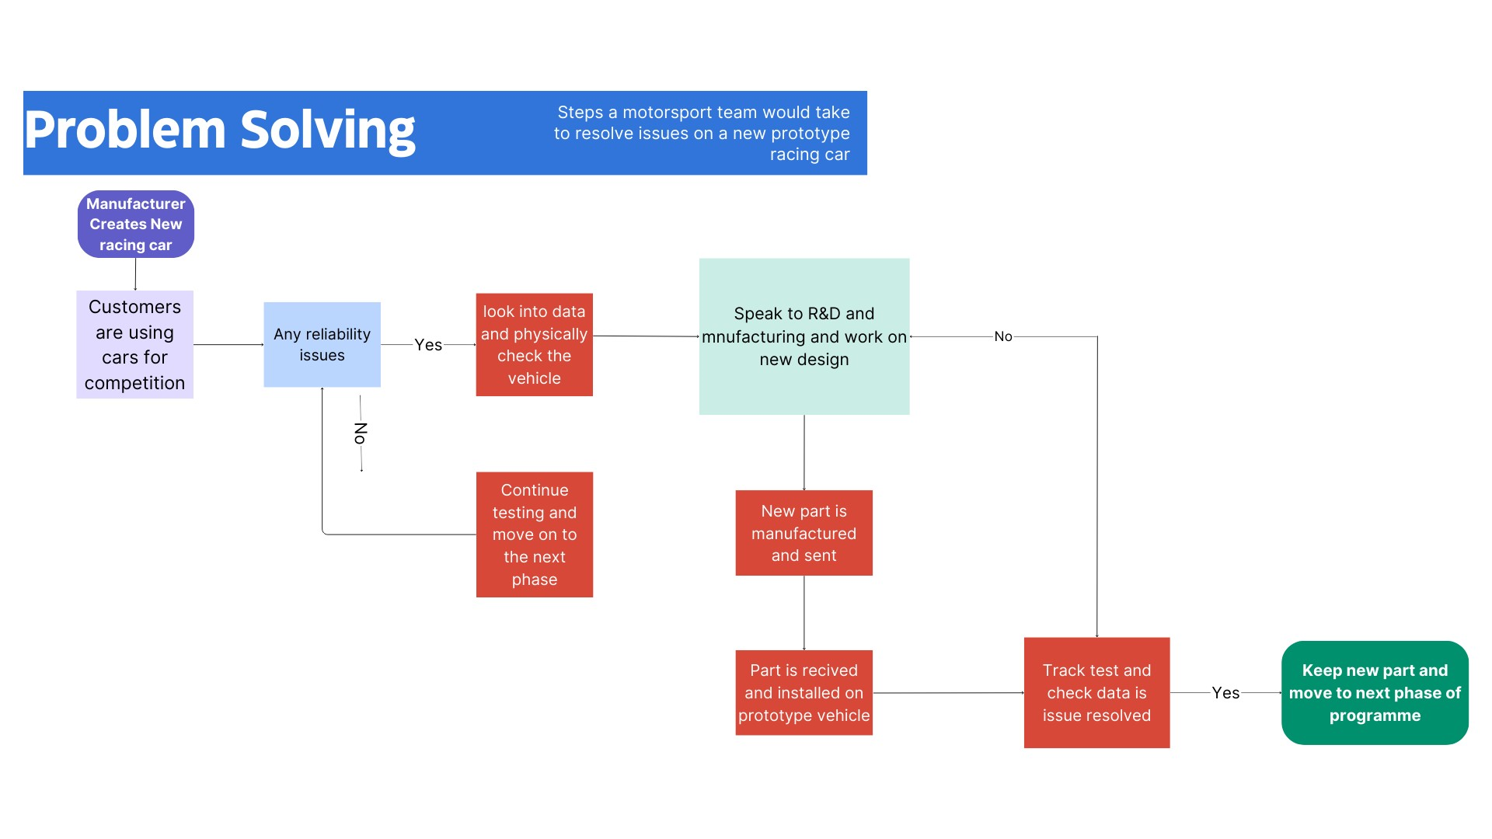
Figure 3.1
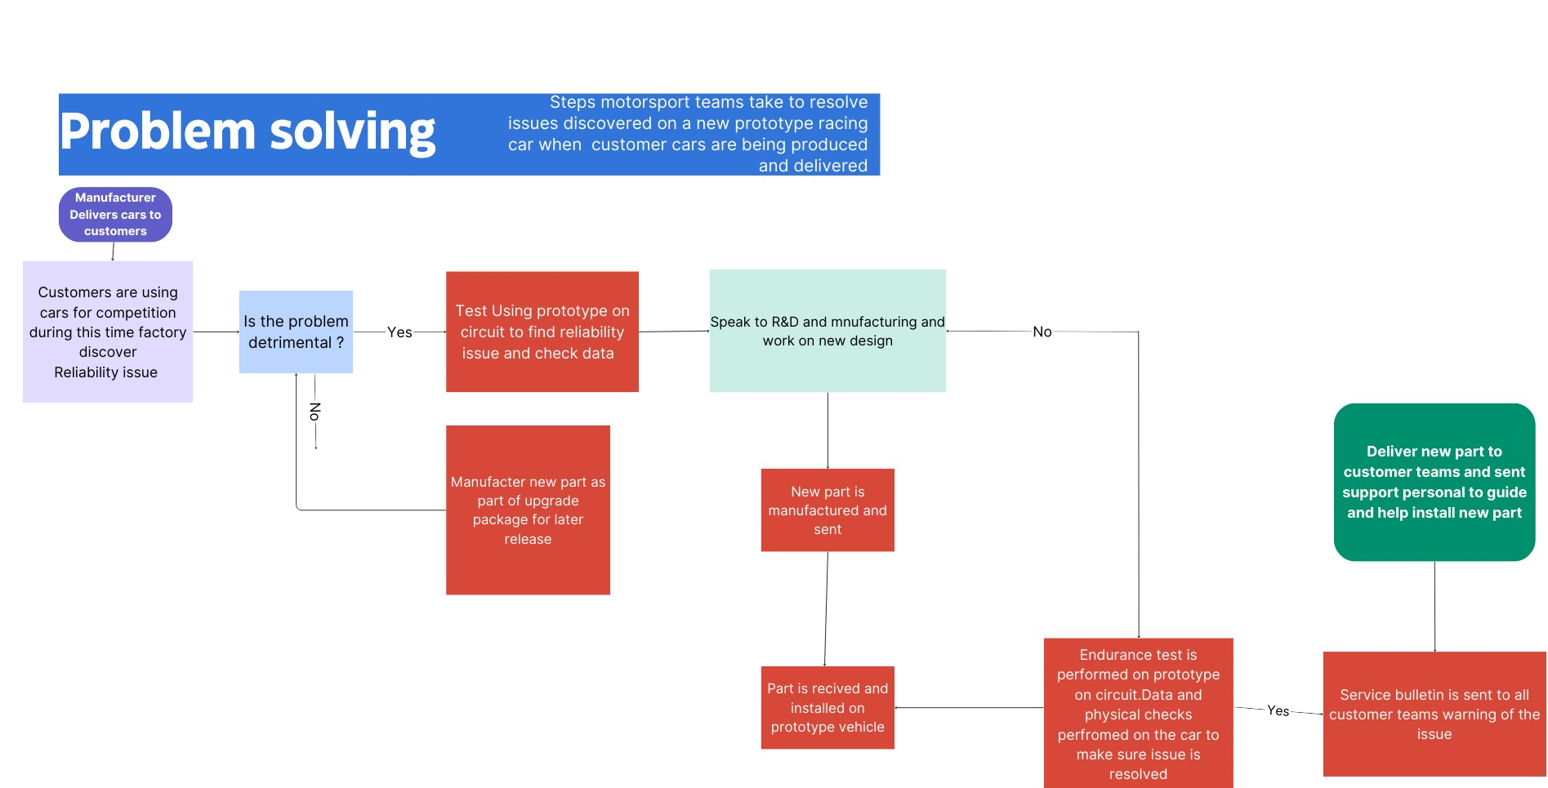
Figure 3.2
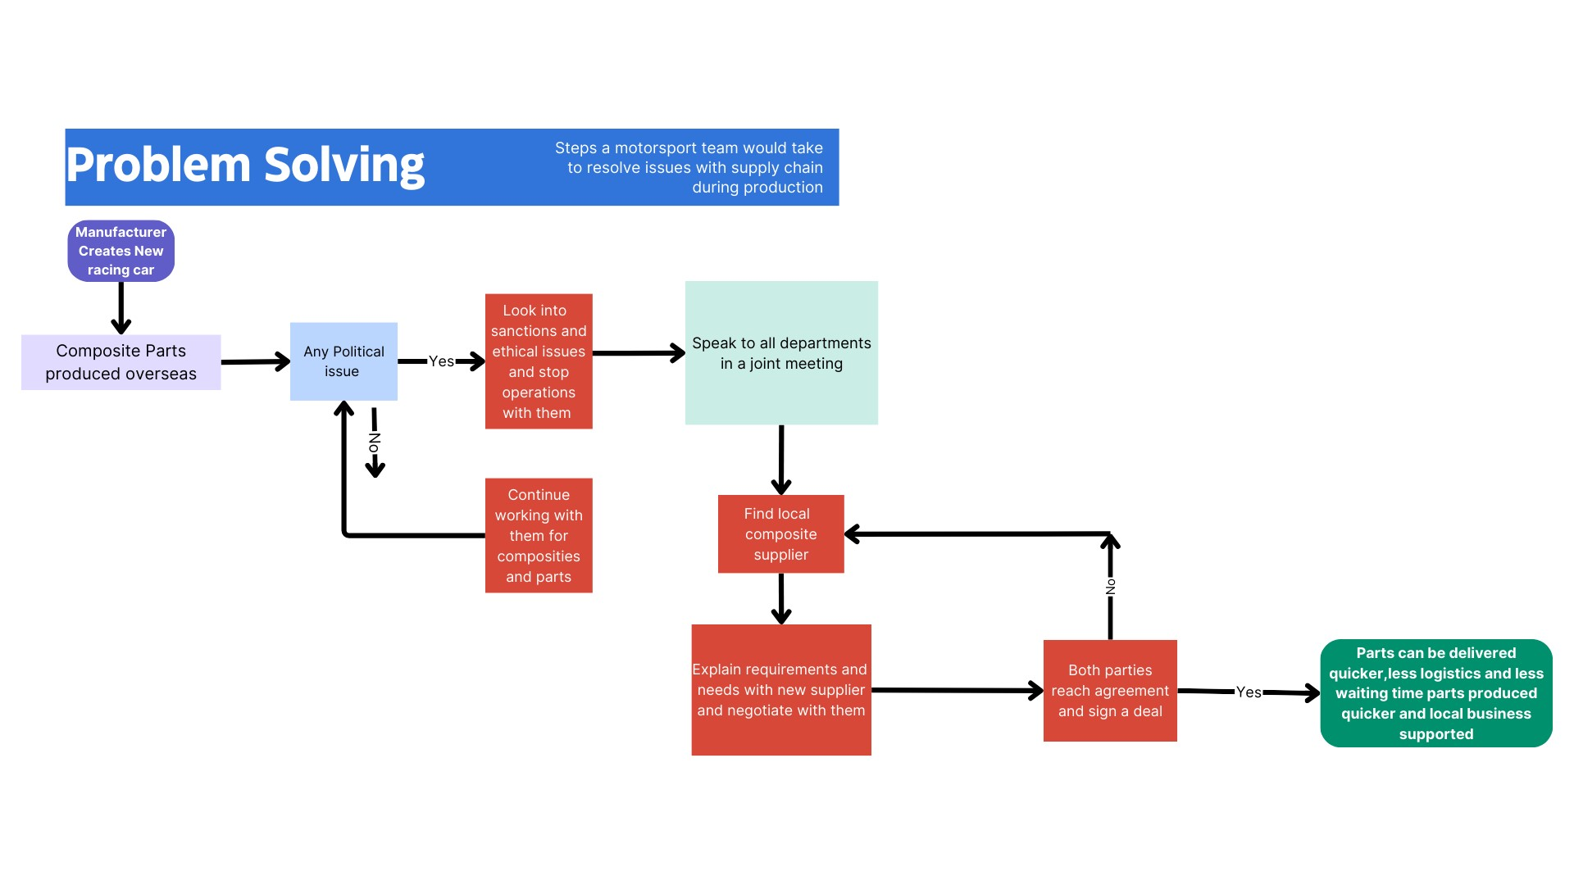Figure 3.3

Team Structure
There have been several times as I’ve grown up where I have had to work in a team. From being in a school football team all the way to my current part time job as a retail worker. I’ve been involved in teamwork since the start of my academic career.
A Time I remember when I was in a team is when I was in high school during my 1st year in sixth form it was project week, and we were given a task to design a product of our choice we went for a football boot as me and my team members were very passionate about football.
We decided to go with a flat team structure as we wanted to keep all the communication streamlined and we wanted to stay open and honest with each other during the development of our product.
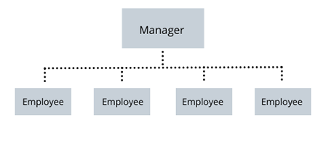 Figure 5.1
The positives and benefits of flat organisational structure are. The communication is streamlined. There is a better spread of communication between all members of the team. There less of a divide between members as there is only one structure of hierarchy in this structure compared to other team structures. Change is quicker and more effective in tasking place as there is no need for a major shift in personnel and there is no need to bring in new people if it’s not necessary and it works in the other way if you don’t need to get rid of someone and you can incorporate the one remaining individual you can giving them a greater sense of involvement which also help boost overall moral of the whole team in general. Everyone gets a greater sense of satisfaction when tasks and projects are completed and when personal and team targets are met. For our application this was perfect as we only had a week to complete our project and because there were only five team members with myself being the leader, we were able to maintain strong communication between each other in high school and after hours sending each other emails and messages on our group chat and meeting outside in public spaces to do group work it allowed us to create a comfortable and inviting environment for the team but this also helped us to be productive as a group and individually.
But the disadvantage of using a flat team structure is that there is not a way for other team members to work at a higher level as the hierarchy is structured very singular with only one person being the leader of the team. If the project had a longer timeline and more people got involved issues for growth could arise as there are no supporting personnel to assist the leader. Even though there is the positivity of getting everyone involved the downside is that there is a lack of speciality or specialist roles that can be assigned to individual. And there can be a lack of stability as there is no clear chain of command.
An alternate structure that could’ve been implemented that would’ve worked with our circumstances is the functional organizational structure.
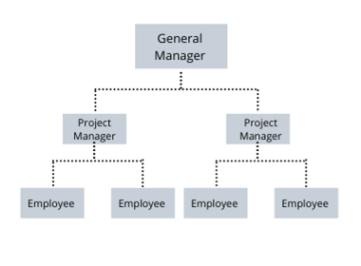Figure 5.2
As Figure 5.2 above shows this structure has a much bigger focus on authority and a more organized hierarchical structure to it. There is the main person in charge then there are two sub managers then there are the employees. With this structure there is more room for specialization for people grouping individuals with similar skill sets and abilities to be grouped together. With a bigger team there is more flexibility to scale and organize as growth increases. The structures gives everyone a clear path of communication as well as increasing accountability amongst everyone. And it provides clear stability. And it keeps everyone focused on their own roles.

Conclusion
In conclusion there is a lot an engineer needs to familiarise themselves with and a lot to take in and follow from health and safety regulations and the risks and potential dangers involved with the projects and tasks they’ll be involved in to the codes of conduct and making sure that they follow the code of conduct at all times to the best of their ability making sure they’re conscious about the affect to the environment and how sustainable the task they’re undertaking is. Problem solving making sure that you can effectively and quickly resolve issues when they arise no matter what the circumstances are is a crucial point it shows your in control and aware of the situation in hand. And lastly being able to work effectively in different team structures for different projects and different scenarios is vital being able to set up to lead people or stay in a lower role and work effectively with your department and team is important having good communication and listening skills is needed. Adaptability is a trait that all competent engineers need to have no two circumstances in the engineering world are the same and if you are faced with the same problem twice you might not get the same outcome twice.

Personal Development Plan

Personal Development Plan

Name – Mohammed Nasir Mahmood
Degree – Motorsport Engineering
Previous Qualifications –
Previous Experience -
Long Term Goals (5 to 10 years)
Become a performance engineer

Short Term Goals (0 to 5 years)
Graduate University

Goal | Objective | Resources Required | Measurement | Target Date
Graduate University | To obtain a high standard qualification | Time  Lectures  Extra-Curricular activities  Study sessions | Graduation  Degree certificate | 2026
Become a performance engineer. | To become a performance engineer for a motorsports team | Attend Graduate Courses  Online learning  Motorsport Placements | Employment email from employer | 2026
Get a job with a racing team competing in world endurance championship | To get a job with a motorsports team competing in the world endurance championship | Motorsport Placements  Online learning  Extra-Curricular activities  Degree | Employment email from employer | 2027

References
Devaney, E. (2023) Business Organisational Structure, Flat organisational structure. Available at: https://www.nibusinessinfo.co.uk/content/flat-organisational-structure#:~:text=Flat%20organisational%20structure%20is%20an,as%20little%20hierarchy%20as%20possible. (Accessed: 23 November 2023).
Dagher, K. (2022a) Team structure: 6 types + tips to build one, Fellow.app. Available at: https://fellow.app/blog/leadership/team-structure-types-tips-to-build-one/ (Accessed: 23 November 2023).
9 types of organizational structure every company should consider (2023) HubSpot Blog. Available at: https://blog.hubspot.com/marketing/team-structure-diagrams (Accessed: 23 November 2023).
Kaplan, K. (2022) 5 DesignOps team structures, Nielsen Norman Group. Available at: https://www.nngroup.com/articles/designops-team-structures/ (Accessed: 23 November 2023).
Personal Protective Equipment (PPE) at Work Regulations from 6 April 2022. Available at: https://www.hse.gov.uk/ppe/ppe-regulations-2022.htm#:~:text=The%20employer%20is%20responsible%20for,report%20that%20to%20your%20employer. (Accessed: 23 November 2023).
The Personal Protective Equipment at work (amendment) regulations 2022 (2022) Legislation.gov.uk. Available at: https://www.legislation.gov.uk/uksi/2022/8/contents/made (Accessed: 23 November 2023).
Targetjobs (2023) Becoming a chartered or incorporated engineer after starting a graduate job, targetjobs. Available at: https://targetjobs.co.uk/careers-advice/engineering/becoming-chartered-or-incorporated-engineer-after-starting-graduate-job#:~:text=While%20both%20are%20highly%20regarded,the%20graduate%20employer%20you%20join. (Accessed: 23 November 2023).
Engineering council. Available at: https://www.engc.org.uk/ceng (Accessed: 23 November 2023).
Indeed (2023) What does a chartered engineer do? (with job description). Available at: https://uk.indeed.com/career-advice/finding-a-job/what-does-chartered-engineer-do (Accessed: 23 November 2023).
IET (no date) Becoming a chartered engineer (ceng), IET. Available at: https://www.theiet.org/career/professional-registration/chartered-engineer/ (Accessed: 23 November 2023).
hse (no date) HSE: Information about health and safety at work, Workplace Health,Safety and Welfare. Available at: https://www.hse.gov.uk/pUbns/priced/l24.pdf (Accessed: 23 November 2023).
Participation, E. (1980) Health and safety at work etc.. act 1974, Legislation.gov.uk. Available at: https://www.legislation.gov.uk/ukpga/1974/37/contents (Accessed: 23 November 2023).
Engineering Council (no date) Engineering council. Available at: https://www.engc.org.uk/ethics#:~:text=Engineering%20professionals%20have%20a%20duty%20to%20obey%20all%20applicable%20laws,work%20is%20lawful%20and%20justified (Accessed: 23 November 2023).
IMEC (no date) Code of conduct explained, IMechE. Available at: https://www.imeche.org/about-us/imeche-governance/governance-and-finance-reviews/code-of-conduct-explained (Accessed: 23 November 2023).

