3/27/2026
Assignment 1

Module name: network operating systems and services
module code: acca 5023
student name: david borst dominguez
student id: 2422936
lecturer: dr. nitheesh kaliyamurthy
University of whales trinity st. david (london campus)
Table of Contents
Task 1 1
Research on Hypervisor: 1
Research on IP Addressing: 6
Based on the above Group Activity, reflect your understanding on IP Addressing with appropriate and adequate in-text citations: 8
Research on Routing: 12
Research on network: 13
Task 2 15
Screenshots: 15
Task 3 22
Technical and Personal Reflections: 22
References 24

Task 1

Research on Hypervisor:
Hypervisors are the foundational technology that makes modern virtualization and cloud computing possible, enabling multiple isolated virtual machines (VMs) to run on a single physical host. Below is a clear, academically structured research overview tailored to help you build a rigorous understanding of hypervisors, their architecture, and their role in contemporary IT systems.

A Type 1 hypervisor:
Also called a bare-metal hypervisor runs directly on the physical hardware without a host operating system, giving it superior performance, stronger isolation, and higher reliability than Type 2 hypervisors. It is the dominant virtualization technology used in enterprise data centres and cloud platforms.
Architecture of Type 1 Hypervisor:
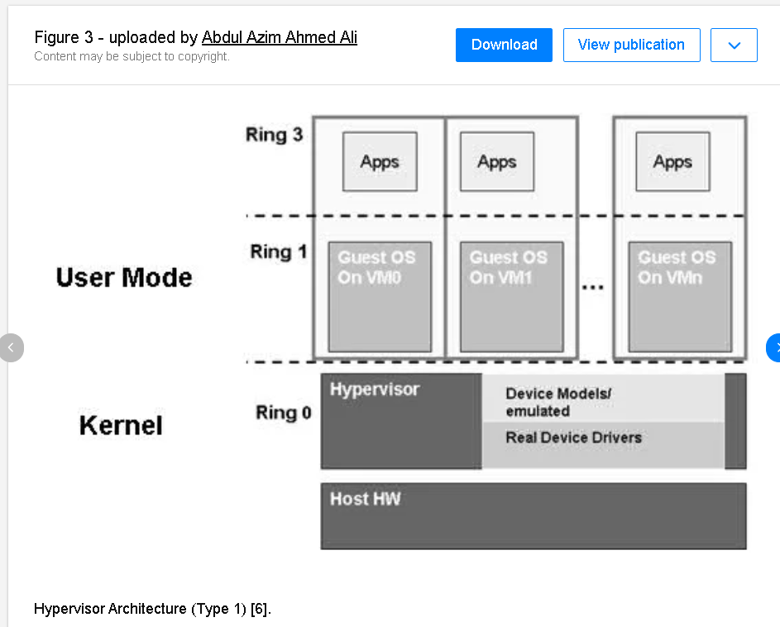 [1]

Note: The hypervisor interacts with the physical hardware component such as the (Memory, Network Interface, CPU, and Storage Device).

A Type 2 Hypervisor:
A Type 2 hypervisor is a hosted hypervisor that runs as an application on top of a standard operating system like Windows, macOS, or Linux, also making it easy to install and ideal for development, testing, and personal virtualization. It relies on the host OS for hardware access, which introduces more overhead than Type 1 hypervisors.

Architecture of Type 2 Hypervisor:
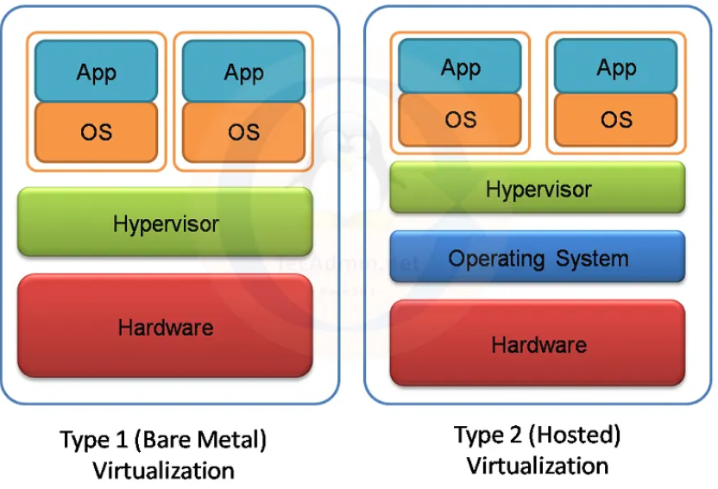 [2]
Comparison of Hypervisor 1, 2:
Type-1 Hypervisors run directly on the physical hardware without the need for a host operating system. They have direct access to the underlying hardware resources, offering better performance and efficiency compared to Type-2 hypervisors. Type-1 hypervisors are commonly used in enterprise data centres and cloud environments. Examples include VMware vSphere/ESXi, Microsoft Hyper-V, and KVM (Kernel-based Virtual Machine).
Type-2 Hypervisor run on top of a host operating system, which in turn runs on the physical hardware. They rely on the host operating system for managing hardware resources and providing device drivers. Type-2 hypervisors are typically used for desktop or development environments. Examples include Oracle VirtualBox, VMware Workstation, and Parallels Desktop.
Key Features of Hypervisors:
Hypervisors Type 1 or Type 2 share several foundational capabilities.
- Hardware abstraction: Presents virtual CPUs, memory, storage, and network interfaces to VMs.
- Resource scheduling: Dynamically allocates CPU cycles, RAM, and I/O bandwidth.
- Isolation: Ensures VMs operate independently without interfering with each other.
- Snapshot & cloning: Capture VM states for rollback, testing, or replication.
- Live migration (Type 1): Move running VMs between hosts with minimal downtime.
- Device emulation & paravirtualization: Supports both legacy and high-performance virtual devices.

Hardware Requirements:
Hardware requirements depending on the hypervisor type and vendor include:
- 64-bit CPU with virtualization extensions (Intel VT-x or AMD-V).
- Sufficient RAM to support host OS (Type 2) and guest VMs.
- Hardware-assisted memory management (e.g., Intel EPT, AMD RVI) for performance.
- Compatible storage controllers and NICs.
- 64-bit processor with SLAT (Second Level Address Translation).
- Minimum 4 GB RAM (more recommended).
- Hardware virtualization enabled in BIOS/UEFI

Advantages of Hypervisors:
Hypervisors deliver several operational and economic benefits:
- Efficiency & Cost Reduction.
- Consolidate multiple workloads on fewer physical servers.
- Reduce power, cooling, and hardware procurement costs.
- Flexibility
- Run different OSes (Windows, Linux, BSD) on the same hardware.
- Rapid provisioning of test or production environments.
- High Availability
- Support failover clustering, live migration, and automated recovery.
- Improved Resource Utilization
- Dynamically scale CPU, memory, and storage allocation based on demand

Brief Summary of Hypervisor Table:
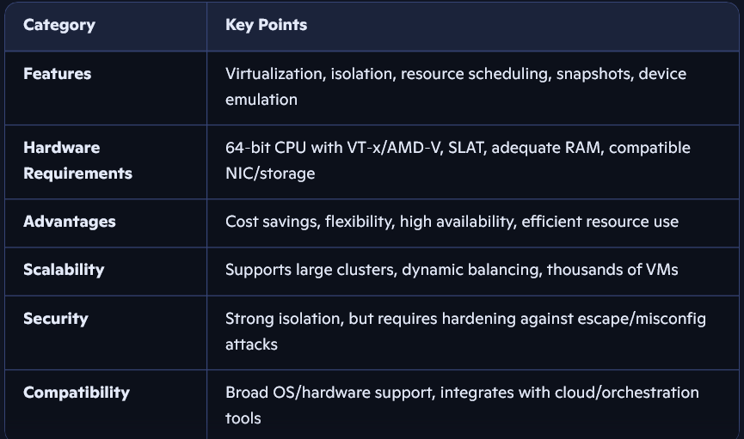
Conclusion:
Based on my findings and how I explained in my structured breakdowns, Hypervisors are the cornerstone of virtualization technology, enabling organizations to maximize resource utilization, improve scalability, and streamline IT operations. Understanding the differences between Type-1 and Type-2 hypervisors, as well as full vs para virtualization techniques, is essential for selecting the right virtualization solution to meet your specific needs. Whether you’re deploying virtualized infrastructure in enterprise data centres, cloud environments, or desktop environments, the choice of hypervisor and virtualization technique can have a significant impact on performance, efficiency, and manageability.

Justification:
I have Justified my choice by considering the domain environment (BIRMINGHAM.ACCA) and the need to support both Windows and Debian clients, including specific hardware constraints or security needs in the topology. The design and selection of infrastructure services for the BIRMINGHAM.ACCA domain must be justified through a clear understanding of the operational environment, the diversity of client systems, and the security and hardware constraints that shape the topology. The domain represents a typical enterprise Windows environment, where Active Directory (AD) provides centralised identity, authentication, and policy enforcement. Any proposed solution must therefore integrate seamlessly with AD while also supporting Debian-based Linux clients, which introduces additional interoperability requirements. This dual-platform context significantly influences the architectural decisions and the technologies selected

Research on IP Addressing:
Understanding how data travels across the Internet requires recognising the central role of IP addressing. When one computer sends data to another, the information is broken into packets, each containing a source IP address, destination IP address, and routing metadata (Tanenbaum & Wetherall, 2011). Routers use these IP addresses to determine the most efficient path across interconnected networks, forwarding packets hop-by-hop until they reach the destination. Switches, by contrast, operate at Layer 2, using MAC addresses to forward frames within a local network, thereby reducing unnecessary traffic (Kurose & Ross, 2021).
IP addressing enables this process by uniquely identifying devices. IPv4 uses a 32-bit structure (e.g., 192.168.1.10), represented in dotted-decimal format. Due to address exhaustion, IPv6 was introduced, using a 128-bit hexadecimal structure (e.g., 2001:0db8:85a3::8a2e:0370:7334), providing vastly more address space and improved routing efficiency.

Switch:
Switch primarily operates within a local area network (LAN) environment, serving as a central device that connects multiple networked devices such as Printers, Computers, and Services. When a device transmits data, the switch examines the Media Access Control (MAC) address, which is a unique hardware identifier assigned to each network interface car (NIC).

Router:
Router function as a device that interconnects different networks, enabling data transmission between a local network and the broader internet. Routers manage communication across multiple distinct networks. While switches forward data frames based on MAC addresses within LAN routers, route packets between networks at the IP layers, switches, and routers play complementary roles in network infrastructure ensuring data is accurately directed.

Example of Switch and Router:
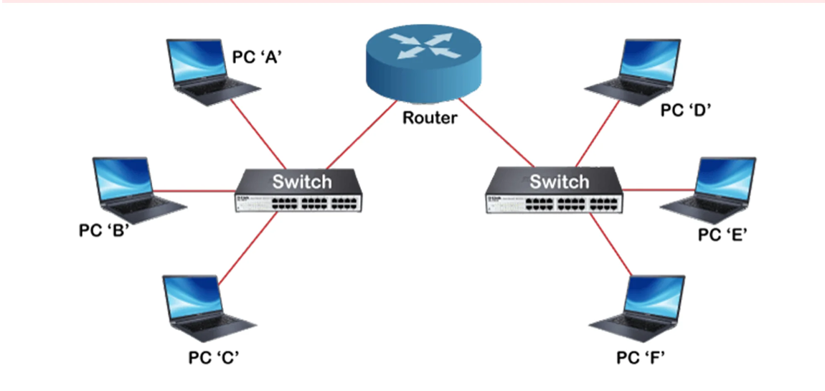

Based on the above Group Activity, reflect your understanding on IP Addressing with appropriate and adequate in-text citations:

Introduction:
Understanding how data travels across the Internet requires recognising the central role of IP addressing. When one computer sends data to another, the information is broken into packets, each containing a source IP address, destination IP address, and routing metadata. Routers use these IP addresses to determine the most efficient path across interconnected networks, forwarding packets hop-by-hop until they reach the destination. IP addressing enables this process by uniquely identifying devices. IPv4 uses a 32-bit structure (e.g., 192.168.1.10), represented in dotted-decimal format. Due to address exhaustion, IPv6 was introduced, using a 128-bit hexadecimal structure (e.g., 2001:0db8:85a3::8a2e:0370:7334), providing vastly more address space and improved routing efficiency. [2]

Roles:
IP Addressing plays a critical role in the operation and efficiency of networks. Each device connected to a network must have a unique IP Adress to enable switch and router to correctly identify and to route data packets. Without the IP Addressing device would not be able to send or receive information over internet or local networks.
Key contributions of IP Addressing include:
Routing and packet delivery: Each device is uniquely identified with a network
Scalability: Hierarchical addressing facilities efficient management of large-scale network
Network Organization: IP Addressing enables network to be segmented into logical subdivisions
Overall, IP addressing underpins the functionality of modern networks by enabling device identification, routing, segmentation, and scalable communication across global infrastructures.

Structure Format and Representation of IP4, and IP6 Overview:
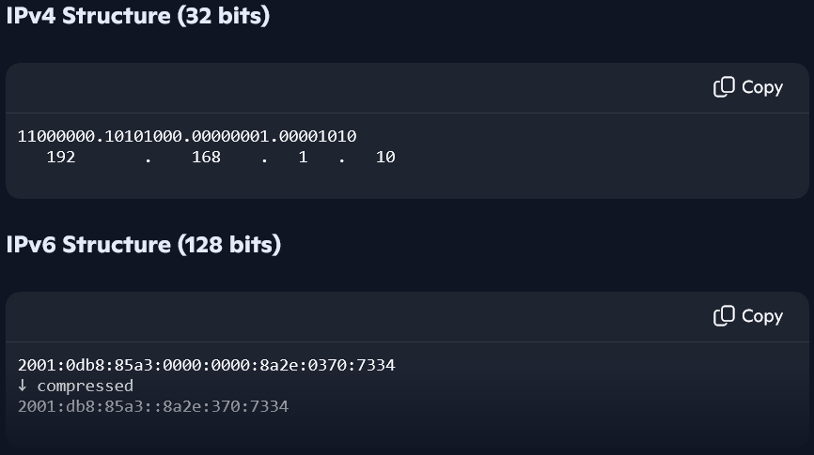

Diagram of IPV4:
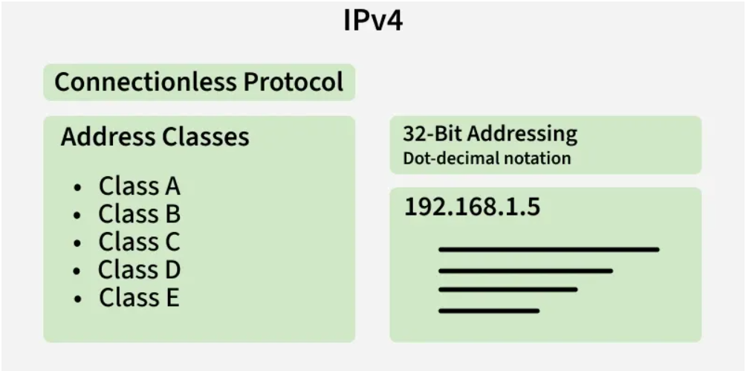 [3]

Example of IPV4 Addresses:
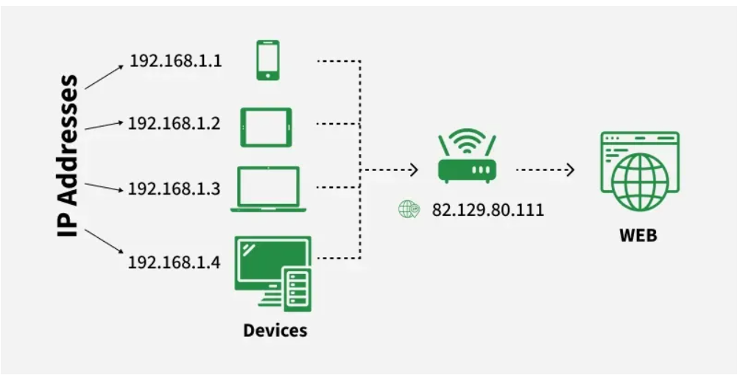 [3]

Example of Subnet Network Addresses:
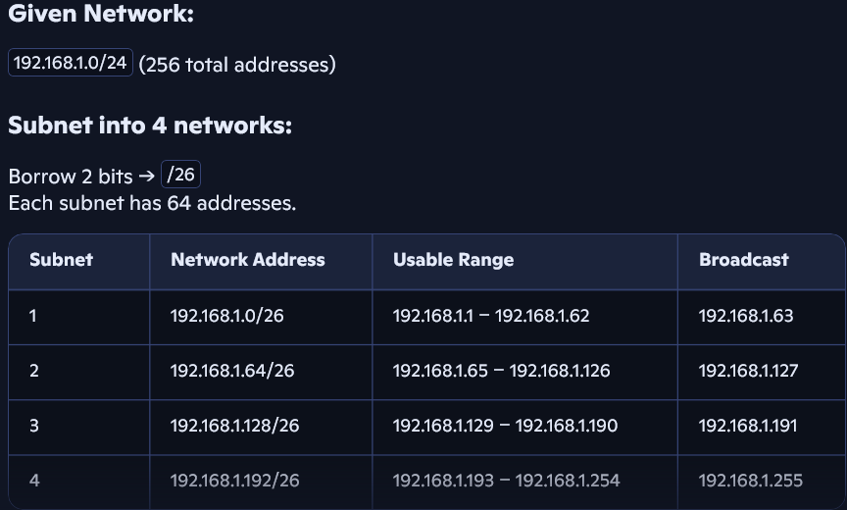 [3]

Diagram example of IPV6:
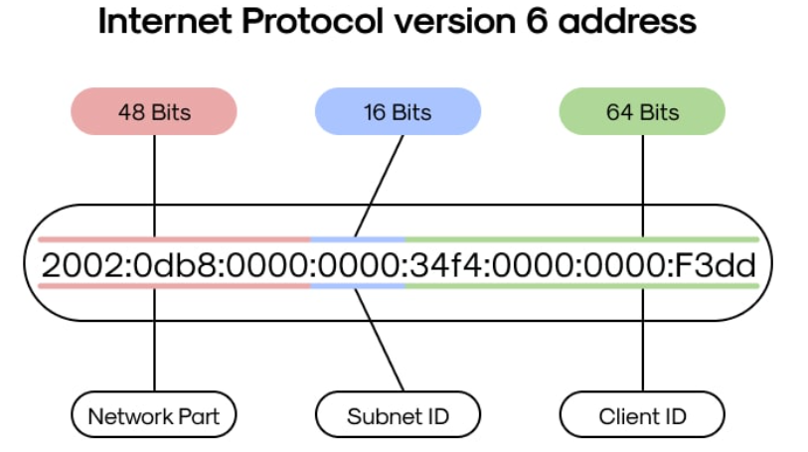 [3]
Note: Showing in a brief example of IPV6 has 8 groups and each group is separated by columns. In each group, there are 4 digits. Each of these digits can be created with4 bits. Total there are 128bits addresses.
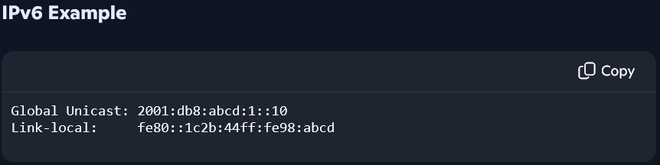

Example of Subnetting:
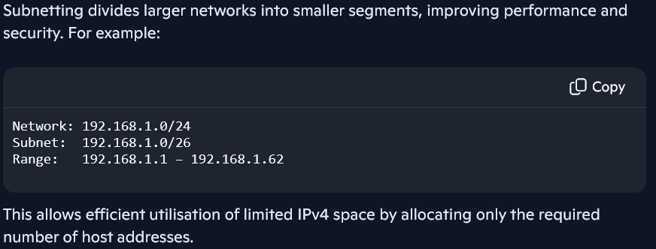

Research on Routing:
Routing is the process that enables data packets to travel across interconnected networks, ensuring they reach the correct destination. When a device sends data, the information is encapsulated into packets containing a source IP address, destination IP address, and protocol information. Routers operate at OSI Layer 3 (Network Layer), using routing tables and algorithms to determine the most efficient path for forwarding packets between networks. A router examines the destination IP address and compares it against entries in its routing table, which may include directly connected networks, static routes, or dynamically learned routes from protocols such as RIP, OSPF, or BGP. These protocols allow routers to exchange topology information, adapt to network changes, and optimise path selection.

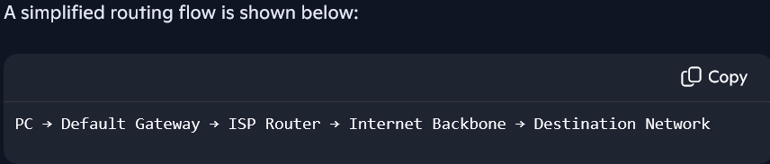

Research on network:
A computer network is a system of interconnected devices that communicate and share resources through wired or wireless links. At its core, a network enables the transmission of data between hosts using standardised communication protocols. The Internet, for example, is a global network of networks built on the TCP/IP model, where each layer contributes to reliable communication. The Network Layer, using IP addressing, ensures that data can be routed across different networks, while the Transport Layer (TCP/UDP) manages end-to-end delivery and reliability. Networks are typically categorised by scale, such as Local Area Networks (LANs), Wide Area Networks (WANs), and Metropolitan Area Networks (MANs). LANs connect devices within a limited area, often using Ethernet or Wi-Fi, whereas WANs span large geographical distances and rely on routers, leased lines, and service providers to interconnect remote sites.
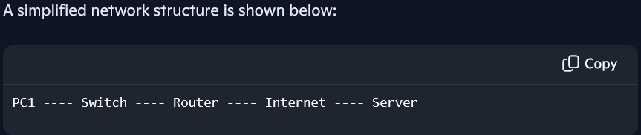
Virtual Private Network (VPN):
A VPN enables users to securely connect to a private network over the internet by creating an encrypted tunnel between the user’s device and the network protecting data from unauthorized access. Key features include encryption, authentication, and secure remote access.

Certificate Authority:
A CA issued certificate that verifies identity and enable secure communication via encryption. Certificates are widely used in HTTPS, VPNS, and secure email systems. Best practices for CA management include safeguarding private keys, implementing certificate lifecycle management, and utilizing trusted certificate authorities to maintain network security.
Diagram Example of LAN vs WAN:
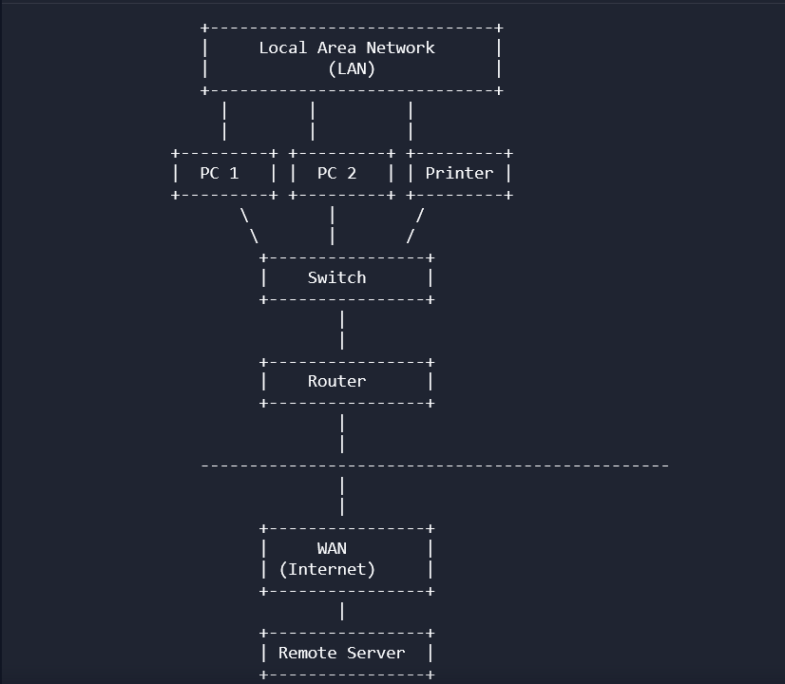

Explanation of LAN and WAN Topology:
- LAN (Local Area Network)
A LAN connects devices within a small geographical area such as a home, school, or office. It typically uses Ethernet or Wi-Fi and is managed by a local administrator. Devices like PCs, printers, and switches operate here.
- WAN (Wide Area Network)
A WAN spans large geographical distances and interconnects multiple LANs. The Internet is the largest WAN. Routers connect LANs to WANs, enabling communication with remote networks and servers.

Task 2

Screenshots:
This is my home screen Creation:
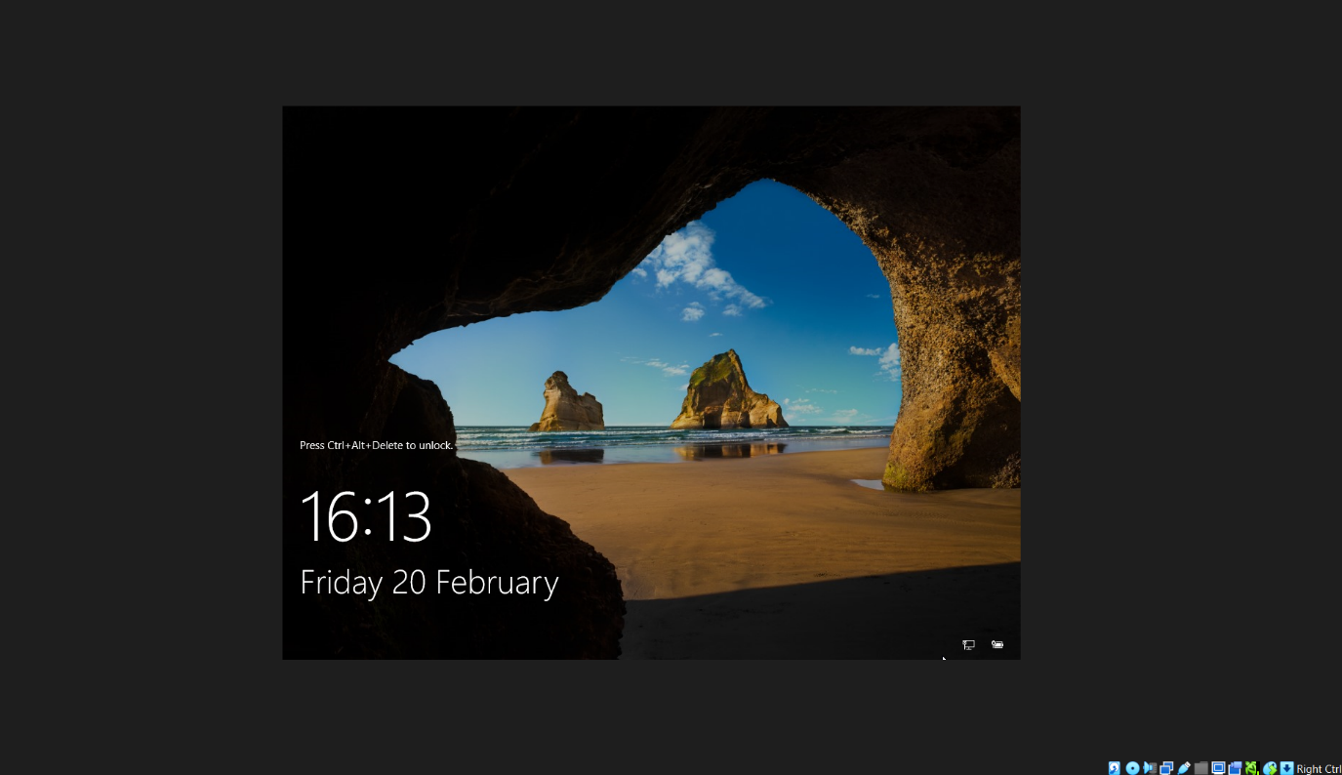

This is created and generated Homepage to logging-in:
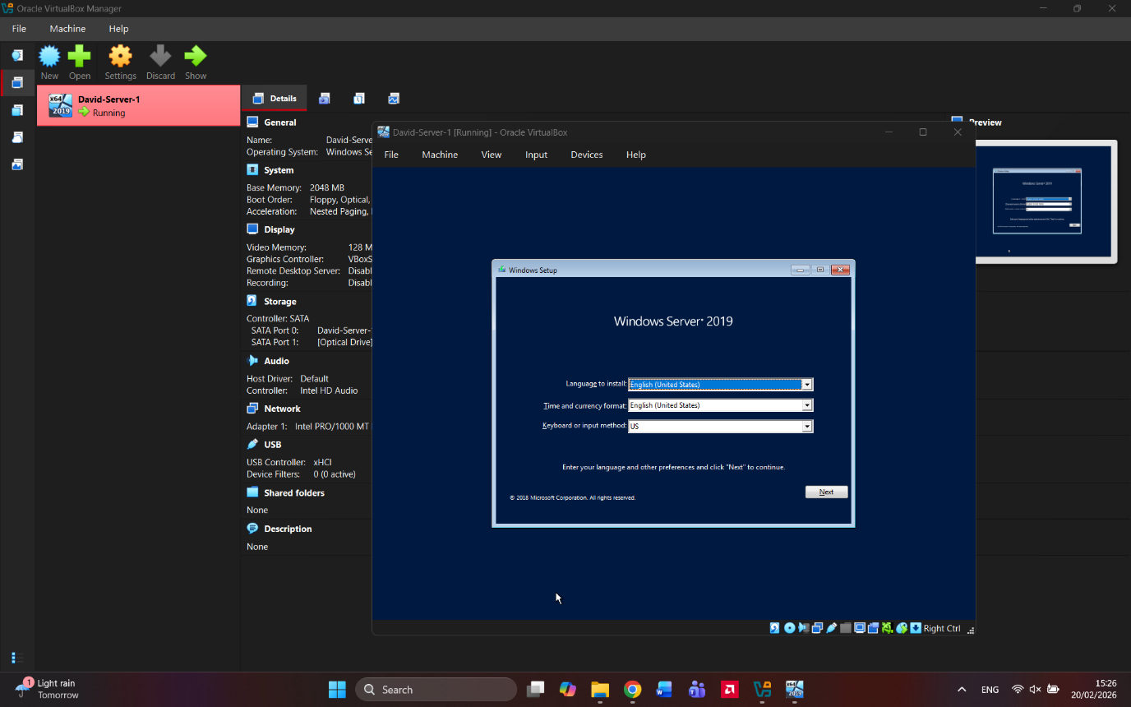
This screenshot is to show how pinging is done: (Pinging)
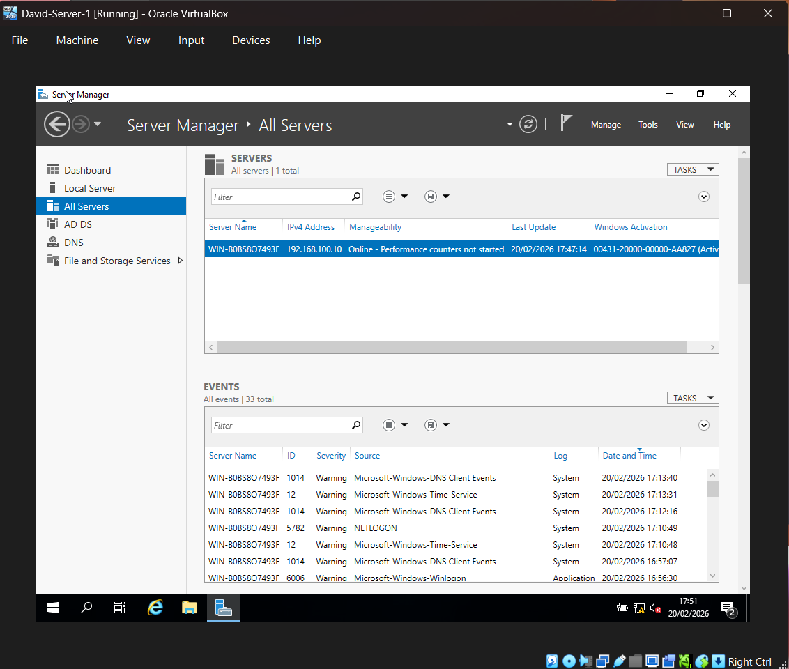
This is to show how to use Configuration/Settings of Local Servers: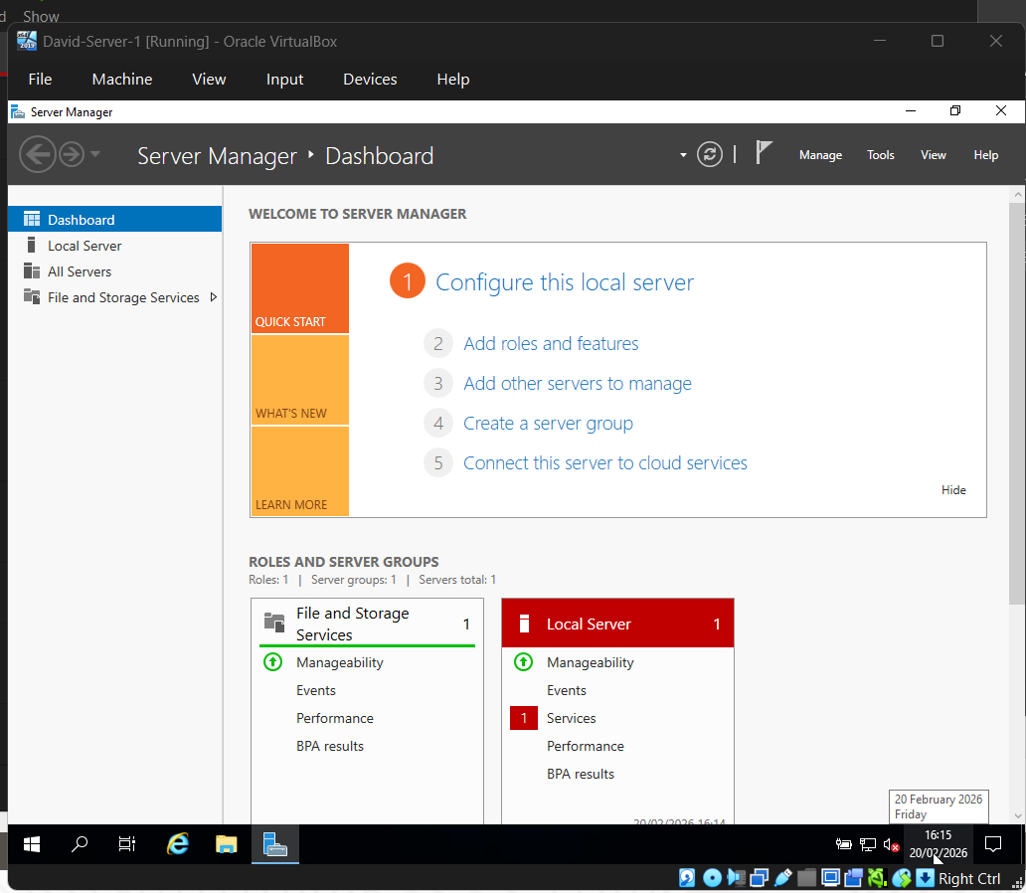
Brief screenshot showing how Live Networks are operative and running: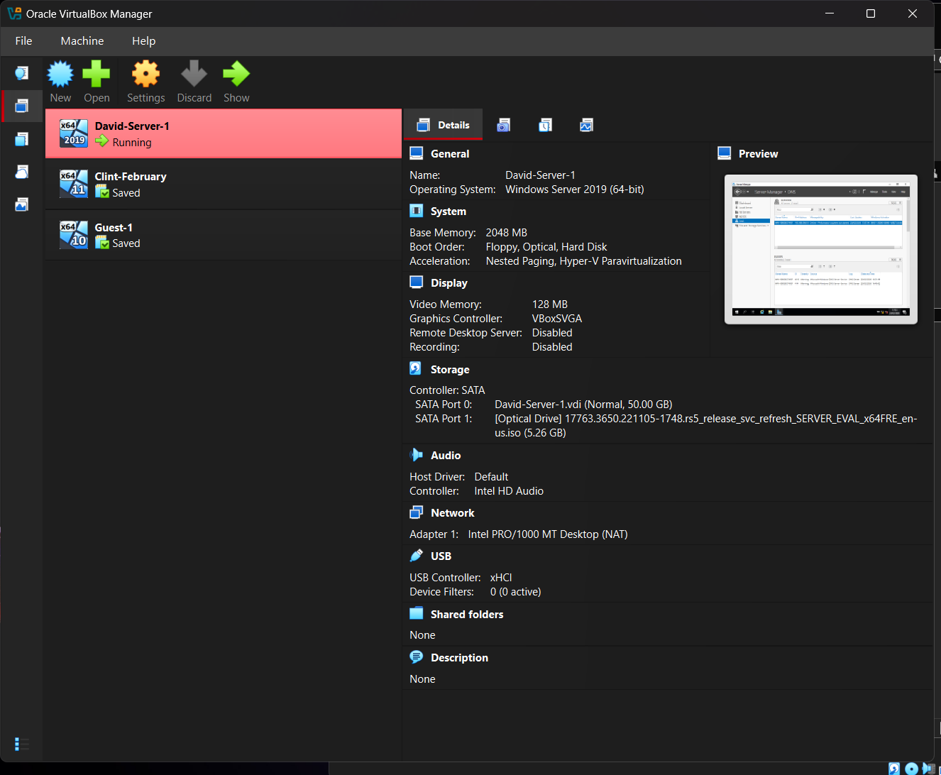

This image shows how to create New Machine Name & Operating Systems:
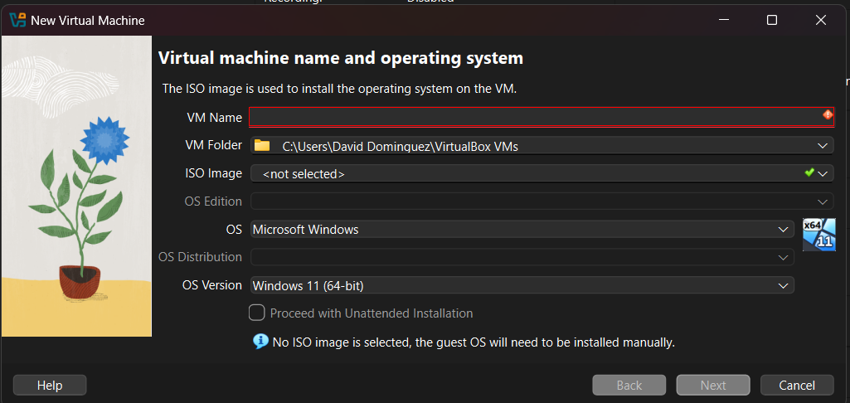

This image is showing how to locate and use DNS connection:
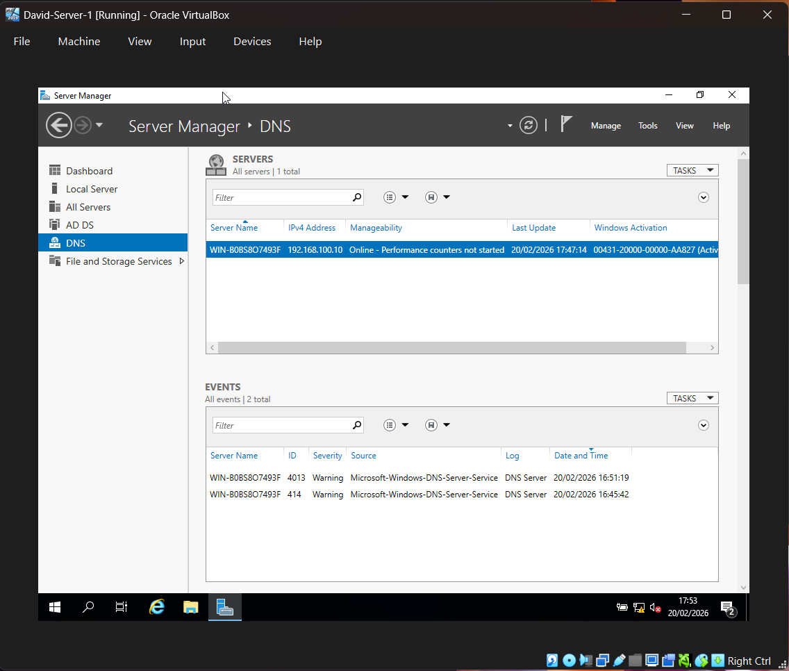
Brief directions in how to find and use Settings: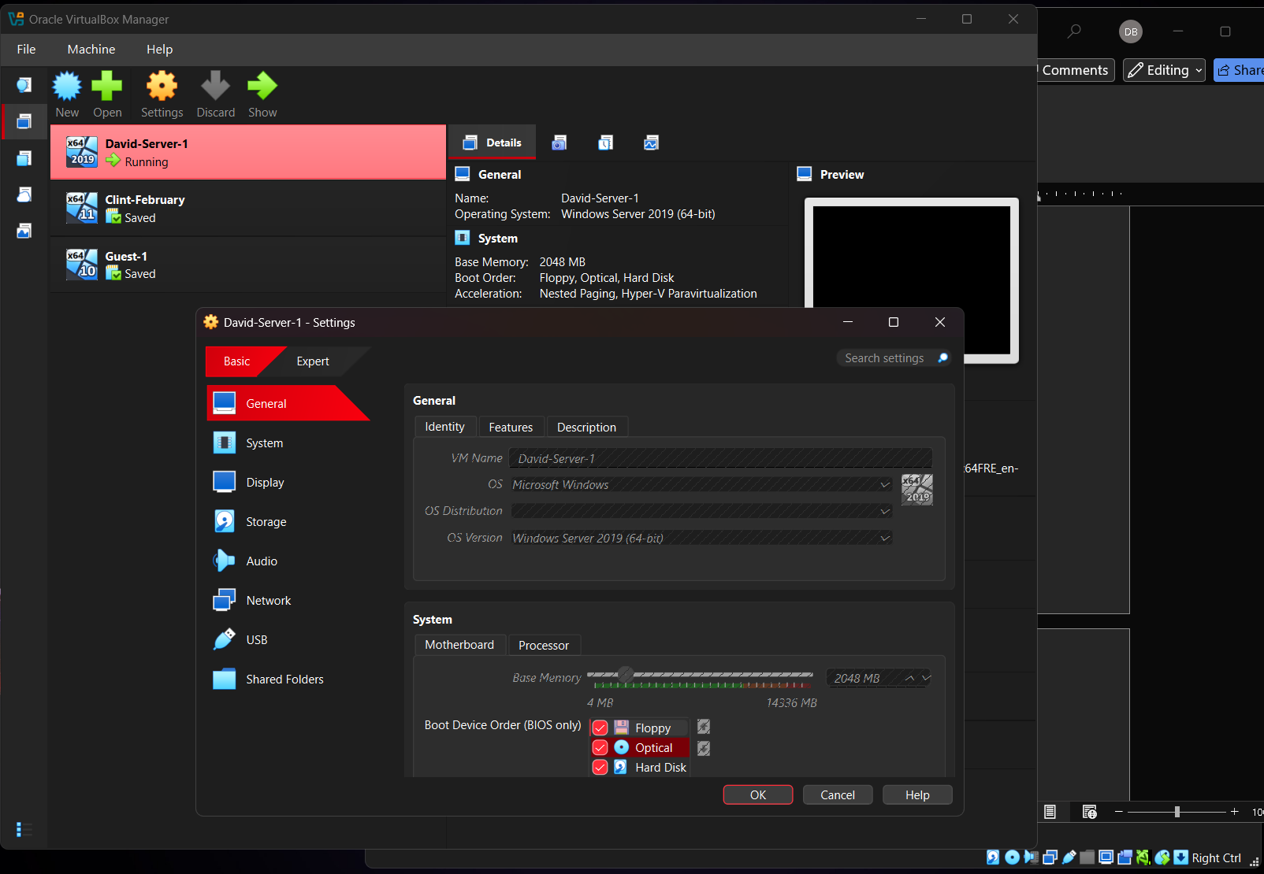
How to locate (Systems use in the settings icon):
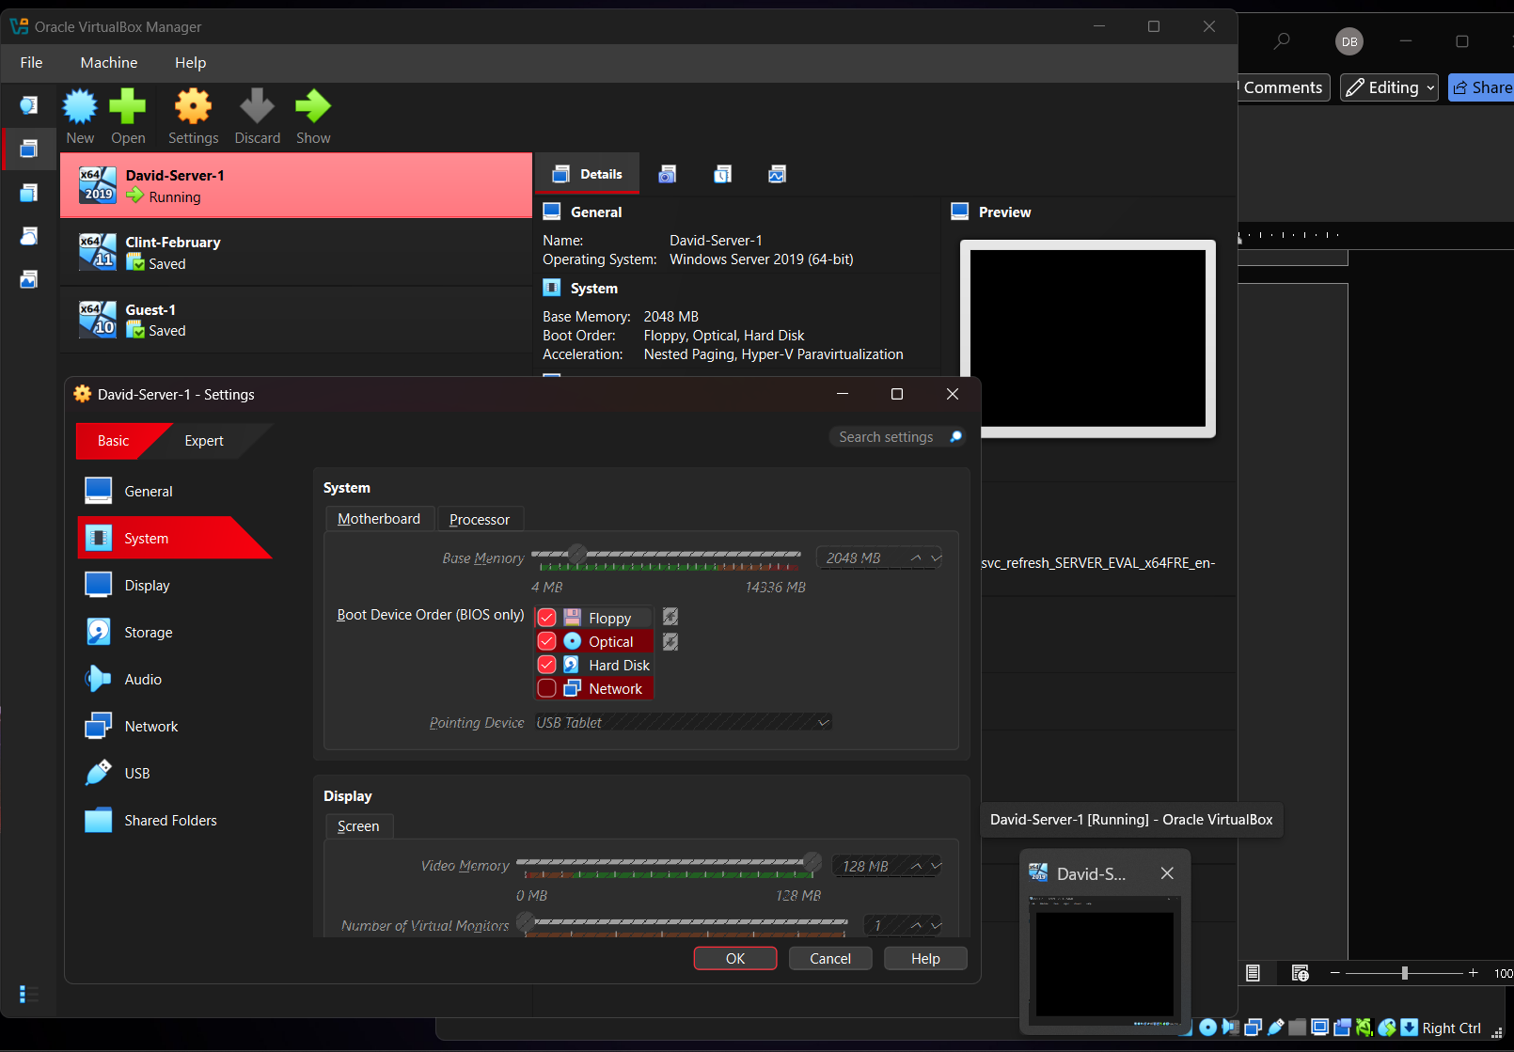

How to initialize Client Server Selections and how to open:
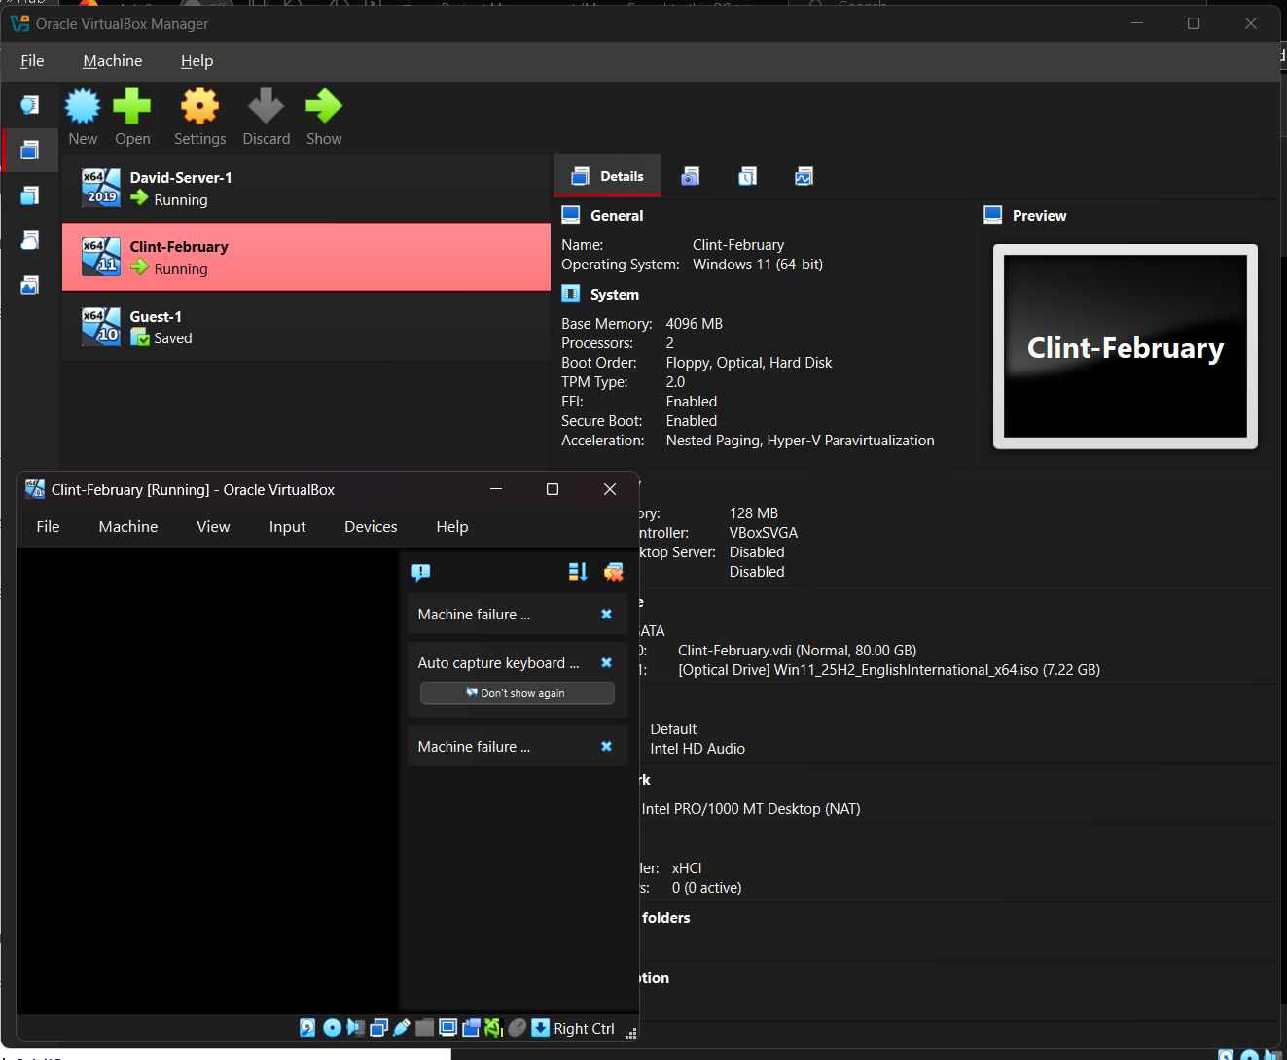

This is to show how to create Guest Servers:
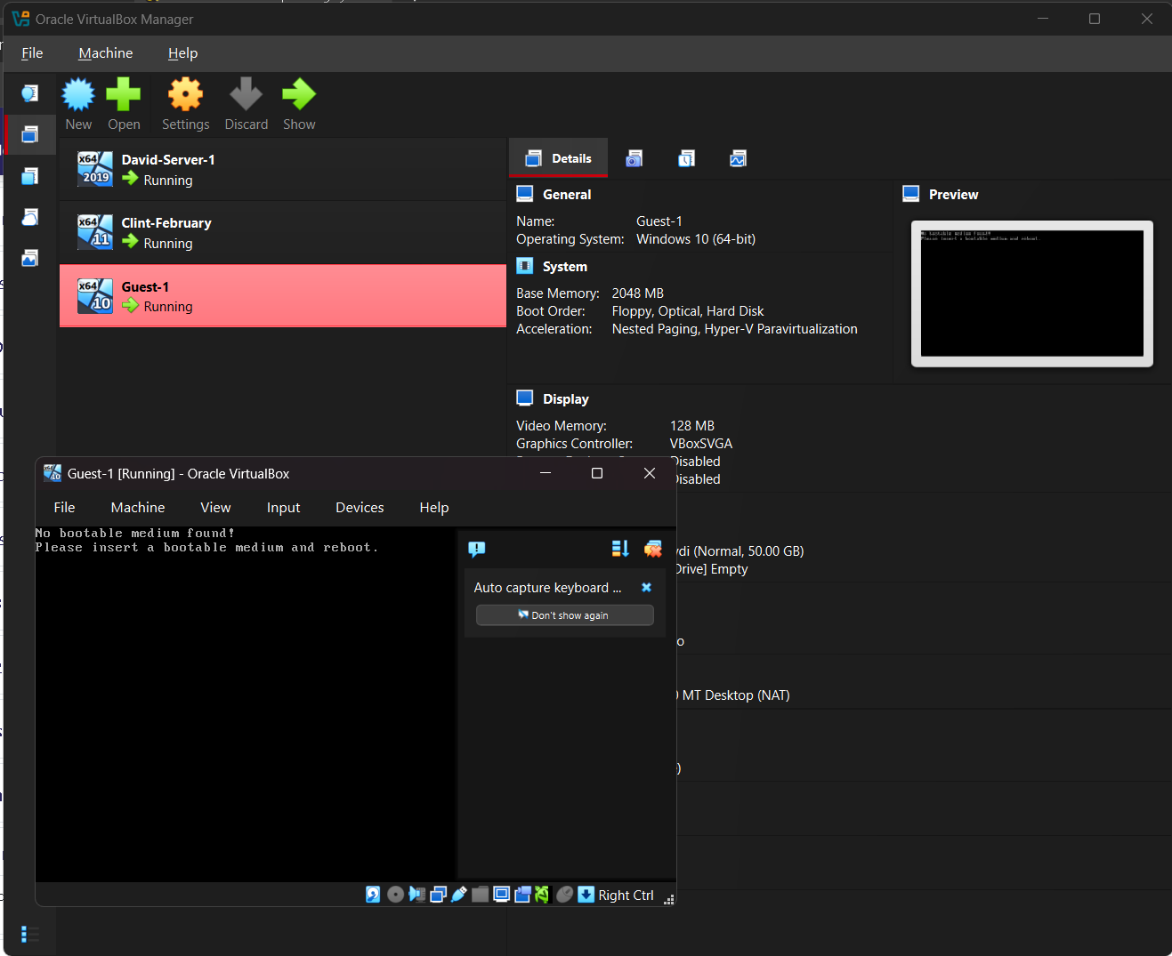

Connectivity tests:
Outcome 1: Successful connectivity within same networks.
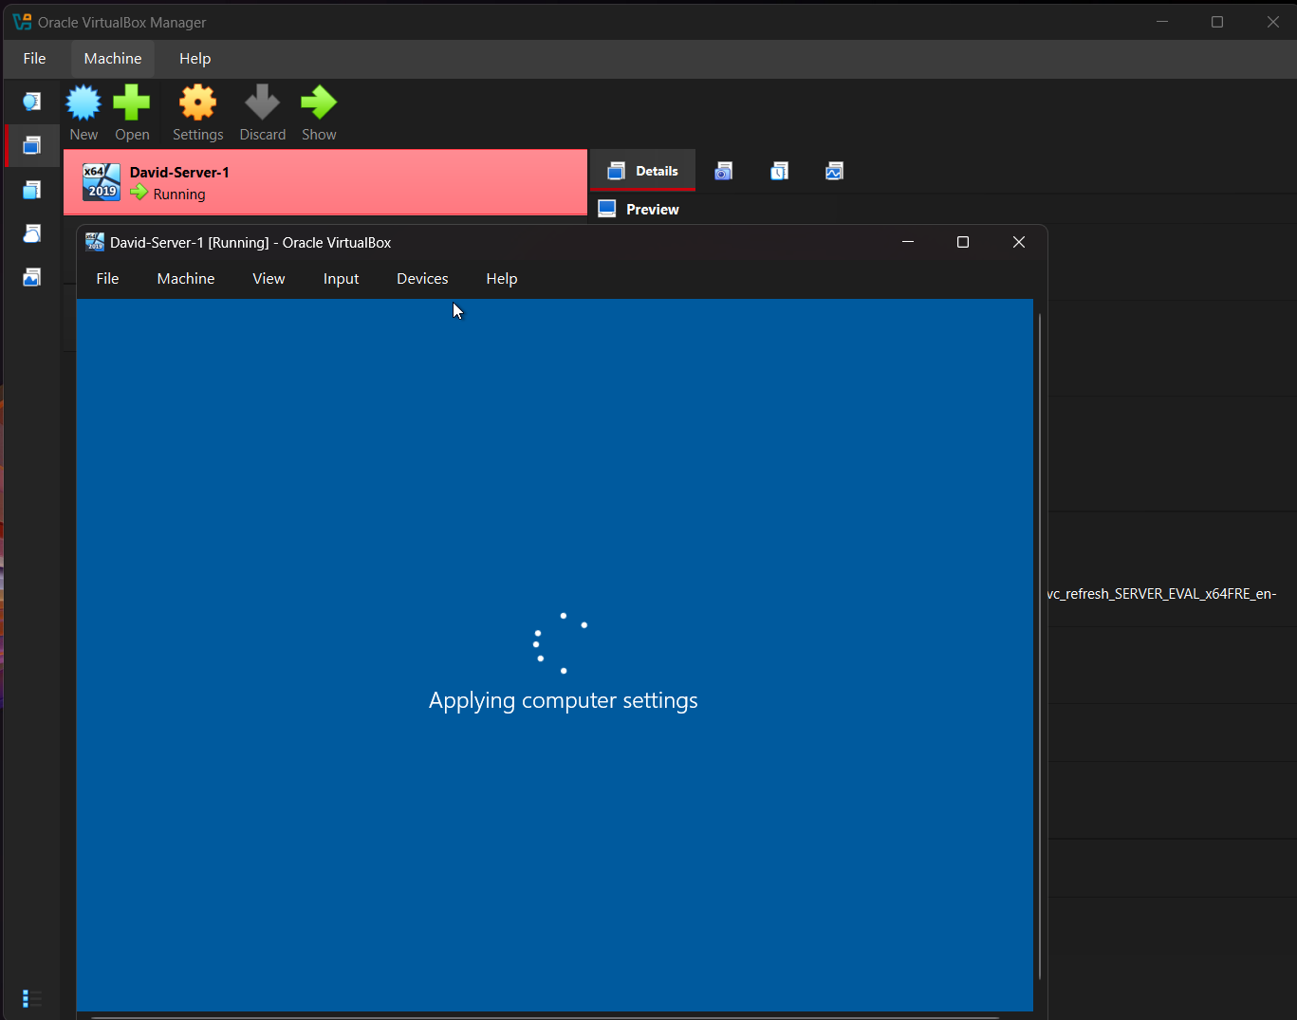

Outcome 2: Unsuccessful connectivity within different networks.
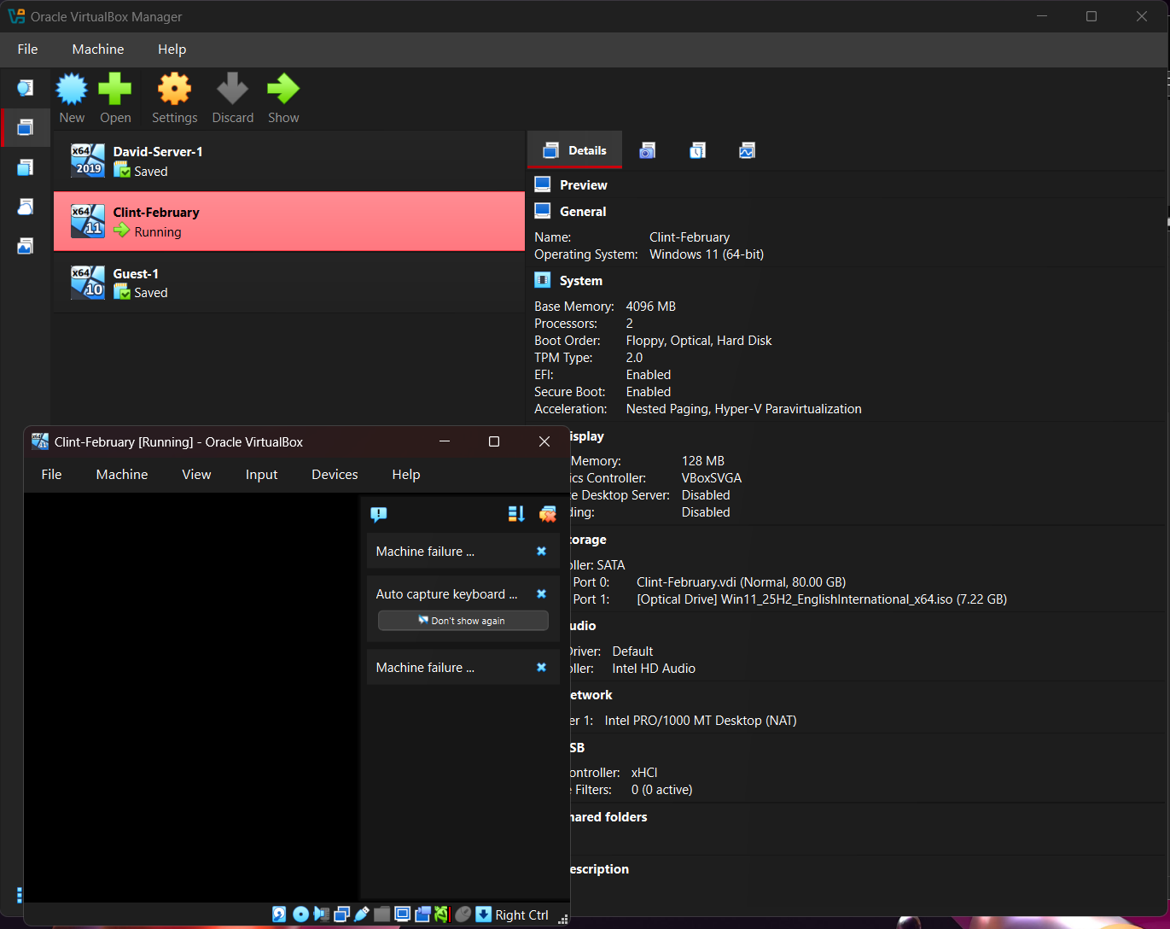

Task 3

Technical and Personal Reflections:

During the deployment and testing of the mixed Debian–Windows Server network environment, several technical challenges emerged. These issues primarily related to IP addressing, DNS resolution, firewall rules, and service interoperability. This reflection documents each issue, the diagnostic process, and the systematic troubleshooting steps taken to resolve them.

Brief encounter of IP Address Conflicts and issues:
The Issues that I have encountered during initial deployment, are that some servers failed to communicate across VLANs. Debian application servers intermittently lost connectivity to the Windows Server domain controller and the symptoms Intermittent ping failures of ARP table showing duplicate MAC entries and DHCP logs showing unexpected lease assignments.
Diagnosis:
I used the following steps that runs on Debian and Windows systems to inspect duplicate IP/MAC mappings by checking DHCP server logs for overlapping scopes and used to identify active hosts and duplicate Ips verified static, and IP assignments on Debian servers.
Root Cause is that Debian server had been manually assigned an IP address inside the DHCP scope used by Windows Server.
Resolution:
I Adjusted DHCP scope to exclude static ranges and reassigned static IPs to a reserved block that cleared ARP caches to ensure clean propagation and connections.

DNS Resolution Failures:
The issue that I Encountered with Debian servers integrated with Active Directory (via SSSD/realm) failed to authenticate users. Windows clients also experienced slow logons. The symptoms logs showing “Cannot resolve KDC” windows event viewer Showed a (DNS lookup timeout) and always returned with inconsistent results.

Diagnosis:
I had to run Debian to test forward and reverse lookups to verify DNS zones on Windows server that had (AD‑integrated) connection. I then checked to ensure Windows DNS was primary used to inspect DNS routing.
Root Cause was that Debian servers were using the router’s DNS as primary instead of the Windows DNS server, causing Kerberos failures.

Resolution:
I Updated Debian DNS configuration to point exclusively to the Windows DNS server to Restart SSSD and cleared all the Kerberos cache and then validated with a successful AD authentication.

Firewall Configuration Issues:
Issues encountered with applications hosted on Debian could not reach the database VLAN, and Windows clients could not access SMB shares.
Symptoms were that connection timeouts on port 5432 (PostgreSQL), SMB shares inaccessible from Debia, and reverse proxy was unable to forward traffic to internal app servers and therefore not able to hold a fast and suffice connection on an End-to-End control.
Diagnosis:
I used and tested port reachability to check firewall rules on Debian, and reviewed windows defender firewall inbound rules to verify inter‑VLAN ACLs on the L3 switches.
Root Cause is that I had Two separate issues:
1. L3 switch ACL blocked traffic from VLAN 20 (apps) to VLAN 50 (database).
2. Windows Firewall blocked SMB traffic from Debian servers.

Resolution:
Updating ACLs allow only required ports, and in principle of least privilege added windows firewall rules for SMB (TCP 445) and added Debian firewall rules for outbound DB traffic.
Personal Reflection:
Working with a hypervisor during the deployment of my network environment was one of the most insightful parts of the project. It pushed me to think beyond individual operating systems and instead consider the entire virtual infrastructure as an interconnected ecosystem. The experience highlighted both the strengths of virtualisation and the practical challenges that arise when multiple virtual machines (VMs) share the same physical host.
When I first began configuring the hypervisor, I underestimated how many decisions needed to be made before even powering on a VM. Choosing between bridged, NAT, or host‑only networking forced me to think carefully about how each virtual machine would communicate with the rest of the network.
I realised quickly that the hypervisor isn’t just a tool for running VMs, it’s effectively a software-defined data centre. This shift in mindset helped me approach the deployment more strategically and how to apply these skills in the real world.

References

[1] | {Ali, Abdul Azim}, “Virtual Machine Escapes,” 2013, p. 0.
[2] | Ravi Patel, “Understanding Hypervisors,” Medium, p. 0, 2024.
[3] | Mr. Sandeep Jain, “GeeksforGeeks,” GFG, January 2008. [Online]. Available: https://www.geeksforgeeks.org/about/. [Accessed 2008].

