Has community heritage played a part in transforming the Blaenavon Big Pit into the National Coal Museum of Wales?

The purpose of this paper is to review existing research into community heritage and highlight the significance of incorporating the narratives and knowledge of communities in heritage sites. The Big Pit National Coal Mine in Blaenavon will be used as an example to illustrate the significance of the role communities play in the British Heritage sector.
Definition of “heritage community”
“A heritage community” consists of people who value specific aspects of cultural heritage which they wish, within the framework of public action, to sustain and transmit to future generations (Zagato, 2015).
Community engagement within heritage is a fluid entity that alters its purpose of involvement according to different concepts, contexts, and situations, and thus the relationship that evolves between community and heritage may vary according to the cultures within societies and the demands of political policies (Deacon & Smeets, 2013:131). Heritage visitor sites and museums are acutely aware ‘they can no longer ignore the voices of the peoples whose pasts they are displaying’ (Dicks, 2003:30), should the past still be represented by the present. As heritage is often formed out of the story’s communities tell, it is reliant on the community as its focus. The ‘building blocks of heritage’ (Crooke, 2010:17) are created by the customs and buildings that define and represent communities and when integrated with the heritage sector the understanding is that ‘community is defined and justified because of its heritage, and that heritage is fostered and sustained by the creation of community’ (ibid:17). Present consideration that heritage can be better understood with the inclusion of local communities is a shift from past generations yet might not be the connection that is considered ‘so natural an affinity that it hardly needs justification or explanation’ (Crooke, 2010:17). Sitting within the modern framework of cultural heritage and approached emphatically and holistically, the aims of community heritage are to represent and validate ‘national, community, family and individual identity’ (Ripp, 2018:4), dismissing the purely object centred focus that has been the focus of generations before our present times.
Heritage is always around us, an ever-present entity, whether in the form of a building, location, object, or community, both as a tangible and intangible presence. The UK has recognised that community heritage must be studied and represented by utilising the skills of both academic professionals and communities, in order that a deeper understanding of local heritage can be reflected. Through programmes such as the Research for Community Heritage projects, initiatives have been taken to explore areas and develop histories. With assistance from the Heritage Lottery Fund, a broad range of themes were applied to help to develop and interpret ‘the changing nature of communities in their historical and cultural contexts and the role of communities in sustaining and enhancing our quality of life’ (Arts & Humanities Council, 2013:3) (ibid:4). A summary of the project concluded ‘community engagement projects can develop skills for all participants, improve historic databases on local, regional, and national levels, and strengthen links between the heritage sector and health and well-being agenda’s (Hale, 2011:6). Further positive impacts have been identified as: increased social capital; shared sense of place; increase civic pride; greater social interaction; empowerment of communities (Evan, 2014:9-10)
Community heritage engagement projects can incur potential issues and challenges, commonly noted as financial restraints, limitations in time and lack of staff (Hale, 2011:6). However, it is through respecting and celebrating our pasts, and uniting community with historic environments, that this powerful integration can provide potential leverage in ‘shaping distinctive, vibrant, prosperous places’ (Evan, 2014:2), where the narratives contributed by local memory and knowledge can explicate the uniqueness of community and place.

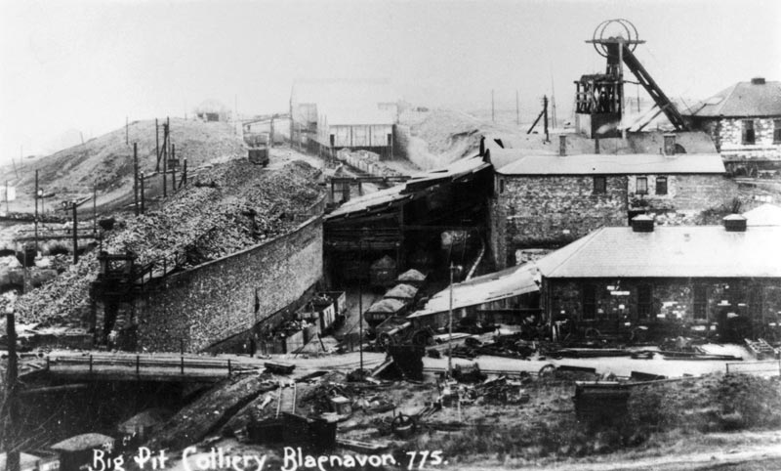
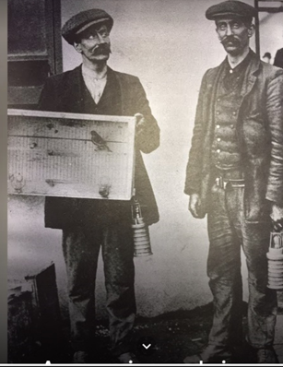
HISTORICAL CONTEXT OF BLAENAVON
2. Canary that was used to test the air at the 'Universal' pit disaster,1913 (musuem wales, 2024)
1. Big Pit Colliery, c.1910 (peoplescollection.wales, 2024)

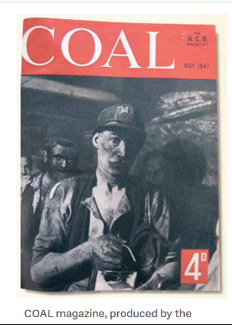
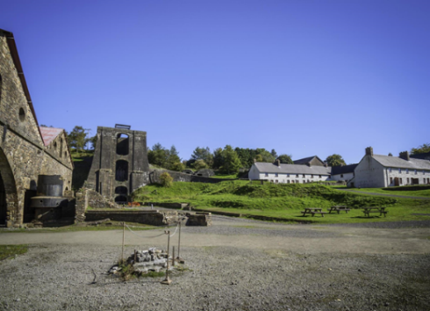
The Blaenavon Mine, commonly referred to as The Big Pit, is one of the ‘oldest deep-shaft mines’ in South Wales (Wanhill, 2012:60), and part of the Blaenavon Industrial World Heritage Site. Due to the discovery of vast quantities of coal in the 1850’s, Blaenavon pit became a formative player in an era that contributed to large scale industrial processing. Along with unearthing iron ore and limestone, the rural area was transformed, and supported by ‘coal serving as the backbone’ (Price & Rhodes, 2022:851), new villages with new communities came into existence, with incomes to support local business. The success of exporting the coal from Blaenavon, as well as providing for domestic use, gave employment to hundreds of workers and helped to develop not only the mining towns but also those further afield (Wanhill 2012:60). By 1980, operational losses had steeply declined, and the mine was closed. As a result of deindustrialisation, the town was damaged by ‘population decline, high unemployment, and a perceived lack of social wellbeing’ (Blaeanaevon Partnership in Walker 2011:29). Torfaen County Borough Council purchased the mine seeing the site as a potential income generator in the guise of a museum. However, due to the location of the building as a mining museum, the positive outcomes expected from the opening could not improve the towns high levels of employment or improve economical stresses (Wanhill, 2012:30). It was not until 2000, due to the Blaenavon pit and surrounding landscape, being inscribed onto the World Heritage list, that improvements in both social and economic environments were identified. Surrounding the industrial sites of both the mine and Blaenavon Ironworks, is a natural landscape in which nestles the town of Blaenavon, and buildings associated with the industry, such as the Workmen’s Hall.
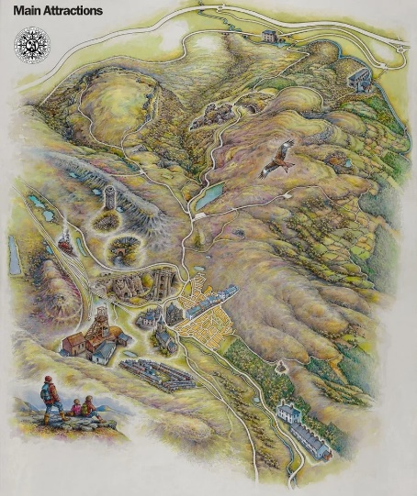
5.Blaeanavon Ironworks (musuems.wales, 2024)
.
4. COAL magazine, 1947 (museums.wales, 2024)
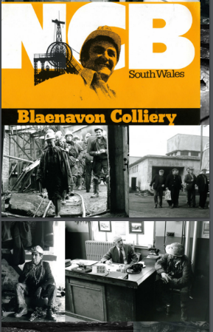
3. Visitor sites in Blaenavon (visitblaenafon.co.uk, 2024)
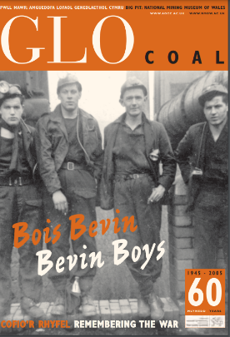
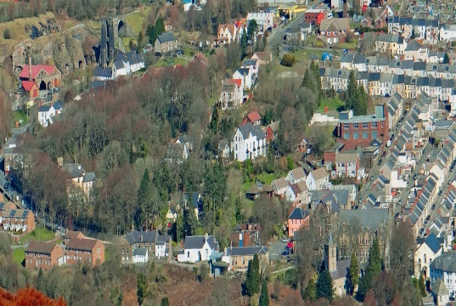

7. The Blaeanavon Townscape (visitblaeanavon.co.uk, 2024)
8. Article in GLO (museums.wales, 2024)

6. GLO magazine (museums.wales, 2024)

Big Pit is a real coal mine and one of Britain's leading mining museums.
With facilities to educate and entertain all ages, Big Pit is an exciting and informative day out. Enjoy a multi-media tour of a modern coal mine with a virtual miner in the Mining Galleries, exhibitions in the Pithead Baths and Historic colliery buildings.
All this AND the world-famous Underground Tour. Go 300 feet underground with a real miner and see what life was like for the thousands of men who worked at the coal face.
An award-winning national museum that still retains many features of its former life as a coal mine, standing high on the heather-clad moors of Blaenavon, the tunnels and buildings that once echoed to the sound of the miners now enjoy the sound of the footsteps and chatter of visitors from all over the world.
(Excerpt from www.musuem.wales.bigpit, 2024)

In preserving the Big Pit, the relict landscapes and settlements that supported the industry, the importance of 19th century Welsh industrialisation has been established as heretically important. It not only illustrates the technology that was essential to material output but also helps in the understanding of the distinct cultures that evolved, thus portraying both the ‘patronage and the social structure of communities.’ (UNESCO,1992).
As an area now considered of vital importance in improving knowledge of the technical, social, and economic processes that are linked to 19th century industrialisation, are we able to identify the concepts of community heritage in relation to the internationally significant site of the Big Pit?
If we look to the WHC for guidance, the Big Pit, and Iron Works, are ‘within public ownership and the wider community, voluntary groups, residents and Town Council’ (unesco,1992) and should maintain close engagement with the overall management. As an objective to develop the financial prospects of mining valley culture, success has been noted in terms of population growth and employment opportunities (Blaenavon Partnership, 2010). Yet, aside from the positive aspects, and the implementation of Cultural Landscape inscription which stresses ‘local cultural values should be balanced with universal values’ (Walker, 2011:30), this has apparently not been the case with Blaenavon. The ‘current, exclusive management’ (ibid) have failed in granting local people access to collaborate in the planning and implementation of projects and that decisions have been mainly upheld by political and professional stakeholders (Walker, 2011:30). By overlooking the community engagement, management have disregarded the community’s narratives of Welsh coal mining and heritage and possibly failed to provide, and encourage, social and cultural equalities (Walker, 2011:32).
However, The Big Pit has employed genuine ex coal miners as guides for the undergrounds tours and as interpreters, which allows for personal narratives to be spoken thus providing authenticity to a visitors experience with regard to ‘the realities of heavy industry’ (Wilks & Kelly, 2008:135). Against a backdrop of tangible buildings and objects the past is being symbolised through intangible means and adds to the community heritage. Within the museum itself are numerous collections of objects and exhibitions which place emphasis on the communities of Blaenavon. Themes illustrate the homelife and health within communities, the lives of children working in mines and day to day existence as part of mining community. By using a former colliery nurse to narrate a story in the Big Pit’s Medical Centre exhibition, the authenticity of community is apparent. The online Peoples Collection Wales site provides opportunity for the everyday person to contribute to an already eclectic collection of community heritage that can be submitted through storytelling, images, audio recordings and documents. Along with these personal testimonies can be found an online publication called GLO, which has been connected to the museums current exhibition ,1984-1985 STRIKE, and succeeds in augmenting the heritage of Blaenvons mining communities. . Describing itself as:
‘a 'people's history' magazine; people are asked to contribute their own views, images, and experiences of a particular topic’ (musuem.wales.ac.uk)
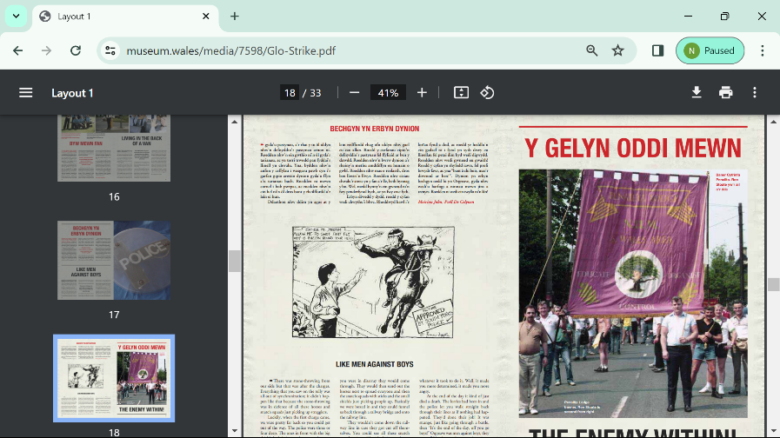
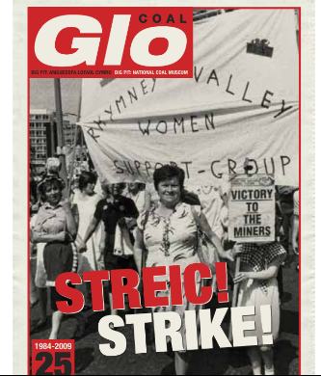
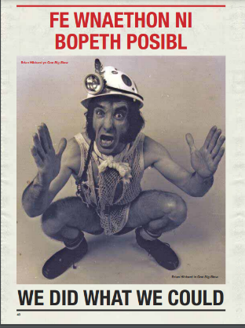

11. 1984 Miners strike, (musuems.wales, 2014)
10. 1984 Miners strike, Wales (musuems.wales, 2014)
9. Image of Brian Hibbard in GLO (museum.wales, 2014)
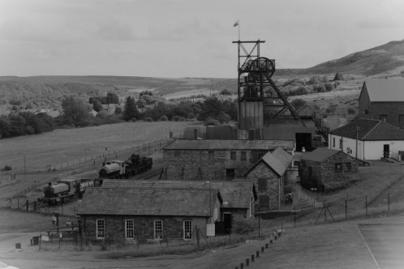
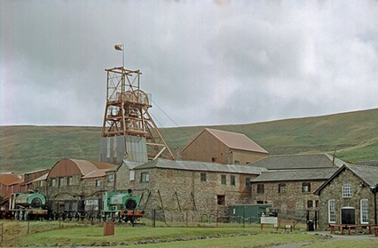
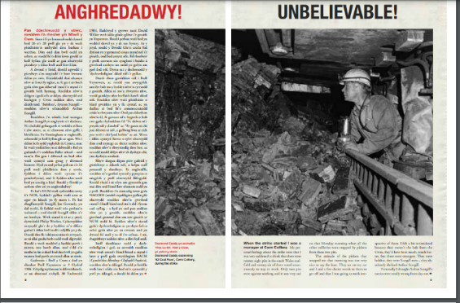
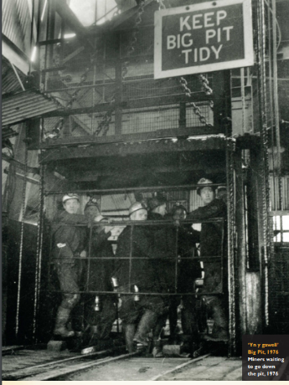
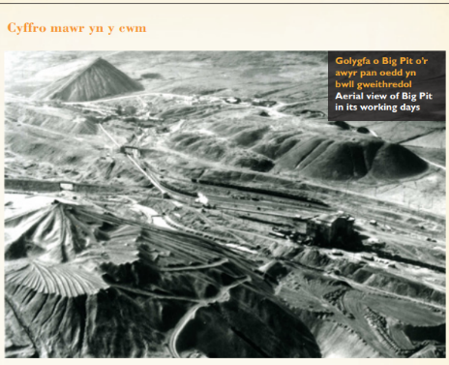
Within the pages of these online stories are an assortment of memories and experiences that describe the events of the year long strike resulting after the National Coal Board declared the closure of twenty mines in South Wales, resulting in the loss of thousands of jobs. By giving voices to the mining communities, who can not only express their valued opinions with regard to their own cultural heritage, but they are also able to ‘sustain and transmit this heritage to future generations’ (Council of Europe, 2006). That they are able to engage and share narratives of “lived lives”, of working and existing in an industrialised landscape, individuals are helping to shape the distinctive culture of Welsh valley communities and possibly enhance local values and that of national understanding of a hugely important past. It can only be surmised at this particular time that the contributors who wrote for the publication, engaged in meaningful collaborations with heritage management and that any interactions have been nurtured in a combined effort, rather than be dominated by stakeholders who have financial or political interests in the Big Pit Museum and former industrial landscapes of Blaeanvon.
14. The Big Pit (musuems.wales, 2024)
15. Working miners in lift at the Big Pit in GLO, 2014 (musuems.wales, 2024)
16. Article in GLO, 2014 (musuems.wales, 2024)
13. Aerial view of The Big Pit & Coity Tips, 1973 (peoplesmusuem, 2024)
12. The Big Pit (musuems.wales, 2024)
REFERENCES

Arts & Humanities Research Council. (2013) Research for Community Heritage:
[Available at: www.archaeologists.net/sites/default/files/AHRC_Research_for_Community_Heritage.pdf] (accessed:25/3/24)
Big Pit National Coal Museum. (2024). [Available at: www.museum.wales] (accessed 25/3/24)
Council of Europe (2006). Council of Europe Framework Convention on the Vlaue of Cultural Heritage for Society: Faro, 27.X.2005. European Council.
Crooke, E., (2010). The politics of community heritage: motivations, authority and control. International Journal of Heritage Studies, 16(1-2), pp.16-29.
Deacon, H. and Smeets, R., (2013). Authenticity, value and community involvement in heritage management under the world heritage and intangible heritage conventions. Heritage & Society, 6(2), pp.129-143.
Dicks, B., (2003). Heritage, governance and marketization: A case-study from Wales. museum and society, 1(1), pp.30-44.
Evan, M., (2014). The Value and Impact of Heritage. Heritage Counts: UK: pp.2-19. [Available at: www.historicengland.org.uk/research/heritage-counts/2014-the-value-and-impact-of-heritage[ (accessed: 25/3/24)
Forgotten Landscapes Partnership. (2008). Strong community involvement was at the heart of an ambitious Landscape Partnership scheme to conserve and create better access to the former industrial landscape of the Blaenavon World Heritage. [Available at: www.heritagefund.org.uk/projects/forgotten-landscapes-partnership] (accessed 25/3/24)
Hale, A., (2011) Linking Communities to Historic Environments. Connected Communities: A research review summary: UK, pp.1-17.,[Available at: www.academia.edu/5146073/Linking_Communities_to_Historic_Environments_2011_] (accessed 25/3/24)
Museum Wales: Amgueddfa Cymru [Available at: www.musuemwales.ac.uk] (accessed 25/3/24)
Peoples Collection Wales. A people’s story of Wales. [Available at: www.peoplescollection.wales] (accessed 25/3/24)
Ripp, M., (2018). Heritage as a system and process that belongs to local communities. Reframing the Role of Local Communities and Stakeholders. Fontecchio.
UNESCO. Blaenavon Industrial Landscape. World Heritage Convention [Available at: www.whc.unesco.org/en/list/984] (accessed 25/3/24)
Wales Tourist Board. (1979). The Tourism Potential of the Big Pit, Blaeanafon. Cardiff: Wales Tourist Board
Walker, D., (2011). Towards a beneficial world heritage: Community involvement in the Blaenavon industrial landscape. Museum international, 63(1-2), pp.25-33.
Wanhill, S. (2000). Mines—A Tourist Attraction: Coal Mining in Industrial South Wales. Journal of Travel Research, 39(1), 60-69.
Wilks, C. & Kelly, C., (2008). 'Fact, fiction and nostalgia: an assessment of heritage interpretation at living museums', International Journal of Intangible Heritage, vol. 3, pp. 128-140.
Zagato, Lauso. “The Notion of “Heritage Community” in the Council of Europe’s Faro Convention. Its Impact on the European Legal Framework”. Adell, Nicolas, et al.. Between Imagined Communities of Practice: Participation, Territory and the Making of Heritage. Göttingen: Göttingen University Press, 2015. (pp. 141-168) [Available at: www.books.openedition.org/gup/220] (accessed: 25/3/24)

ILLUSTRATIONS
1.BigPitcollieryc.1910.
This picture shows the original wooden winding gear at Big Pit. This was replaced by a steel frame in the 1930s when production of steel was at its peak in south Wales, offering a stronger and cheaper alternative.
The wagons of coal lined up in the picture were waiting to be picked up by Nora the locomotive, or one or her sisters. Nora was one of five locomotives at Big Pit, named by the mine manager after his daughters. The sixth engine 'Toto' was named after his dog. Nora can still be seen at Big Pit today. [Available at: www.peoplescollection.wales/items/24339] (accessed 25/3/24)
2. Canary that was used to test the air at the 'Universal' pit disaster,1913. [Available at: https://museum.wales/picture-library/item/720] (accessed:25/3/24)
3. Visit Blaenavon. [Available at: www.visitblaenafon.co.uk] (accessed 25/3/24)
4. Amgueddfa Cymru, (2014). Collections and Research:Front cover of COAL magazine, May 1947. [Available at www. https://museum.wales/articles/1248/Glo---peoples-history-online/] (accessed:25/3/24)
5. Blaenavon Ironworks [Available at: www.museums.wales ] (accessed 25/3/24)
6. Front page of GLO magazine. [Available at: https://museum.wales/media/4482/glo2.pdf] (accessed:25/3/24)
7. Blaenavon Townscape [Available at: https://www.visitblaenavon.co.uk/en/learning/the-blaenavon-townscape] (accessed:25/3/24)
8.Amgueddfa Cymru, (2014). Collections and Research: Article in GLO magazine [Available at: www.museum.wales/media/7598/Glo-Strike] (accessed:25/3/24)
9.Amgueddfa Cymru, (2014). Collections and Research. Image of Brian Hibbard in One Big Blow in GLO magazine. [Available at: https://museum.wales/media/4482/glo2.pdf (accessed: 25/3/24)
10. Amgueddfa Cymru, (2014). Collections and Research: STRIKE 1984-1985 in GLO magazine. [Available at www. https://museum.wales/articles/1248/Glo---peoples-history-online/] (accessed:25/3/24)
11. Amgueddfa Cymru, (2014). Collections and Research: Article and image in GLO magazine. [Available at www. https://museum.wales/articles/1248/Glo---peoples-history-online/] (accessed:25/3/24)
12. Big Pit National Coal Museum {accessed www.museum.wales}
13. Aerial view of Big Pit and Coity Tips, 1973.
The Coity Tip is the former colliery spoil heap for Big Pit. Waste material brought from underground when the coal was mined was tipped onto the landscape over a long period, forming these artificial hills.
After the tipping stopped, nature began to reclaim the land and many plants and secies colonised the area. The Coity Tip today is a haven of biodiversity, with a nature trail walk, popular with visitors. [Available at: https://www.peoplescollection.wales/items/24343] (accessed:25/3/24)
14. Big Pit National Coal Museum {accessed www.museum.wales}
15. Amgueddfa Cymru, (2014). Collections and Research: Article and image in GLO magazine. [Available at www. https://museum.wales/articles/1248/Glo---peoples-history-online/] (accessed:25/3/24)
16. Amgueddfa Cymru, (2014). Collections and Research: Article and image in GLO magazine. [Available at www. https://museum.wales/articles/1248/Glo---peoples-history-online/] (accessed:25/3/24)

