Assignment Title: Maze Game
Student Name: Fraser Sweetman
Student P Number: 148687
Course: MComp Computer Games Development
Lecturer: Kemi Ademoye
Due Submitted 13th October 2017

Contents
Introduction Page 3
Design Page 3
Implementation Page 4
Evaluation Page 5
References Page 6

Introduction
To demonstrate understanding and skills in the development of mobile or web games using Unity I was tasked with the creation of a “Maze Game”. This document contains information on how to play the game as well as information on how it was created and errors that occurred and a self-evaluation of the created game.
The design of the game had five main components. The maze had to be randomly generated, the game had to have at least three levels, and the game had to have a head-up-display or status bar interface. The game had to have a goal/objective e.g. get to the end of the maze. The game had to have randomly generated obstacles or opponents.

Design
This game has been designed as a first person shooter survival horror. The objective of the game is to get from the starting point of the maze to the finish point without being hit by the ghost that will follow the player around the maze in attempt to catch them. The finish point is highlighted by a column of light that shines in the air for the player to know which direction they need to get to. The player can navigate the maze by running, sprinting or jumping. Once the player has gotten to the end of the maze they will be teleported to a new generated maze for them to solve. The aim of the game is to see how many mazes the player can solve before getting caught. In order to help with this the player has a gun that shoots special bullets to fend of the ghost.

Controls
Spacebar - Jump
W/Up key (if number lock is off 8 key on number pad) - Move forward
S/Down key (if number lock is off 2 key on number pad) - Move backwards
A/Left key (if number lock is off 4 key on number pad) - Move left
D/Right (if number lock is off 6 key on number pad) - Move Right
Left Shift (under Caps Lock) - Sprint
Mouse - Change camera direction (look around)
Left mouse click - Shoot
R key – Reload

Implementation
To create and control the ghost a provided asset and prefab and implemented two self-coded scripts called “ToonGhostScript” and “ToonGhostContact”. The “ToonGhostScript” makes the ghost turn and try and contact the player while the “ToonGhostContact” script is used to determine when the ghost avatar comes into contact with the player and to display the message that the player has made contact with the ghost and if they have end the current game.
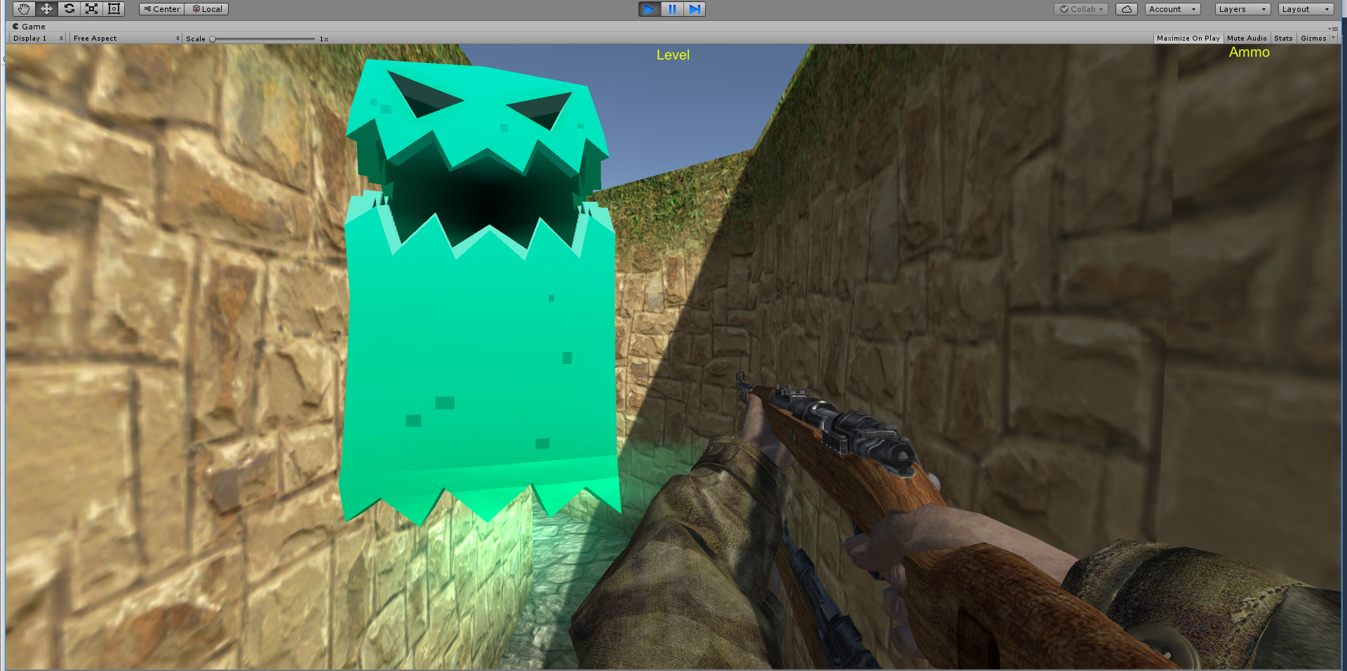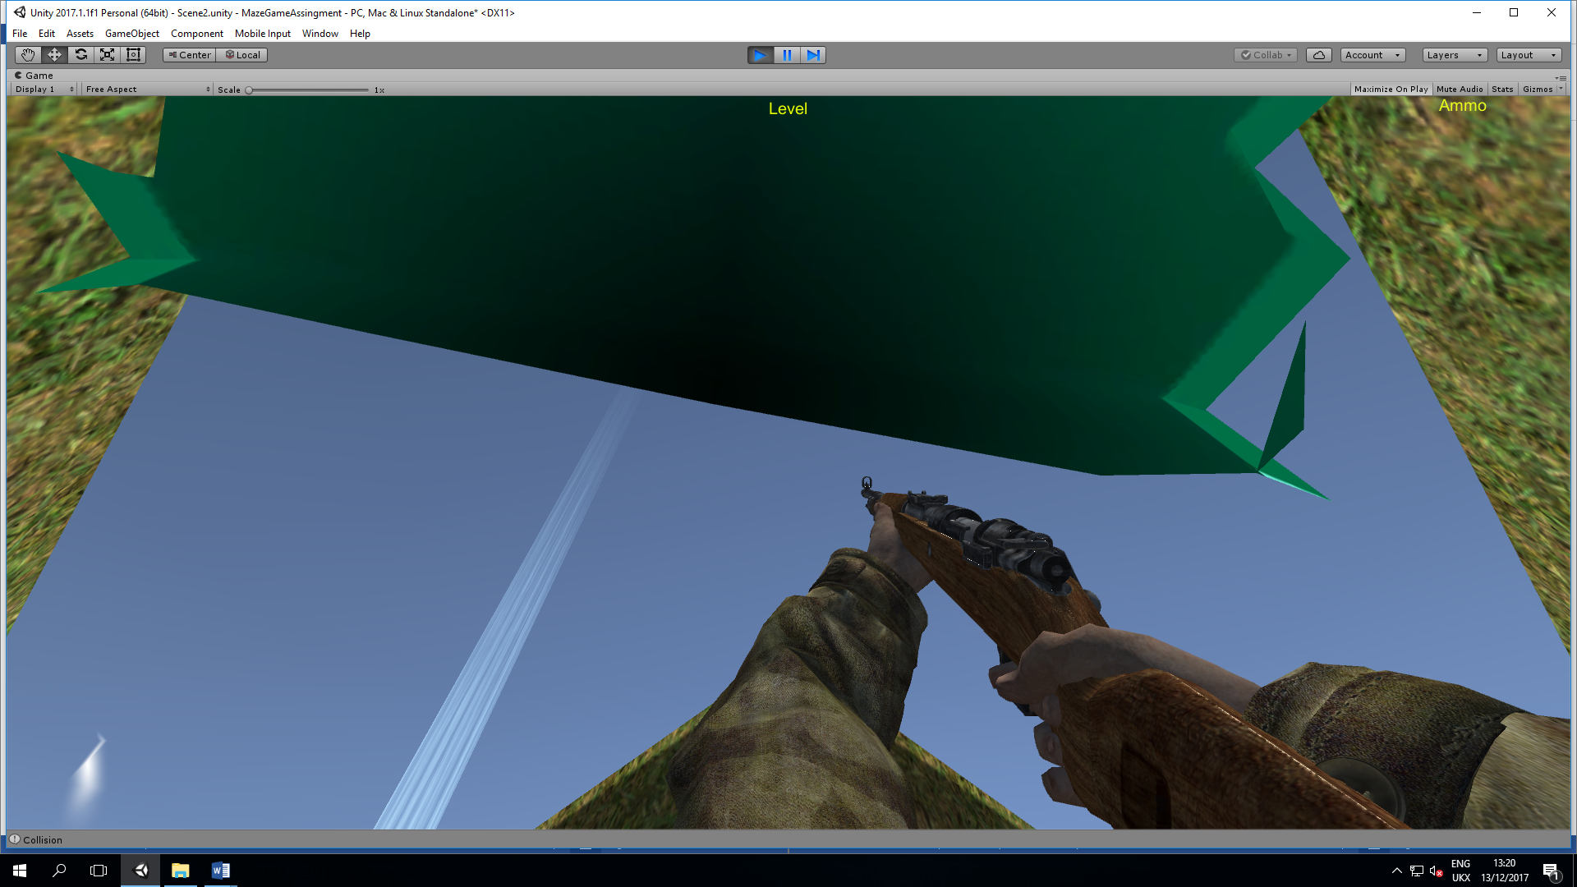
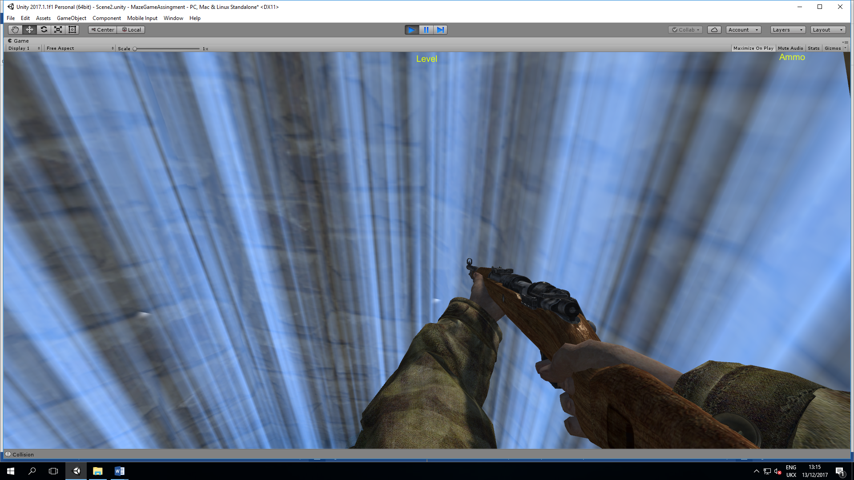
The finish point of the maze uses the “FinishScript” and is meant to recognise that the player has come into contact with the finish and display a mess saying “Level Finished” and then generate a new maze to the next level this should go continuously unless the player manually ends the game or the ghost catches the player.
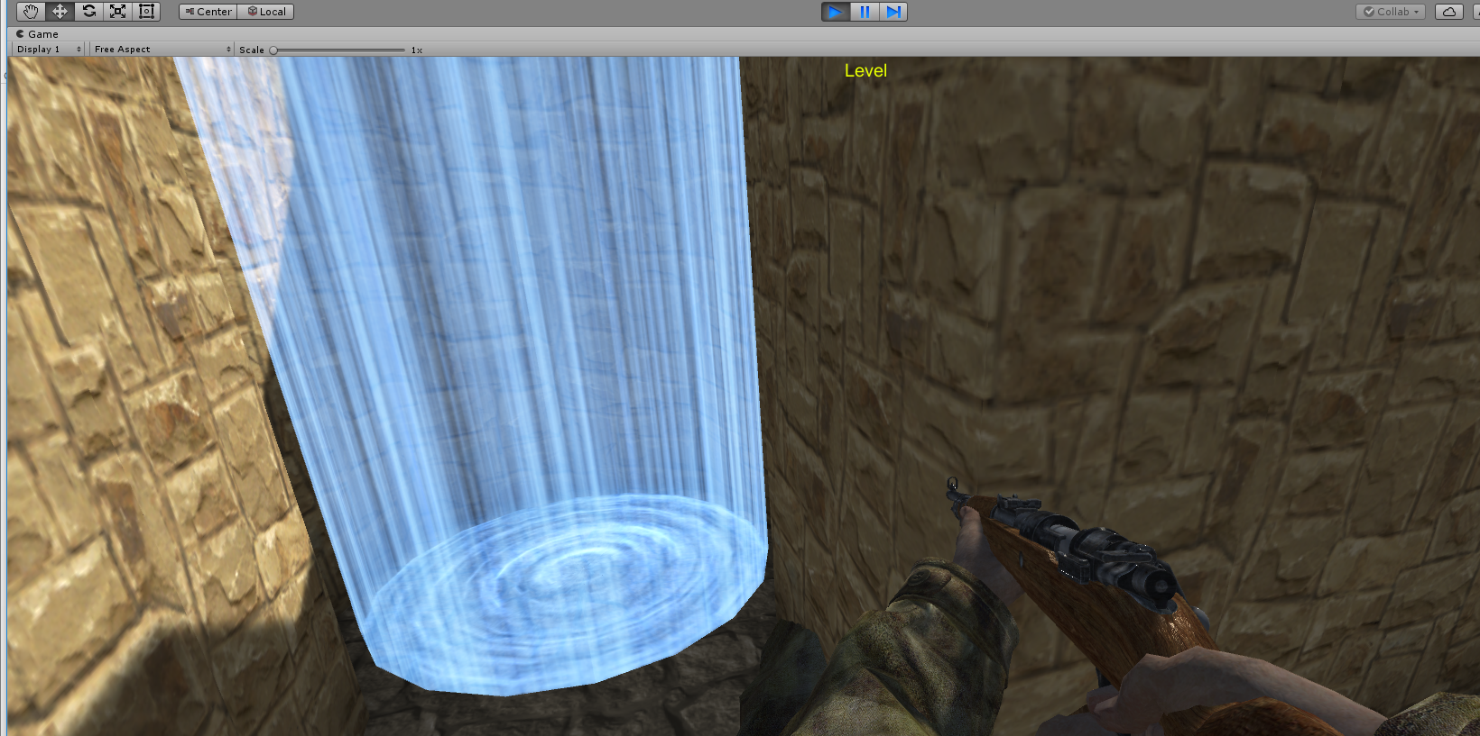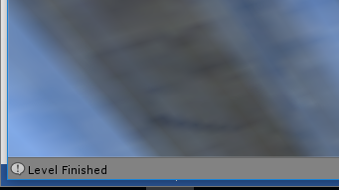
There is a UI (User Interface) script called “LevelUI” that is responsible for displaying the level the player is on and the ammo amount that the players gun has ready to shoot. Currently the level number is not appearing and the amount is also not appearing.
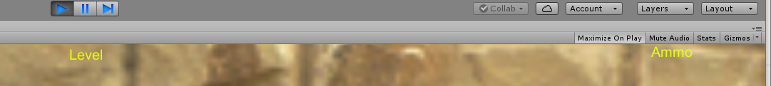
The Majority of the code for this game can be found in the “MazeGame” script. This script has functions such as the generation of the maze, positioning of the player and finish point. And a function that allows the player to have the mouse cursor appear so that they can pause or stop the game.

Evaluation
When developing the game there were several issues and errors that appeared while most have been fixed there are some that still remain in the current and most updated version. Hopefully these will eventually be fixed and the game updated.
One of the issues with the games is with the UI and that is level number is not being displayed and the amount of ammo that is in the gun ready to fire is not being displayed. This problem has not been resolved yet.
There is an issue with the cameras as there is a second player just in front of the actual camera view that the player controls. While attaching a bullet to be able to be fired from the gun, the bullets although attached to the gun that is in the camera that is the player, fires from the second cameras gun and when the second camera is removed some function such as the shooting and as well as the jump, guns aiming and sprint are removed. This has not been resolved yet.
The gun code is not finished, making the gun fire automatically and reload automatically and the bullets do not collide with the ghost. Due to time constraints on the creation of the game and problem solving the other issues this has not been resolved yet. A collision detection function should allow the bullets to hit the ghost and additional code to prevent it from automatically firing and what happens when the bullets collide with the ghost.
There was an issue with the finish collision where it would not recognise the player had reached the finish point. After further testing and troubleshooting and placing the script in several different game objects, the solution was to attach the script to the finish prefab.
Another issue that was occurring during the creation of the game was that the maze would spawn the player in the same spot at the game start and the first maze would be the same. This has been somewhat as the player still starts the game in the same corner but the maze is now randomly dynamically generated and once the player reaches the finish point a new maze is created around the play with the player staying where the previous finish point was.
While coding the game I made use of various sources to help code the game these sources can be found in the references section.

Reflection
Most games especially casual web or mobile device games are created and released as full versions. However there is a steady growth of Beta versions releases which I feel my game is currently at. For future version of this game I would recommend that the unresolved issues to be resolved. Another recommendation would be to add score boards to record which level the player manged to survive to. Thirdly I would recommend making the enemy be able to move faster the higher the level and possible making more enemies spawn on later levels. A functioning menu would be a recommended improvement to pause the game as well as add a buttons that will take you to the score boards and to quit and restart the game instead of pressing the “Esc” key and to get the mouse cursor back and using that to pause or quit the game.

References
Gooking, D. (2013). Beginning Programming with C For Dummies (For Dummies (Computers)). John Wiley & Sons. Retrieved December 10th, 2017
McGarth, M. (2012). C Programming in Easy Steps 4th Edtion (4 ed.). Retrieved December 8th, 2017
Transform.LookAt. (n.d.). Retrieved December 8th, 2017, from unity3d.com: https://docs.unity3d.com/ScriptReference/Transform.LookAt.html

marking criteria and Student FEEDBACK

This section details the assessment criteria. The extent to which these are demonstrated by you determines your mark. The marks available for each criterion are shown. Lecturers will use the space provided to comment on the achievement of the task(s), including those areas in which you have performed well and areas that would benefit from development/improvement.

Common Assessment Criteria Applied (Assignment 1) | Marks available | Marks  awarded
1. Research-informed Literature
Extent of research and/or own reading, selection of credible sources, application of appropriate referencing conventions.
A basic reference list has been provided. Expand the scope of references consulted to help you improve the quality of your work. (Grade mark: 40.00%) | 5 | 2
2. Knowledge and Understanding of Subject
Extent of knowledge and understanding of concepts and underlying principles associated with the discipline.
Demonstrates a basic understanding of implementing a game from a dynamically generated game world. There is very little contribution to the original code given in the class to start the assignment and improvements could also be made to the little code added. (Grade mark: 45.00%) | 20 | 9
3. Analysis
Analysis, evaluation and synthesis; logic, argument and judgement; analytical reflection; organisation of ideas and evidence
A good evaluation of the game, identifying its limitations and some of the challenges faced. The recommendations for future improvements are fair. (Grade mark: 60.00%) | 15 | 9
4. Practical Application and Deployment
Deployment of methods, materials, tools and techniques; application of concepts; formulation of innovative and creative solutions to solve problems.
A fair attempt, but there is generally room for improvement. The main area for improvement is getting the basic mechanics right and adding goals and completion/termination conditions to the game. At the moment, the player character appears to be aimlessly wandering around the maze with no real, specific goal beyond being transported to the next level. There is no finish condition in the game. Aim to complete the class tutorial exercises to help you improve your understanding and also start your next assignment on time. Please see your report for additional comments. Nonetheless, a satisfactory attempt. Well done. (Grade mark: 45.45%) | 55 | 25
5. Skills for Professional Practice
Attributes in professional practice: individual and collaborative working; deployment of appropriate media; presentation and organisation.
The report is satisfactory. See your report for additional comments. (Grade mark: 50.00%) | 5 | 2.5

Assignment Mark (Assessment marks are subject to ratification at the Exam Board. These comments and marks are to give feedback on module work and are for guidance only until they are confirmed. ) | Late Submission Penalties (tick if appropriate) |  | 47.5%
 | Up to one week late |  | 47.5%
 | 1st/2nd/3rd attempt? |  | 47.5%

