Springboard
RESOURCE PACK

Personalised Certificates and Reward Stickers
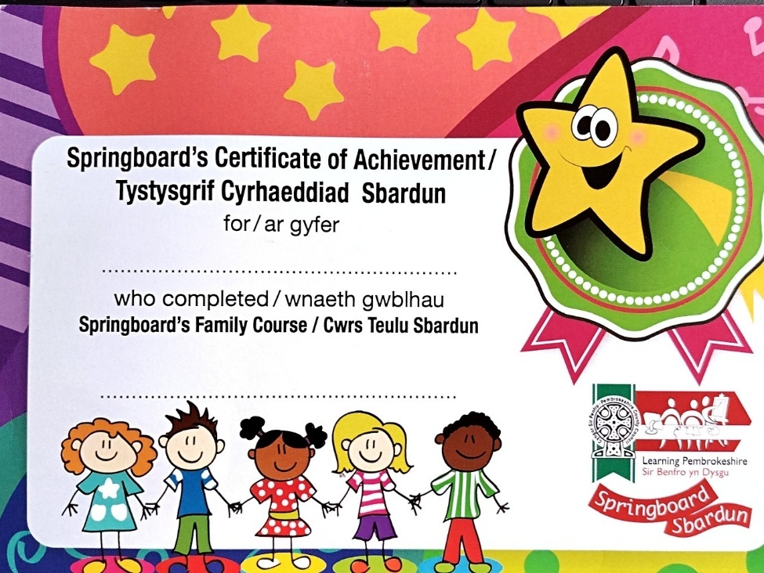

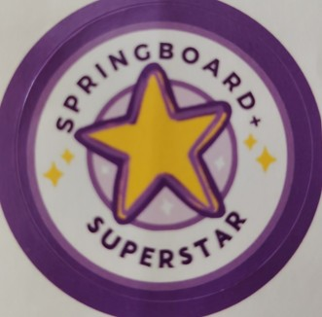

Shelley Holmes (2217784) - ECIE6003 Classroom Management

Contents
Rationale 3

Instructions for use: Personalised certificates and stickers 8

Reference list 10

Rationale
Effective classroom management is not just about managing behaviour, it involves a range of interrelated practices that work together to foster an inclusive, positive learning environment which encourages learners to meet their full potential. The Welsh Government (2023), through the Community Focused Schools framework, emphasises the vital role that families play in this process. Strong supportive links between families and schools contribute to improved behaviour, promote consistency and foster collaboration, which support children’s learning and well-being. Research by Jeynes (2014) and Huat See and Gorard (2015) highlights the benefits of parental involvement in reducing the socio-economic gap, supporting learning at home, improving communication between home and school, reinforcing consistent behaviour expectations and promoting positive behaviour. This collaboration between parents and school supports effective classroom management by creating a consistent and supportive environment that encourages student engagement and fosters a positive learning environment. Although family learning offers many benefits for children and schools alike (Education Endowment Foundation, 2021a; Education Endowment Foundation, 2021b; Desforges and Abouchaar, 2003), it can present challenges when children separate from their family members after an enjoyable session and transition back to the classroom environment. This resource pack will act as a guide to support children’s smooth return to class using operant conditioning rewards to positively support the transition (Skinner, 1963).
The Welsh Government (2021) recognise that well-being and behaviour are interlinked and that behaviour is often a symptom of an unmet need. The Welsh Government (2025) highlight the links between early communication issues, attendance and challenging behaviour. Since the COVID pandemic, there has been an increase in the number of children experiencing delays in speech and language as well as difficulties with social, emotional development and wellbeing (Welsh Government, 2024). These developmental challenges can be attributed to the changes to the interconnected environmental systems that support child development, as described by Bronfenbrenner’s (1979) Ecological Systems Theory. Piaget’s (1954) cognitive development theory can also provide some understanding of the issues facing foundation phase children in schools today. Limited social interaction and engagement during the Sensorimotor and Preoperational stages, combined with an increased use of technology, have reduced opportunities for hands-on exploration, meaningful communication and imaginative play (Aziz et al., 2022). These experiences are critical for developing cognitive processes such as language acquisition and social understanding (Michelle and Francesco, 2023). This has led to an increased number of children entering school with delays in speech, language and communication and a limited understanding of pro-social behaviour and emotional regulation (Hen, Shenaar-Golan and Yatzker, 2022).
Many children in the foundation phase missed out on valuable early interactions and skills development due to reduced social experiences and interactions during COVID-19 restrictions (Welsh Government, 2024). Participating in family learning sessions within the school environment can help strengthen the interconnected systems outlined by Bronfenbrenner (1979), particularly the microsystem and mesosystem, by fostering collaborative and building supportive relationships between families and schools (Desforges and Abouchaar, 2003). Bandura’s (1977) Social Learning theory emphasises the benefits of learning with others, through observational learning, both children and adults can develop new behaviours, attitudes and emotional responses supporting development and fostering relationships and pro-social behaviour. By providing hands-on experiences in a social environment, families can engage in a variety of language-rich, creative, problem-solving activities that support cognitive development (Piaget, 1954) and reinforce secure attachments as described by Bowlby (1988). Through collaborative learning opportunities, family sessions can scaffold the learning and development of both children and adults, model effective communication and support social and emotional regulation, consistent with Vygotsky's (1978, 1987) emphasis on the role of language and inner speech. Family learning environments have been shown to boost attendance, promote positive behaviour, increase confidence, improve communication and emotional regulation and contribute to the overall mental health and wellbeing of both parent and child. Evidence from the Education Endowment Foundation (2021b) suggests that family learning can support children's development by over 3 months.
During family learning sessions, children engage in positive learning experiences with their family members. Since the COVID pandemic, there has been an increase in social, emotional and behavioural difficulties witnessed in the family learning classroom. A common challenge observed is separation anxiety (Bowlby, 1988), where children do not want to leave their family members to return to the classroom after an enjoyable session. Many children are showing emotional dysregulation and difficult behaviours during transitions. To support these transitions, the use of personalised achievement certificates and stickers has been implemented as an effective way to promote positive behaviour and ease the transition. Welsh Government (2025) guidance supports this approach, emphasising that positive reinforcement and person-centred strategies in supportive, predictable settings can significantly reduce anxiety, helping children to feel more secure, fostering emotional regulation and improving behaviour (Learning and Work Institute, 2024).
Behaviourist principles, such as rewards, are widely used in schools today, based on Skinner's (1963) operant conditioning theory, which emphasises that reinforcement shapes behaviour. The Welsh Government (2012) positively promote the use of stickers as part of its positive behaviour support methods to reinforce good behaviour and promote self-esteem. Research shows that rewards like stickers and certificates can improve classroom behaviour and increase short-term motivation (Wilders and Levy, 2020). These types of rewards provide concrete, visual motivation that aligns with Piaget’s (1954) cognitive development theory by matching rewards to the child’s development stage, making it purposeful and meaningful. Stickers and certificates can support self-regulation by helping children to regulate their behaviour and work towards achievable goals. Although Kohn (1999) criticises reward systems, such as stickers, arguing that they often undermine intrinsic motivation, in the short term, offering stickers to younger children can support emotional regulation during transitions. Tangible rewards such as stickers and certificates can provide immediate, achievable incentives that can ease anxiety, promote positive engagement and improve self-esteem (Tang et al., 2025). Alongside a positive, nurturing environment that supports the foundational needs of the child (Maslow, 1943) and promotes secure attachments (Bowlby, 1988), these rewards can encourage cooperation, reduce difficult behaviour, and support a gradual shift towards independent emotional regulation and engagement.
Effective use of these stickers and certificates requires support from parents and family members. Research shows that parents' reactions significantly influence children's emotional responses (Prino et al., 2023), therefore, it is essential for parents to be aware of the session structure and be prepared to positively support and promote the transition back to class. Encouraging parents to engage in a quick and confident goodbye, along with positive prompts such as “Go and get your sticker!” helps to create a supportive and consistent environment that fosters emotional regulation and positive behaviour. Bandura’s (1977) Social learning Theory explains how children learn by observing and imitating the behaviour and emotional responses of others. When parents and family members model confident, reassuring and positive behaviours, children are more likely to internalise and mirror these responses during transitions, which can reduce anxiety and promote calm.
Through social interaction with peers, adults, teachers and more knowledgeable others, both adults and children can develop cognitive and emotional skills. As Vygotsky’s (1978) Sociocultural theory suggests, providing scaffolding within the zone of proximal development, the more knowledgeable others found in the family learning environment can support and model the skills and behaviour needed to support the transition. This aligned approach, supported by strong home-school relationships, ensures continuity of support, promotes positive behaviours, enhances support networks and strengthens the interconnected systems as outlined by Bronfenbrenner (1979). These strategies can collectively reduce anxiety and support children's emotional well-being during these transitions, strengthening social and emotional development.
As Maslow’s (1943) Hierarchy of Needs suggests, addressing foundational needs such as physiological safety and belonging through a welcoming, safe and supporting family learning environment is essential before higher-level needs can be considered. By creating this safe and supportive family learning environment, these foundational needs can be reinforced, supporting social and emotional well-being and reducing behaviour difficulties (Welsh Government, 2025). Providing a humanistic, person-centred approach (Rogers, 1980) within these sessions fosters positive relationships between parents and schools, facilitating effective home-school partnerships. These consistent positive experiences with school support children's emotional development, reduce anxiety and foster a sense of security and belonging (Maslow, 1943). The use of person-centred developmentally appropriate certificates and reward stickers reinforces desired behaviours during transitions back to class. They act as motivational tools that boost confidence and support emotional regulation, reducing anxiety and creating a more positive experience for all involved. Research links these supportive strategies to improved outcomes such as better attendance, engagement, emotional regulation and reduced behavioural difficulties (Education Endowment Foundation, 2021a; Education Endowment Foundation, 2021b; Lin and Faldowski, 2023; Zimmer-Gembeck et al., 2021).
This resource pack has been used effectively in family learning sessions across multiple schools and has proven to be highly effective in supporting children during the transition back to the classroom. When combined with a humanistic, person-centred approach (Rogers, 1980), foundation phase children have reacted positively to both the certificates and the reward stickers and there has been a marked improvement in behaviours shown after a few sessions.

Instructions for use: Personalised certificates and stickers

- Before the children arrive, inform the adults what will happen at the end of the session, asking them to support the transition back to class by encouraging the children to line up quickly when requested. Suggest some positive prompts.

- During the session, write out personalised certificates for each child stating the name of the child and the name of the activity.

- To manage expectations, towards the end of the session, before feedback, positively announce, “After we have shared our feedback, we will be going back to class and you can tell your teacher all about what you have done today!”

- Once the children's feedback is complete, in an upbeat voice, ask, “Who would like a sticker?”

- Encourage the children to line up by the door using the stickers as an incentive.

- Once the children have lined up, lead them into the corridor using the stickers to motivate them to return to class. Be specific about what you would like them to achieve, for example, “We are going to walk, quickly and quietly, back to class so we can tell your teacher what you have been doing in today's session.

- When the children are showing the desired behaviours, use positive reinforcement by issuing the sticker using the child’s name and giving individualised praise.

- If any children are not showing the desired behaviour, listen to the child and acknowledge their concerns. It is useful to explain what will be happening next and when they will be collected (for example, “it will be lunch time in 10 minutes, then it won’t be long before the end of the day and mum will soon be coming to collect you”.

- Encourage the desired behaviour by reiterating what they need to achieve, giving them some positive praise and showing them the stickers.

- Talk to the children about what they have enjoyed about the family learning session and what they have learnt, checking for understanding.

- Always personalise responses.

- Certificates can be issued as the children go back into class. Give positive praise, individualising something the child has done well in front of the teacher whenever possible.

- Encourage the children to share their knowledge from the session with the teacher, praising them individually for their achievements and their positive behaviours and saying how you are looking forward to seeing them again on another Springboard session soon.

