Joel Codd 2117927

Reflective Project
Mechanical Clean of Heat Exchangers

Abstract
Heat exchangers are commonly used across the Petro-Chemical industry and typically face fouling every 10-15 years. This fouling necessitates maintenance shutdowns, leading to potential cost implications due to process downtime, which vary based on the cleaning method applied. This project report examines the effects of cleaning heat exchangers by carrying out a mechanical clean and STAT inspection.
The findings of this project report aim to contribute to the optimisation of heat exchanger maintenance practices, offering a balanced solution that enhances performance, minimizes downtime, and reduces operational costs.

Contents
Abstract 1
Table of Figures 3
Introduction 4
Project Issue/Proposal 5
Critical Path 7
Valero 9
Process Units at Valero 9
White Oils 10
Plant 4 Unifiner (Naphtha Hydrotreater) 10
Unifiner Process issue 11
Hydrotreaters HTU1 and HTU2 12
Continuous Catalyst Regeneration (CCR) 14
Isom Unit 15
RLT (Refinery Leadership Team) 16
Literature Review 18
Heat Exchangers 18
Tube Heat Exchanger 18
SWOT Analysis 19
Mechanical Cleaning Heat Exchangers 21
SSOW (Safe System of Work) 22
LOTO (Lock Out Tag Out) 22
Isolation and Blinding 23
Bundle Extraction 24
Cost Analysis for the Cleaning Process 28
Project Success 28
Conclusion 30
Reflection 31
Bibliography 32
Appendix 33

Table of Figures
Figure 1 Temperature Transfer 6
Figure 2 Flow Rates Before and After Chem Clean 6
Figure 3 Primavera P6 Page 1 7
Figure 4 Primavera P6 Page 2 8
Figure 5 Excel Assignment Timetable Deadlines 8
Figure 6 Process Flow Diagram Unifiner (Valero, 2024) 11
Figure 7 Simple Diagram of Process Issue 11
Figure 8 Train A and B HEX 12
Figure 9 Heat Exchanger Trend (Valero, 2024) 12
Figure 10 Hydrotreater 1 Process Flow Diagram (Valero, 2024) 13
Figure 11 Hydrotreater 2 Process flow Diagram (Valero, 2024) 13
Figure 12 CCR/CRU Process Flow Diagram (Valero, 2024) 14
Figure 13 Isom Process Flow Diagram (Valero, 2024) 15
Figure 14 Unifiner Feed Rate Prediction (Valero, 2024) 16
Figure 15 U Tube bundle Diagram (Anson, 2024) 18
Figure 16 Straight Tube Heat Exchanger (Evapco, 2022) 19
Figure 17 General Diagram for a Plate Heat Exchanger (Anson, 2024) 19
Figure 18 Mechanical Clean SWOT Analysis (Speth, 2017) 20
Figure 19 Chemical Clean SWOT Analysis (Speth, 2017) 20
Figure 20 Bundle Pulling Machine (Valero, 2024) 21
Figure 21 Marked up P&ID of Blind and Isolation Points (Valero, 2024) 23
Figure 22 Isolation Tags Hung in the field (Valero, 2024) 23
Figure 23 Temporary Pipework Installed Sprayed Pink (Valero, 2024) 24
Figure 24 Compressor Used for Tooling (Valero, 2024) 25
Figure 25 Peinemann Bundle Puller in Operation (Valero, 2024) 25
Figure 26 Bundle Fouling (Valero, 2024) 26
Figure 27 Bundle Fouling (Valero, 2024) 26
Figure 28 Bundle Post Cleaning (Valero, 2024) 27
Figure 29 Rate Increase Table (Valero, 2024) 29
Figure 30 Trend Displaying Before and After HEX Clean (Valero, 2024) 29
Figure 31 Page 1 Valero's Isolation Procedure 33
Figure 32 Page 2 Valero's Isolation Procedure 34
Figure 33 Page 3 Valero's Isolation Procedure 35
Figure 34 Page 4 Valero's Isolation Procedure 36
Figure 35 Unifiner Feed Rates Before During and After A Clean 36
Figure 36 A Train Outlet Temperature 37
Figure 37 A Train Feed Hydraulics 37
Figure 38 A Train Duty and Fouling Factor 37
Figure 39 B Train Duty and Fouling Factor 38

Introduction
This project report focuses on finding a cleaning method to effectively remove fouling and deposits from a set of heat exchangers at Valero Pembroke Refinery. The selected method needs to clean efficiently without compromising the Bundle, Shell or pipework's integrity or disrupting the scheduled process downtime. The research will pinpoint the most suitable process unit for project implementation and demonstrate the cleaning's impact. Data collected from this research will be organised in Microsoft Excel to create trends that illustrate the condition before and after cleaning. Additionally, this project report will outline the necessary safety protocols and project management software, including data on technical drawings, trends, permits, isolations, and procedures.
Heat exchangers are critical components in numerous industrial processes, facilitating efficient heat transfer between fluids. Despite their essential role, heat exchangers are prone to fouling, this is where unwanted deposits accumulate on heat transfer surfaces over time. This fouling can significantly degrade performance, leading to reduced efficiency, increased energy consumption, and unplanned downtime for cleaning and maintenance.

Figure 1

Project Issue/Proposal
Heat exchangers often suffer from fouling due to the accumulation of hydrocarbon deposits such as salts, Caesium, Nickel, and Vanadium (Mobil, 2024). This fouling can reduce heat transfer efficiency and maximum flow rate, provided that the differential pressure and temperature remain within acceptable process limits. To address this issue, the process unit must be shut down and purged to eliminate hydrocarbons. The heat exchanger is then isolated and tested for gas leaks, and permits are obtained for maintenance. The bundles are removed from the heat exchanger for cleaning and inspection, which can take several weeks. This results in significant costs due to the downtime of the process, maintenance expenses, and the impact on the flow demand of other process units.
The Unifiner process unit (Unit 4) is currently experiencing restricted flow in one of its heat exchangers, making it an ideal candidate for the implementation of the new cleaning project. The Unifiner process consists of two trains (A and B), which allows for operational flexibility. One train can be taken offline to carry out a mechanical clean without shutting down the entire process unit. This means that only half of the process needs to be taken offline to complete the clean, although this will cause a significant rate impact.
Previously in 2019 Valero carried out a chemical clean on these heat exchangers as seen below in (Figure 1). The initial findings from the chemical clean were very good, the after effects of the chemical cleaning process are illustrated in (Figure 2). The flow through Train A has increased from 136.09 m³/h to 165.04 m³/h, demonstrating the success of the chemical clean and validating the calculations for the overall heat transfer coefficient. This increased flow capacity will enable more Heavy Sweet Naphtha or Full Range Sweet Naphtha to be sent to storage for blending purposes, generating additional revenue.
Although the findings were initially good Valero found that the Heat exchangers began for foul at a faster rate than normal, meaning that another clean was needed before the normal 5–10-year run depending on rate. When discussions began on cleaning the HEX again, the inspection department noted that a STAT inspection was due on these heat exchangers in 2024. This presented an additional advantage to conducting the mechanical clean: the cost of performing a chemical clean now could be saved by completing a full mechanical clean and STAT inspection.
A STAT inspection is a comprehensive assessment of a heat exchanger's condition and performance. Conducting the STAT inspection along with the mechanical clean ensures that the heat exchangers are thoroughly evaluated and maintained, optimizing their performance and potentially extending their operational life.
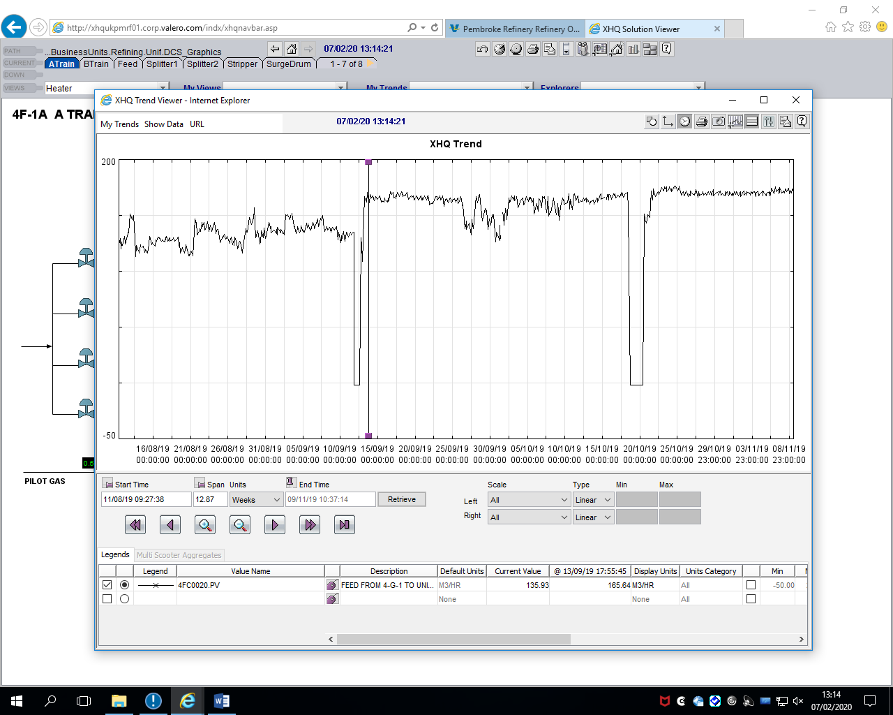
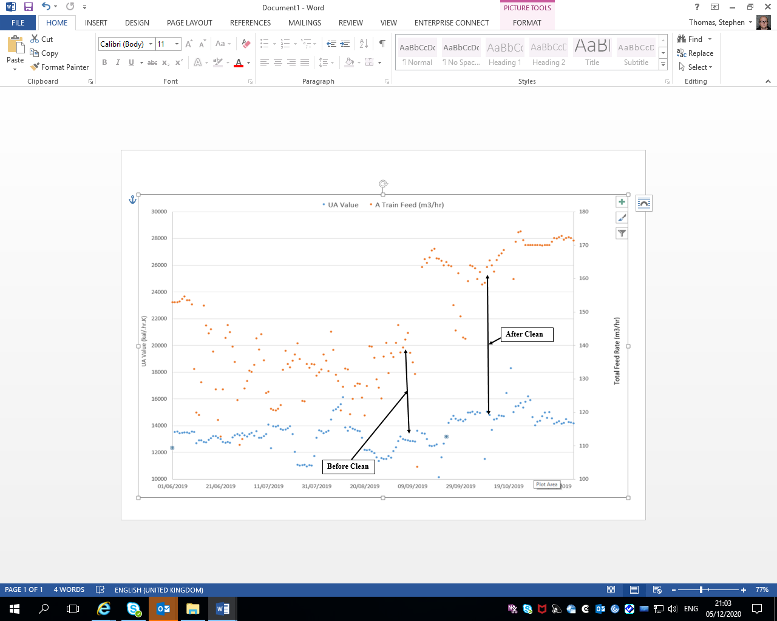
Figure 2 Temperature Transfer

Figure 3 Flow Rates Before and After Chem Clean
A plan was created to carry out a mechanical clean & Statuary inspection of the 4-E-1 heat exchangers, the plan needed to be completed accurately to ensure that the unit could be back on spec & at full rate in a timely manner. Planning & economics needed to be made aware of the timings involved in completing the work this was to ensure the other affected unit feed rates were appropriately aligned to before, during and after the clean.

Critical Path
Primavera P6 Professional was selected to create the plan for this project because it excels at managing planning, activities, resources, and costs efficiently. It is preferred over Microsoft Project due to its ability to accept multiple inputs from different team members and its user-friendly interface (Advantages of Primavera P6, 2018). The Primavera P6 plan for the project can be seen in (Figure 3 & 4), highlighting the critical path and project duration. Activity Networks provide a valuable approach to identifying and tracking the most efficient path, often referred to as the critical path, and creating a realistic schedule for completing a project. These networks are able to be seen, providing a clear summary of all tasks, their sequence, expected durations, and any tasks that can be executed concurrently (Johnivan, 2024).
Critical path for the Heat exchanger clean can be seen below and is the jetting, this drove Valero to get a specialist contractor to the refinery to carry out the jetting.

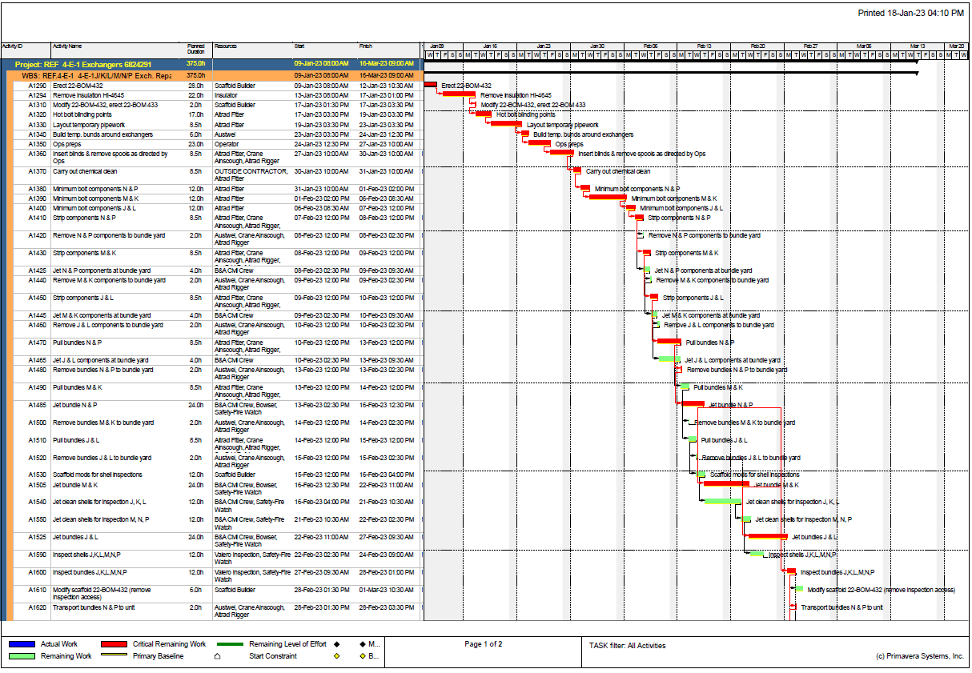
Figure 4 Primavera P6 Page 1
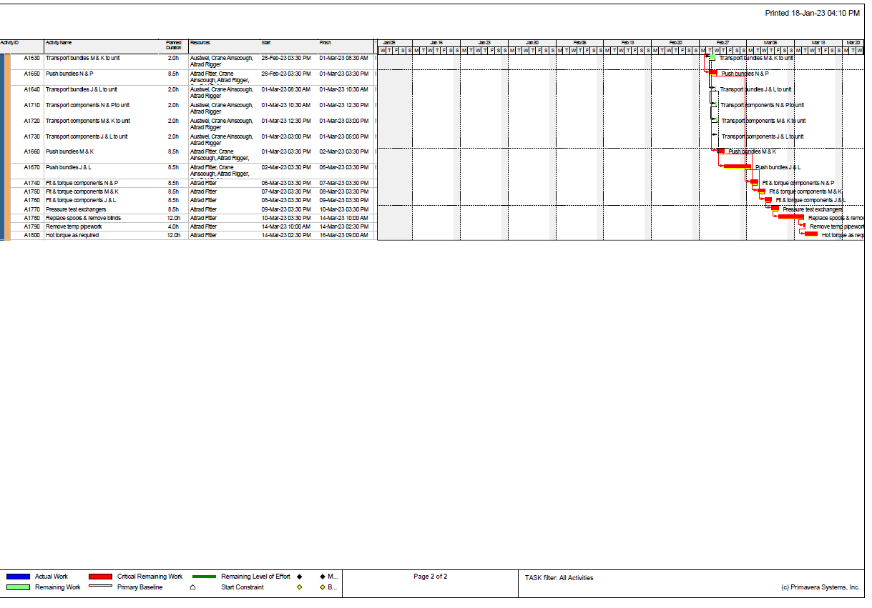
Figure 5 Primavera P6 Page 2
(Figure 5) displays an Excel time table for carrying out an assignment, this was followed to ensure the deadlines were met. If an excel timetable was not carried out, it could have led to the assignment not being completed by the deadline of 22nd May.

Assignment Execution Plan
 | 6/2/24 | 20/2/24 | 5/3/24 | 19/3/24 | 2/4/24 | 16/4/24 | 30/4/24 | 14/5/24 | 22/5/24
 | D | D | D | D | D | D | D | D | D
Assignment Execution Plan
1. Understand Requirements
2. Research Heat Exchangers
3. Outline Structure
4. Collect Data/Resources
5. Draft Introduction
6. Write Literature Review
7. Describe Method
8. Analyse the Data
9. Results/Trend Section
10. Write Reflection/Conclusion
11. Review and Edit
12. Finalize and Submit

Figure 6 Excel Assignment Timetable Deadlines

Valero
The Valero Pembroke Refinery, a major petroleum processing facility in Wales, UK, has been in operation since 1964 and was acquired by Valero Energy Corporation in 2011. Spanning approximately 1,200 acres, the refinery has the capacity to process 270,000 barrels of crude oil daily. It produces a variety of products, including gasoline, diesel, aviation fuel, heating oil, and lubricants. Additionally, the site includes a petrochemical plant that manufactures polypropylene, which is used in products such as packaging, textiles, and automotive parts (Valero, 2024).
Valero Pembroke Refinery is dedicated to safety, environmental stewardship, and sustainability. It has undertaken various initiatives to reduce greenhouse gas emissions, such as the installation of a combined heat and power plant and the adoption of renewable energy sources. The refinery is also committed to supporting the local community through charitable initiatives and partnerships. It invests in regional education, health, and environmental projects and provides employment for thousands of people.
In summary, the Valero Pembroke Refinery plays a crucial role in the UK's energy and manufacturing industries, operating with a focus on safety, sustainability, and community responsibility.

Process Units at Valero
Valero Pembroke remotely control the unit throughput from the control room, as seen in (Figure 5) rates of all units can be seen. In this project the focus will be on the Unifiner, the below figure demonstrates what units will be affected whilst the Unifiner rate drops significantly during the HEX cleaning work. The flow rates below in green are the volumetric flow (m³/s), all the units below are linked in some form, the Unifiner is a white oil unit they will now be explained on the process.
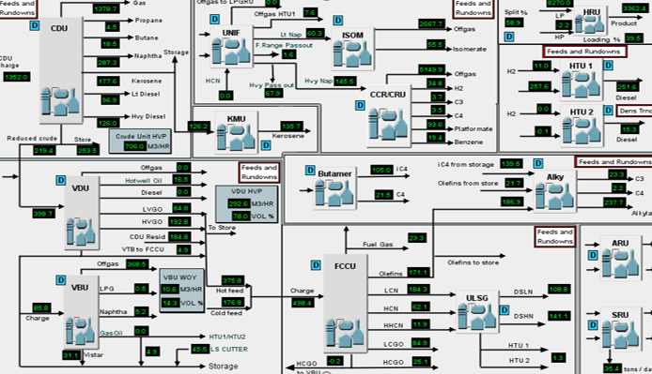

White Oils
White oils units are the light overhead products from the distillation column in the refining process. The relevant units include Unifiner, CCR, CRU, ISOM, HTU1, HTU2, HRU, and LPGRU. These units play a crucial role in the company's process performance and significantly affect overall revenue.

Plant 4 Unifiner (Naphtha Hydrotreater)
The purpose of the Unifiner is to hydrogenate sulphur, nitrogen and oxygen species, remove metal compounds and saturate olefins. If these components are not removed from the feed they would otherwise poison the isomerisation and platforming catalyst. The maximum Unifiner feed rate is 325m3 /hr
Sour naphtha feed, originating from the CDU, FCCU, and VBU, contains impurities that can poison catalysts in downstream units like the CRU (Catalytic Reformation Unit). These impurities include nitrogen, water, and metals such as lead, arsenic, beryllium, chromium, cobalt, antimony, cadmium, vanadium, manganese, mercury, nickel, selenium, molybdenum, and sulphur (Intertek, 2019). The Unifiner removes these substances by injecting high-pressure hydrogen (42 kg/cm²) into the feed, producing ammonia (NH₃) and hydrogen sulphide (H₂S). The H₂S is removed in a stripper, while NH₃ is removed in separators.
The Unifiner operates with two trains (A and B) running in parallel, allowing for increased capacity and maintenance flexibility without shutting down the entire unit. Train A has one reactor and can process up to 190 m³/hr, while Train B has two reactors in series and can process up to 165 m³/hr. To facilitate the removal of impurities, reactors with a nickel-molybdenum catalyst base and exothermic properties are used to accelerate reactions. The process converts Sulphur into H₂S, which is stripped away, and nitrogen into NH₃, which is removed via the sour water system. The resulting products include Heavy Sweet Naphtha for the CRU and Light Sweet Naphtha for the ISOM or storage.
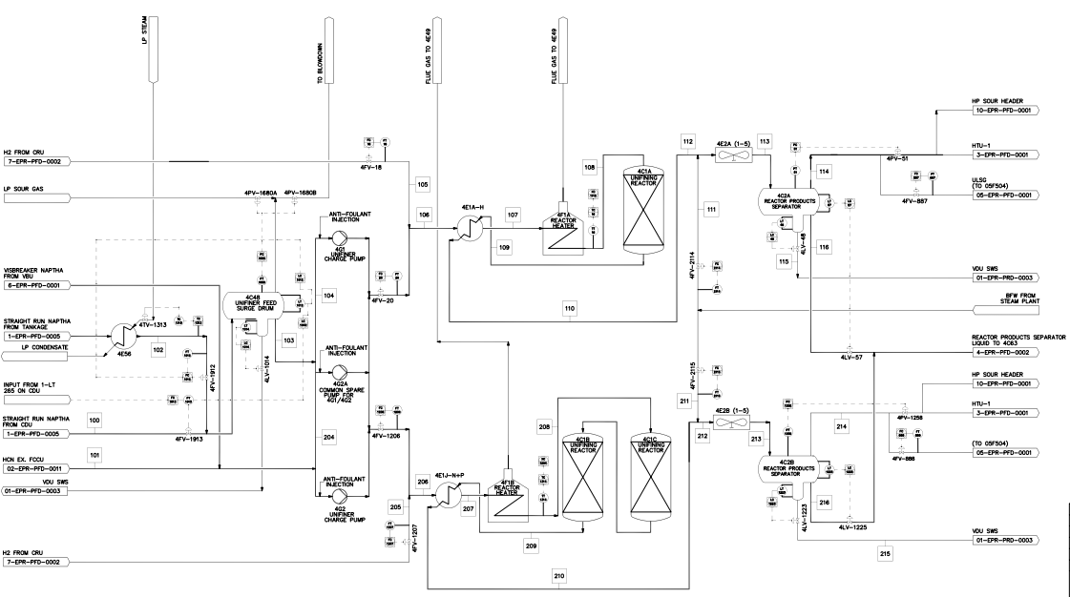
Figure 7 Process Flow Diagram Unifiner (Valero, 2024)

Unifiner Process issue
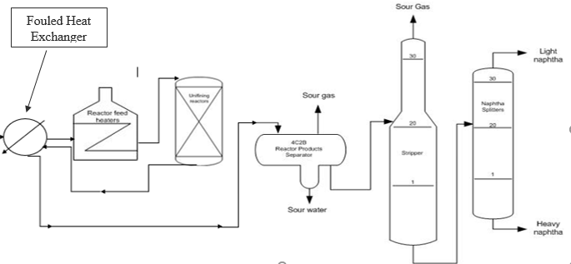
Figure 8 Simple Diagram of Process Issue
The Unifiner process unit is currently facing restricted flow through its shell and tube heat exchanger, resulting in the heater having to work harder and reducing process throughput capabilities. The heat exchanger processes sour naphtha from the crude distillation column, which carries contaminants like water, metals, sulphur, nitrogen, and salts. These salts have caused fouling in the heat exchanger tubes, leading to the current flow issues. The Exchangers generally foul every 5-10 years, depending on the rate capacity.
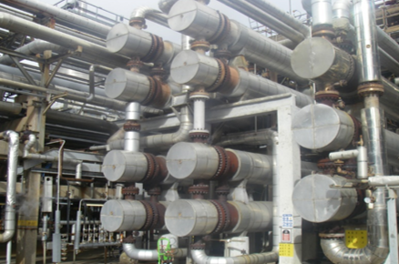
Figure 9 Train A and B HEX
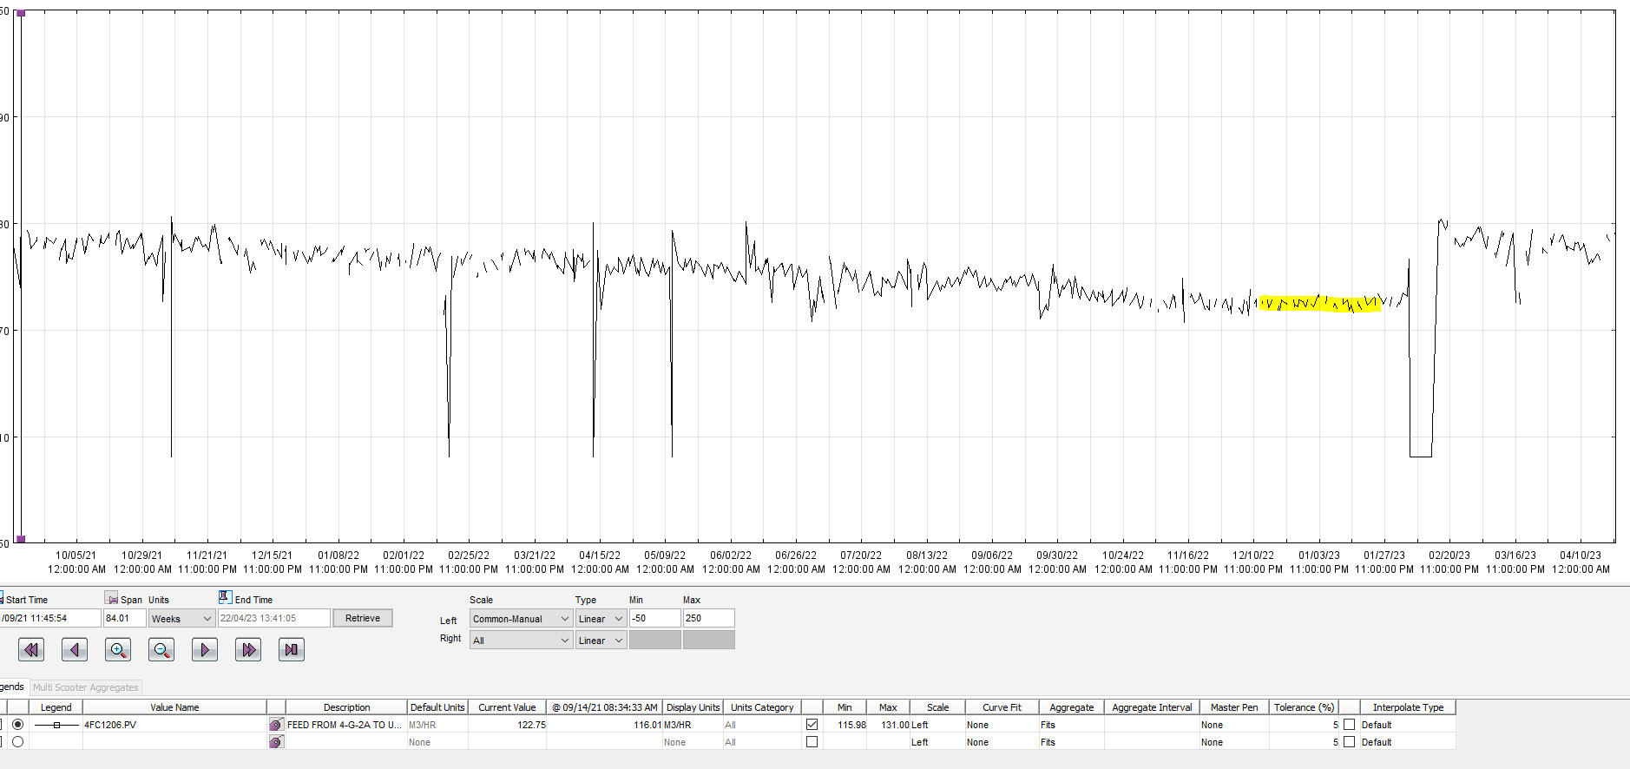
Figure 10 Heat Exchanger Trend (Valero, 2024)
The trend reveals a flow rate of 136 m³/hour through the constrained Unifiner heat exchanger, whereas the usual rate for this process is approximately 165 m³/hour. This noticeable difference over a short period strongly suggests that cleaning the heat exchangers to eliminate deposits is necessary to enhance the flow rate.

Hydrotreaters HTU1 and HTU2
There are 2 Hydrotreaters which both function to reduce the sulphur content of diesel by passing the diesel through a catalyst bed in the presence of hydrogen. The sulphur is removed as H2S which is then absorbed into a solution of diethanolamine (DEA) which will be processed within the amine and sulphur recovery units. The primary objective of this is to make a final diesel product with less than 10 parts per million (ppm) of sulphur suitable for blending into the diesel pool. Additional chemical reactions that take place are aromatic and olefin saturation, de-nitrification, and de-metallization. The maximum feed rate for HTU1 is 255m3/hr. The maximum feed rate for HTU2 is 190m3/hr (Valero, 2024).
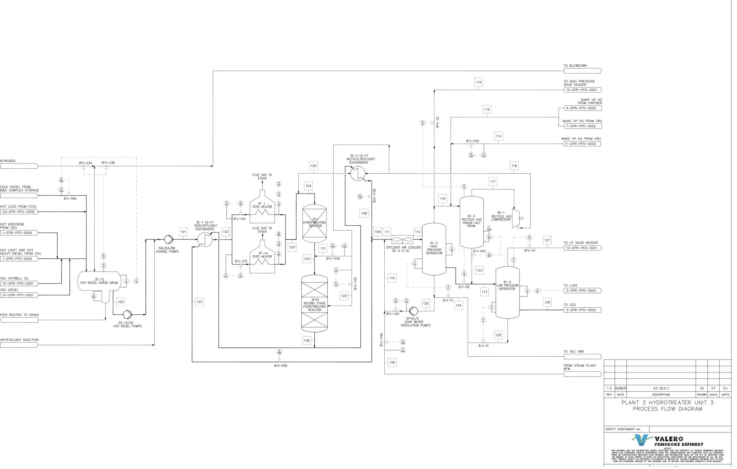
Figure 11 Hydrotreater 1 Process Flow Diagram (Valero, 2024)
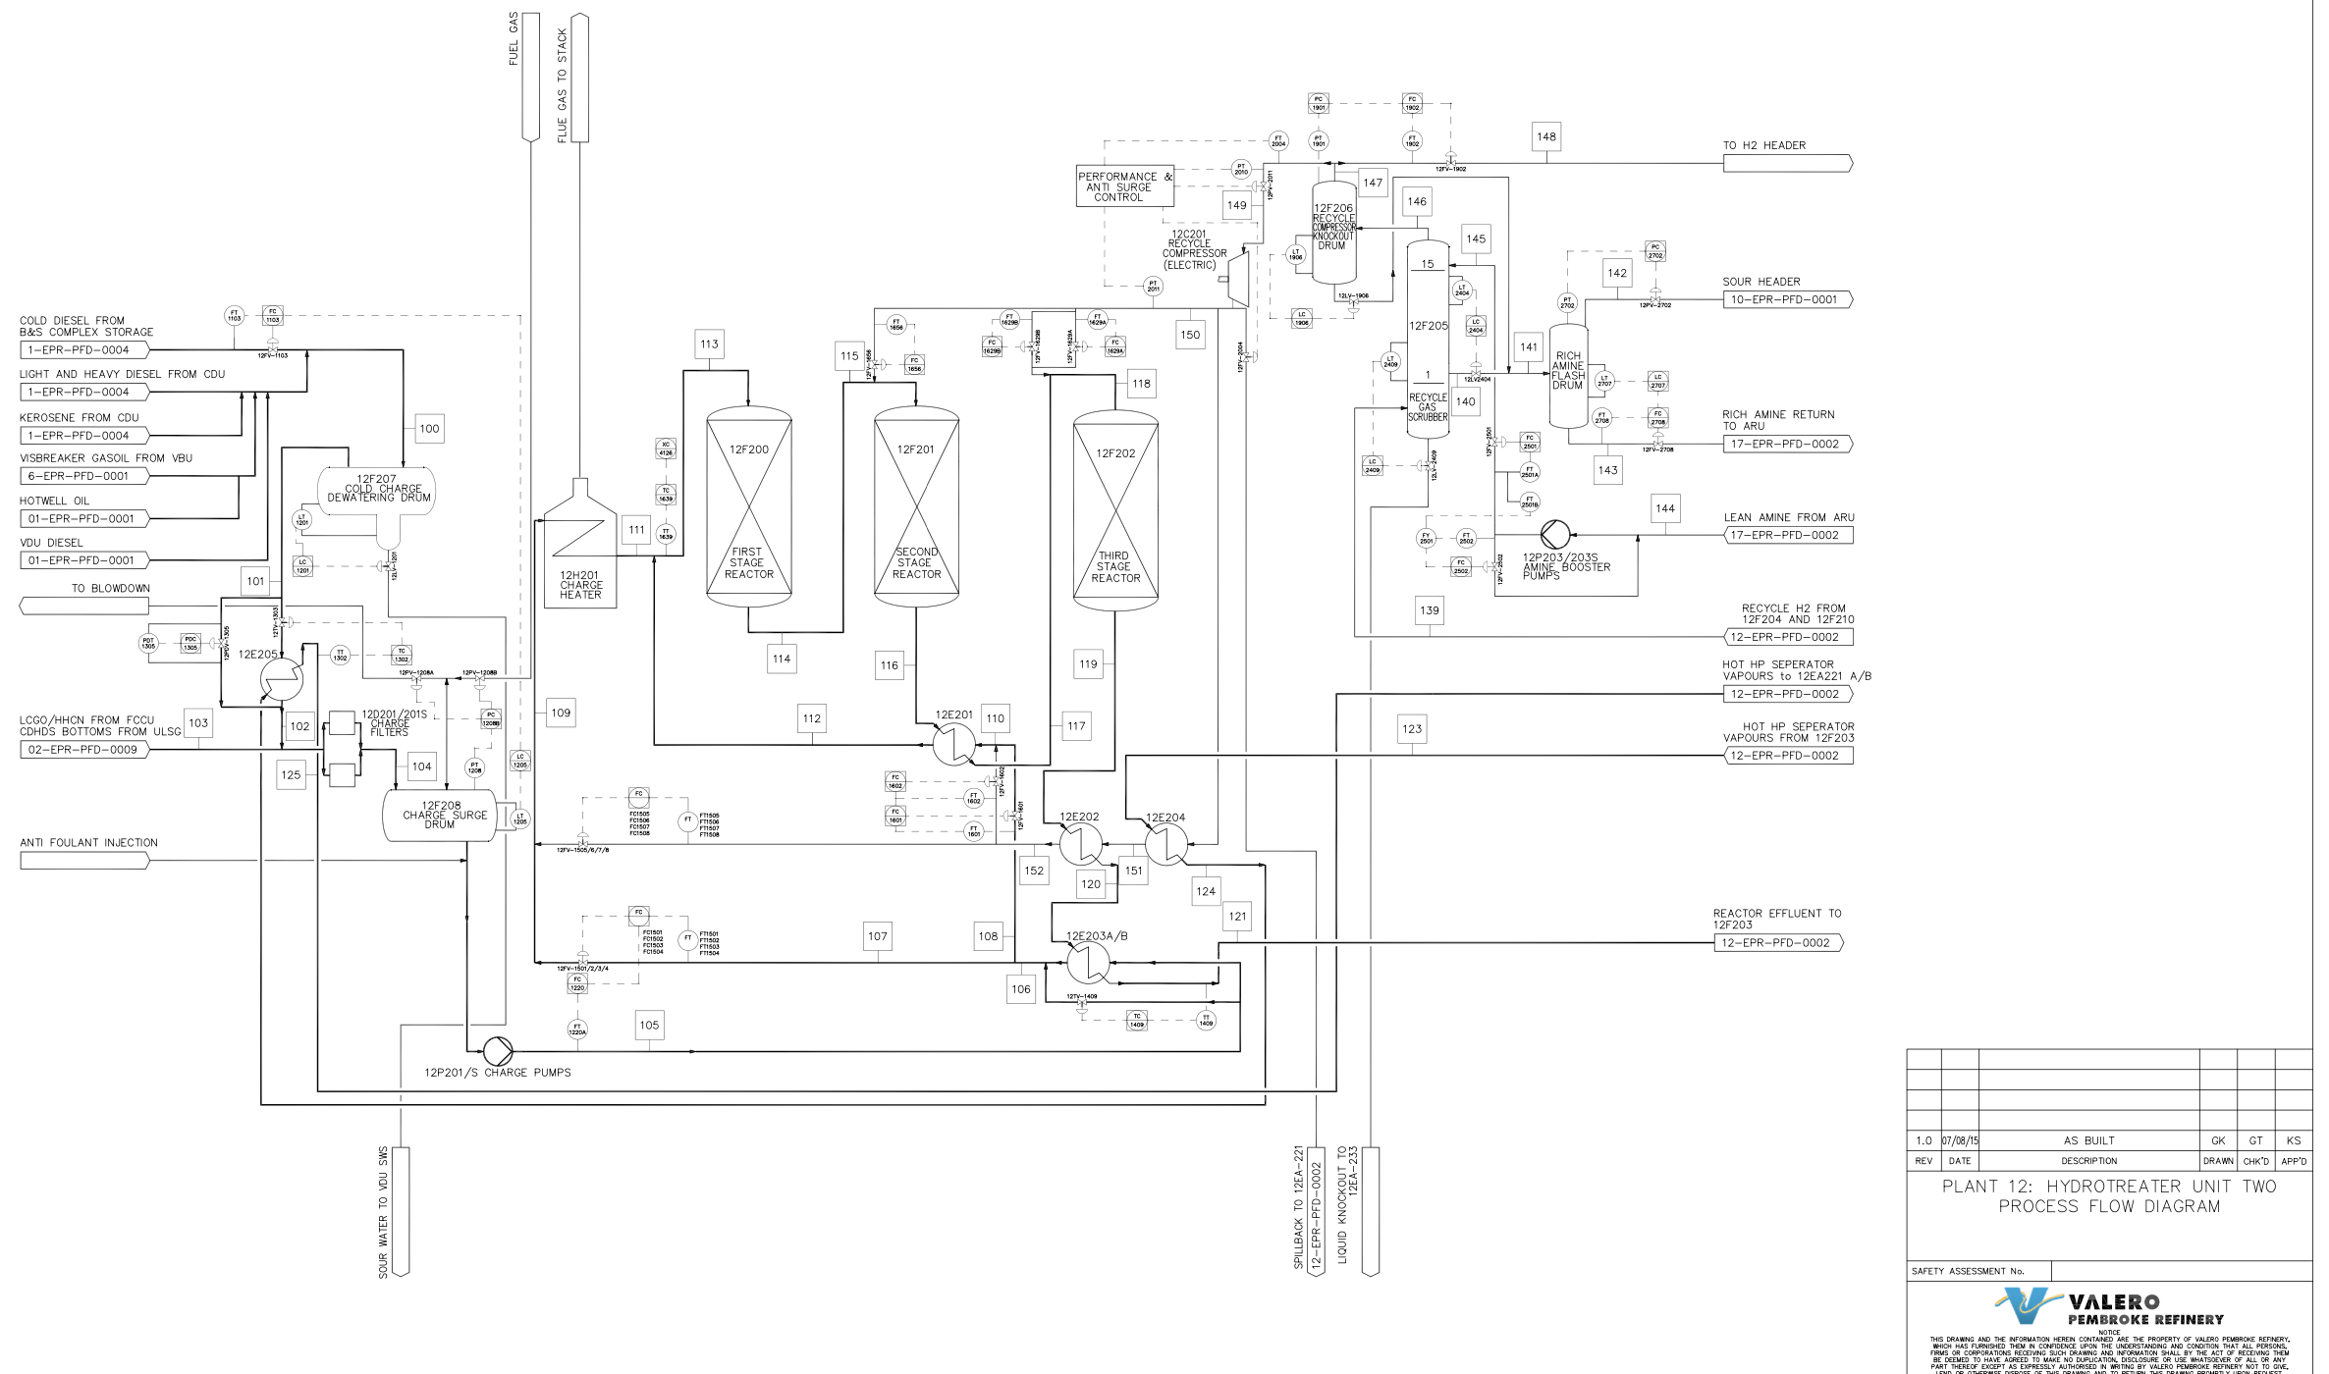
Figure 12 Hydrotreater 2 Process flow Diagram (Valero, 2024)

Continuous Catalyst Regeneration (CCR)
The Platformer unit comprises the Catalytic Reformer unit (CRU) and the Continuous Catalytic Regeneration Unit (CCR). The CRU comprises a 3-stage high temperature process using a platinum catalyst which produces aromatic hydrocarbons from the paraffin’s and naphthalene’s in heavy naphtha from the Unifiner. This conversion produces a high-octane gasoline blend stock known as platformate while benzene, LPG and hydrogen are produced as by-products. Benzene Heart-cut is extracted in the Benzene splitter column and is sold as a product. The platinum catalyst is continuously regenerated in the directly linked CCR. The purpose of the Continuous Catalyst Regeneration/ Catalytic Reformation Unit (Platformer) is to produce aromatic hydrocarbons from paraffins and naphthene’s, forming a higher octane platformate stream used for gasoline blending. The maximum Platformer feed rate is 232m3/hr (Valero, 2024).
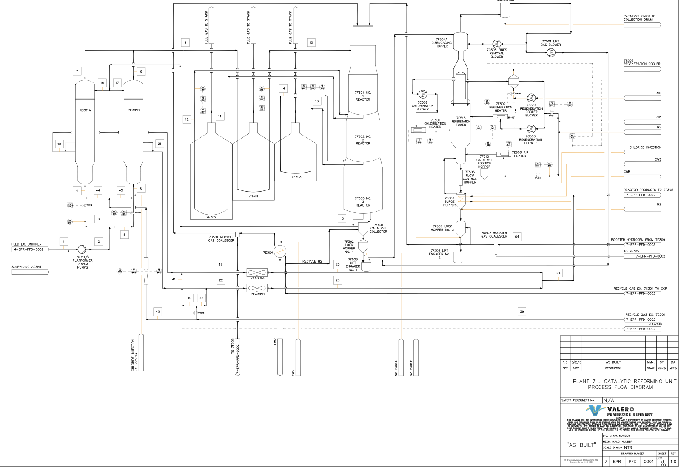
Figure 13 CCR/CRU Process Flow Diagram (Valero, 2024)

Isom Unit
The Isom feed rate is determined by availability of light naphtha from the Unifiner and light platformate from the Platformer, with the maximum feed rate being 110m3/hr. The purpose of the Isom is to isomerise C5 and C6 paraffins within light naphtha and light platformate feed into higher octane iso-paraffin components. Isomerate product is used as a gasoline blend-stock. The ISOM unit converts C5 and C6 straight chain hydrocarbons into their isomers in the presence of hydrogen and a platinum catalyst. The catalyst is activated by means of a chlorocarbon making the off gases acidic and require neutralisation in a caustic scrubber. The isomerized hydrocarbon is used in gasoline blending. Feed rate is determined by availability of light naphtha from the Unifiner and light platformate from the Platformer.
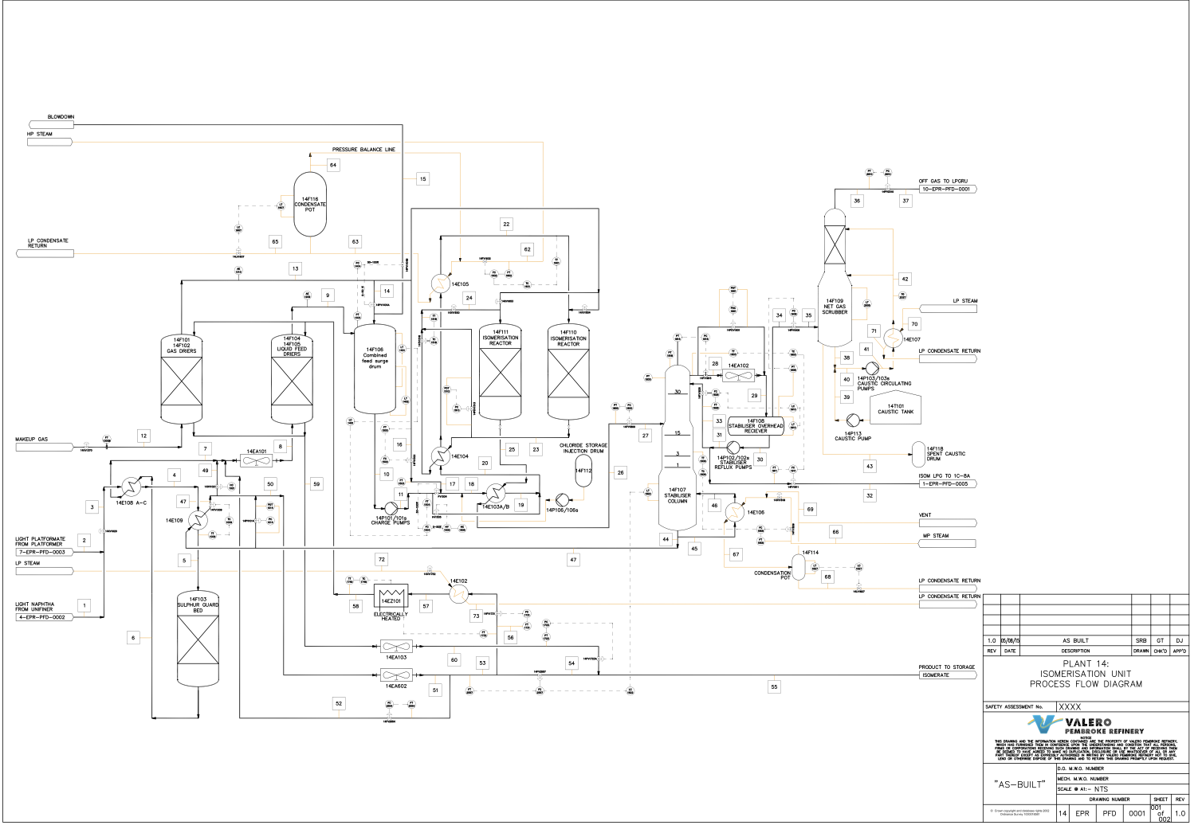
Figure 14 Isom Process Flow Diagram (Valero, 2024)

RLT (Refinery Leadership Team)
The Refinery Leadership Team is made up of manager and directors at the refinery, as a team they decide on the best outcomes for the refinery. As a team in this case, they will decide whether to clean the Unifiner heat exchangers or whether to continue running but with an LPO (loss profit observation). The RLT needed to be supplied with the details to be able to come to a decision on what option to go for.
The RLT had Three options to select from:
- Carry out a chemical clean similar to the 2019 chemical clean.
- Carry out a mechanical clean.
- Do nothing and suffer the LPO
To make a decision the findings had to be produced to the RLT in a meeting, for this the learner had to produce the figures and timings to the RLT. Firstly the cause of the increased fouling needed to be known, this was due to the Crude Distillation Unit having to offline for essential maintenance which caused the Unifiner to have colder feed than normal causing increased fouling. The prediction trend below shows at the current rate of fouling the Unifiner would begin to impact other units whilst online. The current trend shows the rate to decline at around 0.45m3/week. When the blue line crosses the orange line this will begin to impact the crude purchasing strategy, if the blue reaches the red line, it will begin impacting the Platformer (CRU) which would then need to shut down this was the answer to option 3.
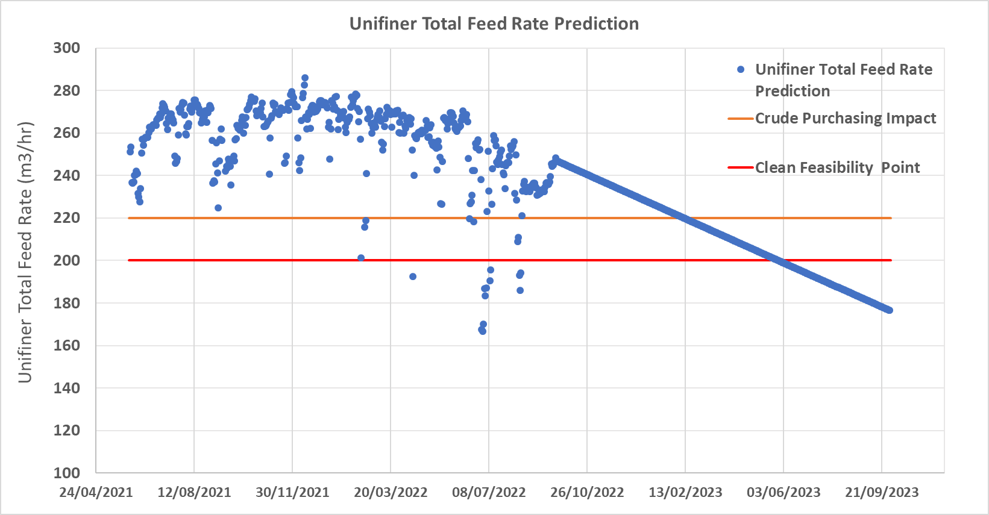
Figure 15 Unifiner Feed Rate Prediction (Valero, 2024)

Option 1
B Train Chemical Clean
- Forecast duration 4.5 days
- Payback 1.1months
- Regain 10 m3/hr in lost duty
- Potential for reactor dP (Differential Pressure) build and crust buster application required. (this happened on the last chemical clean)
Option 2
B Train Mechanical Clean
- Mechanical clean expected return ~6.0 Gcal/hr
- regain 25 m3/hr in lost duty.
- Duration for B train exchangers 10 days mechanical (including STAT inspection requirement- no adverse history indicated)
- 11FTE (full time Equivalent) from maintenance with 1.7 month payback

Literature Review

Heat Exchangers
Heat exchangers are essential components in every industrial process, serving as systems for energy transfer and conservation (Sekulic & Shah, 2023). Various types of heat exchangers are used across industries, all designed to achieve the same outcome: heating a cold fluid using a hot fluid without direct fire or combustion. The most common type of heat exchanger transfers heat from a hot fluid to a cold fluid separated by a metallic surface. The longevity of heat exchangers varies based on their type and the materials used (Thulukkanam, 2012). Common types of heat exchangers include:

Tube Heat Exchanger
A shell and tube heat exchanger are built from a bundle of tubes housed within a larger outer tube or shell. One fluid flows through the inner tubes, while the other fluid moves through the space between the inner tubes and the shell. These fluids can travel in counter-flow or parallel directions (William & Apblett, 1982). The different types of shell and tube heat exchangers are:
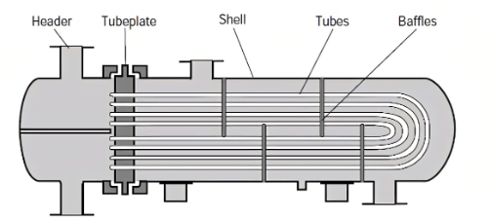
Figure 16 U Tube bundle Diagram (Anson, 2024)
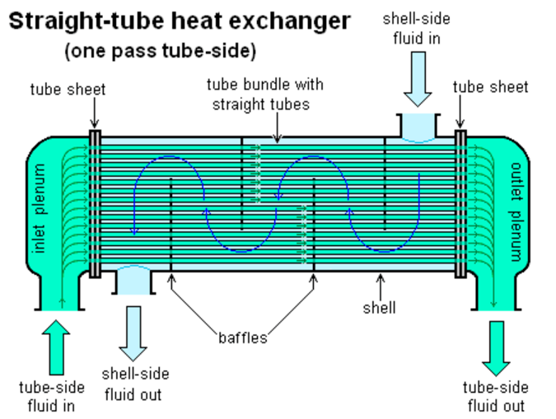
Figure 17 Straight Tube Heat Exchanger (Evapco, 2022)
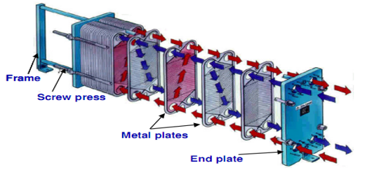
Figure 18 General Diagram for a Plate Heat Exchanger (Anson, 2024)
Parallel plates are arranged side by side to create channels for fluid flow. The space between the plates forms these channels. Inlet and outlet holes at the plate corners allow hot and cold fluids to flow through alternating channels, ensuring each plate is always in contact with both hot and cold fluids (Pivarčiová & Qazizada, 2018).

SWOT Analysis
A SWOT analysis is a strategic planning tool used to identify the strengths, weaknesses, opportunities, and threats related to a business or project. This analysis will help with understanding the internal and external factors that can impact the success of the project (Gurel & Tat, 2017).
Strengths | Weaknesses
The removal of bundles allows for a thorough inspection of tubes and shell internals. | Unit rates decrease for duration of the clean longer than a chemical clean
Known issues surrounding the equipment can be resolved whilst the unit is isolated | Specialist teams required to complete the bundle removal
Always have mechanically cleaned in the past. | Resource levels will be low due to 24-hour working
Opportunities | Threats
STAT inspection due six months’ time so mechanical clean is favoured due to having to isolate the system anyway | Potential for increased duration if inspection find issues with the bundles or shells
 | Potential for injury due to the increased manning in a small area and tiredness from 24-hour working

Figure 19 Mechanical Clean SWOT Analysis (Speth, 2017)

Strengths | Weaknesses
No specialist equipment required like Cranes and jetting equipment. | As An SME (subject matter expert) is required to be on site whist the chemical clean solution is applied.
Less resource required to complete mechanical work for chem clean. | Unit needs to come offline to allow the solution to be injected in the system.
No intrusive work required. no bundle removal required | Chemical clean solution SuperQ needs to be imported for the USA as it is manufactured over there.
Low cost compared to bundle removal due to less resource requirements or specialist equipment | Chemical clean solution has been used before but failed to last for a long period of time after the clean.
Opportunities | Threats
Less process downtime, meaning soon the unit is back online and surrounding units are back on rate. this is because it will take less time than bundle pulling | Only one supplier available to supply SuperQ to Valero. This could leave Valero open to problems if not enough product arrives.

Figure 20 Chemical Clean SWOT Analysis (Speth, 2017)

Mechanical Cleaning Heat Exchangers
(Santamaria, 2019) suggests the need to complete mechanical cleans of heat exchangers, to do this it is suggested that pulling the bundles for a mechanical clean & inspection is the best way to complete it. They also acknowledged the need to carry out high pressure jetting to remove any fouling. The method of how exchangers are pulled can be see in in (figure 12)
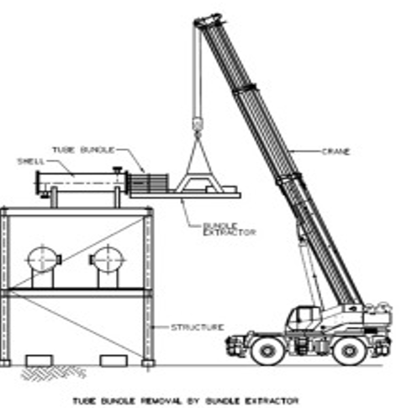
Figure 21 Bundle Pulling Machine (Valero, 2024)
Internal shell and tube components can be cleaned in place using high-pressure steam, water, or by "rodding". If the design allows, tubes can be removed for repair or cleaning. Tube bundles and both the head and shell covers can be taken out using fixed handling devices like davits, hitch points, and pulling posts. Additionally, fixed structures with trolley beams, traveling gantry cranes, and cranes equipped with hydraulic bundle extractors can be utilized. Figure 30 shows a bundle extractor being used at height with the help of a crane. When a heat exchanger is located at ground level, a crane is not needed, as the bundle extractor can be operated using a control system (Anson, 2024).

SSOW (Safe System of Work)
A large number of accidents occur due to the absence or failure of safe systems of work. Implementing these systems is crucial in any industry. For Valero, as a Tier Two COMAH site (Control of Major Accident Hazards) site, upholding the highest safety standards is essential. The law requires employers to ensure that systems of work are planned, organized, performed, maintained, and revised as needed to be, as far as reasonably practicable, safe and without health risks (Dept, 2024).
A safe system of work entails a series of procedures outlining how tasks are to be executed. Safe systems of work become necessary in situations where hazards persist despite efforts to eliminate them, thereby posing potential risks. When formulating SSOW, careful consideration should be given to the manner in which tasks are performed, anticipating challenges that may expose workers to danger. Subsequently, a comprehensive set of procedures must be devised to mitigate the hazards or minimize the chance of accidents or injuries.

LOTO (Lock Out Tag Out)
Lock out Tag out is the SSOW used at Valero Pembroke, for this the operations team follow an isolation list to complete the isolation of the selected equipment. In this case it would be the 4-E-1s see (Figure 13) this displays where the isolation points are and where the blind points need to be. (Figure 14) displays the LOTO tags hung on the isolation points in the field (Valero, 2024).
There are Six different tags which are single use made from recyclable materials, these are available to all operators on site (HSE, 2024). The Six tags are as follows which can be seen in (Figure 14):
- LOTO Tag
- Vent/Bleed Open Tag
- Break/Blind Point Tag
- Line in Service Tag
- General Purpose Tag
- Zero Energy Tag

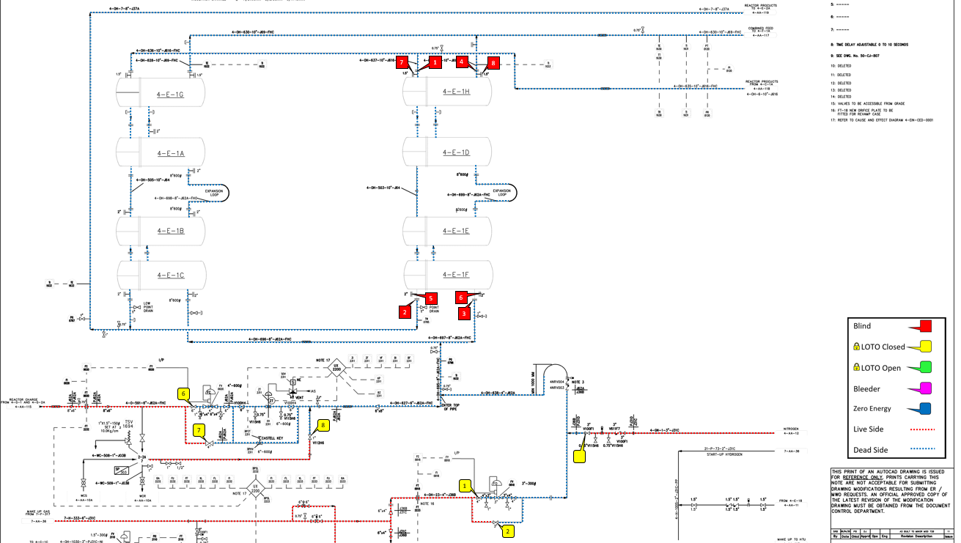
Figure 22 Marked up P&ID of Blind and Isolation Points (Valero, 2024)
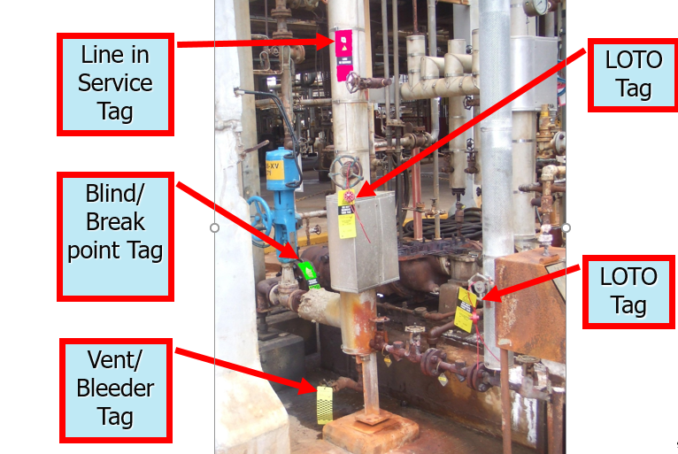
Figure 23 Isolation Tags Hung in the field (Valero, 2024)

Isolation and Blinding
To work on the exchangers and begin preparations to clean the exchanger the sour Naphtha in the system must be removed. To remove the Naphtha from the system Train A must be isolated and de-pressured, in order to do this the charge pump needs to be isolated. The next step is to safely shut the heater down to remove all Hydrogen injection. Following this the train needs to be de-pressured to flare, this means the 40kg of naphtha needs to be sent to flare. Nitrogen is added to the system as it is inert to remove all hydrocarbon from the system making it safe to work. Once operations carry out the gas test and confirm no remaining hydrocarbons, LOTO tags can be put in place & the permit issued to install blinds at the location marked in red in (figure 13) (Dept, 2024).

Bundle Extraction
Once the permit is issued to the maintenance team work can continue to begin preparing the bundles for extraction, as seen in (figure 15) temporary pipework installed this would need to be removed as it presents a hazard, this was part of the SSOW to remove prior to starting work.
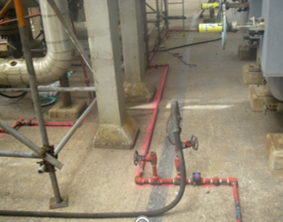
Figure 24 Temporary Pipework Installed Sprayed Pink (Valero, 2024)
Following the removal of the temporary pipework a compressor was set up to allow use of Pneumatic tooling, the reason Pneumatic tools are used is to prevent the likely occurrence of a spark. The compressor also needs to be earthed to prevent any static sparks whilst using the machine.
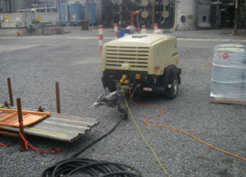
Figure 25 Compressor Used for Tooling (Valero, 2024)
With the blinds now installed the 24-hour working team had to remove all bundle components followed by pulling the bundle in preparation of cleaning. In (figure 17) it can be seen that the bundle puller is in the process of removing a bundle.

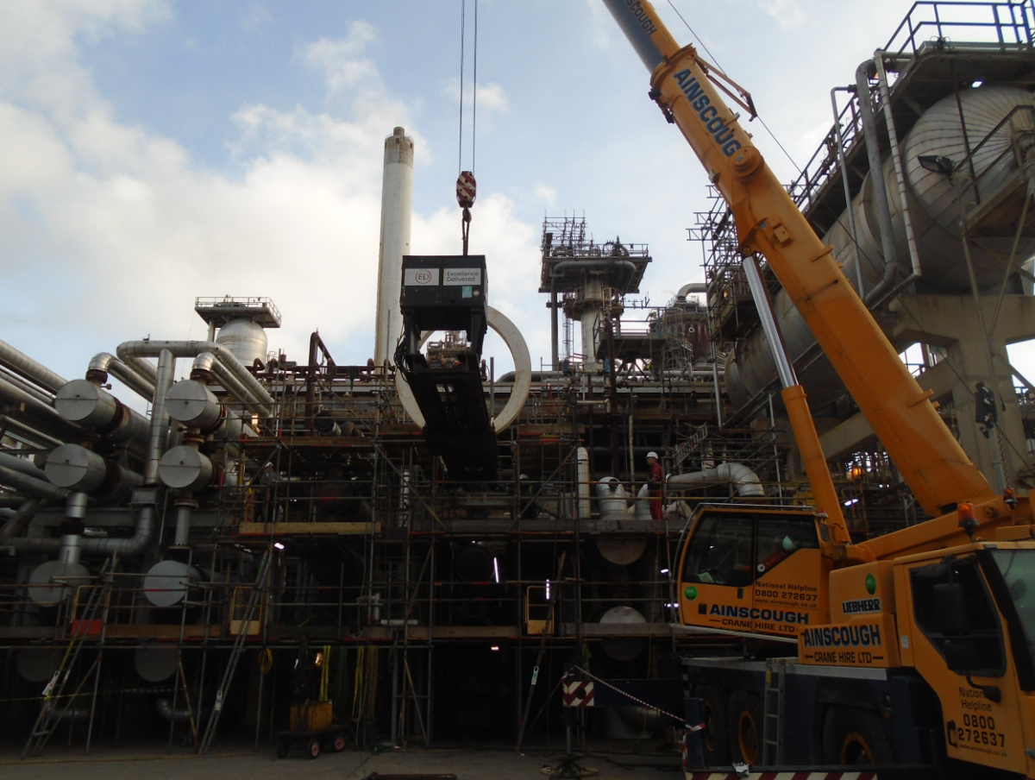
Figure 26 Peinemann Bundle Puller in Operation (Valero, 2024)
Figure 27 Bundle Fouling (Valero, 2024)
(Figure 18 & 19) shows the heavy fouling found when the bundles were extracted for the shells. These bundles were now to be jetted by a professional jetting company called Ajaks. Ajaks travel over from Poland to complete the jetting required at Valero, (Ajaks, 2024) can provide heavy duty industrial cleaning using specialised equipment which can be seen in (figure 20)
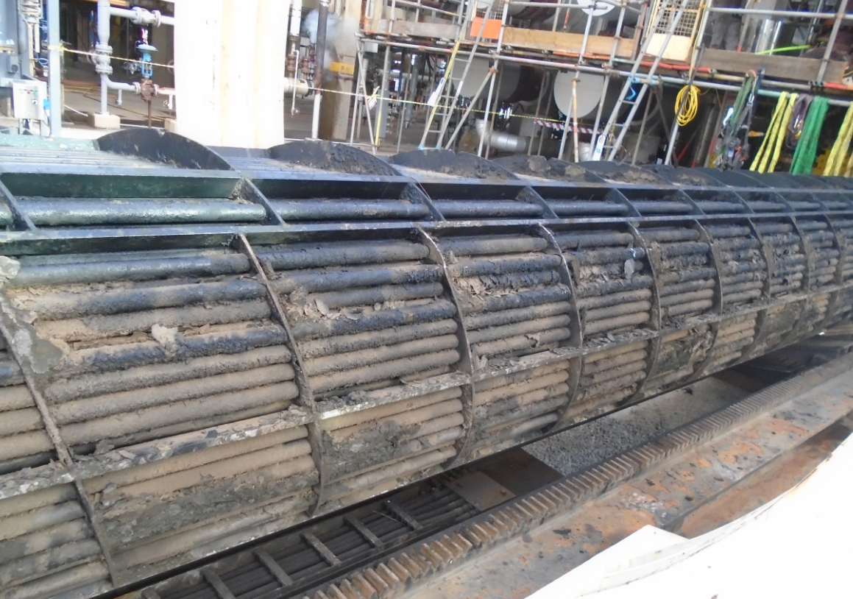
Figure 28 Bundle Fouling (Valero, 2024)
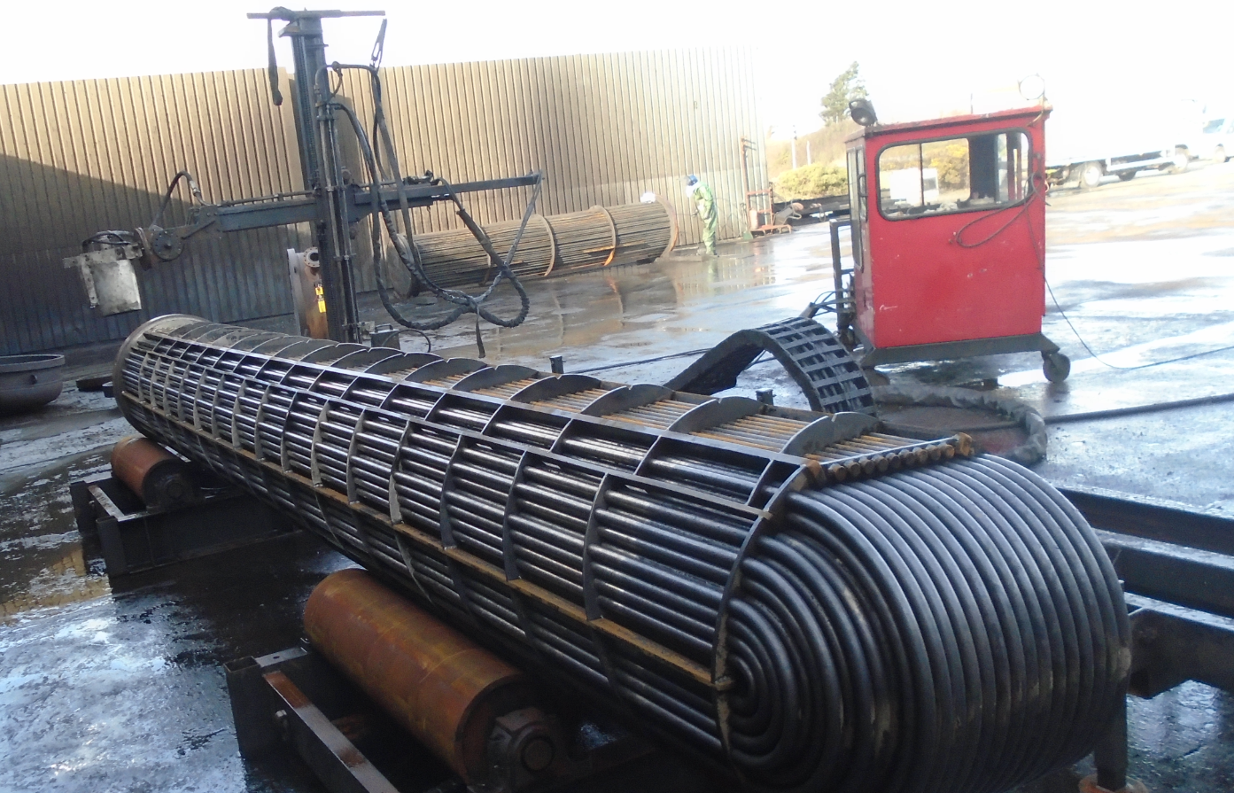
Figure 29 Bundle Post Cleaning (Valero, 2024)

Pros Cons & Improvements
Pros
- The plan came in ahead of the planned duration, 8 days instead of 10 days
- STAT inspection of the heat exchangers found no problems.
- Jetting equipment worked well
Cons
- Unit outage required to complete the mechanical clean
- Although the plan came in 2 days early this affected inspection as they had to execute their parts earlier than the original plan.
- Resource heavy at times which led to personnel standing around which isn’t good for efficiency
Improvements
- Need to ensure that the plan is accurate, coming ahead of plan 2 days is not good for resource allocation.
- Better training for supervision to allow them to make decisions at the job face.

Cost Analysis for the Cleaning Process
During the planning stage of the cleaning process, a cost analysis was performed. For this analysis to be accurate, it was essential to determine the expected feed rate after the exchanger cleaning. Knowing this feed rate allowed for an accurate calculation of the payback period (Scandizzo, 2021). The costs are detailed below:
Initial Costs:
- Labour Costs: Workers involved with HEX clean.
- Equipment Costs: Jetting, Crane, bundle pulling equipment.
- Materials Costs: Spare parts, bolts, and gaskets
- Downtime Costs: Unit offline or on minimum rate LPO (loss of profit opportunity
Expected Benefits Post-Clean:
- Improved Feed Rate: Improved unit throughput.
- Energy Savings: increased pump performance & heat transfer capabilities.
- Maintenance Savings: potential for longer intervals without the need for maintenance intervention
The (figure 21) below outlines all expenses associated with performing a mechanical clean and a STAT inspection. As indicated, the downtime for the B-Train will result in costs of approximately $1,980,000. (Figure 21) below illustrates the rate increase expected after the outage, with a payback period of 52.5 days (Valero, 2024).

Project Success
B train was taken offline on the 6th of February to complete a full mechanical clean of the feed-effluent exchangers (4-E-1 J-N+P). The clean enabled a rate increase of ~30 (m³/hr). During the clean, A train was continuously constrained by 4-E-1 outlet temperature due to elevated feed and reactor temperatures combining with reduced cooling duty. A train has been intermittently constrained by 4-E-1 outlet temperature and feed valve hydraulics following the return to service of B-train. Feed temperature has also been adjusted post mechanical clean to maximise unit throughput. Process recommended temperature is 82°C (Valero, 2024).
An average duty increase of >5.3 (Gcal/hr) has been achieved from the exchangers following the clean. In fuel gas savings alone, this saving was calculated to be $8200/day. However, in terms of rate increase, an overall rate increase of ~30 (m³/hr) has been achieved which can be seen. Based on an incremental Unifiner margin of ~$9/bbl, the increase is worth ~$41,000/day (Valero, 2024). These figures are not correct and are used only to provide costing & payback time.
Mechanical Cleaning |  | B Train
Rate Gain | 30.0 | m3/hr
Duration of Outage | 18.0 | days
Total Cost of event | 1980 | $k
Value of Rate Increase | 37.7 | $k/day
Payback time | 52.5 | days
 | 1.7 | months
Figure 30 Rate Increase Table (Valero, 2024)

The trend below in Figure 22 displays the rate before the heat exchangers were cleaned, the flat line indicates the outage where the unit was shut down to complete the full clean and STAT inspection for the heat exchangers. To the right of the flat line displays the feed rate post clean which can be seen to be significantly more than the prior to the clean.
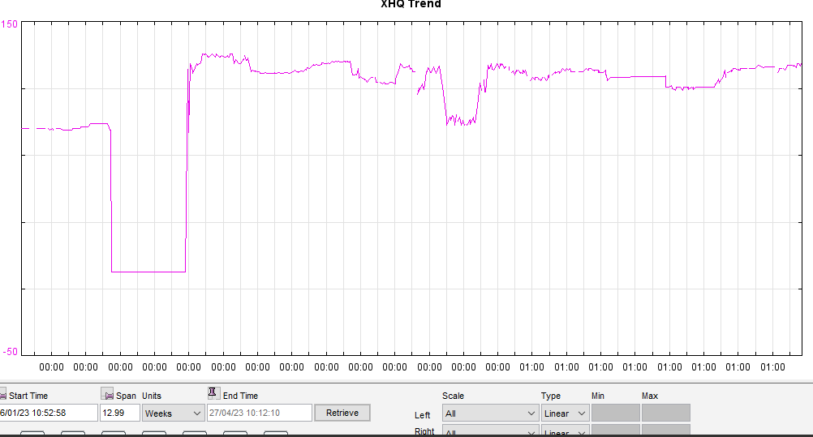
Figure 31 Trend Displaying Before and After HEX Clean (Valero, 2024)

Conclusion
In conclusion, this project has identified that removing fouling from a heat exchanger can be done Two separate ways, these heat exchangers have previously been subject to a chemical clean using a cleaning chemical called SuperQ (SQ), SQ was brought to Valero back in 2019 to complete a chemical clean and was seen to be successful for the short term but over an extended period the exchangers began to foul quicker than they previously would following a mechanical clean. Evidence in the report shows that although initially more costly to carry out the mechanical clean and STAT inspection the further gains seen post clean are a lot better than when the chemical clean was completed.
The research in the report was carried out on the Unifiner and the heat exchanger circuit within that process unit, this was an advantage as it is the learner is very experienced in this field process unit and has a wealth of competence making it the ideal location.
Although the project can be seen as a great success there are a few improvements which could be made to improve on how the execution went. The primavera P6 plan was created showing what the critical paths were and it was detailed to be jetting, this was not the case as can be seen by the pictures of the fouling found it was scaly and didn’t take too much jetting to remove. Once the execution began it was realised that the critical path would now be the inspection department, the plan would move forward because the jetting was faster than anticipated. The inspection department had to be informed of the change and that they would be required sooner than the P6 plan demonstrated.
As the jetting was faster than anticipated the 10-day P6 plan ended up being 8 days although this is a good thing for Valero as the forecast of 10 mechanical days becoming 8 mechanical days would mean that the LPO would be less. The payback time became considerably less also.

Reflection
Firstly, the challenges initially found were overwhelming because the scope was not agreed and the plan for the heat exchangers was not agreed whether they would be mechanically cleaned or chemically cleaned. This was difficult to plan the work scope & manage the workload.
During these early stages of the assignment, it needed to be broken into manageable parts to have efficient time management. This was a learning point along with ensuring all sources are evaluate for authenticity when using journals, although it was a challenge to find detailed information on certain areas of heat exchangers and process information.
Planning the structure of the assignment where the learner allowed time slot for each section to continue progressing the assignment. Adhering to the Excel chart was key to hitting the deadlines for each section. First step was to break the assignment into sections.
Writing the assignment introduction was relatively straight forward which looked at the company and the assignment brief. This was followed by the project issue and plan, literature review into heat exchangers and the surrounding units, methodology for completing the mechanical clean, review the data and trends following the clean, finally the conclusion and reflection on the assignment.
During the assignment many different departments within Valero provided feedback on the effectiveness of the heat exchanger clean. The biggest challenge during the writing of the assignment was sticking to the time slots in the Excel chart but following them made the assignment manageable.

Bibliography
Ajaks. (2024). Ajaks heavy duty industrial cleaning. Retrieved May 20, 2024, from https://ajaks.com/en/services/heavy-duty-industrial-cleaning
Anson. (2024). U Tube Heat Exchanger. Retrieved May 20, 2024, from http://www.ansonindustry.com/pressure-vessel/u-tube-heat-exchanger.html
Dept, H. (2024). Safe Systems of Work . Retrieved from https://www.hsdept.co.uk/services/safe-systems-of-work/
Evapco. (2022). Retrieved May 21, 2024, from https://www.evapco.dk/da/hvad-er-en-varmeveksler
Gurel, E., & Tat, M. (2017). SWOT Analysis: A Theoretical Review.
HSE. (2024). Retrieved May 22, 2024, from https://www.hse.gov.uk/managing/management-system/index.htm
Johnivan, J. (2024, April). What Is a Critical Path Method in Project Management. Retrieved May 17, 2024, from Project Management: https://project-management.com/what-is-critical-path/
Mobil, E. (2024). Our global organization. Retrieved 05 18, 2023, from Exxon Mobil: https://corporate.exxonmobil.com/who-we-are/our-global-organization
Pivarčiová, E., & Qazizada, M. E. (2018). Heat Transfer and Global Energy Balance in a Plate Heat Exchanger.
Santamaria. (2019). Cleaning scheduling and control of heat exchanger.
Scandizzo, P. (2021). Impact and Cost - Benefit Analysis.
Sekulic, D., & Shah, R. (2023, September). Wiley online library. Retrieved May 20, 2024, from Heat Exchanger Design: https://onlinelibrary.wiley.com/doi/epdf/10.1002/9781119883296.fmatter
Speth, C. (2017). The SWOT Analysis.
Thulukkanam, K. (2012). Heat Exchangers.
Valero. (2024). Valero Pembroke Refinery. Retrieved from https://www.valero.com/about/locations/pembroke-refinery
William, R., & Apblett, J. (1982). Shell & Tube Heat Exchangers. A S M International.

Appendix
Valero’s isolation procedure to hand the heat exchangers to maintenance safely. This looks at all the areas to isolate and de-pressure in a controlled manner.
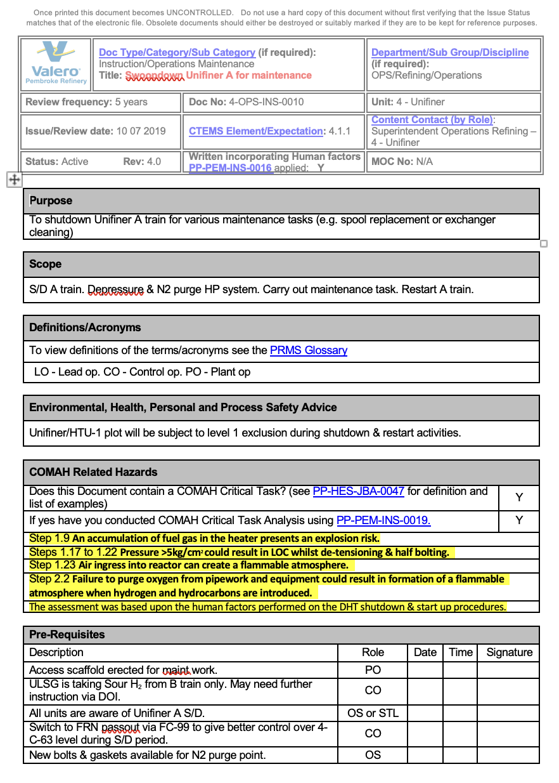
Figure 32 Page 1 Valero's Isolation Procedure
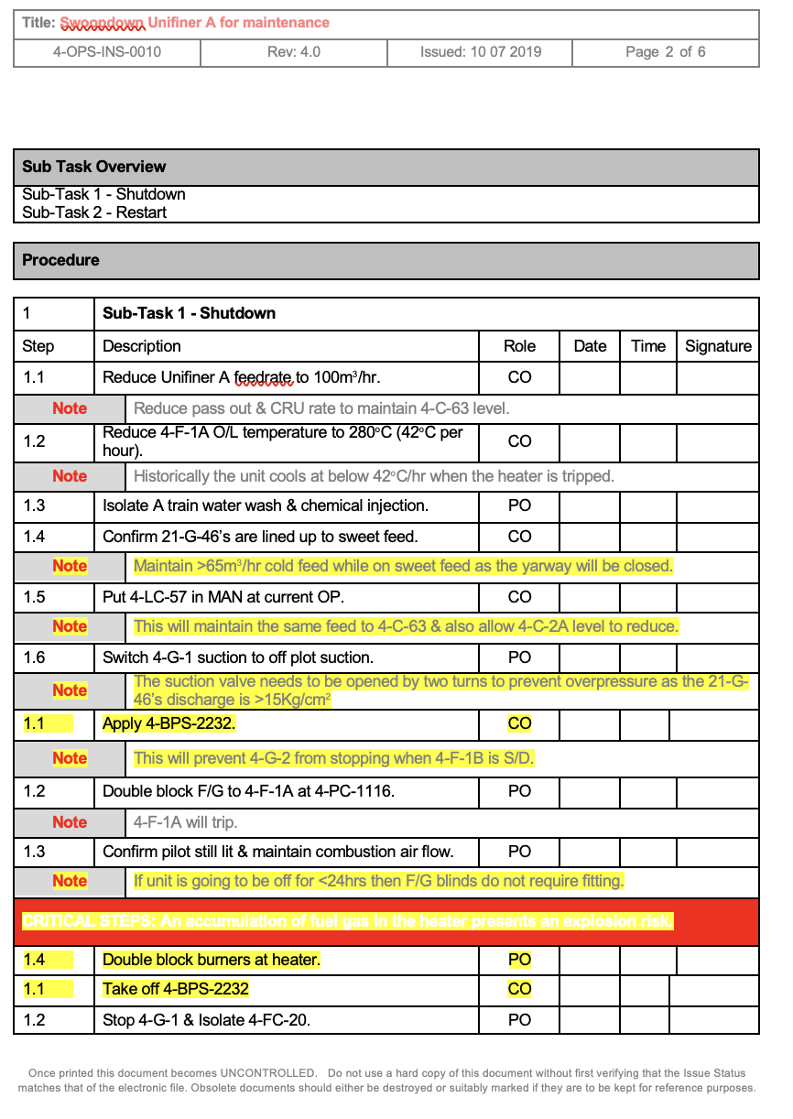
Figure 33 Page 2 Valero's Isolation Procedure
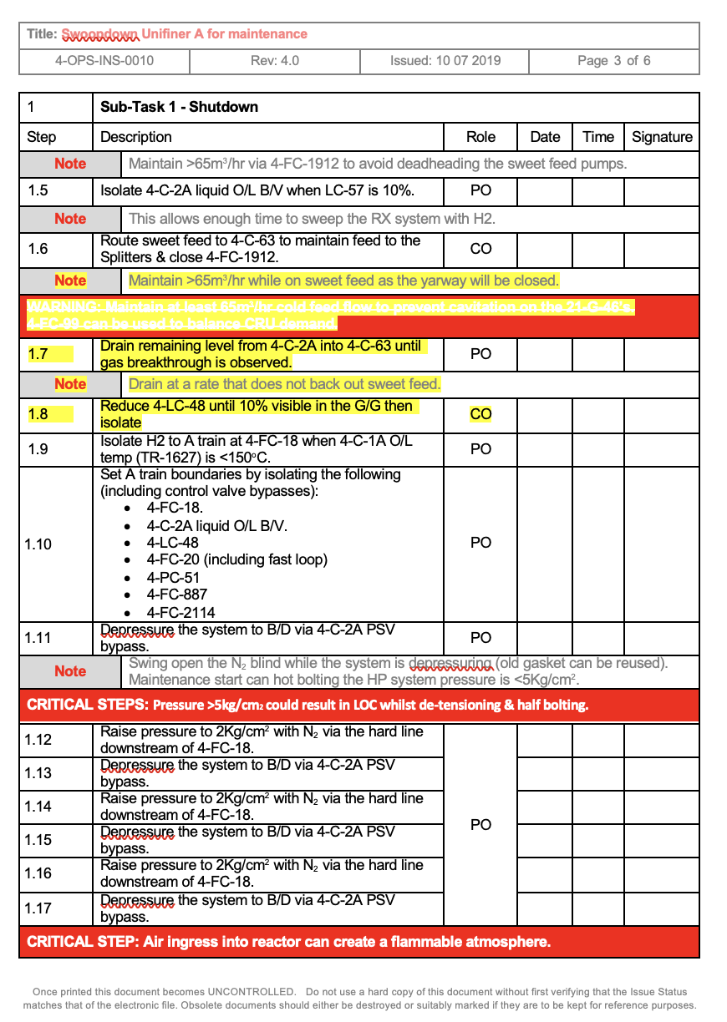
Figure 34 Page 3 Valero's Isolation Procedure
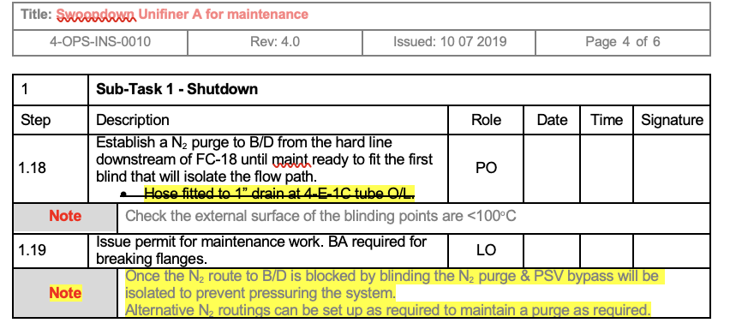
Figure 35 Page 4 Valero's Isolation Procedure
Unifiner feed rates:
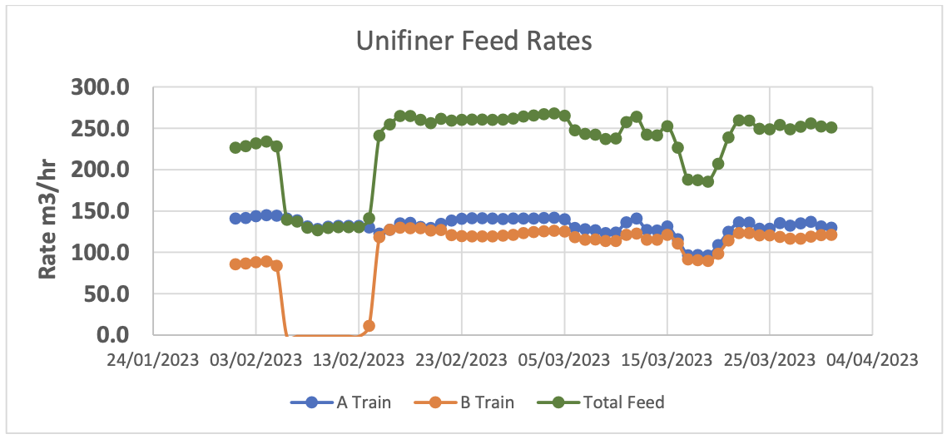
Figure 36 Unifiner Feed Rates Before During and After A Clean
The Unifiner has operated to its individual train constraints throughout the month. B train was taken offline on the 6th of February to complete a full mechanical clean of the feed-effluent exchangers (4-E-1 J-N+P). The clean enabled a rate increase of ~30 (m³/hr). During the clean, A train was continuously constrained by 4-E-1 outlet temperature due to elevated feed and reactor temperatures combining with reduced cooling duty. A train has been intermittently constrained by 4-E-1 outlet temperature and feed valve hydraulics following the return to service of B-train. Feed temperature has also been adjusted post mechanical clean to maximise unit throughput. Process recommended temperature is 82°C.
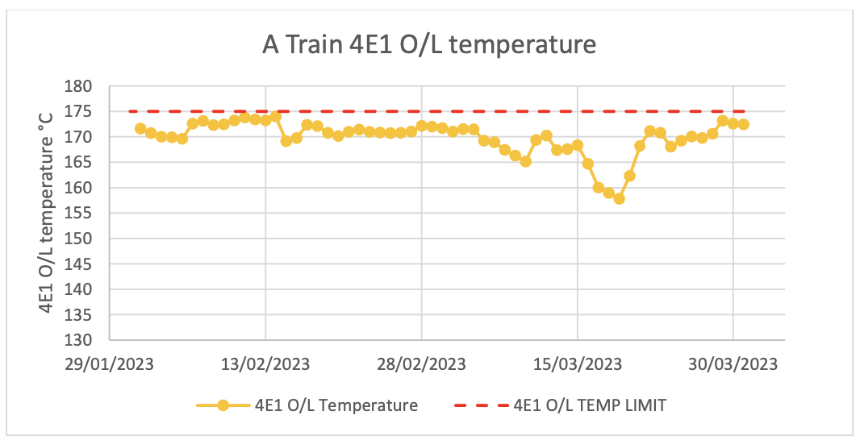
Figure 37 A Train Outlet Temperature
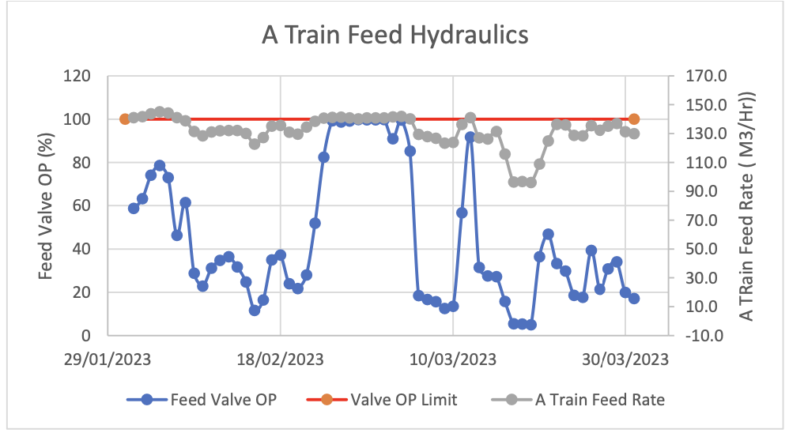
Figure 38 A Train Feed Hydraulics
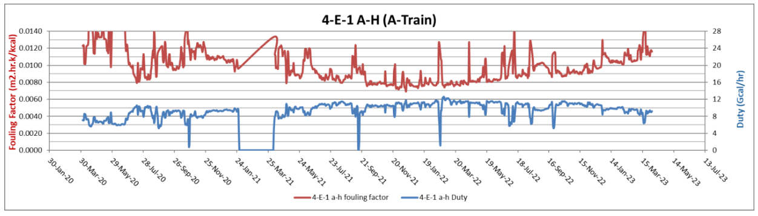
Figure 39 A Train Duty and Fouling Factor
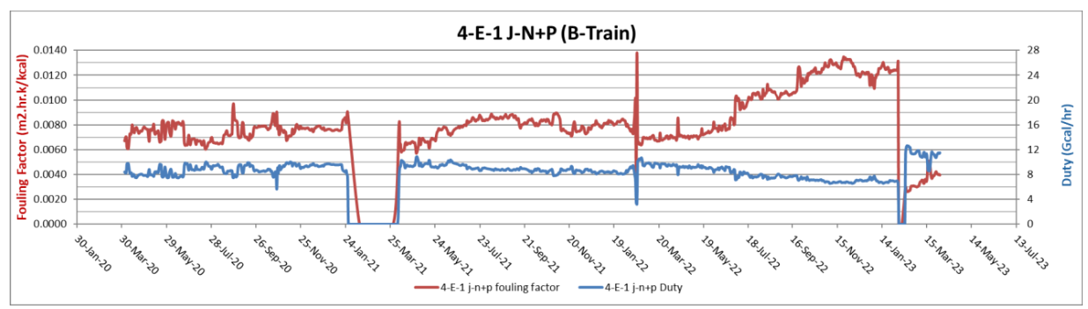
Figure 40 B Train Duty and Fouling Factor

