Business Management
(LCBB5000)

Data Handling and Business Intelligence

Georgel-Laurentiu Oprea - 2114879

Table of Contents
Introduction 3
Determining the decline or increase in average price 4
Evaluating the use of Microsoft Excel for pre-processing the data, analyzing the data and visualizing the data 5
Pre-processing data in Excel 5
Analyzing data in Excel 5
Visualizing data in Excel 6
Demonstrating how to perform these tasks practically with IF and Pivot Table functions 6
Pivot table function 6
If Function 11
Producing appropriate and meaningful charts 13
Students who are male and female 14
Number of students qualify and do not qualify for reduced/free lunch 14
The mean and median of students who qualify and do not qualify for reduced/free lunch 15
The mean and median differences between students' pre-test and post-test scores 17
K-Means Clustering 18
Explaining 5 most common data mining and text mining methods for each 20
Data mining methods 20
Text mining methods 22
Discussing the advantages and disadvantages of using SPSS and Excel 22
Conclusion 26
References 27

Introduction
Tools like Microsoft Excel and SPSS are crucial for data analysis in today's data-driven business environment. Although Excel and SPSS each have advantages and drawbacks, they are both frequently used for pre-processing, analysis, and data visualisation. Small and medium-sized organisations choose Excel because it is an accessible product that is simple to use. Researchers and larger organisations use SPSS, a more potent programme with sophisticated statistical features. However, both tools have their limitations, so users should take into account their unique needs and needs for data analysis before choosing a tool.

Part 1

Determining the decline or increase in average price
The data collection demonstrates how economic and outside variables affect the hotel sector. While there may be fluctuations in the industry's average hotel room price, it is important to comprehend the underlying causes of these trends. By having this knowledge, players in the hotel sector can make wise choices regarding their pricing policies and day-to-day operations.

An intriguing pattern can be seen in the data set, which displays the average cost of a hotel room from 2017 to 2021. The typical price was about 250 in 2017, and it rose to 390 in 2018 by a substantial margin. The price fell to 240 in 2019, which was nearly the same as in 2017. The average price continued to drop, to around 220 in 2020, and to around 210 in 2021, the lowest price in the time frame of five years.
The fluctuations in the average cost of a hotel room over five years imply that the hospitality sector underwent a substantial transformation during this time. The high demand for hotel rooms, which resulted in increased competition for accommodations, maybe the cause of the increase in the average price of a hotel room in 2018 (Sarantakos, 2017). Because of this, hotels were able to raise their rates, which may have been influenced by variables like rising tourism and the economy.
The worldwide economic slowdown and increasing competition, however, could be blamed for a decline in hotel room demand, which would explain the fall in the average price of a hotel room in 2019. Hotels reduced their pricing as a result to draw in business. As the COVID-19 pandemic severely hurt the hospitality sector in 2020, the same pattern persisted. To remain competitive, hotels had to lower their rates as fewer people were travelling.
The decline in the average cost of a hotel room in 2021 implies that the hospitality sector is still readjusting to the effects of the pandemic (Michael, 2014). Although the introduction of the vaccine has helped the situation, the recovery is probably going to be gradual, and prices might still be below pre-pandemic levels.

Evaluating the use of Microsoft Excel for pre-processing the data, analyzing the data and visualizing the data
One of the most widely used programmes for pre-processing, analysis, and visualisation of data is Microsoft Excel. It provides a variety of tools and functionalities that enable users to work with data simply and effectively. Here is a review of how well Microsoft Excel works for these things.

Pre-processing data in Excel
Before analysis, data can be cleaned up and formatted using Excel. It provides numerous tools for data organisation, including text-to-columns, filtering, and sorting. Excel is an excellent tool for data pre-processing since it can easily handle enormous datasets. Excel, however, is less capable than other programmes when it comes to managing intricate data structures or huge datasets.

Analyzing data in Excel
A variety of tools and formulas in Excel make it possible to analyse data quickly and simply. For instance, users can utilise built-in functions to compute averages, totals, and percentages (Bendat & Piersol, 2018). Large datasets can also be summarised and analysed using pivot tables. Excel also offers tools for statistical analysis such as regression and correlation analysis. Excel is the perfect tool for simple data analysis because of these characteristics, but it might not work well for intricate statistical modelling.

Visualizing data in Excel
Charts, graphs, and tables are just a few of the different visualisation possibilities Excel provides. Users can convey data using these visualisations in an approachable manner. Excel charts are simple to make and modify, and users may select from a variety of chart kinds, including bar, pie, and line charts. Sparklines, a feature of advanced visualisation that Excel supports that may be used to show trends over time, is another function (Tukey, 2011). The greatest tool for developing intricate or interactive visualisations might not be Excel, though. Data pre-processing, analysis, and visualisation may all be done with the help of Microsoft Excel. It is the perfect instrument for simple data analysis thanks to its user-friendly features and functionalities. Excel might not be the best tool for processing complicated data structures or producing intricate visualisations, though. As a data analyst, it's critical to assess the task's needs and select the best tool for the job.

Demonstrating how to perform these tasks practically with IF and Pivot Table functions

Pivot table function
Microsoft Excel is an effective instrument for data preprocessing, analysis, and visualization. This presentation will use the data set on the average cost of a hotel room from 2017 to 2021 to demonstrate how to practically execute these tasks using IF, PIVOT TABLES, and other Excel functions. A new spreadsheet titled "Pivot Function" has been constructed next to the "Hotel Reservation" spreadsheet. To begin, select cell A1 and pick the "Insert" tab (Zhou, 2021). Choose "PivotTable" followed by "Existing Worksheet" from the drop-down menu. Click "OK" in the "Create PivotTable" dialogue window.
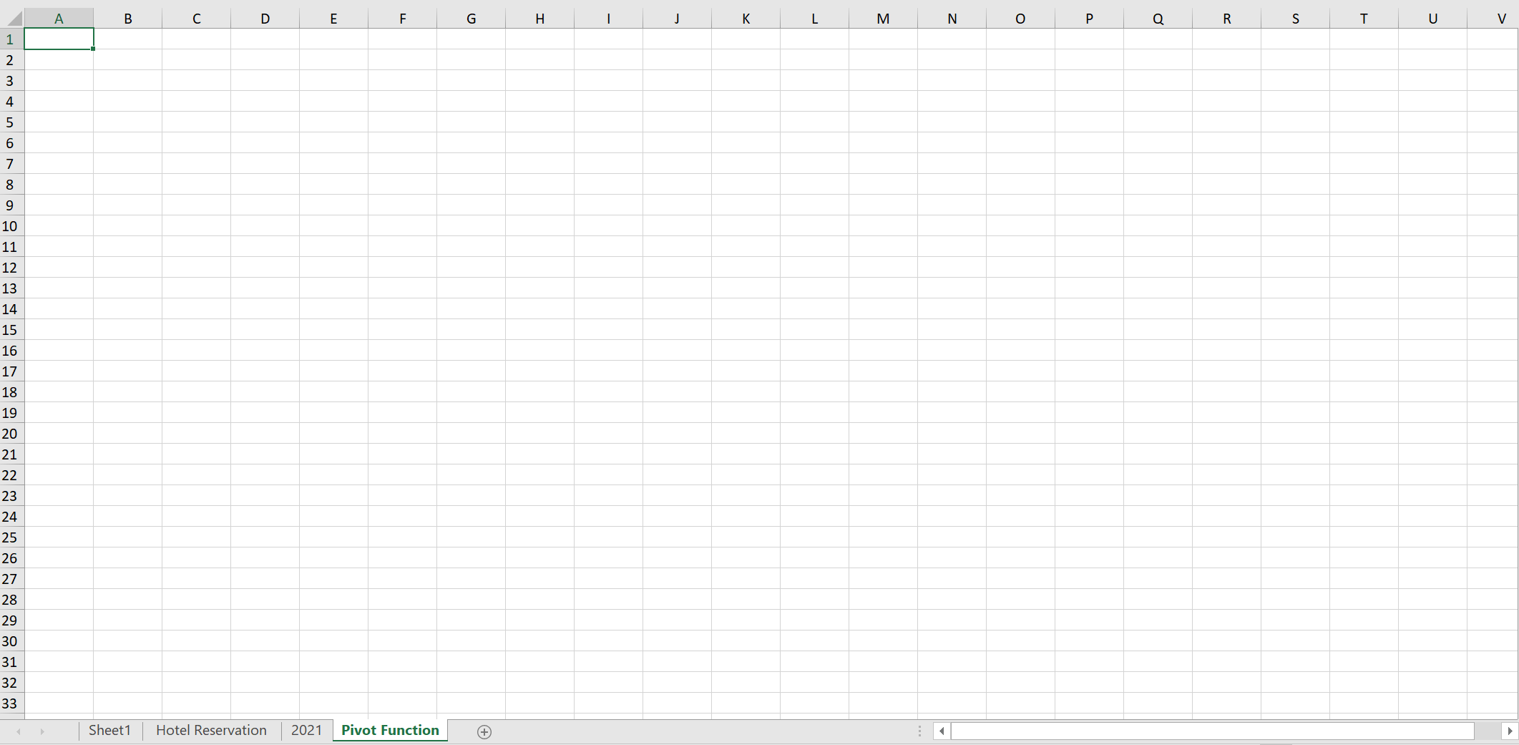
First selecting a new Sheet called Pivot Functions and shifting the data to this will have to be done. Selecting the area from columns A to S is the next step of it. Then, there will have to write “Hotel Reservation” and then left-click and hit OK.
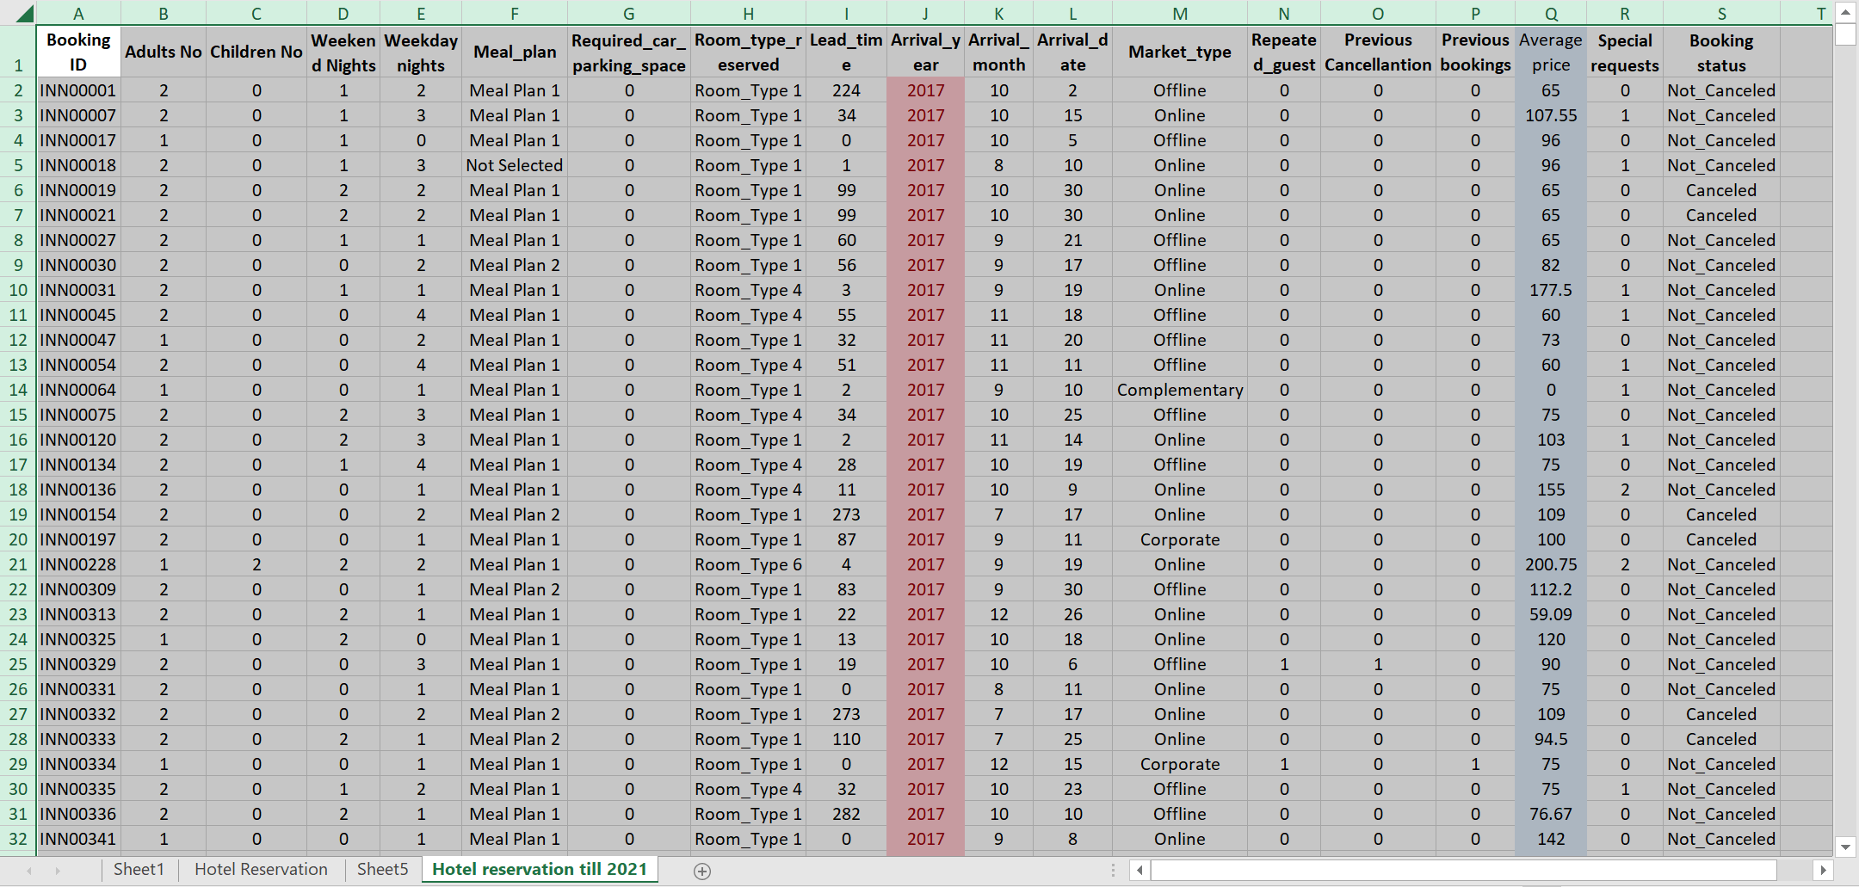
Selecting all data from the previous sheet will be the next move. As there will have to be taken the action before 2021, the rest of them will be unselected (Heiberger & Neuwirth, 2019). For this, the column Arrival year will have to be selected. Then, sorting it from oldest to newest will sort the whole sheet.
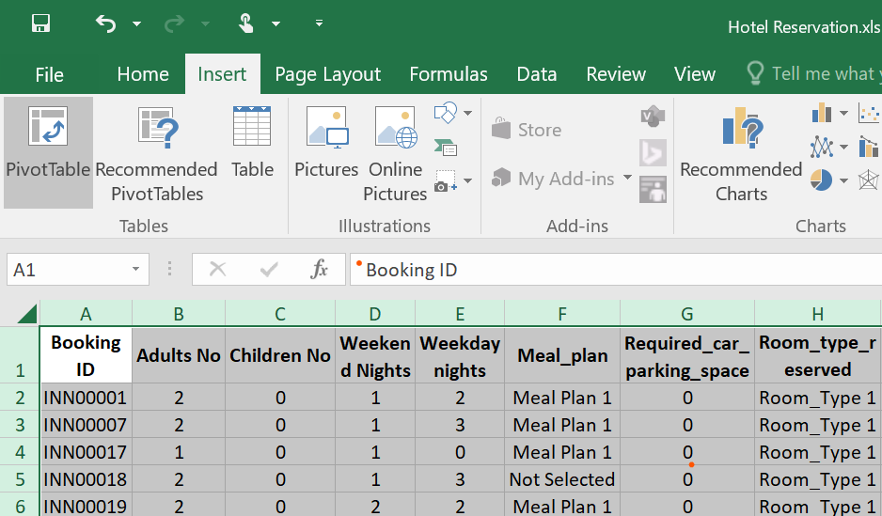
After selecting the data from 2017 to 2021, the user will have to go to Insert and hit the Pivot Table button. It will create the Pivot table. Before that, they will ask to make this into a new table or an existing table.
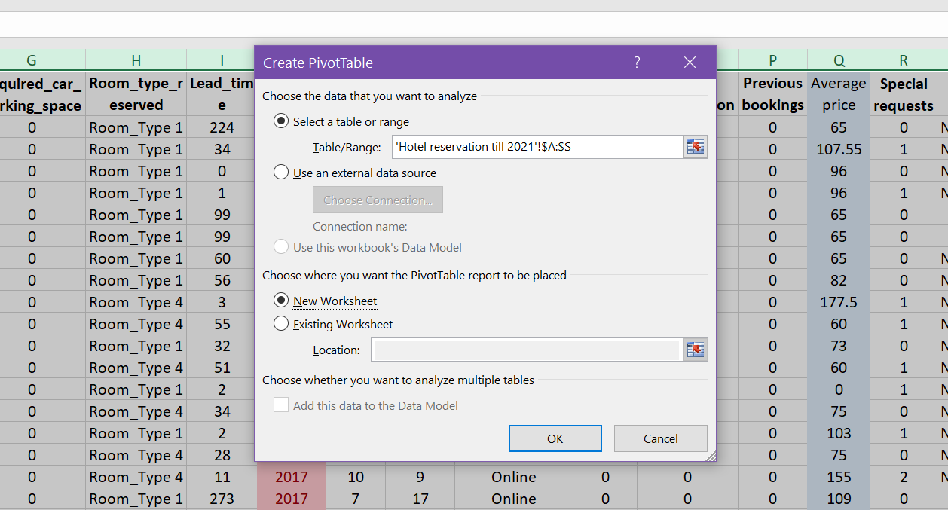
Shifting to a new table will be a more efficient move, then the table format will be ready for that pivot table.
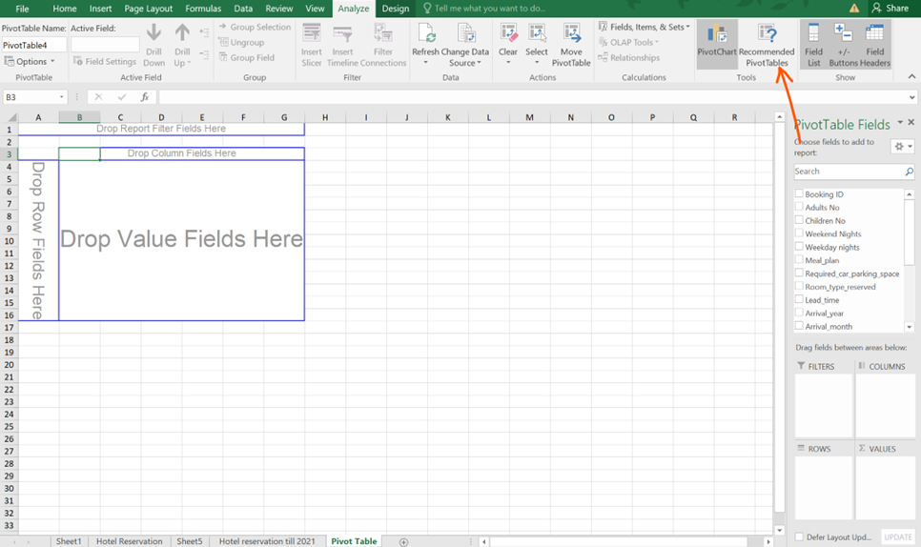
Selecting a cell inside the Pivot and hitting the recommended pivot table will create a bunch of tables and information. On the right-hand side, there will be the timeline form in which the user selects the perfect one.
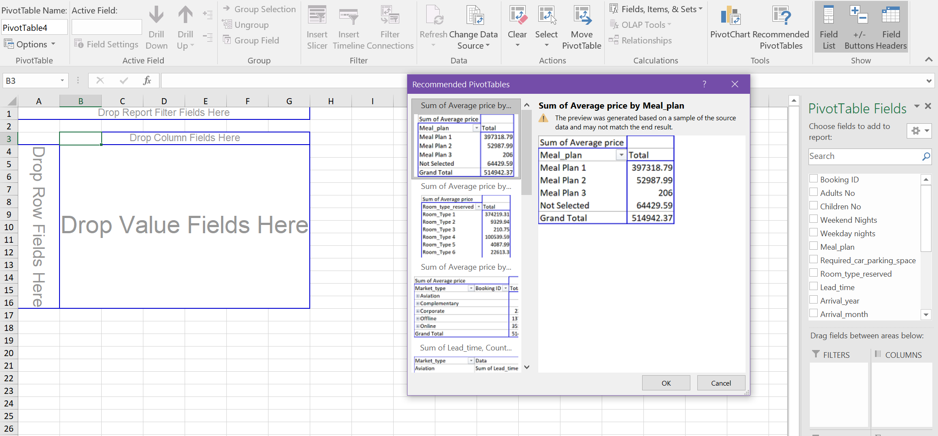

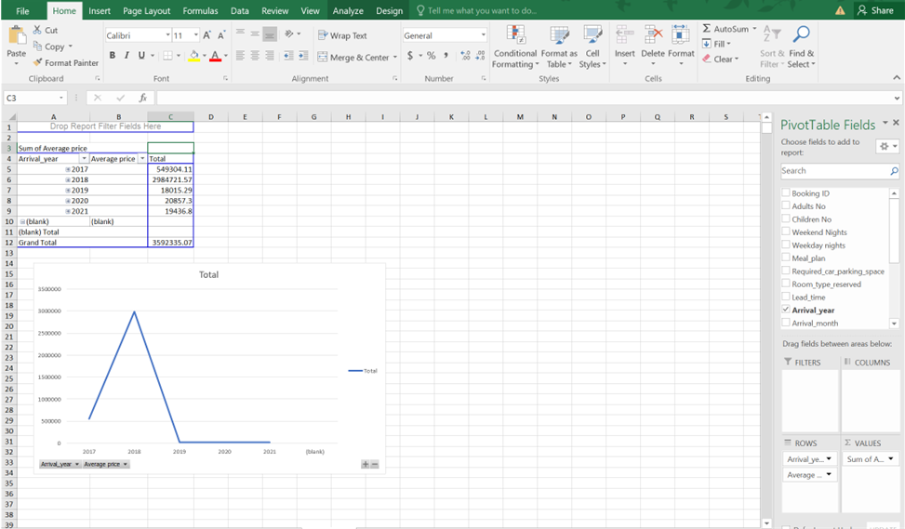
Providing the checkmark to the year and the average price will make the table. Select the data from that table, there will appear a button called chart. Hitting the Pivot chart will provide the chart to the report (Zhou, 2021). This is how the Pivot table and the Pivot chart will be made.

If Function
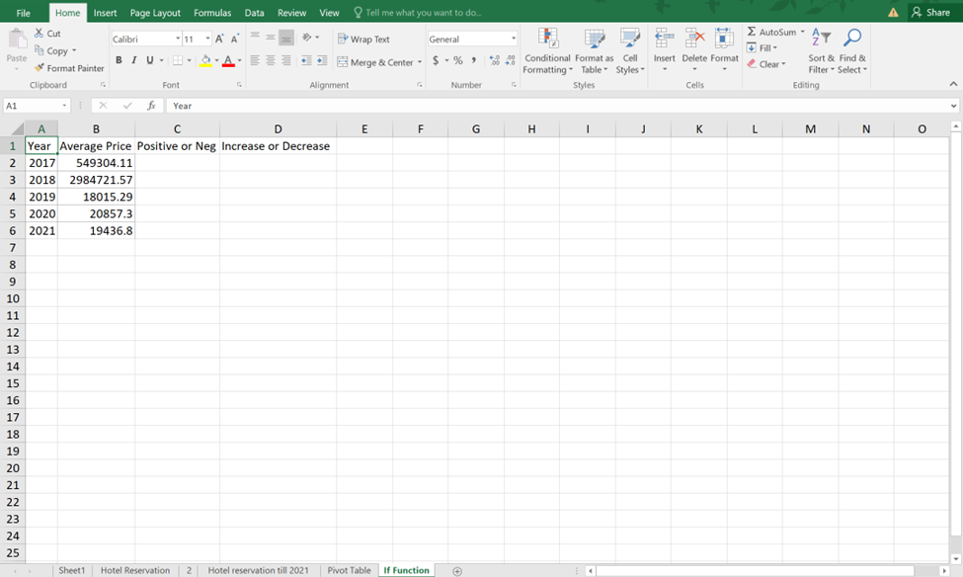
From the Pivot table, the years and the average price values will be copied to a new Sheet which is called the If Function. In this table, there will be four columns to demonstrate the data. Just after the average column, there will be a positive or negative value.

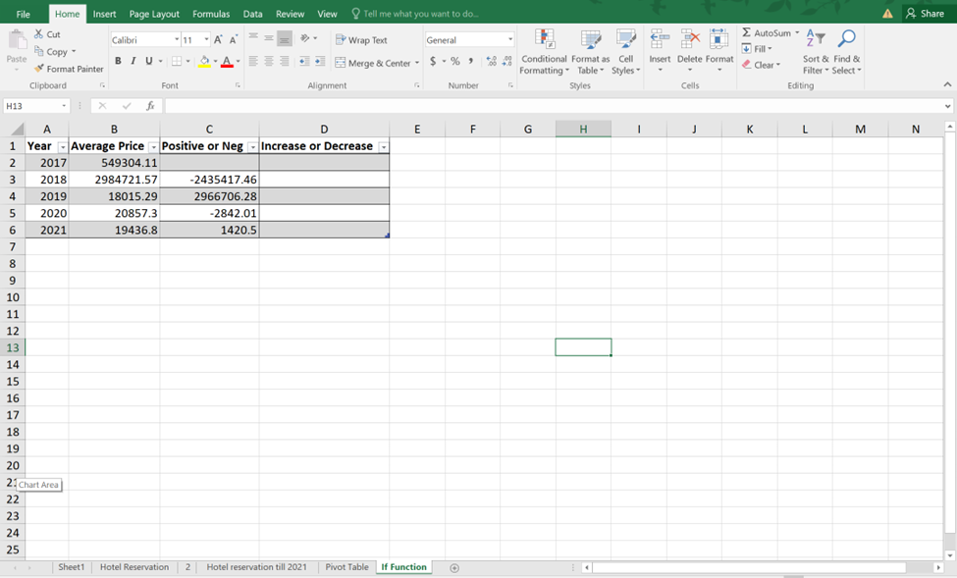
The positive or negative value will be calculated by using the previous cell. There should have to be put The value of, =B2-B3 in the first cell. By dragging them down, the rest of the cells will be filled up.
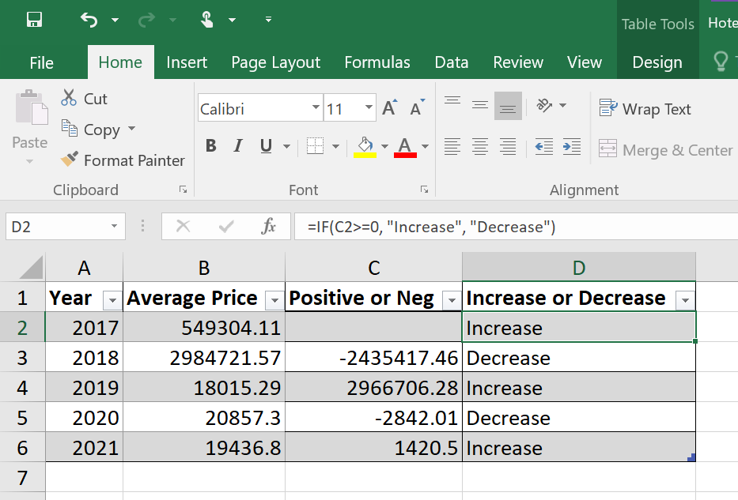
IF Functions deserve increase or decrease values in this table. To use the IF function, there should have to use a value which is actually for the cell D2, =IF(C2>=0, "Increase", "Decrease") (Bissett, 2007). For D3, it will be, =IF(C3>=0, "Increase", "Decrease") and then by selecting the box and dragging them to the rest of the side it will complete the IF functions.

Producing appropriate and meaningful charts
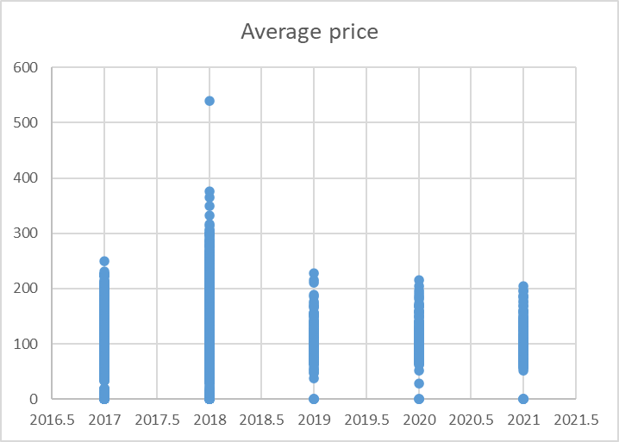
The average cost of hotel reservations from 2017 to 2021 is shown on the graph. The year is represented by the horizontal axis, while the vertical axis displays the average price in monetary units. The graph shows that the average cost of booking a hotel room grew from 2017 to 2018, with a notable increase in 2018. The average price did, however, significantly decline from 2018 to 2019 (Carlberg, 2013). The average price was seen to be lower in 2020 than it had been in the previous years, and it further fell in 2021.
According to the graph, there was an overall rise in the average cost of hotel reservations from 2017 to 2018, which was followed by a sharp decline in 2019. In 2020 and 2021, the average price remained low. Making educated decisions for the hotel sector can benefit from the graph's clear portrayal of the trend in the average cost of hotel reservations over time.

Part 2

Students who are male and female
Typing =COUNTIF(H: H, "Male") and =COUNTIF(H: H, "Female") the number of Males and females can get.
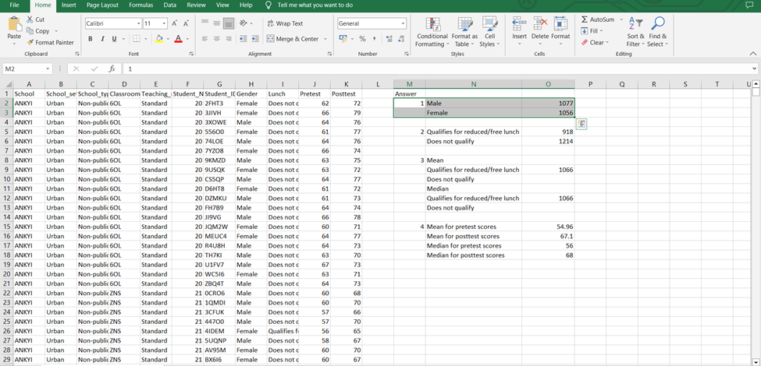
So, 1056 Students are female and 1077 Students are male in this list

Number of students qualify and do not qualify for reduced/free lunch
Here again, the COUNTIF function has been used. So the formula will be as follows,
=COUNTIF(I2:I2134,"Qualifies for reduced/free lunch")
The following is a demonstration of the students who are qualified and not qualified for free launch.
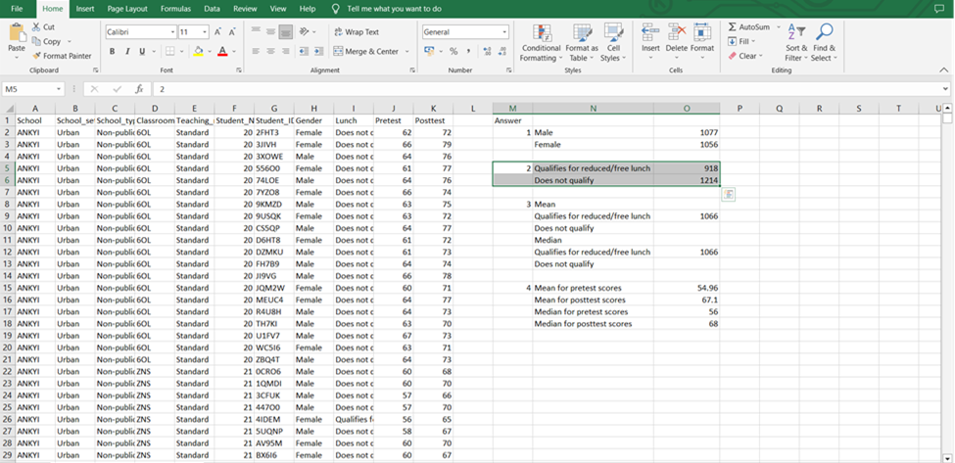
After calculation, it has been found that the number of students who have qualified for free/ reduced launch is 918 and those who have not qualified for free/reduced launch are 1214.

The mean and median of students who qualify and do not qualify for reduced/free lunch
Mean is recognized as the average value of a certain data set. In Excel, the mean value can be calculated easily. To calculate the mean, the mean function must be used in Excel. In the context of the given data sets the following formula has been used to calculate the mean of the students who qualify and do not qualify for reduced/free lunch,
Mean: =AVERAGE(O5,O6)
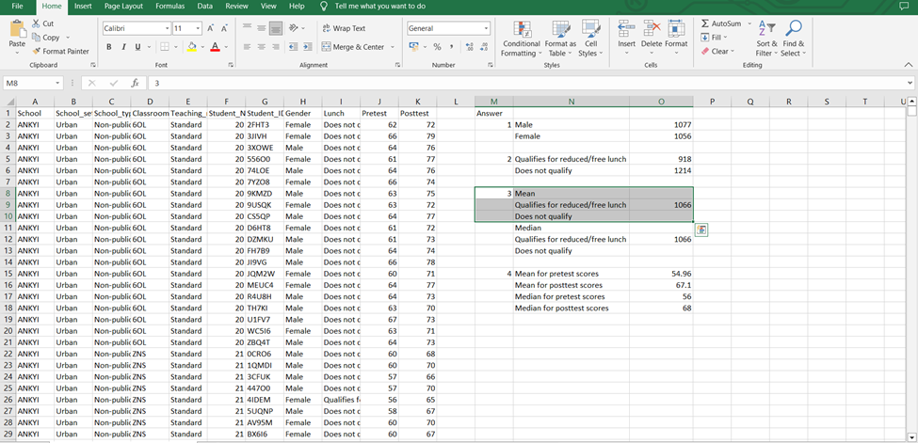
The above Excel screenshot demonstrated that the mean value of the students who qualify and do not qualify for reduced/free lunch is 1066.
The median is the number that is located exactly in the centre of a sorted list of integers. Compared to the average, the median might provide greater insight into a particular data collection. From the given data set to calculate the median value the following formula can be used,
Median: =MEDIAN(O5,O6)
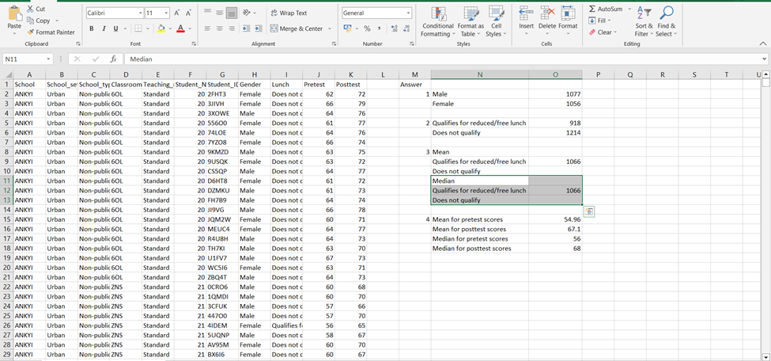
The highlighted portion in Excel shows that the median of the students who qualify and do not qualify for reduced/free lunch is 1066.

The mean and median differences between students' pre-test and post-test scores
The following formulas can be used to calculate the mean and median differences between students' pre-test and post-test scores,
Mean for pre-test scores: =AVERAGE(J2:J2134)
Mean for post test scores: =AVERAGE(K2:K2134)
Median for pre-test scores: =MEDIAN(J2:J2134)
Median for post test scores: =MEDIAN(K2:K2134)
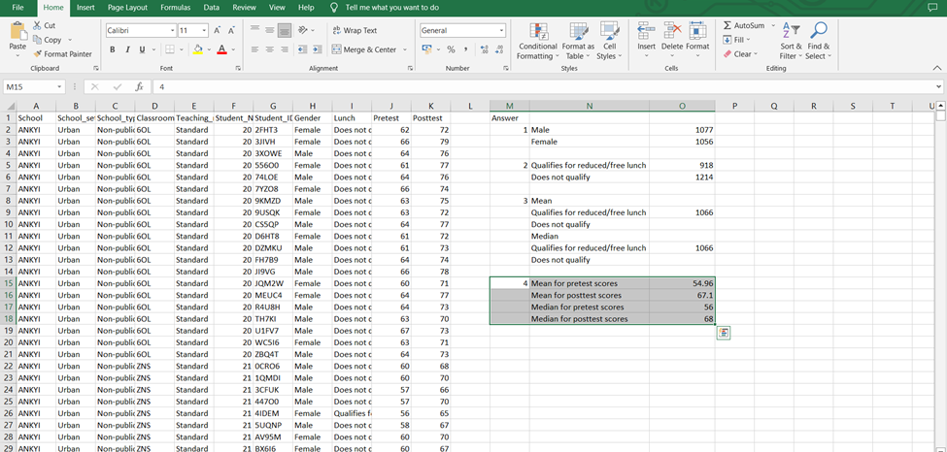
After applying the formula in Excel, the cells show the following outcome:
Mean for pre-test scores = 54.96
The mean for post-test score = 67.10
The median for pre-test scores = 56
The median for post-test scores = 68
Now calculating the differences,
The mean difference for students between pre-test and post-test scores (67.10 – 54.96) is 12.14.
The median difference between students between pre-test and post-test scores (68 - 56) is 12

K-Means Clustering
Clustering refers to the process of separating a population or set of points of information into several groups in such a way that the data points in each group are more similar to each other than they are to the data points in the other groups. In its most basic form, it is a collection of things that are organised according to the degrees to which they resemble or differ from one another (Freedman et al., 2018). The k-means clustering method is a straightforward kind of unsupervised learning that is used in the resolution of clustering issues. A given data set is put through a straightforward process of categorization into several clusters, each of which is denoted by the letter 'k'. After that, the clusters are arranged in the form of points, and all of the observations or data points are linked to the cluster that is geographically closest to them before being calculated and modified. The procedure is then again with the new settings in place until the desired outcome is achieved. In this scenario, the SPSS may be used to cluster the data that has been provided, which tells something about the student as well as their pre-test and post-test results. Step-by-step instructions on how to utilise SPSS in this context are provided below.
Step 1: From the source of the data set data needs to import into the SPSS.
Step 2: The user clicks on Analyse > Classify > K-Means Cluster.
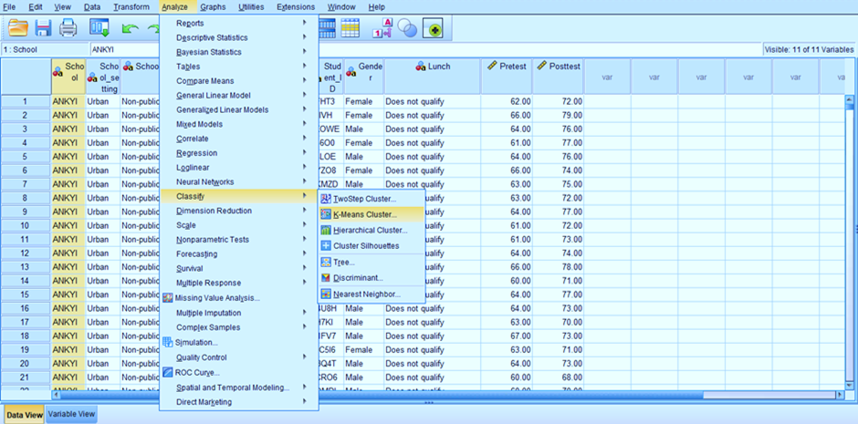
Step 3: Then the variables should be input in the pre and post-test option and a clustered value has to be chosen. For this context the cluster value is taken as 3, so K= 3.
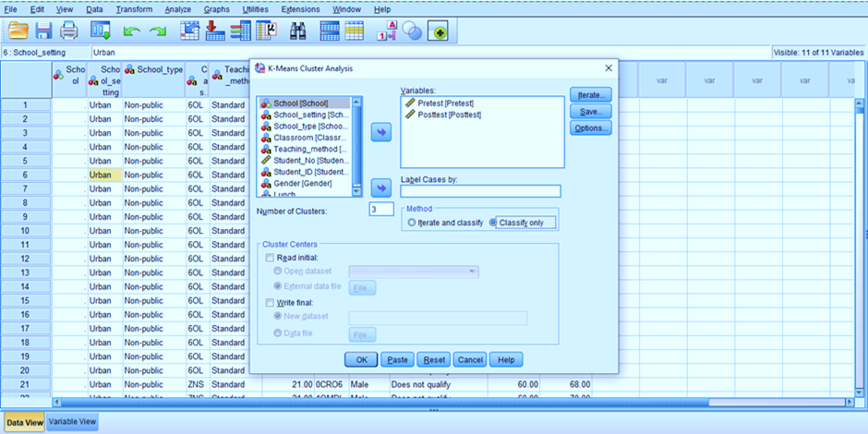
Step 4: Now the user has to press OK to run the algorithm.
Step 5: When the algorithm is performed the following output can be observed.
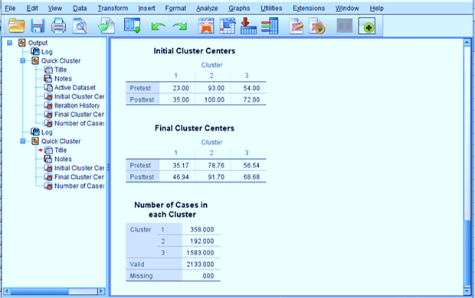
The beginning sites for each of the three clusters are presented in the section titled "Initial Cluster Centres," which can be found on the page. The table labelled "Final Cluster Centres" presents the final centroids that were found to be associated with each cluster. The overall number of cases that have been classified into the different categories is shown in the table that is located under the heading "Number of Cases in each Cluster."

Explaining 5 most common data mining and text mining methods for each
For modern enterprises, data mining and text mining are effective tools that can offer insightful information. Both data mining and text mining can be done in a variety of ways, but the methods indicated above are some of the most popular ones. Numerous industries, including marketing, can use these techniques. To extract meaningful information from massive datasets and text documents, enterprises must utilise text mining and data mining approaches. Here are some of the most widely used techniques in modern businesses for both data mining and text mining:

Data mining methods
Association rule mining: A data mining method called association rule mining is used to uncover connections and patterns in huge datasets. It entails figuring out which goods usually appear in tandem during a specific transaction (Lee, 2015). To increase sales and better display their products, retailers might utilise association rule mining to find products that customers commonly buy together, like milk and bread.
Clustering: Using the data mining approach of clustering, related objects or observations in a dataset are grouped based on shared characteristics. It is employed in many different fields, including marketing, finance, and healthcare. To combine patients with comparable diseases and determine the most effective treatment options for each group, healthcare providers might, for instance, utilise clustering. The process of clustering, a common data mining approach, involves assembling related data points into clusters according to their characteristics (Lee, 2015). Clustering's ultimate purpose is to find underlying structures and patterns in the data so that we can use these understandings to improve business decisions. It can be utilised across a variety of sectors and application cases, including consumer segmentation in marketing, fraud detection in banking, and anomaly detection in cybersecurity.
Classification: Data are categorised based on specified criteria using the data mining process of classification. It is employed in many different fields, including marketing and fraud detection. For instance, banks may classify transactions based on certain characteristics, such as transaction size and location, to identify fraudulent ones.
Regression analysis: Regression analysis is a data mining method for examining the relationship between two or more variables and forecasting future results. It is employed in several fields, including healthcare, finance, and economics (Lee, 2015). Regression analysis is a tool that economists can use, for instance, to examine the link between interest rates and inflation and forecast future trends. One dependent variable and one or more independent variables are examined using regression analysis, a statistical approach. The dependent variable's value is predicted using the values of the independent variables. Finance, economics, healthcare, and social sciences are just a few of the industries that can benefit from regression analysis. It is an effective technique for determining relationships and creating predictions and may be applied to both straightforward and sophisticated analyses.
Decision trees: A decision-making process can be represented visually using decision trees, a data mining technique. They are employed in several fields, including marketing and finance (Kim, 2019). Retailers, for instance, may utilise decision trees to determine the most effective marketing plans based on consumer behaviour and preferences.

Text mining methods
Sentiment analysis: Text mining techniques like sentiment analysis are used to find and extract subjective information from text data, like views and attitudes. It is employed in many different fields, including marketing and customer service. As an illustration, businesses may utilise sentiment analysis to find client feedback and enhance their goods and services.
Text classification: Text data can be categorised using the text mining approach of text classification according to particular criteria like subject or emotion (Kim, 2019). It is utilised across several sectors, including journalism and social media. For instance, news outlets may employ text categorization to group articles into categories based on particular topics like politics and sports.
Named entity recognition: A text mining approach called named entity recognition is used to locate and extract certain entities from text data, including persons, companies, and locations. It is employed in several fields, including law and finance (Hearst, 2012). For instance, law firms might utilise named entity recognition to extract important details from contracts and other legal documents.
Topic modelling: A text mining technique called topic modelling is used to locate and extract important topics from sizable text data collections. It is utilised in a variety of fields, including marketing and social media. To pinpoint important trends and subjects in user-generated material, for instance, social media firms may utilise topic modelling.
Text summarization: A text mining technique called text summarising is used to produce a brief overview of substantial text data sets (Hearst, 2012). It is utilised in many different fields, including journalism and research. Journalists, for instance, could use text summarising to produce a succinct summary of a lengthy article or report.

Discussing the advantages and disadvantages of using SPSS and Excel
Advantages and disadvantages of SPSS
Advantages | Disadvantages
Advanced statistical analysis: SPSS is a statistical program created for advanced data analysis, making it a fantastic tool for complex statistical modelling. Regression analysis, factor analysis, and cluster analysis are just a few of the statistical tests it can do (Educba, 2023). It can also handle a wide range of data types.  For example, consider the following scenario: A researcher examining the link between customer happiness and customer loyalty in a retail environment may use SPSS to do a multiple regression analysis to pinpoint the crucial elements that influence consumer loyalty. | SPSS is expensive: SPSS is expensive, which could be a drawback for individuals or small enterprises on a tight budget.  An independent researcher might not have the funds to buy a licence for SPSS and may instead need to rely on free or inexpensive options like Excel.
Data organization and management: SPSS is renowned for its capacity to handle and manage huge datasets. Complex data structures, split and merge datasets, and clean and transform data are all things it can manage.  To enhance patient care and outcomes, a healthcare institution may utilize SPSS to organize and analyze patient data, including demographics, medical history, and treatment outcomes. | Steep learning curve: A significant learning curve is there even though SPSS is user-friendly for simple statistical analysis (Educba, 2023). The software has many features and capabilities, and it could take some time to become familiar with them all.  An illustration would be that teaching a novice statistician how to use SPSS to conduct complex statistical analyses like structural equation modelling might be difficult.
SPSS offers a user-friendly interface that makes it simple for non-technical users to navigate and carry out sophisticated analyses (TrustRadius, 2023).  A marketing team might use SPSS to analyse survey data to create more specialised marketing campaigns and gain a deeper understanding of consumer behaviour and preferences. | Limited adaptability: Because SPSS is primarily intended for statistical analysis, it might not be as adaptable for other types of data analysis or visualisation.  For instance, a business analyst might find it challenging to use SPSS to design unique dashboards or visualisations to track important performance indicators.

Advantages and disadvantages of using Excel
Advantages | Disadvantages
Wide availability: Excel is generally accessible and available, and the majority of individuals are at least somewhat familiar with the programme. For many firms and organisations, it serves as the standard tool for data analysis and visualisation.  Example: To track sales data and expenses and make wise financial decisions, a small business owner might utilise Excel. | Limited statistical analysis: Basic statistical analysis is possible with Excel, but more complex statistical modelling requires SPSS, which Excel cannot handle.  To find the important predictors of patient outcomes, a researcher examining how a new medicine affects patient outcomes may need to utilise SPSS to perform a multivariate analysis of variance (TrustRadius, 2023).
Flexible: Excel is a versatile tool that can be used for many different data analysis and visualisation activities, including more complicated data models and visualisations as well as fundamental statistical analyses like mean, median, and mode (GraphPad, 2023). Excel can be used, for instance, by a financial analyst to build financial models and forecasts that inform corporate choices. | Restricted processing power: Excel works well with small to medium-sized datasets but could struggle with larger datasets that need intricate calculations and analysis. Working with huge datasets might cause them to be sluggish or crash, which can lead to delays and mistakes in data processing.
Easy to learn: Excel is quite simple to master, and the majority of people can rapidly grasp the fundamentals. Online users can learn about more sophisticated features and capabilities by using the many available resources.  Excel can be used as an example by a student of statistics or data science to hone their data analysis and visualisation skills. | Lack of control: Excel's lack of version control and audit trails is another drawback. It can be challenging to manage changes when numerous users work on the same Excel file, which could result in version control problems and possible data inaccuracies. Additionally, Excel does not offer an audit trail of data changes, which can make it challenging to spot and fix mistakes or discrepancies (GraphPad, 2023). For businesses like those in the financial or healthcare sectors that must guarantee data quality and consistency, this can be a serious issue.

Conclusion
Both SPSS and Excel are effective tools for data analysis. Excel is appropriate for small and medium-sized organisations since it is user-friendly and generally accessible. Larger organisations and researchers, on the other hand, use SPSS, a more potent programme with sophisticated statistical skills. Before choosing a tool, users should carefully consider their unique needs and data analysis requirements because both tools have their limitations. In today's data-driven corporate environment, it is crucial to select the appropriate tool for the task to ensure accurate and effective data analysis and decision-making.

References
Bendat, J.S. and Piersol, A.G. (2018) Random Data: Analysis and measurement procedures. New York: Wiley.
Bissett, B. (2007) Automated Data Analysis Using Excel. Boca Raton: Chapman & Hall/CRC.
Carlberg, C.G. (2013) Business analysis: Microsoft Excel 2010. Indianapolis, IN: Que.
Educba (2023) SPSS vs excel: Top 8 significant differences you need to know, EDUCBA. Available at: https://www.educba.com/spss-vs-excel/ (Accessed: May 4, 2023).
Freedman, D., Pisani, R. and Purves, R. (2018) Statistics. New Delhi etc.: Viva Books.
GraphPad (2023) The Pros and cons of using Excel for statistical calculations, GraphPad by Dotmatics. Available at: https://www.graphpad.com/support/faq/the-pros-and-cons-of-using-excel-for-statistical-calculations/ (Accessed: 4AD).
Hearst, M.A. (2012) “Text data mining,” Oxford Handbooks Online [Preprint]. Available at: https://doi.org/10.1093/oxfordhb/9780199276349.013.0034.
Heiberger, R.M. and Neuwirth, E. (2019) “R through Excel.” Available at: https://doi.org/10.1007/978-1-4419-0052-4.
Kim, H.-J. (2019) “Text mining methods for hierarchical document indexing,” Encyclopedia of Data Warehousing and Mining, Second Edition, pp. 1957–1965. Available at: https://doi.org/10.4018/978-1-60566-010-3.ch299.
Lee, D. (2015) “Session details: Methods for bio-data and text mining,” Proceedings of the ACM Ninth International Workshop on Data and Text Mining in Biomedical Informatics [Preprint]. Available at: https://doi.org/10.1145/3252352.
Lewis-Beck, S. (2010) Data Analysis: An introduction. Thousand Oaks: Sage.
Michael (2014) Data Analysis. New York: Springer.
Sarantakos, S. (2017) Data Analysis. Los Angeles: SAGE.
TrustRadius (2023) IBM SPSS Statistics Reviews & Ratings 2023, TrustRadius. Available at: https://www.trustradius.com/products/ibm-spss/reviews?qs=pros-and-cons (Accessed: May 4, 2023).
Tukey, J.W. (2011) Exploratory Data Analysis. Reading, Mass,: Addison Wesley Pub. Co.
Zhou, H. (2021) “Master excel through projects,” Mastering Excel Through Projects, pp. 1–33. Available at: https://doi.org/10.1007/978-1-4842-7842-0_1.
Zhou, H. (2021) “Pivottable Data Analysis,” Mastering Excel Through Projects, pp. 169–201. Available at: https://doi.org/10.1007/978-1-4842-7842-0_7.

